Setup A Static Effective Sample Size Report
Setup: setup_a
Report timestamp: 20260417_150440
Source notebook: setup_A_static_effective_sample_size.ipynb

Executive summary
Setup A is treated as a static optical sampling problem. The report uses a cylindrical first-order sampling-volume approximation to examine how penetration depth and bulk density set the effective sampled mass in a stationary powder bed. The main result is that effective sample size increases linearly with both penetration depth and density when illuminated area is fixed.

Key parameters
- Probe diameter (mm): 5
- Penetration depth range (mm): 0.1 to 2.0
- Penetration depth step (mm): 0.1
- Bulk densities (g/cm^3): 0.4, 0.5, 0.6

Background
Setup A represents a static powder bed measured with a contact or near-contact diffuse reflectance NIR probe. In this configuration, powder motion is neglected during acquisition, so the optical interaction zone can be approximated from probe geometry and effective penetration depth.
Effective sample size matters because it links measured spectral response to how much material actually contributes to the signal. This directly influences interpretation, robustness, and representativity.
A static powder bed is conceptually the simplest setup because dynamic transport and re-sampling effects are absent in the first approximation. The remaining challenge is optical interaction geometry.
It is important to distinguish the geometric interaction volume from the true optical sensitivity distribution. Real diffuse reflectance sampling is non-uniform with depth and lateral position. This notebook starts with a cylindrical approximation to provide a clear first-order model for sensitivity analysis and order-of-magnitude understanding.

Objective
Simulate sampled volume and sampled mass for a 5 mm circular probe as a function of effective penetration depth from 0.1 mm to 2.0 mm, and examine the influence of powder bulk density.

Theory
For a circular probe window:
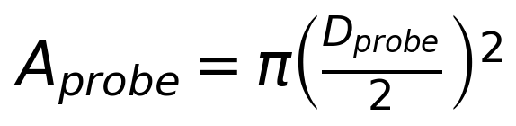
First-generation sampled volume approximation:
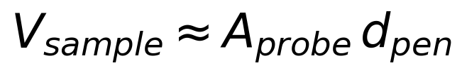
Sampled mass approximation:
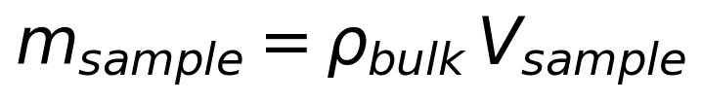
Symbols and units:
- D_probe: probe window diameter [m]
- A_probe: probe area [m^2]
- d_pen: effective penetration depth [m]
- rho_bulk: bulk density [kg/m^3]
- V_sample: sampled volume [m^3]
- m_sample: sampled mass [kg]
This is a first-generation geometric approximation. The true optical sensitivity distribution is not perfectly cylindrical.

Assumptions
- static powder bed
- uniform bulk density
- circular probe window
- uniform effective penetration depth
- cylindrical optical interaction volume approximation
- no particle motion during acquisition
- no resampling
- no detailed radiative transfer model yet

Worked example
A representative worked example is shown for a penetration depth of 1.0 mm and a bulk density of 0.5 g/cm^3. This gives one concrete reference point before the full static sweep is interpreted.
Quantity | Value | Unit
Bulk density | 0.5 | g/cm^3
Penetration depth | 1.0 | mm
Illuminated area | 0.1963 | cm^2
Sampled volume | 0.0196 | cm^3
Effective sample size | 9.8175 | mg

Model scenarios and sweep design
The static sweep varies only two quantities: penetration depth and bulk density. The illuminated area is fixed by probe geometry, so the report isolates how optical depth and density convert directly into sampled volume and sampled mass.
- penetration depth from 0.1 to 2.0 mm in 0.1 mm steps
- bulk-density scenarios of 0.4, 0.5, 0.6 g/cm^3
This produces 60 modeled scenarios.

Selected results table
The selected table below shows representative static scenarios spanning low, medium, and high penetration depth across the three density cases.
bulkdensityg_cm3 | penetrationdepthmm | sampledvolumecm3 | effectivesamplesize_mg
0.4 | 0.5 | 0.0098 | 3.9270
0.4 | 1.0 | 0.0196 | 7.8540
0.4 | 2.0 | 0.0393 | 15.7080
0.5 | 0.5 | 0.0098 | 4.9087
0.5 | 1.0 | 0.0196 | 9.8175
0.5 | 2.0 | 0.0393 | 19.6350
0.6 | 0.5 | 0.0098 | 5.8905
0.6 | 1.0 | 0.0196 | 11.7810
0.6 | 2.0 | 0.0393 | 23.5619

Figures
The figures are presented in causal order: first the geometric sampled volume set by penetration depth, then the resulting effective sampled mass once bulk density is applied.
Figure 1. Geometric sampled volume versus penetration depth for Setup A.
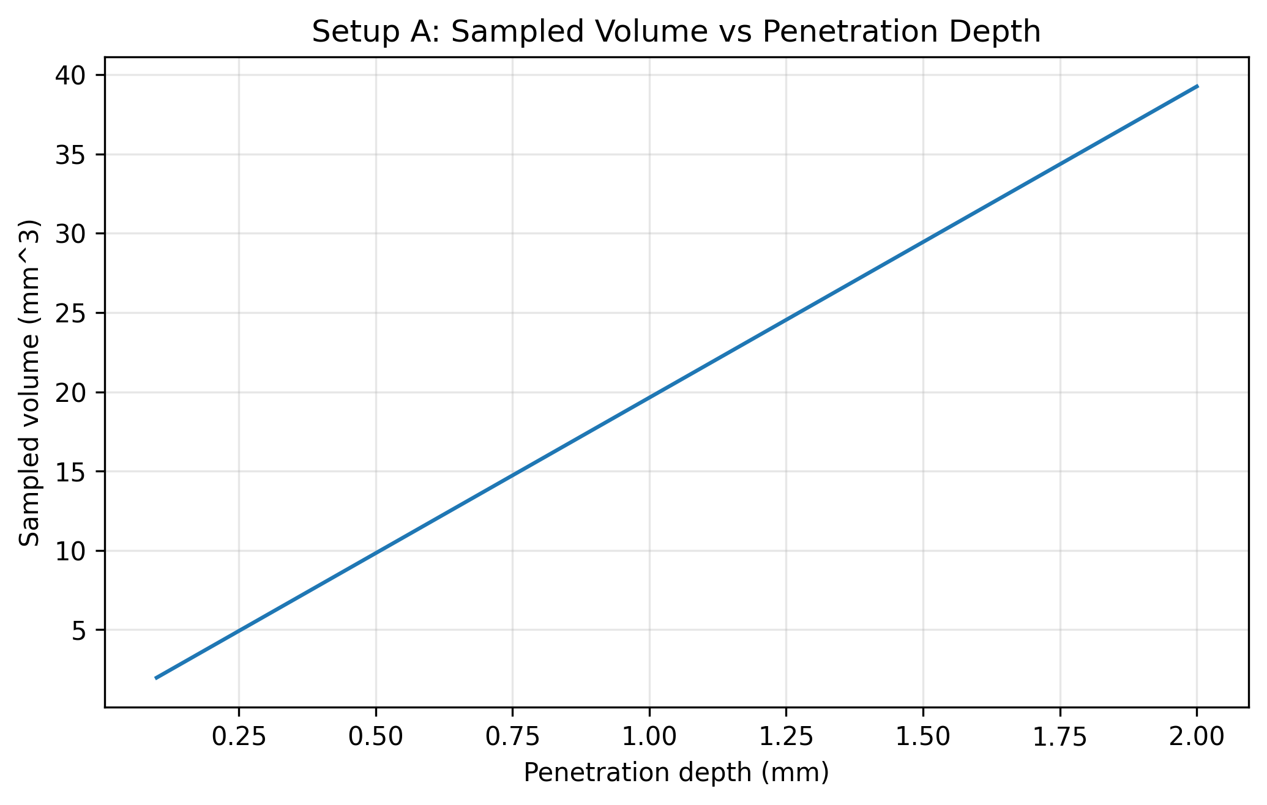
Figure 2. Effective sampled mass versus penetration depth for the three bulk-density scenarios.
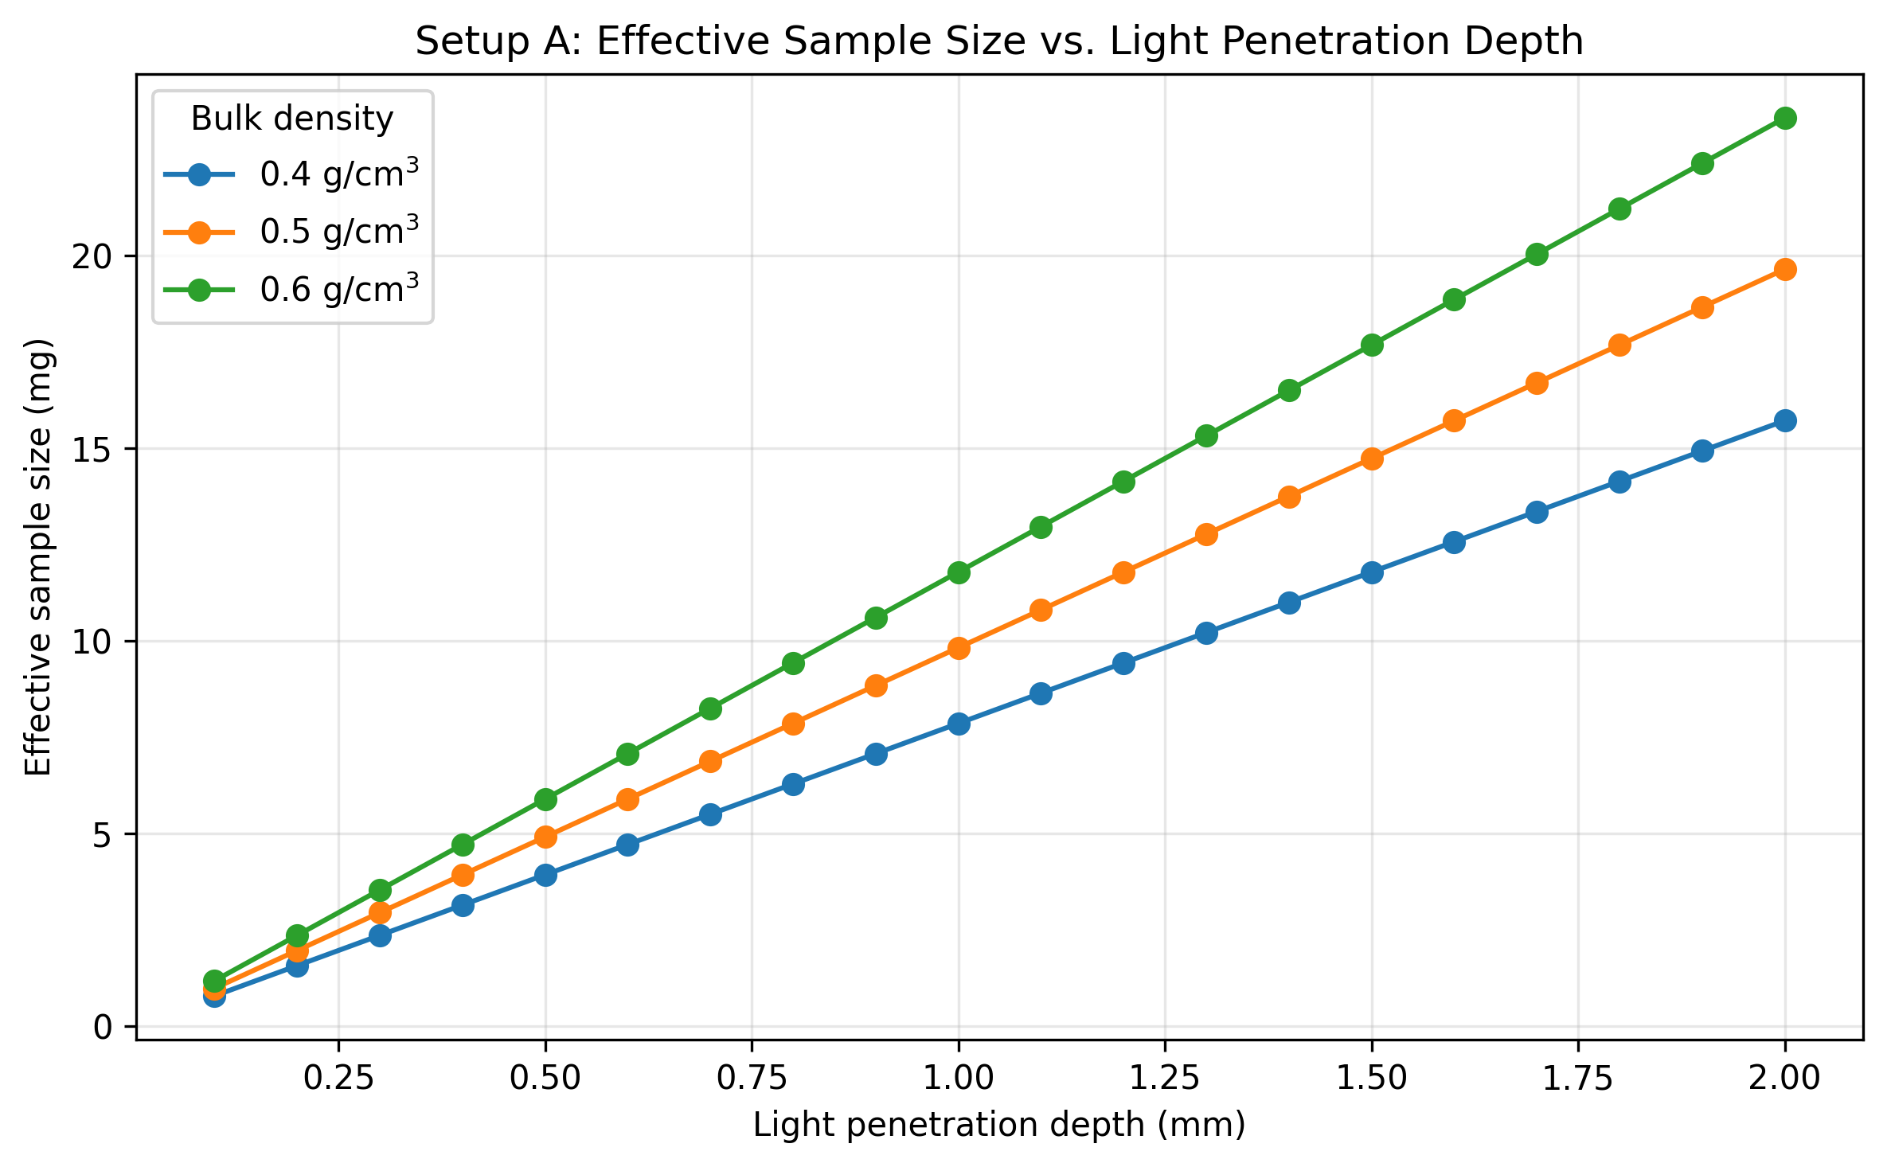

Results Interpretation
- effective sample size (sampled mass) scales linearly with penetration depth when illuminated area is fixed
- effective sample size increases with bulk density at any fixed penetration depth
- three density curves (0.40, 0.50, 0.60 g/cm^3) provide discrete scenario comparison for static Setup A
- this remains a geometric first approximation rather than a full optical transport model

Practical Implications
- uncertainty in penetration depth strongly affects estimated effective sample size
- bulk density matters when converting interaction volume to sampled mass
- this framework is useful for comparing powders and probe setups

Limitations
- true photon sampling distribution is non-uniform
- penetration depth is an effective parameter, not a sharp boundary
- bulk density may vary with compaction and handling
- particle-level sampling statistics are not yet included
- no correction factor for optical weighting yet

Appendices

Next logical extensions
- interaction volume correction factor
- particle count estimation
- sensitivity analysis for probe diameter
- uncertainty bands for penetration depth
- non-uniform optical weighting functions

Exported artifacts
CSV files
- results_full.csv
- summary_table.csv
- input_summary.csv
Figure files
- plot_01_sampled_volume_vs_penetration_depth.png
- plot_02_effective_sample_size_vs_penetration_depth.png

