Setup D Powder Flow and Effective Sample Size Proxy Report
Setup: setup_d
Report timestamp: 20260417_150746
Source notebook: setup_D_pipe_effective_sample_size.ipynb

Executive summary
Setup D is assessed as a first-order renewal-driven NIR sampling problem in an inclined powder pipe. The report separates transport-side powder presentation from optical reduction at the probe and uses that framework to estimate a refresh-based proxy effective mass during one 1.8 s acquisition. The results show that throughput and penetration depth increase the proxy, while density cancels at fixed throughput within the present superficial-velocity formulation.

Key parameters
- Pipe diameter (mm): 65
- Pipe tilt from vertical (deg): 26.5
- Pipe total height (mm): 340
- Inlet-outlet displacement (mm): 100.2
- Probe diameter (mm): 5
- Acquisition time (s): 1.8
- Throughput range (kg/h): 40 to 100
- Density scenarios (g/cm^3): 0.4, 0.5, 0.6
- Penetration depth range (mm): 0.1 to 2.0

1. Purpose and scope
This notebook develops a first-order engineering proxy for powder renewal and effective sample size during one NIR spectrum acquisition in Setup D: an inclined powder pipe with a wall-mounted diffuse-reflectance probe near the lower side of the pipe.
The report focuses on two linked questions:
- how the pipe flow presents fresh powder past the probe during one acquisition
- how that presentation, together with an assumed optical penetration depth, sets the refresh-based proxy effective mass m_eff,proxy
The reported quantity is a refresh-based proxy effective mass, denoted m_eff,proxy. It is intended for comparative engineering assessment and sensitivity analysis. It is not an exact geometric union of all photon-contributing material, and it is not presented as a validated independent sample mass.

2. Scientific background

Optical sampling concept
In diffuse reflectance NIR measurements, light enters a powder bed, interacts with particles over a limited depth, and a fraction of the scattered light returns to the detector. The measured spectrum therefore reflects an optically weighted near-surface region rather than the entire bulk stream.
For engineering comparisons, the instantaneous optical interaction region is approximated here as a simple cylinder with:
- cross-sectional area equal to the probe footprint
- depth equal to an assumed optical penetration depth
This simplification ignores depth-dependent photon weighting, scattering anisotropy, packing-dependent path-length effects, and spectral absorption details, but it provides a transparent basis for comparative analysis.

Probe-flow geometry
In Setup D, the probe is mounted in the pipe wall and looks radially inward. The powder flows axially along the pipe. These directions are perpendicular.
At any instant, the probe sees a shallow optical disc of powder pressed against the wall:
- the disc face is the probe footprint with diameter d_probe
- the disc depth is the optical penetration depth d_pen extending radially into the powder
Because the probe looks perpendicular to the flow, renewal occurs by material sliding across the probe window rather than being pushed into it. The flow supplies fresh material axially, while the light samples radially.

Why a renewal model is appropriate
During one acquisition, the probe does not observe a single static neighborhood of powder. Instead, moving material repeatedly replaces the near-wall region in front of the probe. A renewal model is therefore a natural first-order way to connect powder motion to the mass that can contribute to one spectrum.

Why superficial velocity is still useful
The notebook uses a superficial bulk velocity to estimate the renewal driver from throughput, bulk density, and full pipe cross-sectional area. This is a deliberate engineering approximation: the local wall velocity may differ from the cross-sectional average, but the superficial velocity still provides a transparent transport-side baseline for sensitivity analysis and model comparison.

3. Physical system and engineering context
Setup D is treated as an inclined internal-flow geometry with the following fixed hardware and operating context:
- pipe internal diameter = 65 mm
- pipe axis tilt = 26.5 degrees from vertical
- total pipe height = 340 mm
- horizontal inlet-to-outlet displacement = 100.2 mm
- NIR probe diameter = 5 mm
- acquisition time = 1.8 s
The probe is flush with the lower pipe wall and looks radially inward. Powder moves axially downward through the pipe and is expected to slide preferentially along the lower side, so the probe interacts with a covered near-wall region rather than a free-falling or dilute suspension.

Expected powder state at the probe
For the modeled operating window, the engineering picture is more consistent with slow dense-phase sliding than with dilute pneumatic transport. The practical interpretation is:
- the lower wall is likely to remain covered under normal operating throughputs
- the near-wall material is likely denser and slower than the cross-sectional average
- mild consolidation near the wall is possible
- intermittent exposure could occur only toward the low-throughput edge and is not included in the base model

Consequence for the base model
The base model therefore uses superficial velocity only as a first-order renewal driver. That is reasonable for comparative assessment, but it likely overestimates the local renewal rate if the wall-adjacent powder moves more slowly than the bulk average.

4. Model assumptions
The base model is intentionally simple. Its assumptions are grouped below so the reader can see exactly where the engineering approximation enters the calculation.

Optical and geometric assumptions
- the instantaneous optical sampling region is approximated as a cylinder with volume Aprobe * dpen
- the probe window is fully covered by powder at all times
- the probe footprint remains the relevant lateral scale for both the optical proxy and the renewal approximation

Transport and renewal assumptions
- powder renewal at the probe is approximated by a first-order renewal approximation with characteristic axial length of order d_probe
- the renewal rate is derived from a bulk superficial velocity computed from throughput, density, and full pipe cross-sectional area
- no explicit blocking events or recirculation corrections are included

Flow-state assumptions
- bulk density is constant and spatially uniform within each scenario
- the powder at the probe is assumed to be in a dense-phase, gravity-driven sliding regime rather than an aerated or fluidized state
- de-aeration during transit through the pipe is assumed but not explicitly modeled
- velocity profiles across the pipe cross-section are not resolved; the superficial velocity represents a bulk average
- local wall velocity may differ from the average superficial velocity, but that difference is ignored in the base model

Interpretation boundary
- the output is a refresh-based proxy effective mass intended for comparative engineering analysis, not a validated independent sample mass
These assumptions intentionally favor transparency and internal consistency over full optical or granular-flow realism.

5. Mathematical model
Internal units used throughout the simulation are:
- geometry in cm
- area in cm^2
- volume in cm^3
- time in s
- density in g/cm^3
- throughput entered in kg/h and converted internally to g/s
- penetration depth entered in mm and converted internally to cm
- final reported proxy effective sample masses in mg

Geometric directions at the probe
The probe is mounted in the pipe wall, looking radially inward. The powder flows axially past the probe. The model uses three perpendicular directions:
Direction | Symbol | Physical meaning
Axial (along flow) | v * t_acq | distance powder travels during acquisition
Tangential (in the wall plane) | d_probe | probe footprint width
Radial (into powder) | d_pen | light penetration depth from wall into powder

At any single instant, the probe sees a shallow optical disc of powder with face area Aprobe and radial depth dpen. Over a finite acquisition, the model does not claim that the sampled material is an exact geometric sweep or an exact union. Instead, it uses a first-order renewal approximation in which the near-wall powder in front of the probe is refreshed over a characteristic axial length of order d_probe.

Pipe and flow quantities
Pipe cross-sectional area:
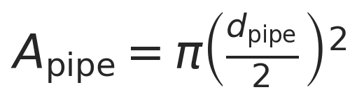
Mass flow conversion:
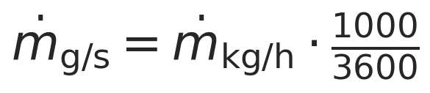
Superficial velocity (axial direction):
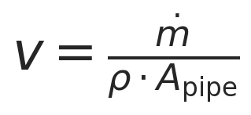
Units: [g/s] / ([g/cm^3] [cm^2]) = [cm/s].
This is the cross-sectional average axial velocity of the powder along the pipe. In this notebook it is used only as a first-order renewal driver.
Worked-example check (dotm = 95 kg/h, rho = 0.4 g/cm^3, d_pipe = 65 mm):
Step | Value | Unit
dotm | 95 x 1000 / 3600 = 26.3889 | g/s
A_pipe | pi (6.5/2)^2 = 33.1831 | cm^2
rho * A_pipe | 0.4 x 33.1831 = 13.2732 | g/cm
v = dotm / (rho * A_pipe) | 26.3889 / 13.2732 = 1.9882 | cm/s

Instantaneous optical mass
Probe footprint area:
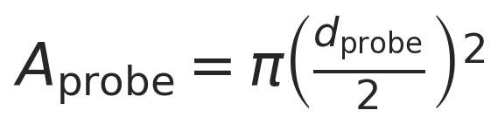
Instantaneous optical mass:

This is the instantaneous optically weighted mass adjacent to the probe under the cylindrical optical-volume approximation.

Refresh factor
The first-order renewal approximation assumes that the powder in front of the probe is refreshed when material advances by a characteristic axial length of order d_probe. The corresponding refresh factor during one acquisition is:
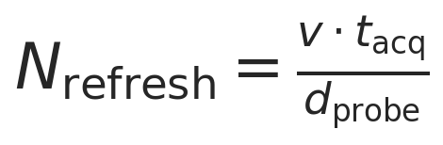
This is a renewal-based proxy, not an exact count of independent packets of powder.

Proxy effective sample mass
The proxy effective sample mass is defined as:

Combining the expressions gives:
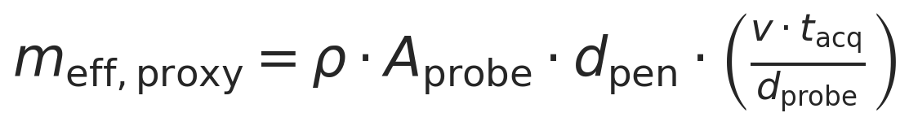
Interpretation of this expression:
- it is a first-order mechanistic proxy model
- it assumes renewal of powder over a characteristic length scale of order d_probe
- it is not the exact geometric union of sampled material
- it is intended for comparative engineering analysis

Convective reference mass-flow proxy
The convective reference mass-flow proxy is a bookkeeping reference quantity: it asks how much powder is presented past the probe footprint during one acquisition under the same superficial-velocity model used elsewhere in the notebook. It ignores optical penetration depth and should not be read as an exact 3D sampled volume or an exact geometric union of illuminated powder.
Using the superficial velocity and footprint area defined above,
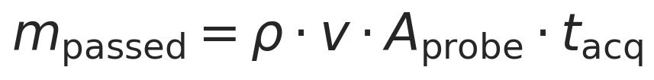
This is the turnover mass associated with successive probe-footprint-scale neighborhoods being renewed past the probe during one acquisition, under the first-order superficial-velocity model.
Key assumptions:
- The powder is a continuous, uniform stream (no gaps, no clumps).
- Every bit of powder counted by this turnover reference is included, regardless of whether the light actually reaches it.
- The speed is the bulk average — powder near the wall might actually move slower.

Relation to the effective sample size proxy
The convective reference counts the full footprint-scale mass associated with the renewal process. The optical proxy counts only the shallow optically active mass within that same renewal process:
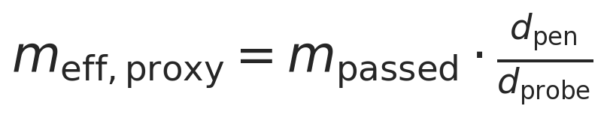

Renewal-event interpretation of the ratio
The factor dpen / dprobe should not be read as "the light penetrates partway through one common slab of thickness d_probe." In this model it is the ratio of two proxy masses assigned to the same renewal event at the probe.
The shared renewal count is:

For one renewal event, the convective reference counts

while the optical proxy counts

Multiplying both by the same renewal count gives
so that
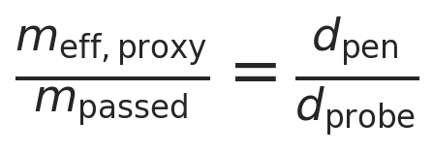
The two quantities share the same rho, Aprobe, and Nrefresh. The only substituted length is the characteristic depth assigned to one renewal event.

Cross-directional meaning of the ratio
The ratio compares a radial optical depth to an axial renewal length:
- axial motion sets the renewal count
- tangential extent contributes to the footprint area A_probe
- radial extent sets the optical mass counted within each renewal event
The ratio works because the model compares two bookkeeping definitions built on the same renewal process, not because the light literally penetrates a fraction of the way through an axial slab. The schematic below makes that distinction explicit.

Why d_probe appears in the denominator
The denominator is d_probe because the renewal count is defined at the probe-footprint scale:

The model asks how many probe-sized renewal events occur during one acquisition, not how many pipe-diameter-length events occur.

Numerical check with worked example
Using the worked example (dpen = 1 mm, dprobe = 5 mm):
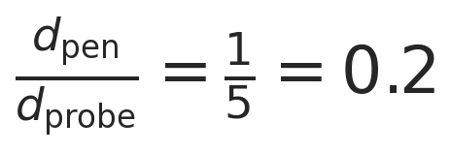
So, for each renewal event, the optical proxy counts one-fifth of the mass counted by the convective reference because it uses dpen instead of dprobe.

Summary of the three related quantities
Quantity | What it answers | Formula
v | How fast is the powder moving? | dotm / (rho * A_pipe)
m_passed | How much powder is presented past the probe footprint under the convective reference model? | rho v Aprobe * tacq
m_eff,proxy | How much mass is counted by the optical renewal proxy? | mpassed * dpen / d_probe

The ratio dpen / dprobe is therefore a bookkeeping consequence of the proxy model. Its value is to keep the convective reference and the optical proxy conceptually separate.

Density cancellation within this model
The superficial velocity relation is:

Substituting into the proxy effective-mass expression gives:

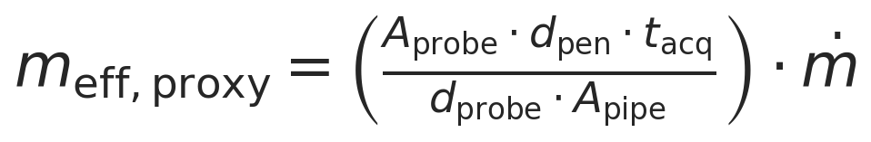
In this model, the density terms cancel exactly. That cancellation is model-dependent: it follows from using the same bulk density in both the instantaneous optical mass and the superficial-velocity approximation.
This cancellation is worth understanding because it is one of the sharpest internal consistency checks in the notebook. At fixed mass throughput, increasing density does two equal and opposite things within this formulation: it increases the instantaneous optical mass, but it decreases the renewal rate by the same factor through the superficial-velocity relation. If a reader misses that cancellation, they will misread the model and attribute density sensitivity to a proxy that, by construction, does not contain it. Seeing the cancellation tells you exactly what the current model captures, and exactly which additional physics would need to be added before density could matter again.

Worked example
The worked example provides a numerical anchor for the later sweep. It shows the magnitude of the transport-side turnover mass, the optical mass per renewal event, and the resulting proxy effective mass at one representative operating point.
Quantity | Value | Unit
Throughput | 95.0 | kg/h
Density | 0.4 | g/cm^3
Superficial velocity | 1.3952 | cm/s
Instantaneous optical mass | 7.8540 | mg
Refresh factor | 7.1573 | -
Convective reference mass-flow proxy | 295.8580 | mg
Effective sample size proxy | 56.2130 | mg

Model scenarios and sweep design
The sweep is designed to separate the transport driver, the optical contribution per renewal event, and the combined proxy response.
- throughput from 40 to 100 kg/h
- density scenarios of 0.4, 0.5, and 0.6 g/cm^3
- penetration depth from 0.1 to 2.0 mm in 0.1 mm steps
- fixed 5 mm probe diameter and 1.8 s acquisition time
This produces 780 modeled scenarios.

Selected results table
The selected table below samples low, mid, and high throughput together with representative penetration depths. Full scenario tables are exported separately as CSV files.
throughputkgh | densitygcm3 | penetrationdepthmm | superficialvelocitycm_s | opticalmassperrefreshmg | n_refresh | effectivesamplemassproxymg | convectivereferencemassproxymg
40 | 0.4 | 0.5 | 0.8371 | 3.9270 | 3.0136 | 11.8343 | 118.3432
40 | 0.4 | 1.0 | 0.8371 | 7.8540 | 3.0136 | 23.6686 | 118.3432
40 | 0.4 | 2.0 | 0.8371 | 15.7080 | 3.0136 | 47.3373 | 118.3432
70 | 0.4 | 0.5 | 1.4649 | 3.9270 | 5.2738 | 20.7101 | 207.1006
70 | 0.4 | 1.0 | 1.4649 | 7.8540 | 5.2738 | 41.4201 | 207.1006
70 | 0.4 | 2.0 | 1.4649 | 15.7080 | 5.2738 | 82.8402 | 207.1006
100 | 0.4 | 0.5 | 2.0928 | 3.9270 | 7.5340 | 29.5858 | 295.8580
100 | 0.4 | 1.0 | 2.0928 | 7.8540 | 7.5340 | 59.1716 | 295.8580
100 | 0.4 | 2.0 | 2.0928 | 15.7080 | 7.5340 | 118.3432 | 295.8580
40 | 0.5 | 0.5 | 0.6697 | 4.9087 | 2.4109 | 11.8343 | 118.3432
40 | 0.5 | 1.0 | 0.6697 | 9.8175 | 2.4109 | 23.6686 | 118.3432
40 | 0.5 | 2.0 | 0.6697 | 19.6350 | 2.4109 | 47.3373 | 118.3432
70 | 0.5 | 0.5 | 1.1719 | 4.9087 | 4.2190 | 20.7101 | 207.1006
70 | 0.5 | 1.0 | 1.1719 | 9.8175 | 4.2190 | 41.4201 | 207.1006
70 | 0.5 | 2.0 | 1.1719 | 19.6350 | 4.2190 | 82.8402 | 207.1006
100 | 0.5 | 0.5 | 1.6742 | 4.9087 | 6.0272 | 29.5858 | 295.8580
100 | 0.5 | 1.0 | 1.6742 | 9.8175 | 6.0272 | 59.1716 | 295.8580
100 | 0.5 | 2.0 | 1.6742 | 19.6350 | 6.0272 | 118.3432 | 295.8580
40 | 0.6 | 0.5 | 0.5581 | 5.8905 | 2.0091 | 11.8343 | 118.3432
40 | 0.6 | 1.0 | 0.5581 | 11.7810 | 2.0091 | 23.6686 | 118.3432
40 | 0.6 | 2.0 | 0.5581 | 23.5619 | 2.0091 | 47.3373 | 118.3432
70 | 0.6 | 0.5 | 0.9766 | 5.8905 | 3.5158 | 20.7101 | 207.1006
70 | 0.6 | 1.0 | 0.9766 | 11.7810 | 3.5158 | 41.4201 | 207.1006
70 | 0.6 | 2.0 | 0.9766 | 23.5619 | 3.5158 | 82.8402 | 207.1006
100 | 0.6 | 0.5 | 1.3952 | 5.8905 | 5.0226 | 29.5858 | 295.8580
100 | 0.6 | 1.0 | 1.3952 | 11.7810 | 5.0226 | 59.1716 | 295.8580
100 | 0.6 | 2.0 | 1.3952 | 23.5619 | 5.0226 | 118.3432 | 295.8580

Figures
Figures are embedded in mechanism-to-outcome order. The schematic establishes the geometry and renewal-event bookkeeping; the next two plots isolate the transport and optical drivers; the remaining plots show the resulting proxy response.
Figure 1. Schematic of the probe geometry and the renewal-event bookkeeping used to relate the convective reference mass to the optical proxy.
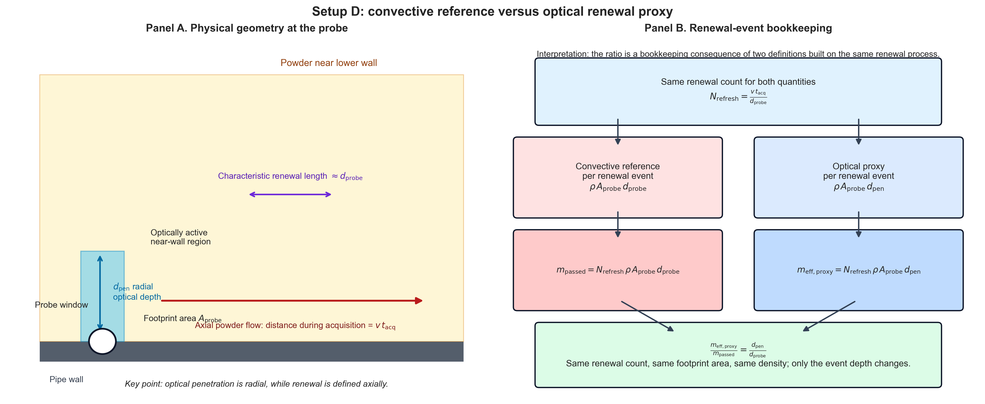
Figure 2. Superficial velocity versus throughput, showing the transport-side renewal driver used by the model.
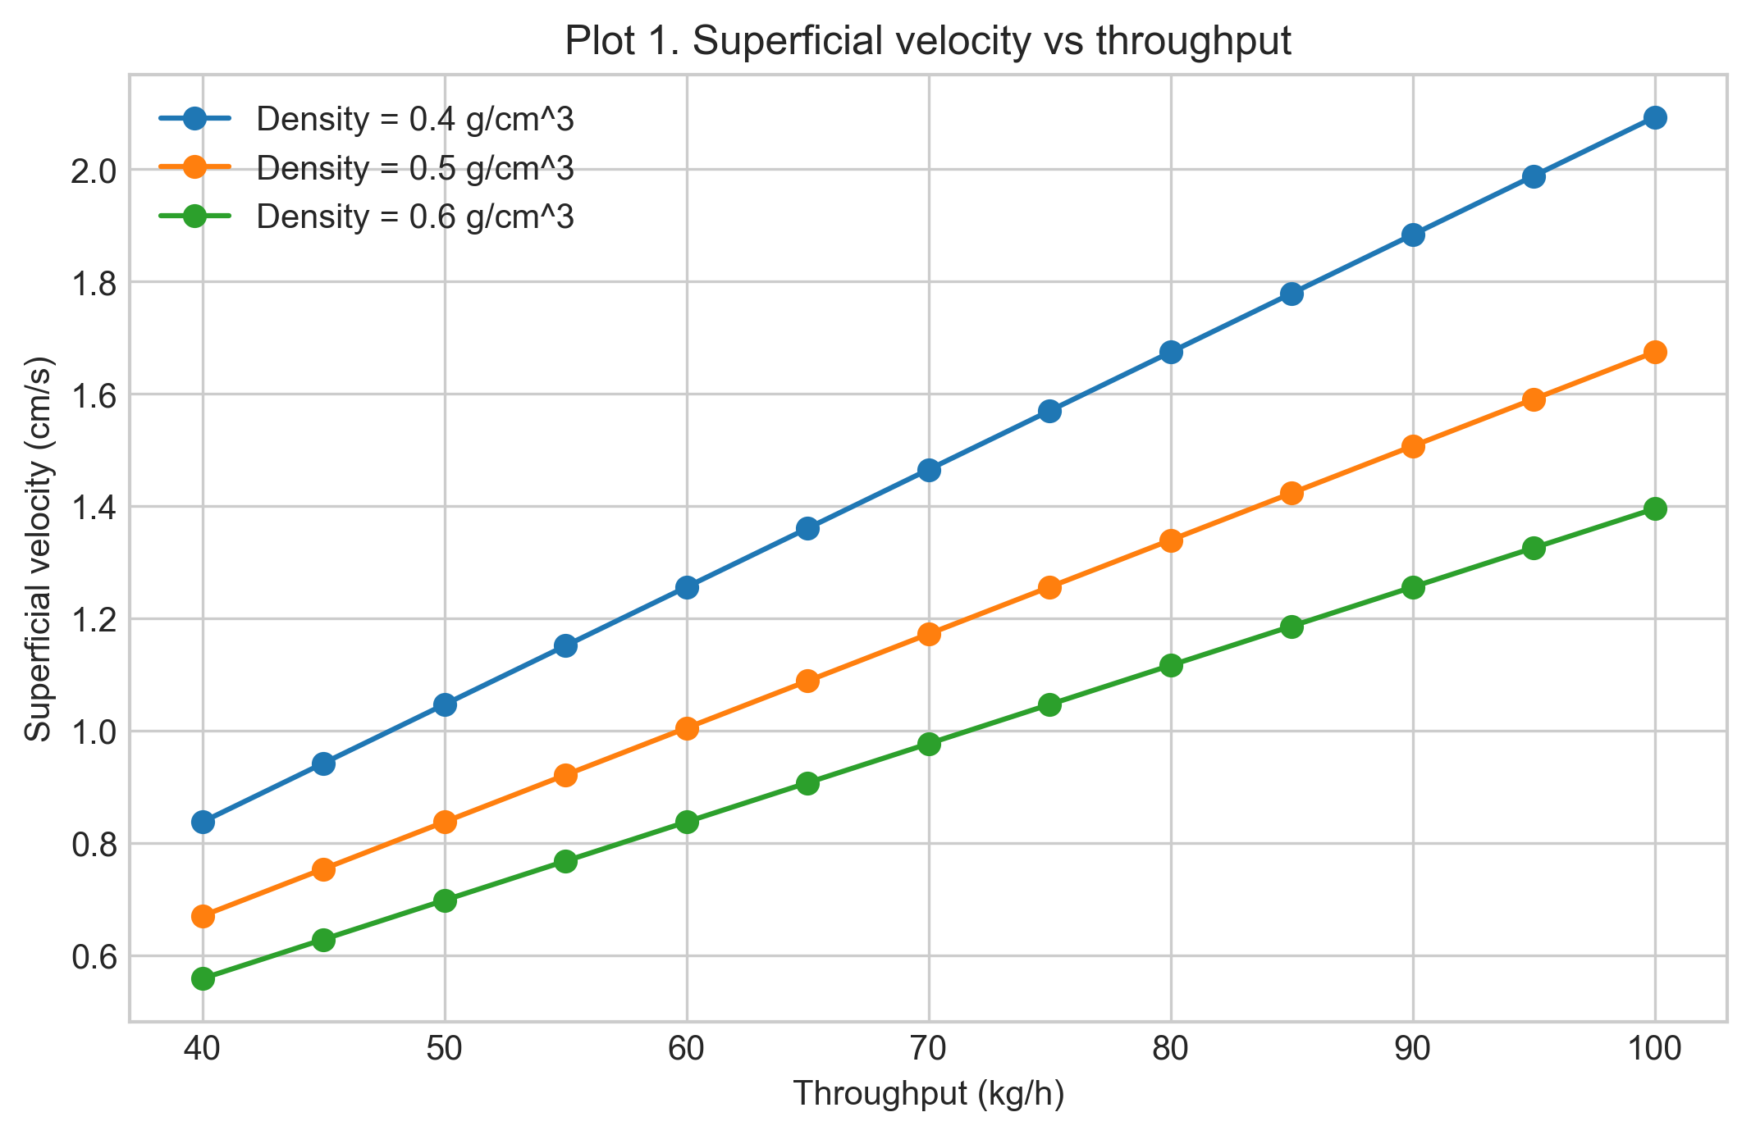
Figure 3. Instantaneous optical mass per renewal event versus penetration depth.
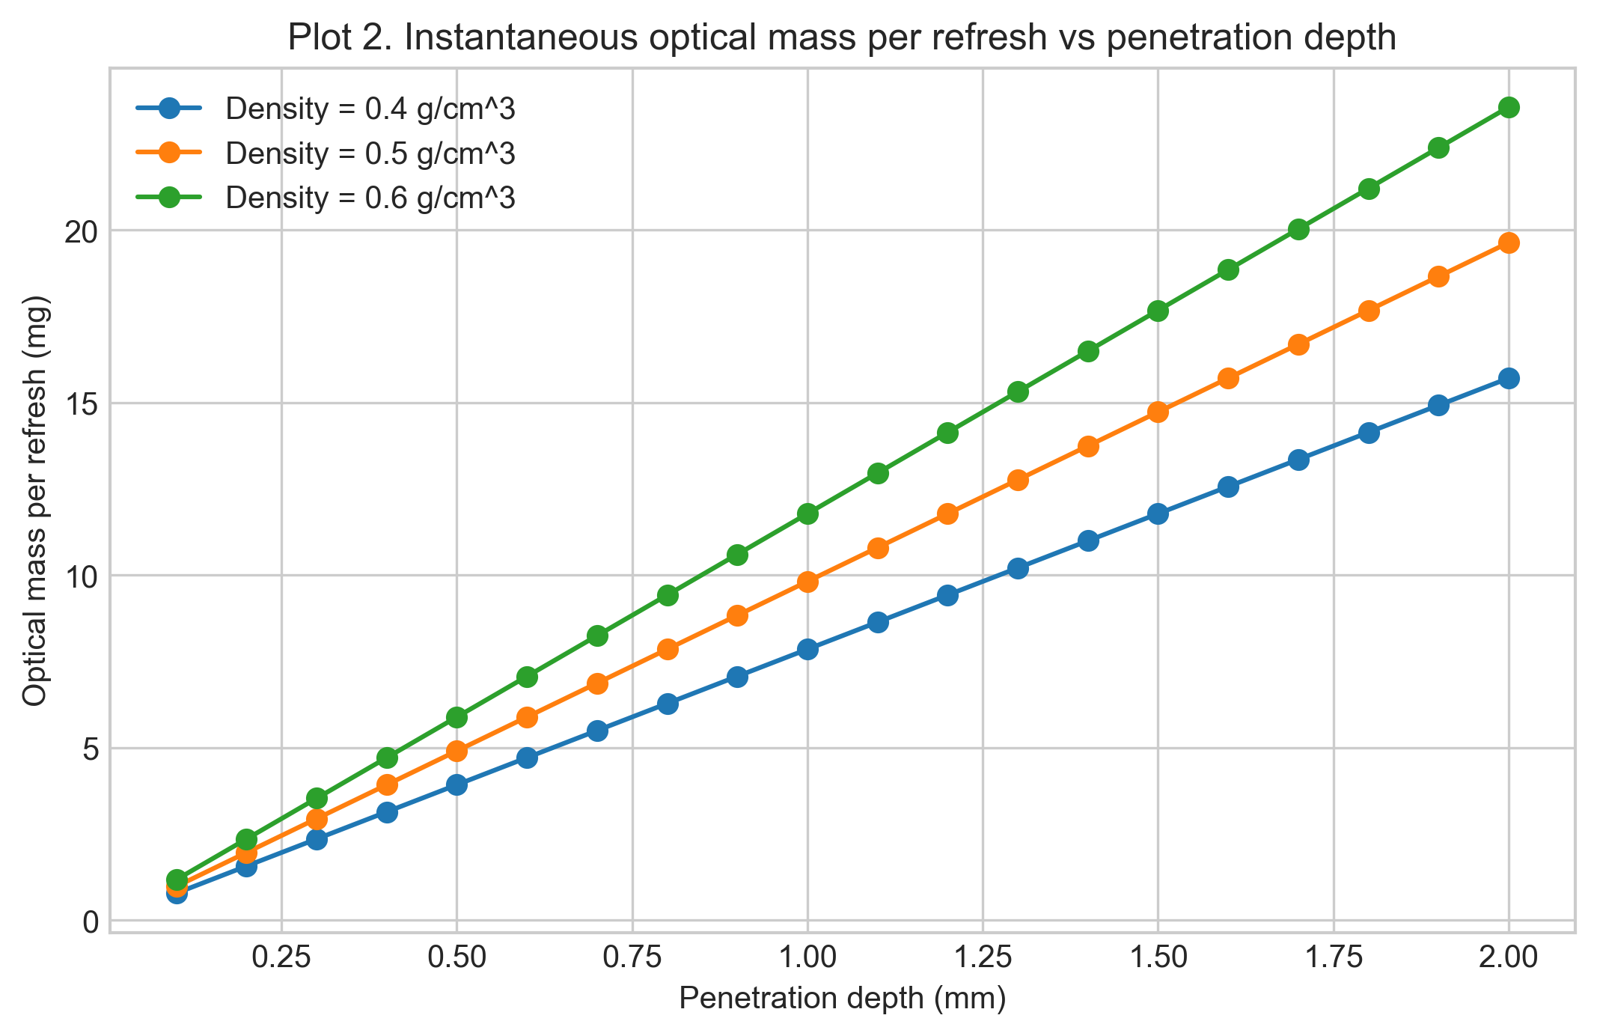
Figure 4. Convective reference mass-flow proxy versus throughput at fixed penetration depth.
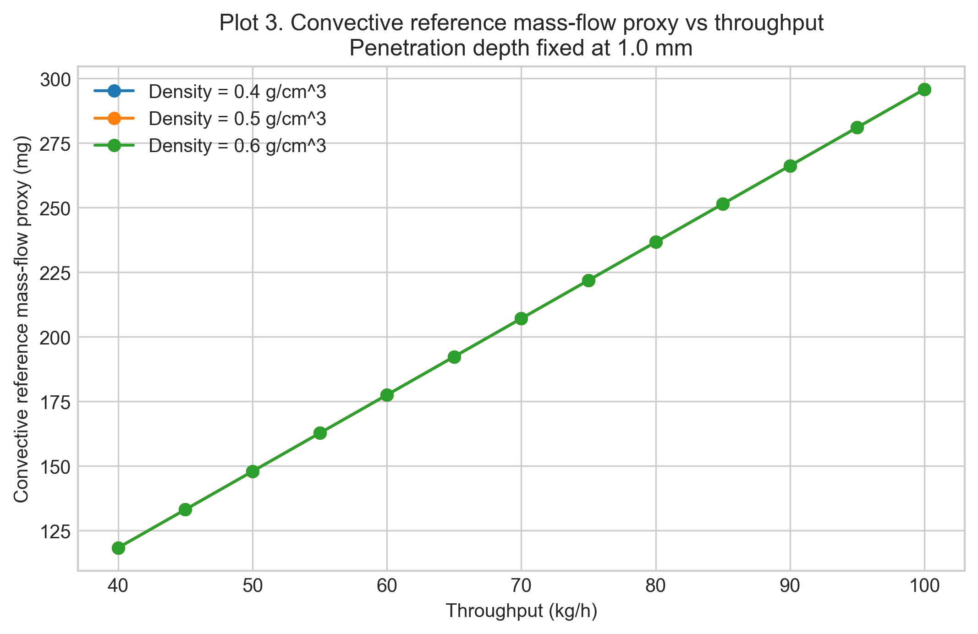
Figure 5. Effective sample size proxy versus penetration depth at fixed throughput.
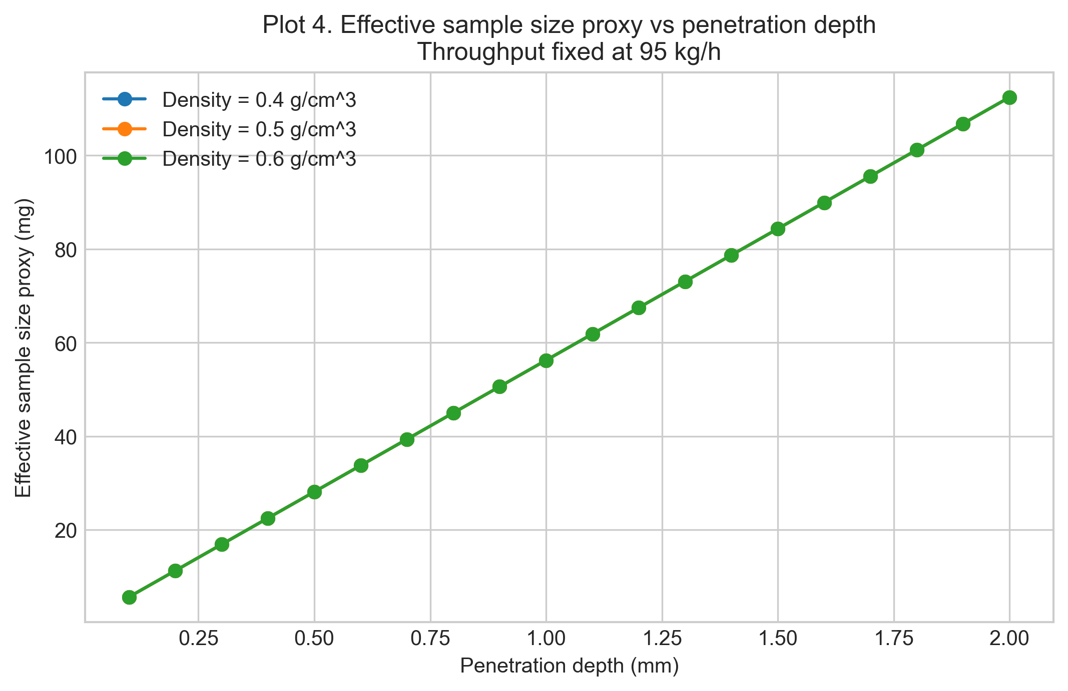
Figure 6. Effective sample size proxy versus throughput at fixed penetration depth.
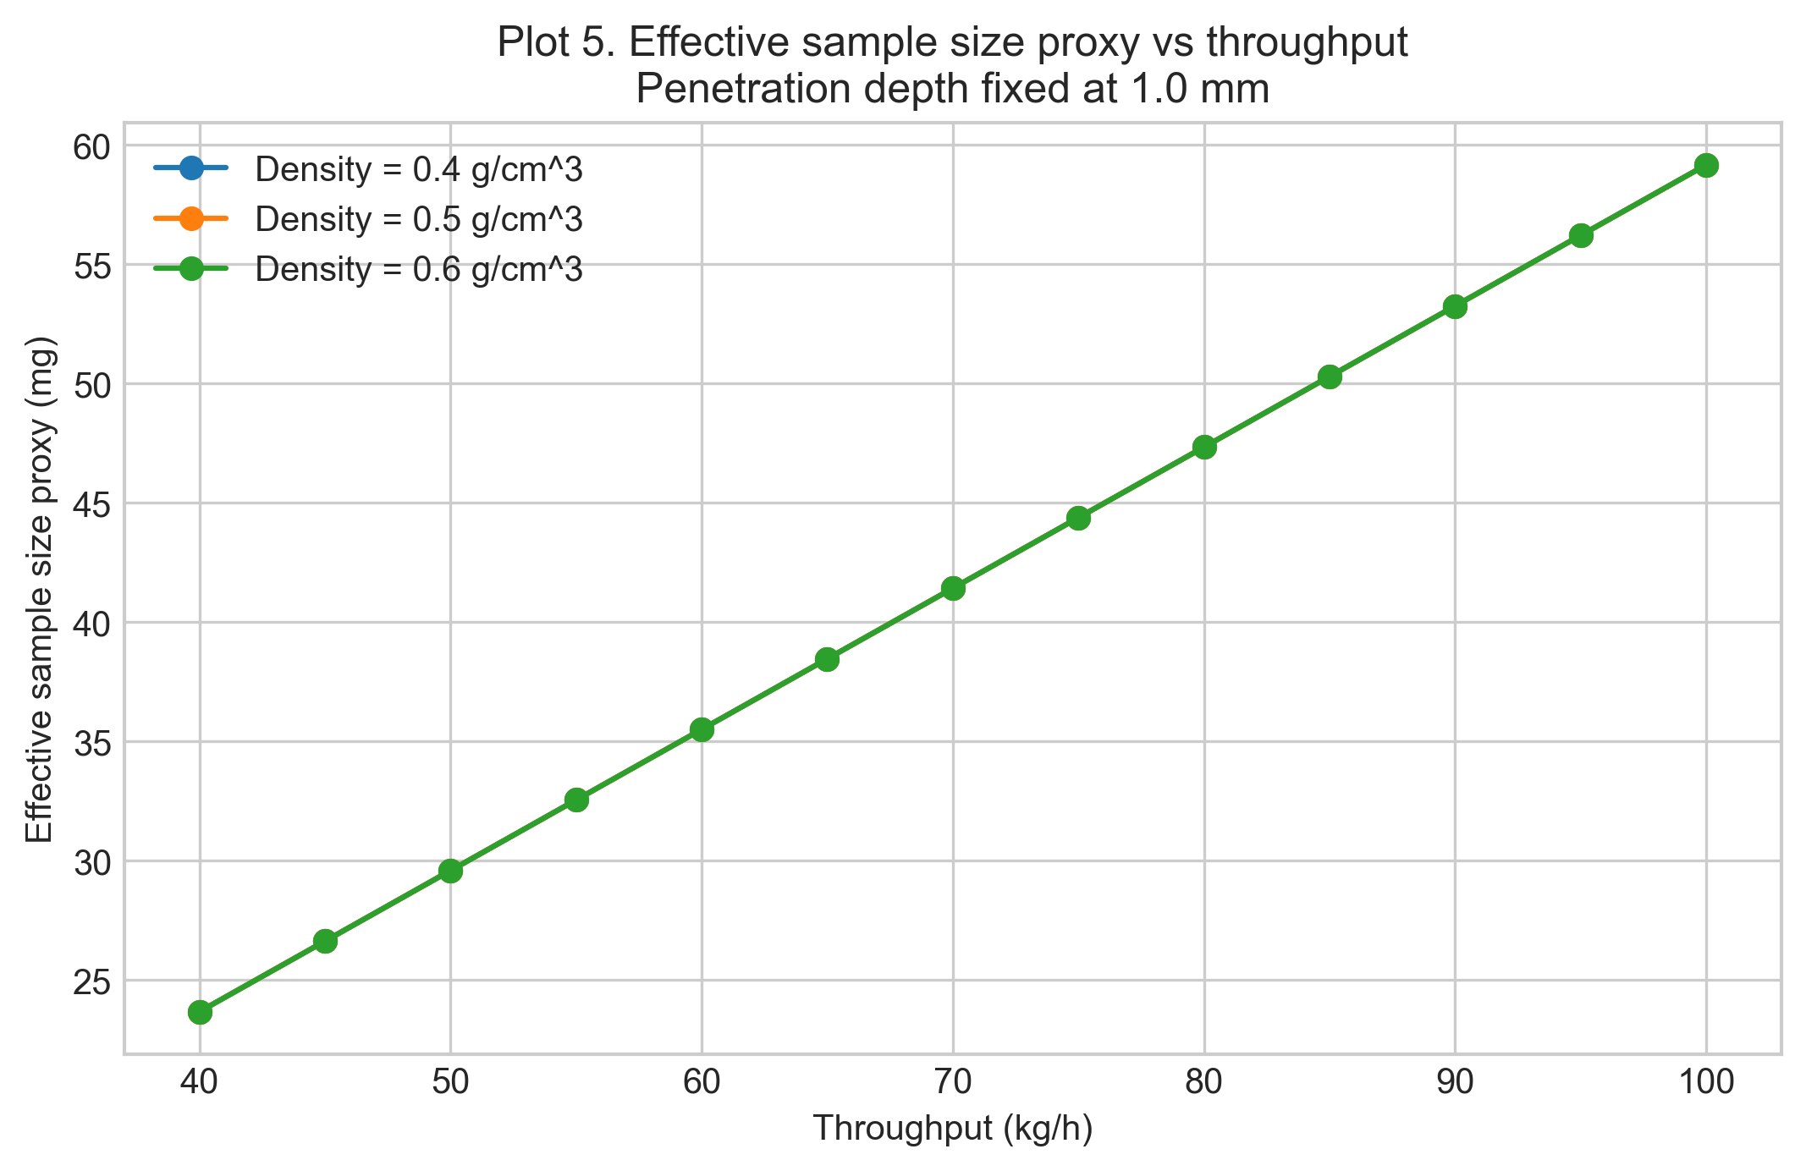
Figure 7. Two-dimensional contour summary of the proxy response for density 0.4 g/cm^3.
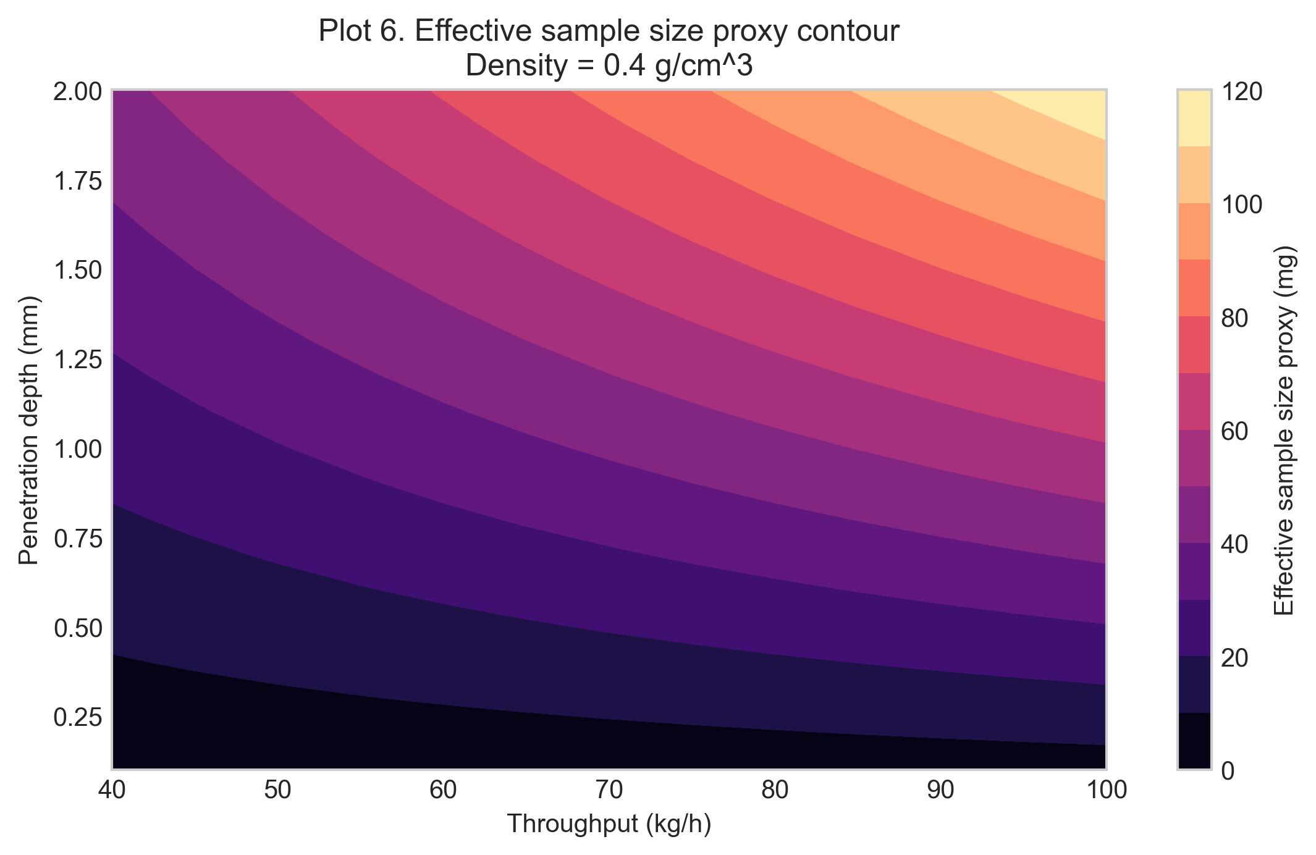

13. Interpretation of trends
The reordered figures are meant to be read as a causal chain from transport to optical sampling to the final proxy response.
- Transport driver. Plot 1 shows that superficial velocity increases with throughput and decreases with density for fixed mass throughput.
- Optical contribution per renewal event. Plot 2 shows that deeper penetration and higher density increase the instantaneous optical mass associated with one renewal event.
- Transport-side reference mass. Plot 3 shows the convective reference mass-flow proxy. Within the present formulation it scales with throughput and is density independent because the same rho that raises mass per volume also lowers superficial velocity.
- Combined proxy response. Plots 4 and 5 show that the effective sample size proxy increases with both penetration depth and throughput.
- Two-dimensional summary. Plot 6 compresses the joint dependence on throughput and penetration depth into one representative response surface.

Why density cancels within this model
In this model, density enters in two places that act in opposite directions.
Effect 1: more mass in the instantaneous optical region. A denser powder packs more mass into the same optical cylinder in front of the probe:

Effect 2: lower superficial velocity and fewer refreshes. For fixed mass throughput, a denser powder needs less volumetric flow, so the superficial velocity decreases:

The proxy effective mass combines those two effects:

Substituting v = dotm/(rho * A_pipe) gives:

Within this model, the density terms cancel exactly. That cancellation is model-dependent, not a universal physical law. It is one of the most useful internal consistency checks in the notebook: if density still appeared in the final proxy at fixed throughput, the present formulation would not be algebraically self-consistent.
Density would re-enter if any of the following effects were modeled explicitly:
- nonuniform velocity profiles or wall-local velocity corrections
- partial filling or changes in flowing cross-sectional area
- consolidation or compaction near the wall
- repeated presentation of the same powder to the probe
- changes in optical path-length distribution with packing state

14. Model limitations
Important limitations of this assessment are:
- no velocity-profile resolution across the pipe cross-section
- no explicit local lower-wall velocity correction
- no residence-time distribution model
- possible re-sampling of the same powder is not resolved
- no optical path-length distribution or radiative-transfer model
- no explicit wall slip, compaction, or segregation correction
- the 26.5 degree tilt is represented only qualitatively in the base model
- no intermittent coverage or slug-flow correction at low throughput
- no direct link to analytical variance or Gy sampling theory
These limitations matter most when interpreting the absolute magnitude of the reported proxy. The notebook is strongest as a relative engineering comparison across throughput, density, and penetration-depth scenarios.

15. Conclusions
This notebook supports four main conclusions:
- The inclined-pipe probe geometry is well described, at first order, as a problem of axial renewal combined with radial optical penetration.
- Throughput increases the proxy primarily by increasing the renewal rate, while penetration depth increases it by increasing the optical mass counted within each renewal event.
- The convective reference mass-flow proxy is useful because it separates the transport-side presentation problem from the optical-reduction problem.
- Density independence at fixed throughput is a consequence of the present model structure, not a general physical law; it should be read as a diagnostic of what the model includes and excludes.
Taken together, the notebook is most useful as a design-stage scientific and engineering assessment of how transport renewal and optical penetration jointly set the effective sample size proxy during one acquisition in the inclined powder pipe.

Appendices

Glossary of Variables and Symbols
The table below summarizes the variables used in the governing equations.
Symbol | Name | Definition | Units
m_eff,proxy | Effective sample size proxy | Refresh-based proxy effective mass during one acquisition. | g internally; mg reported
m_opt | Instantaneous optical mass | Optical mass associated with the probe footprint and penetration depth at one instant. | g internally; mg reported
N_refresh | Refresh factor | Number of characteristic probe-length renewals during one acquisition. | dimensionless
dotm | Mass throughput | Bulk powder mass flow rate through the pipe. | kg/h input; g/s internally
rho | Bulk density | Assumed bulk density of the powder in a given scenario. | g/cm^3
v | Superficial velocity | Cross-sectional average axial velocity used as the renewal driver. | cm/s
A_probe | Probe footprint area | Circular area of the probe window in the wall plane. | cm^2
A_pipe | Pipe cross-sectional area | Internal cross-sectional area of the pipe. | cm^2
d_probe | Probe diameter | Diameter of the circular probe window. | mm input; cm internally
d_pipe | Pipe diameter | Internal diameter of the pipe. | mm input; cm internally
d_pen | Penetration depth | Assumed radial optical penetration depth into the powder. | mm input; cm internally
t_acq | Acquisition time | Spectrum acquisition time for one measurement. | s

Exported artifacts
CSV files
- results_full.csv
- summary_table.csv
- velocity_summary.csv
Figure files
- plot_00_convective_reference_schematic.png
- plot_01_superficial_velocity_vs_throughput.png
- plot_02_optical_mass_per_refresh_vs_penetration_depth.png
- plot_03_convective_reference_mass_proxy_vs_throughput.png
- plot_04_proxy_vs_penetration_depth.png
- plot_05_proxy_vs_throughput.png
- plot_06_proxy_contour_density_04.png

