Setup E PAT Rig Effective Sample Size Report
Setup: setup_e
Report timestamp: 20260417_150814
Source notebook: setup_E_PATrig_effective_sample_size.ipynb

Executive summary
Setup E treats the PAT rig as a flow-past-probe renewal problem in which the effective sample size is approximated by the new mass presented during one acquisition. The report separates instantaneous illuminated mass, refreshed new mass, total mass passed the probe footprint, and refresh fraction so that acquisition-time and throughput effects can be interpreted mechanistically rather than as a single aggregate metric.

Key parameters
- Pipe diameter (cm): 10
- Probe window diameter (cm): 0.5
- Measurement depth (cm): 0.1
- Bulk density (g/cm^3): 0.3
- Throughput (kg): 95
- Throughput time (s): 3600
- Acquisition time range (s): 0.1 to 5.0
- Axial length model: window_diameter

Background
Setup E models a PAT (Process Analytical Technology) rig scenario where powder flows through a pipe past a flush-mounted diffuse-reflectance NIR probe. Unlike the static Setup A, powder motion during each spectral acquisition creates a dynamic sampling situation.
Three distinct mass metrics are relevant:
- Instantaneous probed mass (m_inst): mass simultaneously illuminated at any single instant.
- New mass presented per acquisition (m_new): unique material refreshed across the probe window during one acquisition time, bounded by the instantaneous mass.
- Mass passed probe footprint (m_pass): total mass that crosses the probe window plane during acquisition — grows linearly with time and is not bounded by instantaneous mass.
This notebook uses plug-flow assumptions to compute these metrics and sweeps key operating parameters (acquisition time, throughput) to examine their sensitivity.

Objective
Compute instantaneous probed mass, new mass presented per acquisition, and mass passed the probe footprint for a PAT rig configuration. Sweep acquisition time and throughput to examine sensitivity, and export results using the standard reporting workflow.

Theory
Powder velocity from throughput and pipe cross-section:
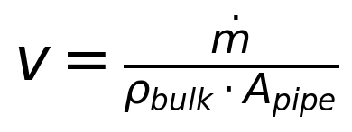
Instantaneous probed mass (mass in view at any instant):
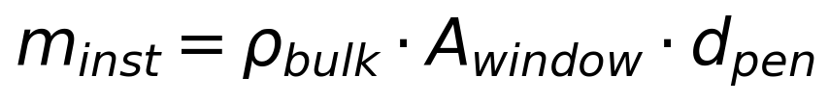
Axial advance during acquisition:
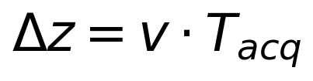
Refresh fraction (fraction of probe volume replaced during acquisition):
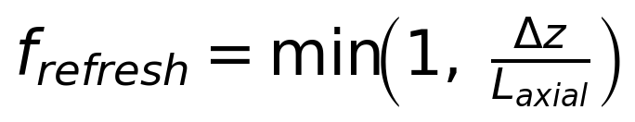
New mass presented per acquisition:
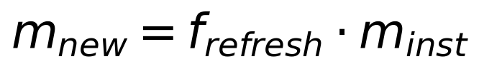
Mass passed the probe footprint during acquisition:
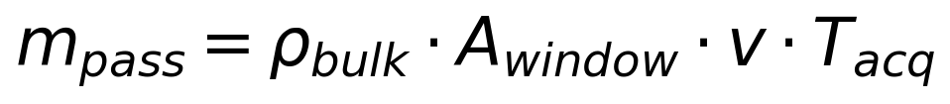
Symbols and units:
- dotm: mass flow rate [g/s]
- rho_bulk: bulk density [g/cm^3]
- A_pipe: pipe cross-section area [cm^2]
- A_window: probe window area [cm^2]
- d_pen: measurement (penetration) depth [cm]
- T_acq: spectral acquisition time [s]
- L_axial: axial sampling length (proxy for probe window diameter) [cm]

Assumptions
- plug-flow velocity profile (uniform across pipe cross-section)
- uniform bulk density
- circular pipe and circular probe window flush-mounted on the pipe wall
- measurement depth is small relative to pipe diameter
- axial sampling length approximated by probe window diameter
- no turbulence, no particle segregation
- no detailed radiative transfer model yet

Compute Effective Sample Size Metrics
Run 1D acquisition-time sweep and 2D throughput × acquisition-time sweep.

Worked example
The baseline case below reports the instantaneous mass at the probe, the refreshed new mass during one acquisition, the total mass passed the probe footprint, and the resulting refresh fraction.
Quantity | Value
velocitymms | 11.1998
acquisitiontimes | 1
refreshfractionper_acq | 1
probemassmg_instant | 5.89049
newmassmgperacq | 5.89049
masspassedmgperacq | 65.9722
effectivesamplesize_mg | 5.89049

Model scenarios and sweep design
The Setup E analysis combines a one-dimensional acquisition-time sweep with a two-dimensional throughput-by-acquisition-time sweep. This lets the report distinguish time saturation effects from throughput-driven transport effects.
- acquisition time swept from 0.1 to 5.0 s
- throughput swept from 10 to 90 kg over the fixed throughput-time basis
- bulk density fixed at 0.3 g/cm^3
- axial sampling length model: window_diameter
This produces 420 modeled rows across the 1D and 2D sweeps.

Selected results table
The selected table below samples representative acquisition times from the baseline sweep so the reader can compare instantaneous illuminated mass, refreshed new mass, passed mass, refresh fraction, and the resulting effective sample-size proxy side by side.
acquisitiontimes | velocitymms | probemassmg_instant | newmassmgperacq | masspassedmgperacq | refreshfractionper_acq | effectivesamplesize_mg
0.1000 | 11.1998 | 5.8905 | 1.3194 | 6.5972 | 0.2240 | 1.3194
0.8737 | 11.1998 | 5.8905 | 5.8905 | 57.6389 | 1.0000 | 5.8905
2.4211 | 11.1998 | 5.8905 | 5.8905 | 159.7222 | 1.0000 | 5.8905
5.0000 | 11.1998 | 5.8905 | 5.8905 | 329.8611 | 1.0000 | 5.8905

Figures
The figures are ordered from one-dimensional mechanism checks to two-dimensional operating maps: refreshed new mass, mass passed, refresh fraction, then the throughput-acquisition heatmaps.
Figure 1. New mass per acquisition versus acquisition time.
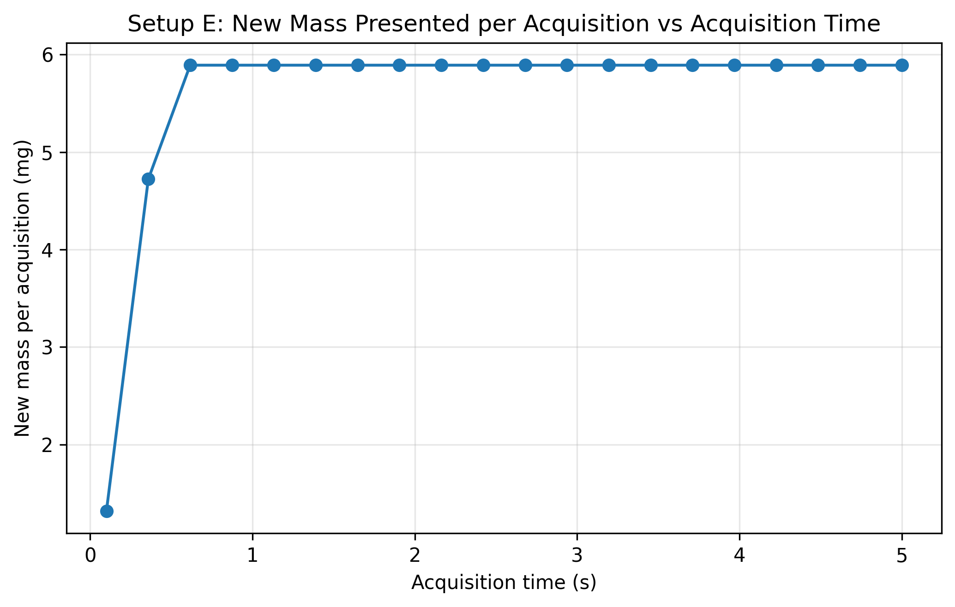
Figure 2. Mass passed the probe footprint versus acquisition time.
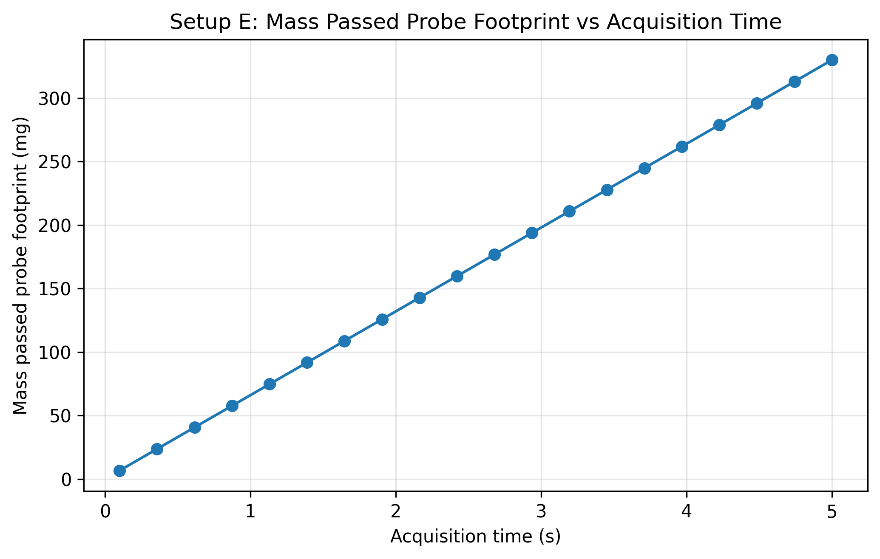
Figure 3. Refresh fraction versus acquisition time.
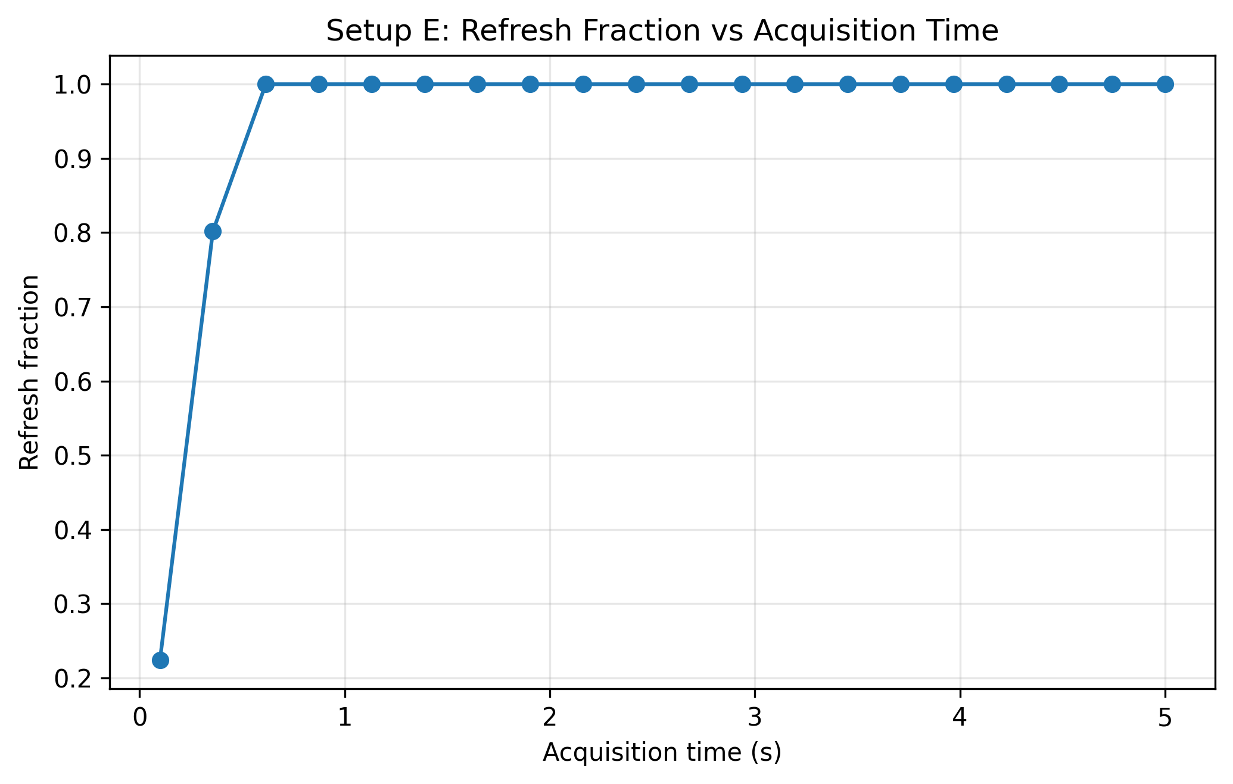
Figure 4. Throughput-acquisition heatmap for the mass passed the probe footprint.
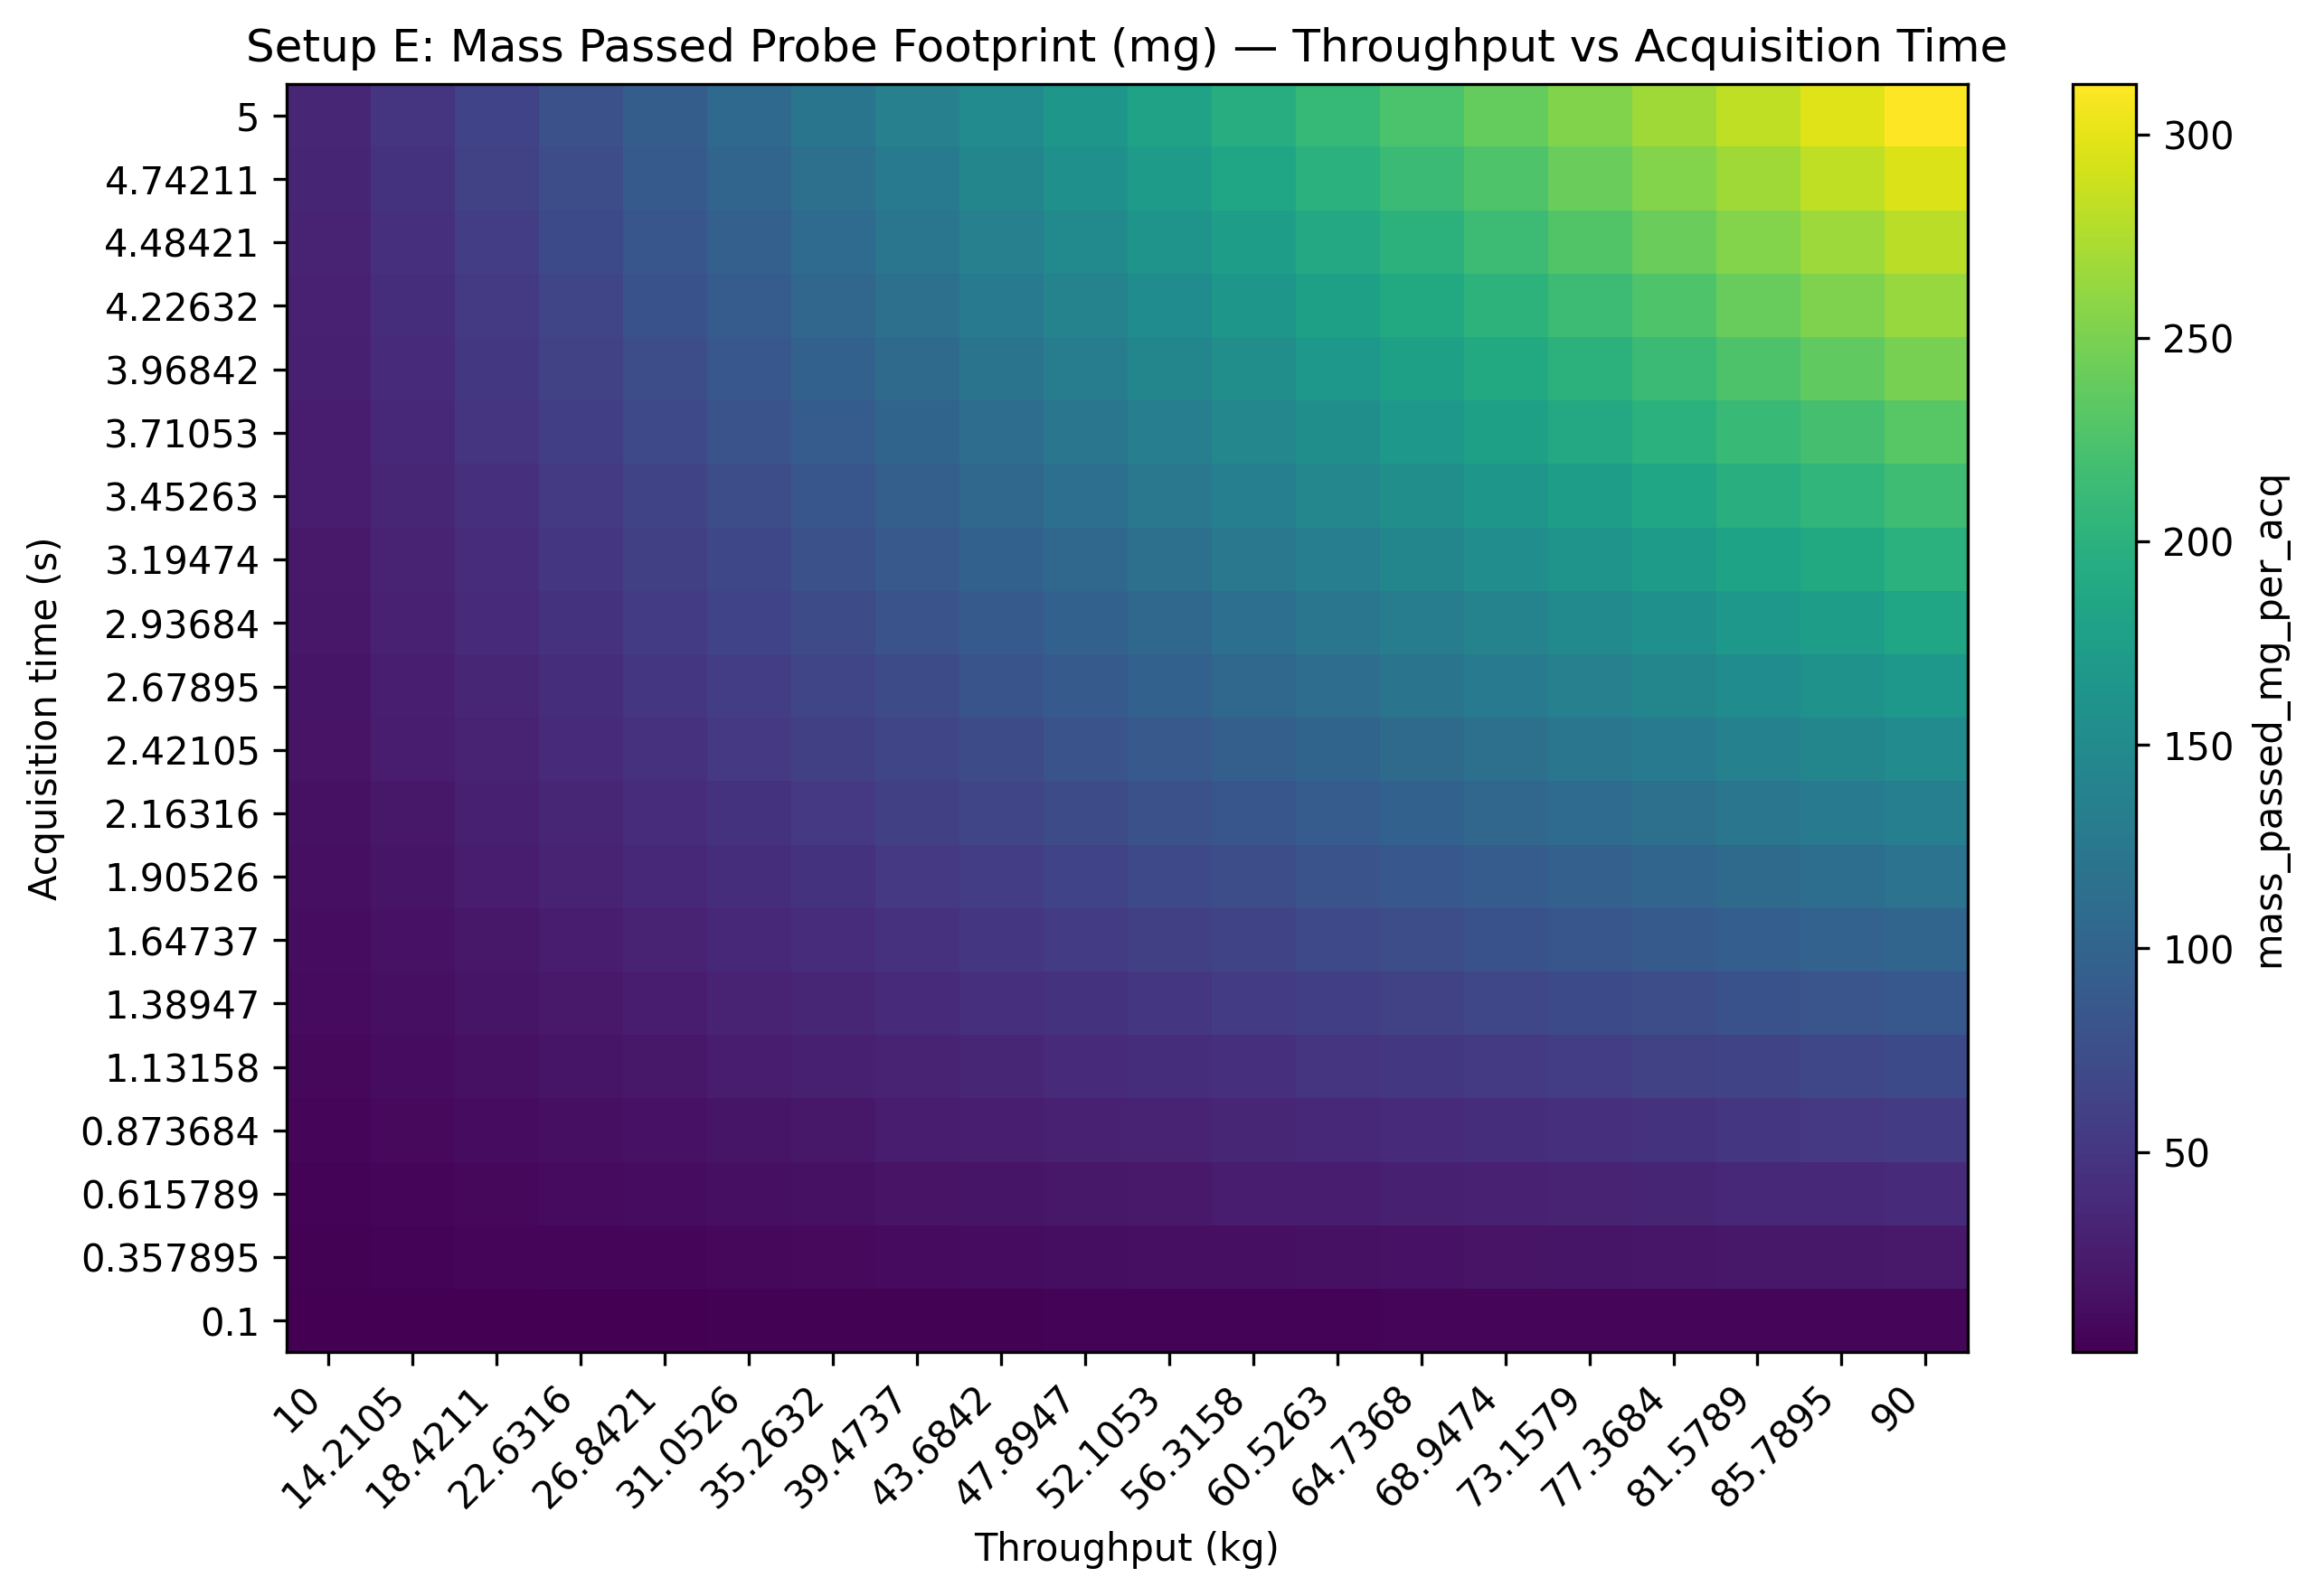
Figure 5. Throughput-acquisition heatmap for the refresh-based new mass metric.
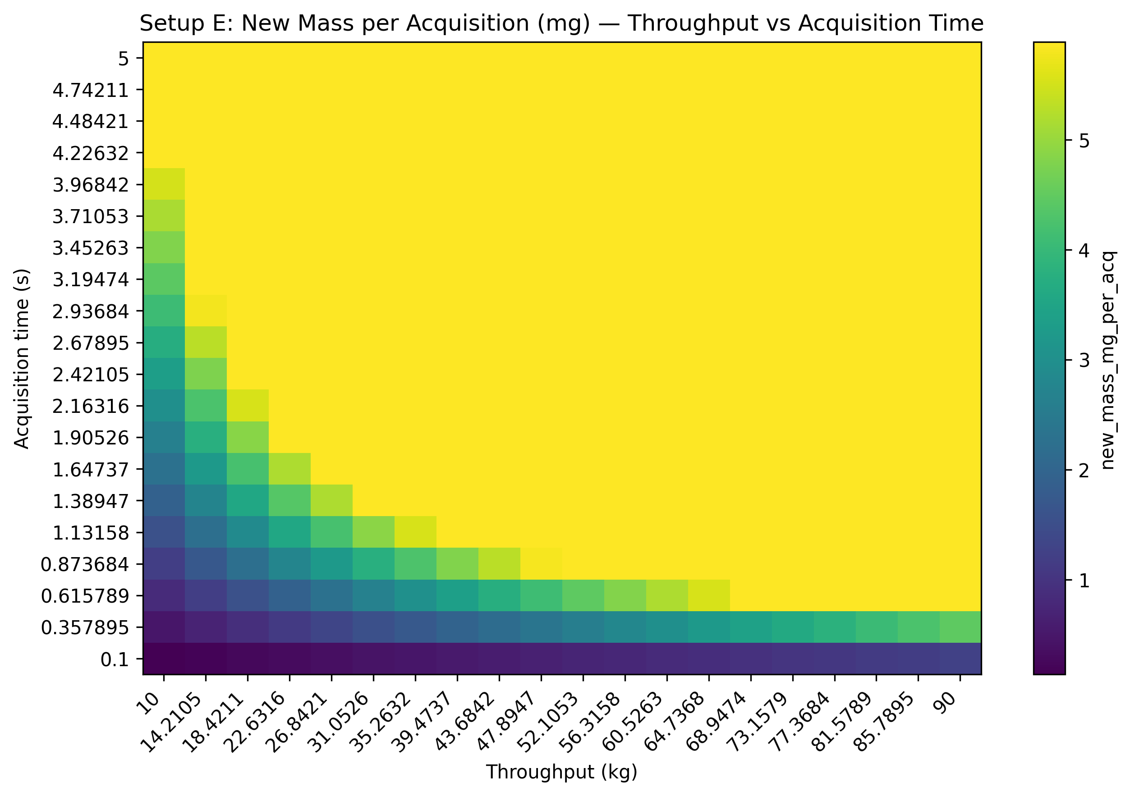

Results Interpretation
- new mass per acquisition saturates once the powder advance exceeds the probe window diameter (full refresh)
- mass passed the probe footprint grows linearly with both acquisition time and throughput
- at low throughput or short acquisition times, refresh fraction is small and the effective sample size is limited
- the heatmaps reveal the operating envelope where effective sampling is most sensitive to parameter changes

Practical Implications
- acquisition time selection trades off spectral quality against how much unique material is sampled
- throughput directly controls powder velocity and therefore refresh rate
- for real-time PAT decisions, understanding whether the probe has seen enough unique material is critical

Limitations
- plug-flow assumption ignores radial velocity profile
- no turbulence or mixing model
- penetration depth is an effective parameter, not a sharp boundary
- bulk density assumed uniform and constant
- no particle-level sampling statistics
- no correction factor for optical weighting yet

Appendices

Next Logical Extensions
- radial velocity profile (laminar / turbulent)
- particle count estimation from effective sample size
- sensitivity analysis for measurement depth
- uncertainty bands for penetration depth and bulk density
- non-uniform optical weighting functions

Exported artifacts
CSV files
- results_full.csv
- summary_table.csv
- input_summary.csv
Figure files
- plot_01_new_mass_per_acq_vs_acquisition_time.png
- plot_02_mass_passed_vs_acquisition_time.png
- plot_03_refresh_fraction_vs_acquisition_time.png
- plot_04_heatmap_mass_passed_throughput_vs_acquisition.png
- plot_05_heatmap_new_mass_throughput_vs_acquisition.png

