Setup D Effective Sample Size Report

Run Metadata
Setup name: setup_d
Run timestamp: 20260320_143650
Notebook filename: setup_D_pipe_effective_sample_size.ipynb
Run directory: C:\temp files\EFS\reports\setup_d\20260320_143650

Notebook Narrative

Setup D: inclined pipe effective sample size proxy

1. Title and purpose
This notebook develops a first-order engineering model for Setup D, an inclined powder pipe with an NIR diffuse reflectance probe mounted in the lower part of the pipe. The objective is to estimate a flow-based effective sample size proxy during one spectrum acquisition.
The result is best interpreted as a gross refreshed optical mass / effective sample size proxy. It is not a full radiative-transfer model, not a particulate sampling-theory model, and not a validated estimate of independent sample mass.

2. Scientific background

NIR diffuse reflectance analysis of powders
In diffuse reflectance NIR measurements, light enters a powder bed, interacts with particles over a limited depth, and a fraction of the scattered light returns to the detector. The measured spectrum therefore reflects an optically weighted near-surface volume rather than the entire bulk stream.

Why use a simple optical interaction approximation?
For engineering comparisons, it is often useful to approximate the optical interaction region with a simple geometric volume. Here, the optical sampling region is approximated as a cylinder with:
- cross-sectional area equal to the probe window footprint
- depth equal to an assumed light penetration depth
This simplification ignores depth-dependent photon weighting, scattering anisotropy, particle packing effects, and spectral absorption details, but it provides a practical way to compare conditions.

Why moving powder increases the sampled mass during one acquisition
If powder continuously moves past the probe during one acquisition, the optical interaction zone is refreshed. Faster renewal means that more powder volume can pass through the probe footprint during the acquisition period. That does not guarantee statistical independence of all material seen by the instrument, but it increases the gross refreshed optical mass available to contribute to the measurement.

Why Setup D differs from other geometries
Setup D differs from a static powder bed because the material in front of the probe is continuously replaced. It also differs from a mechanically refreshed geometry such as the spiderwheel because the refresh mechanism is not imposed by discrete compartments or controlled mechanical presentation. Instead, it is driven by gravity-assisted powder transport through a tilted pipe.

Why a superficial velocity model is useful
A practical first approximation is to connect throughput, bulk density, and pipe cross-sectional area to a superficial bulk velocity. This gives a simple estimate of how quickly powder is renewed in front of the probe. In reality, the local flow at the lower wall of a tilted pipe may differ substantially from the cross-sectional average, but the superficial velocity remains a useful baseline for sensitivity analysis and engineering intuition.

4. Model assumptions
The base model uses the following assumptions:
- the optical sampling volume is approximated as a cylinder: probe window area x penetration depth
- the probe window is fully covered by powder at all times
- powder renewal at the probe is approximated by a bulk superficial velocity derived from throughput, density, and pipe cross-sectional area
- bulk density is constant and spatially uniform
- no explicit blocking events occur
- no recirculation correction is included
- local wall velocity may differ from average superficial velocity, but that difference is ignored in the base model
- the powder at the probe is assumed to be in a dense-phase, gravity-driven sliding regime rather than an aerated or fluidized state
- de-aeration during transit through the pipe is assumed but not explicitly modeled
- velocity profiles across the pipe cross-section are not resolved; the superficial velocity represents a bulk average
- the output is a flow-based effective sample size proxy, not a validated independent sample mass
These assumptions intentionally favor transparency and reuse over physical completeness.

5. Mathematical model
Internal units used throughout the notebook are:
- geometry in cm
- time in s
- density in g/cm³
- throughput entered in kg/h and converted internally to g/s
- penetration depth entered in mm and converted internally to cm
- final reported effective sample size proxy in mg
Pipe radius:
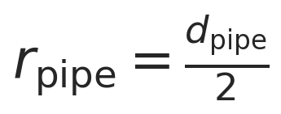
Pipe cross-sectional area:
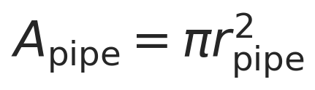
Mass flow conversion:
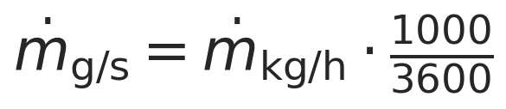
Superficial velocity:
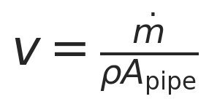
Probe footprint area:
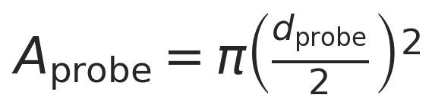
Optical volume per static slice:

Optical mass per static slice:
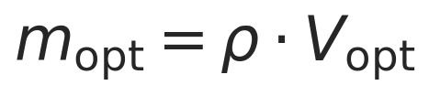
Crossing time of one probe diameter:
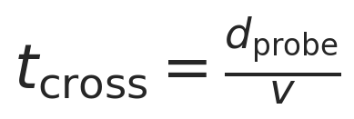
Number of refreshes during acquisition:
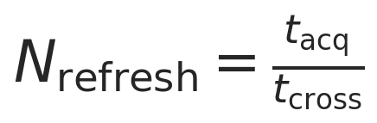
Effective sample size proxy:

Equivalent transported-volume view:
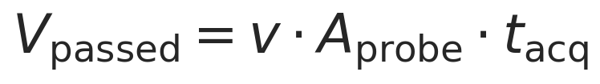
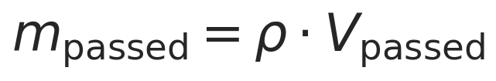
Under the simplified assumptions, these forms are equivalent because the probe footprint is refreshed by translation of material past the window. The 26.5 degree tilt remains part of the physical setup description, but the base model still uses the cross-sectional superficial velocity as the first-order renewal velocity approximation.

10. Parameter sweep across throughput, density, and penetration depth
The full sweep spans:
- throughput from 40 to 100 kg/h
- density = 0.4, 0.5, 0.6 g/cm³
- penetration depth from 0.1 to 2.0 mm in 0.1 mm steps
- probe diameter fixed at 5 mm
- acquisition time fixed at 1.0 s unless changed in the parameter cell

11. Results tables

12. Visualization

13. Interpretation of trends
Several clear trends appear in this first-order model.
- Increasing density increases the optical mass per static slice linearly because mopt = rho Aprobe d_pen.
- Increasing penetration depth increases the optical mass per static slice linearly because the modeled optical volume grows linearly with depth.
- Increasing throughput increases the superficial velocity linearly for fixed density and pipe area.
- Increasing superficial velocity decreases the crossing time and therefore increases the refresh count during one acquisition.
- The result should be interpreted as a flow-based refreshed optical mass proxy, not necessarily an independent sampling mass.

Density cancellation under the simplified assumptions
Starting from:
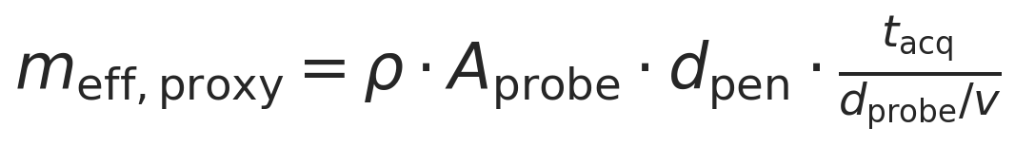
and substituting:

gives:
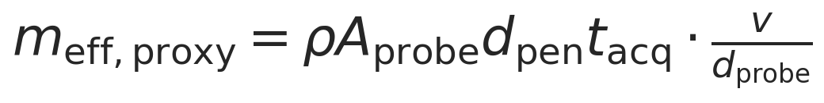
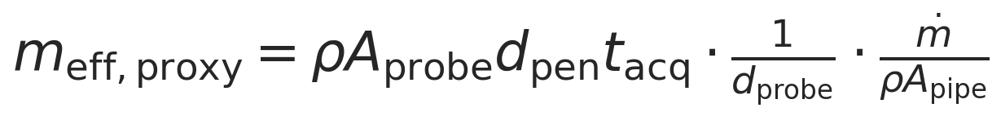
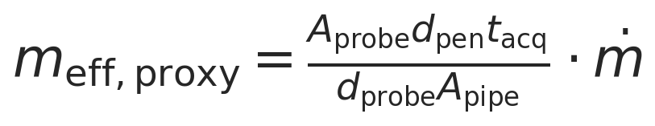
So, in this specific simplified model, density cancels completely for the effective sample size proxy when throughput is fixed in mass units and the whole pipe cross-section is assumed to participate in the superficial flow. Physically, a higher density increases the static optical mass seen at one instant, but it simultaneously reduces the superficial velocity in the same proportion. The larger mass per refresh and the smaller number of refreshes offset each other.
This complete cancellation is a direct consequence of the model structure. In a more realistic tilted-pipe model, density could re-enter through changes in flowing layer thickness, local wall velocity, consolidation, slip, or coverage dynamics.

14. Model limitations
Important limitations of this notebook are:
- the cylindrical optical volume is only an approximation
- there is no radiative-transfer model and no photon weighting with depth
- superficial velocity may differ from the true local wall velocity at the probe location
- the 26.5 degree tilt is represented only qualitatively in the base model
- there is no correction for asymmetric sliding-layer thickness
- there is no correction for stagnant regions or wall slip
- there is no model for powder compaction or de-aeration along the pipe length
- there is no correction for intermittent flow or slug behavior at low throughputs
- there is no particle size or particle count model
- there is no recirculation correction
- the model is not linked directly to analytical variance or Gy sampling theory
Useful future refinements could include:
- an effective moving-layer thickness
- a local wall velocity factor
- a filling fraction or flowing cross-sectional area correction
- a residence-time or particle revisit model
- a compaction or de-aeration model for the powder state along the pipe
- a coverage model for intermittent or slug-like flow at low throughputs

15. Conclusions
This notebook estimates a first-order flow-based effective sample size proxy for Setup D, expressed as refreshed optical mass during one spectrum acquisition.
Within this model, the strongest explicit drivers are:
- throughput, which sets superficial velocity and refresh rate
- penetration depth, which scales the optical mass per refresh
- probe and pipe geometry, which determine the footprint and renewal scale
The notebook is useful for sensitivity analysis, quick scenario comparison, and engineering intuition during development. A more advanced model could incorporate local lower-wall flow kinematics, effective moving-layer thickness, nonuniform filling, revisit behavior, and optical depth weighting.

Export and Reporting
This export section writes timestamped CSV, PNG, JSON, and Word outputs into the setup-specific reports/ folder. python-docx and nbformat are required for Word export with Markdown rendering.

Purpose
Setup D estimates a first-order flow-based effective sample size proxy in a tilted pipe by combining optical mass per refresh with a refresh rate derived from superficial velocity.

Assumptions
Superficial velocity is used as a first-order flow approximation, density is uniform within each scenario, the optical volume is cylindrical, and the tilt effect is captured only through the stated simplified geometry.

Parameter Summary
- Pipe diameter (mm): 65
- Pipe tilt from vertical (deg): 26.5
- Pipe total height (mm): 340
- Inlet-outlet displacement (mm): 100.2
- Probe diameter (mm): 5
- Acquisition time (s): 1.8
- Throughput range (kg/h): 40 to 100
- Density scenarios (g/cm^3): 0.4, 0.5, 0.6
- Penetration depth range (mm): 0.1 to 2.0

Exported CSV Files
- results_full.csv
- summary_table.csv
- velocity_summary.csv
Detailed tables are saved separately as CSV files in the run folder.

Figures
- plot_01_proxy_vs_penetration_depth.png
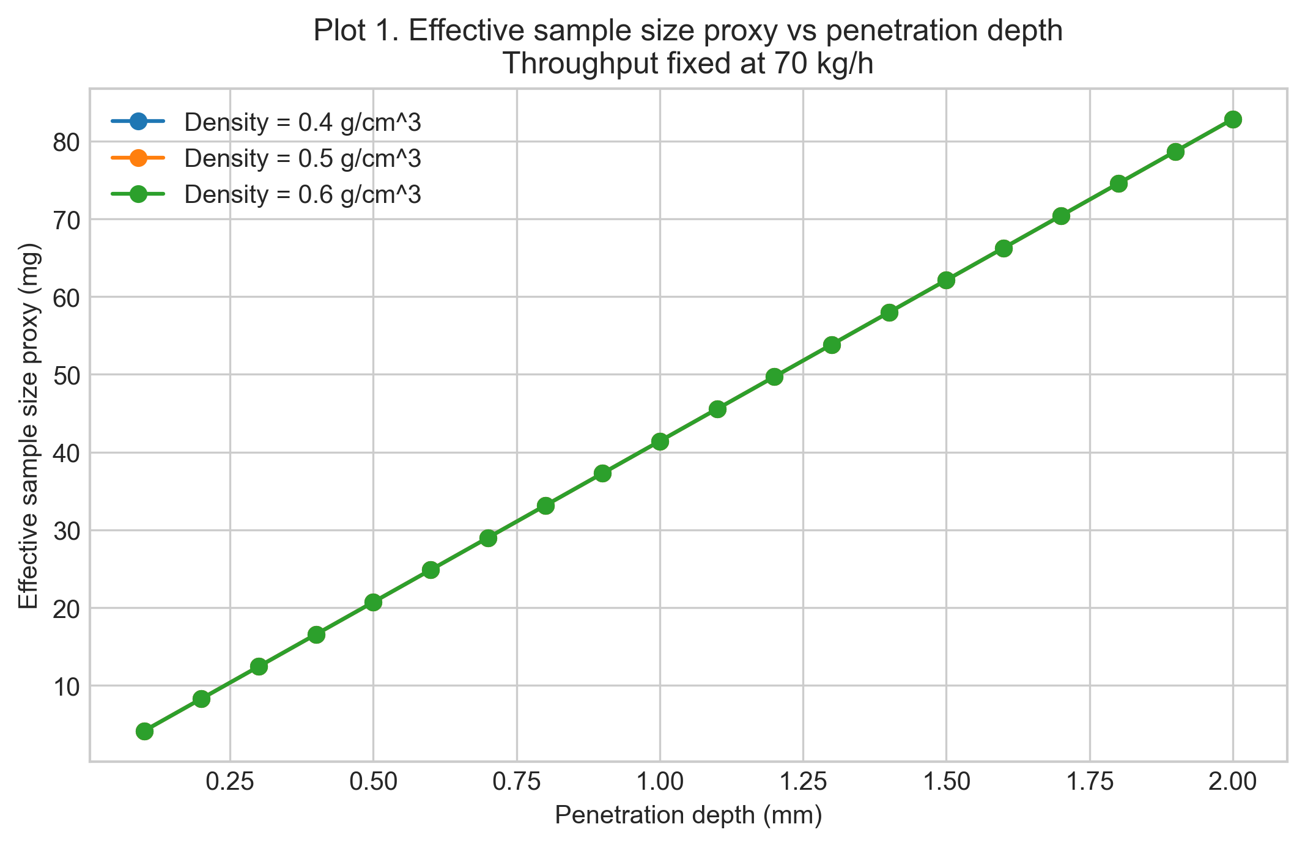
- plot_02_proxy_vs_throughput.png
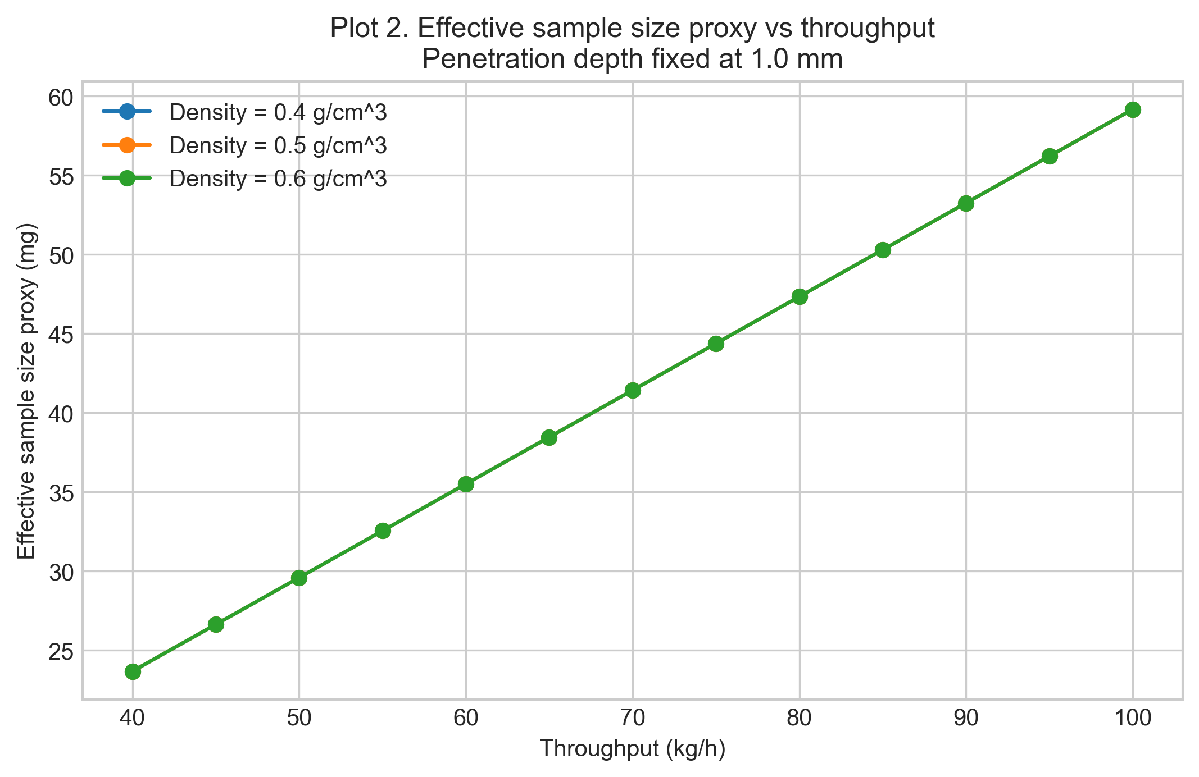
- plot_03_heatmap_density_05.png
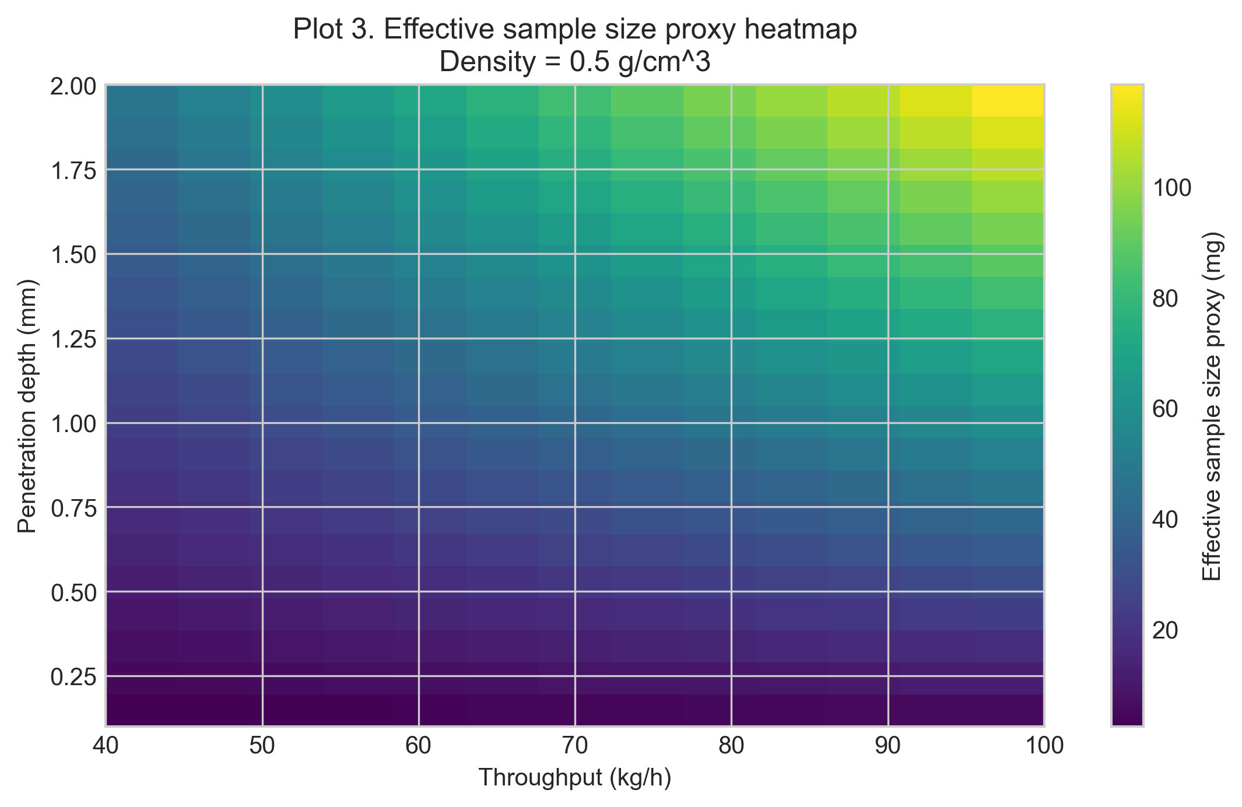
- plot_04_superficial_velocity_vs_throughput.png
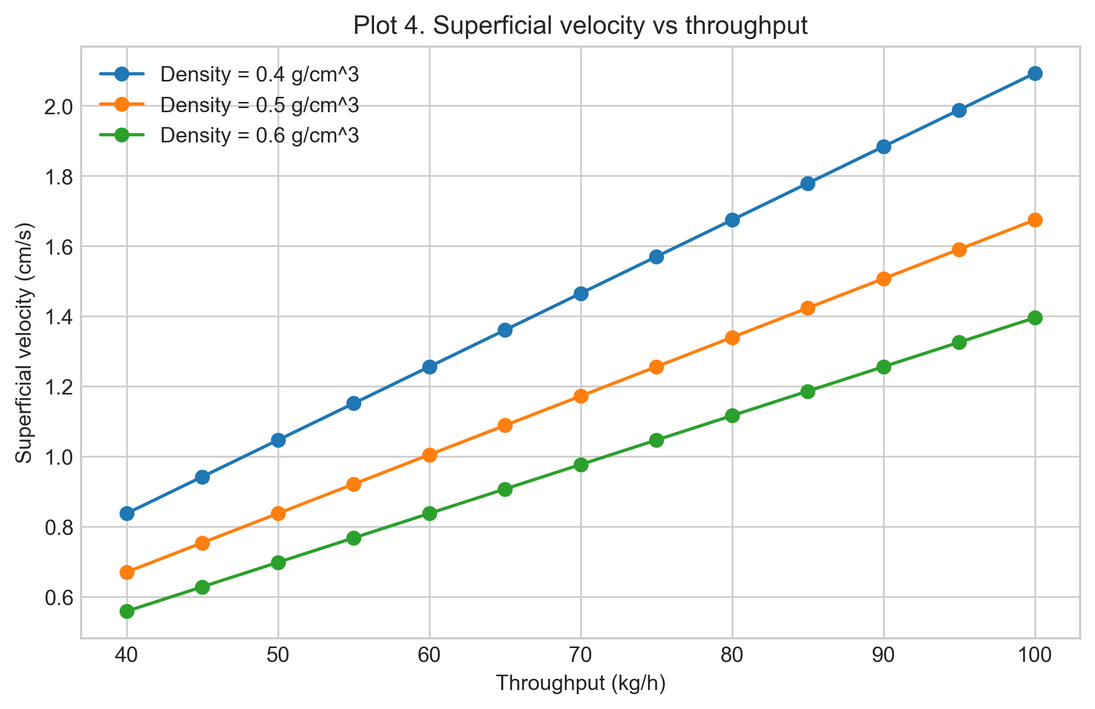
- plot_05_optical_mass_per_refresh.png
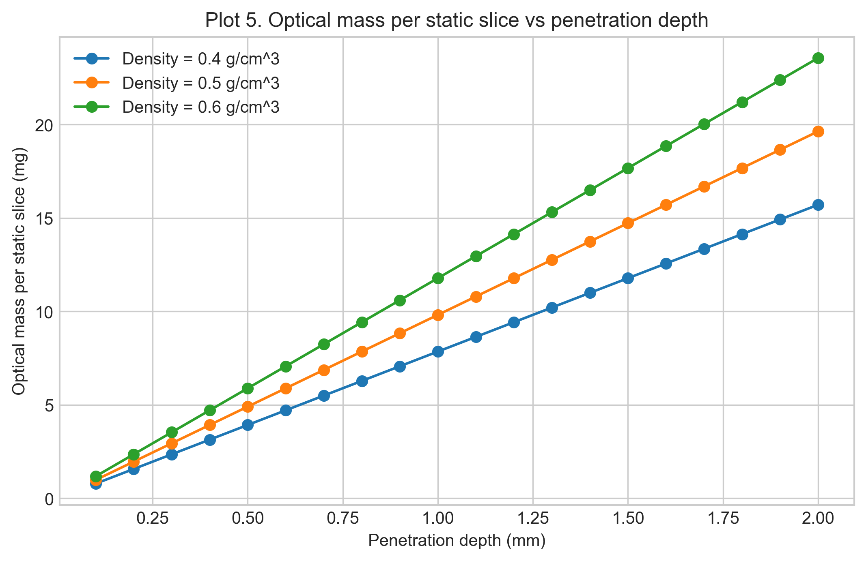
- plot_06_contour_density_06.png
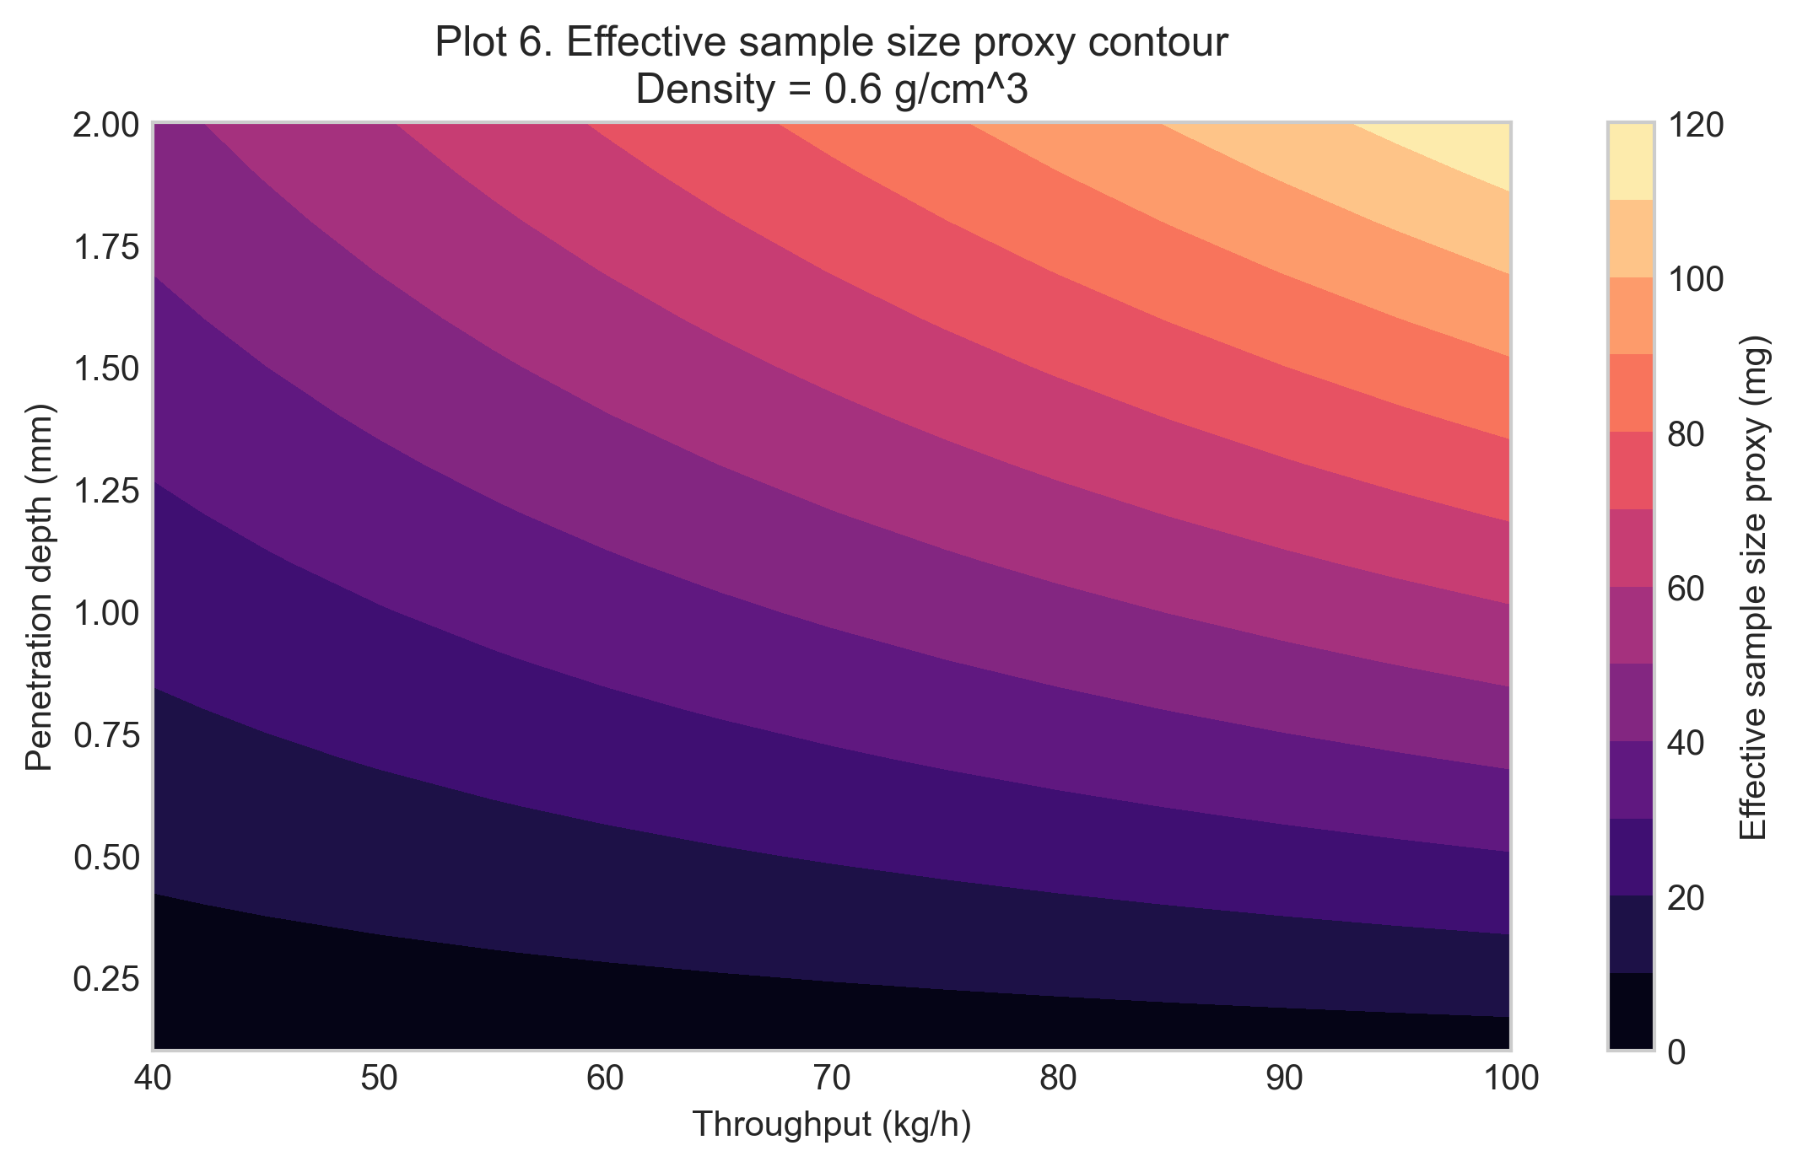
- plot_07_passed_mass_vs_throughput.png
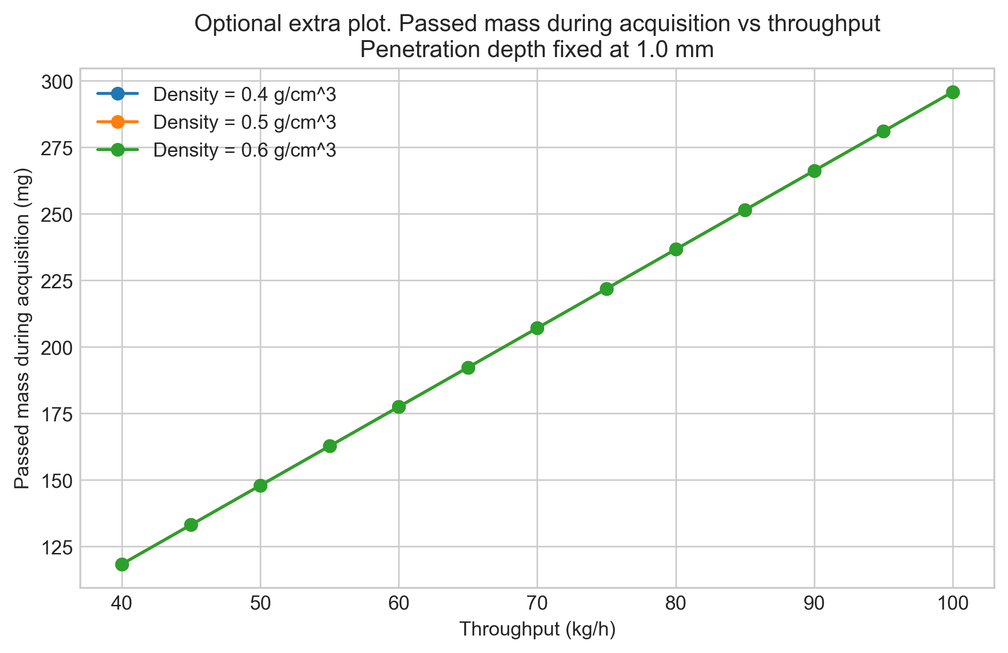

Closing Note
This report captures the notebook narrative, summary metadata, and exported artifacts for this run.

