Setup D Effective Sample Size Proxy Report

Run Metadata
Setup name: setup_d
Run timestamp: 20260414_145659
Notebook filename: setup_D_pipe_effective_sample_size.ipynb
Run directory: C:\temp files\EFS\reports\setup_d\20260414_145659

Notebook Narrative

Setup D: inclined pipe effective sample size proxy

1. Title and purpose
This simulation develops a first-order mechanistic proxy model for Setup D, an inclined powder pipe with an NIR diffuse reflectance probe mounted in the lower part of the pipe. The objective is to estimate an effective sample size proxy during one spectrum acquisition.
The reported quantity is a refresh-based proxy effective mass, denoted meff,proxy. It assumes renewal of powder in front of the probe over a characteristic axial length of order dprobe. It is not the exact geometric union of all material contributing photons, and it is intended for comparative engineering analysis rather than as a validated independent sample mass.

2. Scientific background

NIR diffuse reflectance analysis of powders
In diffuse reflectance NIR measurements, light enters a powder bed, interacts with particles over a limited depth, and a fraction of the scattered light returns to the detector. The measured spectrum therefore reflects an optically weighted near-surface volume rather than the entire bulk stream.

Why use a simple optical interaction approximation?
For engineering comparisons, it is often useful to approximate the instantaneous optical interaction region with a simple geometric volume. Here, the near-wall optical region at any instant is approximated as a cylinder with:
- cross-sectional area equal to the probe window footprint
- depth equal to an assumed light penetration depth
This simplification ignores depth-dependent photon weighting, scattering anisotropy, particle packing effects, and spectral absorption details, but it provides a practical basis for comparative analysis.

Probe-flow geometry: perpendicular viewing
In Setup D, the NIR probe is mounted in the pipe wall and looks radially inward toward the center of the pipe. The powder, meanwhile, flows axially along the length of the pipe. These two directions are perpendicular to each other.
At any instant, the probe sees a shallow optical disc of powder pressed against the wall:
- the disc face is the probe footprint (a circle of diameter d_probe), flush with the inner pipe wall
- the disc depth is the optical penetration depth d_pen, extending radially inward into the flowing powder
Because the probe looks perpendicular to the flow, powder renewal happens by material sliding across the probe window rather than being pushed into it. The flow delivers fresh material laterally past the probe footprint, while the light penetrates in the radial direction.
This perpendicular arrangement means three independent length scales govern the first-order model:
Direction | Physical meaning | Length scale
Axial (along flow) | distance powder travels during acquisition | v * t_acq
Tangential (in the wall plane) | probe footprint width | d_probe
Radial (into powder) | light penetration depth | d_pen

Rather than treating the full acquisition as an exact geometric sweep or exact union of sampled material, the model uses a first-order renewal approximation. Powder in front of the probe is assumed to refresh over a characteristic axial length of order d_probe, which leads to a refresh-based proxy for effective sample mass.

Why moving powder increases the proxy effective mass during one acquisition
If powder continuously moves past the probe during one acquisition, the optical interaction zone is repeatedly refreshed. Faster renewal means that more powder can contribute to the measurement over the acquisition period. That does not guarantee statistical independence of all material seen by the instrument, but it increases the proxy effective mass available for comparative engineering analysis.

Why Setup D differs from other geometries
Setup D differs from a static powder bed because the material in front of the probe is continuously replaced. It also differs from a mechanically refreshed geometry such as the spiderwheel because the refresh mechanism is not imposed by discrete compartments or controlled presentation. Instead, it is driven by gravity-assisted powder transport through a tilted pipe.

Why a superficial velocity model is useful
A practical first approximation is to connect throughput, bulk density, and pipe cross-sectional area to a superficial bulk velocity. This gives a simple estimate of how quickly powder is renewed in front of the probe. In reality, the local flow at the lower wall of a tilted pipe may differ substantially from the cross-sectional average, but the superficial velocity remains a useful baseline for sensitivity analysis and engineering intuition.

4. Model assumptions
The base model uses the following assumptions:
- the instantaneous optical sampling region is approximated as a cylinder with volume Aprobe * dpen
- the probe window is fully covered by powder at all times
- powder renewal at the probe is approximated by a first-order renewal approximation with characteristic axial length of order d_probe
- the renewal rate is derived from a bulk superficial velocity computed from throughput, density, and full pipe cross-sectional area
- bulk density is constant and spatially uniform within each scenario
- no explicit blocking events occur
- no recirculation correction is included
- local wall velocity may differ from average superficial velocity, but that difference is ignored in the base model
- the powder at the probe is assumed to be in a dense-phase, gravity-driven sliding regime rather than an aerated or fluidized state
- de-aeration during transit through the pipe is assumed but not explicitly modeled
- velocity profiles across the pipe cross-section are not resolved; the superficial velocity represents a bulk average
- the output is a refresh-based proxy effective mass intended for comparative engineering analysis, not a validated independent sample mass
These assumptions intentionally favor transparency and internal consistency over full optical or granular-flow realism.

5. Mathematical model
Internal units used throughout the simulation are:
- geometry in cm
- area in cm^2
- volume in cm^3
- time in s
- density in g/cm^3
- throughput entered in kg/h and converted internally to g/s
- penetration depth entered in mm and converted internally to cm
- final reported proxy effective sample masses in mg

Geometric directions at the probe
The probe is mounted in the pipe wall, looking radially inward. The powder flows axially past the probe. The model uses three perpendicular directions:
Direction | Symbol | Physical meaning
Axial (along flow) | v * t_acq | distance powder travels during acquisition
Tangential (in the wall plane) | d_probe | probe footprint width
Radial (into powder) | d_pen | light penetration depth from wall into powder

At any single instant, the probe sees a shallow optical disc of powder with face area Aprobe and radial depth dpen. Over a finite acquisition, the model does not claim that the sampled material is an exact geometric sweep or an exact union. Instead, it uses a first-order renewal approximation in which the near-wall powder in front of the probe is refreshed over a characteristic axial length of order d_probe.

Pipe and flow quantities
Pipe cross-sectional area:
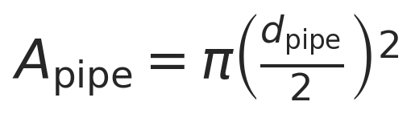
Mass flow conversion:
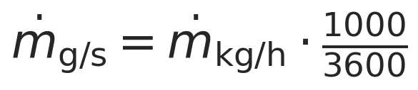
Superficial velocity (axial direction):
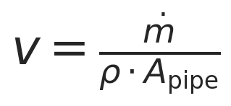
Units: [g/s] / ([g/cm^3] [cm^2]) = [cm/s].
This is the cross-sectional average axial velocity of the powder along the pipe. In this notebook it is used only as a first-order renewal driver.
Worked-example check (dotm = 95 kg/h, rho = 0.4 g/cm^3, d_pipe = 65 mm):
Step | Value | Unit
dotm | 95 x 1000 / 3600 = 26.3889 | g/s
A_pipe | pi (6.5/2)^2 = 33.1831 | cm^2
rho * A_pipe | 0.4 x 33.1831 = 13.2732 | g/cm
v = dotm / (rho * A_pipe) | 26.3889 / 13.2732 = 1.9882 | cm/s

Instantaneous optical mass
Probe footprint area:
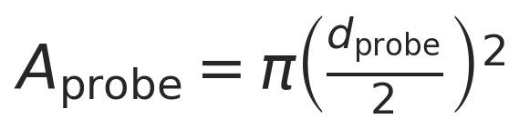
Instantaneous optical mass:

This is the instantaneous optically weighted mass adjacent to the probe under the cylindrical optical-volume approximation.

Refresh factor
The first-order renewal approximation assumes that the powder in front of the probe is refreshed when material advances by a characteristic axial length of order d_probe. The corresponding refresh factor during one acquisition is:
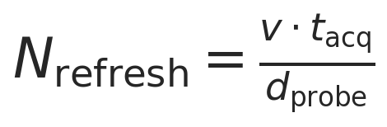
This is a renewal-based proxy, not an exact count of independent packets of powder.

Proxy effective sample mass
The proxy effective sample mass is defined as:

Combining the expressions gives:
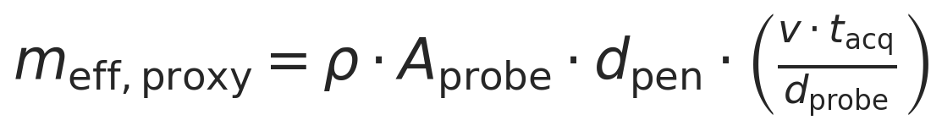
Interpretation of this expression:
- it is a first-order mechanistic proxy model
- it assumes renewal of powder over a characteristic length scale of order d_probe
- it is not the exact geometric union of sampled material
- it is intended for comparative engineering analysis

Convective reference mass-flow proxy

Overview
The convective reference mass-flow proxy answers a simple question: how much powder slid past the probe window during the time the instrument was acquiring one spectrum?
Imagine you are sitting behind a small window in the wall of a tilted pipe, watching powder flow past. The convective reference mass-flow proxy is the total mass of powder that crossed the window plane while you were watching. It does not care how deep the light can penetrate into the powder. It just asks: what total mass of powder crossed the window area while the probe was looking?

Step 1: How fast is the powder moving?
You know how many kilograms of powder enter the top of the pipe every second (dotm). You know how tightly the powder is packed (rho). You know how wide the pipe is (A_pipe). From those three facts, you can figure out how fast the powder must be sliding — that is the superficial velocity v.

Input | What it means | Units
dotm | mass flow rate | g/s
rho | bulk density (how heavy per unit volume) | g/cm^3
A_pipe | pipe cross-sectional area | cm^2
Output: v | superficial velocity | cm/s

Assumption: The powder fills the entire pipe cross-section uniformly and moves at the same speed everywhere. In reality, powder near the wall moves slower, but this is ignored here.

Step 2: How big is the probe window?
The probe window is a small circle cut into the pipe wall. This equation calculates the area of that circle:

Input | What it means
d_probe | diameter of the circular window (0.5 cm)
Output: A_probe | area of the window (~0.1963 cm^2)

Step 3: How much powder slid past the window?
Picture a conveyor belt of powder moving past the probe window. During the time the instrument acquires one spectrum (tacq), a certain length of powder ribbon passes by (that is v * tacq). The ribbon's cross-section is the window area (A_probe). Multiply length by area to get volume, then multiply by density to get mass.
Think of it as an invisible rectangular box of powder that slides through the window during one measurement:
◄───── v · t_acq ─────►
┌──────────────────────┐
│ │ ↕ probe window
│ powder that passed │ (area = A_probe)
│ │
└──────────────────────┘
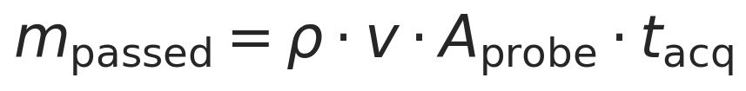
Input | Meaning | Worked example value
rho | bulk density | 0.4 g/cm^3
v | superficial velocity | ~1.99 cm/s
A_probe | probe window area | ~0.1963 cm^2
t_acq | how long the instrument acquires | 1.8 s
Output: m_passed | mass that slid past | reported in mg

Key assumptions:
- The powder is a continuous, uniform stream (no gaps, no clumps).
- Every bit of powder that crosses the window plane is counted, regardless of whether the light actually reaches it.
- The speed is the bulk average — powder near the wall might actually move slower.
This quantity is retained only as a convective reference mass-flow proxy based on the same superficial-velocity model. It should not be interpreted as a literal exact convected slab or as an exact geometric union of the material seen by the instrument.

How the effective sample size proxy relates to the passed mass
The convective reference says: "This much total powder slid past the window."
The effective sample size proxy says: "But the light only penetrates a shallow layer into the powder, so the probe only 'sees' a fraction of that."
Under the same proxy assumptions:
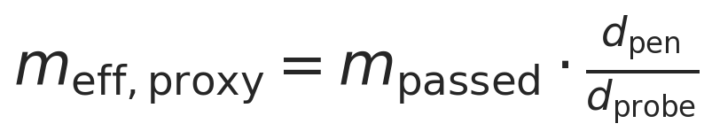

Why the fraction is dpen / dprobe
This ratio is not assumed — it falls out algebraically when you divide the two independently defined quantities. To see why, start from both definitions:
Definition 1: mpassed = rho v Aprobe * t_acq
Definition 2: meff,proxy = underbracerho Aprobe dpenmopt underbracefracv tacqdprobeN_refresh
Dividing Definition 2 by Definition 1:
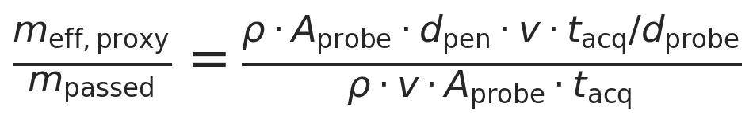
Cancel rho, v, Aprobe, and tacq from top and bottom:
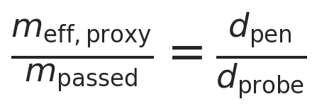

Physical interpretation of the fraction
The ratio dpen / dprobe compares two lengths that live in perpendicular directions. Understanding why it still works requires looking at the 3D geometry at the probe.
Three perpendicular directions at the probe. The probe sits in the pipe wall. Three independent directions matter:
radial (into powder)
↑ d_pen (light penetrates this way)
│
│
──────────●──────────→ axial (powder flow direction)
│ d_probe (renewal length)
/
/
↙ tangential (along wall surface)
d_probe (window width)
- Radial (into the powder, away from the wall): the light penetrates to depth d_pen in this direction.
- Axial (along the flow): the powder slides past in this direction; d_probe is the distance the powder must travel before the patch in front of the probe is fully replaced.
- Tangential (along the wall, perpendicular to flow): the probe window spans d_probe in this direction too.
dpen and dprobe are not measured in the same direction. The light goes radially inward; the renewal happens axially. They are at 90 degrees to each other.
How the two quantities are built from these directions. Both mpassed and meff,proxy can be written as a product of the same factors except for one substitution. Rewrite mpassed using v tacq = dprobe Nrefresh:
m_passed = rho * A_probe * underbraced_probe_axial chunk size * N_refresh
m_eff,proxy = rho * A_probe * underbraced_pen_radial optical depth * N_refresh
Both expressions share rho, Aprobe, and Nrefresh. The only difference is:
Quantity | Characteristic depth used | Direction of that depth
m_passed | d_probe | axial — one chunk length in the flow direction
m_eff,proxy | d_pen | radial — light penetration into the powder

Why the ratio works despite the perpendicular directions. Think of each "probe-sized chunk" of powder that slides past. Each chunk is a cylinder with face Aprobe and axial length dprobe:
◄── d_probe ──►
┌──────────────┐ ─┬─
│ │ │ d_pen (light reaches
│ one chunk │ │ only this thin layer
│ of powder │ │ in the radial direction)
│ │ │
│ │ │ d_probe (full axial
│ │ │ extent of the chunk)
└──────────────┘ ─┴─
↑ face = A_probe
(probe window circle)

axial direction ──────►
radial direction ↑
- mpassed treats each chunk as having mass rho Aprobe d_probe — the full axial extent of the chunk.
- meff,proxy treats each chunk as contributing only rho Aprobe d_pen — the thin radial slice the light actually reaches.
The ratio between them is dpen / dprobe, even though these two lengths are measured in perpendicular directions. This is a cross-directional ratio: it compares the radial optical depth to the axial renewal length, not two depths in the same direction.
Why this is not "the light reaches partway through a slab." A natural first reading of dpen / dprobe might suggest that the light penetrates a fraction of the way through a layer of thickness dprobe. That interpretation is incorrect. The light goes radially inward; the chunk extends axially along the flow. The ratio happens to equal the fraction because both mpassed and meff,proxy use the same Aprobe and N_refresh, so everything cancels except the one substituted length.

Why dprobe appears in the denominator (not dpipe)
The denominator is dprobe, not dpipe, because mpassed already uses Aprobe (not Apipe). The passed mass is only the powder that crossed the probe window, not the entire pipe. So when you ask "what fraction did the light reach?", you are comparing dpen to the characteristic thickness of the material stream at the probe window scale, which is d_probe.
Nrefresh = v tacq / dprobe divides the ribbon length by the probe diameter to get the number of "probe-sized chunks" that passed. Each chunk has optical mass mopt = rho Aprobe * dpen. Meanwhile, mpassed counts all of those same chunks but with depth dprobe instead of dpen. The ratio of the depth you "see" to the depth you "count" is dpen / d_probe.

Numerical check with worked example
Using the worked example (dpen = 1 mm, dprobe = 5 mm):
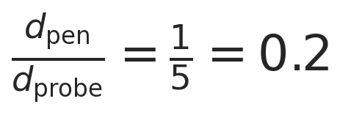
Dividing the effective proxy by the passed mass gives exactly 0.2. The fraction is purely geometric within this model: the light only reaches 1/5 of the way through the "probe-sized" depth of powder.

Summary of the three related quantities
Quantity | What it answers | Formula
v | How fast is the powder moving? | dotm / (rho * A_pipe)
m_passed | How much powder slid past the window? | rho v Aprobe * tacq
m_eff,proxy | How much did the probe optically interact with? | mpassed * dpen / d_probe

The ratio dpen / dprobe is an algebraic consequence of the proxy model, not a statement about exact geometric sampling.

Density cancellation within this model
The superficial velocity relation is:

Substituting into the proxy effective-mass expression gives:

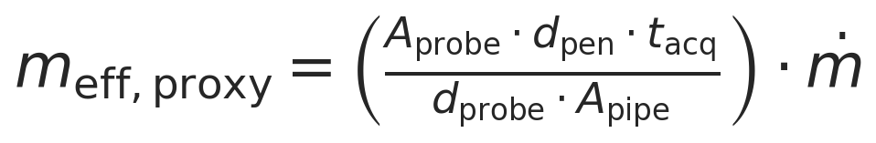
In this model, the density terms cancel exactly. That cancellation is model-dependent: it follows from using the same bulk density in both the instantaneous optical mass and the superficial-velocity approximation.

10. Parameter sweep across throughput, density, and penetration depth
The full sweep spans:
- throughput from 40 to 100 kg/h
- density = 0.4, 0.5, 0.6 g/cm^3
- penetration depth from 0.1 to 2.0 mm in 0.1 mm steps
- probe diameter fixed at 5 mm
- acquisition time fixed at 1.8 s unless changed in the parameter cell

11. Results tables
All reported effective sample size values below are proxy values, i.e. evaluations of m_eff,proxy from the first-order renewal model.

12. Visualization
The plots below report either the effective sample size proxy or supporting quantities from the same first-order renewal model.

13. Interpretation of trends
Several clear trends appear in this first-order proxy model.
- Increasing density increases the instantaneous optical mass linearly because mopt = rho Aprobe d_pen.
- Increasing penetration depth increases the instantaneous optical mass linearly because the modeled optical volume grows linearly with depth.
- Increasing throughput increases the superficial velocity linearly for fixed density and pipe area.
- Increasing superficial velocity increases N_refresh and therefore increases the proxy effective mass during one acquisition.
- The result should be interpreted as a refresh-based proxy effective mass, not as a validated independent sampling mass.

Why density cancels within this model
In this model, density enters in two places that act in opposite directions.
Effect 1: more mass in the instantaneous optical region. A denser powder packs more grams into the same optical cylinder in front of the probe:

Effect 2: lower superficial velocity and fewer refreshes. For fixed mass throughput, a denser powder needs less volumetric flow, so the superficial velocity decreases:

The proxy effective mass combines those two effects:

Substituting v = dotm/(rho * A_pipe) gives:

Within this model, the density terms cancel exactly. That cancellation is model-dependent, not a universal physical law.
Physical interpretation. The notebook treats the probe as an optical footprint with an instantaneous optical mass and a renewal factor. The resulting m_eff,proxy is therefore a first-order mechanistic proxy for comparative engineering analysis. It is useful for ranking scenarios, but it is not an exact geometric union of sampled material and does not prove full statistical independence of the powder contributing to the spectrum.
Why density cancellation is model-dependent. Density would re-enter if any of the following effects were modeled explicitly:
- nonuniform velocity profiles or wall-local velocity corrections
- partial filling or changes in flowing cross-sectional area
- consolidation or compaction near the wall
- repeated presentation of the same powder to the probe
- changes in optical path-length distribution with packing state

14. Model limitations
Important limitations of this simulation are:
- no velocity profile resolution across the pipe cross-section
- no residence-time distribution model
- possible re-sampling of the same powder is not resolved
- no optical path-length distribution or radiative-transfer model
- no explicit wall effects such as slip or compaction corrections
- no segregation effects
- the 26.5 degree tilt is represented only qualitatively in the base model
- no intermittent coverage or slug-flow correction at low throughput
- no direct link to analytical variance or Gy sampling theory
These omissions are consistent with the notebook's role as a concise, first-order engineering proxy model rather than a full particulate-flow or radiative-transfer simulation.

15. Conclusions
This simulation estimates a first-order refresh-based effective sample size proxy for Setup D, expressed as proxy effective mass during one spectrum acquisition.
Within this model, the strongest explicit drivers are:
- throughput, which sets superficial velocity and renewal rate
- penetration depth, which scales the instantaneous optical mass
- probe and pipe geometry, which determine the footprint and characteristic refresh length
The simulation is useful for comparative engineering analysis, quick scenario comparison, and sensitivity assessment during development. A more advanced model could incorporate local lower-wall flow kinematics, nonuniform filling, revisit behavior, optical path-length weighting, and wall-specific flow effects.

Export and Reporting
This export section writes timestamped CSV, PNG, JSON, and Word outputs into the setup-specific reports/ folder. python-docx and nbformat are required for Word export with Markdown rendering.

Glossary of Variables and Symbols
The table below summarizes the variables used in the governing equations.
Symbol | Name | Definition | Units
m_eff,proxy | Effective sample size proxy | Refresh-based proxy effective mass during one acquisition. | g internally; mg reported
m_opt | Instantaneous optical mass | Optical mass associated with the probe footprint and penetration depth at one instant. | g internally; mg reported
N_refresh | Refresh factor | Number of characteristic probe-length renewals during one acquisition. | dimensionless
dotm | Mass throughput | Bulk powder mass flow rate through the pipe. | kg/h input; g/s internally
rho | Bulk density | Assumed bulk density of the powder in a given scenario. | g/cm^3
v | Superficial velocity | Cross-sectional average axial velocity used as the renewal driver. | cm/s
A_probe | Probe footprint area | Circular area of the probe window in the wall plane. | cm^2
A_pipe | Pipe cross-sectional area | Internal cross-sectional area of the pipe. | cm^2
d_probe | Probe diameter | Diameter of the circular probe window. | mm input; cm internally
d_pipe | Pipe diameter | Internal diameter of the pipe. | mm input; cm internally
d_pen | Penetration depth | Assumed radial optical penetration depth into the powder. | mm input; cm internally
t_acq | Acquisition time | Spectrum acquisition time for one measurement. | s

Purpose
Setup D estimates a first-order refresh-based effective sample size proxy in a tilted pipe by combining instantaneous optical mass with a renewal factor derived from superficial velocity.

Assumptions
The optical region is approximated as a cylinder, renewal is represented by a first-order approximation with characteristic length of order d_probe, and the result is interpreted as a comparative engineering proxy.

Parameter Summary
- Pipe diameter (mm): 65
- Pipe tilt from vertical (deg): 26.5
- Pipe total height (mm): 340
- Inlet-outlet displacement (mm): 100.2
- Probe diameter (mm): 5
- Acquisition time (s): 1.8
- Throughput range (kg/h): 40 to 100
- Density scenarios (g/cm^3): 0.4, 0.5, 0.6
- Penetration depth range (mm): 0.1 to 2.0

Single-case worked example
The worked example uses 95.0 kg/h, 0.4 g/cm^3, a 5.0 mm probe, 1.0 mm penetration depth, and 1.8 s acquisition time.
Computed proxy result: 56.2130 mg. Convective reference mass-flow proxy: 295.8580 mg.

Parameter sweep
Throughput spans 40-100 kg/h, density spans 0.4, 0.5, 0.6 g/cm^3, penetration depth spans 0.1-2.0 mm, and acquisition time is 1.8 s. Generated 780 scenarios.

Visualization
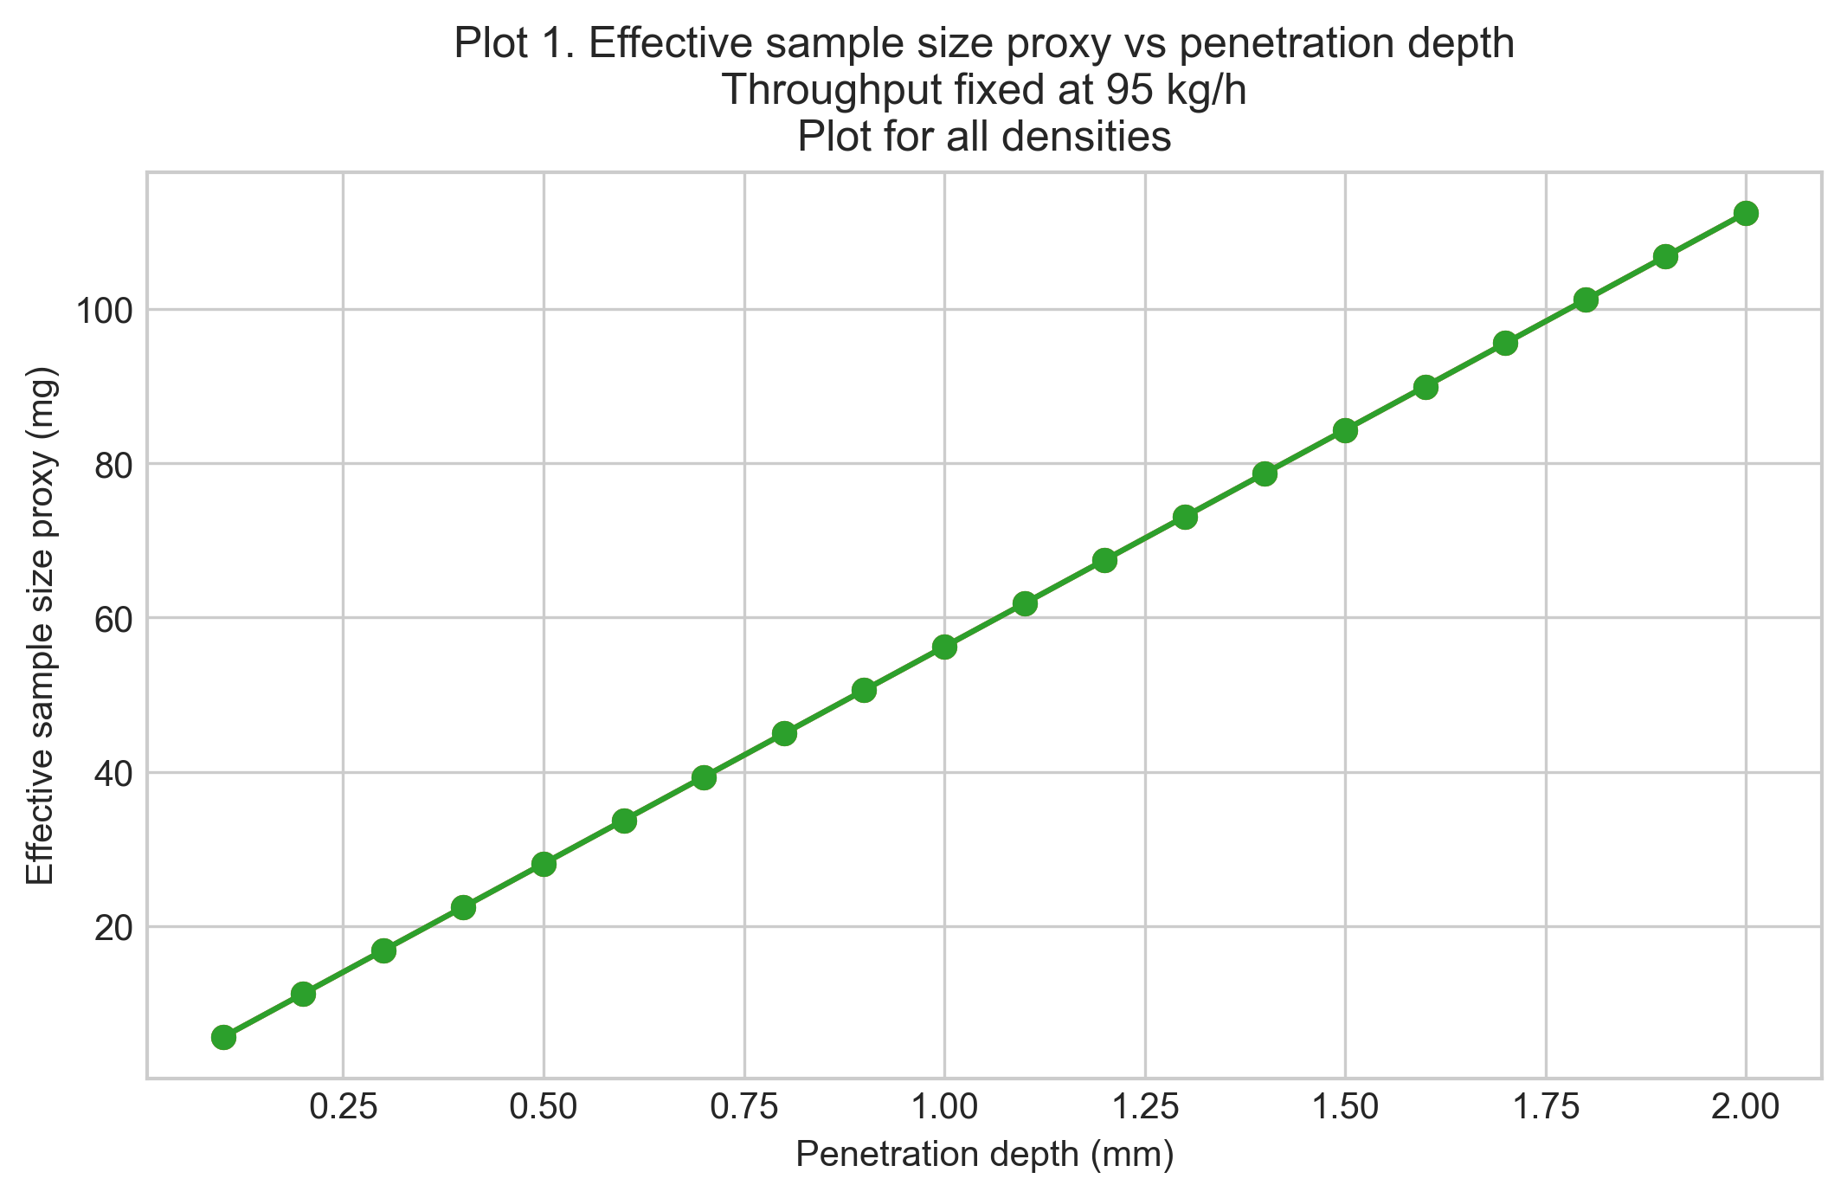
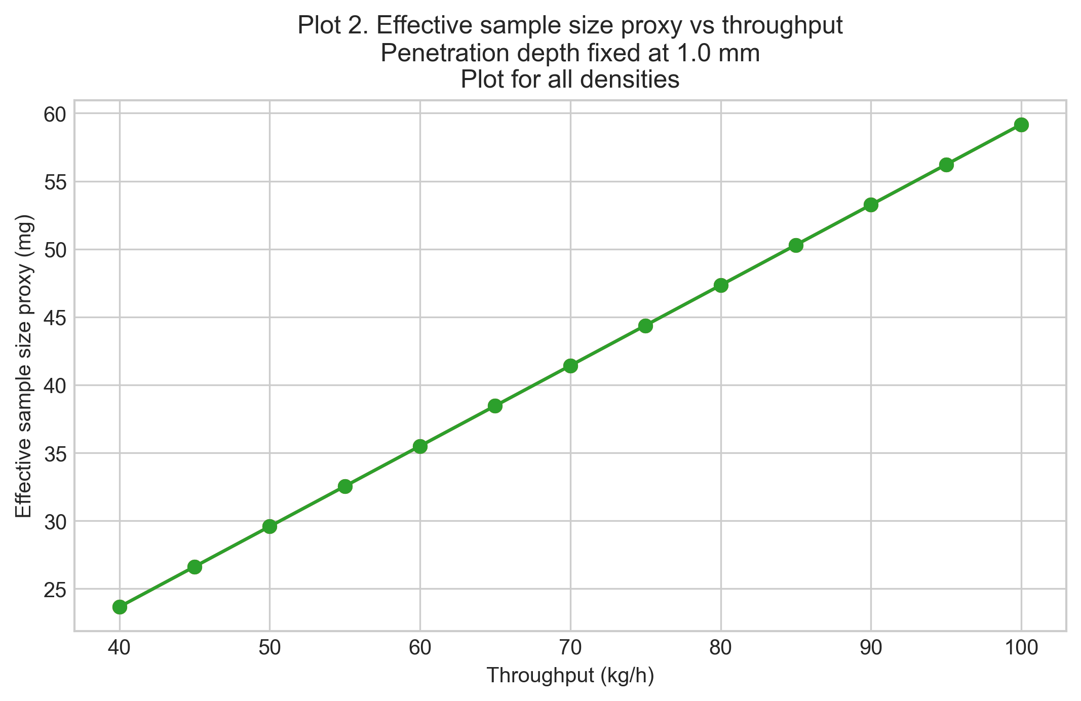
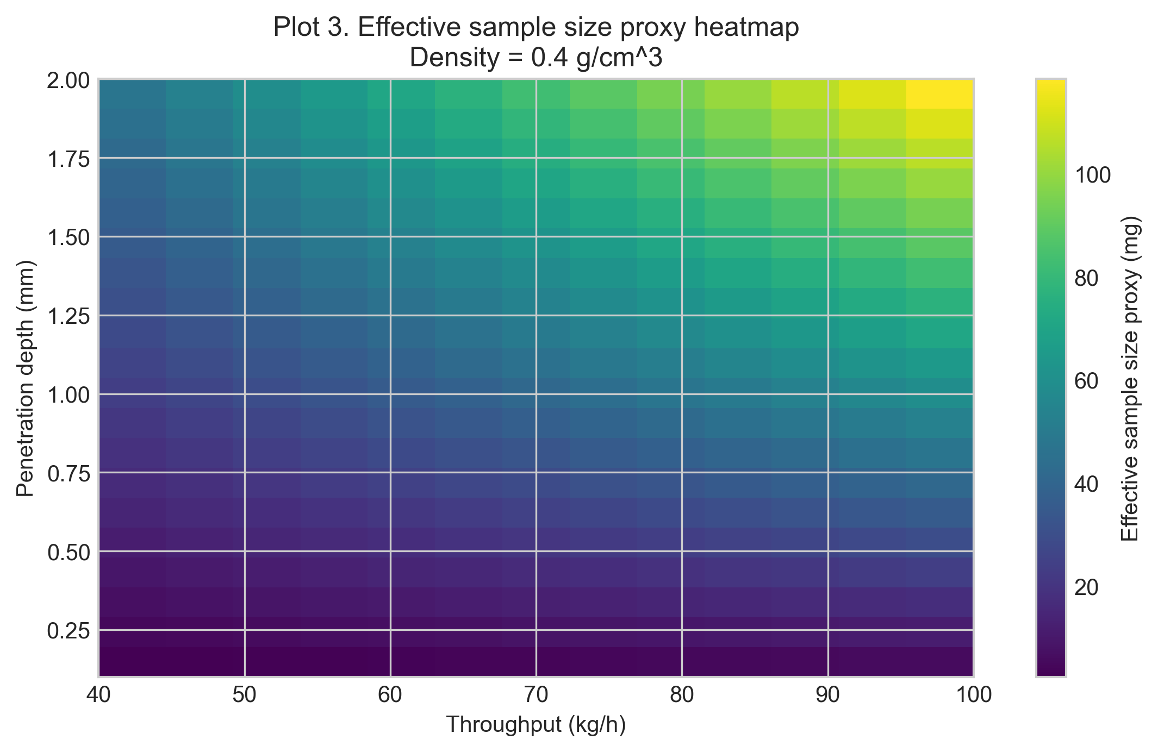
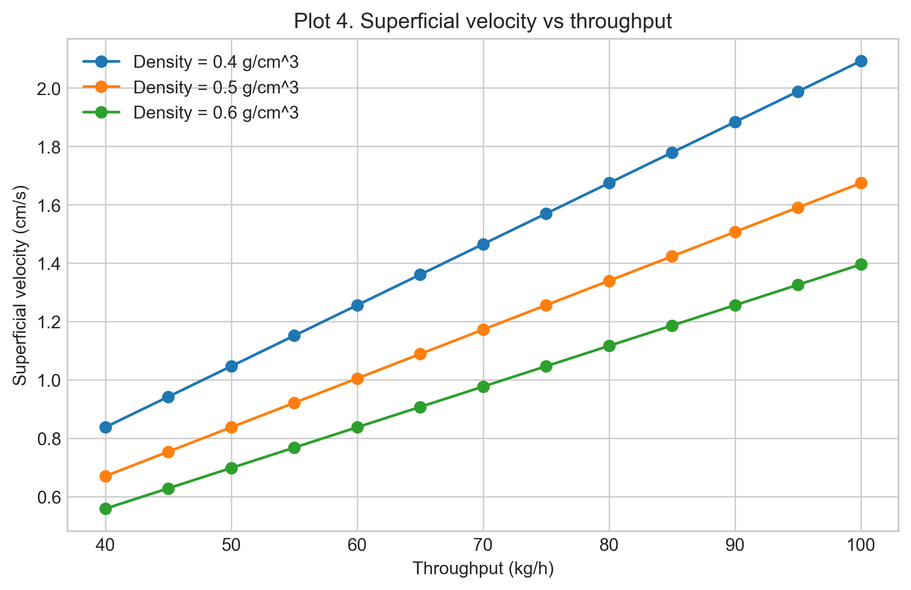
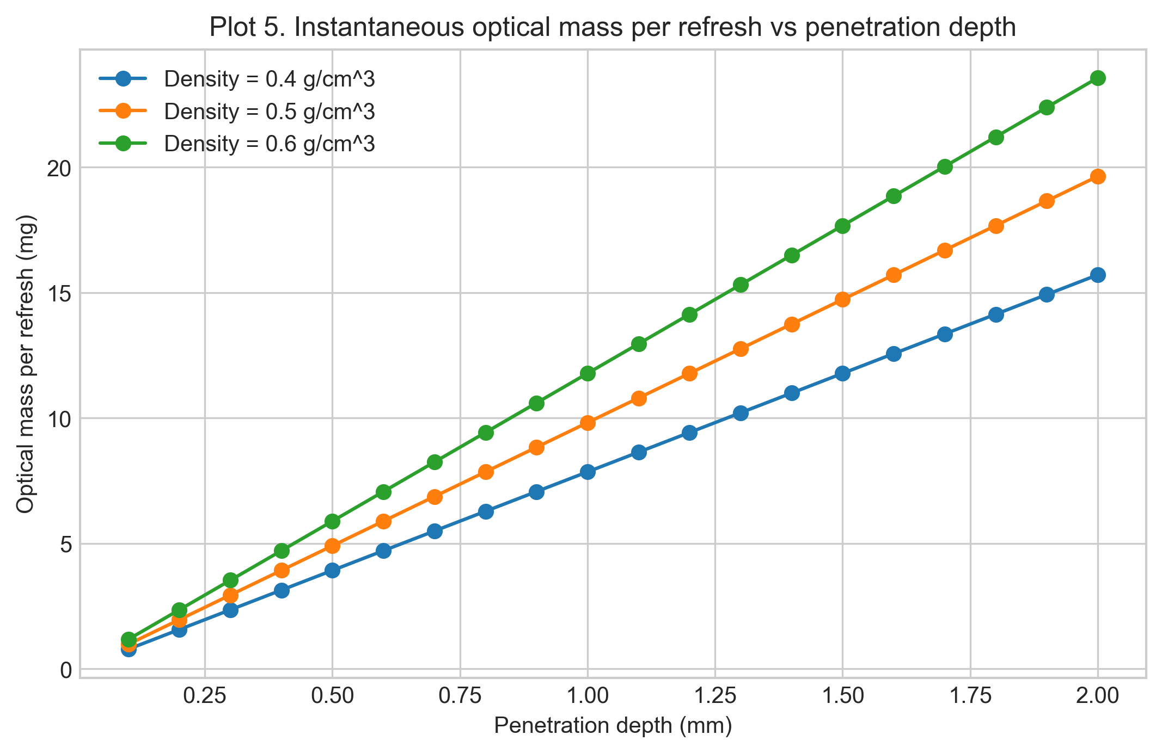
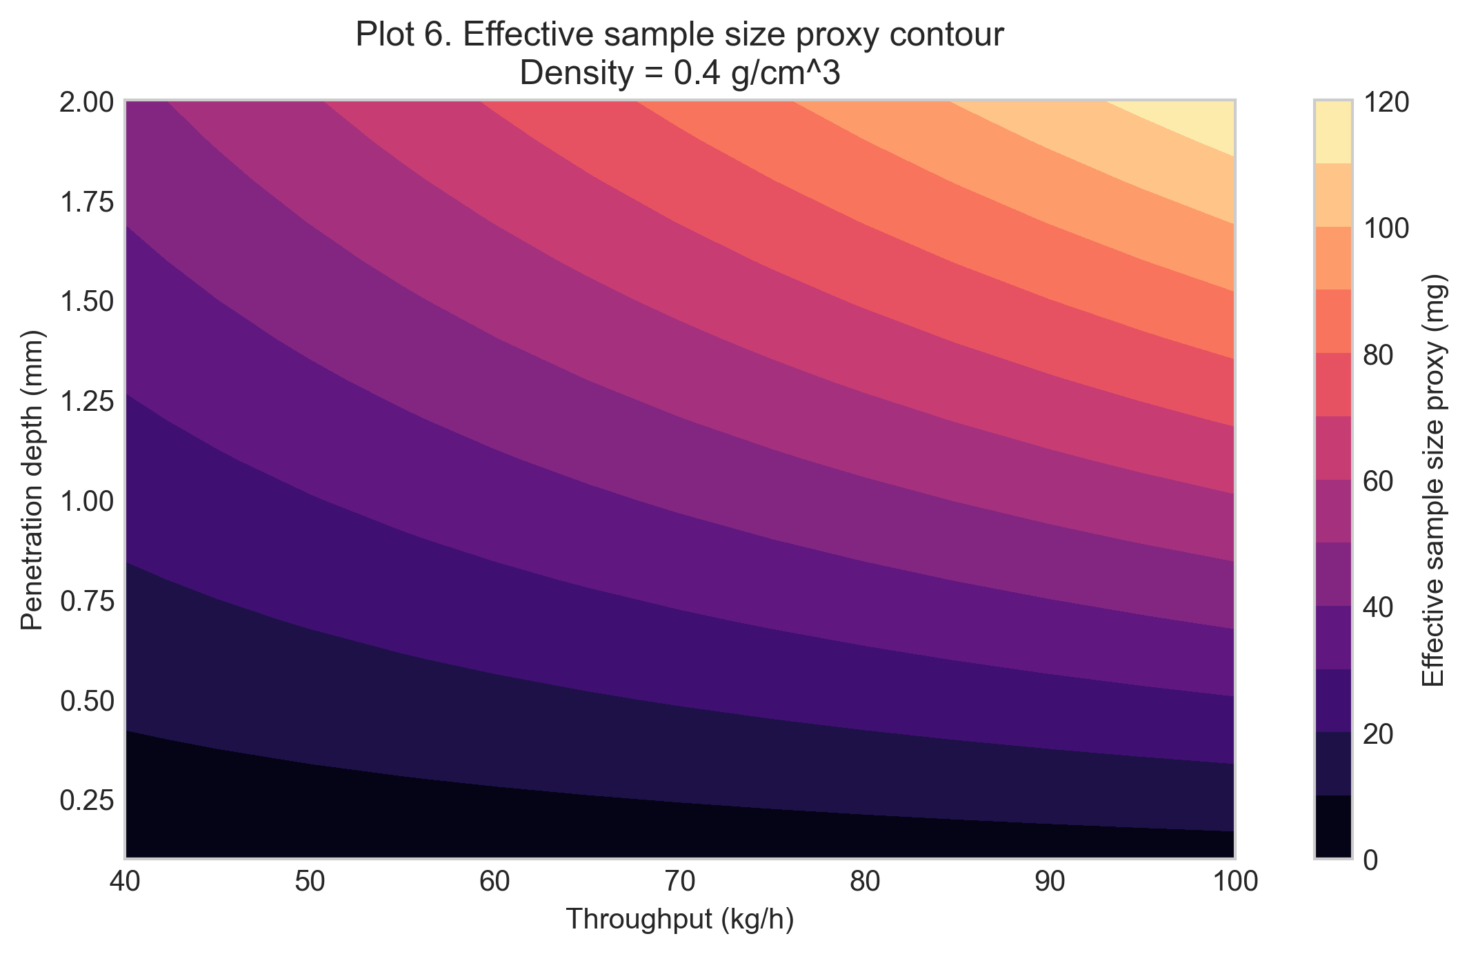
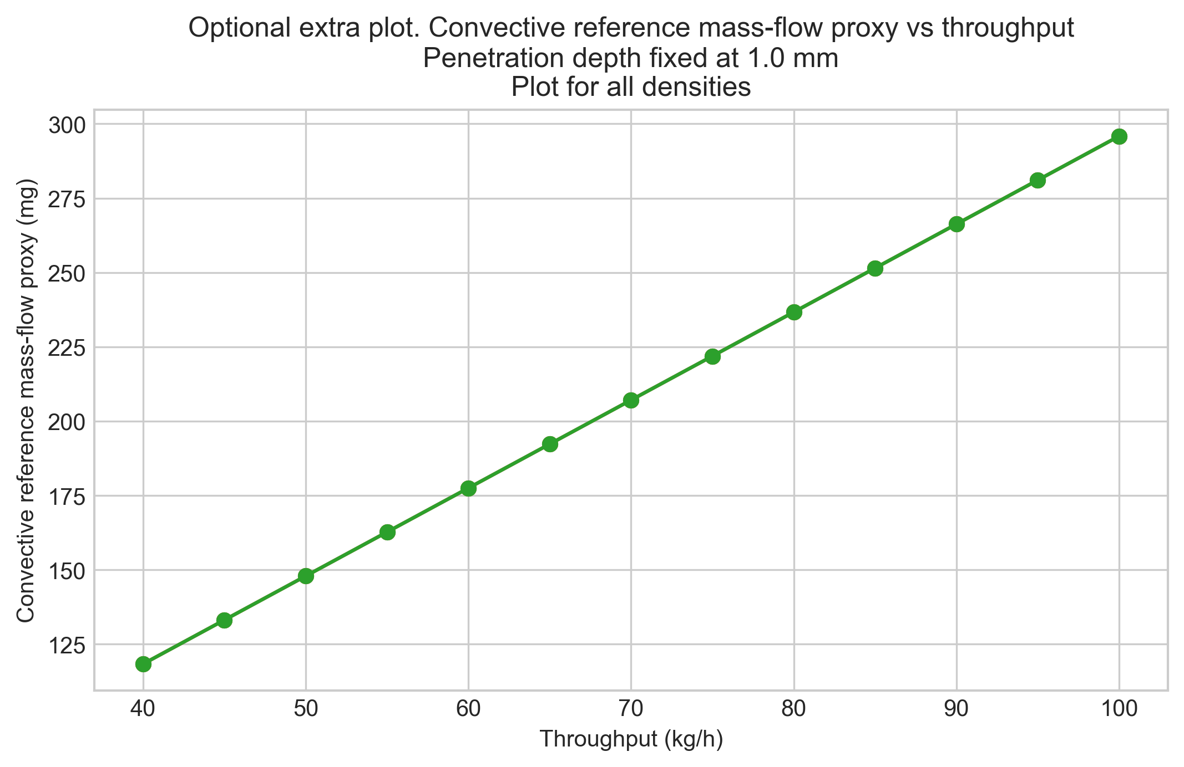

Interpretation of trends
The reported effective sample sizes are proxy values. The model combines instantaneous optical mass mopt with a refresh factor Nrefresh, so density cancellation is a model property, not a universal physical law.

Model limitations
Limitations include no velocity profile resolution, no residence-time distribution, unresolved re-sampling, no optical path-length distribution, no explicit wall slip or compaction correction, and no segregation model.

Conclusions
The notebook is intended for comparative engineering analysis and sensitivity assessment, not as an exact geometric or statistical sampling model.

Glossary of Variables and Symbols
Symbol | Name | Definition | Units
m_eff,proxy | Effective sample size proxy | Refresh-based proxy effective mass during one acquisition. | g internally; mg reported
m_opt | Instantaneous optical mass | Optical mass at one instant near the probe. | g internally; mg reported
N_refresh | Refresh factor | Number of characteristic probe-length renewals during one acquisition. | dimensionless
m_dot | Mass throughput | Bulk powder mass flow rate through the pipe. | kg/h input; g/s internally
rho | Bulk density | Assumed bulk density of the powder. | g/cm^3
v | Superficial velocity | Cross-sectional average axial velocity used as the renewal driver. | cm/s
A_probe | Probe footprint area | Circular area of the probe window. | cm^2
A_pipe | Pipe cross-sectional area | Internal cross-sectional area of the pipe. | cm^2
d_probe | Probe diameter | Diameter of the circular probe window. | mm input; cm internally
d_pipe | Pipe diameter | Internal diameter of the pipe. | mm input; cm internally
d_pen | Penetration depth | Assumed radial optical penetration depth. | mm input; cm internally
t_acq | Acquisition time | Spectrum acquisition time. | s

Exported CSV Files
- results_full.csv
- summary_table.csv
- velocity_summary.csv
Detailed tables are saved separately as CSV files in the run folder.

Figures
- plot_01_proxy_vs_penetration_depth.png
- plot_02_proxy_vs_throughput.png
- plot_03_proxy_heatmap_density_05.png
- plot_04_superficial_velocity_vs_throughput.png
- plot_05_optical_mass_per_refresh.png
- plot_06_proxy_contour_density_06.png
- plot_07_convective_reference_mass_proxy.png

Closing Note
This report captures the notebook narrative, summary metadata, and exported artifacts for this run.

