Setup D Effective Sample Size Report

Run Metadata
Setup name: setup_d
Run timestamp: 20260326_114127
Notebook filename: setup_D_pipe_effective_sample_size.ipynb
Run directory: C:\temp files\EFS\reports\setup_d\20260326_114127

Notebook Narrative

Setup D: inclined pipe effective sample size estimate

1. Title and purpose
This notebook develops a first-order engineering model for Setup D, an inclined powder pipe with an NIR diffuse reflectance probe mounted in the lower part of the pipe. The objective is to estimate a flow-based effective sample size estimate during one spectrum acquisition.
The result is best interpreted as a gross refreshed optical mass / effective sample size estimate. It is not a full radiative-transfer model, not a particulate sampling-theory model, and not a validated estimate of independent sample mass.

2. Scientific background

NIR diffuse reflectance analysis of powders
In diffuse reflectance NIR measurements, light enters a powder bed, interacts with particles over a limited depth, and a fraction of the scattered light returns to the detector. The measured spectrum therefore reflects an optically weighted near-surface volume rather than the entire bulk stream.

Why use a simple optical interaction approximation?
For engineering comparisons, it is often useful to approximate the optical interaction region with a simple geometric volume. Here, the optical sampling region is approximated as a cylinder with:
- cross-sectional area equal to the probe window footprint
- depth equal to an assumed light penetration depth
This simplification ignores depth-dependent photon weighting, scattering anisotropy, particle packing effects, and spectral absorption details, but it provides a practical way to compare conditions.

Why moving powder increases the sampled mass during one acquisition
If powder continuously moves past the probe during one acquisition, the optical interaction zone is refreshed. Faster renewal means that more powder volume can pass through the probe footprint during the acquisition period. That does not guarantee statistical independence of all material seen by the instrument, but it increases the gross refreshed optical mass available to contribute to the measurement.

Why Setup D differs from other geometries
Setup D differs from a static powder bed because the material in front of the probe is continuously replaced. It also differs from a mechanically refreshed geometry such as the spiderwheel because the refresh mechanism is not imposed by discrete compartments or controlled mechanical presentation. Instead, it is driven by gravity-assisted powder transport through a tilted pipe.

Why a superficial velocity model is useful
A practical first approximation is to connect throughput, bulk density, and pipe cross-sectional area to a superficial bulk velocity. This gives a simple estimate of how quickly powder is renewed in front of the probe. In reality, the local flow at the lower wall of a tilted pipe may differ substantially from the cross-sectional average, but the superficial velocity remains a useful baseline for sensitivity analysis and engineering intuition.

4. Model assumptions
The base model uses the following assumptions:
- the optical sampling volume is approximated as a cylinder: probe window area x penetration depth
- the probe window is fully covered by powder at all times
- powder renewal at the probe is approximated by a bulk superficial velocity derived from throughput, density, and pipe cross-sectional area
- bulk density is constant and spatially uniform
- no explicit blocking events occur
- no recirculation correction is included
- local wall velocity may differ from average superficial velocity, but that difference is ignored in the base model
- the powder at the probe is assumed to be in a dense-phase, gravity-driven sliding regime rather than an aerated or fluidized state
- de-aeration during transit through the pipe is assumed but not explicitly modeled
- velocity profiles across the pipe cross-section are not resolved; the superficial velocity represents a bulk average
- the output is a flow-based effective sample size estimate, not a validated independent sample mass
These assumptions intentionally favor transparency and reuse over physical completeness.

5. Mathematical model
Internal units used throughout the notebook are:
- geometry in cm
- time in s
- density in g/cm³
- throughput entered in kg/h and converted internally to g/s
- penetration depth entered in mm and converted internally to cm
- final reported effective sample size estimate in mg
Pipe radius:
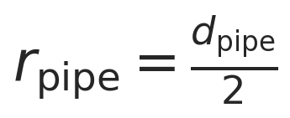
Pipe cross-sectional area:
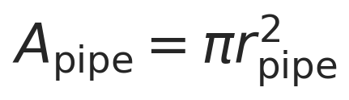
Mass flow conversion:
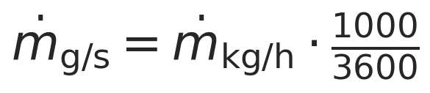
Superficial velocity:
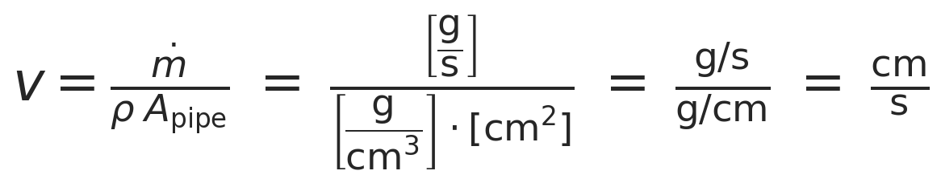
Worked-example check (dotm = 95 kg/h, rho = 0.4 g/cm^3, d_pipe = 65 mm):
| Step | Value | Unit | |---|---|---| | dotm | 95 x 1000 / 3600 = 26.3889 | g/s | | Apipe | pi (6.5/2)^2 = 33.1831 | cm² | | rho Apipe | 0.4 x 33.1831 = 13.2732 | g/cm | | v = dotm / (rho A_pipe) | 26.3889 / 13.2732 = 1.9882 | cm/s |
Probe footprint area:
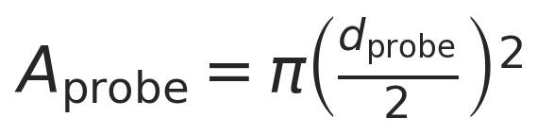
Optical volume per static slice:

Optical mass per static slice:
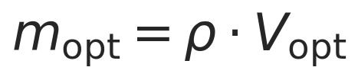
Crossing time of one probe diameter:
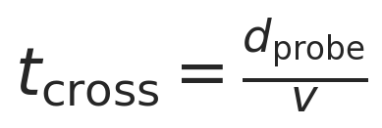
Number of refreshes during acquisition:
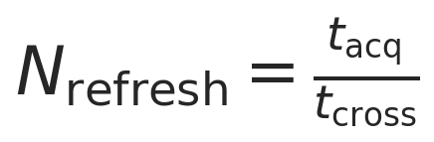
Effective sample size estimate:


Gross transported mass (reference quantity)
The passed volume and passed mass represent the total volume and mass of powder that slides past the full probe window during one acquisition, treating the probe footprint as a gate across the entire probe diameter:
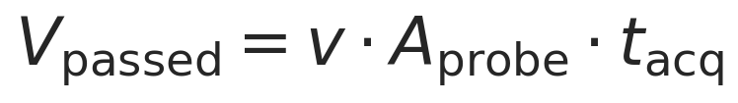
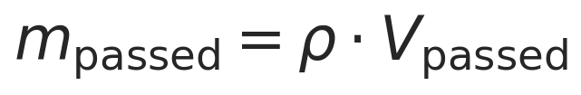
This quantity does not account for the optical penetration depth. It represents all material that crosses the probe footprint, regardless of how deep the light penetrates.

Relationship between meff and mpassed
The effective sample size estimate is always smaller than the passed mass by the ratio of penetration depth to probe diameter:
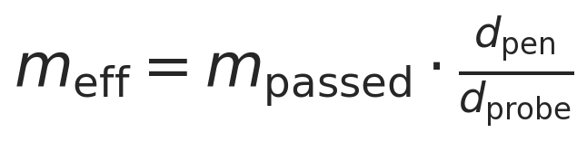
This is because the instrument only interacts with powder within the penetration depth dpen, not across the full probe diameter dprobe. The passed mass serves as a gross upper bound — the maximum mass that could contribute if the probe could see through its entire diameter. The ratio dpen / dprobe scales it down to the optically relevant fraction.
For the worked example (dpen = 1.0 mm, dprobe = 5.0 mm):
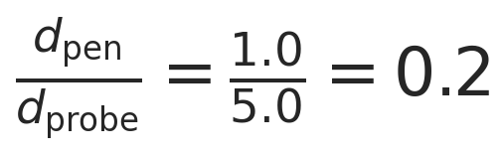
so meff is 20% of mpassed.
The 26.5 degree tilt remains part of the physical setup description, but the base model still uses the cross-sectional superficial velocity as the first-order renewal velocity approximation.

10. Parameter sweep across throughput, density, and penetration depth
The full sweep spans:
- throughput from 40 to 100 kg/h
- density = 0.4, 0.5, 0.6 g/cm³
- penetration depth from 0.1 to 2.0 mm in 0.1 mm steps
- probe diameter fixed at 5 mm
- acquisition time fixed at 1.0 s unless changed in the parameter cell

11. Results tables

12. Visualization

13. Interpretation of trends
Several clear trends appear in this first-order model.
- Increasing density increases the optical mass per static slice linearly because mopt = rho Aprobe d_pen.
- Increasing penetration depth increases the optical mass per static slice linearly because the modeled optical volume grows linearly with depth.
- Increasing throughput increases the superficial velocity linearly for fixed density and pipe area.
- Increasing superficial velocity decreases the crossing time and therefore increases the refresh count during one acquisition.
- The result should be interpreted as a flow-based refreshed optical mass estimate, not necessarily an independent sampling mass.

Why density cancels completely: mechanistic explanation
In this model, density enters in two places that work in opposite directions. The two effects have exactly equal magnitude and cancel each other.
Effect 1 — more mass per snapshot. A denser powder packs more grams into the same optical cylinder in front of the probe. The static optical mass scales linearly with density:

Doubling the density doubles the mass the probe sees at any instant.
Effect 2 — slower flow, fewer refreshes. The pipe must deliver the same mass throughput dotm (in kg/h). If the powder is denser, fewer cubic centimeters per second are needed to carry that mass. The superficial velocity is inversely proportional to density:
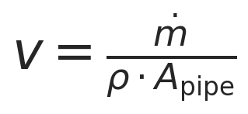
Doubling the density halves the velocity, which halves the number of probe-diameter crossings during the acquisition, and therefore halves the refresh count.
Net result. Twice the mass per refresh multiplied by half as many refreshes gives the same total:
m_eff = underbracerho * A_probe * d_pen_mass per refresh x underbracefract_acq * vd_probe_number of refreshes
Substituting v = dotm/(rho A_pipe), the rho in the numerator from optical mass and the 1/rho from velocity cancel exactly:
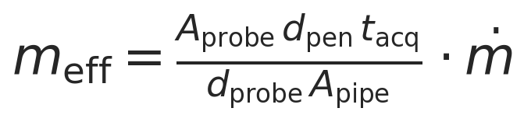
No rho remains. The effective sample size estimate depends only on mass throughput, geometry, and acquisition time.
Physical intuition. The probe footprint acts as a small window in a pipe carrying a fixed mass flow. During one acquisition, a certain mass of powder is transported past that window. That transported mass depends on how much of the pipe's total mass flow is intercepted by the probe footprint (the geometric ratio Aprobe / Apipe), how long the acquisition lasts (tacq), and an optical depth scaling (dpen / dprobe). None of these involve density. Whether the stream is a slow trickle of dense material or a faster flow of light material, the mass flux through the probe window is the same because rho * v = dotm / Apipe depends only on throughput and pipe geometry.
Why this is a model property, not a universal physical truth. The cancellation is exact only because the model assumes: (1) the full pipe cross-section carries flow uniformly, (2) density is spatially uniform, and (3) the velocity at the probe equals the cross-sectional average. In reality, density would re-enter through any of these mechanisms:
- Filling fraction: a denser powder may fill a smaller cross-sectional fraction of the tilted pipe, changing A_flowing and therefore the actual local velocity.
- Wall friction: denser powders may have different friction coefficients against the pipe wall, altering the local velocity where the probe sits.
- Consolidation: denser powder may compact more under its own weight, creating a local density at the probe that differs from the bulk average.
- Flow regime transitions: at extreme densities the flow could transition between sliding, rolling, and slug regimes, each with different renewal characteristics.

14. Model limitations
Important limitations of this notebook are:
- the cylindrical optical volume is only an approximation
- there is no radiative-transfer model and no photon weighting with depth
- superficial velocity may differ from the true local wall velocity at the probe location
- the 26.5 degree tilt is represented only qualitatively in the base model
- there is no correction for asymmetric sliding-layer thickness
- there is no correction for stagnant regions or wall slip
- there is no model for powder compaction or de-aeration along the pipe length
- there is no correction for intermittent flow or slug behavior at low throughputs
- there is no particle size or particle count model
- there is no recirculation correction
- the model is not linked directly to analytical variance or Gy sampling theory
Useful future refinements could include:
- an effective moving-layer thickness
- a local wall velocity factor
- a filling fraction or flowing cross-sectional area correction
- a residence-time or particle revisit model
- a compaction or de-aeration model for the powder state along the pipe
- a coverage model for intermittent or slug-like flow at low throughputs

15. Conclusions
This notebook estimates a first-order flow-based effective sample size estimate for Setup D, expressed as refreshed optical mass during one spectrum acquisition.
Within this model, the strongest explicit drivers are:
- throughput, which sets superficial velocity and refresh rate
- penetration depth, which scales the optical mass per refresh
- probe and pipe geometry, which determine the footprint and renewal scale
The notebook is useful for sensitivity analysis, quick scenario comparison, and engineering intuition during development. A more advanced model could incorporate local lower-wall flow kinematics, effective moving-layer thickness, nonuniform filling, revisit behavior, and optical depth weighting.

Export and Reporting
This export section writes timestamped CSV, PNG, JSON, and Word outputs into the setup-specific reports/ folder. python-docx and nbformat are required for Word export with Markdown rendering.

Purpose
Setup D estimates a first-order flow-based effective sample size estimate in a tilted pipe by combining optical mass per refresh with a refresh rate derived from superficial velocity.

Assumptions
Superficial velocity is used as a first-order flow approximation, density is uniform within each scenario, the optical volume is cylindrical, and the tilt effect is captured only through the stated simplified geometry.

Parameter Summary
- Pipe diameter (mm): 65
- Pipe tilt from vertical (deg): 26.5
- Pipe total height (mm): 340
- Inlet-outlet displacement (mm): 100.2
- Probe diameter (mm): 5
- Acquisition time (s): 1.8
- Throughput range (kg/h): 40 to 100
- Density scenarios (g/cm^3): 0.4, 0.5, 0.6
- Penetration depth range (mm): 0.1 to 2.0

Single-case worked example
The worked example uses:
- throughput = 95.0 kg/h
- density = 0.4 g/cm³
- pipe diameter = 65 mm
- pipe tilt = 26.5 degrees from vertical
- pipe total height = 340 mm
- horizontal displacement = 100.2 mm
- probe diameter = 5.0 mm
- penetration depth = 1.0 mm
- acquisition time = 1.8 s
This example should be interpreted as a first-order estimate. In a real tilted pipe, the local velocity at the lower wall may differ from the superficial velocity because the flowing layer can be asymmetric and concentrated near the lower side.

Computed results
- Pipe cross-sectional area: 33.1831 cm²
- Throughput: 26.3889 g/s
- Superficial velocity: 1.9881 cm/s
- Probe area: 0.196350 cm²
- Optical volume per static slice: 0.019635 cm³
- Optical mass per static slice: 7.8540 mg
- Crossing time: 0.2515 s
- Number of refreshes: 7.1573
- Effective sample size estimate: 56.2130 mg
- Passed volume during acquisition: 0.702663 cm³
- Passed mass during acquisition: 281.0651 mg

Parameter sweep
The full parameter sweep spans:
- throughput from 40 to 100 kg/h in 5 kg/h steps
- density = 0.4, 0.5, 0.6 g/cm³
- penetration depth from 0.1 to 2.0 mm in 0.1 mm steps
- probe diameter fixed at 5.0 mm
- acquisition time fixed at 1.8 s
Generated 780 modeled scenarios.

Visualization
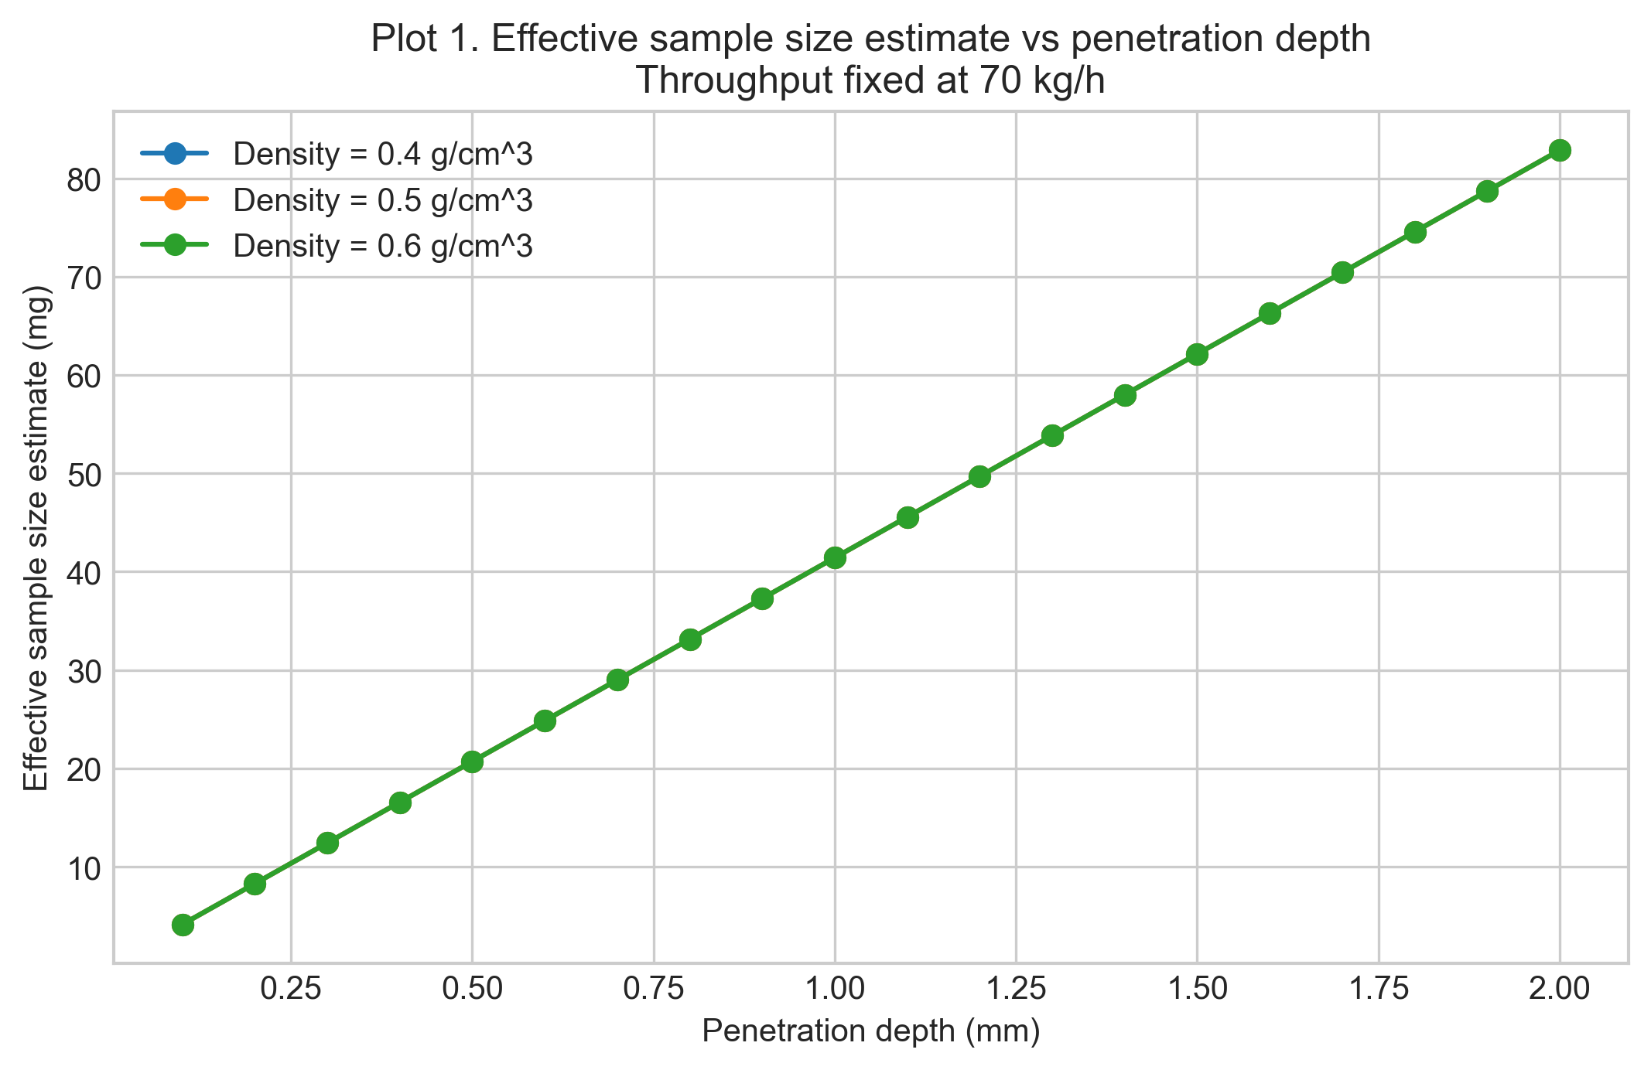
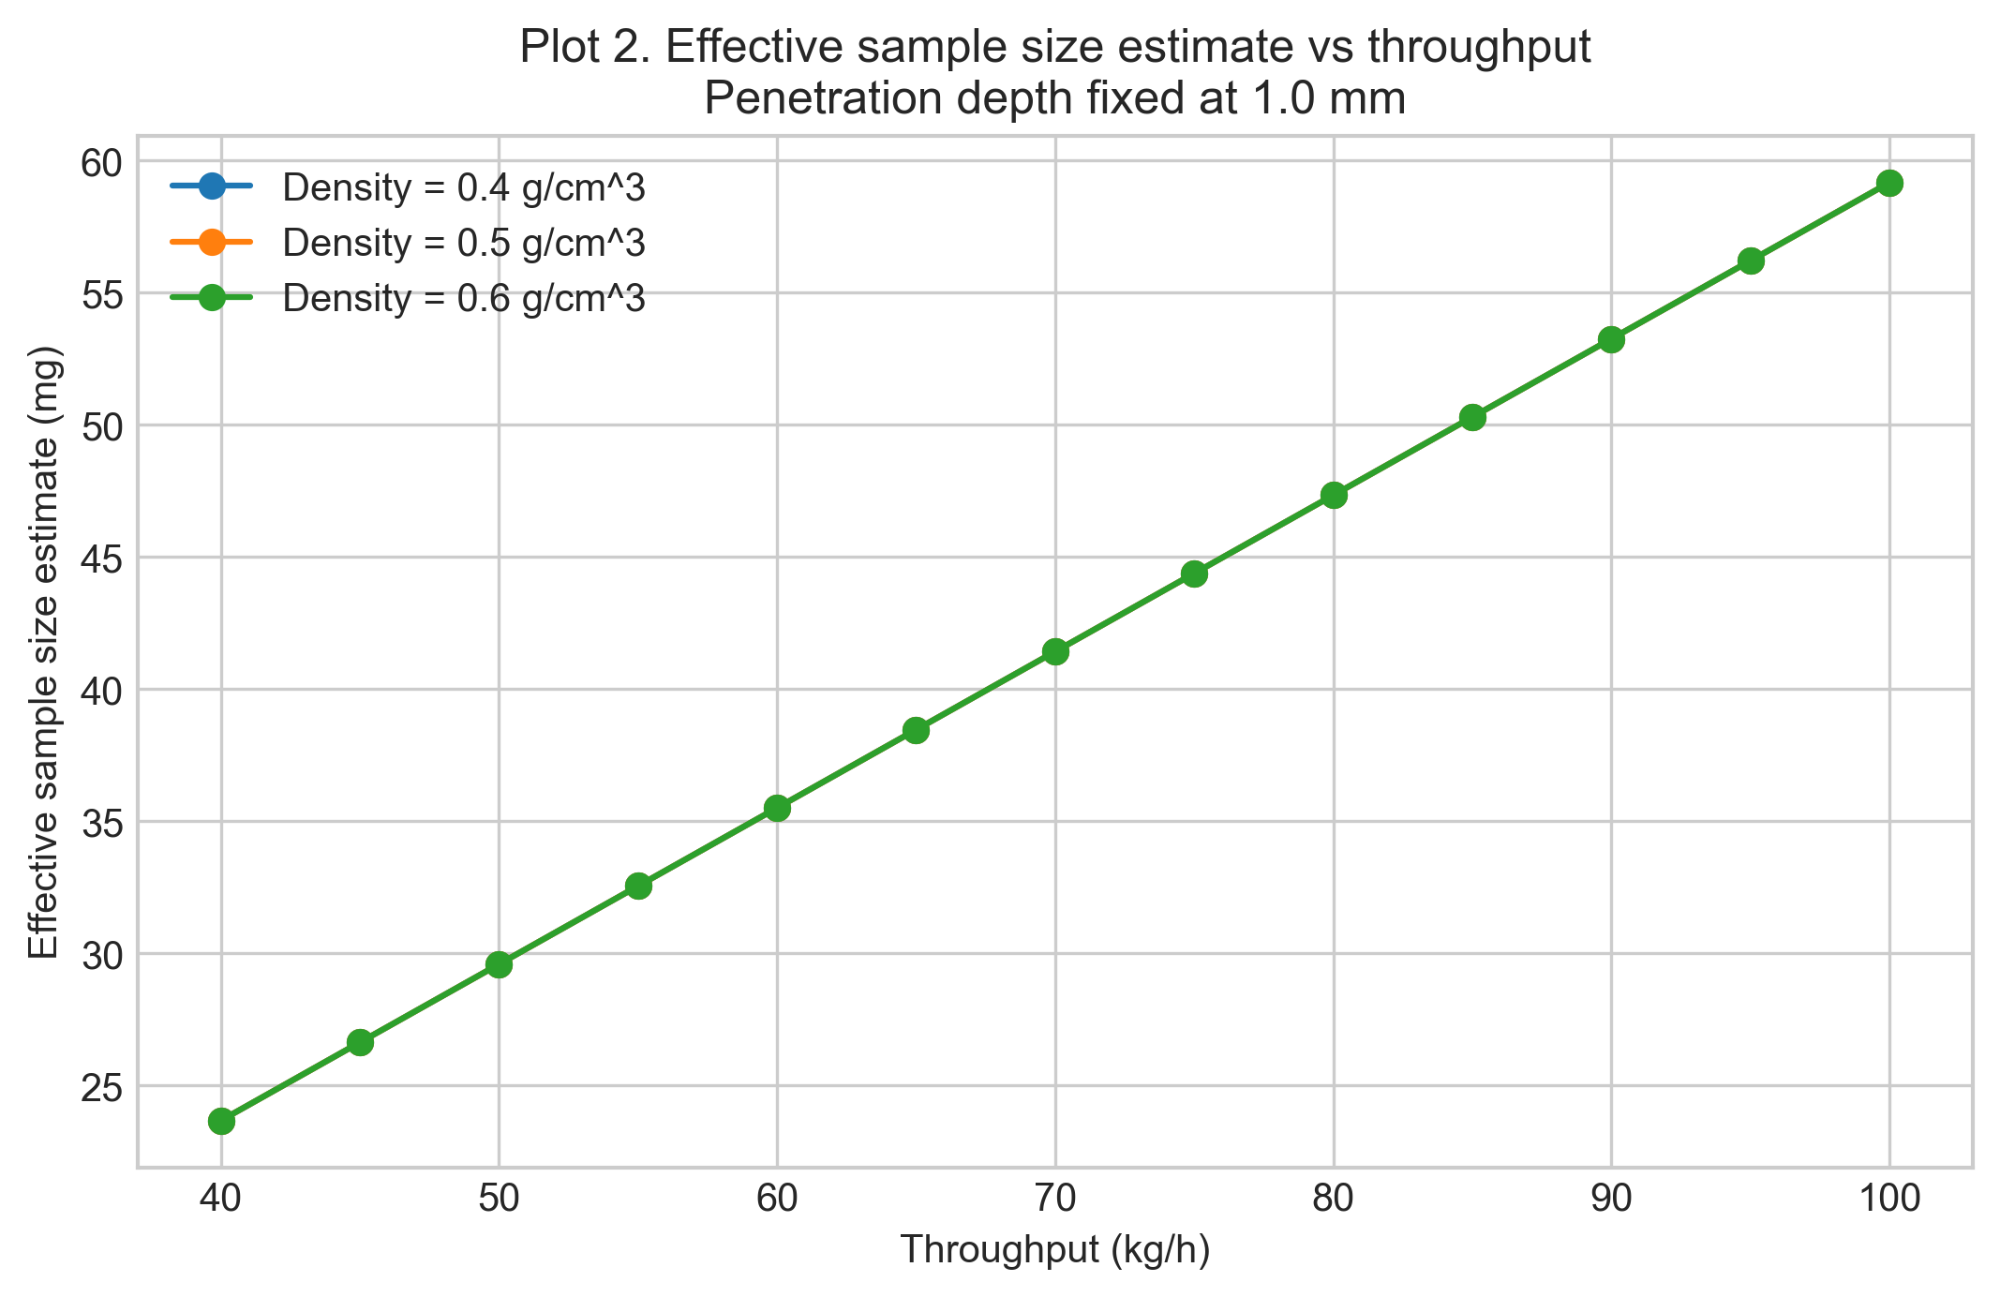
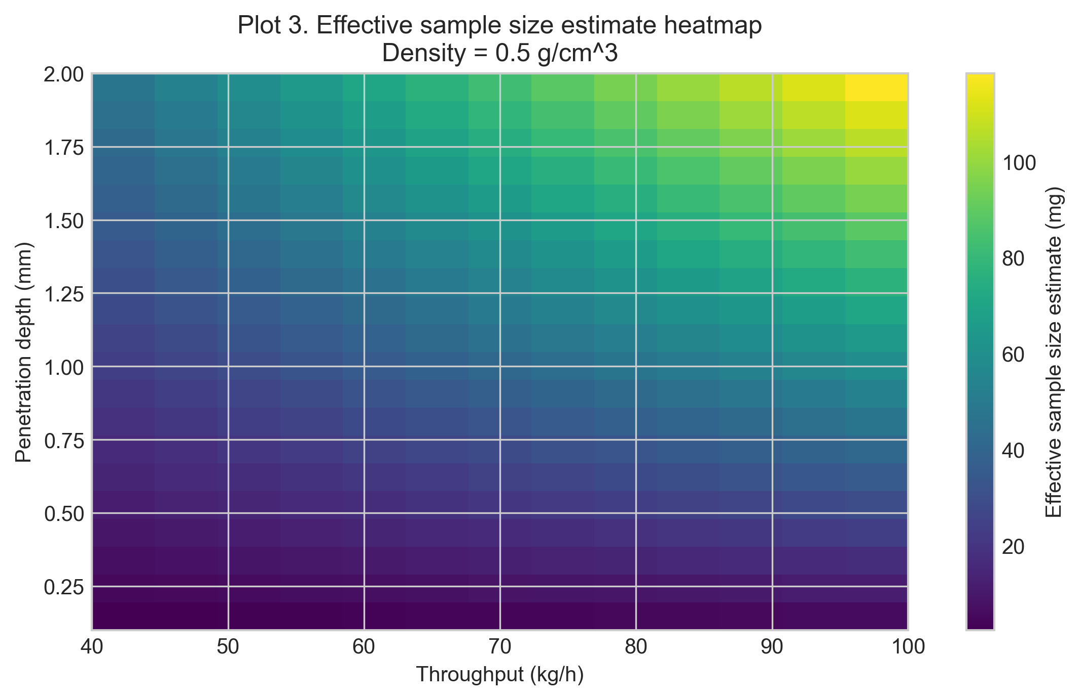
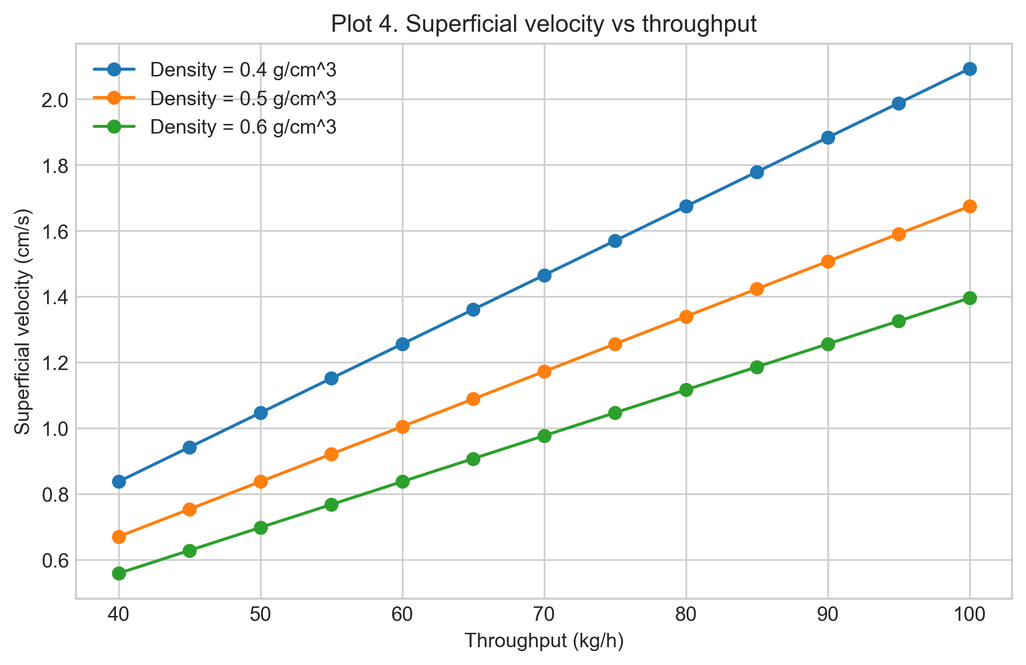
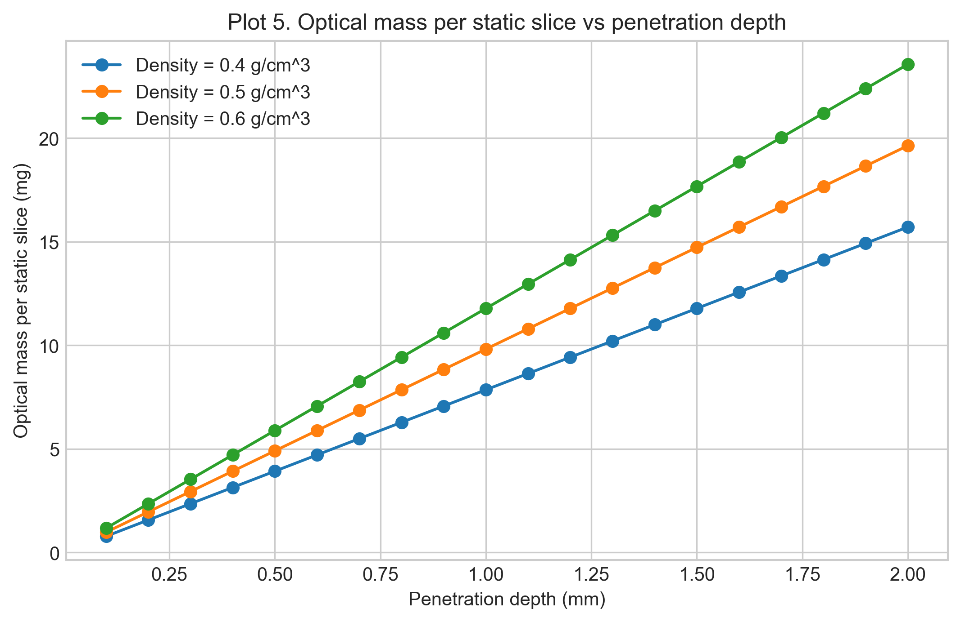
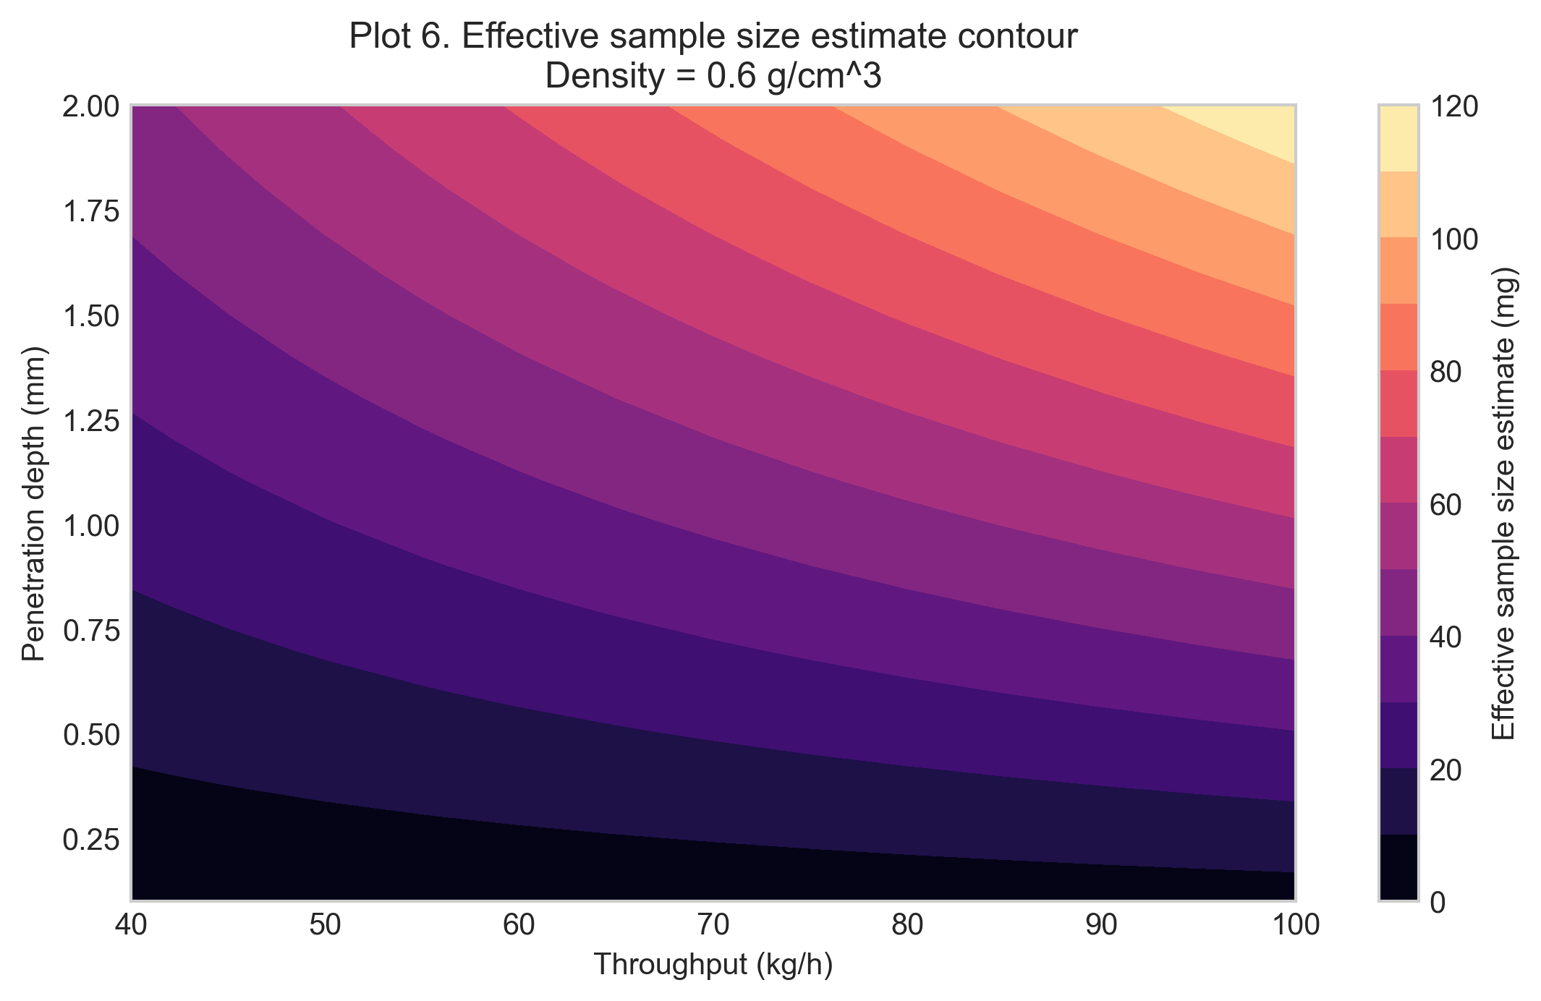
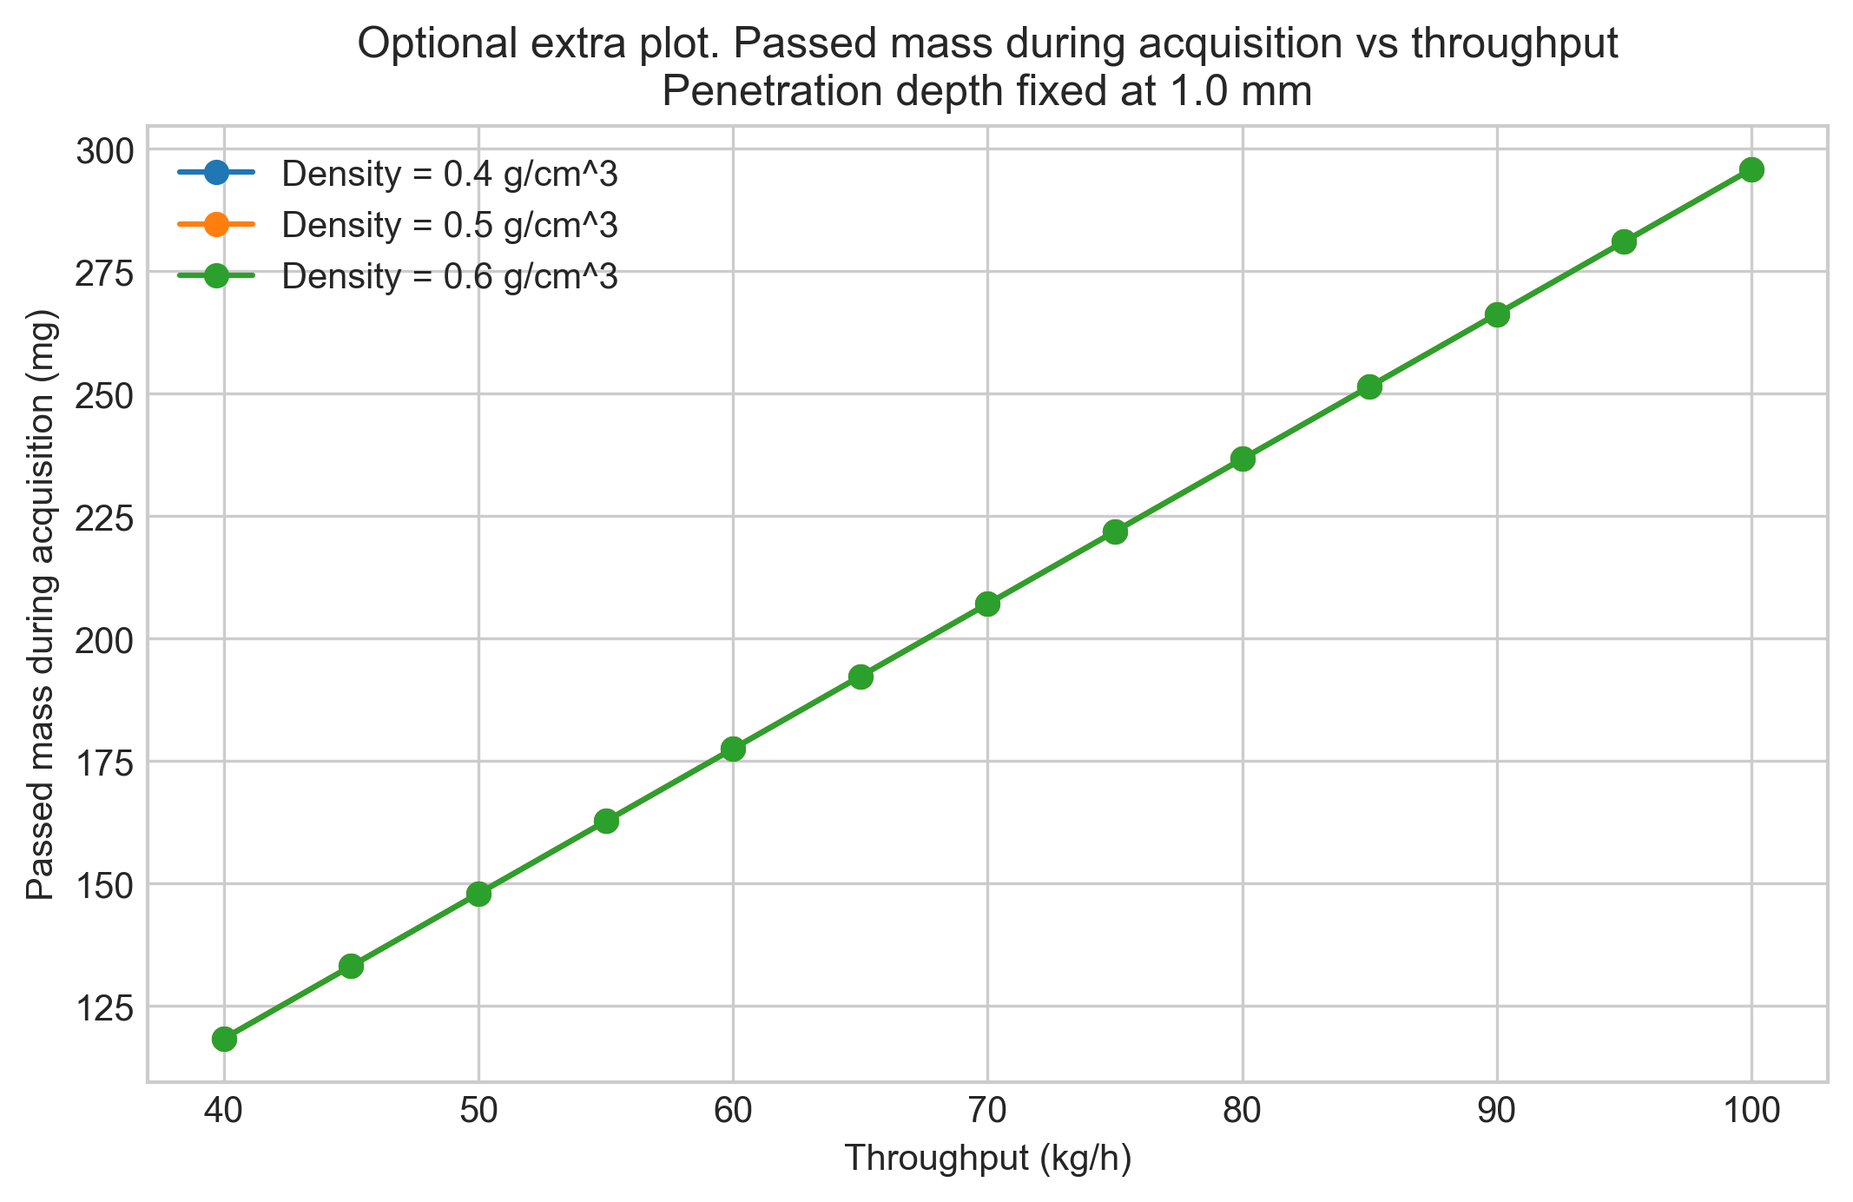

Interpretation of trends
Several clear trends appear in this first-order model.
- Increasing density increases the optical mass per static slice linearly because the optical volume is scaled by density.
- Increasing penetration depth increases the optical mass per static slice linearly because the modeled optical volume grows linearly with depth.
- Increasing throughput increases the superficial velocity linearly for fixed density and pipe area.
- Increasing superficial velocity decreases the crossing time and therefore increases the refresh count during one acquisition.
- The result should be interpreted as a flow-based refreshed optical mass estimate, not necessarily an independent sampling mass.

Why density cancels completely
Density enters in two places that work in opposite directions with exactly equal magnitude. A higher density increases the static optical mass seen at one instant (more grams per cubic centimeter in the optical volume), but simultaneously reduces the superficial velocity in the same proportion (fewer cubic centimeters per second needed to deliver the same mass throughput). The larger mass per refresh and the smaller number of refreshes offset each other exactly.
This complete cancellation is a direct consequence of the model structure. In a more realistic tilted-pipe model, density could re-enter through changes in flowing layer thickness, local wall velocity, consolidation, slip, or coverage dynamics.

Model limitations
Important limitations of this notebook are:
- the cylindrical optical volume is only an approximation
- there is no radiative-transfer model and no photon weighting with depth
- superficial velocity may differ from the true local wall velocity at the probe location
- the tilt angle is represented only qualitatively in the base model
- there is no correction for asymmetric sliding-layer thickness
- there is no correction for stagnant regions or wall slip
- there is no model for powder compaction or de-aeration along the pipe length
- there is no correction for intermittent flow or slug behavior at low throughputs
- there is no particle size or particle count model
- there is no recirculation correction
- the model is not linked directly to analytical variance or Gy sampling theory
Useful future refinements could include:
- an effective moving-layer thickness
- a local wall velocity factor
- a filling fraction or flowing cross-sectional area correction
- a residence-time or particle revisit model
- a compaction or de-aeration model for the powder state along the pipe
- a coverage model for intermittent or slug-like flow at low throughputs

Conclusions
This notebook estimates a first-order flow-based effective sample size estimate for Setup D, expressed as refreshed optical mass during one spectrum acquisition.
Within this model, the strongest explicit drivers are:
- throughput, which sets superficial velocity and refresh rate
- penetration depth, which scales the optical mass per refresh
- probe and pipe geometry, which determine the footprint and renewal scale
The notebook is useful for sensitivity analysis, quick scenario comparison, and engineering intuition during development. A more advanced model could incorporate local lower-wall flow kinematics, effective moving-layer thickness, nonuniform filling, revisit behavior, and optical depth weighting.

Exported CSV Files
- results_full.csv
- summary_table.csv
- velocity_summary.csv
Detailed tables are saved separately as CSV files in the run folder.

Figures
- plot_01_estimate_vs_penetration_depth.png
- plot_02_estimate_vs_throughput.png
- plot_03_heatmap_density_05.png
- plot_04_superficial_velocity_vs_throughput.png
- plot_05_optical_mass_per_refresh.png
- plot_06_contour_density_06.png
- plot_07_passed_mass_vs_throughput.png

Closing Note
This report captures the notebook narrative, summary metadata, and exported artifacts for this run.

