Setup E PAT Rig Effective Sample Size Report
Setup: setup_e
Report timestamp: 20260421_140148
Source notebook: setup_E_PATrig_effective_sample_size.ipynb

Executive summary
Setup E treats the PAT rig as a covered-probe vertical sampling interface in which powder continuously moves past a side-window non-contact NIR measurement location. The refactored study compares three bulk-density scenarios alongside penetration depth, acquisition time, and throughput-acquisition operating conditions while keeping the 25 mm spot geometry fixed so that instantaneous illuminated mass, refreshed new mass, and a simpler time-weighted contribution proxy can be compared mechanistically.

Key parameters
- Pipe diameter (cm): 10
- NIR spot diameter (cm): 2.5
- Base measurement depth (cm): 0.1
- Measurement depth sweep (mm): 0.1 to 2.0
- Bulk density scenarios (g/cm^3): 0.4, 0.5, 0.6
- Base throughput (kg/h): 95
- Acquisition time sweep (s): 1.0 to 5.0
- Throughput sweep (kg/h): 10 to 100
- Axial length model: spot_diameter

Background
Setup E models a PAT (Process Analytical Technology) rig as a vertical cylindrical sampling interface fed continuously from an upstream manufacturing unit. A rotating outlet valve at the bottom controls discharge, while level sensors along the wall maintain the rig at approximately half full during operation.
The primary NIR instrument views the powder through a side optical window positioned near the lower part of the rig. In the base case used here, the measurement location is placed one-quarter of the rig height above the bottom outlet and the non-contact NIR spot diameter is 25 mm.
Three distinct mass metrics are relevant:
- Instantaneous probed mass (m_inst): mass simultaneously illuminated at any single instant.
- New mass presented per acquisition (m_new): unique material refreshed across the NIR spot during one acquisition time, bounded by the instantaneous mass.
- Mass passed probe footprint (m_pass): total mass that crosses the probe footprint during acquisition and is not bounded by the instantaneous mass.
This notebook treats the occupied lower section of the PAT rig as a first-order dense moving powder column. It uses the maintained fill level to determine whether the probe is covered by powder and then uses throughput-driven axial motion to estimate renewal at the probe position.

Objective
Compute instantaneous probed mass, new mass presented per acquisition, and mass passed the NIR spot footprint for a level-controlled PAT rig configuration. Use a half-filled base case with the measurement window located one-quarter of the rig height from the bottom, sweep acquisition time and throughput, and export results using the standard reporting workflow.

Theory

Covered-probe PAT rig geometry
The PAT rig is represented as a vertical cylindrical flow region observed through a side optical window. The operating assumption in this notebook is that the process is controlled so the probe window is always buried in powder during normal operation. Probe coverage is therefore treated as guaranteed rather than modeled as a variable.

Throughput-driven axial velocity
Powder motion near the covered probe is approximated as a first-order dense moving column. The axial velocity is estimated from throughput and the full cylindrical cross-section:
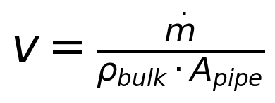
where
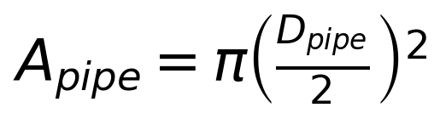
This remains a simplifying assumption: it ignores detailed wall slip, outlet-valve kinematics, and any nonuniform velocity profile near the probe.

Instantaneous probed mass
The non-contact NIR spot is represented as a circular optical footprint with area:
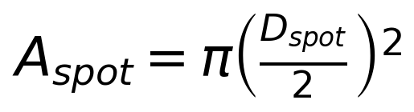
The instantaneous probed mass is:
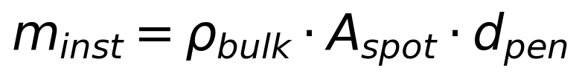

Axial advance and refresh fraction
Axial advance during one acquisition is:
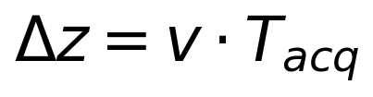
The axial sampling length is represented by a proxy length L_axial. In the base case this is taken as the NIR spot diameter. The refresh fraction is then:
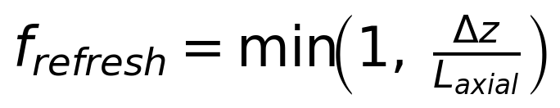

New mass and mass passed
New mass presented per acquisition is:
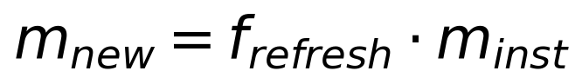
Mass passed the probe footprint during acquisition is:
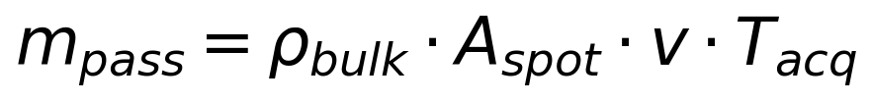
Symbols and units:
- dotm: mass flow rate [g/s]
- rho_bulk: bulk density [g/cm^3]
- A_pipe: pipe cross-section area [cm^2]
- A_spot: NIR spot area [cm^2]
- D_spot: NIR spot diameter [cm]
- d_pen: measurement (penetration) depth [cm]
- T_acq: spectral acquisition time [s]
- L_axial: axial sampling length proxy [cm]

Interpreting Density, Velocity, and Throughput
At fixed mass throughput, the local powder velocity in this model is inversely proportional to bulk density:

This means that, for the same throughput in kg/h and the same PAT rig cross-section, lower bulk-density powder occupies a larger volumetric flow rate and therefore moves faster past the probe, while higher bulk-density powder moves more slowly.
This relationship has two important consequences for the present model:
- Increasing bulk density increases the instantaneous mass in the optical region because the same illuminated volume contains more mass.
- Increasing bulk density decreases the local axial velocity, which reduces how quickly new material replaces the powder already in view.
These two effects oppose each other. As a result, some modeled outputs separate strongly across bulk density, while others partially collapse or become less sensitive than a reader might first expect.
The notebook therefore treats bulk density as an important material property not only because it changes the illuminated mass directly, but also because it changes the local transport rate that controls refresh behavior during one spectral acquisition.

Time- and Space-Weighted Contribution to the Spectrum
The notebook distinguishes between three different ideas:
- the instantaneous mass in the optical region at any one moment
- the total unique powder illuminated at least once during an acquisition
- the effective contribution of that powder to the integrated spectrum
The third quantity is the most analytically relevant, because a measured NIR spectrum is a time-integrated signal. Some powder parcels are present in the probe field for longer than others and therefore contribute more strongly to the final spectrum, even if all parcels are counted equally as unique material.
A fully general model would represent this using a time- and space-dependent weighting field W(\mathbfx, t), so that the contribution of a parcel depends on both where it is within the optical sensitivity field and how long it remains there during acquisition.
This notebook does not unfold the full space-time weighting model. Instead, it introduces a simpler first-generation proxy based only on time integration under a top-hat intensity assumption. That proxy is useful for indicating how integrated spectral exposure grows with acquisition time, but it should not be interpreted as a full optical weighting model.

Assumptions
- vertical cylindrical PAT rig with top feed and bottom discharge through a rotating outlet valve
- the operating window is controlled so the probe window remains continuously covered during normal operation
- no explicit level-control dynamics are modeled because probe coverage is treated as guaranteed by design
- the powder near the probe is treated as a dense moving column
- powder velocity at the probe is approximated from throughput and full pipe cross-section
- the NIR spot is circular and viewed through a side optical window
- measurement depth is small relative to pipe diameter
- axial sampling length is approximated by the NIR spot diameter unless overridden
- no explicit outlet-valve kinematics, turbulence, segregation, or wall-slip correction
- no detailed radiative transfer model yet

Compute Effective Sample Size Metrics
Run a discrete bulk-density comparison together with a penetration-depth sweep by density, an acquisition-time sweep by density, and a throughput x acquisition-time sweep by density while keeping the covered-probe geometry and 25 mm NIR spot fixed.

Worked example
The baseline case below reports the center density scenario, the base-case penetration depth, the instantaneous mass at the probe, the refreshed new mass during one acquisition, the total mass passed the NIR spot footprint, the time-weighted contribution proxy, and the resulting refresh fraction.
Quantity | Value
measurementdepthcm | 0.1
bulkdensitygpercm3 | 0.5
velocitymms | 6.71988
acquisitiontimes | 1
refreshfractionper_acq | 0.268795
probemassmg_instant | 245.437
newmassmgperacq | 65.9722
masspassedmgperacq | 1649.31
timeweightedcontributionproxymg_s | 245.437
effectivesamplesize_mg | 65.9722

Model scenarios and sweep design
The Setup E analysis combines a discrete bulk-density comparison with a penetration-depth sweep by density, an acquisition-time sweep by density, and a throughput-by-acquisition-time sweep by density. This separates material-density sensitivity from optical-depth sensitivity and renewal-time sensitivity while holding the covered-probe geometry and 25 mm spot size fixed.
- bulk density scenarios: 0.4, 0.5, and 0.6 g/cm^3
- penetration depth swept from 0.1 to 2.0 mm in 0.1 mm steps for each density
- acquisition time swept from 1.0 to 5.0 s for each density
- throughput swept from 10 to 100 kg/h for each density
- NIR spot diameter fixed at 2.5 cm
- axial sampling length model: spot_diameter
This produces 1323 modeled rows across the density-aware sweeps.

Selected results table
The selected table below compares the three bulk-density scenarios at the common base operating condition so the reader can compare velocity, instantaneous illuminated mass, refreshed new mass, passed mass, time-weighted contribution proxy, refresh fraction, and effective sample size side by side.
bulkdensitygpercm3 | velocitymms | probemassmg_instant | newmassmgperacq | masspassedmgperacq | timeweightedcontributionproxymg_s | refreshfractionper_acq | effectivesamplesize_mg
0.4000 | 8.3998 | 196.3495 | 65.9722 | 1649.3056 | 196.3495 | 0.3360 | 65.9722
0.5000 | 6.7199 | 245.4369 | 65.9722 | 1649.3056 | 245.4369 | 0.2688 | 65.9722
0.6000 | 5.5999 | 294.5243 | 65.9722 | 1649.3056 | 294.5243 | 0.2240 | 65.9722

Figures
The figures are ordered from one-dimensional density comparisons to density-specific operating maps, followed by the time-weighted contribution proxy versus acquisition time. This allows the reader to distinguish optical-volume effects, refresh-limited replacement, and time-integrated exposure behavior within the same report.
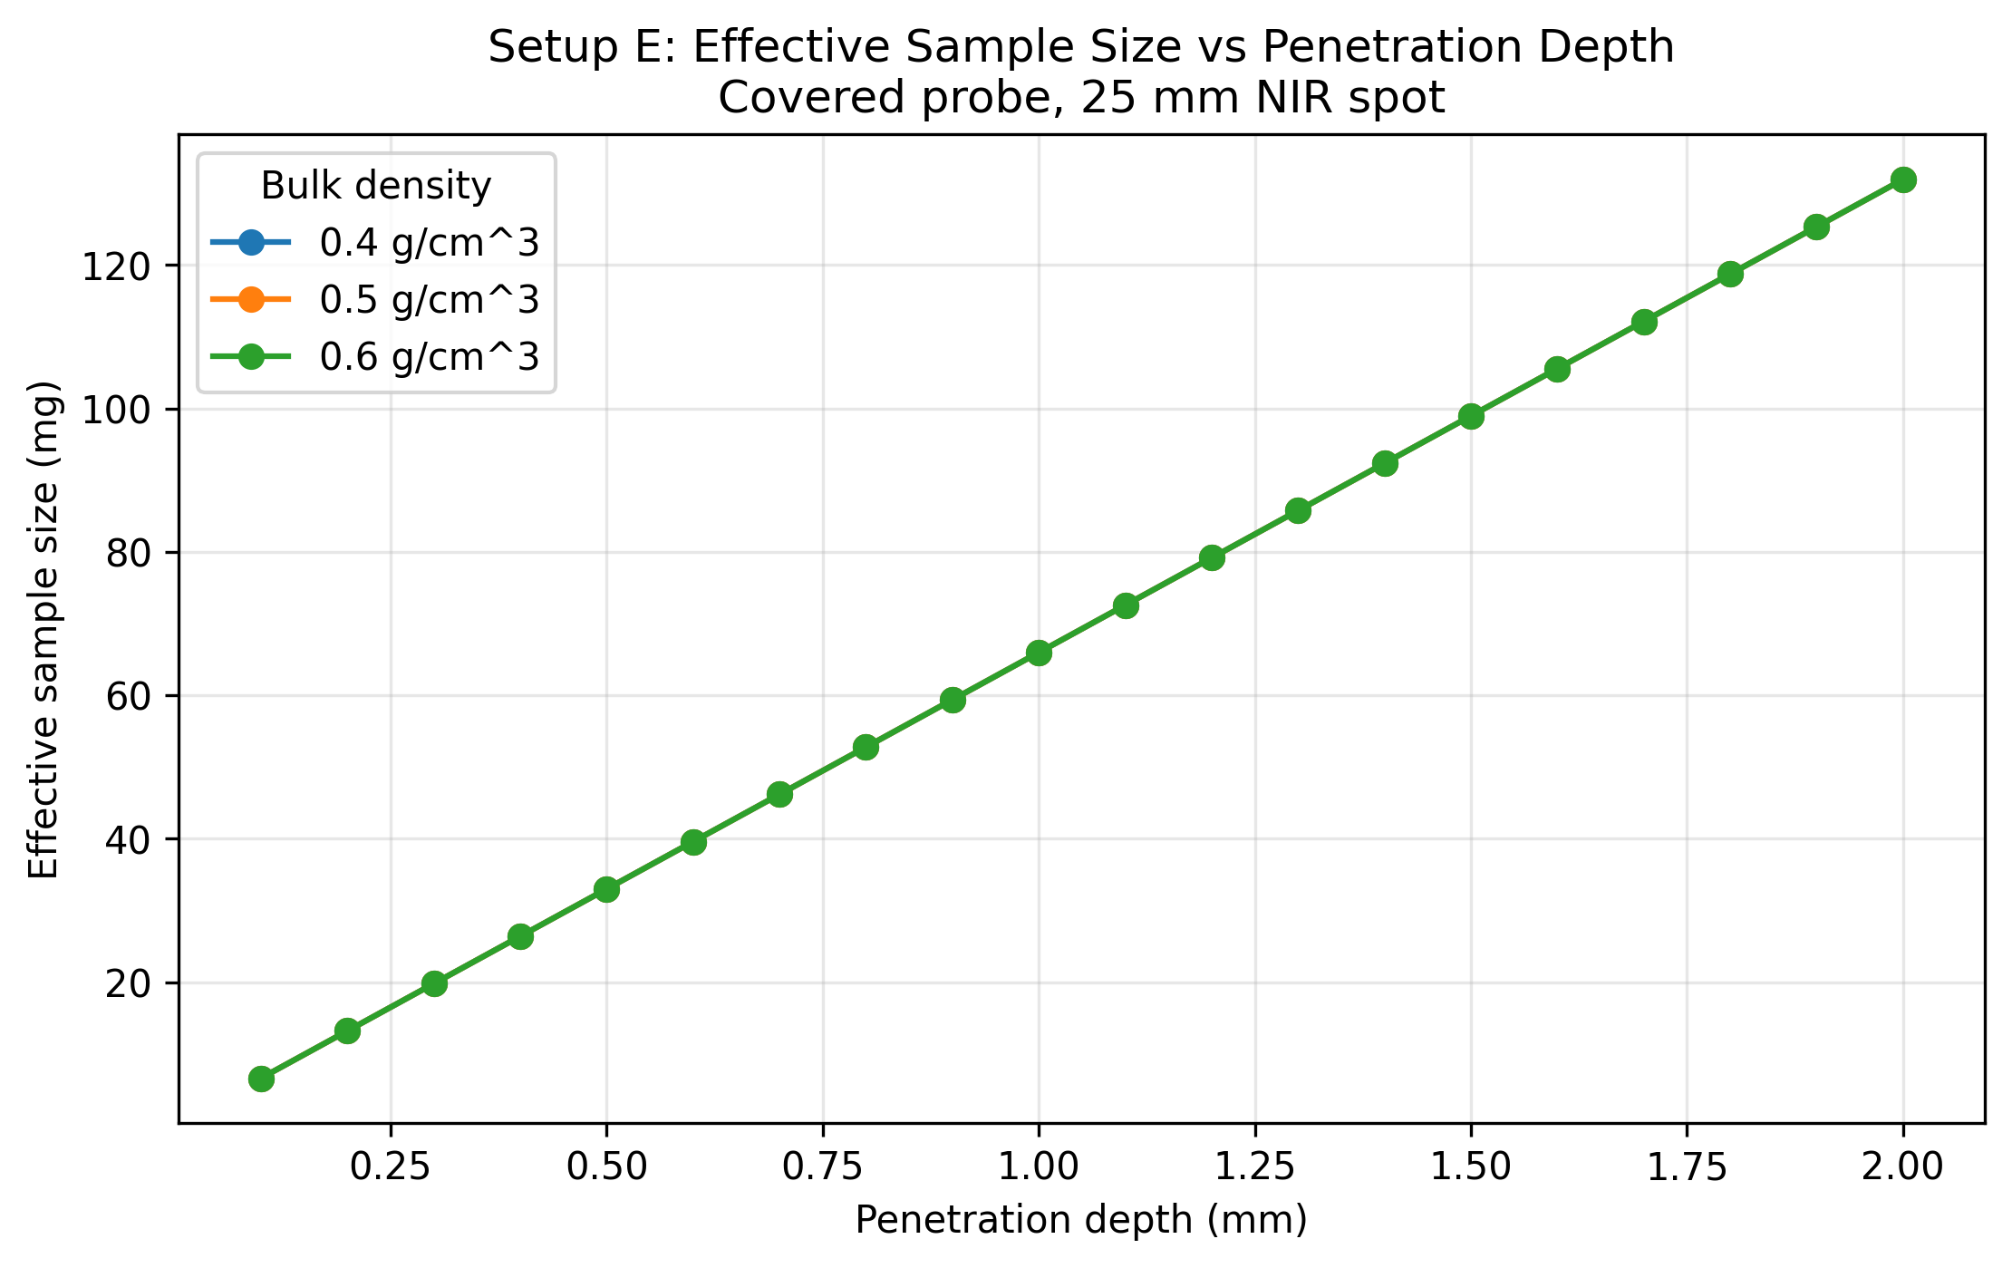
Figure 1. Effective sample size versus penetration depth for bulk densities of 0.4, 0.5, and 0.6 g/cm^3 (fixed throughput: 95 kg/h; fixed acquisition time: 1.0 s; fixed NIR spot diameter: 25 mm).
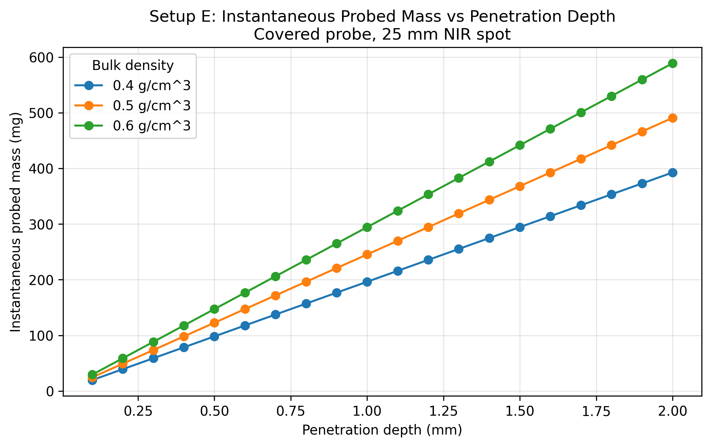
Figure 2. Instantaneous probed mass versus penetration depth for the three bulk-density scenarios (fixed throughput: 95 kg/h; fixed acquisition time: 1.0 s; fixed NIR spot diameter: 25 mm).
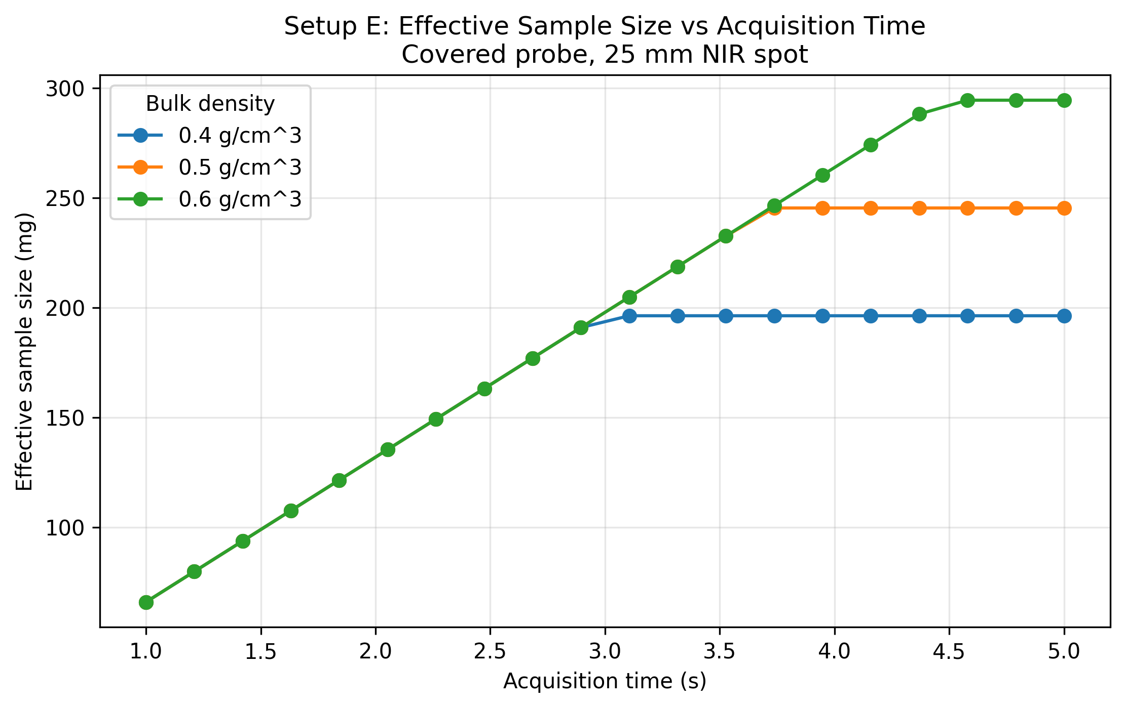
Figure 3. Effective sample size versus acquisition time for the three bulk-density scenarios (fixed throughput: 95 kg/h; fixed penetration depth: 1.0 mm; fixed NIR spot diameter: 25 mm).
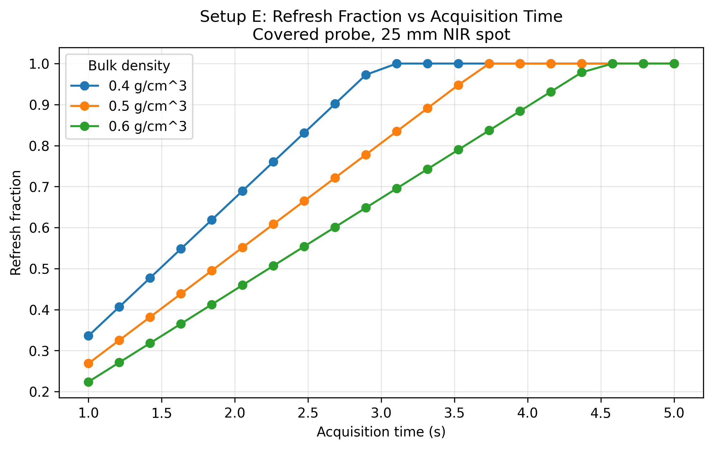
Figure 4. Refresh fraction versus acquisition time for the three bulk-density scenarios (fixed throughput: 95 kg/h; fixed penetration depth: 1.0 mm; fixed NIR spot diameter: 25 mm).
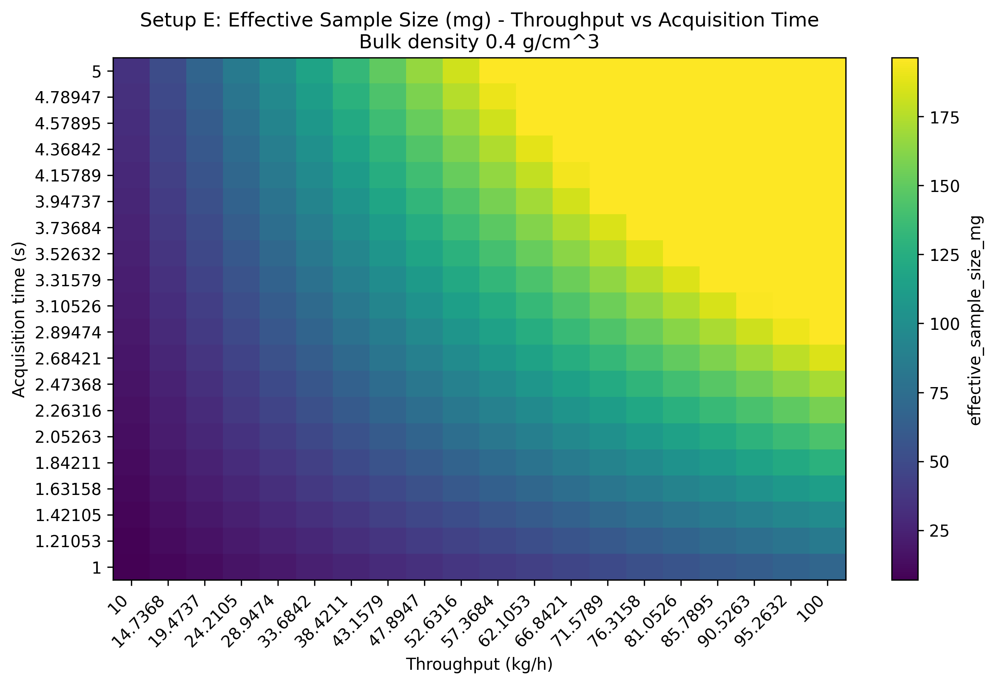
Figure 5. Throughput-acquisition heatmap for effective sample size at 0.4 g/cm^3 bulk density (fixed penetration depth: 1.0 mm; fixed NIR spot diameter: 25 mm).
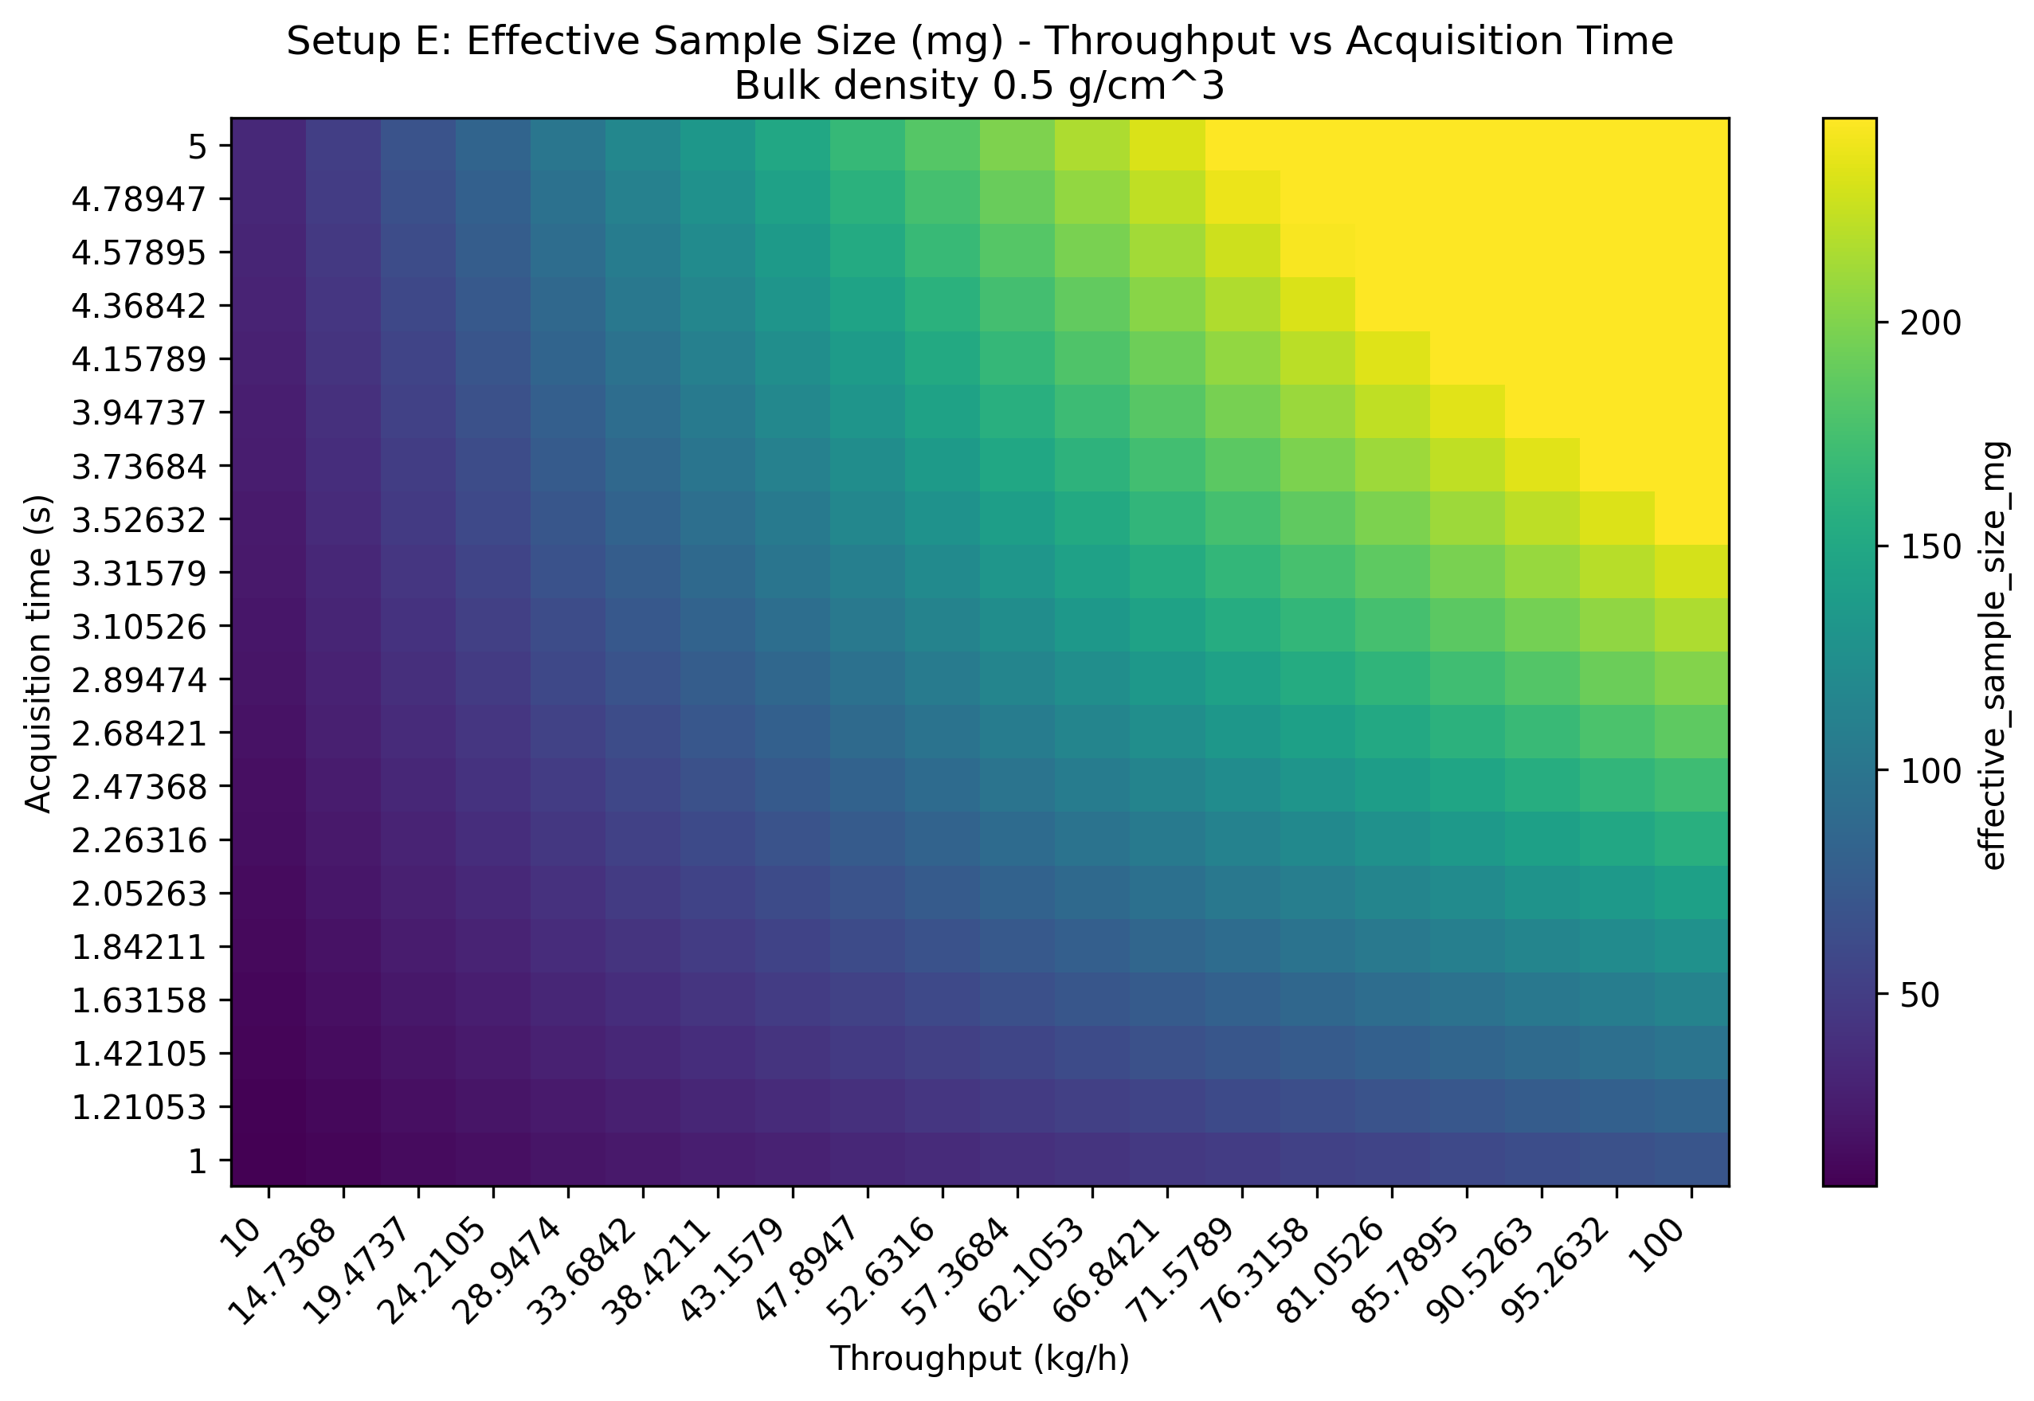
Figure 6. Throughput-acquisition heatmap for effective sample size at 0.5 g/cm^3 bulk density (fixed penetration depth: 1.0 mm; fixed NIR spot diameter: 25 mm).
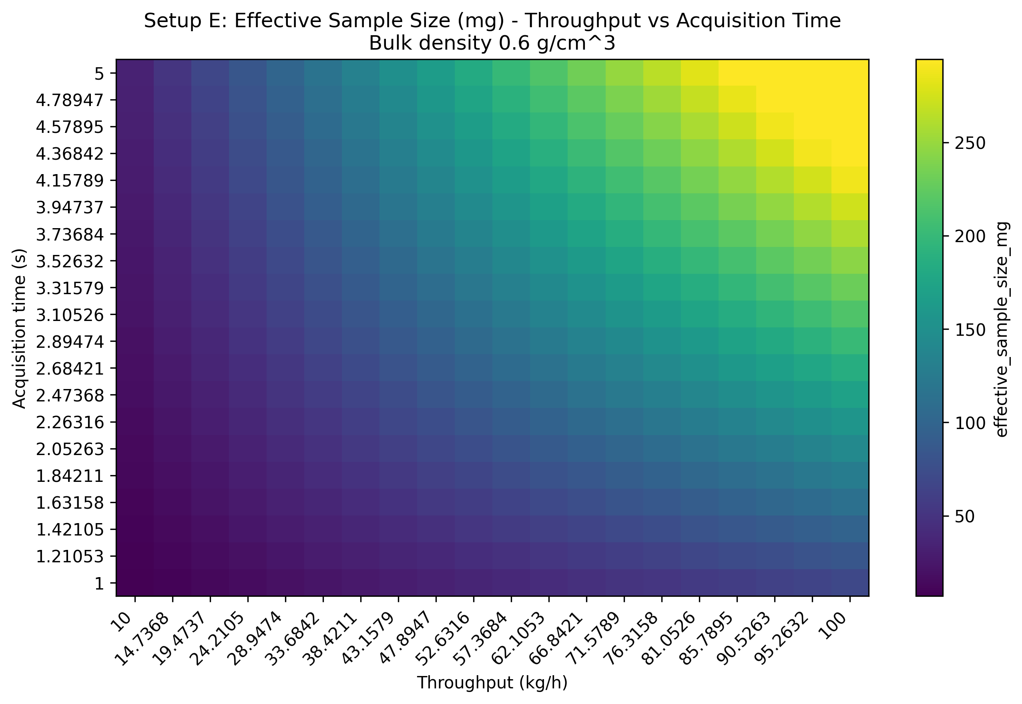
Figure 7. Throughput-acquisition heatmap for effective sample size at 0.6 g/cm^3 bulk density (fixed penetration depth: 1.0 mm; fixed NIR spot diameter: 25 mm).
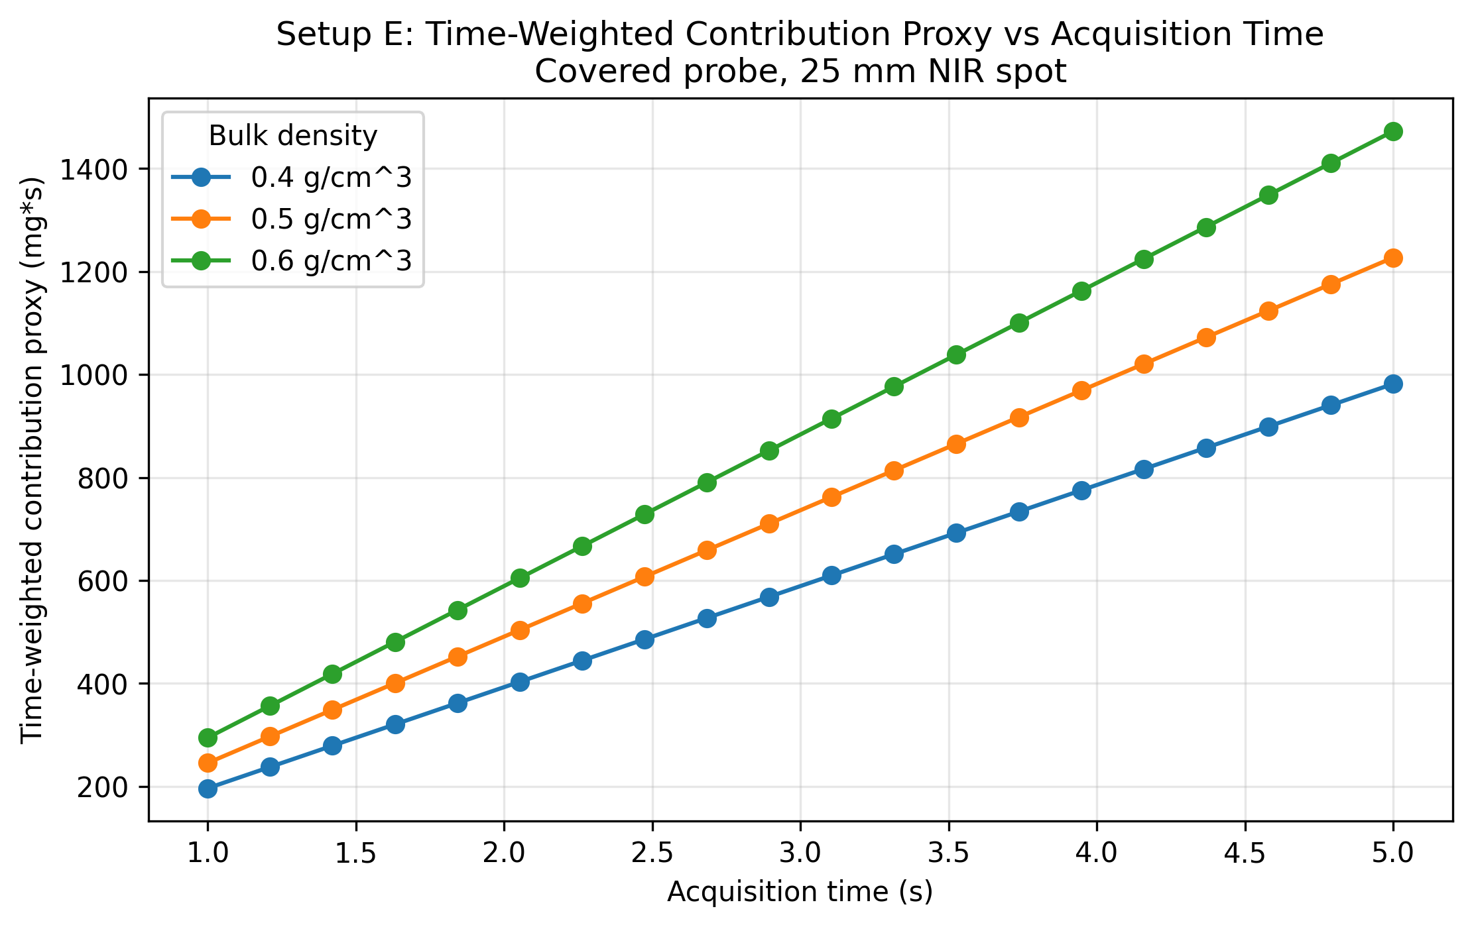
Figure 8. Time-weighted contribution proxy versus acquisition time for bulk densities of 0.4, 0.5, and 0.6 g/cm^3 (fixed throughput: 95 kg/h; fixed penetration depth: 1.0 mm; fixed NIR spot diameter: 25 mm).

Results Interpretation
- the probe is treated as continuously covered by design during normal operation
- increasing penetration depth raises both instantaneous illuminated mass and the effective-sample-size ceiling for all three bulk-density scenarios
- increasing acquisition time raises refresh fraction and effective sample size until transport renewal approaches saturation, but the saturation time shifts with density because the throughput-derived local velocity changes
- lower bulk density increases the local volumetric transport rate at fixed throughput, which raises refresh fraction more quickly but does not automatically maximize every mass-based metric
- the time-weighted contribution proxy continues to rise with acquisition time even after refreshed new mass begins to saturate, because it tracks accumulated exposure rather than only unique replacement
- the 25 mm NIR spot is fixed across all sweeps, so the trends isolate density, depth, time, and throughput effects rather than changes in spot geometry

Practical Implications
- bulk density differences across materials or operating states can materially change the effective sample mass seen by the NIR measurement even when throughput and spot geometry are unchanged
- penetration depth uncertainty still matters directly because it changes the illuminated mass and the resulting effective sampled mass proxy
- acquisition time selection trades off spectral quality against how much unique material is refreshed through the side-window NIR measurement
- a longer acquisition may increase integrated spectral contribution even after the unique refreshed mass per scan is close to saturation
- throughput directly controls powder velocity and therefore refresh rate near the measurement location, but the effect should now be interpreted together with the bulk-density scenario

Limitations
- probe coverage is assumed guaranteed and is not stress-tested against abnormal operating states
- the rotating outlet valve is not modeled dynamically
- the local velocity near the probe is approximated from throughput and full pipe cross-section
- no turbulence, wall-slip, or recirculation model is included
- penetration depth is swept as an effective parameter, not derived from a wavelength-dependent optical model
- bulk density is treated as spatially uniform and fixed within each scenario
- bulk density and optical penetration depth may be correlated in reality, but are treated independently here
- the time-weighted contribution proxy is only a top-hat time-integration approximation, not a full space-time optical weighting model
- no particle-level sampling statistics or optical weighting correction are included

Appendices

Next Logical Extensions
- improved local velocity model near the covered probe
- coupled uncertainty bands for measurement depth and bulk density
- non-uniform optical weighting functions for the 25 mm NIR spot
- wavelength-dependent penetration-depth model
- material-specific calibration of density-dependent sampling behavior
- replace the top-hat time-weighted proxy with a full time- and space-dependent weighting field for spectral contribution
- calibration of the proxy against measured PAT spectra and tracer-style transport experiments

Exported artifacts
CSV files
- results_full.csv
- summary_table.csv
- penetration_depth_table.csv
- acquisition_time_table.csv
- input_summary.csv
Figure files
- plot_01_effective_sample_size_vs_penetration_depth_by_density.png
- plot_02_instantaneous_probed_mass_vs_penetration_depth_by_density.png
- plot_03_effective_sample_size_vs_acquisition_time_by_density.png
- plot_04_refresh_fraction_vs_acquisition_time_by_density.png
- plot_05_heatmap_effective_sample_size_density_04.png
- plot_06_heatmap_effective_sample_size_density_05.png
- plot_07_heatmap_effective_sample_size_density_06.png
- plot_08_time_weighted_contribution_proxy_vs_acquisition_time_by_density.png

