Setup A Effective Sample Size Report

Run Metadata
Setup name: setup_a
Run timestamp: 20260315_213602
Notebook filename: setup_A_static_effective_sample_size.ipynb
Run directory: C:\Users\Erik\Documents\Projects\EFS\reports\setup_a\20260315_213602

Notebook Narrative

Setup A - Effective Sample Size for Static NIR Reflectance Measurement
Static powder bed, circular probe window, deterministic first-generation model

Background
Setup A represents a static powder bed measured with a contact or near-contact diffuse reflectance NIR probe. In this configuration, powder motion is neglected during acquisition, so the optical interaction zone can be approximated from probe geometry and effective penetration depth.
Effective sample size matters because it links measured spectral response to how much material actually contributes to the signal. This directly influences interpretation, robustness, and representativity.
A static powder bed is conceptually the simplest setup because dynamic transport and re-sampling effects are absent in the first approximation. The remaining challenge is optical interaction geometry.
It is important to distinguish the geometric interaction volume from the true optical sensitivity distribution. Real diffuse reflectance sampling is non-uniform with depth and lateral position. This notebook starts with a cylindrical approximation to provide a clear first-order model for sensitivity analysis and order-of-magnitude understanding.

Objective
Simulate sampled volume and sampled mass for a 5 mm circular probe as a function of effective penetration depth from 0.1 mm to 2.0 mm, and examine the influence of powder bulk density.

Theory
For a circular probe window:
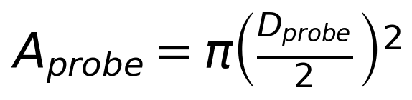
First-generation sampled volume approximation:
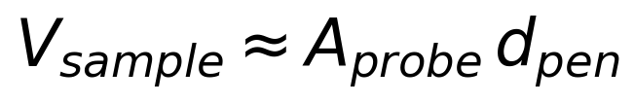
Sampled mass approximation:
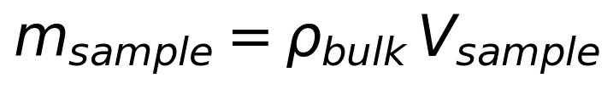
Symbols and units:
- D_probe: probe window diameter [m]
- A_probe: probe area [m^2]
- d_pen: effective penetration depth [m]
- rho_bulk: bulk density [kg/m^3]
- V_sample: sampled volume [m^3]
- m_sample: sampled mass [kg]
This is a first-generation geometric approximation. The true optical sensitivity distribution is not perfectly cylindrical.

Assumptions
- static powder bed
- uniform bulk density
- circular probe window
- uniform effective penetration depth
- cylindrical optical interaction volume approximation
- no particle motion during acquisition
- no resampling
- no detailed radiative transfer model yet

Input Parameters
Baseline and sweep configuration:
- baseline probe diameter: 5.0 mm
- penetration depth range: 0.1 mm to 2.0 mm (inclusive), step 0.1 mm
- Setup A bulk densities (discrete scenarios): 0.40, 0.50, 0.60 g/cm^3
Setup A examines only these three representative bulk-density cases for moderately light to moderately dense pharmaceutical powder beds/blends. The intent is scenario comparison, not continuous interpolation.
Internal calculations use SI units.

Interpretation of the Simulation Table
Each row corresponds to one penetration depth and one bulk-density scenario for static Setup A. Effective sample size is treated as sampled mass from a static illuminated volume and computed as:
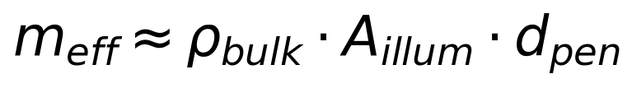
where the illuminated area is fixed by probe geometry and penetration depth is swept from 0.1 to 2.0 mm.

Plot 1: Sampled Volume vs Penetration Depth
This plot shows the geometric sampled volume as a function of penetration depth. In this model, sampled volume does not depend on bulk density.

Plot 2: Effective Sample Size vs Light Penetration Depth
Setup A assumes a static powder bed. Effective sample size is approximated as bulk density x illuminated area x penetration depth, so the plotted quantity is the estimated sampled mass contributing to the reflectance measurement. Penetration depth is varied from 0.1 to 2.0 mm to examine sensitivity to optical sampling depth, and three bulk-density scenarios (0.4, 0.5, 0.6 g/cm^3) represent lighter to denser powder beds.

Results Interpretation
- effective sample size (sampled mass) scales linearly with penetration depth when illuminated area is fixed
- effective sample size increases with bulk density at any fixed penetration depth
- three density curves (0.40, 0.50, 0.60 g/cm^3) provide discrete scenario comparison for static Setup A
- this remains a geometric first approximation rather than a full optical transport model

Practical Implications
- uncertainty in penetration depth strongly affects estimated effective sample size
- bulk density matters when converting interaction volume to sampled mass
- this framework is useful for comparing powders and probe setups

Limitations
- true photon sampling distribution is non-uniform
- penetration depth is an effective parameter, not a sharp boundary
- bulk density may vary with compaction and handling
- particle-level sampling statistics are not yet included
- no correction factor for optical weighting yet

Next logical extensions
- interaction volume correction factor
- particle count estimation
- sensitivity analysis for probe diameter
- uncertainty bands for penetration depth
- non-uniform optical weighting functions

Export and Reporting
This export section writes timestamped CSV, PNG, JSON, and Word outputs into the setup-specific reports/ folder. python-docx and nbformat are required for Word export with Markdown rendering.

Purpose
Setup A estimates static optical sampling mass for a fixed circular probe over a penetration-depth sweep and compares three representative bulk-density scenarios.

Assumptions
Static powder bed, fixed illuminated area from probe geometry, uniform bulk density within each scenario, and a single effective penetration depth used as a first-order optical volume approximation.

Parameter Summary
- Probe diameter (mm): 5
- Penetration depth range (mm): 0.1 to 2.0
- Penetration depth step (mm): 0.1
- Bulk densities (g/cm^3): 0.4, 0.5, 0.6

Exported CSV Files
- results_full.csv
- summary_table.csv
- input_summary.csv
Detailed tables are saved separately as CSV files in the run folder.

Figures
- plot_01_sampled_volume_vs_penetration_depth.png
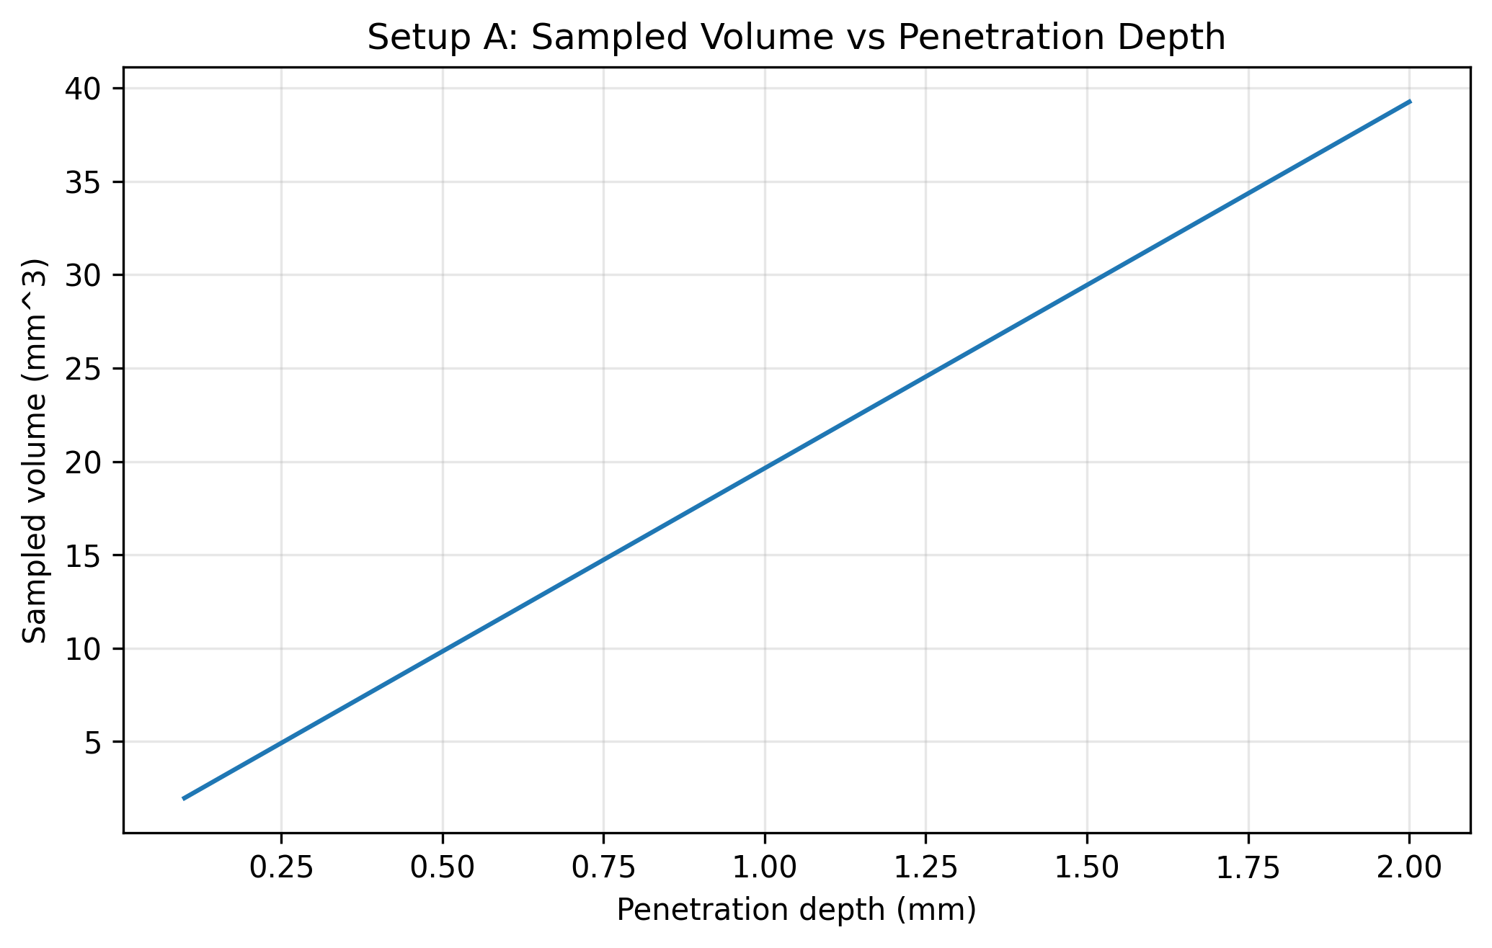
- plot_02_effective_sample_size_vs_penetration_depth.png
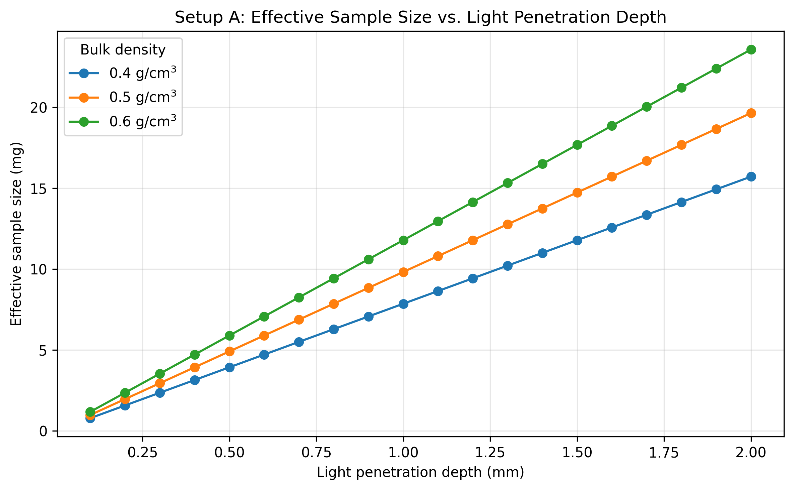

Closing Note
This report captures the notebook narrative, summary metadata, and exported artifacts for this run.

