Setup B Effective Sample Size Report

Run Metadata
Setup name: setup_b
Run timestamp: 20260315_214727
Notebook filename: setup_B_spoon_effective_sample_size.ipynb
Run directory: C:\Users\Erik\Documents\Projects\EFS\reports\setup_b\20260315_214727

Notebook Narrative

Setup B -- Effective Sample Size for Spoon-Based NIR Measurement
Independent spoon samples measured as repeated static optical measurements during one spectral acquisition

Background
Setup B represents a spoon or flip-sampler interface where powder originates from a flowing process stream, is captured in a spoon, and is measured by the NIR probe while static during each spoon presentation.
The upstream process is dynamic, but each optical event is treated as a static-bed measurement during the spoon exposure. During one reported spectrum, multiple spoon presentations may occur. Under the assumptions used here, effective sample size is governed by optical interaction mass per spoon, total acquisition time, and spoon flipping frequency. It is not directly governed by upstream throughput in this first deterministic model.

Objective
This notebook simulates Setup B effective sample size by quantifying:
- static optical sampled mass per spoon
- number of spoon samples contributing during one spectrum
- effective sampled mass per spectrum
as functions of penetration depth, bulk density, flip frequency, and acquisition settings.

Theory
For one spoon presentation (static measurement):
A_probe = pi\(\fracD_probe2\)^2
V_static \ approx A_probe\ d_pen
m_static = rho_bulk\ V_static
Acquisition timing:
t_acq = N_subscans\ t_int
t_spoon = \frac1f_flip
N_spoons = t_acq\ f_flip
Effective sampled mass during one reported spectrum:
m_eff = m_static\ N_spoons
Symbol definitions and units:
- D_probe: probe diameter [m]
- A_probe: probe area [m^2]
- d_pen: effective penetration depth [m]
- rho_bulk: bulk density [kg/m^3]
- V_static: static sampled volume per spoon [m^3]
- m_static: static sampled mass per spoon [kg]
- N_subscans: number of averaged sub-scans [-]
- t_int: integration time per sub-scan [s]
- t_acq: total acquisition time [s]
- f_flip: spoon flipping frequency [Hz]
- t_spoon: spoon interval [s]
- N_spoons: spoon samples contributing during one acquisition [-]
- m_eff: effective sampled mass per spectrum [kg]

Interpretation of the Model
In this setup, one spoon presentation is one independent static optical sample. If acquisition time spans multiple spoon presentations, the reported spectrum integrates multiple independent increments.
In this notebook, N_spoons is allowed to be non-integer as a deterministic first approximation for effective mass scaling. Under the stated assumptions, throughput is not explicitly modeled.

Assumptions
- spoon always completely filled
- filling is reproducible
- consecutive spoons are independent
- powder is static during each spoon measurement
- circular probe window
- cylindrical optical interaction volume approximation
- uniform bulk density
- no resampling within a spoon
- no segregation correction
- no stochastic independence correction
- no detailed radiative transfer model yet

Input Parameters
Baseline optical, acquisition, and spoon-frequency settings are defined below. SI units are used internally, while engineering units are kept in labels and summary tables for readability.

Interpretation of Simulation Table
Each row represents one parameter combination of penetration depth, bulk density, and time between spoon flips.
- staticsampledmass_mg is the per-spoon static optical sampled mass.
- spoons_contributing is the deterministic estimate of spoon presentations during one spectrum.
- effectivesampledmass_mg is the scaled effective sampled mass per spectrum under independent spoon assumptions.

Plot 1: Static Sampled Volume per Spoon vs Penetration Depth
This plot shows static sampled volume per spoon as a function of penetration depth for the cylindrical first-generation optical approximation.

Plot 2: Static Sample Mass per Spoon (Representative Depth)
This plot shows static sample mass per spoon (mg) for bulk densities 0.4, 0.5, and 0.6 g/cm^3, using the Setup B spoon geometry at a representative penetration depth of 1.0 mm.

Plot 3: Spoons Contributing per Spectrum vs Spoon Flip Interval
This plot shows how the number of spoon presentations contributing to one spectrum changes with time between spoon flips.

Results Interpretation
- Plot 2 shows static sample mass per spoon for three representative bulk densities: 0.4, 0.5, and 0.6 g/cm^3
- Plot 4 uses only representative bulk density 0.5 g/cm^3
- Plot 4 x-axis is time between spoon flips (s), not flip frequency (Hz)
- shorter spoon intervals produce more independent spoon presentations during acquisition, increasing effective sample size

Limitations
- independence between spoons is assumed
- complete and reproducible filling is assumed
- no explicit throughput effect is included
- no dynamic filling physics is modeled
- no partial spoon overlap model is included
- no integer/discrete spoon capture model is enforced
- no optical weighting correction yet

Next logical extensions
- enforce integer spoon counting or partial spoon weighting
- include incomplete filling scenarios
- include non-independent spoons
- include spoon geometry explicitly
- include particle count estimation
- include uncertainty in penetration depth and bulk density

Export and Reporting
This export section writes timestamped CSV, PNG, JSON, and Word outputs into the setup-specific reports/ folder. python-docx and nbformat are required for Word export with Markdown rendering.

Purpose
Setup B estimates effective sampled mass per spectrum by combining static optical mass per spoon with the deterministic number of spoon presentations during one spectral acquisition.

Assumptions
Each spoon presentation is treated as an independent static optical event, spoon filling is reproducible, and effective sample size scales with flip frequency over the acquisition window.

Parameter Summary
- Probe diameter (mm): 5
- Penetration depth range (mm): 0.1 to 2.0
- Penetration depth step (mm): 0.1
- Bulk densities (g/cm^3): 0.4, 0.5, 0.6
- Subscans: 256
- Integration time (ms): 15
- Acquisition time (s): 3.84
- Spoon intervals (s): 1, 2, 3, 4, 5

Exported CSV Files
- results_full.csv
- summary_table.csv
- input_summary.csv
- flip_summary.csv
- plot2_static_sample_mass_table.csv
- plot4_spoon_interval_effect_table.csv
- selected_depths_interval_table.csv
Detailed tables are saved separately as CSV files in the run folder.

Figures
- plot_01_static_sampled_volume_per_spoon.png
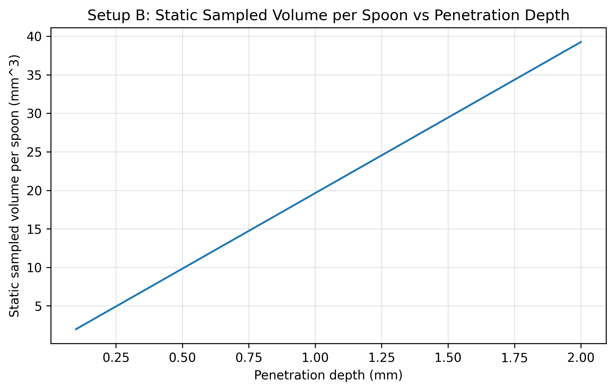
- plot_02_static_sample_mass_per_spoon.png
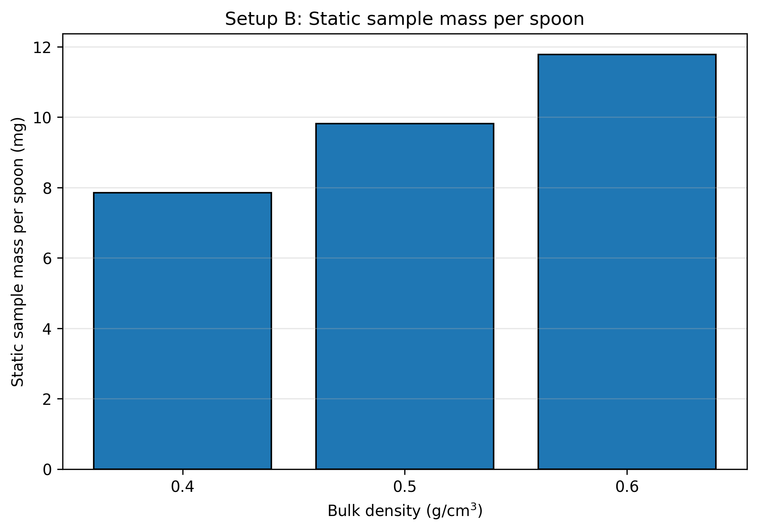
- plot_03_spoons_contributing_vs_interval.png
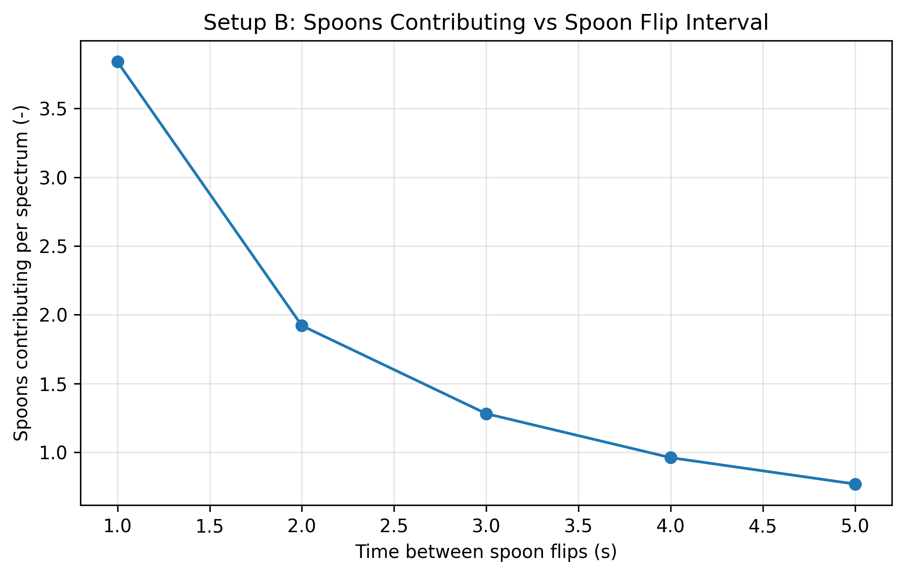
- plot_04_effective_sample_size_vs_flip_interval.png
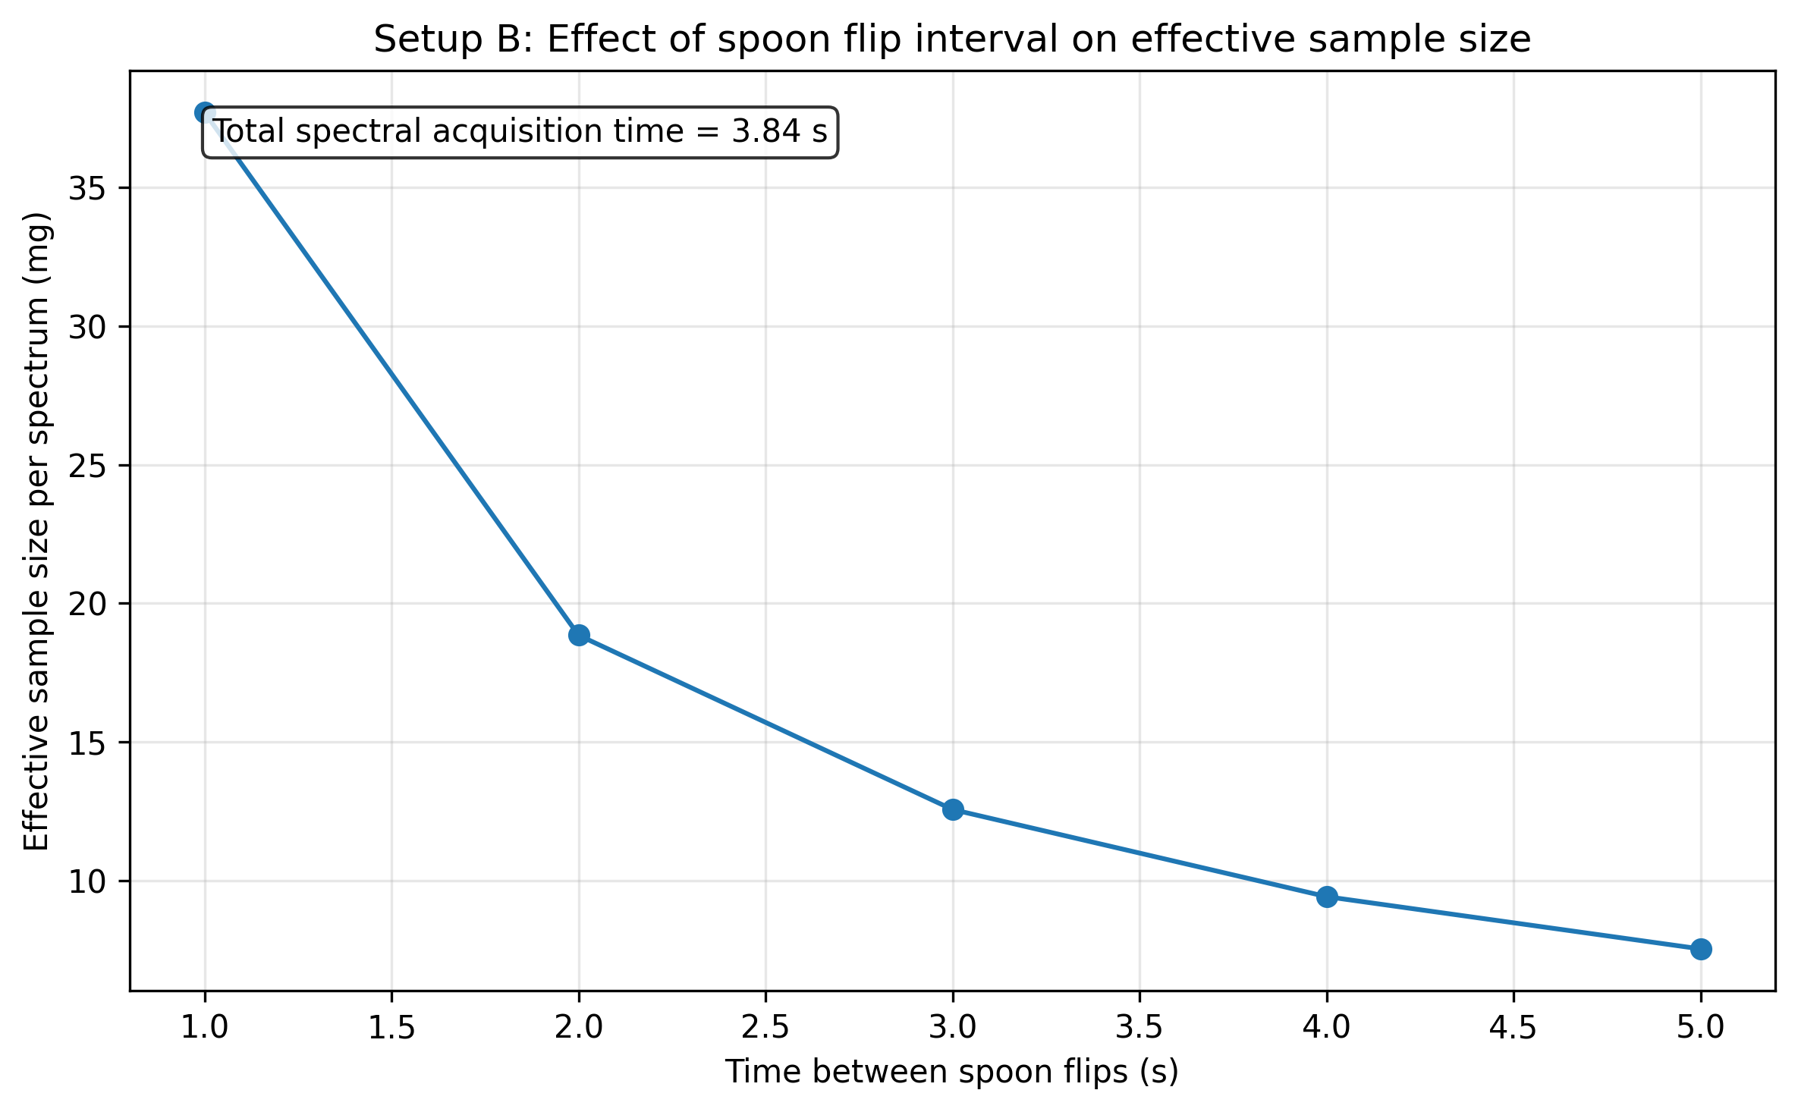
- plot_05_effective_mass_vs_flip_interval_selected_depths.png
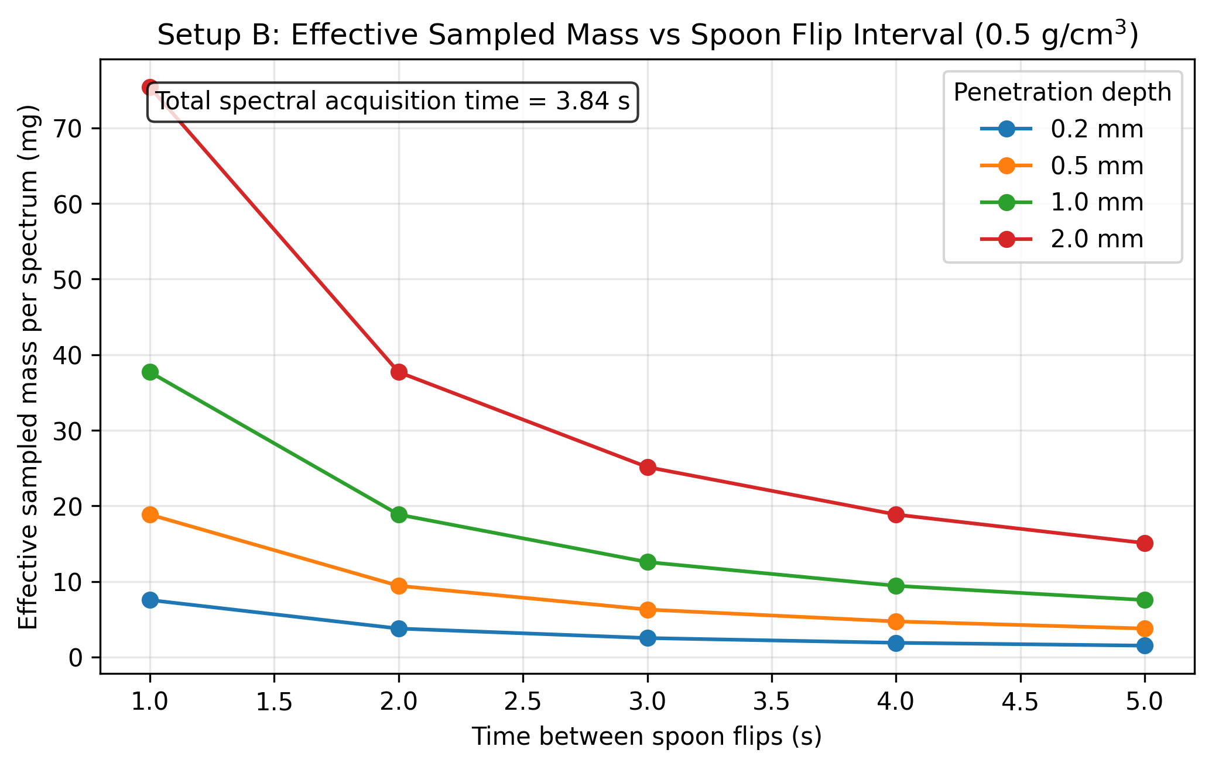

Closing Note
This report captures the notebook narrative, summary metadata, and exported artifacts for this run.

