Setup C Effective Sample Size Report

Run Metadata
Setup name: setup_c
Run timestamp: 20260315_213339
Notebook filename: setup_C_spiderwheel_effective_sample_size.ipynb
Run directory: C:\Users\Erik\Documents\Projects\EFS\reports\setup_c\20260315_213339

Notebook Narrative

Setup C: spiderwheel effective sample size proxy
This notebook estimates a first-order refreshed optical mass proxy for a spiderwheel-driven NIR diffuse reflectance powder interface. It is intended as a presentation-ready engineering notebook, not a radiative-transfer model or a Gy sampling-theory model.

Scientific background
NIR diffuse reflectance probes interrogate a shallow powder layer in front of the optical window. In practical engineering studies, the optical interaction region is often approximated with a simple geometry so that motion, density, and penetration depth can be compared without a full photon-transport model.
Mechanical renewal matters because one spectrum is acquired over a finite time window. If fresh powder is repeatedly moved through the probe field during that interval, the measurement can represent a larger gross refreshed optical mass than a static bed. Setup C differs from a static powder bed and from a simple through-flow interface because a rotating spiderwheel actively sweeps powder through the local probe region. The same geometry can also periodically block the optical window when a finger passes the probe.

Setup C device description
The device is modeled as a 4-legged spiderwheel centered in a powder stream. The NIR probe sits at the true 1 o'clock position relative to the wheel center, with a fixed probe window diameter of 5 mm. The fingers move powder through the field of view, but when a finger overlaps the probe region the window is treated as fully blocked. This notebook uses a first-order mechanistic approximation based on the wheel geometry conventions used in spiderwheel.ipynb.

Model assumptions
- Optical sampling volume is approximated as a cylinder.
- Optical mass per refresh equals probe footprint area times penetration depth times bulk density.
- Powder renewal is approximated from tangential wheel motion at the probe radius.
- Wheel fingers block the probe during overlap intervals.
- Blocked time is subtracted from total acquisition time.
- Bulk density is constant and spatially uniform.
- Powder re-presentation and recirculation are ignored.
- Binary blocking is assumed rather than partial attenuation.
- Output is a refresh-based effective sample size proxy, not a validated independent sample mass.

Mathematical model
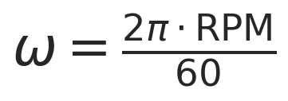
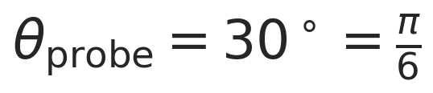
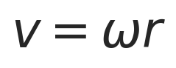
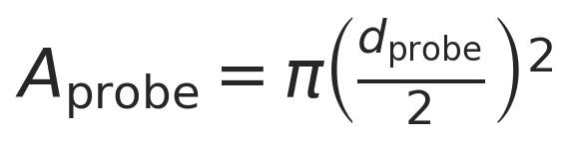
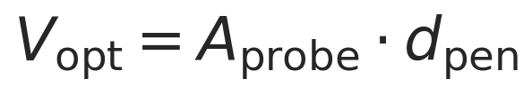
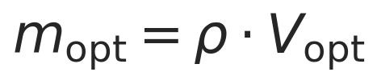
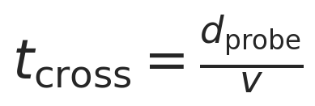

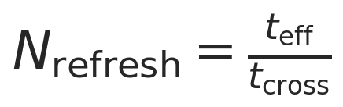

Blocked time is estimated from a combined angular overlap of finger width and probe width at the probe radius. The result is best interpreted as a gross refreshed optical mass proxy during one spectrum.

Imports

User-defined parameters

Helper functions

Single-case worked example

Parameter sweep across density, RPM, and penetration depth

Results tables

Visualization
The blocking model assumes full blocking when a finger overlaps the probe region; it does not model partial attenuation.

Interpretation of trends
Increasing density increases mass linearly. Increasing penetration depth increases optical mass per refresh linearly in this simplified model. Increasing RPM decreases crossing time and tends to increase refresh count, while blocking reduces effective acquisition time and partially offsets that gain. The output is a refreshed optical mass proxy, not necessarily an independent sampling mass.

Model limitations
- Cylindrical optical volume is only an approximation.
- No radiative transfer or photon weighting with depth.
- No powder recirculation or revisit probability.
- No correction for repeated presentation of the same powder.
- Binary blocking rather than partial attenuation.
- Constant bulk density assumption.
- No particle size or particle count model.
- Not linked directly to analytical variance or Gy sampling theory.

Conclusions
The notebook estimates a first-order refreshed optical mass proxy for Setup C. Density, penetration depth, RPM, probe size, and blocking geometry strongly influence the result. This is useful for sensitivity analysis and engineering intuition, while future improvements could include phase-resolved blocking, revisit probability, partial blocking, and more realistic optical weighting.

Export and Reporting
This export section writes timestamped CSV, PNG, JSON, and Word outputs into the setup-specific reports/ folder. python-docx and nbformat are required for Word export with Markdown rendering.

Purpose
Setup C estimates a refreshed optical mass proxy for a spiderwheel presentation by combining optical mass per refresh with a refresh count derived from wheel speed and blocked acquisition time.

Assumptions
Uniform bulk density, full blocking simplification for wheel fingers, cylindrical optical sampling volume, and deterministic refresh counting without revisit or partial-blocking corrections.

Parameter Summary
- Finger count: 4
- Wheel radius (cm): 3
- Probe radius (cm): 1.8
- Finger width (cm): 0.3
- Probe diameter (mm): 5
- Acquisition time (s): 1
- Density scenarios (g/cm^3): 0.4, 0.5, 0.6
- RPM range: 10 to 35
- Penetration depth range (mm): 0.1 to 2.0

Exported CSV Files
- results_full.csv
- summary_table.csv
- blocking_summary.csv
Detailed tables are saved separately as CSV files in the run folder.

Figures
- plot_01_proxy_vs_penetration_depth.png
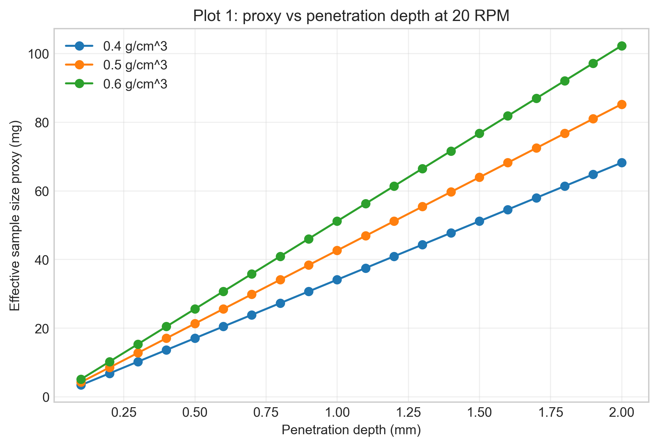
- plot_02_proxy_vs_rpm.png
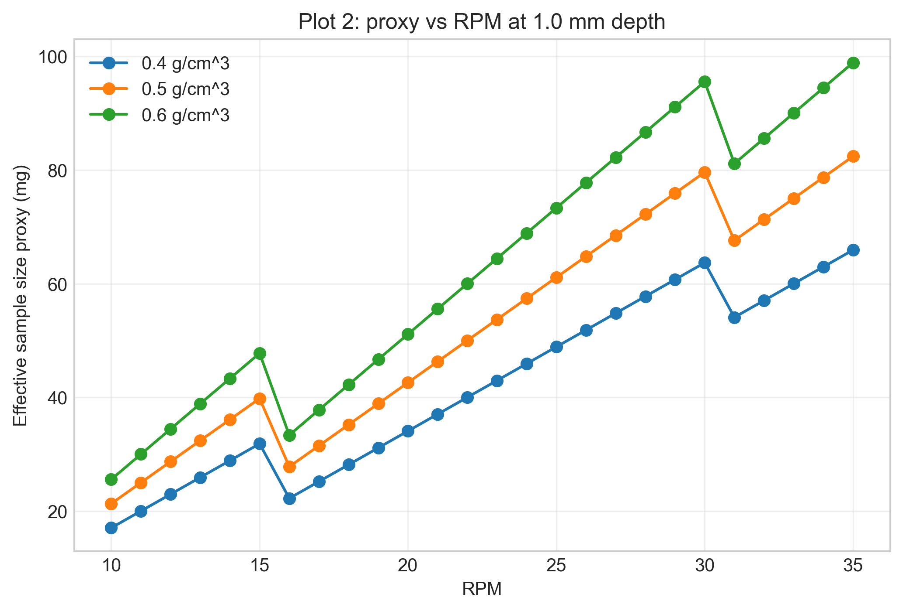
- plot_03_heatmap_density_05.png
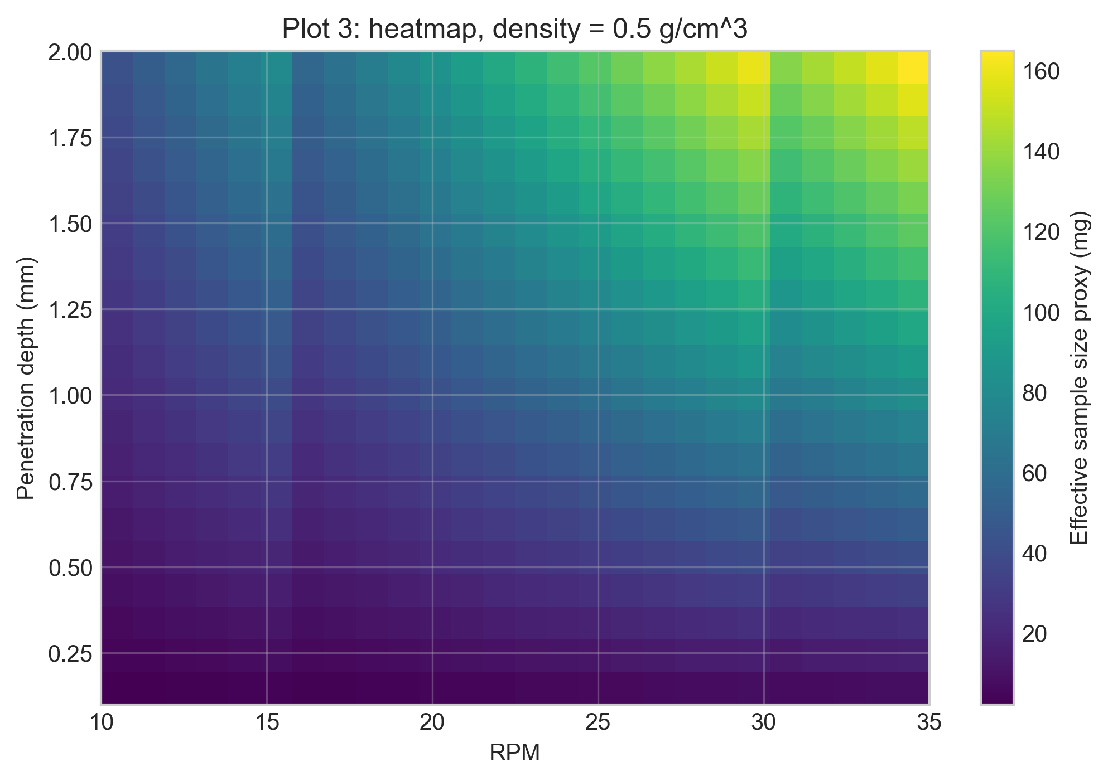
- plot_04_blocked_time_fraction_vs_rpm.png
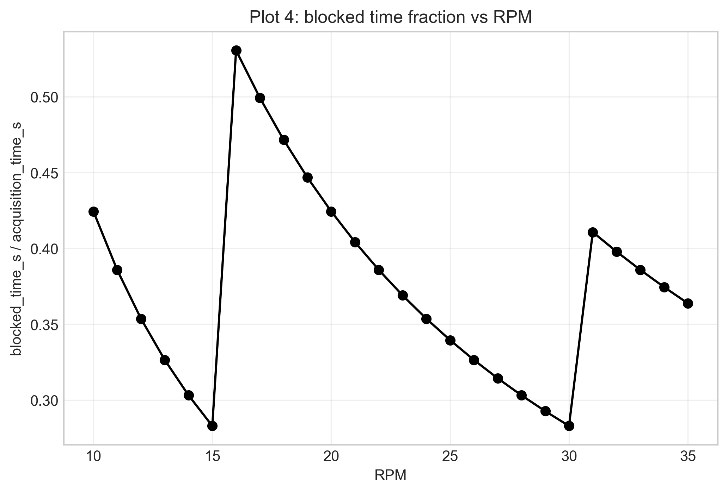
- plot_05_optical_mass_per_refresh.png
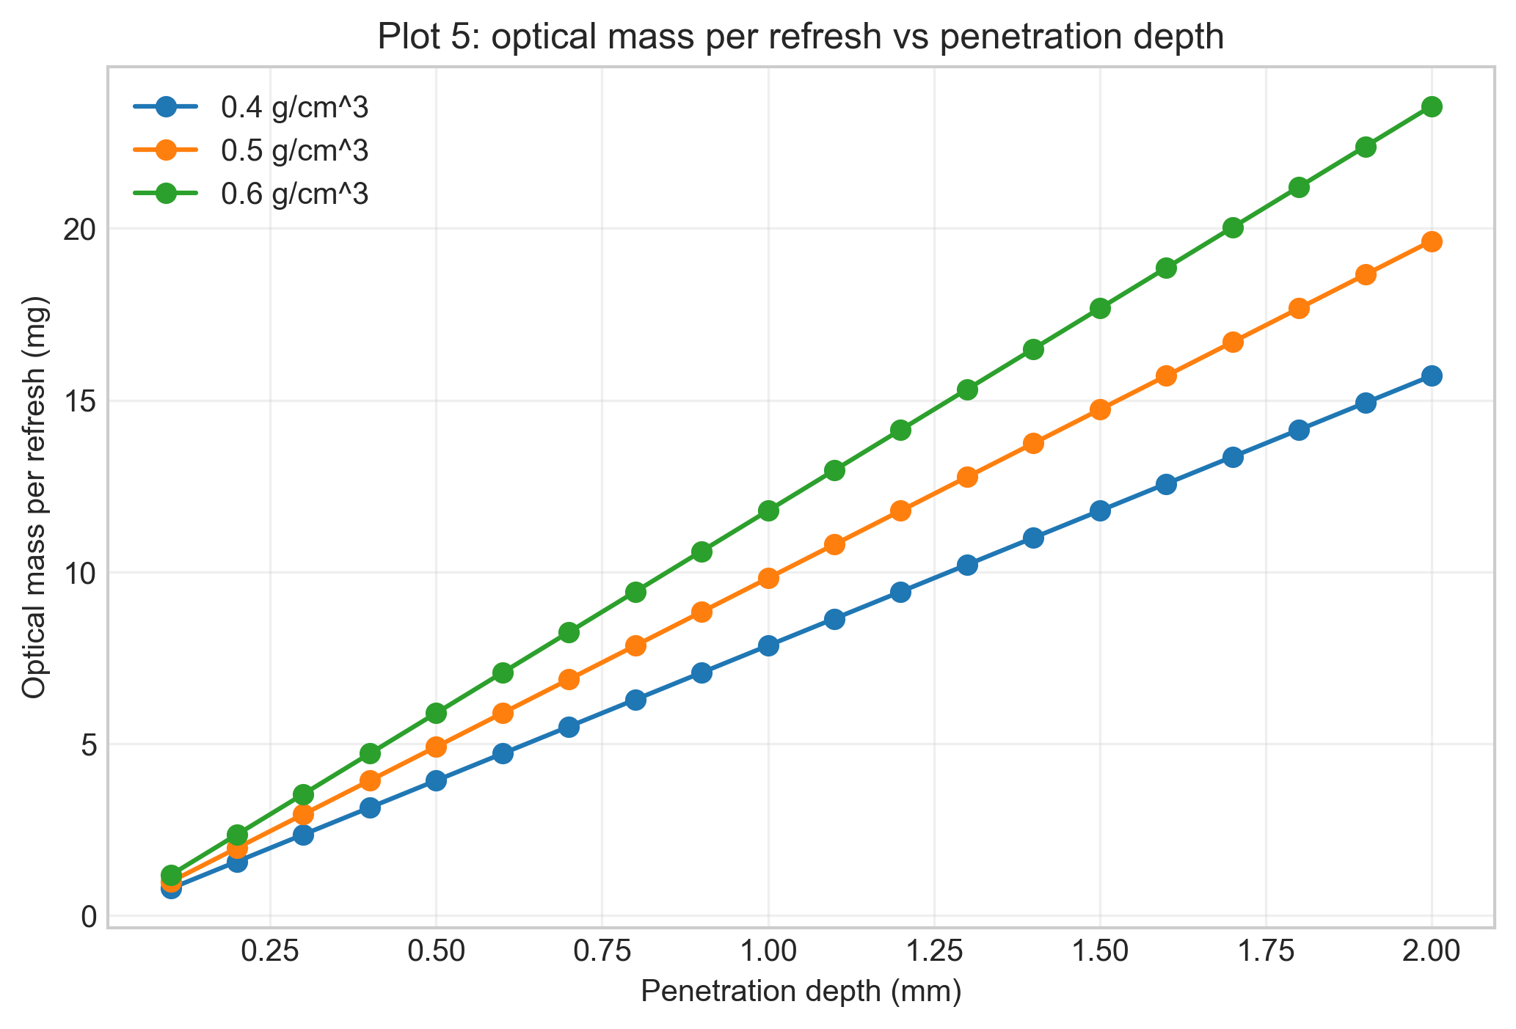
- plot_06_contour_density_06.png
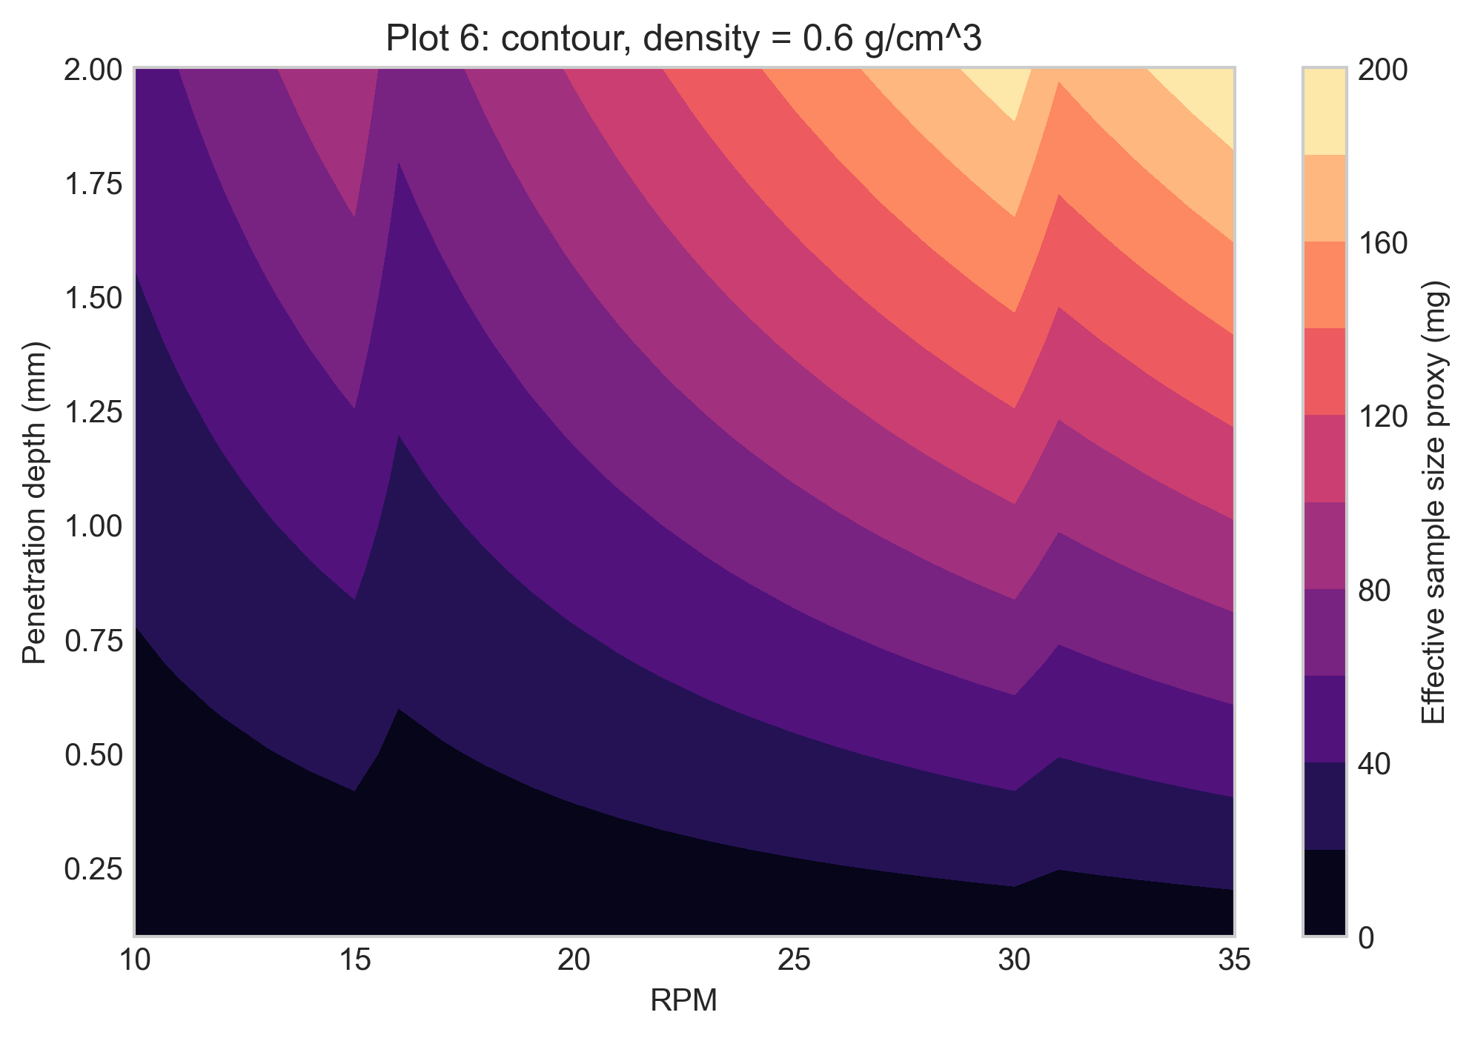

Closing Note
This report captures the notebook narrative, summary metadata, and exported artifacts for this run.

