Setup D Effective Sample Size Proxy Report

Run Metadata
Setup name: setup_d
Run timestamp: 20260326_213412
Notebook filename: setup_D_pipe_effective_sample_size.ipynb
Run directory: C:\Users\Erik\Documents\Projects\EFS\reports\setup_d\20260326_213412

Notebook Narrative

Setup D: inclined pipe effective sample size proxy

1. Title and purpose
This simulation develops a first-order mechanistic proxy model for Setup D, an inclined powder pipe with an NIR diffuse reflectance probe mounted in the lower part of the pipe. The objective is to estimate an effective sample size proxy during one spectrum acquisition.
The reported quantity is a refresh-based proxy effective mass, denoted meff,proxy. It assumes renewal of powder in front of the probe over a characteristic axial length of order dprobe. It is not the exact geometric union of all material contributing photons, and it is intended for comparative engineering analysis rather than as a validated independent sample mass.

2. Scientific background

NIR diffuse reflectance analysis of powders
In diffuse reflectance NIR measurements, light enters a powder bed, interacts with particles over a limited depth, and a fraction of the scattered light returns to the detector. The measured spectrum therefore reflects an optically weighted near-surface volume rather than the entire bulk stream.

Why use a simple optical interaction approximation?
For engineering comparisons, it is often useful to approximate the instantaneous optical interaction region with a simple geometric volume. Here, the near-wall optical region at any instant is approximated as a cylinder with:
- cross-sectional area equal to the probe window footprint
- depth equal to an assumed light penetration depth
This simplification ignores depth-dependent photon weighting, scattering anisotropy, particle packing effects, and spectral absorption details, but it provides a practical basis for comparative analysis.

Probe-flow geometry: perpendicular viewing
In Setup D, the NIR probe is mounted in the pipe wall and looks radially inward toward the center of the pipe. The powder, meanwhile, flows axially along the length of the pipe. These two directions are perpendicular to each other.
At any instant, the probe sees a shallow optical disc of powder pressed against the wall:
- the disc face is the probe footprint (a circle of diameter d_probe), flush with the inner pipe wall
- the disc depth is the optical penetration depth d_pen, extending radially inward into the flowing powder
Because the probe looks perpendicular to the flow, powder renewal happens by material sliding across the probe window rather than being pushed into it. The flow delivers fresh material laterally past the probe footprint, while the light penetrates in the radial direction.
This perpendicular arrangement means three independent length scales govern the first-order model:
| Direction | Physical meaning | Length scale | |---|---|---| | Axial (along flow) | distance powder travels during acquisition | v * tacq | | Tangential (in the wall plane) | probe footprint width | dprobe | | Radial (into powder) | light penetration depth | d_pen |
Rather than treating the full acquisition as an exact geometric sweep or exact union of sampled material, the model uses a first-order renewal approximation. Powder in front of the probe is assumed to refresh over a characteristic axial length of order d_probe, which leads to a refresh-based proxy for effective sample mass.

Why moving powder increases the proxy effective mass during one acquisition
If powder continuously moves past the probe during one acquisition, the optical interaction zone is repeatedly refreshed. Faster renewal means that more powder can contribute to the measurement over the acquisition period. That does not guarantee statistical independence of all material seen by the instrument, but it increases the proxy effective mass available for comparative engineering analysis.

Why Setup D differs from other geometries
Setup D differs from a static powder bed because the material in front of the probe is continuously replaced. It also differs from a mechanically refreshed geometry such as the spiderwheel because the refresh mechanism is not imposed by discrete compartments or controlled presentation. Instead, it is driven by gravity-assisted powder transport through a tilted pipe.

Why a superficial velocity model is useful
A practical first approximation is to connect throughput, bulk density, and pipe cross-sectional area to a superficial bulk velocity. This gives a simple estimate of how quickly powder is renewed in front of the probe. In reality, the local flow at the lower wall of a tilted pipe may differ substantially from the cross-sectional average, but the superficial velocity remains a useful baseline for sensitivity analysis and engineering intuition.

4. Model assumptions
The base model uses the following assumptions:
- the instantaneous optical sampling region is approximated as a cylinder with volume Aprobe * dpen
- the probe window is fully covered by powder at all times
- powder renewal at the probe is approximated by a first-order renewal approximation with characteristic axial length of order d_probe
- the renewal rate is derived from a bulk superficial velocity computed from throughput, density, and full pipe cross-sectional area
- bulk density is constant and spatially uniform within each scenario
- no explicit blocking events occur
- no recirculation correction is included
- local wall velocity may differ from average superficial velocity, but that difference is ignored in the base model
- the powder at the probe is assumed to be in a dense-phase, gravity-driven sliding regime rather than an aerated or fluidized state
- de-aeration during transit through the pipe is assumed but not explicitly modeled
- velocity profiles across the pipe cross-section are not resolved; the superficial velocity represents a bulk average
- the output is a refresh-based proxy effective mass intended for comparative engineering analysis, not a validated independent sample mass
These assumptions intentionally favor transparency and internal consistency over full optical or granular-flow realism.

5. Mathematical model
Internal units used throughout the simulation are:
- geometry in cm
- area in cm^2
- volume in cm^3
- time in s
- density in g/cm^3
- throughput entered in kg/h and converted internally to g/s
- penetration depth entered in mm and converted internally to cm
- final reported proxy effective sample masses in mg

Geometric directions at the probe
The probe is mounted in the pipe wall, looking radially inward. The powder flows axially past the probe. The model uses three perpendicular directions:
| Direction | Symbol | Physical meaning | |---|---|---| | Axial (along flow) | v * tacq | distance powder travels during acquisition | | Tangential (in the wall plane) | dprobe | probe footprint width | | Radial (into powder) | d_pen | light penetration depth from wall into powder |
At any single instant, the probe sees a shallow optical disc of powder with face area Aprobe and radial depth dpen. Over a finite acquisition, the model does not claim that the sampled material is an exact geometric sweep or an exact union. Instead, it uses a first-order renewal approximation in which the near-wall powder in front of the probe is refreshed over a characteristic axial length of order d_probe.

Pipe and flow quantities
Pipe cross-sectional area:
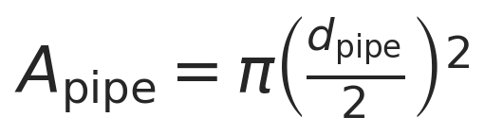
Mass flow conversion:
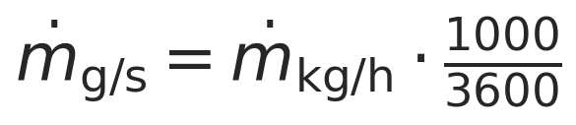
Superficial velocity (axial direction):
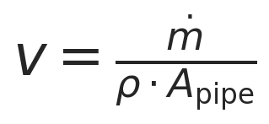
Units: [g/s] / ([g/cm^3] [cm^2]) = [cm/s].
This is the cross-sectional average axial velocity of the powder along the pipe. In this notebook it is used only as a first-order renewal driver.
Worked-example check (dotm = 95 kg/h, rho = 0.4 g/cm^3, d_pipe = 65 mm):
| Step | Value | Unit | |---|---|---| | dotm | 95 x 1000 / 3600 = 26.3889 | g/s | | Apipe | pi (6.5/2)^2 = 33.1831 | cm^2 | | rho Apipe | 0.4 x 33.1831 = 13.2732 | g/cm | | v = dotm / (rho A_pipe) | 26.3889 / 13.2732 = 1.9882 | cm/s |

Instantaneous optical mass
Probe footprint area:
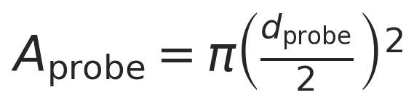
Instantaneous optical mass:

This is the instantaneous optically weighted mass adjacent to the probe under the cylindrical optical-volume approximation.

Refresh factor
The first-order renewal approximation assumes that the powder in front of the probe is refreshed when material advances by a characteristic axial length of order d_probe. The corresponding refresh factor during one acquisition is:
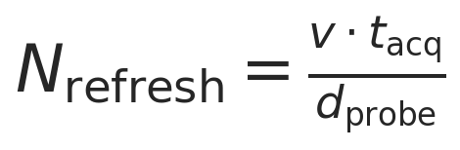
This is a renewal-based proxy, not an exact count of independent packets of powder.

Proxy effective sample mass
The proxy effective sample mass is defined as:

Combining the expressions gives:
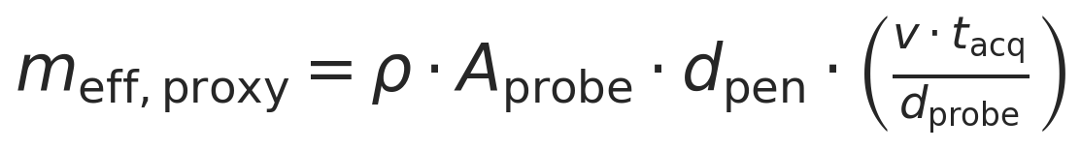
Interpretation of this expression:
- it is a first-order mechanistic proxy model
- it assumes renewal of powder over a characteristic length scale of order d_probe
- it is not the exact geometric union of sampled material
- it is intended for comparative engineering analysis

Convective reference mass-flow proxy
For comparison, the notebook also reports:
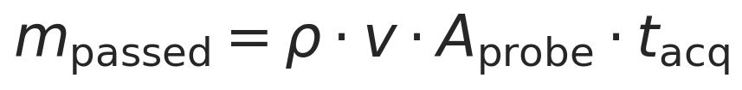
This quantity is retained only as a convective reference mass-flow proxy based on the same superficial-velocity model. It should not be interpreted as a literal exact convected slab or as an exact geometric union of the material seen by the instrument.
Under the same proxy assumptions:
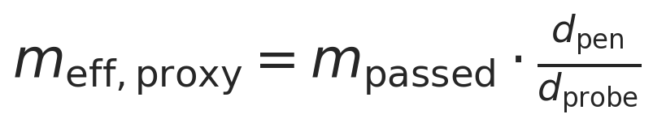
The ratio above is an algebraic consequence of the proxy model, not a statement about exact geometric sampling.

Density cancellation within this model
The superficial velocity relation is:

Substituting into the proxy effective-mass expression gives:

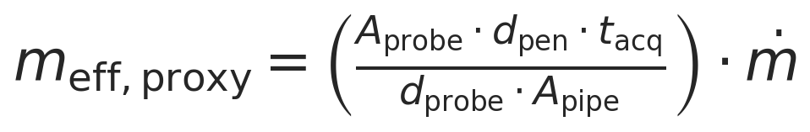
In this model, the density terms cancel exactly. That cancellation is model-dependent: it follows from using the same bulk density in both the instantaneous optical mass and the superficial-velocity approximation.

10. Parameter sweep across throughput, density, and penetration depth
The full sweep spans:
- throughput from 40 to 100 kg/h
- density = 0.4, 0.5, 0.6 g/cm^3
- penetration depth from 0.1 to 2.0 mm in 0.1 mm steps
- probe diameter fixed at 5 mm
- acquisition time fixed at 1.8 s unless changed in the parameter cell

11. Results tables
All reported effective sample size values below are proxy values, i.e. evaluations of m_eff,proxy from the first-order renewal model.

12. Visualization
The plots below report either the effective sample size proxy or supporting quantities from the same first-order renewal model.

13. Interpretation of trends
Several clear trends appear in this first-order proxy model.
- Increasing density increases the instantaneous optical mass linearly because mopt = rho Aprobe d_pen.
- Increasing penetration depth increases the instantaneous optical mass linearly because the modeled optical volume grows linearly with depth.
- Increasing throughput increases the superficial velocity linearly for fixed density and pipe area.
- Increasing superficial velocity increases N_refresh and therefore increases the proxy effective mass during one acquisition.
- The result should be interpreted as a refresh-based proxy effective mass, not as a validated independent sampling mass.

Why density cancels within this model
In this model, density enters in two places that act in opposite directions.
Effect 1: more mass in the instantaneous optical region. A denser powder packs more grams into the same optical cylinder in front of the probe:

Effect 2: lower superficial velocity and fewer refreshes. For fixed mass throughput, a denser powder needs less volumetric flow, so the superficial velocity decreases:

The proxy effective mass combines those two effects:

Substituting v = dotm/(rho * A_pipe) gives:

Within this model, the density terms cancel exactly. That cancellation is model-dependent, not a universal physical law.
Physical interpretation. The notebook treats the probe as an optical footprint with an instantaneous optical mass and a renewal factor. The resulting m_eff,proxy is therefore a first-order mechanistic proxy for comparative engineering analysis. It is useful for ranking scenarios, but it is not an exact geometric union of sampled material and does not prove full statistical independence of the powder contributing to the spectrum.
Why density cancellation is model-dependent. Density would re-enter if any of the following effects were modeled explicitly:
- nonuniform velocity profiles or wall-local velocity corrections
- partial filling or changes in flowing cross-sectional area
- consolidation or compaction near the wall
- repeated presentation of the same powder to the probe
- changes in optical path-length distribution with packing state

14. Model limitations
Important limitations of this simulation are:
- no velocity profile resolution across the pipe cross-section
- no residence-time distribution model
- possible re-sampling of the same powder is not resolved
- no optical path-length distribution or radiative-transfer model
- no explicit wall effects such as slip or compaction corrections
- no segregation effects
- the 26.5 degree tilt is represented only qualitatively in the base model
- no intermittent coverage or slug-flow correction at low throughput
- no direct link to analytical variance or Gy sampling theory
These omissions are consistent with the notebook's role as a concise, first-order engineering proxy model rather than a full particulate-flow or radiative-transfer simulation.

15. Conclusions
This simulation estimates a first-order refresh-based effective sample size proxy for Setup D, expressed as proxy effective mass during one spectrum acquisition.
Within this model, the strongest explicit drivers are:
- throughput, which sets superficial velocity and renewal rate
- penetration depth, which scales the instantaneous optical mass
- probe and pipe geometry, which determine the footprint and characteristic refresh length
The simulation is useful for comparative engineering analysis, quick scenario comparison, and sensitivity assessment during development. A more advanced model could incorporate local lower-wall flow kinematics, nonuniform filling, revisit behavior, optical path-length weighting, and wall-specific flow effects.

Export and Reporting
This export section writes timestamped CSV, PNG, JSON, and Word outputs into the setup-specific reports/ folder. python-docx and nbformat are required for Word export with Markdown rendering.

Glossary of Variables and Symbols
The table below summarizes the variables used in the governing equations.
| Symbol | Name | Definition | Units | |---|---|---|---| | meff,proxy | Effective sample size proxy | Refresh-based proxy effective mass during one acquisition. | g internally; mg reported | | mopt | Instantaneous optical mass | Optical mass associated with the probe footprint and penetration depth at one instant. | g internally; mg reported | | Nrefresh | Refresh factor | Number of characteristic probe-length renewals during one acquisition. | dimensionless | | dotm | Mass throughput | Bulk powder mass flow rate through the pipe. | kg/h input; g/s internally | | rho | Bulk density | Assumed bulk density of the powder in a given scenario. | g/cm^3 | | v | Superficial velocity | Cross-sectional average axial velocity used as the renewal driver. | cm/s | | Aprobe | Probe footprint area | Circular area of the probe window in the wall plane. | cm^2 | | Apipe | Pipe cross-sectional area | Internal cross-sectional area of the pipe. | cm^2 | | dprobe | Probe diameter | Diameter of the circular probe window. | mm input; cm internally | | dpipe | Pipe diameter | Internal diameter of the pipe. | mm input; cm internally | | dpen | Penetration depth | Assumed radial optical penetration depth into the powder. | mm input; cm internally | | t_acq | Acquisition time | Spectrum acquisition time for one measurement. | s |

Purpose
Setup D estimates a first-order refresh-based effective sample size proxy in a tilted pipe by combining instantaneous optical mass with a renewal factor derived from superficial velocity.

Assumptions
The optical region is approximated as a cylinder, renewal is represented by a first-order approximation with characteristic length of order d_probe, and the result is interpreted as a comparative engineering proxy.

Parameter Summary
- Pipe diameter (mm): 65
- Pipe tilt from vertical (deg): 26.5
- Pipe total height (mm): 340
- Inlet-outlet displacement (mm): 100.2
- Probe diameter (mm): 5
- Acquisition time (s): 1.8
- Throughput range (kg/h): 40 to 100
- Density scenarios (g/cm^3): 0.4, 0.5, 0.6
- Penetration depth range (mm): 0.1 to 2.0

Single-case worked example
The worked example uses 95.0 kg/h, 0.4 g/cm^3, a 5.0 mm probe, 1.0 mm penetration depth, and 1.8 s acquisition time.
Computed proxy result: 56.2130 mg. Convective reference mass-flow proxy: 295.8580 mg.

Parameter sweep
Throughput spans 40-100 kg/h, density spans 0.4, 0.5, 0.6 g/cm^3, penetration depth spans 0.1-2.0 mm, and acquisition time is 1.8 s. Generated 780 scenarios.

Visualization
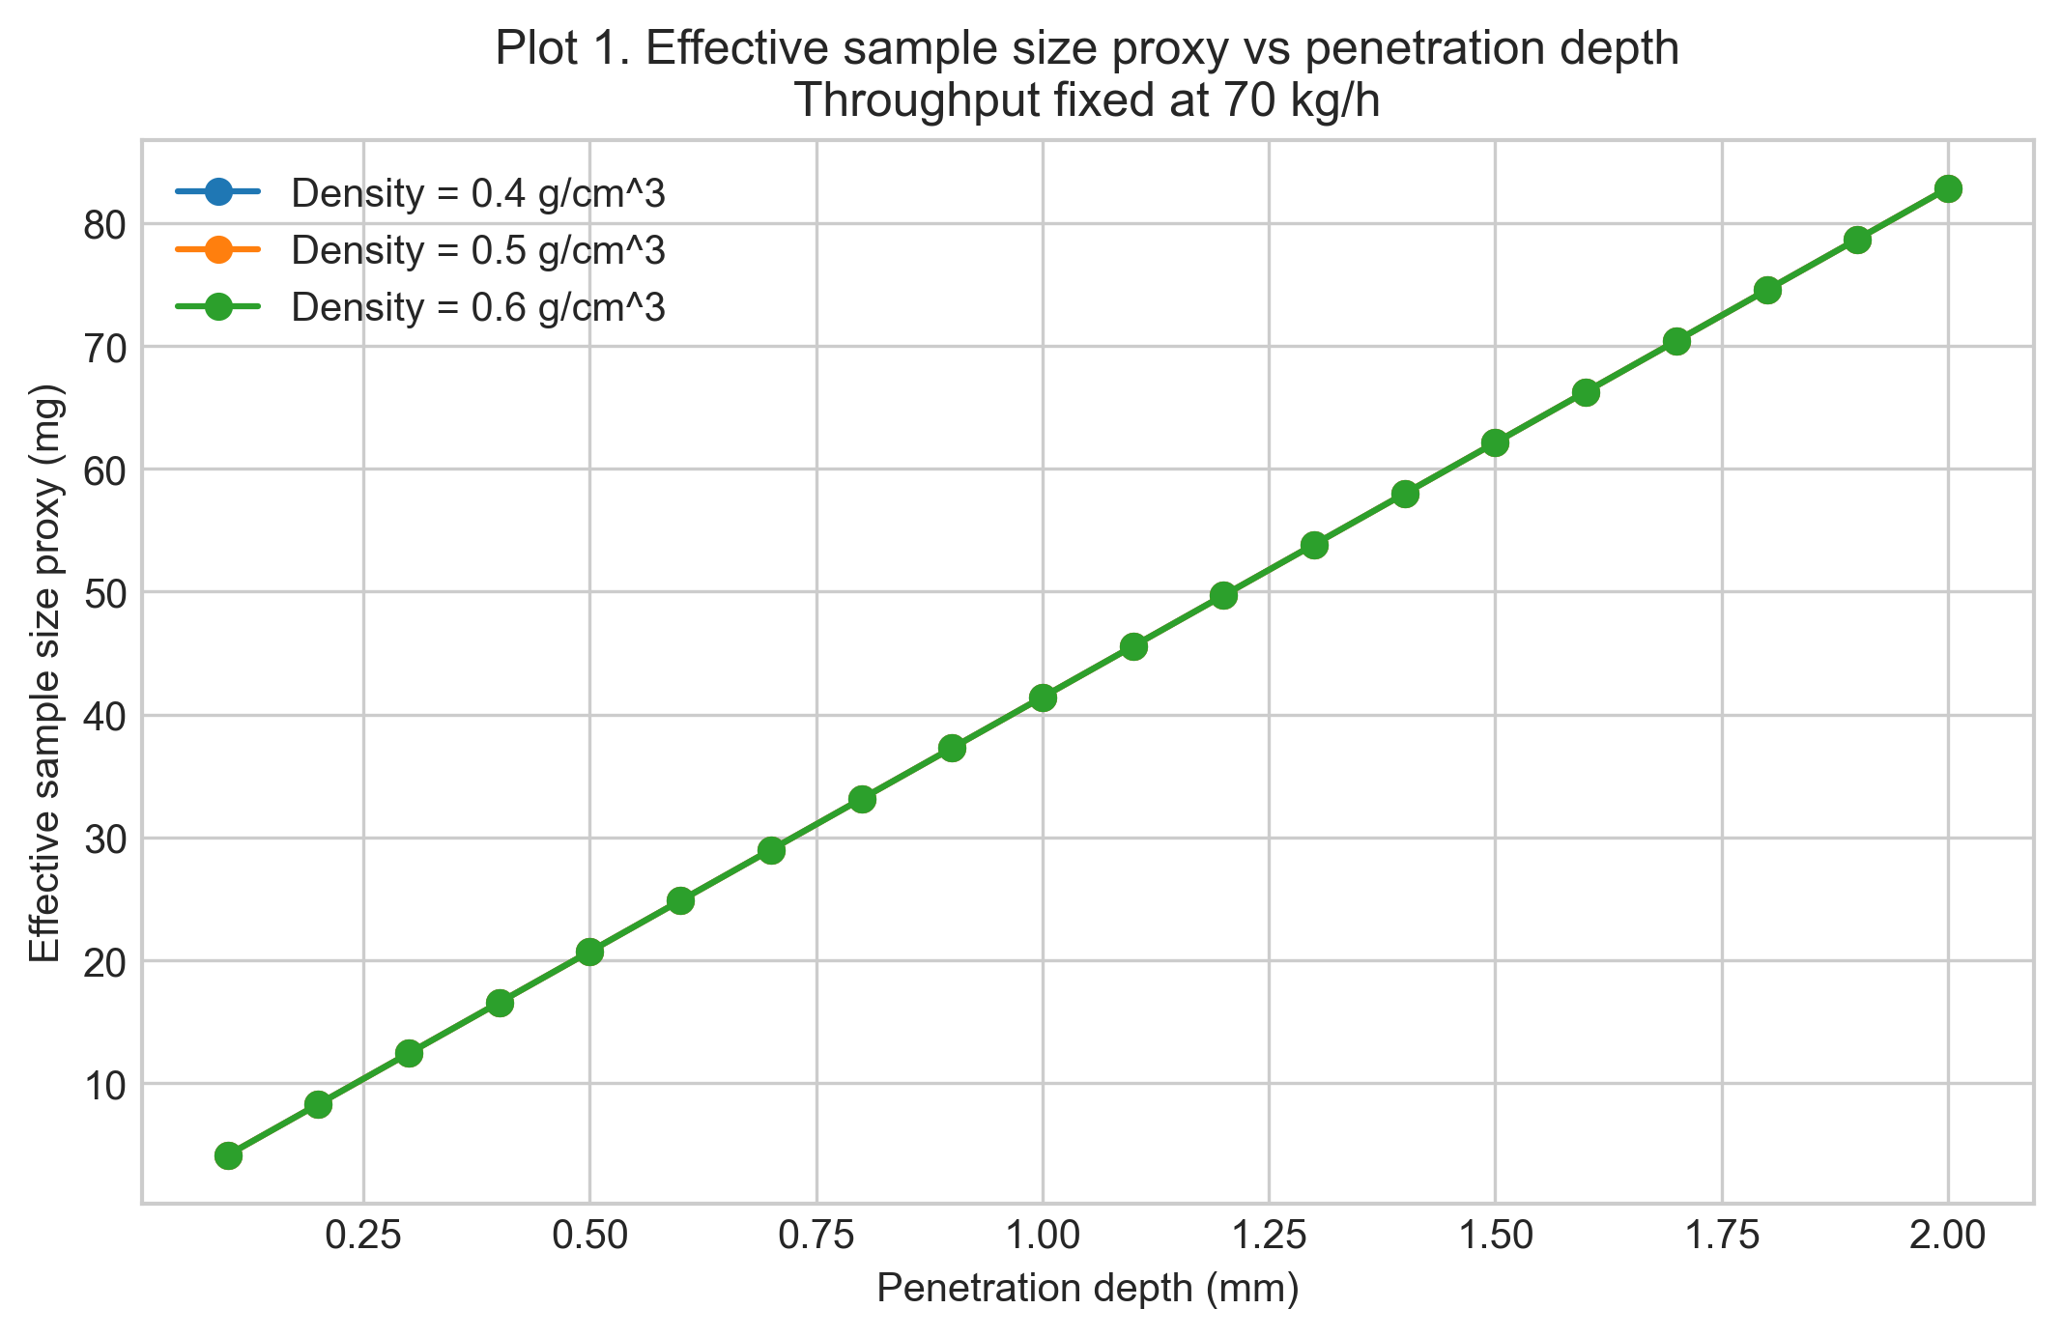
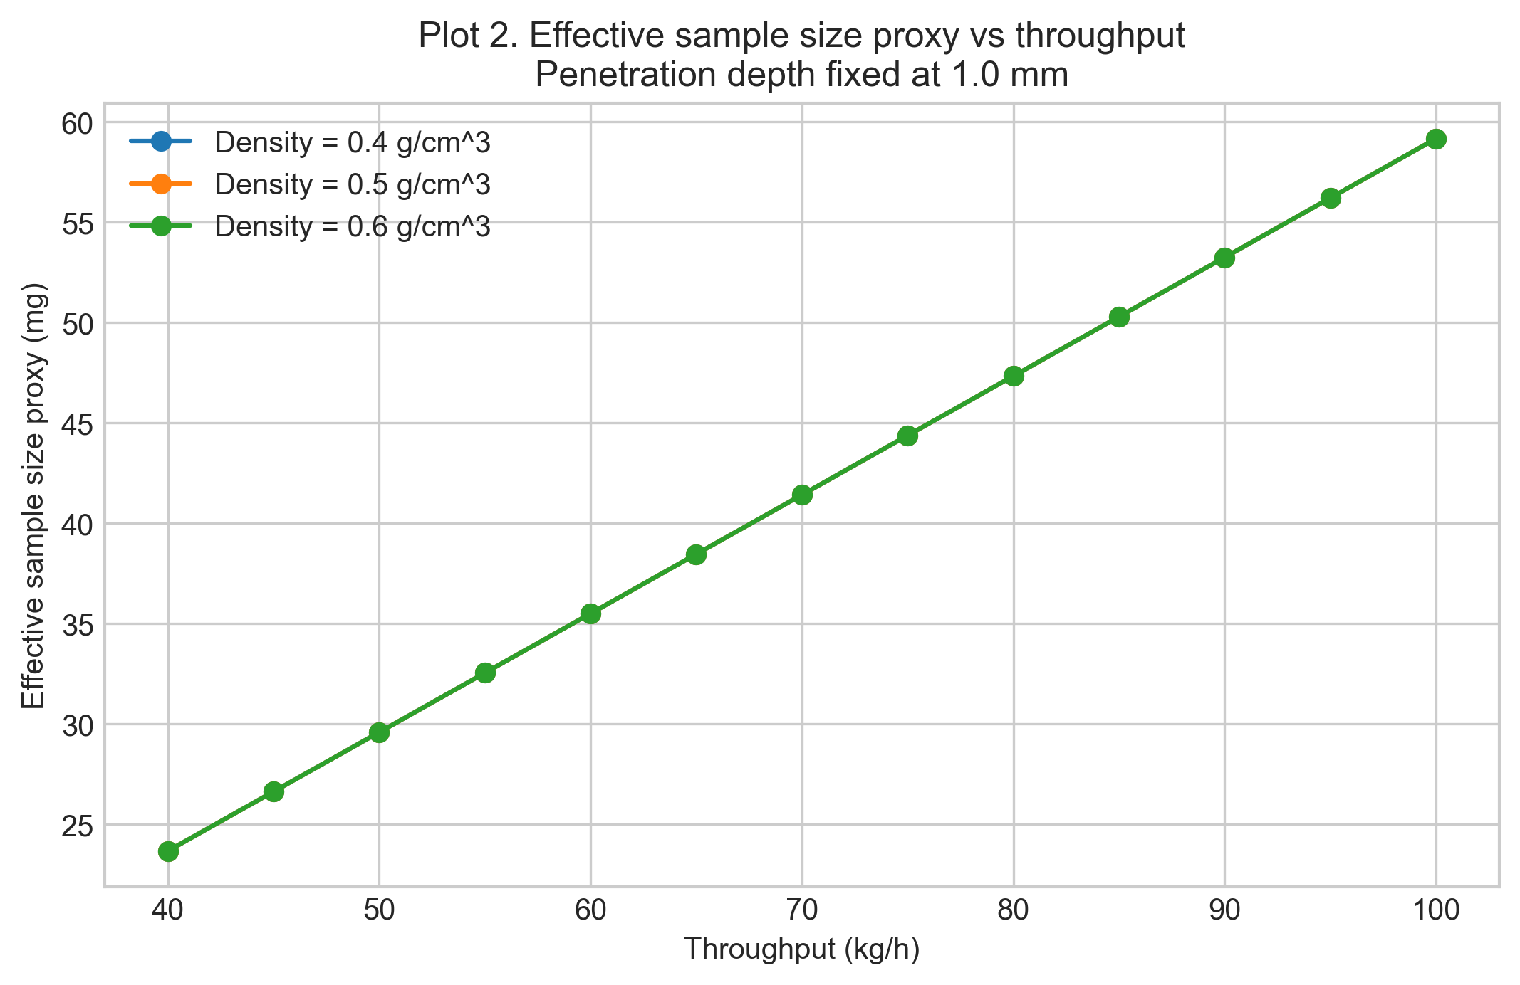
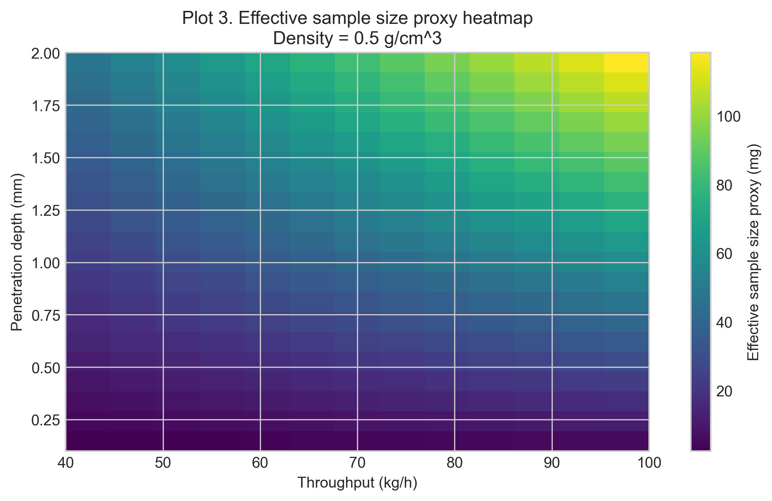
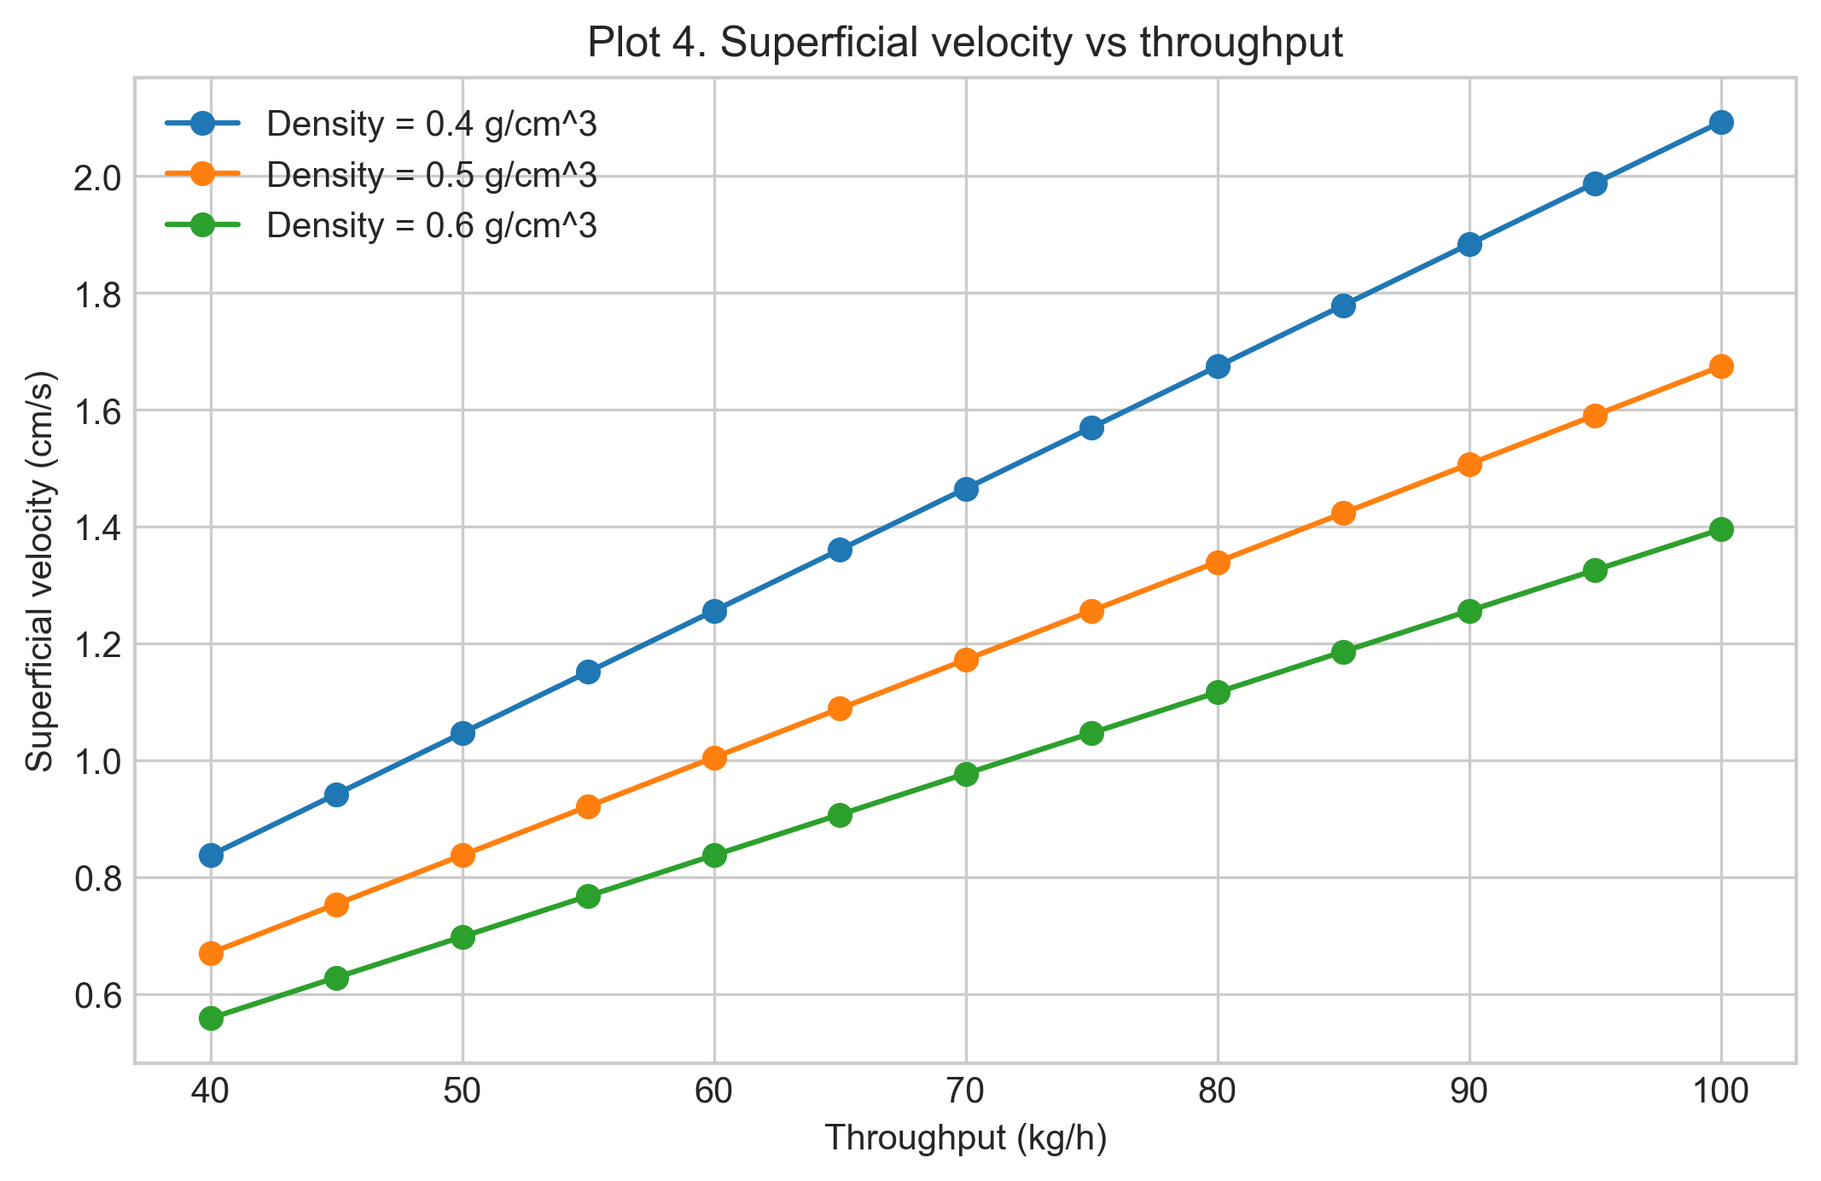
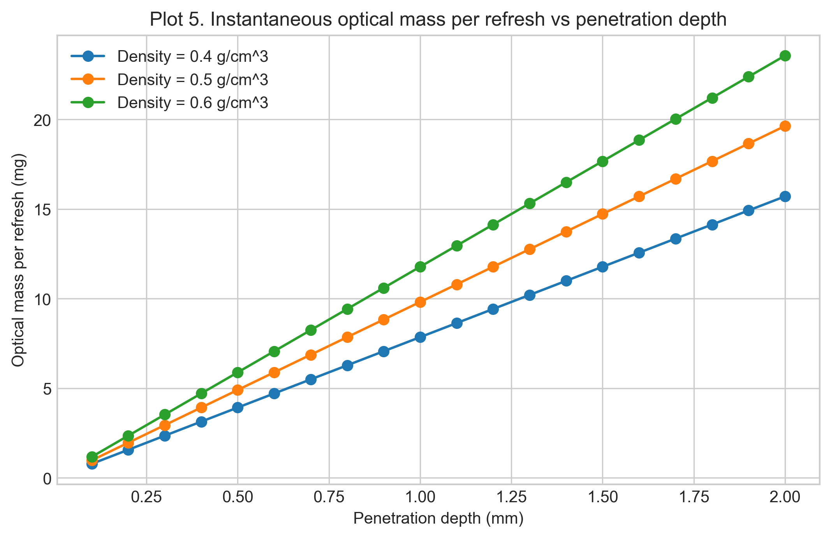
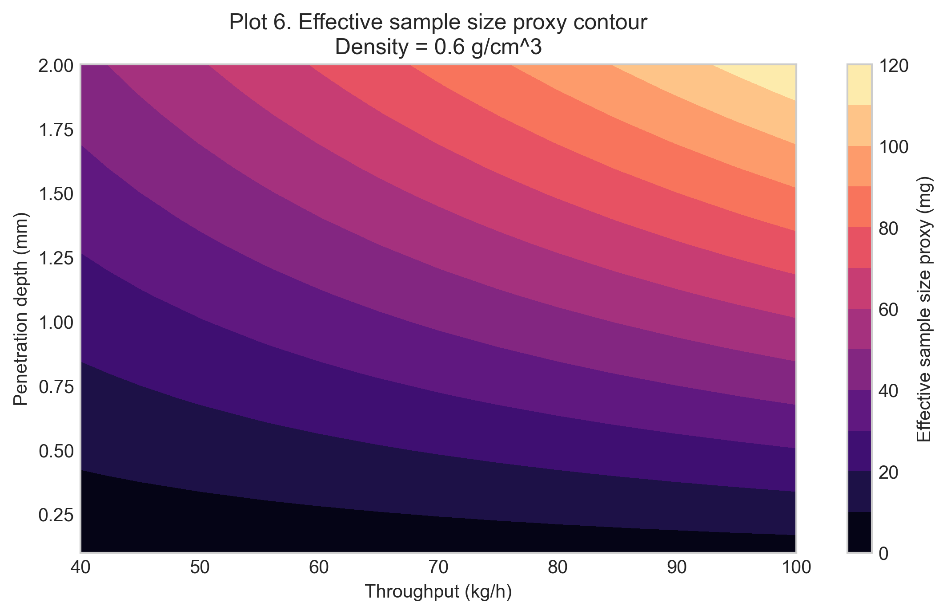
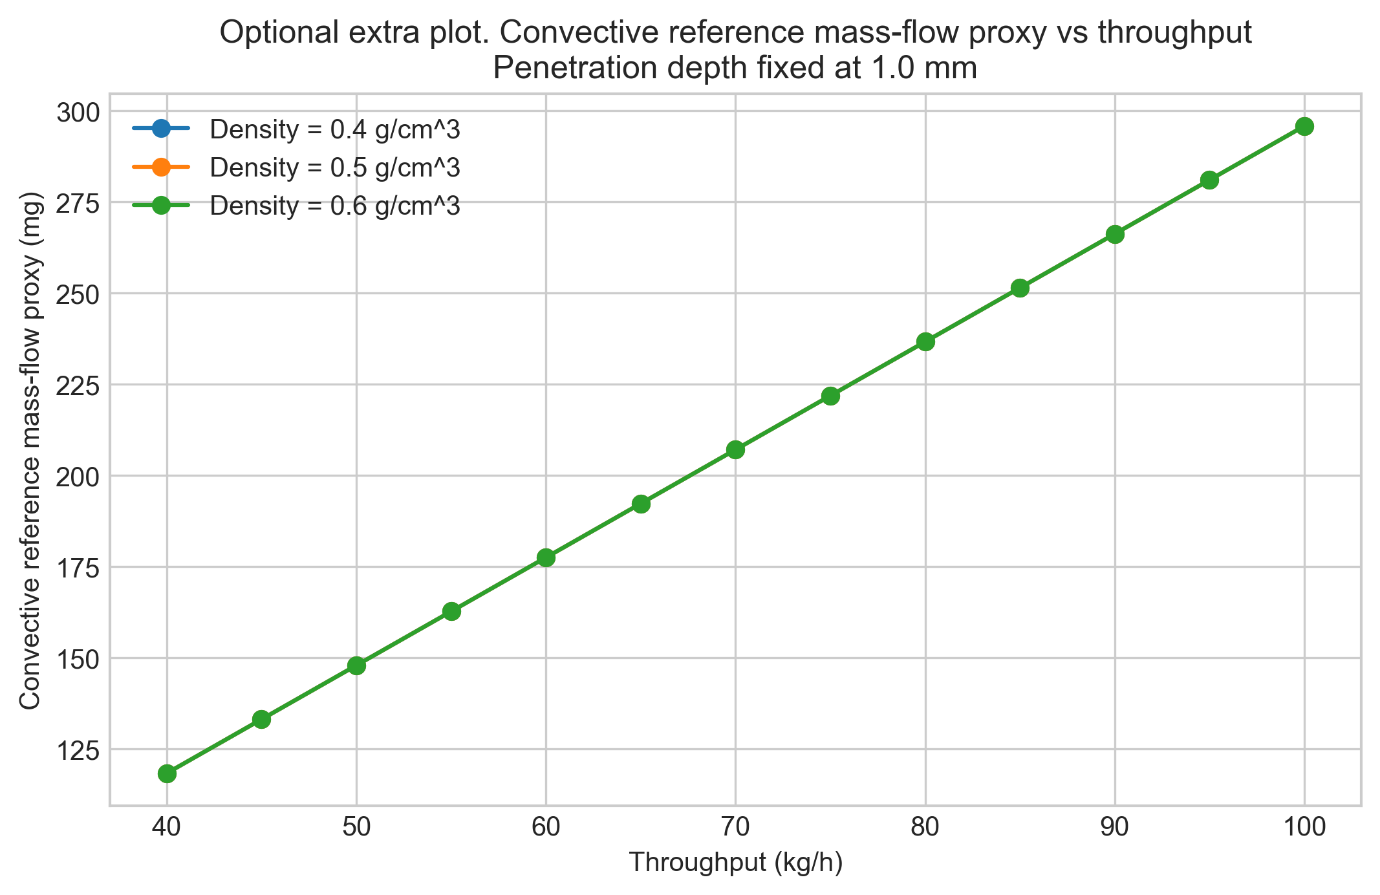

Interpretation of trends
The reported effective sample sizes are proxy values. The model combines instantaneous optical mass mopt with a refresh factor Nrefresh, so density cancellation is a model property, not a universal physical law.

Model limitations
Limitations include no velocity profile resolution, no residence-time distribution, unresolved re-sampling, no optical path-length distribution, no explicit wall slip or compaction correction, and no segregation model.

Conclusions
The notebook is intended for comparative engineering analysis and sensitivity assessment, not as an exact geometric or statistical sampling model.

Glossary of Variables and Symbols
| Symbol | Name | Definition | Units | |---|---|---|---| | meff,proxy | Effective sample size proxy | Refresh-based proxy effective mass during one acquisition. | g internally; mg reported | | mopt | Instantaneous optical mass | Optical mass at one instant near the probe. | g internally; mg reported | | Nrefresh | Refresh factor | Number of characteristic probe-length renewals during one acquisition. | dimensionless | | mdot | Mass throughput | Bulk powder mass flow rate through the pipe. | kg/h input; g/s internally | | rho | Bulk density | Assumed bulk density of the powder. | g/cm^3 | | v | Superficial velocity | Cross-sectional average axial velocity used as the renewal driver. | cm/s | | Aprobe | Probe footprint area | Circular area of the probe window. | cm^2 | | Apipe | Pipe cross-sectional area | Internal cross-sectional area of the pipe. | cm^2 | | dprobe | Probe diameter | Diameter of the circular probe window. | mm input; cm internally | | dpipe | Pipe diameter | Internal diameter of the pipe. | mm input; cm internally | | dpen | Penetration depth | Assumed radial optical penetration depth. | mm input; cm internally | | tacq | Acquisition time | Spectrum acquisition time. | s |

Exported CSV Files
- results_full.csv
- summary_table.csv
- velocity_summary.csv
Detailed tables are saved separately as CSV files in the run folder.

Figures
- plot_01_proxy_vs_penetration_depth.png
- plot_02_proxy_vs_throughput.png
- plot_03_proxy_heatmap_density_05.png
- plot_04_superficial_velocity_vs_throughput.png
- plot_05_optical_mass_per_refresh.png
- plot_06_proxy_contour_density_06.png
- plot_07_convective_reference_mass_proxy.png

Closing Note
This report captures the notebook narrative, summary metadata, and exported artifacts for this run.

