Software Requirements Specification
for
<Information System for ECommerce Product and Order Management>
Version 1.0 approved
Participating students:
Cipu Marinel
Bancu Alexandru-Georgian
Iordachescu Iulian-Daniel
Specialization: Computers (in English)
Group: 3.1A & 3.2A
Table of Contents
Table of Contents ii
Revision History iii
1. Introduction 1
1.1 Purpose 1
1.2 Document Conventions 1
1.3 Intended Audience and Reading Suggestions 1
1.4 Product Scope 1
1.5 References 1
2. Overall Description 2
2.1 Product Perspective 2
2.2 Product Functions 2
2.3 User Classes and Characteristics 2
2.4 Operating Environment 3
2.5 Design and Implementation Constraints 3
2.6 User Documentation 3
2.7 Assumptions and Dependencies 3
3. External Interface Requirements 4
3.1 User Interfaces 4
3.2 Hardware Interfaces 6
3.3 Software Interfaces 6
3.4 Communications Interfaces 7
4. System Features 7
4.1 Customer Account Creation (User Registration) 8
4.2 User Authentication (Login / Logout) 8
4.3 Product Catalog Browsing………………………………………………………………...9
4.4 Product Search and Filtering………………………………………………………………9
4.5 Shopping Cart Management………………………………………………………………9
4.6 Order Placement and Checkout………………………………………………………….9
4.7 Order Tracking and History……………………………………………………………..11
4.8 Administration Product Management……………………………………………………12
4.9 Sales Reports and Data Export…………………………………………………………..12
4.10 User Profile and Address Management …………………………………………………13
4.11 Password Reset and Security…………………………………………………………….13
4.12 Advanced Product Catalog&Categories…………………………………………………13
4.13 Product Reviews and Rating……………………………………………………………..14
4.14 Wishlist Management……………………………………………………………………14
4.15 Advanced Cart & Promotions……………………………………………………………15
4.16 Administrator Order Managent…………………………………………………………..15
4.17 Administrator Dashboard & Audit Logging……………………………………………..16
5. Other Nonfunctional Requirements.. 17
5.1 Performance Requirements 17
5.2 Safety Requirements 17
5.3 Security Requirements 17
5.4 Software Quality Attributes 18
5.5 Business Rules 19
6. Other Requirements 19
Appendix A: Glossary 19
Appendix B: Analysis Models 20
Appendix C: To Be Determined List 20

Revision History
Name | Date | Reason For Changes | Version
Cipu Marinel  Bancu Alexandru-Georgian  Iordachescu Iulian-Daniel | 28.2.2026 | Initial creation date; defined chapter 1 | 1.0
Cipu Marinel  Bancu Alexandru-Georgian | 5.3.2026 | Slight changes to chapter 1; defined and completed chapters 2 & 3 | 1.1
Cipu Marinel  Bancu Alexandru-Georgian  Iordachescu Iulian-Daniel | 8.3.2026 | Minor adjustments to chapter 3; defined and completed chapters 4, 5 & 6 + Appendixes A, B and C | 1.2

Introduction

Purpose
This document specifies the software requirements for the "Information System for E-Commerce Product and Order Management". It describes the scope, features, and constraints of the application to ensure all project stakeholders have a clear understanding of the system being built.

Document Conventions
Term/Acronym | Definition
UID | Unique identifier for the user
DB | Database
DESC | Description

Intended Audience and Reading Suggestions
This document is intended for the developers implementing the system, the testers creating test scenarios based on the requirements, and the coordinating professor evaluating the project's architecture and database usage.

Product Scope
The software will automate online shopping workflows, including product browsing, cart management, order processing, and payment tracking. The system will provide two main web portals:
- For Customers: Account creation, product search and filtering, shopping cart management, checkout workflow, and order history.
- For Administrators: Product and category management, inventory control, sales and customer behavior reporting, and data export functionalities (CSV, XML, PDF).

References
- IEEE SRS Template: srs_template-ieee.doc
- Project Requirements: 13. Information System for E-Commerce Product and Order Management.docx
- Coding Styles for JS/C#: JS Guide & C# Guide
- Code Quality Standard: MISRA-C:2004

Overall Description

Product Perspective
Our web application helps an e-commerce business manage its product catalog, process customer orders, and track sales.

Product Functions
- Users can create accounts, securely log in, and log out of the web portal.

- Administrators can add, update, and manage the product catalog and store categories.

- Customers can search for specific products and apply filters based on price, category, and rating.

- Customers can manage their shopping carts and securely complete the checkout workflow.

- Customers can track the status of their active orders and view their past order history.

- Administrators can generate visual reports regarding overall sales, customer behavior, and product performance.

- Administrators can export system data into CSV, XML, and PDF formats.

- The system automatically logs all operations and supports database backup and recovery.

User Classes and Characteristics
The system will be used by three distinct user classes, each with different technical backgrounds and goals:

- Unregistered Visitors: These are casual internet users with basic web navigation skills who visit the website to discover products. They use the platform occasionally and require a fast, intuitive interface to search and view items before deciding to create a personal account.

- Registered Customers: These are individuals who have created personal accounts to securely purchase goods and track their order history. With basic technical expertise, they use the application periodically to manage their shopping carts, complete checkout workflows, save shipping addresses, and submit product reviews.

- Administrators: These are store owners or designated staff members responsible for the daily operations of the e-commerce business. Operating the system on a daily basis with intermediate technical skills, their primary goal is to manage the product catalog, process customer orders, and use complex dashboards to generate sales reports or data exports (CSV, XML, PDF).

Operating Environment
The system is a client-server web application with the following environment requirements:

- Client Application: The frontend is platform-independent and runs in any modern web browser (Chrome 130+, Apple Safari 18+, Mozilla Firefox 130+) across all major operating systems, including Windows 11, macOS 26, Linux (e.g., Ubuntu 24.04 LTS, and mobile devices (iOS 18+, Android 15+).

- Application Server: The server-side logic (ASP.NET Core REST API) requires a server operating system equipped with the .NET 10 Runtime. This environment can be hosted on a Windows Server (utilizing IIS 10+) or a modern Linux distribution (e.g., Ubuntu Server 24.04), either natively or within a containerized environment (Docker).

- Database Server: The data persistence layer requires a dedicated server environment running MySQL 8.4 LTS (or newer). The database server must be configured to accept secure TCP/IP connections strictly from the designated Application Server to ensure data security.

Design and Implementation Constraints
- Backend & Tools: The server logic is strictly limited to C# 14 and ASP.NET Core 10 (.NET 10 LTS), requiring a .NET 10 Runtime environment and compatible IDEs (e.g., Microsoft Visual Studio 2026). ASP.NET Core was chosen for its high performance, built-in security features, and strong typing, which are critical for handling sensitive e-commerce business logic securely.

- Database Architecture: The system must use MySQL 8.4 LTS (or newer), constraining the data structure to a strict relational model (tables, foreign keys) to ensure ACID-compliant e-commerce transactions. A relational database ensures strict data integrity, preventing fatal errors like lost orders, duplicate payments, or incorrect inventory counts during concurrent purchases.

- Frontend Architecture: The user interface development is constrained to the React 19 library, utilizing its latest native features (e.g., React Compiler, Server Components) for optimal client-side performance. React allows the creation of a dynamic Single Page Application (SPA) with reusable components, ensuring a fast, seamless, and interactive shopping experience without constant page reloads.

- Deployment: While development is fully supported cross-platform (including macOS), the production hosting environment is constrained to Windows (IIS 10+) or Linux servers. Production environments must be cloud platforms (e.g., Microsoft Azure, AWS) that natively support both .NET 10 applications and managed MySQL instances. Cloud deployment guarantees system scalability to handle sudden traffic spikes (e.g., Black Friday sales) while providing automated backups and high availability.

- Payment Processing Gateway: The system is constrained to use the Stripe API for processing financial transactions, explicitly prohibiting the local storage of raw credit card data. Stripe was chosen over other processors due to its superior developer-friendly documentation and seamless frontend integration.

User Documentation
All required guidance details will be written in this document.

Assumptions and Dependencies
Assumptions:

- Users must have a stable internet connection to access the web portal.

- The client's web browser must have JavaScript enabled for the React frontend to function correctly.

Dependencies:

- External Libraries: The system relies on third-party packages (e.g., Entity Framework Core for database mapping, and libraries for PDF/CSV generation).

- External Services: The application depends on third-party APIs for processing financial transactions (e.g., Stripe), and relies on external Courier APIs (e.g., Shippo) for automated shipping label (AWB) generation and real-time parcel tracking.

External Interface Requirements

User Interfaces
The web application will feature a modern, clean, and responsive Graphical User Interface (GUI), ensuring a seamless shopping experience across both desktop and mobile devices.

- Authentication Interface: The login and registration screens will feature clear input fields for email and password, a primary "Sign In / Register" button.

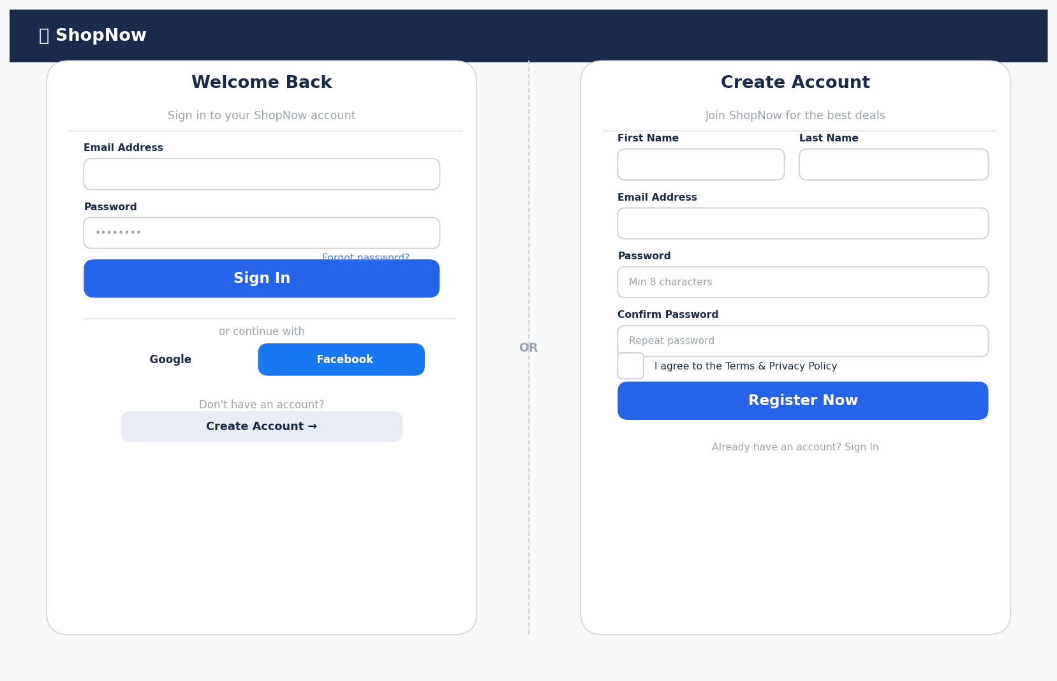

- Storefront & Product Browsing: The main interface for guests and customers will include a top navigation bar with a search text box. The product listing pages will feature a left sidebar for applying filters (price range, category, rating) and a main grid displaying product cards with images, prices, and "Add to Cart" buttons.

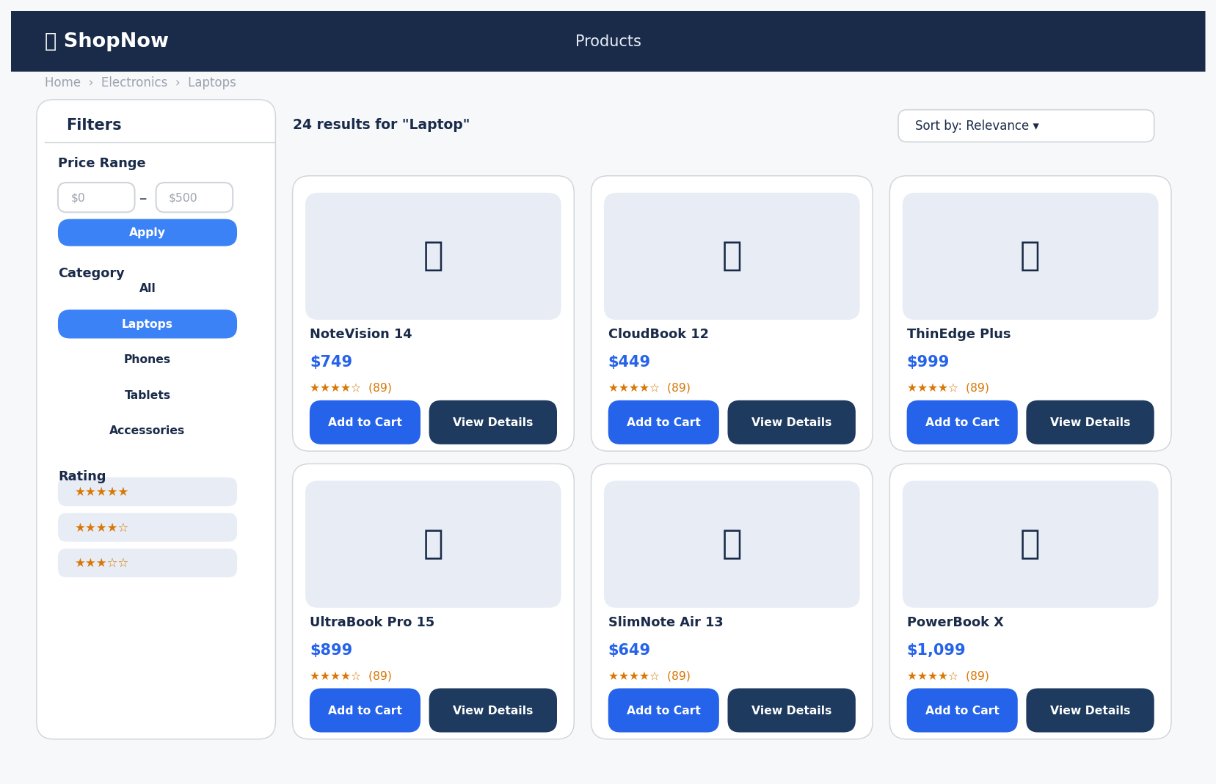
- Customer Portal & Checkout: Once logged in, customers will have access to a personal dashboard. The interface will use clean tables to display recent orders, visual tracking timelines for order status, and an intuitive shopping cart screen with an order summary and a "Proceed to Checkout" workflow.
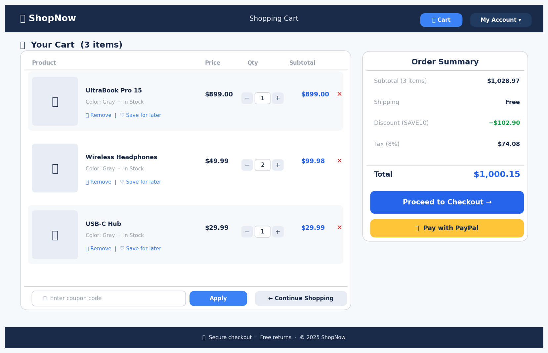

- Administrator Dashboard: The interface for store owners will be strictly separated. It will feature a left-hand vertical navigation menu (Products, Orders, Customers, Reports) and a main content area displaying visual graphs for revenue, summary cards for key metrics, and data tables for managing ongoing operations.
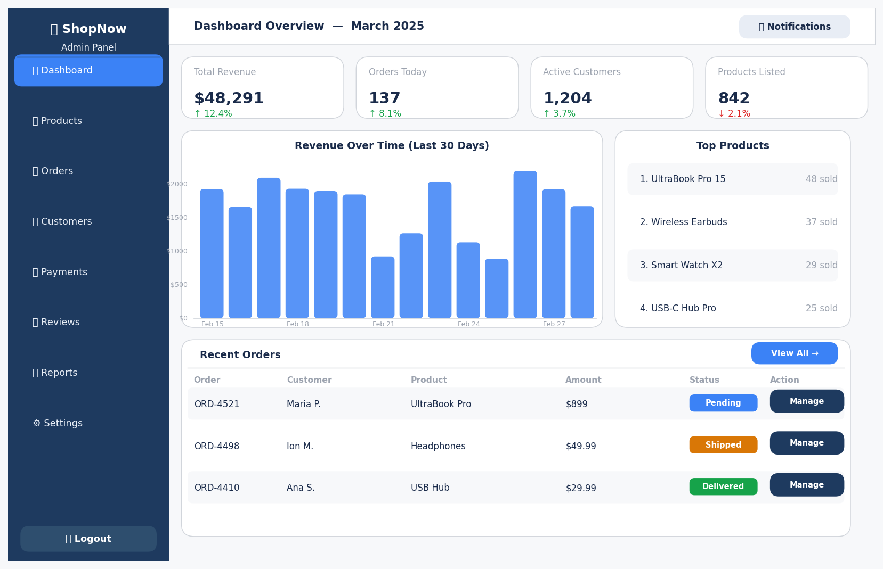

Hardware Interfaces
NOT APPLICABLE.

Software Interfaces
The system interacts with several external software components and libraries to function correctly:

- Database Management System: The application integrates with MySQL Server. The backend uses this external system to persistently store and retrieve all business entities (Users, Products, Orders).

- ORM Library: The backend utilizes Microsoft Entity Framework (EF) Core as its primary data access library. EF Core translates C# object-oriented code into optimized, parameterized SQL queries, preventing SQL injection vulnerabilities.

- Frontend Libraries: The client-side application relies on the React.js library for rendering the UI and the Axios (or native Fetch) library to send asynchronous HTTP requests to the backend.
- Payment Gateway API: The backend strictly communicates with the Stripe API via secure HTTPS to create payment intents and process webhooks. During the development and testing phases, the system will exclusively use Stripe Sandbox / Test Mode, utilizing mock credit cards to simulate successful and failed transactions without processing real funds.

- Courier Service API: The backend integrates with a third-party Logistics API (e.g., Shippo). When an order is processed, the system sends an HTTP POST request to the Courier's Sandbox Environment, which returns a mock AWB (Air Waybill) PDF and a simulated tracking number. This allows developers to test label generation and tracking webhook events (e.g., "In Transit", "Delivered") without dispatching actual physical couriers.

Data Flow & Communications:
The React frontend sends HTTP requests (GET, POST, PUT, DELETE) containing JSON payloads to the ASP.NET Core backend API. The backend processes the request, applies business logic, and uses EF Core to send SQL queries to the MySQL database. The database returns execution status codes or the requested data sets, which the backend then serializes back into JSON and returns to the client.

Core API Endpoints & Interfaces (Examples):

- GET /api/products : Retrieves a list of available products.

- POST /api/orders : Submits a new customer order to the database.

- Task<User> AuthenticateUser(string email, string password) : Backend interface for verifying user credentials.

- Task<int> SaveChangesAsync() : EF Core interface command to commit data changes to the MySQL database.

Communications Interfaces
- Client-Server (HTTPS): All communication between the React frontend and ASP.NET Core backend occurs strictly over encrypted HTTPS to protect sensitive user and transaction data.

- Data Formatting (REST & JSON): The frontend and backend communicate via a RESTful API architecture, exchanging data payloads exclusively in JSON format.

- Email Services (SMTP): The system uses the Simple Mail Transfer Protocol (SMTP) to send automated notifications, such as order confirmations.

- Database Connection (TCP/IP): The backend server connects to the MySQL database over a secure TCP/IP connection.

System Features

Customer Account Creation (User Registration)
4.1.1 Description and Priority
High Priority. The system allows a new visitor to create a secure customer account. The backend is responsible for hashing passwords and storing user data in the relational database.
4.1.2 Stimulus/Response Sequences
- Input: Visitor fills in the registration form (First Name, Last Name, Email, Password) and clicks 'Register'.

- Output: The backend validates the data, hashes the password, creates a new record in the Users database table, and redirects the user to the login screen.

- Input: Visitor enters an email address that already exists in the database.
- Output: System catches the database constraint violation and displays: 'An account with this email already exists.'
4.1.3 Functional Requirements
- REQ-01: The registration form shall accept First Name, Last Name, Email Address, and Password.
- REQ-02: The system must check the Users database table to ensure the provided email address is unique.
- REQ-03: The backend system (ASP.NET Core) must securely hash the user's password (e.g., using BCrypt or PBKDF2) before storing it in the database. Plain-text passwords shall never be saved.
- REQ-04: The client-side form shall validate the email format and enforce a minimum password length of 8 characters.
- REQ-05: Upon successful creation of the database record, the system shall redirect the user to the login page.

User Authentication (Login / Logout)
4.2.1 Description and Priority
Critical Priority. The system authenticates registered users and issues secure sessions for subsequent database access.
4.2.2 Stimulus/Response Sequences
- Input: User enters valid email and password and clicks 'Login'.
- Output: System verifies credentials against the database, generates a secure JSON Web Token (JWT), and grants access to the Customer Dashboard.
- Input: Logged-in user clicks 'Logout'.
- Output: System invalidates the current session token and redirects to the home page.
4.2.3 Functional Requirements
- REQ-06: The login form shall accept an email address and a password.
- REQ-07: The backend shall query the database for the user's email and compare the provided password against the stored password hash.
- REQ-08: On successful login, the backend shall generate and return a secure session token (JWT) containing the user's ID and role (Customer/Admin).
- REQ-09: The system shall lock the account for 15 minutes after 5 consecutive failed login attempts to prevent brute-force attacks.
- REQ-10: On logout, the client application shall delete the session token from local storage.

4.3 Product Catalog Browsing
4.3.1 Description and Priority
High Priority. Customers and guests can browse the product catalog retrieved dynamically from the database.
4.3.2 Stimulus/Response Sequences
- Input: User navigates to the main product listing page.
- Output: System queries the database and displays a paginated list of active products.
- Input: User clicks on a specific product card.
- Output: System queries the database for the specific Product ID and displays the detailed view (images, description, stock status).
4.3.3 Functional Requirements
- REQ-11: The system shall query the Products table to retrieve items where the status is set to 'active'.
- REQ-12: The product listing shall support pagination, displaying a maximum of 20 products per page to optimize database load.
- REQ-13: The product detail page shall display: Name, Description, Price, Category, and Stock Quantity.
- REQ-14: The system shall visually indicate 'Out of Stock' and disable the 'Add to Cart' button if the database StockQuantity column is 0.

4.4 Product Search and Filtering
4.4.1 Description and Priority
Medium Priority. Users can execute apply filters to find specific products.
4.4.2 Stimulus/Response Sequences
- Input: User types a keyword in the search bar and applies a "Price < 500" filter.
- Output: The backend executes a filtered SQL query and returns the matching products.
4.4.3 Functional Requirements
- REQ-15: The search function shall allow users to find products by typing keywords, matching them against both product names and descriptions, regardless of uppercase or lowercase letters.
- REQ-16: The system shall provide filtering options, allowing users to narrow down results by selecting a specific Category or defining a Price range.
- REQ-17: Users shall be able to combine search keywords and filters at the same time to get highly specific results.
- REQ-18: If no products match the user's search or filter criteria, the system shall clearly display the message: 'No products found matching your criteria.'

4.5 Shopping Cart Management
4.5.1 Description and Priority
High Priority. Customers can compile a list of products, adjust quantities, and review their total costs before placing a formal order.
4.5.2 Stimulus/Response Sequences
- Input: Customer clicks 'Add to Cart' on a product or adjusts the quantity of an existing item.
- Output: System creates or updates a record in the CartItems database table.
- Input: Unregistered guest clicks 'Add to Cart' on a product.
- Output: The system intercepts the action, redirects the user to the Login/Registration screen, and displays a warning message.
- Input: Customer changes the quantity of an item to 0 or clicks the “Remove” icon.
- Output: System executes a DELETE query for that specific item, removes it from the user interface, and instantly recalculates totals.
4.5.3 Functional Requirements
- REQ-19: The system shall validate the requested cart quantity against the actual StockQuantity available in the Products table. Whenever a user clicks "Add to Cart" or increases the item quantity, the backend will verify the database to ensure sufficient stock exists.
- REQ-20: The system shall restrict all cart operations exclusively to authenticated users.
- REQ-21: If an unauthenticated guest attempts to trigger the "Add to Cart" action, the frontend application must immediately redirect them to the authentication page.
- REQ-22: The system shall dynamically calculate and continuously update the cart's financial summary in real-time. The frontend interface will display a detailed breakdown that multiplies each item's database price by its selected quantity to generate a subtotal.

4.6 Order Placement and Checkout
4.6.1 Description and Priority
Critical Priority. The system processes the cart contents into a formal order, executes database transactions, and manages inventory.
4.6.2 Stimulus/Response Sequences
- Input: Customer submits the checkout form with shipping details.
- Output: The system executes a database transaction to create the Order, decrements the product stock, and clears the user's cart.
4.6.3 Functional Requirements
- REQ-23: The checkout process shall collect the customer's shipping address and contact information.
- REQ-24: Upon order submission, the backend shall initiate a secure database Transaction (ACID compliance).
- REQ-25: The system shall insert a new record into the Orders table (containing total price, date, user ID, shipping address).
- REQ-26: The system shall insert multiple records into the OrderDetails table mapping the purchased products to the new Order ID.
- REQ-27: The system must execute an UPDATE query to decrement the StockQuantity of the purchased products.
- REQ-28: If the stock is insufficient during the transaction, the entire transaction must be rolled back and an error displayed to the user.
- REQ-29: Upon successful transaction commit, the system shall clear the user's cart from the database.

4.7 Order Tracking and History
4.7.1 Description and Priority
Medium Priority. Customers can view their past transactions and current order status.
4.7.2 Stimulus/Response Sequences
- Input: Customer navigates to 'My Orders'.
- Output: System queries the Orders table by the Customer's ID and displays the history.
4.7.3 Functional Requirements
- REQ-30: The system shall execute a query to fetch all orders associated with the authenticated user's ID.
- REQ-31: Orders shall be sorted by creation date in descending order (newest first).
- REQ-32: The interface shall display the current state of the order based on the database Status column (Pending, Shipped, Delivered, Cancelled).
- REQ-33: The backend shall enforce authorization checks to ensure a user can only retrieve their own orders.

4.8 Administrator Product Management
4.8.1 Description and Priority
High Priority. Administrators have full CRUD (Create, Read, Update, Delete) access to the product catalog.
4.8.2 Stimulus/Response Sequences
- Input: Administrator submits the 'Add New Product' form.
- Output: System executes an INSERT query to add the product to the database.
- Input: Administrator clicks 'Delete' on a product.
- Output: System performs a soft-delete by updating the product's status in the database.
4.8.3 Functional Requirements
- REQ-34: The backend shall verify the administrator role from the session token before allowing any modifications.
- REQ-35: The system shall provide an interface to Create, Update, and Read product records.
- REQ-36: The database shall enforce a UNIQUE constraint on the Product SKU (Stock Keeping Unit) column.
- REQ-37: Product deletion shall be implemented as a "soft-delete" (e.g., setting IsDeleted = true in the DB) to ensure past order records remain intact.

4.9 Sales Reports and Data Export
4.9.1 Description and Priority
Medium Priority. Administrators can extract aggregate data from the database to analyze business performance.
4.9.2 Stimulus/Response Sequences
- Input: Administrator selects a date range and clicks "Generate Revenue Report".
- Output: The backend executes aggregate SQL queries (e.g., SUM, COUNT) and displays the results.
4.9.3 Functional Requirements
- REQ-38: The system shall allow administrators to query total sales revenue for a specific date range.
- REQ-39: The system shall execute JOIN queries between Orders, OrderDetails, and Products to determine the top-selling items.
- REQ-40: The system shall provide functionality to export the results of the Orders table into a standard CSV file format for external spreadsheet analysis.

4.10 User Profile and Address Management
4.10.1 Description and Priority
High Priority. Customers must be able to manage their personal information and multiple shipping addresses, requiring relational database mapping (Users 1-to-Many Addresses).
4.10.2 Stimulus/Response Sequences
- Input: Customer submits a new shipping address in their profile.
- Output: System inserts a new record into the Addresses table linked via Foreign Key to the Customer's ID.
4.10.3 Functional Requirements
- REQ-41: The system shall allow users to update their First Name, Last Name, and Phone Number.
- REQ-42: Customers shall be able to save, edit, and delete multiple shipping addresses.
- REQ-43: The database shall support designating one address as the 'Default Shipping Address'.
- REQ-44: The system shall allow users to change their password by validating their current hashed password before applying the new one.
- REQ-45: To comply with GDPR, the system shall allow users to request account deletion, triggering a soft-delete (anonymization) in the database to preserve historical order integrity.
- REQ-46: The profile dashboard shall display the user's account creation date, fetched directly from the database timestamp.

4.11 Password Reset and Security
4.11.1 Description and Priority
Medium Priority. Secure mechanism for users who forget their passwords.
4.11.2 Stimulus/Response Sequences
- Input: User submits their email in the "Forgot Password" form.
- Output: System generates a secure token, saves it in the DB with an expiration time, and sends a reset link via email.
4.11.3 Functional Requirements
- REQ-47: The system shall verify if the submitted email exists in the Users table.
- REQ-48: The backend shall generate a secure, time-limited reset token (valid for 1 hour) and store it in a PasswordResets database table.
- REQ-49: The system shall send the reset token to the user via an external SMTP server.
- REQ-50: The system shall invalidate the reset token immediately after a successful password change.

4.12 Advanced Product Catalog & Categories
4.12.1 Description and Priority
Medium Priority. Enhancing the catalog with sorting, relationships, and multiple images.
4.12.2 Stimulus/Response Sequences
- Input: User selects "Sort by: Price (Low to High)".
- Output: Backend appends an ORDER BY Price ASC clause to the SQL query and refreshes the list.
4.12.3 Functional Requirements
- REQ-51: The product listing shall support dynamic sorting by Price (ASC/DESC), Date Added (Newest first), and Name (Alphabetical).
- REQ-52: The database shall support multi-level categories using a parent-child relational structure (e.g., Electronics -> Laptops).
- REQ-53: The system shall display a "Related Products" section by querying items that share the same Category ID.
- REQ-54: The database shall allow multiple images per product, storing URLs in a separate ProductImages table linked via Foreign Key.
- REQ-55: The system shall increment a ViewCount column in the database each time a product detail page is accessed.

4.13 Product Reviews and Ratings
4.13.1 Description and Priority
High Priority. Customers can leave feedback, requiring database aggregation for average scores.
4.13.2 Stimulus/Response Sequences
- Input: Customer submits a 5-star rating and a text review for a purchased product.
- Output: System inserts the review into the database and updates the product's average rating cache.
4.13.3 Functional Requirements
- REQ-56: Authenticated users shall be able to submit a rating (1 to 5 stars) for a product.
- REQ-57: Users shall be able to submit an optional text review alongside their star rating.
- REQ-58: The backend shall strictly enforce that a user can only review a product if they have a Delivered order containing that Product ID.
- REQ-59: The database shall calculate and store the average rating for each product using SQL aggregation functions (AVG()).
- REQ-60: Administrators shall have the ability to soft-delete or hide reviews that violate community guidelines.

4.14 Wishlist Management
4.14.1 Description and Priority
Low Priority. Customers can save items for future purchases.
4.14.2 Stimulus/Response Sequences
- Input: Customer clicks the "Heart" icon on a product.
- Output: System inserts a record into the WishlistItems table.
4.14.3 Functional Requirements
- REQ-61: Authenticated users shall be able to add products to a personal Wishlist.
- REQ-62: The database shall store Wishlist items in a junction table linking UserID and ProductID.
- REQ-63: Users shall be able to remove items from their Wishlist (executing a DELETE query).
- REQ-64: Users shall be able to move an item directly from the Wishlist to the Shopping Cart, executing a transactional DB move.

4.15 Advanced Cart & Promotions
4.15.1 Description and Priority
Medium Priority. Handling discounts and database maintenance.
4.15.2 Stimulus/Response Sequences
- Input: User enters "SUMMER20" in the promo code input.
- Output: System queries the PromoCodes table, validates the code, and recalculates the cart total.
4.15.3 Functional Requirements
- REQ-65: The system shall support discount codes, querying a PromoCodes database table.
- REQ-66: The database shall validate the promo code's expiration date and usage limits before applying the discount.
- REQ-67: The system shall automatically calculate regional shipping costs based on the user's selected shipping address.
- REQ-68: The backend shall implement a background worker or SQL event to automatically delete abandoned guest carts older than 7 days.
- REQ-69: Upon successful checkout, the system shall send an automated order confirmation email (via SMTP) containing the Order ID and invoice details.

4.16 Administrator Order Management
4.16.1 Description and Priority
High Priority. Admins need an interface to process and fulfill customer orders.
4.16.2 Stimulus/Response Sequences
- Input: Admin changes an order status from "Pending" to "Shipped".
- Output: System updates the Orders table and logs the action.
4.16.3 Functional Requirements
- REQ-70: Administrators shall be able to view a master grid of all orders across the system.
- REQ-71: Administrators shall be able to update the order status (Pending -> Processing -> Shipped -> Delivered).
- REQ-72: The database shall record a timestamp every time an order status changes.
- REQ-73: Administrators shall be able to cancel an order, which must automatically trigger an UPDATE query to replenish the StockQuantity of the canceled items.
- REQ-74: Administrators shall be able to view the complete customer profile and past order history directly from the order details panel.

4.17 Administrator Dashboard & Audit Logging
4.17.1 Description and Priority
Medium Priority. Real-time statistics and security auditing for business owners.
4.17.2 Stimulus/Response Sequences
- Input: Admin navigates to the dashboard homepage.
- Output: System executes multiple aggregate queries to display total revenue, user count, and recent activity.
4.17.3 Functional Requirements
- REQ-75: The admin dashboard shall display real-time total revenue utilizing SQL SUM() queries on completed orders.
- REQ-76: The dashboard shall display the exact count of new orders placed on the current day.
- REQ-77: The dashboard shall list the "Top 5 Customers" by executing a SQL query aggregating total spend grouped by User ID.
- REQ-78: The system shall maintain an AuditLogs table to track critical administrative actions (e.g., deleting a product, changing an order status).
- REQ-79: The audit logs must capture the Admin ID, Action Type, Target Table, and a secure Timestamp.
- REQ-80: The database architecture shall support scheduled, automated backups to ensure data recovery in case of system failure.

Other Nonfunctional Requirements

Performance Requirements
Startup & Load Time: The React frontend application must load and become fully interactive in under 3 seconds on a standard broadband connection.
Database Concurrency: The MySQL database server must successfully process at least 200 simultaneous user connections to handle peak shopping events (e.g., Black Friday traffic) without performance degradation.
API Response Time: All standard database Read operations (e.g., fetching the product catalog) must be executed and returned by the ASP.NET Core API in under 2 seconds.
Transaction Speed: Complex Write operations, such as the order placement transaction (which includes multiple INSERTs and stock UPDATEs), must execute in under 4 seconds to prevent timeout errors and duplicate submissions.

Safety Requirements
NOT APPLICABLE.

Security Requirements
Password Hashing: All user passwords must be hashed using strong cryptographic algorithms (e.g., BCrypt or PBKDF2) before being saved to the database. Plain-text passwords must never be stored.
SQL Injection Prevention: The backend must exclusively use Entity Framework Core LINQ queries or strictly parameterized SQL commands. Direct string concatenation for SQL queries is strictly forbidden.
Data Encryption: All client-server communication must occur over encrypted HTTPS/TLS 1.2+ protocols.
Session Management: User sessions must be managed via secure JSON Web Tokens (JWT) with a maximum expiration time of 2 hours, after which the user must re-authenticate.

Software Quality Attributes
Every if, else, or while must have curly brackets { }, even if there is only one line of code.
Every variable must have a starting value before we use it.
We must not use == or != to check float (decimal) numbers.
We must use the decimal data type in C# and MySQL for all financial and price calculations, never float or double.
We must never use the goto command.
We must use descriptive names for all variables and functions, and we must never use single-letter names (except for loop counters like i or j).
We must write all code comments, variable names, and function names exclusively in English.
We must use exactly 4 spaces for code indentation and we must never use the Tab character.
Every C# class must be placed in its own separate .cs file; we must not define multiple classes in the same file.
We must not copy-paste identical blocks of code (DRY principle); we must extract repeated logic into a separate, reusable function.
We must not use hardcoded "magic numbers" directly in our business logic; we must declare them as named constants.
We must use plural nouns for all MySQL database table names (e.g., Products, Orders) and singular nouns for column names.
We must never write raw SQL queries by concatenating strings to prevent SQL injection; we must use parameterized queries or Entity Framework Core LINQ.
Every C# interface name must start with a capital I (e.g., IUserRepository).
Every asynchronous method name in the C# backend must end with the Async suffix.
We must never use empty catch blocks that swallow and hide errors from the system.
We must never directly mutate the React state object; we must always use the designated state setter functions (React Hooks).
Every API controller method must return a standardized HTTP response code (e.g., 200 OK, 400 Bad Request, 404 Not Found).
We must only use XML documentation comments (///) when describing the purpose of C# classes and public methods.
We must ensure that database connections are always closed and disposed of immediately after the query is executed.

Business Rules
Data Privacy (GDPR): The system must respect user privacy laws. Customers can request the deletion of their accounts, which will trigger a soft-delete (anonymization) in the database to keep financial order history intact while removing personally identifiable information.
Currency Formatting: All monetary values in the database must be stored using a precise decimal data type (e.g., DECIMAL(10,2)) to prevent floating-point rounding errors during financial calculations.
Inventory Rule: A product strictly cannot be purchased or added to a cart if its database stock quantity is exactly zero.

Other Requirements
NOT APPLICABLE.

Appendix A: Glossary
DB: Database.
GUI: Graphical User Interface.
SKU (Stock Keeping Unit): A unique identifier code assigned to each product in the catalog.
ACID: A set of rules that guarantee database transactions (like placing an order) are processed safely and reliably.
GDPR: General Data Protection Regulation (laws regarding user data privacy).

Appendix B: Analysis Models
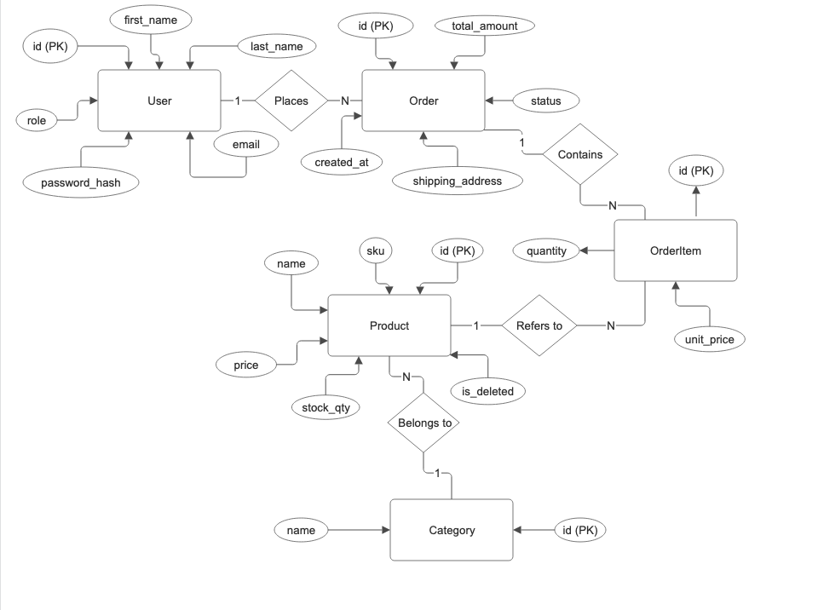
Appendix C: To Be Determined List
TBD-1: The exact third-party service (e.g., SendGrid or Mailgun) that will be used to send automated order confirmation emails.
TBD-2: The specific cloud hosting platform (e.g., Microsoft Azure or AWS) where the web server and the MySQL database will be deployed.
TBD-3: The specific JavaScript or C# library that will be used to generate the PDF sales reports for the administrators.

