Worksheet-7 in R

**Worksheet for R Programming**

**Instructions:** Use RStudio or the RStudio Cloud accomplish this work- sheet. Save the R script as *RWorksheet#7.R*. Copy the R script and save it to the Gdrive link you created for assignments. Accomplish this worksheet by answering the questions being asked and writing the code manually.

1. The table shows the enrollment of BS in Computer Science, SY 2010-2011.

|  |  |
| --- | --- |
| Course Year | 2019 - 2020 |
| 1st | 80 |
| 2nd | 75 |
| 3rd | 70 |
| 4th | 60 |

* 1. Plot the data using a bar graph. Write the codes and copy the result.

**Code:**

#1

enrollment_data <- data.frame(

Course <- c("1st", "2nd", "3rd", "4th"),

Year <- c (80, 75, 70, 60)

)

colnames(enrollment_data) <- c("Course Year", "2019-2020")

enrollment_data

#a

barplot(enrollment_data$`2019-2020`)

**Result:** 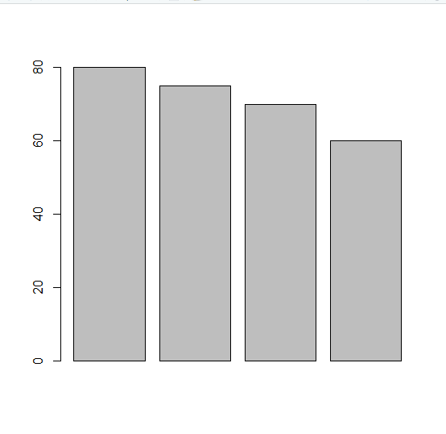

* 1. Using the same table, label the barchart with Title = ” Enrollment of BS Computer Science horizontal axis = “Curriculum Year” and vertical axis = “number of students”

**Codes:**

barplot(enrollment_data$`2019-2020`,

main = "Enrollment of BS in Computer Science,SY 2010-2011",

names.arg = enrollment_data$Course,

col = "darkred",

xlab = "Curriculum Year",

ylab = "number of students"

)

**Result:** 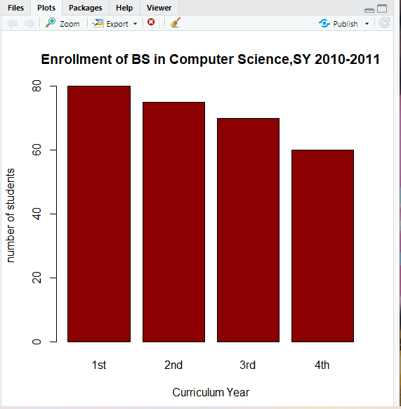

1. The monthly income of De Jesus family was spent on the following:

60% on Food, 10% on electricity, 5% for savings, and 25% for other miscellaneous expenses.

* 1. Create a table for the above scenario. Write the codes and its result.

**Codes:** income_data <- data.frame(

misc_exp <- c ("Food", "Electricity", "Savings", "Miscellaneous expenses"),

spent <- c (60, 10, 5, 25)

)

colnames(income_data) <- c("Expenses", "Spent")

income_data

View(income_data)

**Result:** 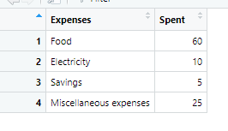

* 1. Plot the data using a pie chart. Add labels, colors and legend. Write the codes and its result.

**Code:** data_labels <- round(income_data$Spent/sum(income_data$Spent) * 100, 1)

data_labels <- paste (data_labels, "%", sep = "")

pie (income_data$Spent, main = "De jesus Family Expenses", col = rainbow(length(income_data$Spent)), labels = data_labels, cex = 0.8)

legend (0.9, 0.5, income_data$Expenses, cex = 0.8, fill = rainbow((length(income_data$Spent))))

**Result:** 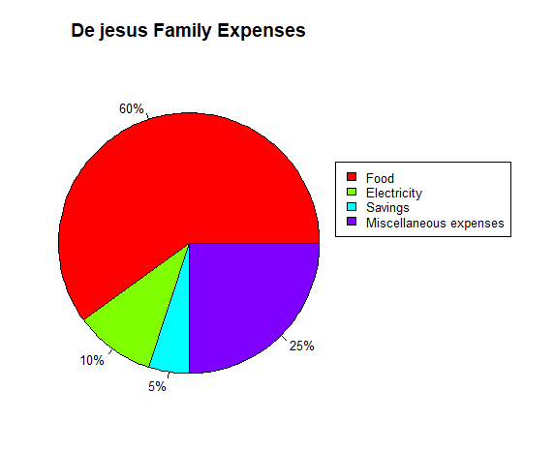

1. Open the mtcars dataset.
   1. Create a simple histogram specifically for **mpg** (miles per gallon) variable. Use $ to select the *mpg* only. Write the codes and its result.

**Codes:**

data("mtcars")

View(mtcars)

#a

hist(mtcars$mpg)

**Resutls:** 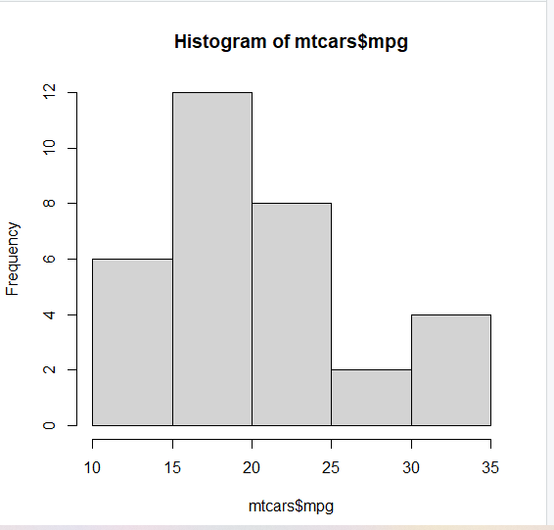

* 1. Colored histogram with different number of bins.

hist(mtcars$mpg, breaks=12, col="red")

Note: breaks= controls the number of bins

**Result:**

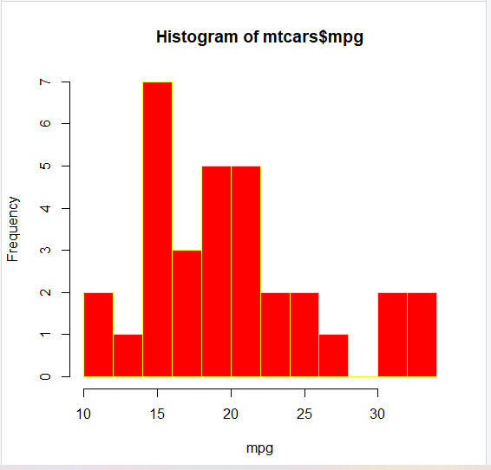

* 1. Add a Normal Curve

x <- mtcars$mpg

h<-hist(x, breaks=10, col="red", xlab="Miles Per Gallon",

main="Histogram with Normal Curve") xfit<-seq(min(x),max(x),length=40)

yfit<-dnorm(xfit,mean=mean(x),sd=sd(x)) yfit <- yfit*diff(h$mids[1:2])*length(x) lines(xfit, yfit, col="blue", lwd=2)

Copy the result.

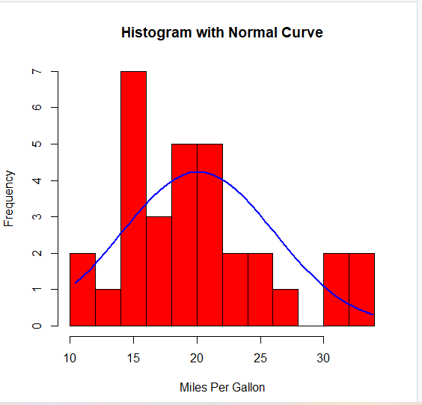

1. Open the iris dataset. Create a subset for each species.
   1. Write the codes and its result.

**Codes:**

data("iris")

View(iris)

Virginica_Data <- subset(iris, Species == "virginica", select = "Species")

Versicolor_Data <- subset(iris, Species == "versicolor", select = "Species")

Setosa_Data <- subset(iris, Species == "setosa", select = "Species")

Virginica_Data

Versicolor_Data

Setosa_Data

**Result:** 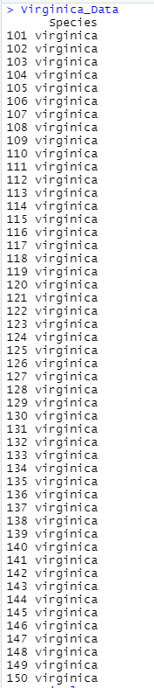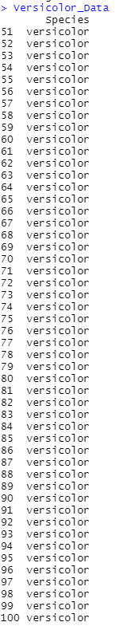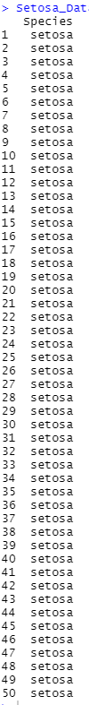

* 1. Get the mean for every characteristics of each species using colMeans(). Write the codes and its result.

Example: setosa <- colMeans(setosa[sapply(setosaDF,is.numeric)])

**Code:**

virginica_df <- subset (iris, Species == "virginica", select = -c(Species))

versicolor_df <- subset (iris, Species == "versicolor", select = -c(Species))

setosa_df <- subset (iris, Species == "setosa", select = -c(Species))

Virginica_F_data <- colMeans(virginica_df)

Versicolor_F_data <- colMeans(versicolor_df)

Setosa_F_data <- colMeans(setosa_df)

species <- c ("Virginica", "Versicolor", "Setosa")

colors <- c("green", "Orange", "brown")

Virginica_F_data

Versicolor_F_data

Setosa_F_data

**Result:** 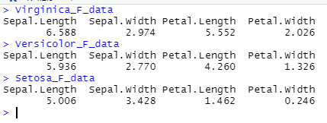

* 1. Combine all species by using rbind()

The table should be look like this:

|  |  |  |  |
| --- | --- | --- | --- |
| Sepal.Length | Sepal.Width | Petal.Length | Petal.Width |
| setosa |  |  |  |
| versicolor |  |  |  |
| virginia |  |  |  |

* 1. From the data in 4-c: Create the barplot(). Write the codes and its result.

The barplot should be like this.

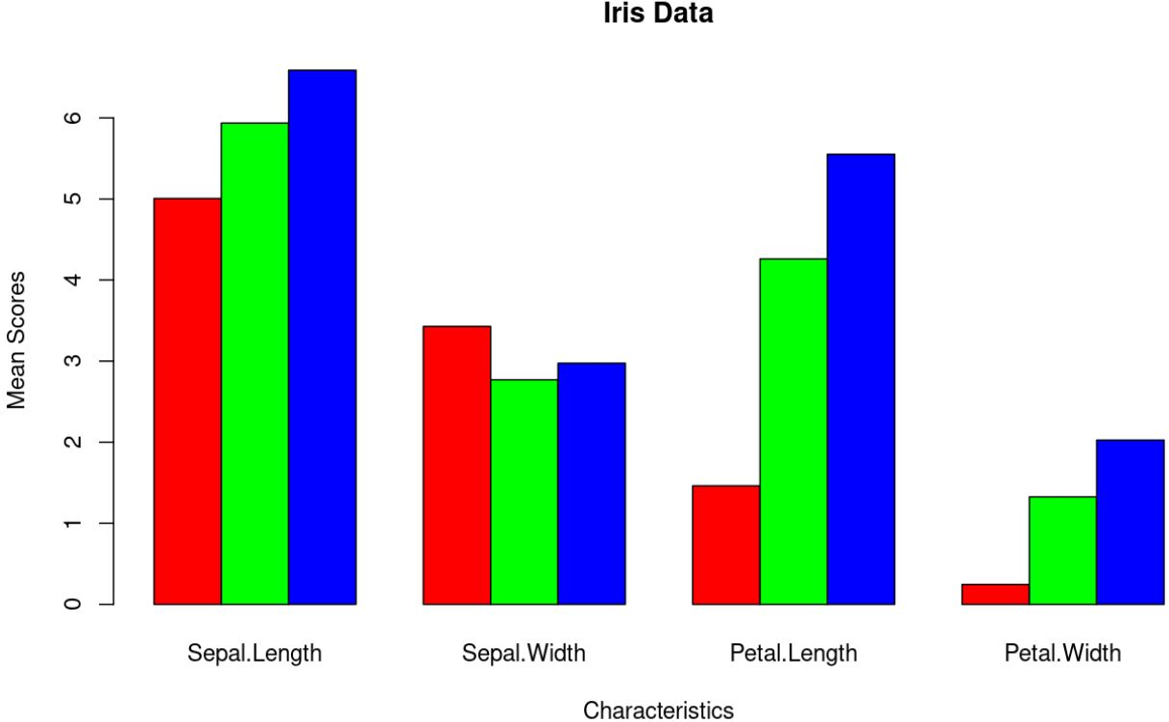

Figure 1: Iris Data using Barplot

**Codes:**

final_form_data <- rbind (Virginica_F_data, Versicolor_F_data, Setosa_F_data)

final_form_data

View(final_form_data)

barplot(final_form_data, col = colors, beside = T)

legend ("topright", species, cex = 1, fill = colors)

**Result:** 