Set 1: Basic Arithmetic and If-Else Branching
Input:

a = 15;
b = 5;
if (a > 10) {
result = a + b * 2;
} else {
result = a - b / 2;
}
print result;
END
Output:

================ THREE-ADDRESS CODE (TAC) ================
0: a = 15
1: b = 5
2: if a > 10 goto 4
3: goto 9
4: t1 = b * 2
5: t2 = a + t1
6: result = t2
7: goto 13
8: goto 13
9: t3 = b / 2
10: t4 = a - t3
11: result = t4
12: goto 13
13: print result
14: HALT
==========================================================
================ TAC RUNTIME EXECUTION ================
[OUTPUT]: 25
Execution completed (8 instructions executed).
Final Variable States:
a = 15
b = 5
result = 25
=======================================================
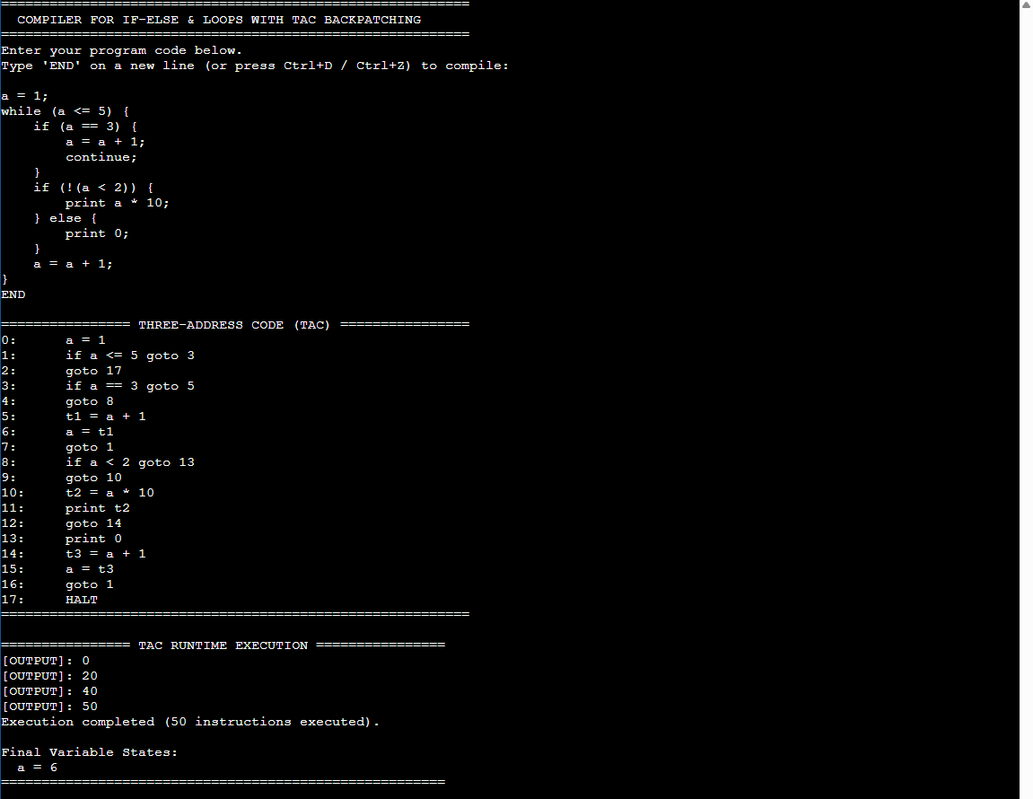

Set 2: Compound Short-Circuit Condition with Negation
Input:

x = 8;
y = 20;
flag = 0;
if (!(x > 10) && y >= 15 || flag != 0) {
ans = y / x;
} else {
ans = 0;
}
print ans;
END
Output:
================ THREE-ADDRESS CODE (TAC) ================
0: x = 8
1: y = 20
2: flag = 0
3: if x > 10 goto 6
4: goto 5
5: if y >= 15 goto 8
6: if flag != 0 goto 8
7: goto 11
8: t1 = y / x
9: ans = t1
10: goto 13
11: ans = 0
12: goto 13
13: print ans
14: HALT
==========================================================
================ TAC RUNTIME EXECUTION ================
[OUTPUT]: 2
Execution completed (10 instructions executed).
Final Variable States:
ans = 2
flag = 0
x = 8
y = 20
=======================================================
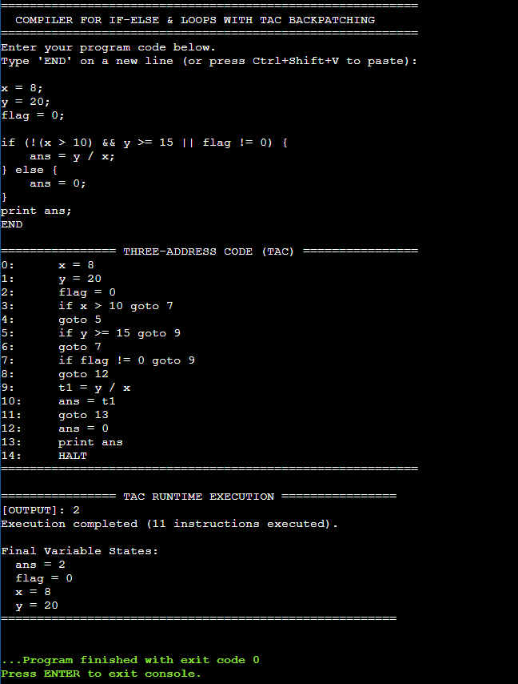

Set 3: While Loop with Break, Continue, and Branching
Input:

a = 1;
while (a <= 5) {
if (a == 3) {
a = a + 1;
continue;
}
if (!(a < 2)) {
print a * 10;
} else {
print 0;
}
a = a + 1;
}
END
Output:

================ THREE-ADDRESS CODE (TAC) ================
0: a = 1
1: if a <= 5 goto 3
2: goto 20
3: if a == 3 goto 5
4: goto 8
5: t1 = a + 1
6: a = t1
7: goto 1
8: if a < 2 goto 14
9: goto 10
10: t2 = a * 10
11: print t2
12: goto 16
13: goto 16
14: print 0
15: goto 16
16: t3 = a + 1
17: a = t3
18: goto 1
19: goto 1
20: HALT
==========================================================
================ TAC RUNTIME EXECUTION ================
[OUTPUT]: 0
[OUTPUT]: 20
[OUTPUT]: 40
[OUTPUT]: 50
Execution completed (58 instructions executed).
Final Variable States:
a = 6
=======================================================
