When loading first time, the quick select box is empty.
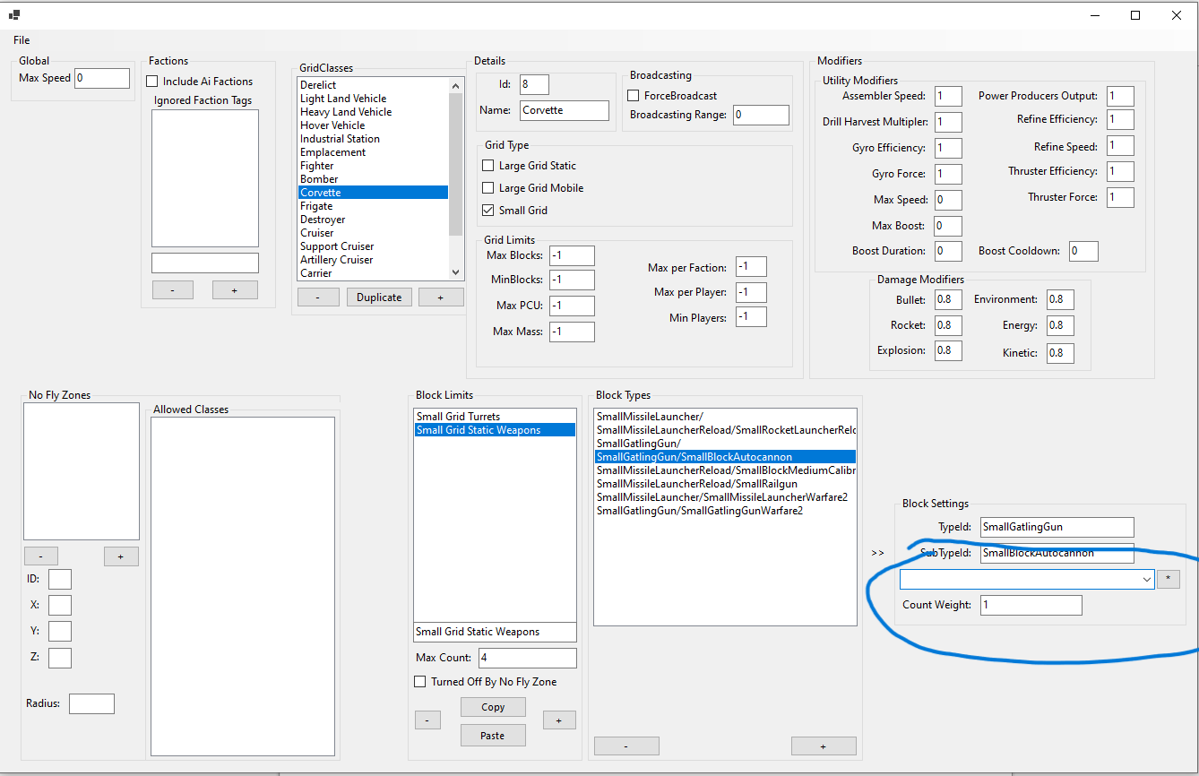
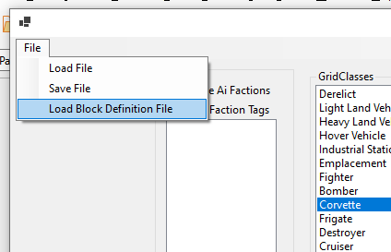
Click on the menu to load a definition file, and navigate to your game files to select a cube definitions file
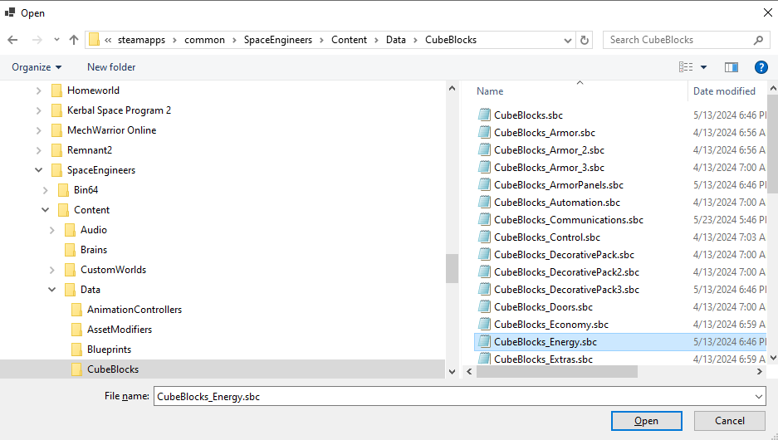

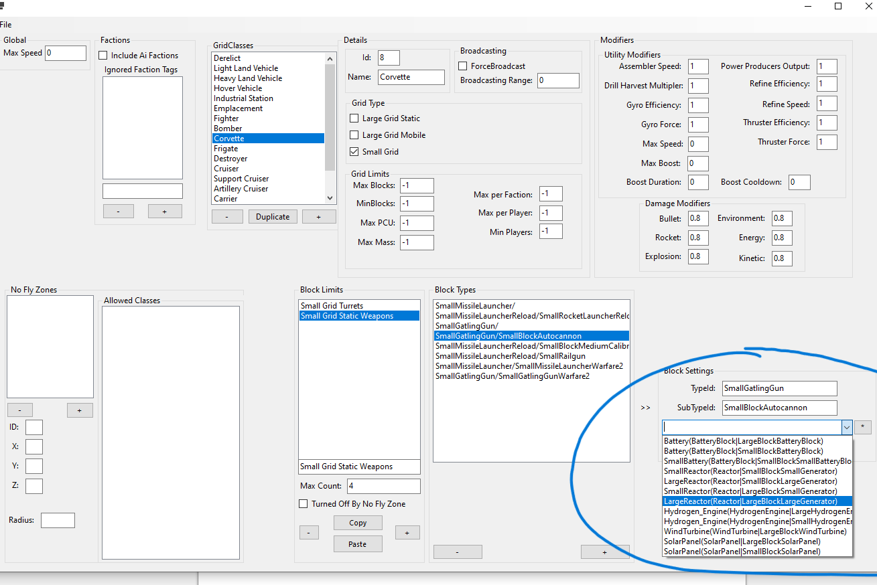
definitions are now loaded into the application and can be selected in the quick select box
click on the * button to copy the definition into the current selected block type
