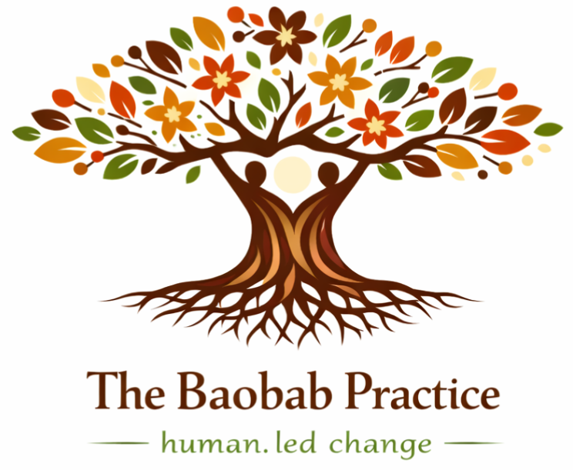
THE BAOBAB PRACTICE
human.led change
Website Mock & Content Specification
Developer Handoff

This document lays out the full website, page by page, in the intended structure and with final copy. Each page shows its content blocks and a short build note. Use it to update the live site.
Prepared October 2026 · thebaobabpractice.com

READ ME FIRST
How to use this document

Each section below is one page or tab of the site. Bold text is on-screen copy. Grey BUILD NOTE boxes are instructions for you, not website text.
Live visual references
Four pages are already built as interactive previews. Open these alongside the spec to see the exact layout, colour and spacing intended (they adapt to light and dark and to mobile):
Page |  | Live preview link
Our Approach |  | claude.ai/artifact/Kx2Ab31nRkFbceSbxfMsw3
Our Services |  | claude.ai/artifact/5j4v7KYhirKL2ymtY6RFG5
Our Philosophy |  | claude.ai/artifact/1ERpBRTC8BAa4RjWW24Yh9
Founder & Contact |  | claude.ai/artifact/PPyfqS4pavJvJ7gb8Z1CYG
 | BUILD NOTE These preview links are private to the owner. Share access from each page’s Share menu before sending to anyone outside the account.
Brand quick reference
Token | Hex | Use
Earth | #4A3728 | Headings, dark sections
Clay | #C46A3A | Primary accent, buttons
Green | #6F8A6D | Secondary accent
Gold | #C99A52 | Tertiary accent
Sand | #E6D8C9 | Soft callouts, chips
Light | #F7F4EF | Page / card background
Fonts: a display serif (Playfair Display) for headings, a clean sans (Inter) for body. Match to the site’s existing fonts if they differ.
Site map
1. Homepage (Hero)
2. About — Vision, Mission & Values
3. Our Approach
4. Our Services
5. Our Philosophy
6. Founder’s Story
7. Let’s Talk (Contact)
8. Global Footer

PAGE 1 · HOMEPAGE
Hero

The business is growing. Can the organisation grow with it?
The Baobab Practice helps growth-stage entrepreneurs and leadership teams build the leadership, culture, capabilities, systems and ways of working needed to scale, without losing what makes the organisation matter.
Measure what enables growth. See what constrains it. Track what needs to evolve.
Start a Growth Readiness Conversation
BUILD NOTE Full-width hero. Headline in display serif. The button is the primary call to action (Clay #C46A3A) and should link to the Contact / Let’s Talk section.

PAGE 2 · ABOUT (NEW TAB)
Vision, Mission & Values

Vision
A world where people and organisations grow stronger by leading their own change.
Mission
The Baobab Practice helps growth-stage entrepreneurs and leadership teams build organisations capable of sustainable growth, strengthening the leadership, culture, capabilities, systems and ways of working required to scale.
CORE QUESTION
Can your organisation carry its next stage of growth?

What we Practice
Human First  Dignity, relationships, and the human experience at the center of every transformation. | Practice Over Prescription  Habits and shared learning, not just plans or recommendations.
Courageous Truth  Safe spaces for difficult conversations and surfacing what is unseen. | Shared Ownership  Leaders and teams taking responsibility for their future.
Growth With Integrity
Scaling that strengthens, not dilutes, purpose and culture.
BUILD NOTE Five value cards. A 3 + 2 or responsive grid works; keep equal card heights per row.

PAGE 3 · OUR APPROACH
What makes us different

Traditional consulting focuses on static adoption. We focus on sustainable, living adaptation.
Instead of |  | We believe in
Planning, then implementing |  | Experimenting, then learning
Managing resistance |  | Engaging resistance as data
Focusing on adoption |  | Focusing on adaptation
Creating dependency |  | Building internal capability
Measuring compliance |  | Measuring learning and growth
Linear project timelines |  | Cyclical, ongoing practice
 | BUILD NOTE Left column recessed / muted; right column emphasised with a green marker. See the live “Our Approach” preview for the exact paired-row treatment.
Baobab Distinctive Practices
The “Both/And” Method  Balance competing values: stability and agility, performance and well-being, individual and collective success, legacy and innovation. | Heat Regulation  Manage the “productive heat” of change. Avoid complacency and burnout, and keep engagement and creativity alive.
Loss Acknowledgement Rituals  Honor what is being left behind. Grieve endings, and create psychological safety for new beginnings. | Good Enough for Now, Safe Enough to Try  Encourage rapid prototyping, value learning over perfection, and treat failure as data.

PAGE 4 · OUR SERVICES
The Baobab Scaling Framework™

Growth Without Losing Soul
A baobab grows from the inside out. Deep roots first, strong trunk second, branches last. Sustainable organisational growth follows the same logic: strengthen the conditions that allow growth before asking the organisation to carry more.
THE GROWTH GAP
A business can have a strong market opportunity and a clear growth strategy while the organisation behind it is not yet ready to carry that growth.
A four-stage journey
Stage (action leads; baobab as subtitle) |  | Core question | Measurement layer
Stage 01 — Assess Readiness & Align Ambition (rooting the work) |  | Are we ready for the growth we want? | Growth Readiness + Cultural Baseline
Stage 02 — Build Scalable Foundations (strengthening the trunk) |  | Are we building the capabilities and behaviours required to scale? | Capability + Values Practice Tracker
Stage 03 — Scale & Integrate (spreading the branches) |  | Is growth creating organisational or cultural friction? | Growth Friction + System Alignment
Stage 04 — Sustain & Evolve (tending the canopy) |  | Can we sustain growth while continuing to adapt? | Scaling Sustainability + Cultural Embeddedness
 | BUILD NOTE Stage names lead with the business action; the baobab appears as a small italic subtitle (a verb: rooting / strengthening / spreading / tending). The all-caps ROOT/TRUNK/BRANCH/CANOPY labels are retired, so this page no longer echoes the Philosophy tab’s tree nouns.
How we work with you
One master methodology, applied through specialist lenses.
MASTER METHODOLOGY — THE BAOBAB SCALING FRAMEWORK™
The primary journey for growth-stage organisations, from assessing readiness to sustaining growth.

Specialist lens — Leadership & Founder Transition  Founder to leader: delegation, decision rights, leadership depth and succession. | Specialist lens — Culture & Identity  Help culture evolve as the organisation grows, while protecting what matters.
Specialist lens — Organisational Regrounding  Address trust, ownership, collaboration and performance when growth creates friction. | Specialist lens — Adaptive Change & Crisis  Support organisations when disruption or rapid change tests their ability to respond.
BUILD NOTE Visual hierarchy is important here: the master methodology must sit above the four lenses as a single prominent block, with the lenses clearly subordinate beneath it. See the live “Our Services” preview.

PAGE 5 · NEW TAB
Our Philosophy

BUILD NOTE Renamed from “The Baobab Growth Cycle.” This tab is philosophy only — no trademark, no stage table, no deliverables. One tree vocabulary is used across the whole site: Roots, Trunk, Branches, Canopy (Leaves and Flowers are retired). Here the tree is used as nouns (belief); on Our Services the same four parts appear as verbs (method), so the two pages never read as the same list twice. The four-stage methodology lives on one page only: Our Services (the Baobab Scaling Framework™).


In the heart of Africa grows a tree unlike any other. For over 2,000 years the Baobab has outlived empires, storing water, shedding leaves, and blooming in time with its pollinators.
“It does not fight its environment. It dances with it.”
Most organizations brace against every drought, fire and storm, clinging to each leaf until they exhaust themselves. What if yours grew like a Baobab instead?

A living promise
The Baobab stands for wisdom that endures: deep roots, patient strength, and the ability to withstand generations of change. Practice means growth through disciplined, mindful action.
The Fourfold Wisdom — Four principles, drawn from the Baobab tree
Four beliefs about growth, each mapped to a part of the baobab. They are the thinking beneath everything we do. Growth is cyclical, not linear, and it lasts when it is built from the inside out.
The Roots · Grow Deep and Wide  Depth in values, wide in impact. Purposeful growth across your ecosystem. | The Trunk · Store Your Water  Build strategic resilience through intentional reserve, not bureaucratic bulk.
The Branches · Reach Without Overreaching  Spread wisely. Distinguish between essential identity and expendable tradition. | The Canopy · Endure Through the Seasons  Sustain what you have built, and keep adapting without losing who you are.

This is how we think. The Baobab Scaling Framework is how we put it to work.

CLOSING CALL TO ACTION — READY FOR HUMAN.LED CHANGE?
Let’s move from traditional consulting to sustainable, living adaptation for your organization.
Start a Conversation
BUILD NOTE Four principle cards (2×2), philosophy only — no stage codes, no deliverables. The closing line points clients to Our Services for the methodology. See the live “Our Philosophy” preview.

PAGE 6 · FOUNDER’S STORY
Growth that endures

 | Watau Gaita  Organizational Development Coach · Founder, The Baobab Practice  For over two decades I have worked with organizations across Africa in moments of change, when the path forward is not clear and what worked before no longer works.

What I have seen is this: most organizations do not lack strategy or talent. They lack the space and capability to work through change in a way that truly lasts. That realization is what led me to create The Baobab Practice.
The baobab does not rush. It grows strong by developing deep roots, storing what it needs, and adapting to its environment. I chose it as our symbol because it reflects something I believe deeply about growth.
It endures not because it resists change, but because it knows how to grow through it. That is the kind of growth I help organizations build.
As an Organizational Development Coach, I work alongside leaders and teams to help them make sense of complexity, strengthen how they lead and work together, and build practices that sustain growth.
My experience spans global technology and international development, including leadership roles at Microsoft and BroadReach Group. Across all of it, what has mattered most to me is not just the outcomes, but how people and institutions move through change with greater clarity, confidence and connection.
BUILD NOTE Portrait photo beside the opening line, then full-width prose. Pull the italic sentence out as a feature quote.

PAGE 7 · LET’S TALK
Contact

Every transformation begins with a conversation
We are based in Nairobi and work across Africa. Reach out, and let’s begin.

Get in touch
Phone | +254 722 289642
Email | hello@thebaobabpractice.com
Location | Nairobi, Kenya
Hours | Mon–Fri, 9 AM–6 PM
Message form
Fields: Your name · Email · How can we help? (message) · button: Send Message
BUILD NOTE Wire the form to deliver to hello@thebaobabpractice.com (host form handler or a service such as Formspree). Make the phone a tel: link and the email a mailto: link. See the live “Founder & Contact” preview for layout.

GLOBAL
Footer

Human-led transformation rooted in trust, clarity, and resilience.
Quick Links  · About Us  · Services  · Founder  · Contact | Contact Info  · +254 722 289642  · hello@thebaobabpractice.com  · 24808 00502  · Nairobi, Kenya

© 2026 The Baobab Practice. All rights reserved.
BUILD NOTE Confirm the “24808 00502” entry — is this a postal code / P.O. Box? Label it so it is clear to visitors.

