PERSONAL INFORMATION | Ilhan Skender
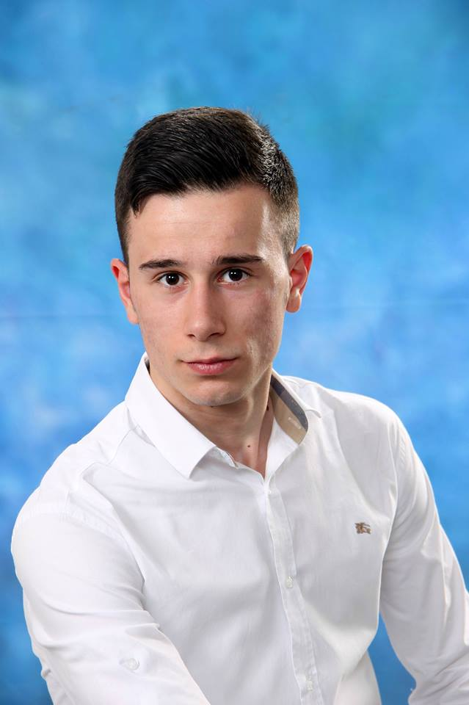 |   Karl Maria von Webbergasse 1, Graz 8010, Steiermark, Austria
 |  +43 660 66 387 60

ilhan.skender@student.tugraz.at
 | Sex Male | Date of birth 14/10/1996 | Nationality Bosnia and Herzegovina

JOB APPLIED FOR

(2020 expected)

2015-March 2017

May 2015

(2020 expected)  2015-March 2017  May 2015 | Bachelor of Science: Computer Science  Graz University Of Technology – Graz, Seiermark
(2020 expected)  2015-March 2017  May 2015 | - Relevant Courses:  Structured Programming,  Microcontrolers,  Databases,  Logic and Computability.  German Course - OeAD University Preparation Programme Graz  - C1 language level certificate.  High School Diploma  Prva Gimnazija Zenica – Zenica, Bosnia and Herzegovina.

PERSONAL SKILLS

Mother tongue(s) | Bosnian/Croatian
Other language(s) | UNDERSTANDING |  | SPEAKING |  | WRITING
Other language(s) | Listening | Reading | Spoken interaction | Spoken production
English | Advanced | Advanced | Advanced | Advanced | Intermediate
German | C1 | C1 | C1 | C1 | C1
 | OeAD VGUH language certificate C1.
 | Levels: A1/A2: Basic user - B1/B2: Independent user - C1/C2 Proficient user

Communication skills | - Ability to work in a team, possess problem-solving approach and have good communication skills.

Job-related skills | - Possess experience of writing C programs (university projects) and have understanding of data structures and basic algorithms.  - Basic concepts of OOP in C++.  - Other programming languages: MySQL, HTML(beginner) .  - Linux shell scripting(basic) for compiling and debugging C/ C++  - IDEs that I'm familiar with: CLion, Visual Studio and Visual Studio Code.  - Familiar with basic concepts in Verilog, Logisim and Git.

Digital skills | SELF-ASSESSMENT
Digital skills | Information processing | Communication | Content creation | Safety | Problem solving
 | Proficient user | Independent user | Independent user | Proficient user | Proficient user
 | Levels: Basic user - Independent user - Proficient user

Other skills | - Ability to interact with colleges, costumers and stress resistance as a result of my prior experience in bartending (1,5 year).

