Introducting Splunk

1- What is Splunk

SIEM: Security Information and Event Management

Splunk is a network analysis tool that serves as a plateform to conduct your big data analytics

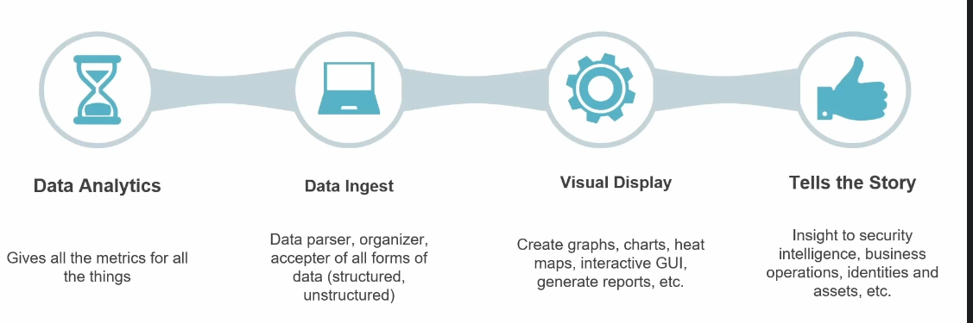

Splunk recupères les informations à partir de différentes sources de votre infra
Il parse ses informations qui serviront à créer des reports et des dashbord.

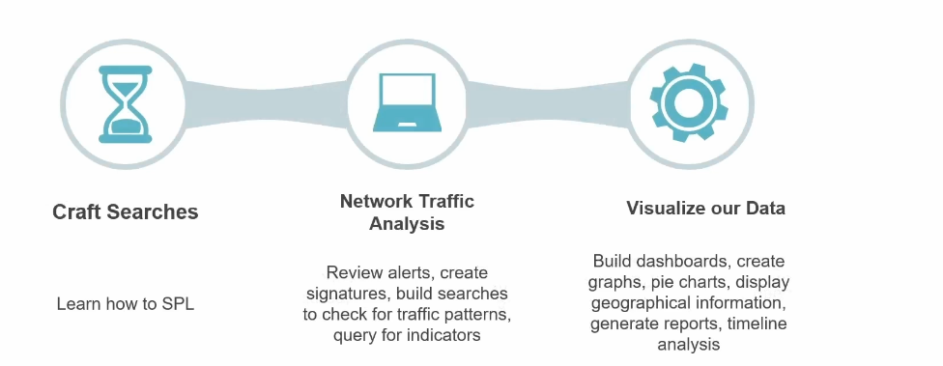

2- Splunk architecture
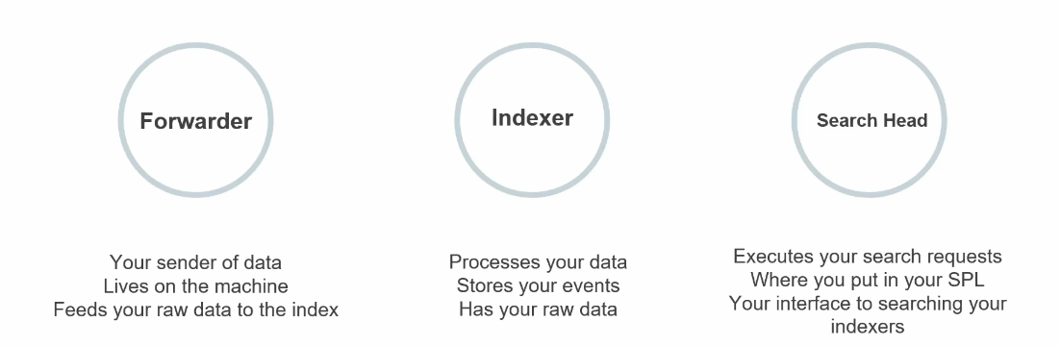
3- Types de déploiement de Splunk
- Standalone
- Basic
- Multi-instance

1- Standalone

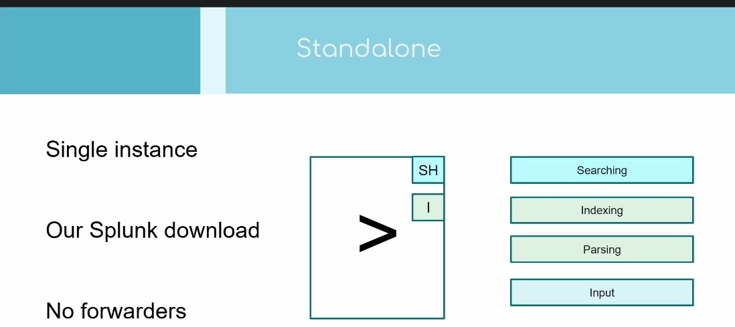
2- Basic

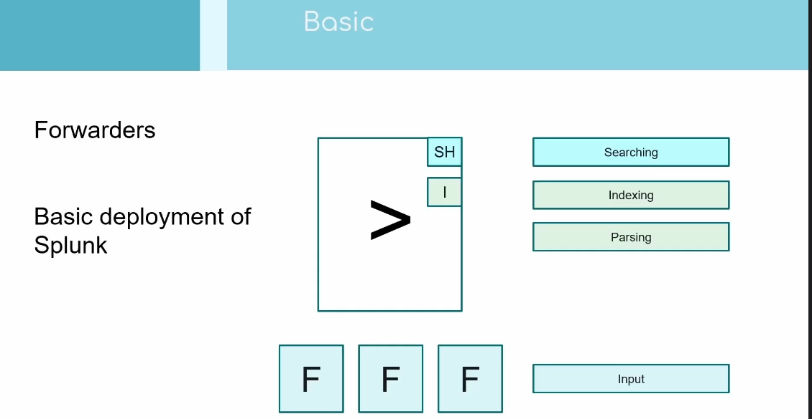
3- Multi instance

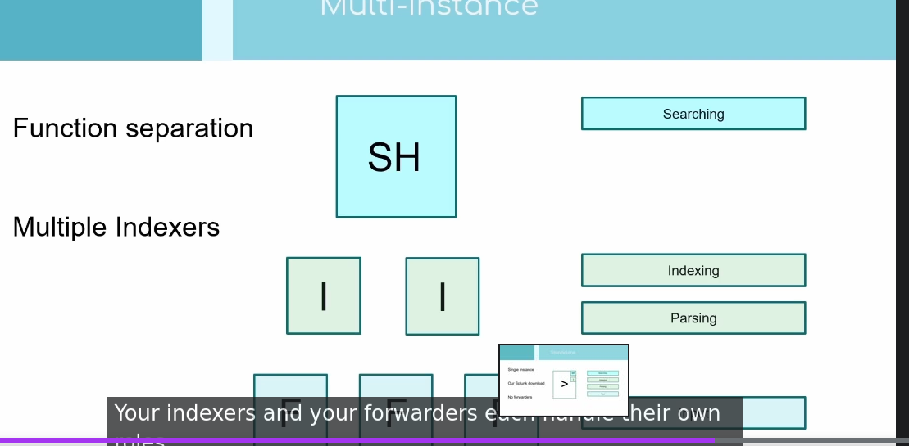

4- Clustering

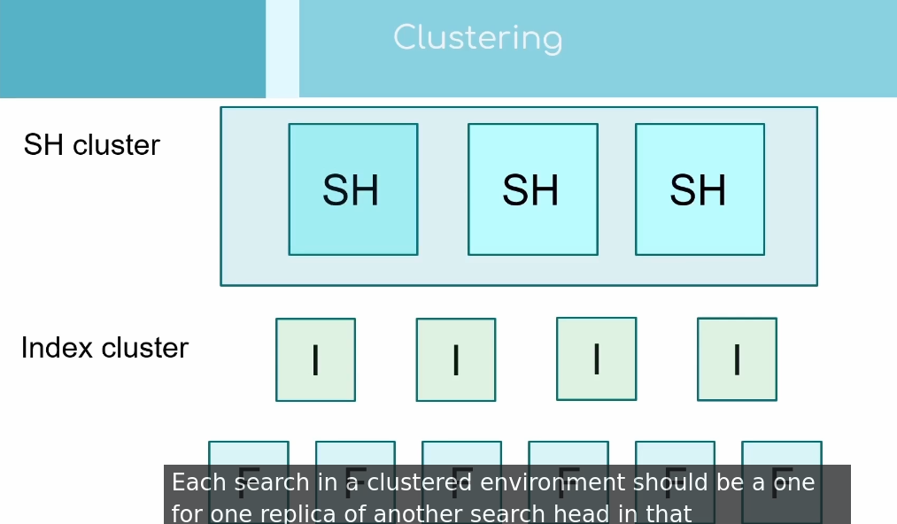
Splunk Installation:
Depuis le site de splunk

Jouer avec les données
Install app
Cisco add on
Unix Add On

source="access.log" host="web2" index="web" sourcetype="access_combined"
index=*

Getting data in Splunk

4- Data pipeline

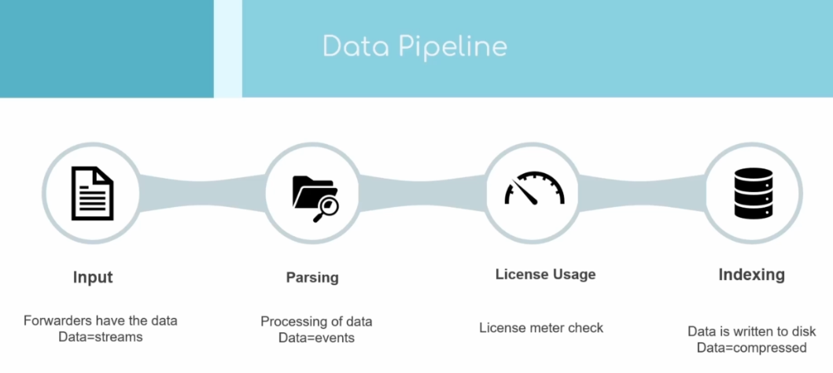
Input phase:

upload data manually, http event collector, network log

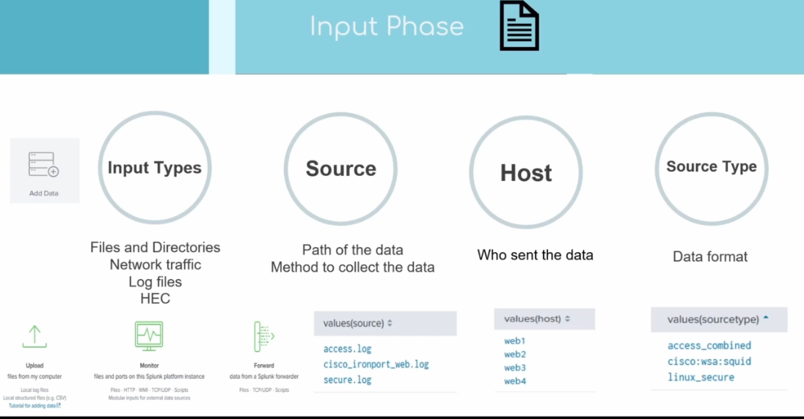

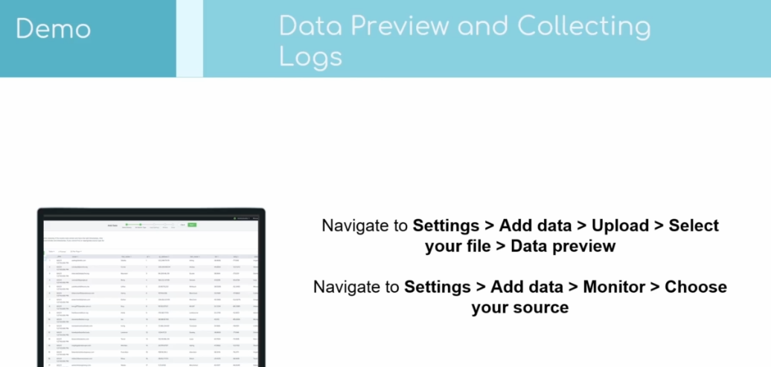
d

Data preview and Creating Inputs

App vs Addon
splunk base, community
SOAR plateform
examples of addon

Add-os : Un composant que vous pouvez déveloper ou réutilisr dans Splunk.
Exemple

a custom search command
- a modular input
- a data model definition
- a custom rest endpoint
- some custom field extractions, sourcetype definitions or macros
- some reusable javascript/CSS such as a custom D3 visualization
Apps:
So one of the key differentiators between Apps and Add-ons is the presentation of a user interface. And we are somewhat spoiled with choice now in Splunk 6 with so many options to consider for developing the UI. So here is a brief overview of the options and why you might choose one over another.

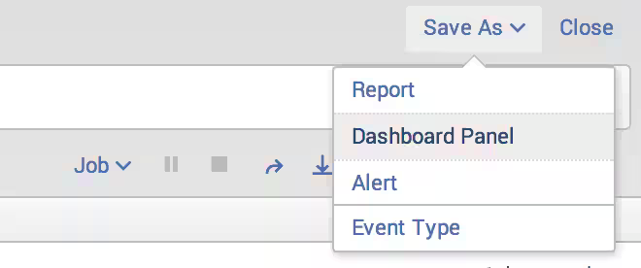
V

https://www.splunk.com/en_us/blog/tips-and-tricks/what-are-splunk-apps-and-add-ons.html

The basics of Searching
source="access.log" host="web1" index="web" sourcetype="access_combined_wcookie" GET

action!= purchage
bytes >=200
bytes <=200

index = web1 NOT action=purchage
wildcard: *

index=security fail*

What are Kos: Knowledges
Knowledge: Alert, Search, Reports, Event types

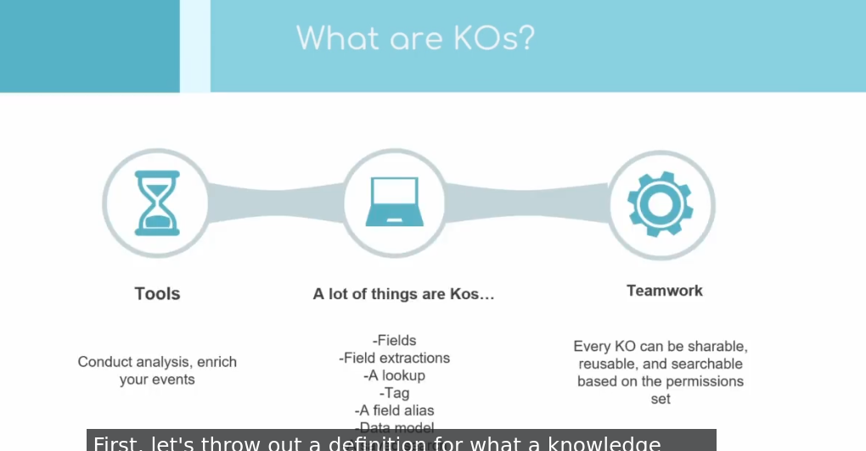
dd
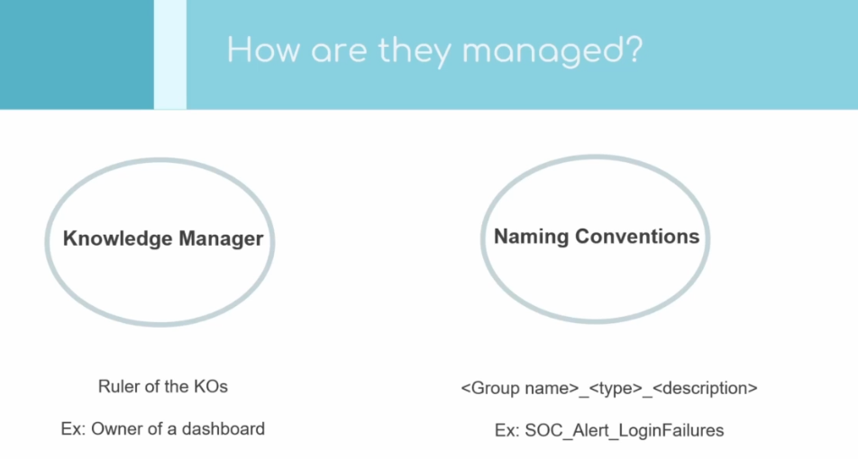
d

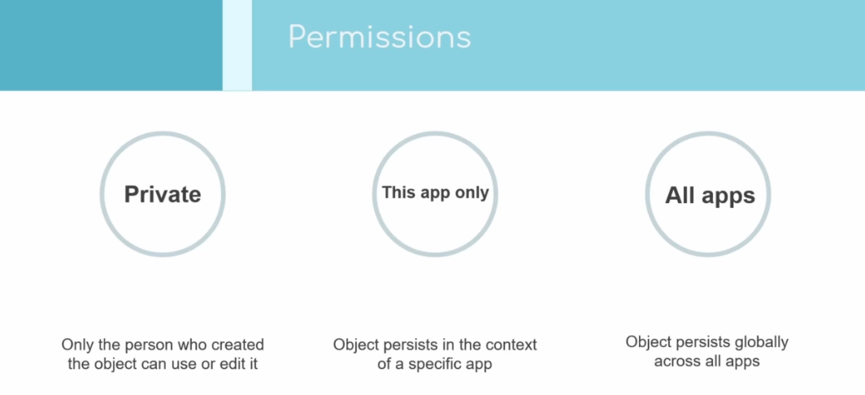
dd

Event type:

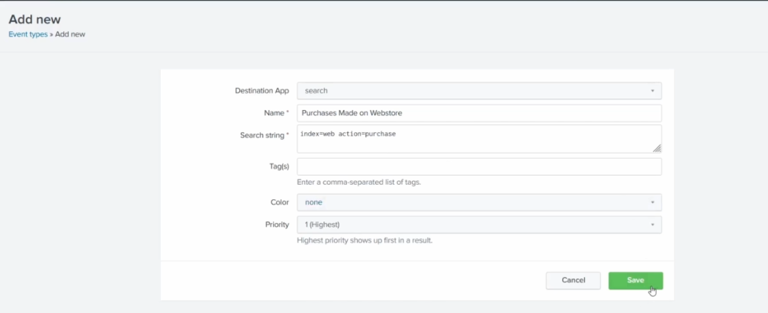
j

Les knowledges Objects on peut gérer les permissions

Show the fields:

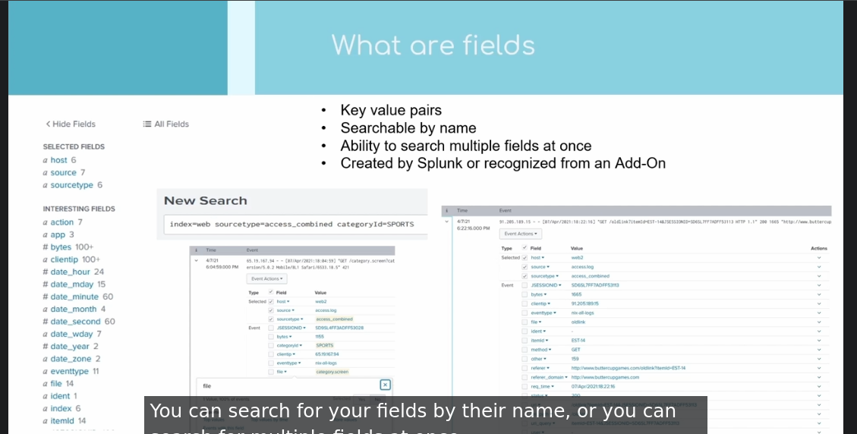
d
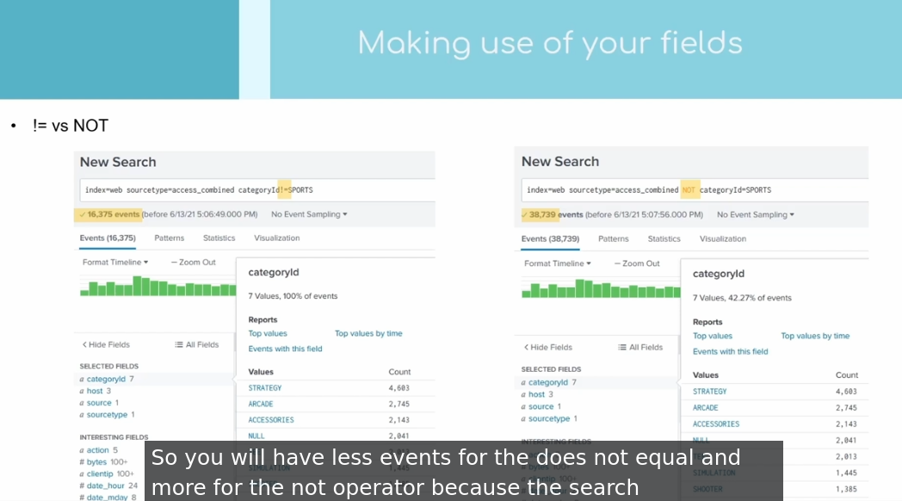
https://djangocas.dev/blog/splunk-search-not-equal-vs-not/

Both!= field expression and NOT operator exclude events from your search, but produce different results
- Example: status != 200
  - Returns events where status field exists and value in field doesn’t equal 200
- Example: NOT status = 200
  - Returns events where status field exists and value in field doesn’t equal 200 – and all events where status field doesn’t exist
- Does != and NOT ever yield the same results?
  - Yes, if you know the field you’re evaluating always exists in the data you’re searching
  - For example:
    - index=web sourcetype=access_combined status!=200
    - index=web sourcetype=access_combined NOT status=200 yields same results because status field always exists in access_combined sourcetype.

Search Processing Languages: SPL

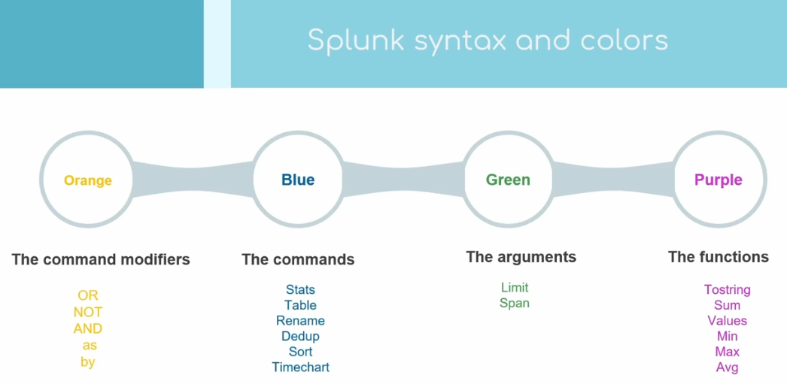
d
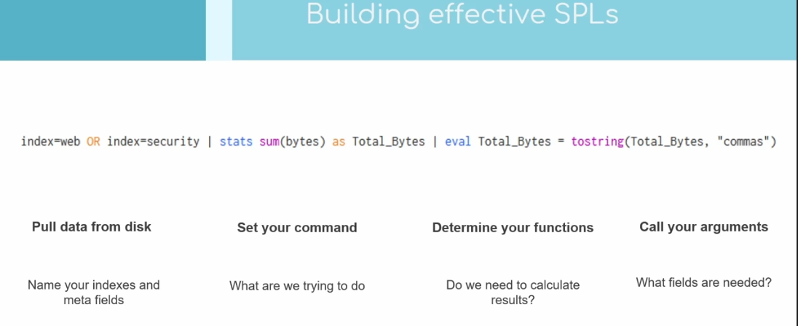
s

source="secure.log" host="web1" index="security" sourcetype="linux_secure"

stats
sum
eval

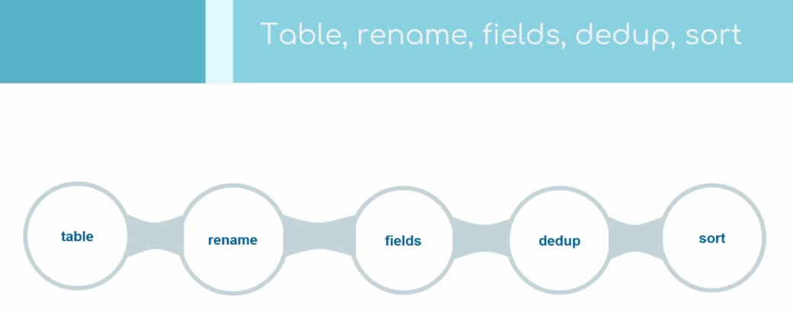
d
index=web OR index=security | stats sum(bytes) as Total_Bytes

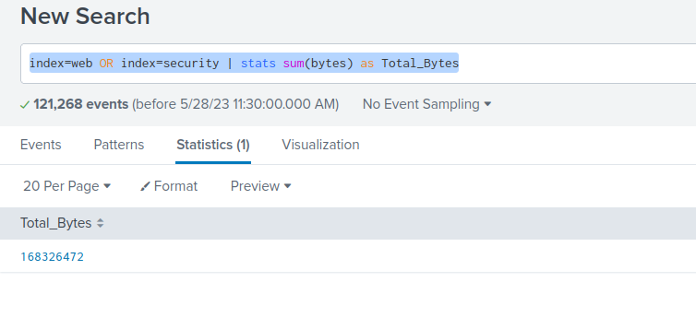
d

index=web OR index=security | stats sum(bytes) as Total_Bytes | eval Total_Bytes = tostring (Total_Bytes, "commas")
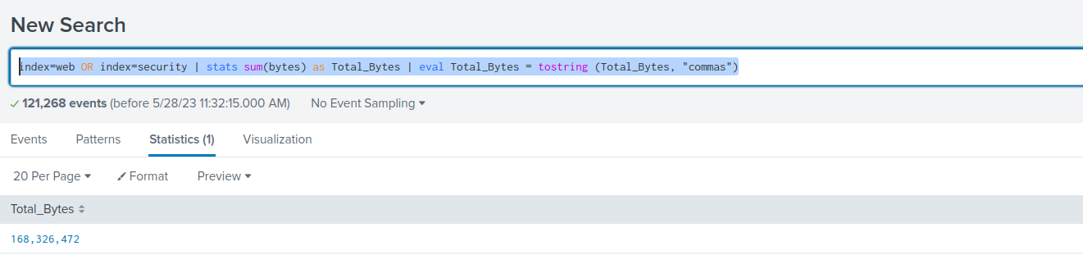
d

index=web action=purchase
| top limit=4 categoryId

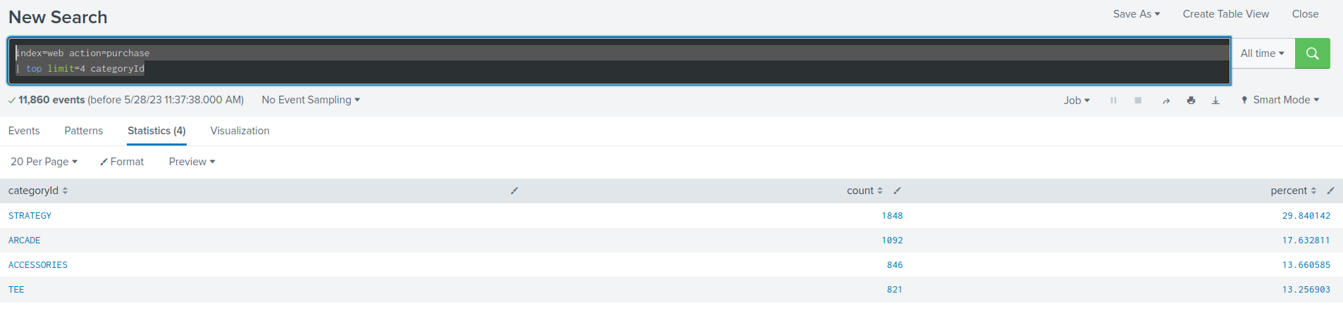
d

index=web action=purchase
| top limit=4 categoryId
| stats sum(count) as "Total achat"
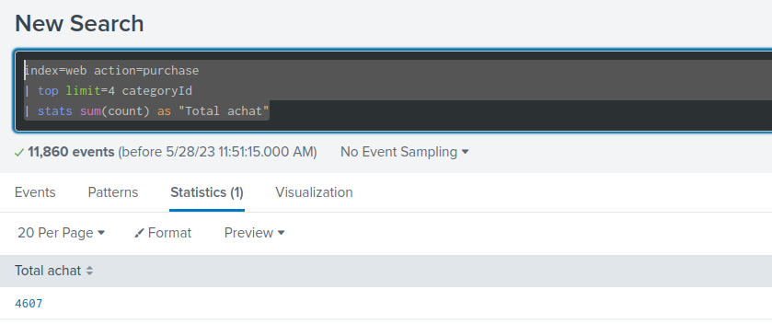
d

index=web
| table clientip, action categoryId, status
| where isnotnull(action)

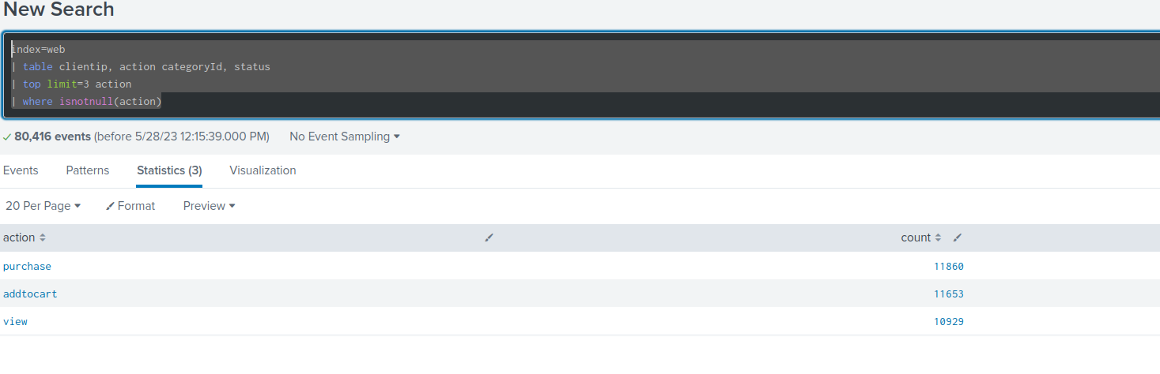
d
s

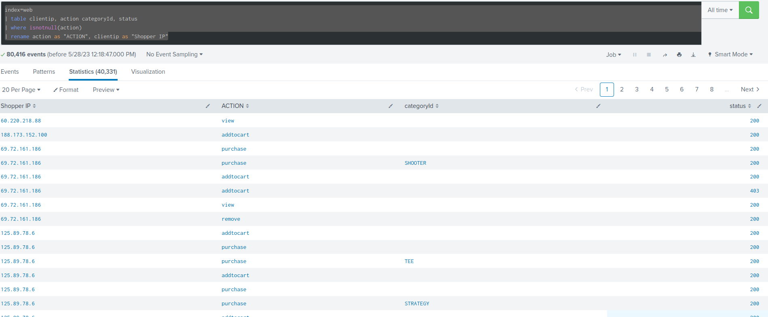
d

Fields:
index=web
| fields clientip, action categoryId, status

Table:
index=web
| table clientip, action categoryId, status

Dedup

index=web
| table clientip
| dedup clientip

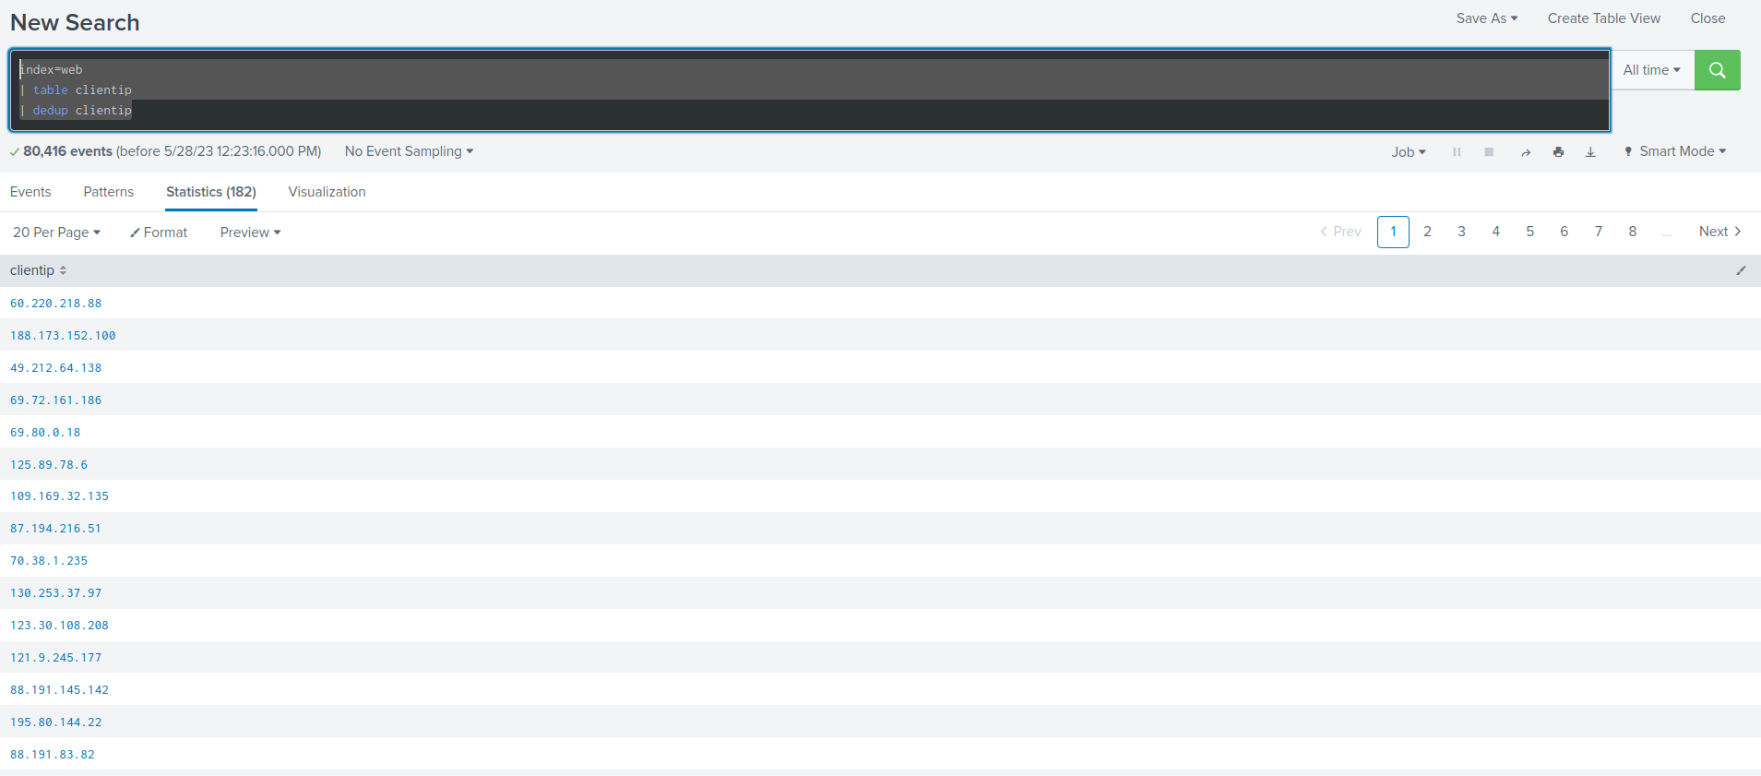
d

index=web
| table clientip
| dedup clientip
| sort = clientip

Operator: AND, OR, NOT, !=, =, >=, >, <, <=
stats
dedup, sort, count

index=web
| stats count by clientip

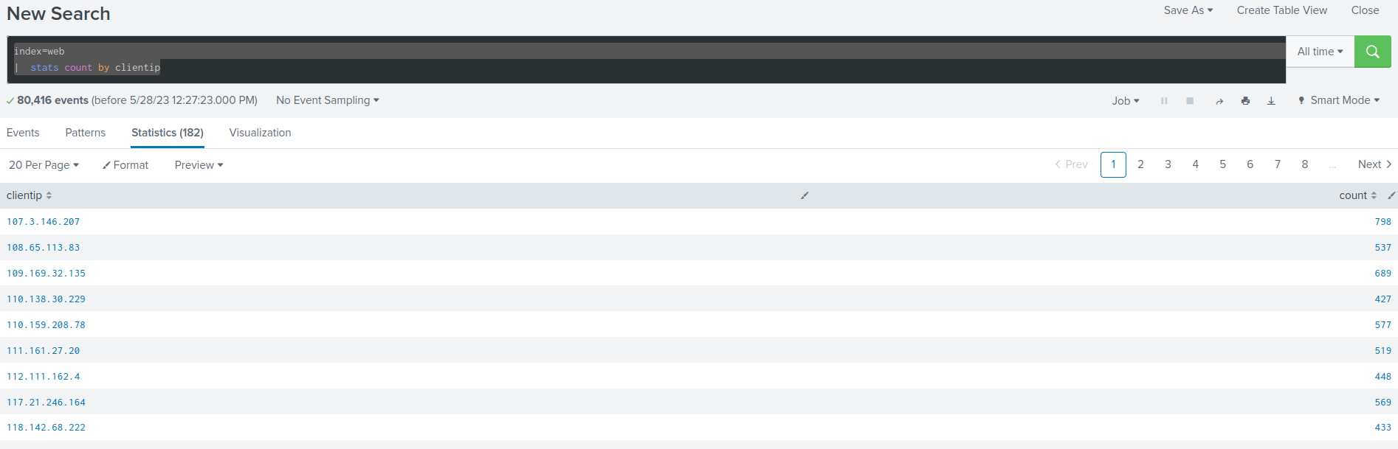
d

Transforming your chearch
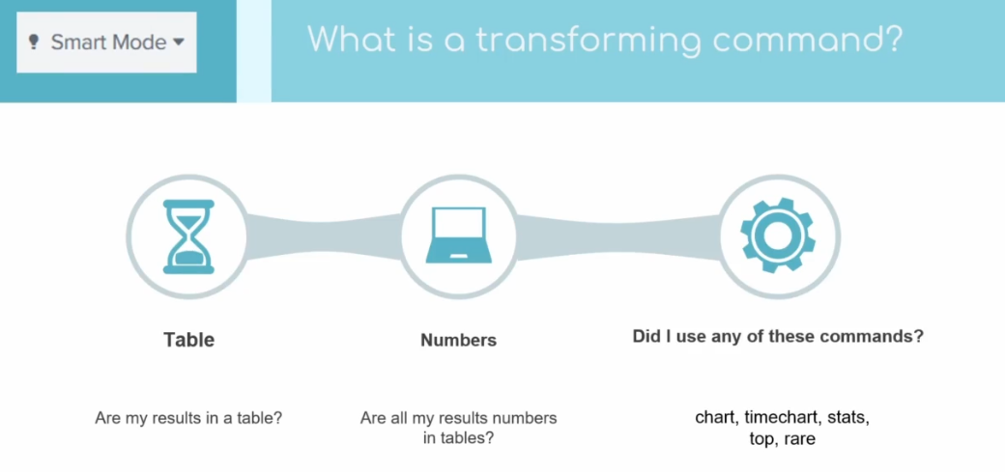
d

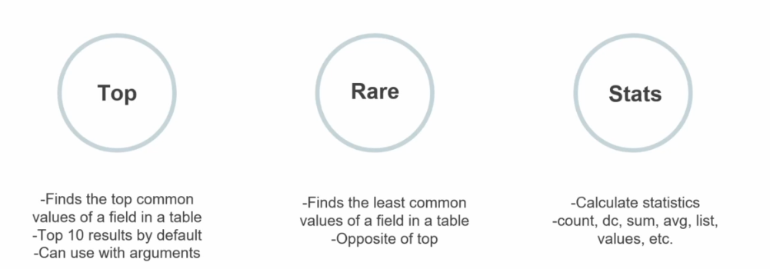
d

Transforming commands

index=web | top file
index=web | to limit=3 file

index=web
| top limit=1 categoryId

index=web
| rare limit=1 categoryId

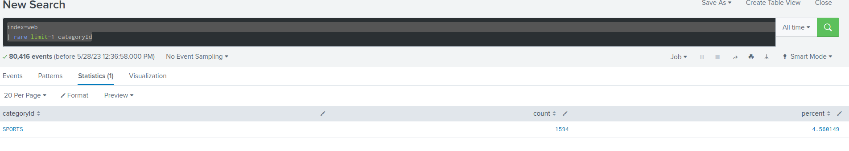
d

stats function:
- sum, avg, count, dc, list …

dc: distinct count

index=web
| dedup categoryId
| stats list(categoryId)

# index=web
| stats count by referer_domain, action
| stats sum(count) by referer_domain

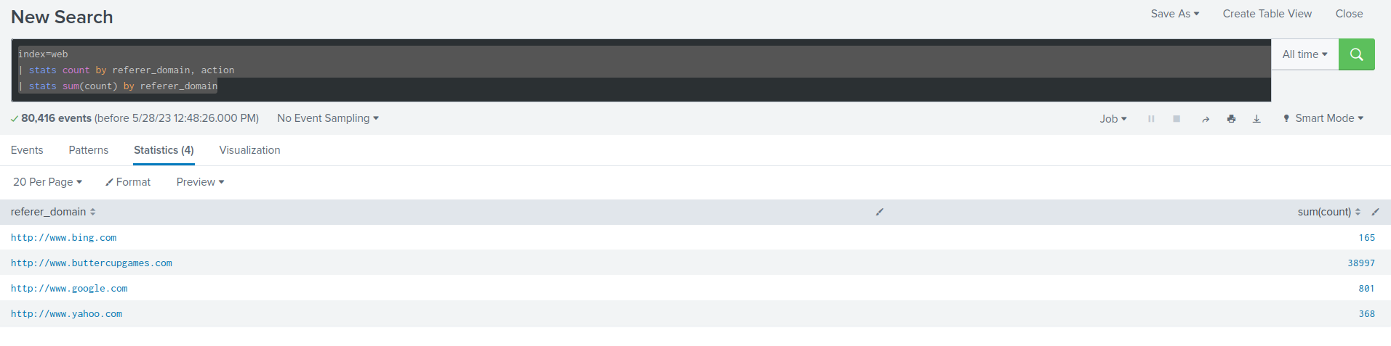
What are the events telling me?
Transaction command
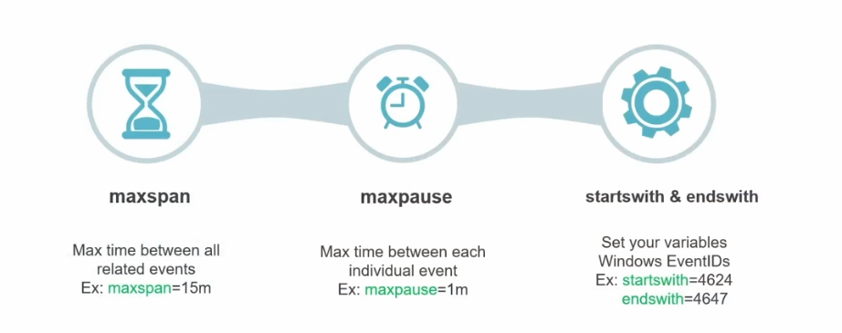
d
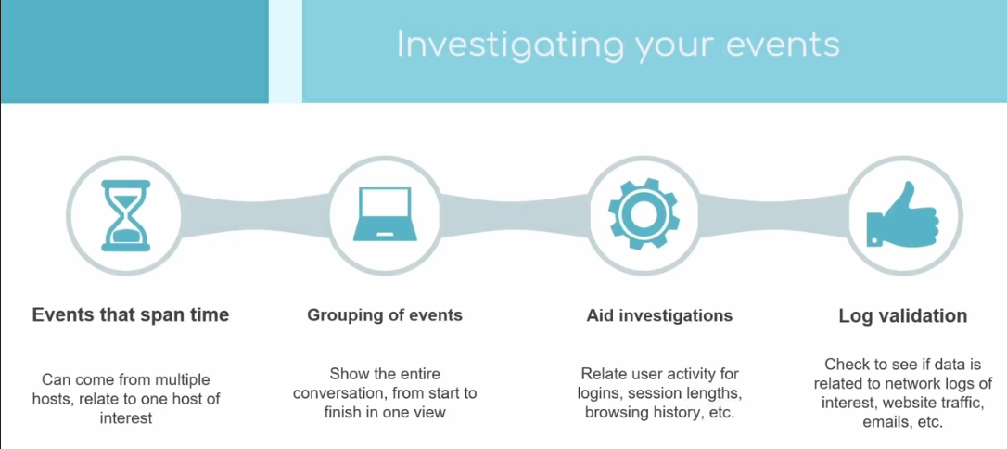
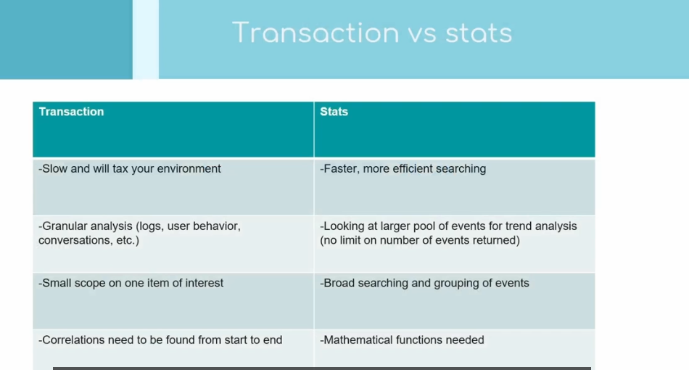
Les transactions
maxspan, maxpause
index=web
| transaction maxspan=10m maxpause=3s

index=web
| transaction JSESSIONID maxspan=10m maxpause=3s

index=web
| search status=404
| transaction JSESSIONID maxspan=10m maxpause=3s

index=security
| transaction src startswith=sshd maxspan=3m maxpause=3s

endwith

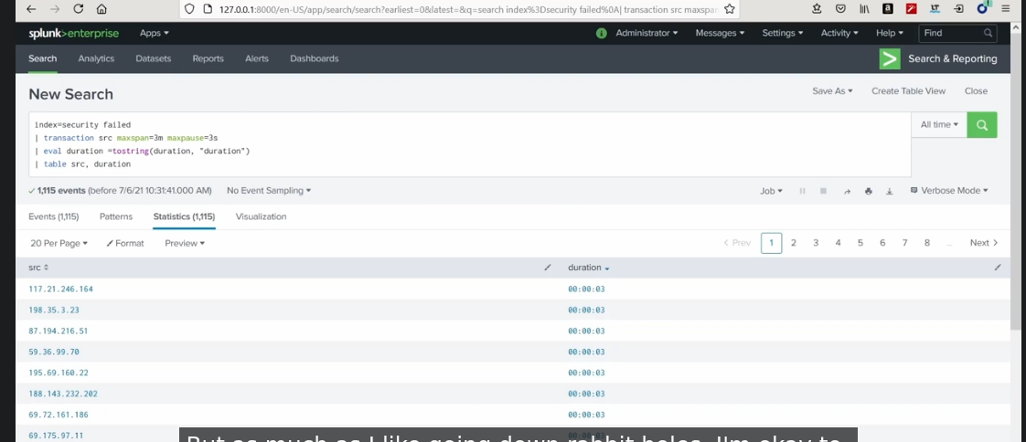
h

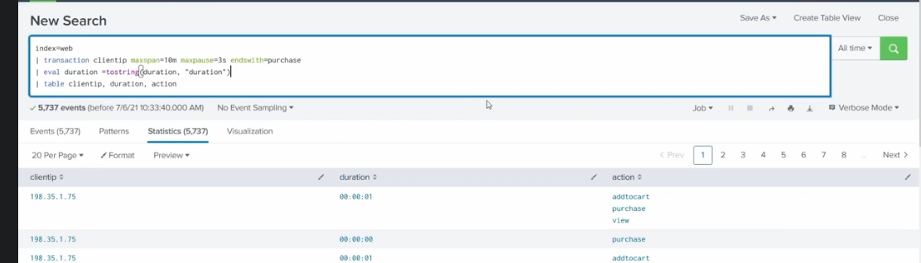
c

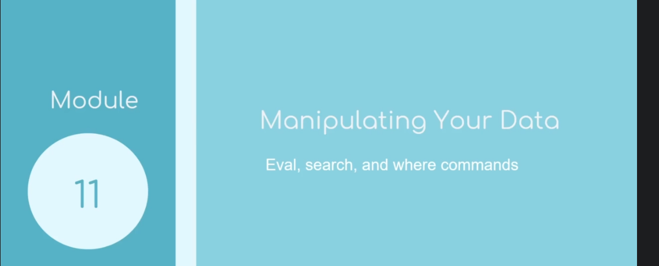
Eval commands

https://docs.splunk.com/Documentation/SCS/current/SearchReference/EvalCommandExamples

Stats

https://docs.splunk.com/Documentation/Splunk/9.0.4/SearchReference/Stats

sourcetype=access_* | stats count BY status, host

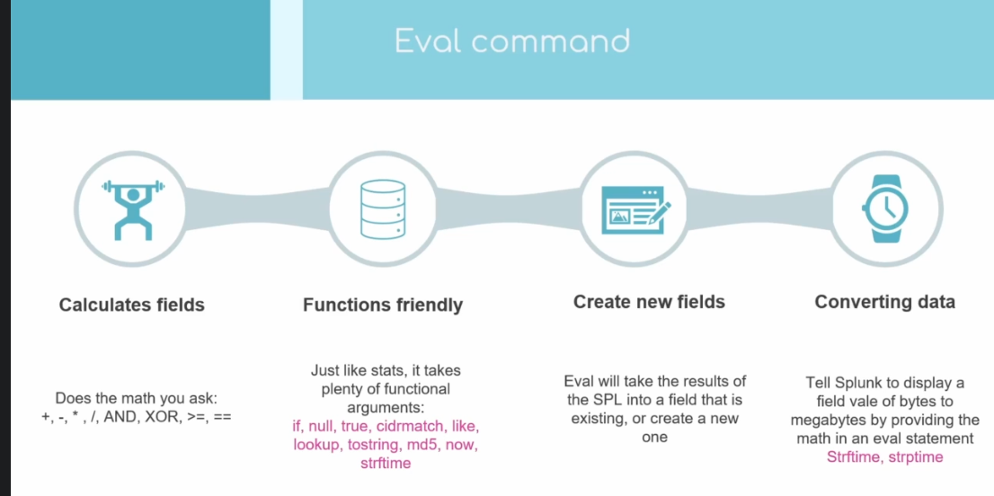
d
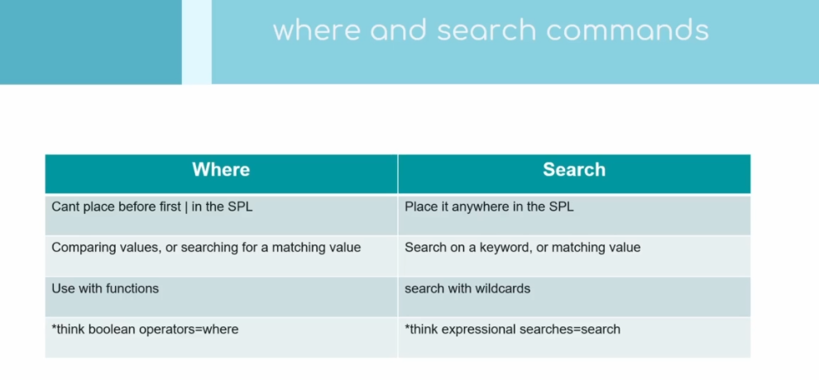
d
index="_internal"
| eval epoch_time = strptime(_time, "%s")
| eval human_redable_time = strftime(epoch_time, "%m/%d/%y")
| table _time, epoch_time, human_redable_time

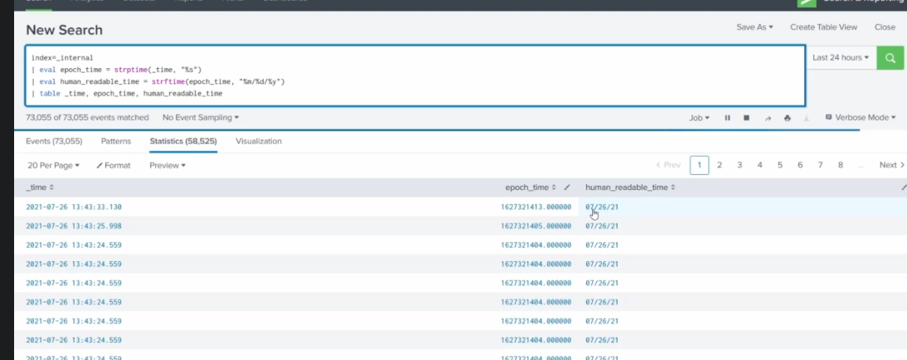
index="_internal"
| eval epoch_time = strptime(_time, "%s")
| eval human_redable_time = strftime(epoch_time, "%m/%d/%y %H:%M")
| table _time, epoch_time, human_redable_time

index="_internal"
| eval DayOfTheYear = strftime(_time, "%j")
| search DayOfTheYear

functions:
- strptime
- strftime

search commands
https://docs.splunk.com/Documentation/SCS/current/SearchReference/SearchCommandExamples

index=web
| eval status_codes = case ( (status=404), "not found", (status==400), "bad request response")
| stats count by status, status_codes

index=web
| eval status_codes = case ( (status=404), "not found", (status==400), "bad request response", (status==200), "Success")
| stats count by status, status_codes

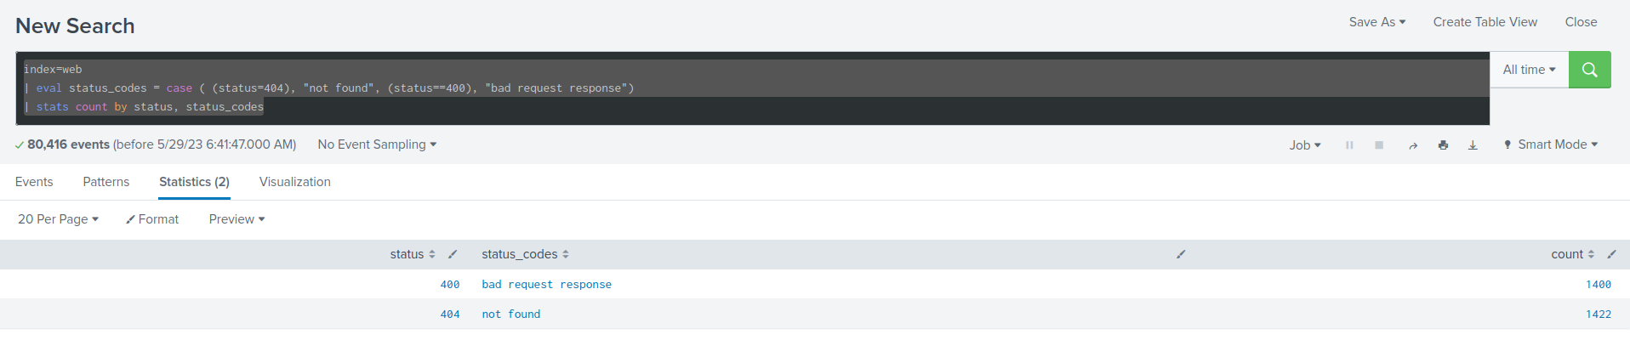
s
index=web
| stats count(eval(status==404)) as "Not found"

hash

index=web | eval hash=md5(file)| search hash=7bd51c850d0aa1df0a4ad7073aeaadf7

dedup commands
https://docs.splunk.com/Documentation/SCS/current/SearchReference/DedupCommandExamples
index=web
| dedup file
| table file

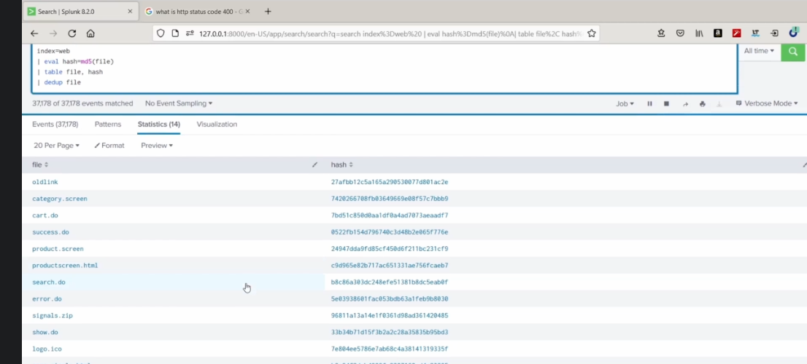
g
Where commands

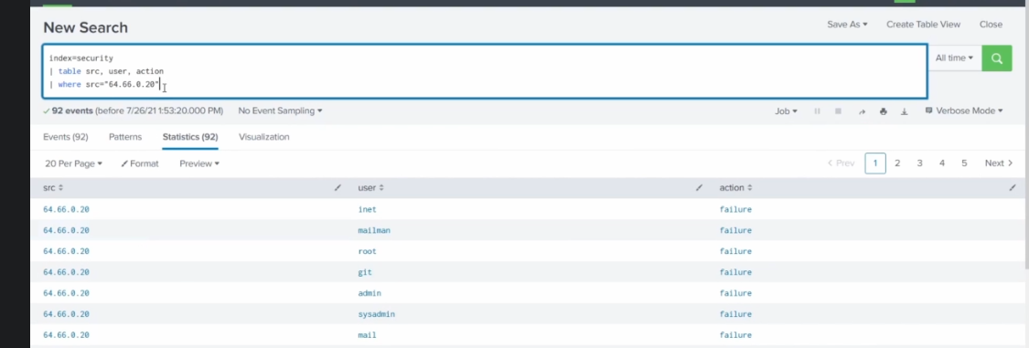
d
like
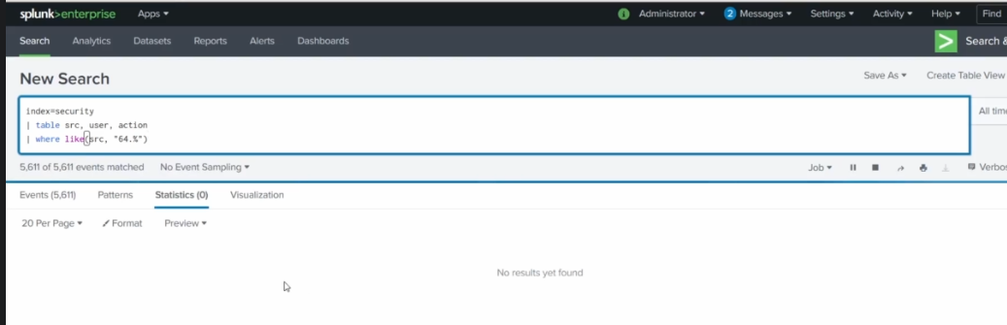
f

Fields, Parts 2

Extractions methods
Erex & Rex commands
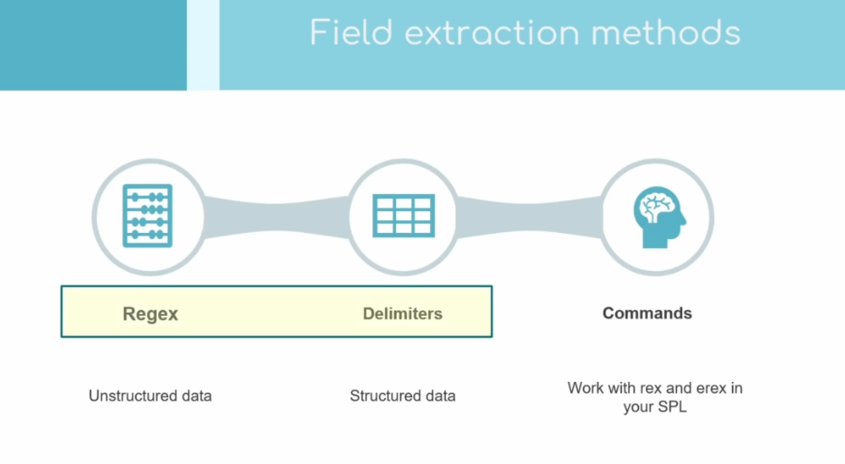
rf
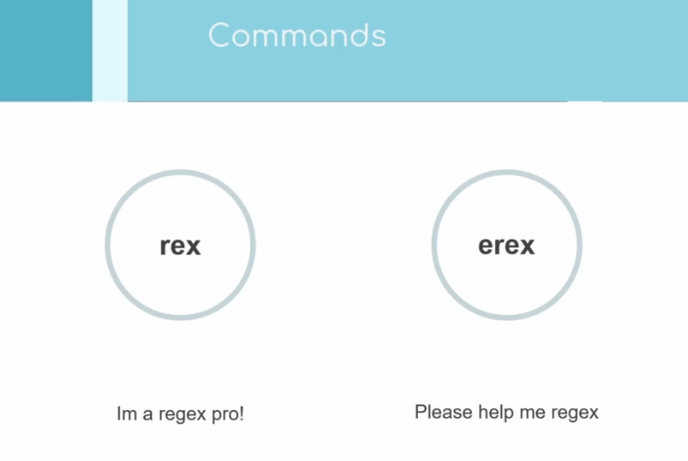
hh

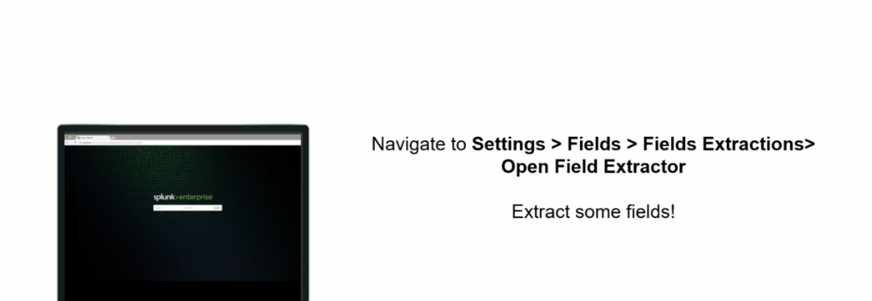
d
rex
index=web
| rex field=_raw (?<email>"\S+@\S+.com")
| table email

regex101.com

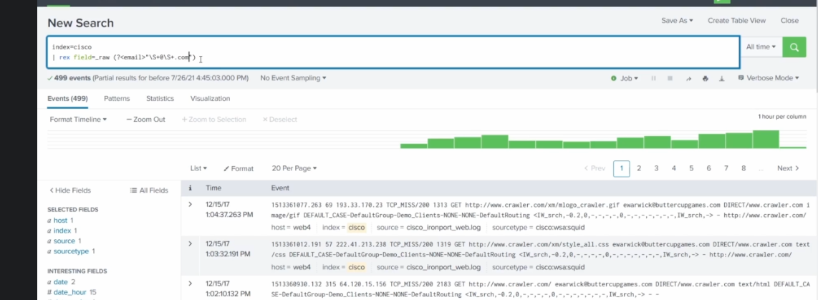
h

Lookups
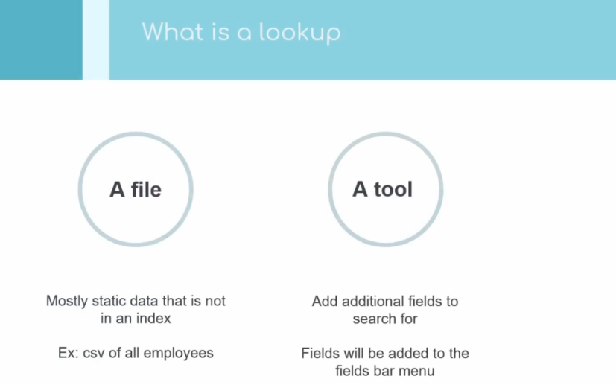
h

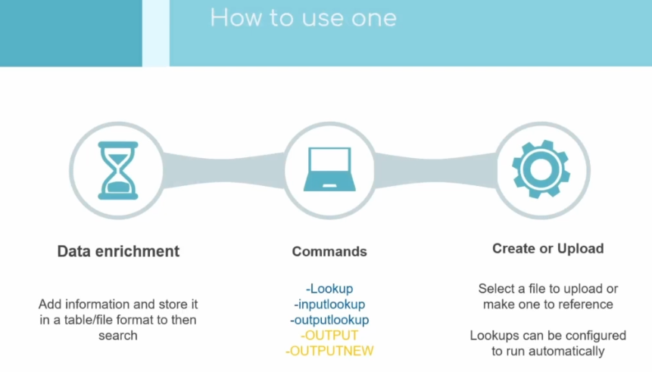
h

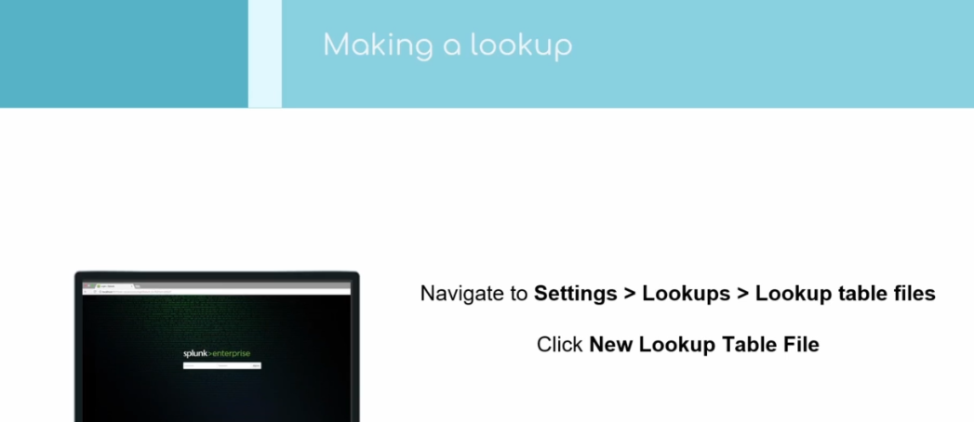
l
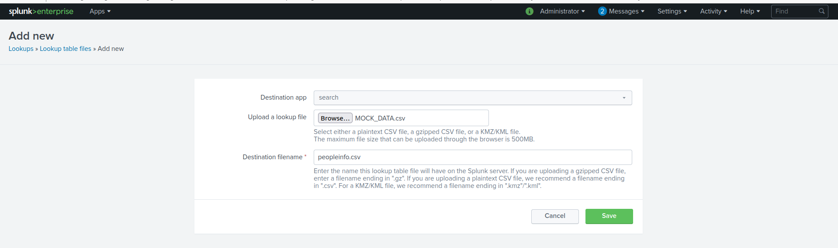

| inputlookup peopleinfo.csv

| inputlookup peopleinfo.csv where first_name=Henry

create lookup definition

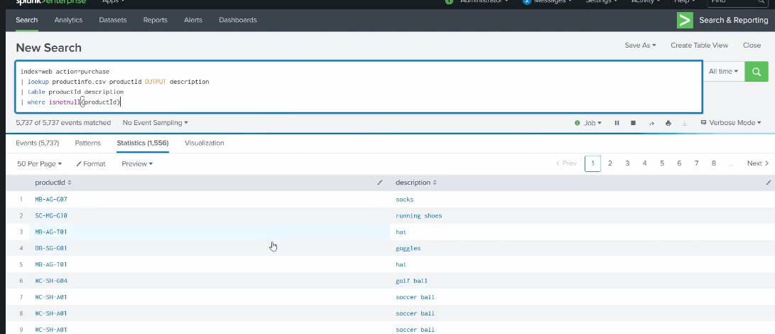
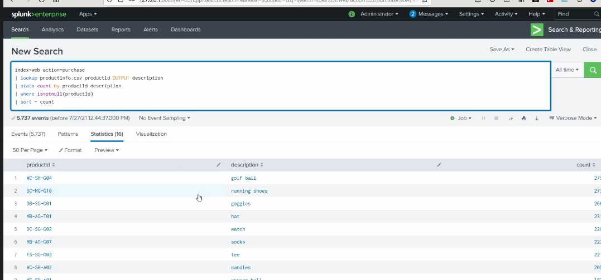
d

dedup commands
https://docs.splunk.com/Documentation/SCS/current/SearchReference/DedupCommandExamples
d

lookup
https://docs.splunk.com/Documentation/SCS/current/SearchReference/LookupCommandExamples

| inputlookup people.csv
where first_name=”Henry”

| inputlookup peopleinfo.csv where (state="New York")

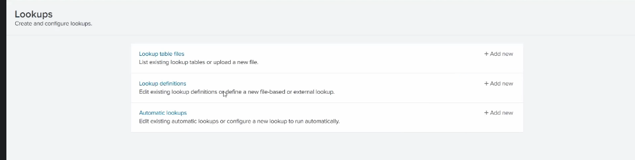
d

lookup definitions
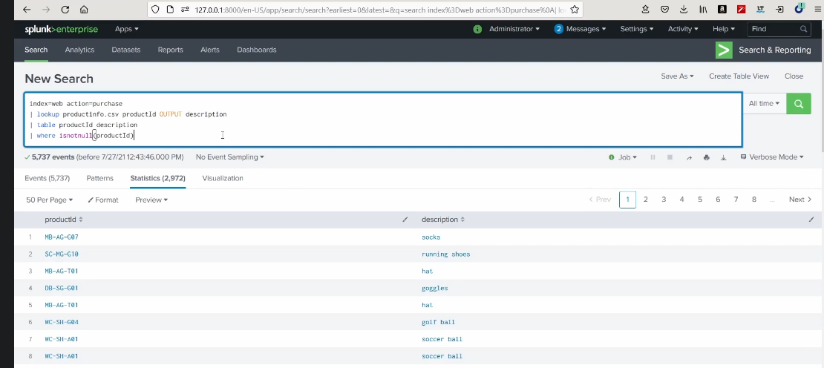
l
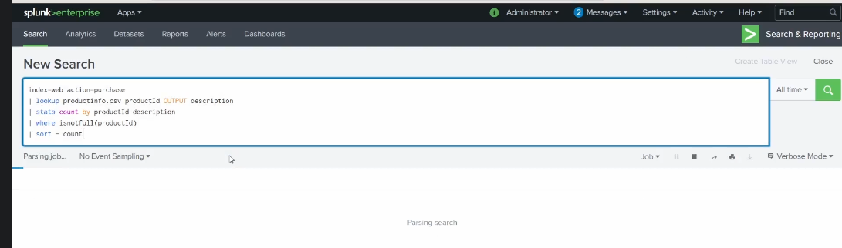
l
Visualize your data
chart, timechart
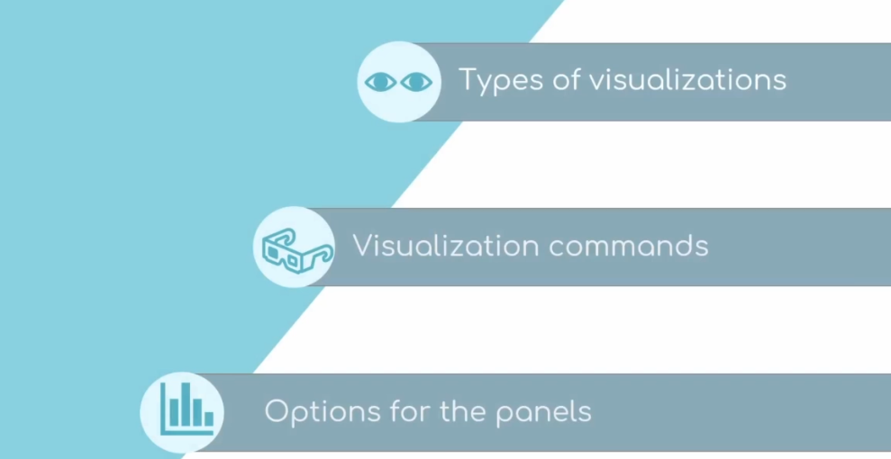
f

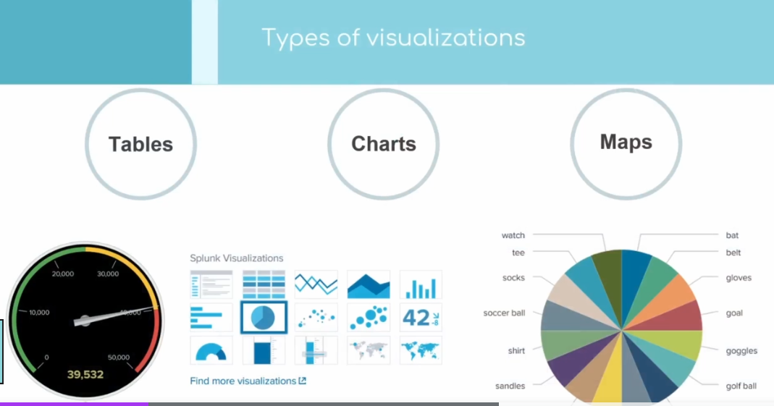
hh

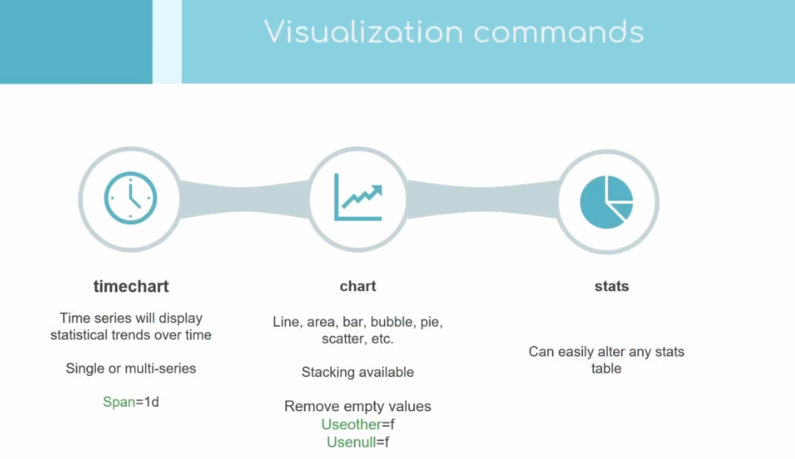
x

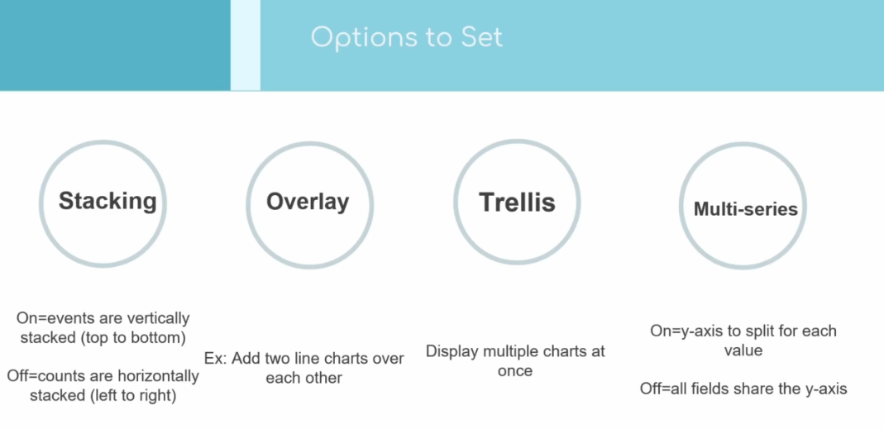
index=web
| timechart avg(bytes)

Column chart
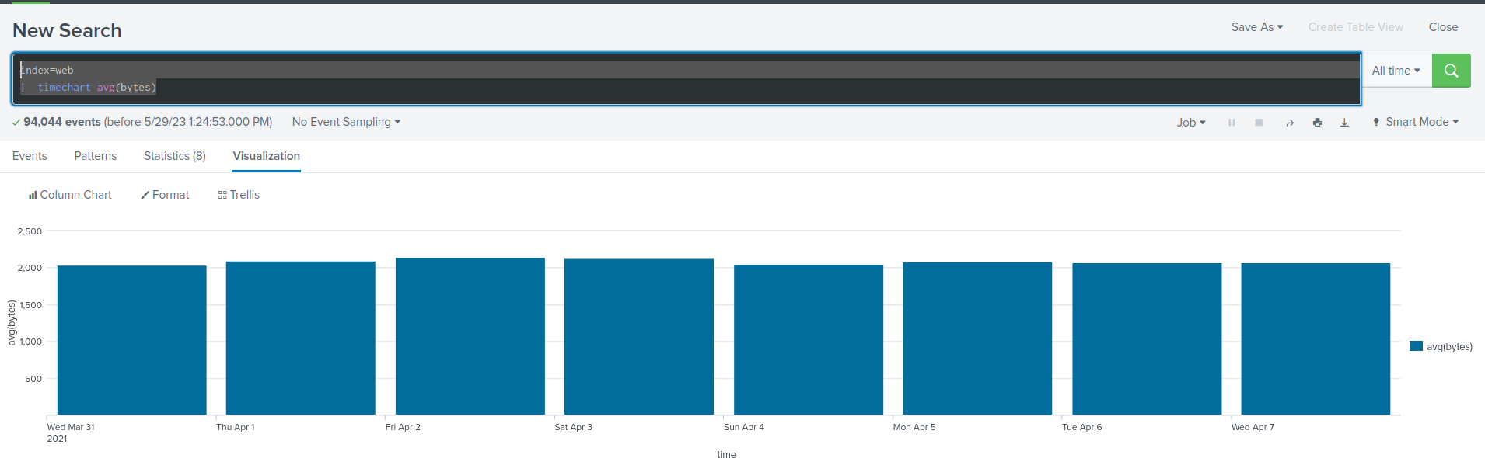
d
Line chart
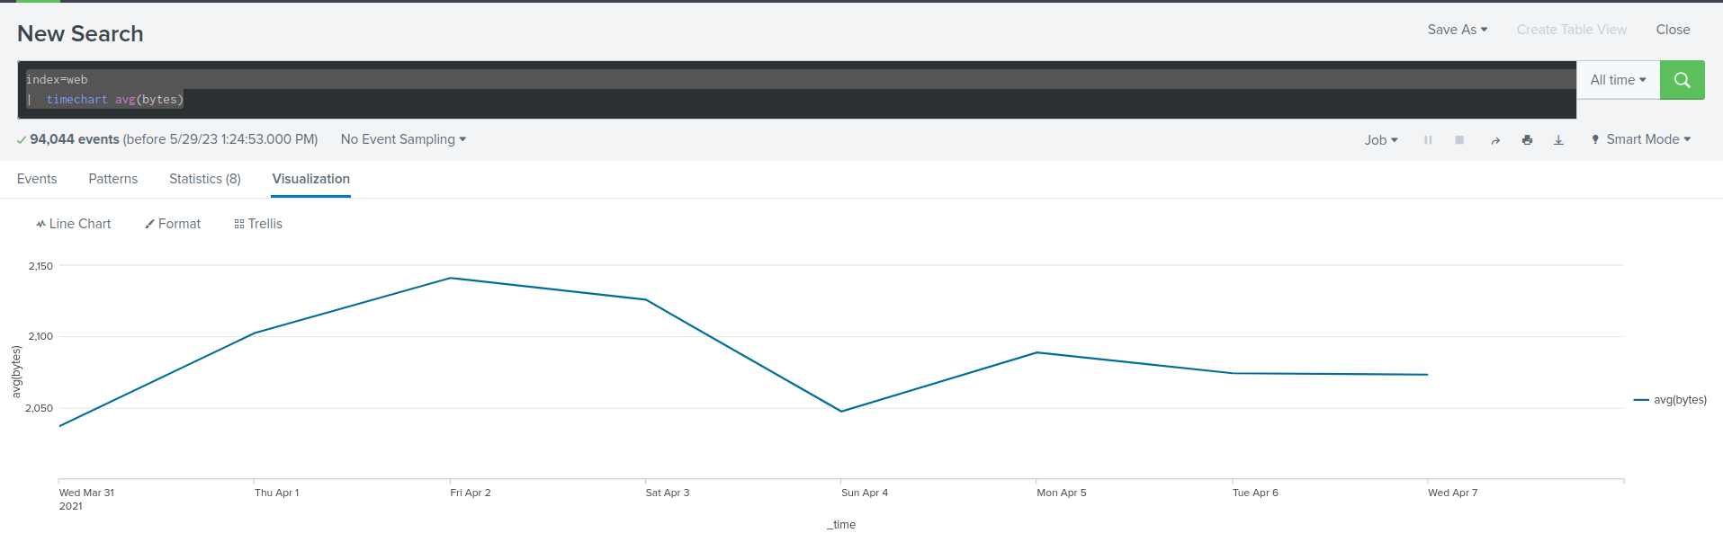
dd
Bar Chart
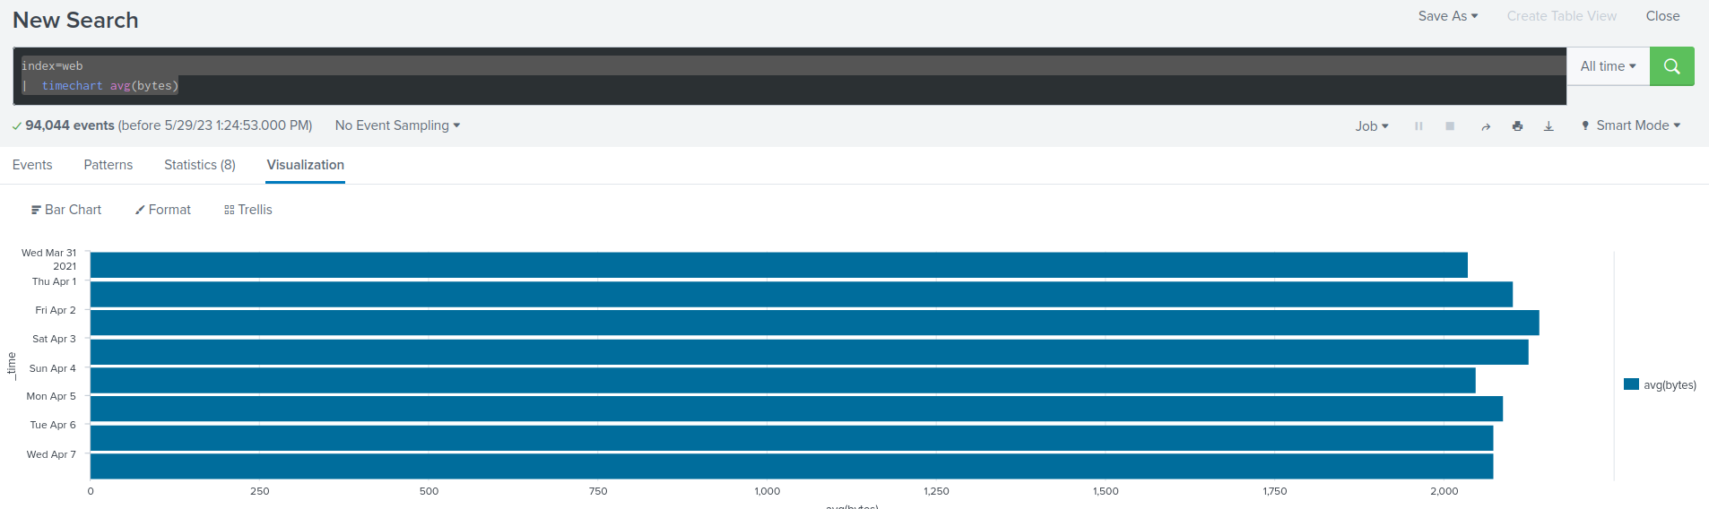
d
index=web
| where isnotnull(action)
| timechart count by action

index=web
| stats count by action
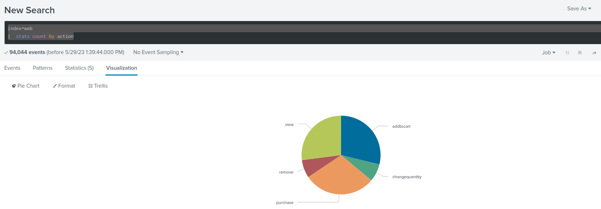
d
Nous pouvons ajouter plusieurs pannels dans un dashboard

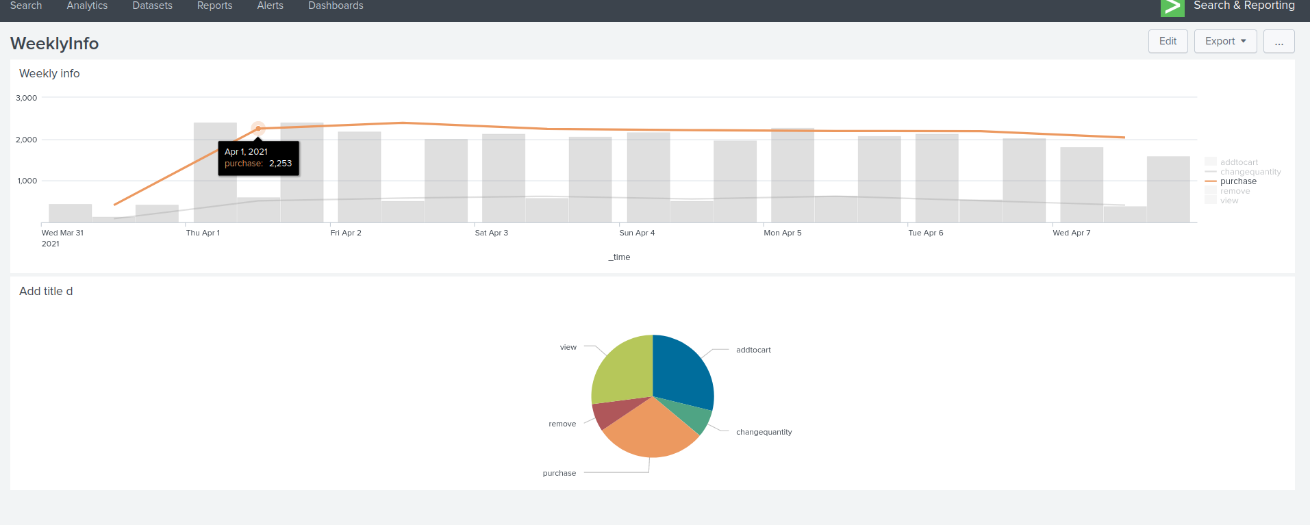
d
Single value
index=web action=purchase
| stats count
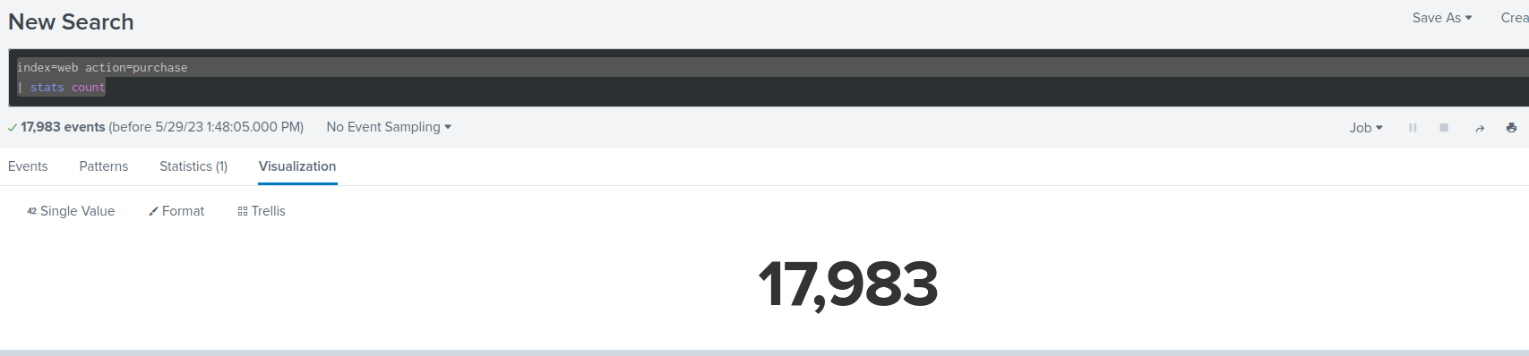
d
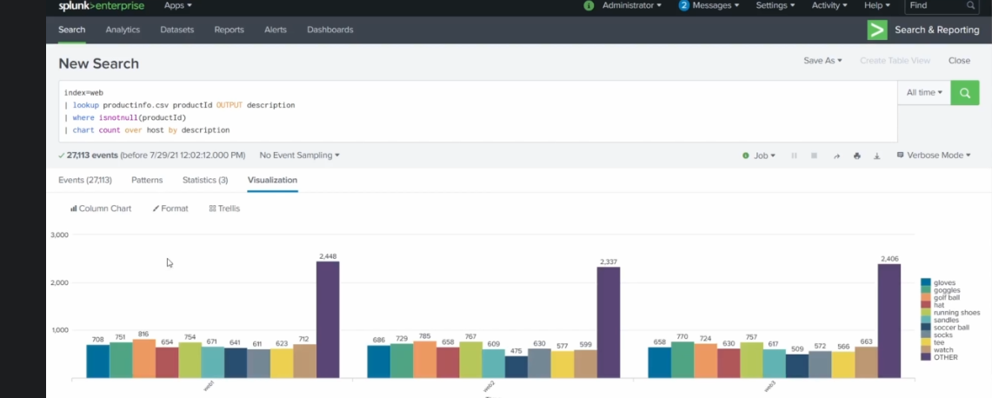
g
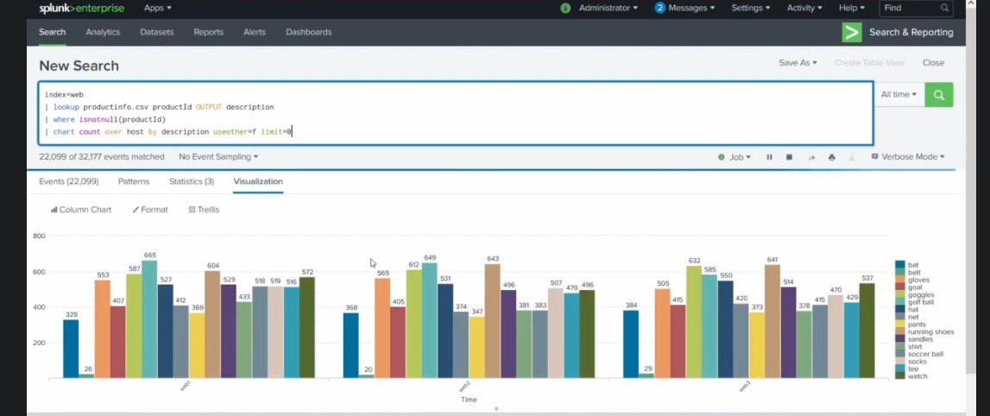
f

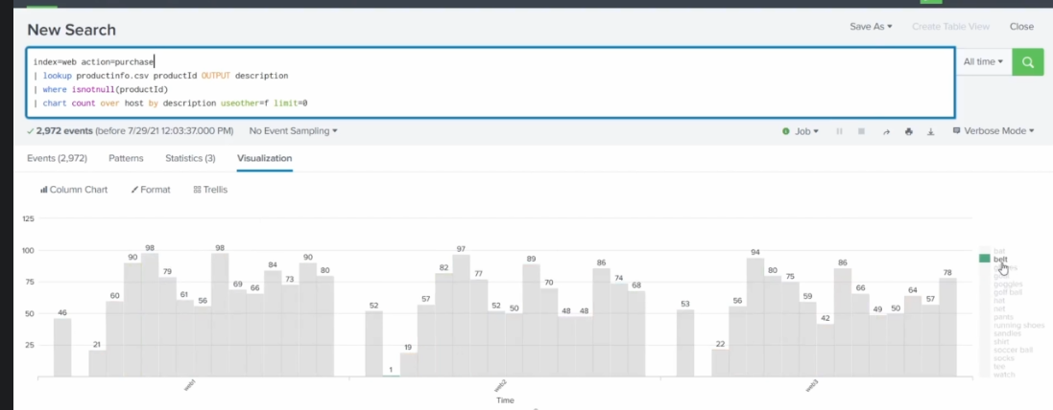
d

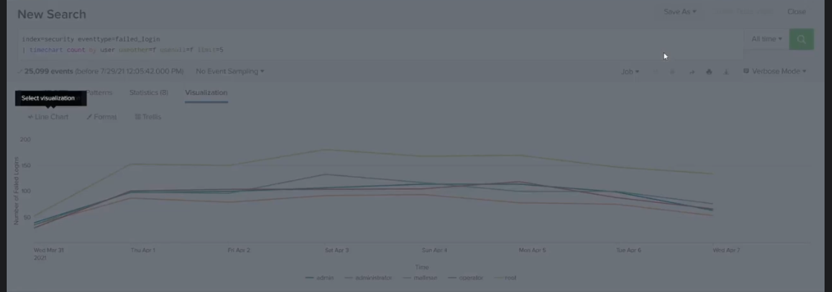
ac

Actions
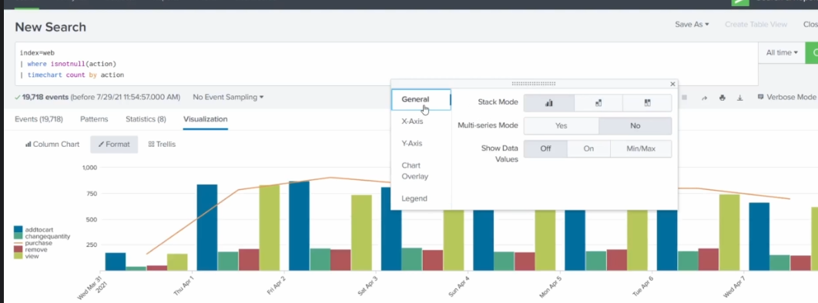
d
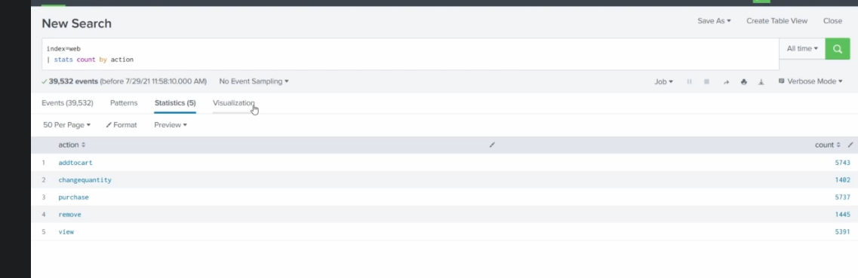
k
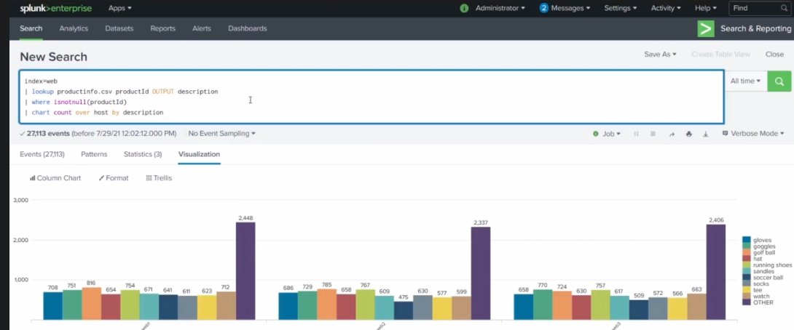
j

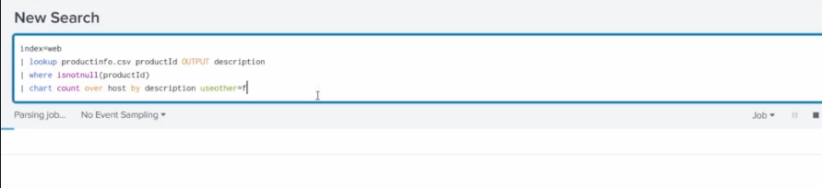
d
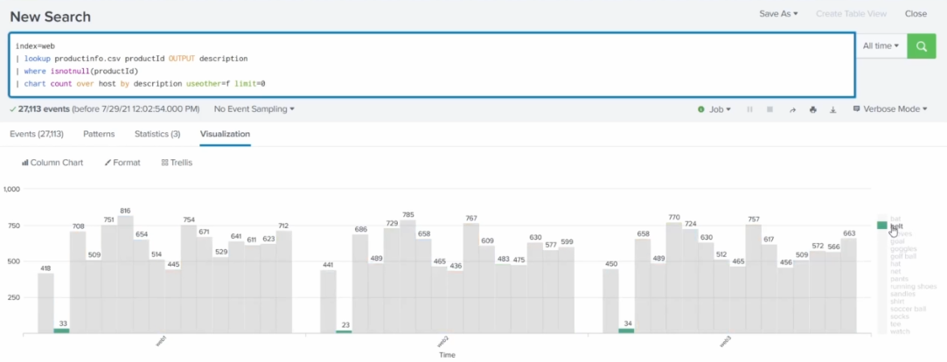
f
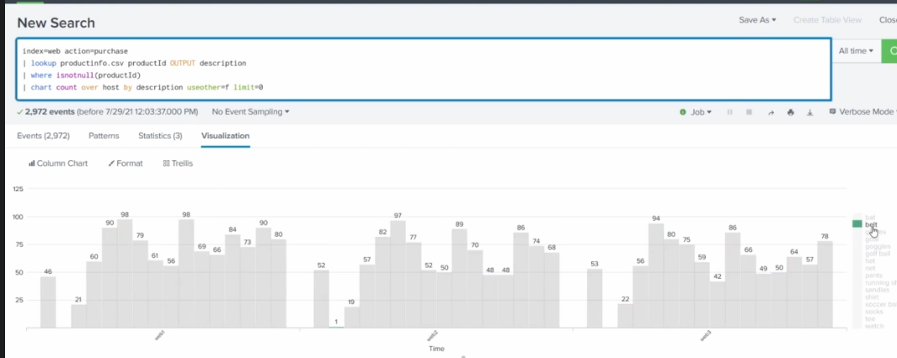
dd

Attacks
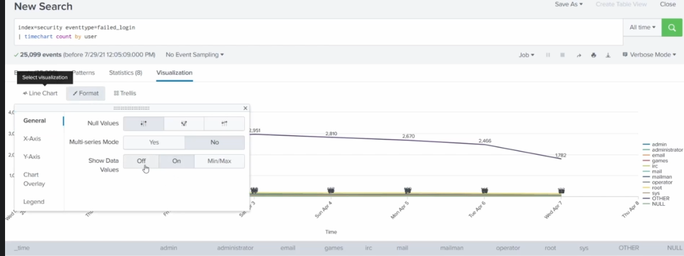
hh
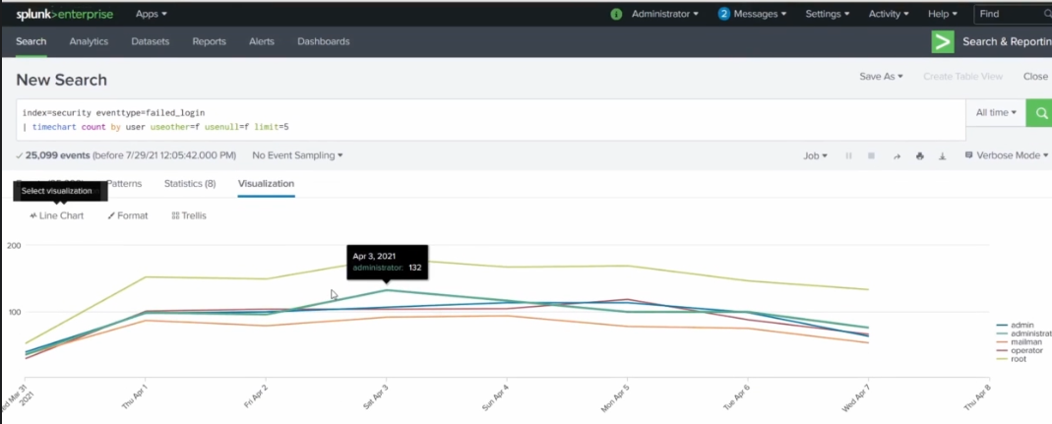
kk
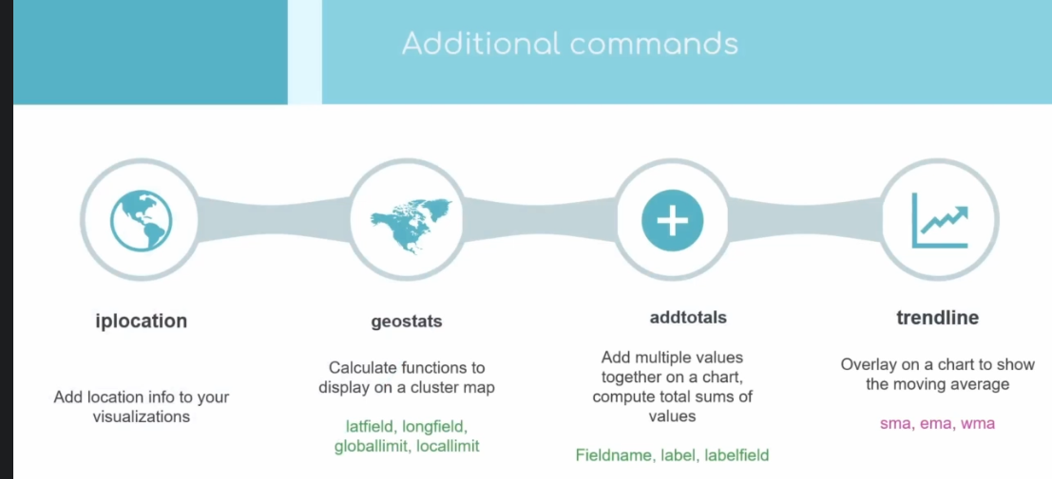
jj

Build another dashboard

index=_internal sourcetype="splunkd"
| timechart count
| trendline sma5(count) as "Our Movig average o total events"
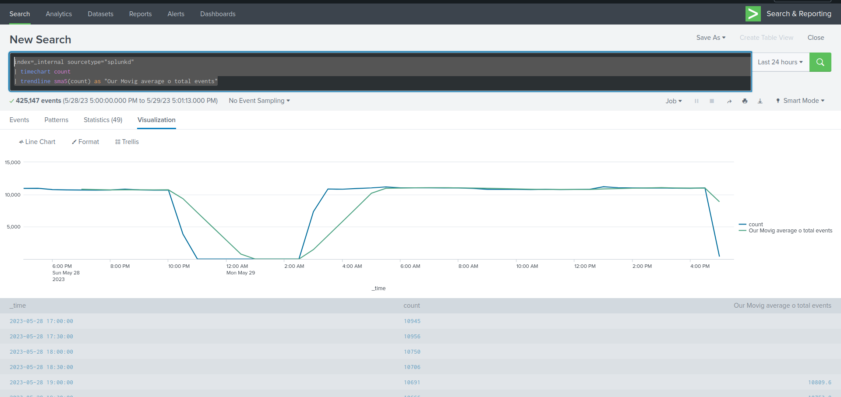
s
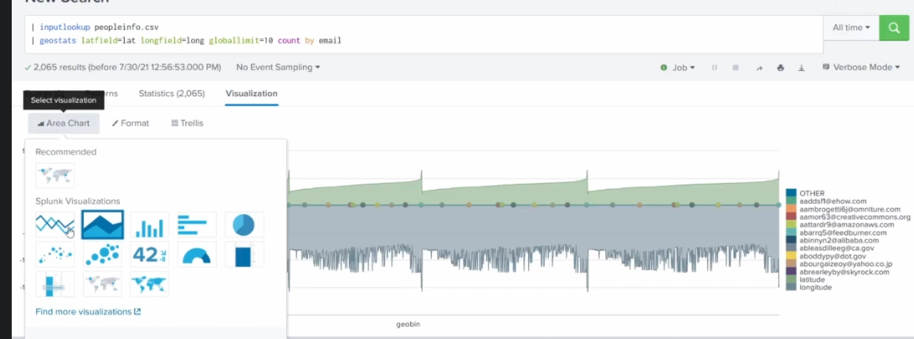
f
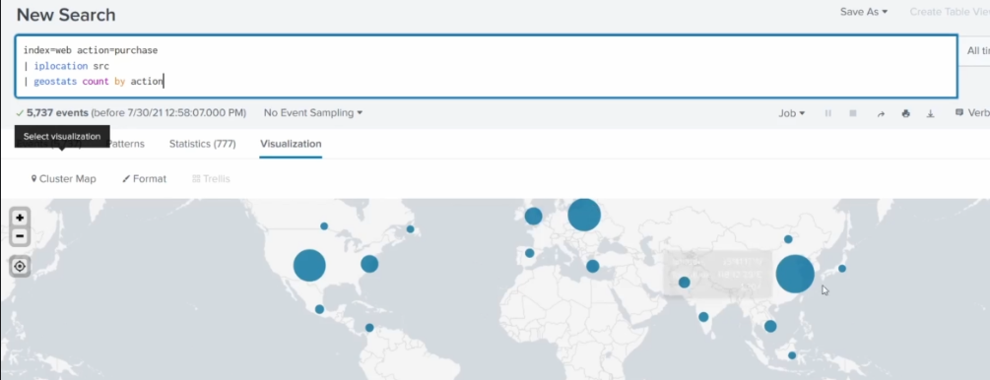
dd
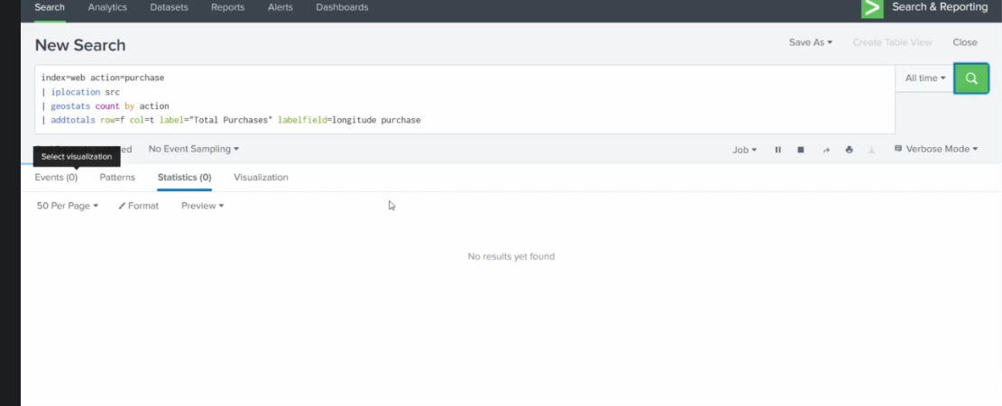
kk
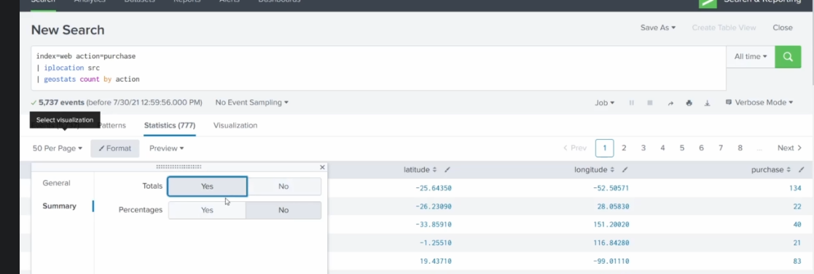
kkk

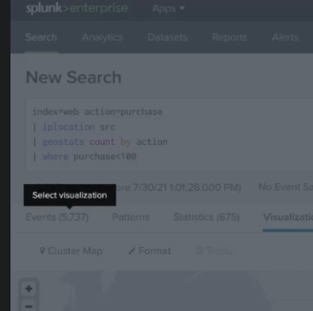
l

Reports & Drilldowns
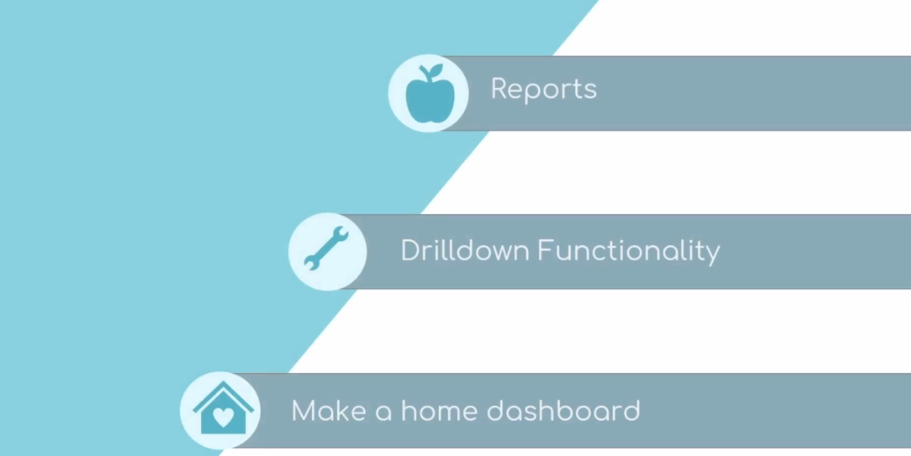
dd
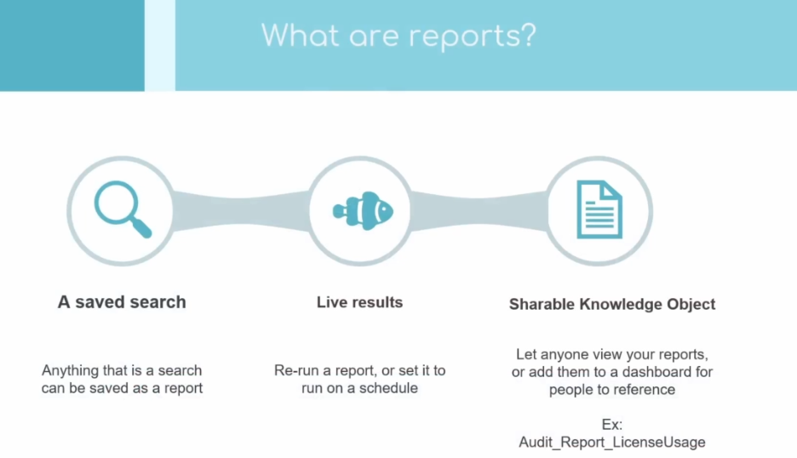
ddd
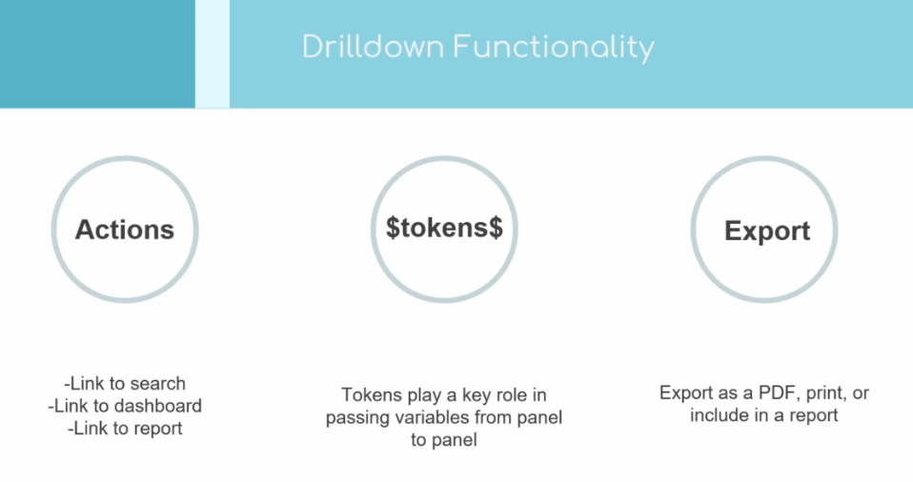
d
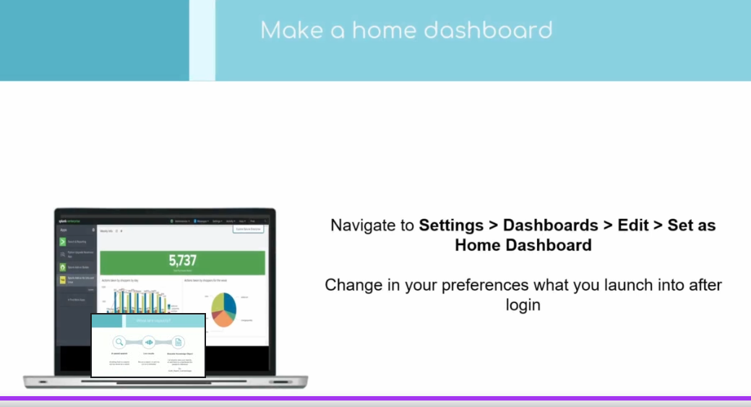
gg

index=_internal log_level=*
| eval Date=strftime(_time, "%m/%d/%Y")
| where isnotnull(reason)
| table log_level, reason, Date

index=_internal log_level=*
| eval Date=strftime(_time, "%m/%d/%Y")
| where isnotnull(reason)
| table log_level, reason, Date
| dedup reason
| sort Date

On peut ajouter un Report à un dashboard

index=_internal log_level=$loglevel$
| eval Date=strftime(_time, "%m/%d/%Y")
| where isnotnull(reason)
| table log_level, reason, Date
| dedup reason
| sort Date

Dans le report
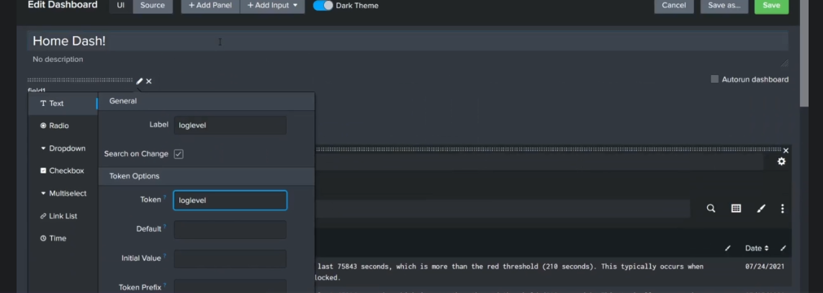
d
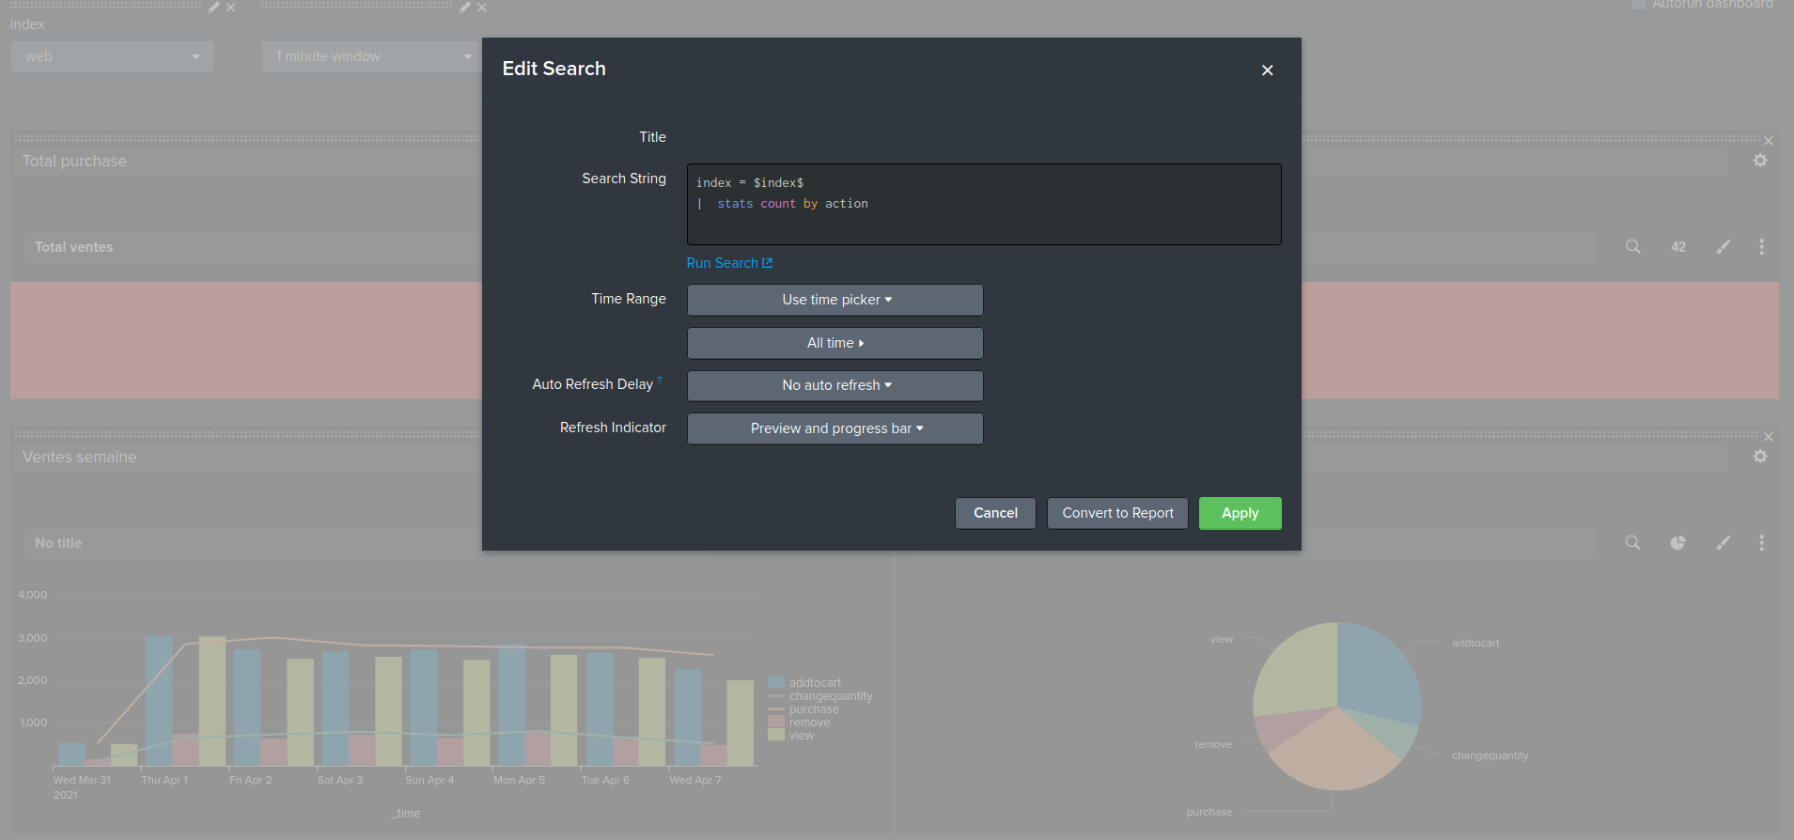
ff
Les Alerts

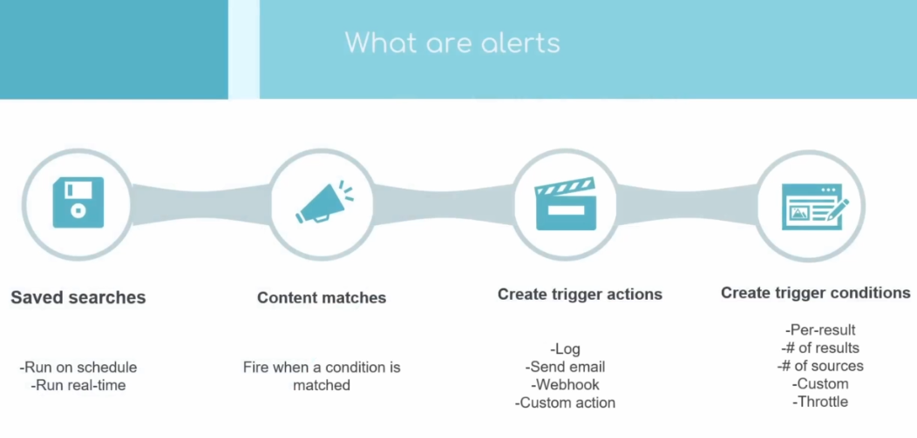
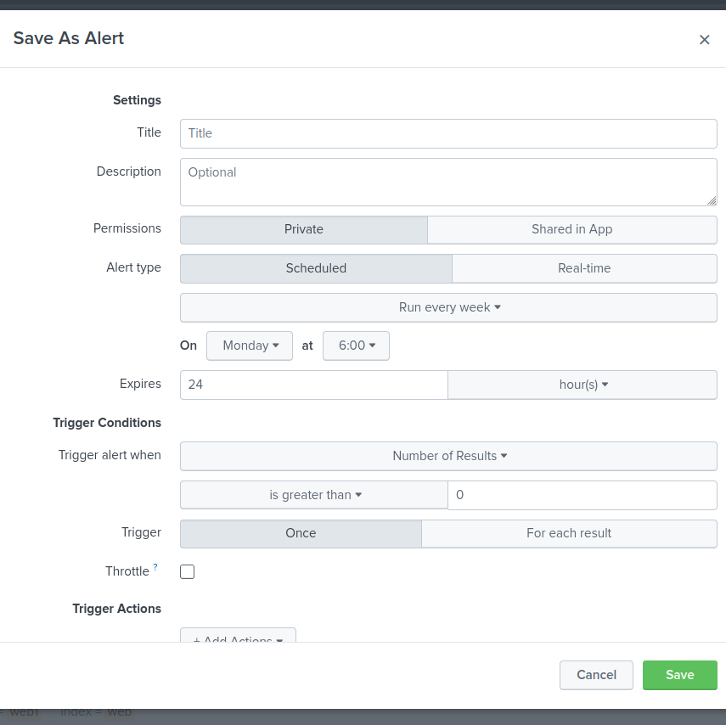
k
d
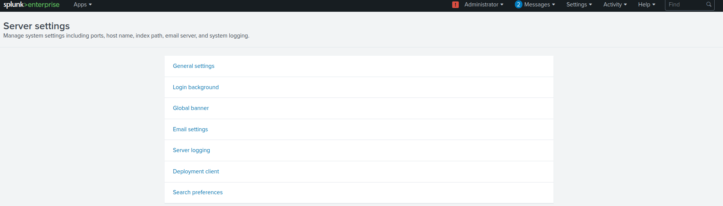
d
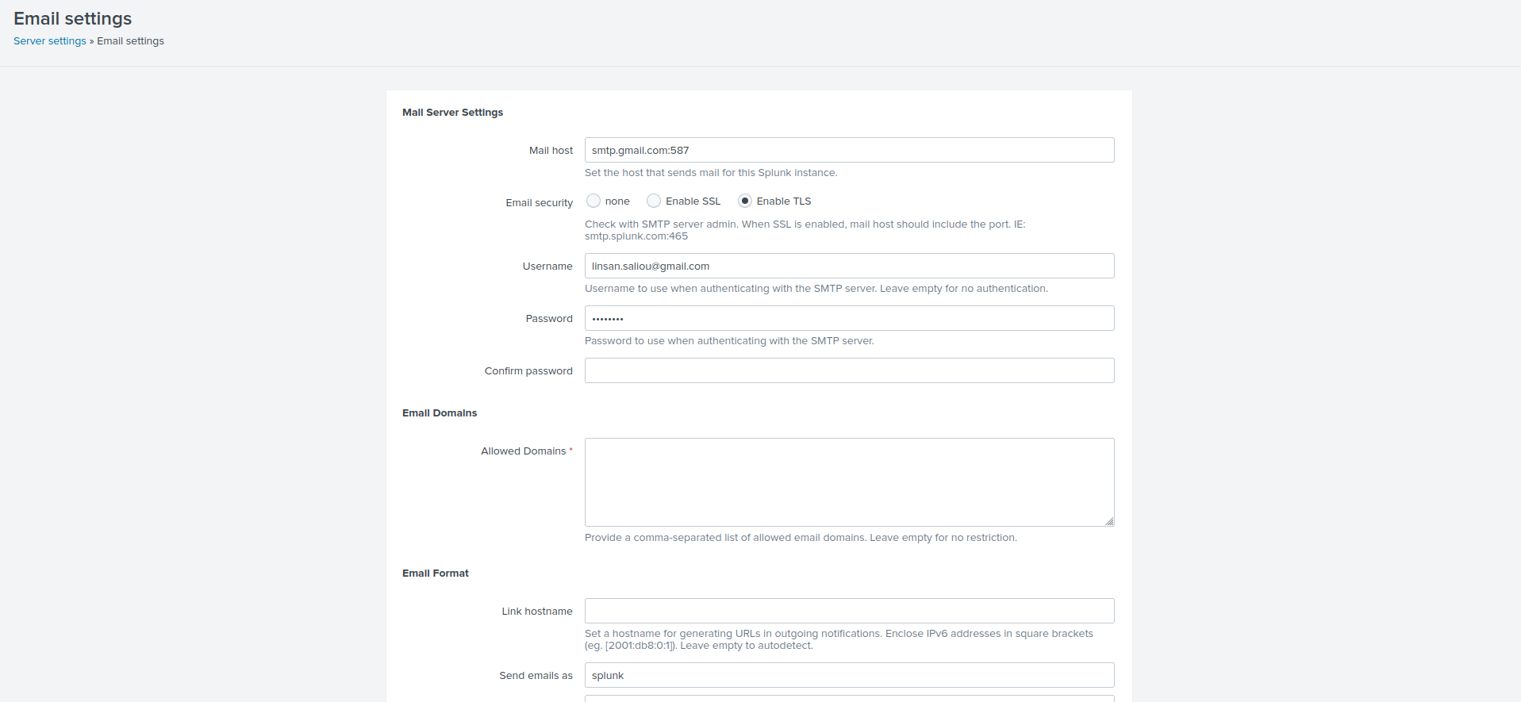
Configure server mail settings
Cron tab
https://crontab.guru
every minute: */1 * * * *

Tags & Events

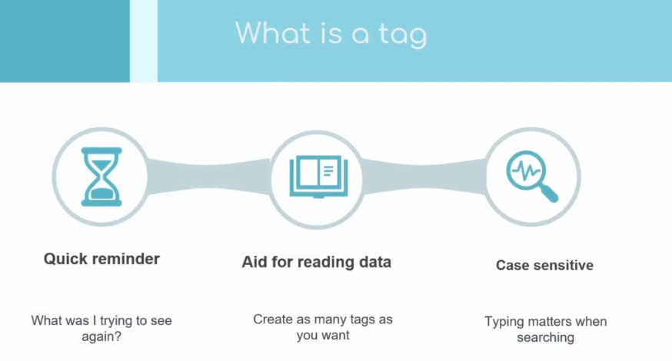
d
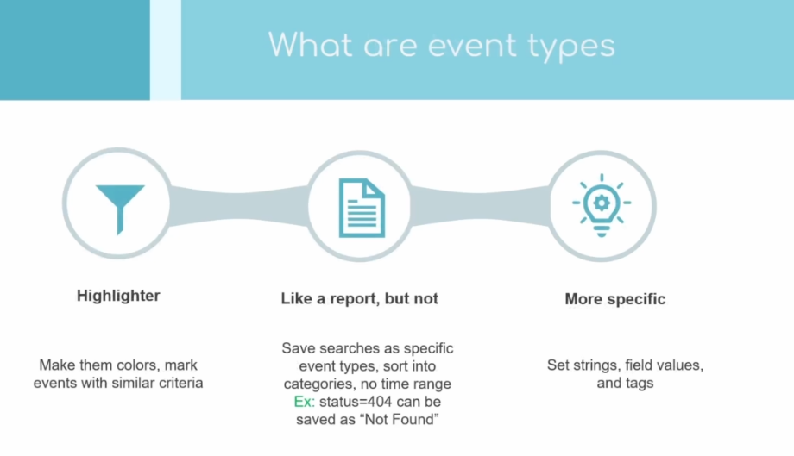
d
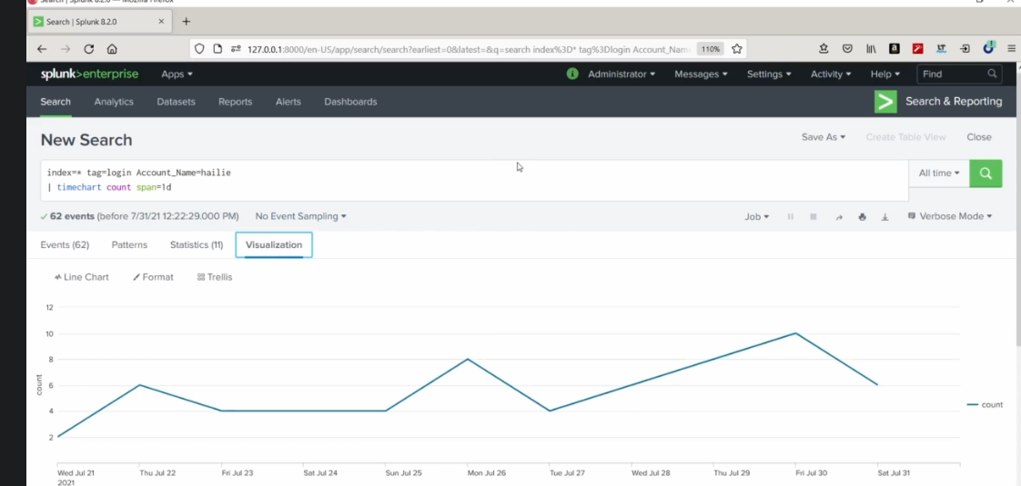
Events types
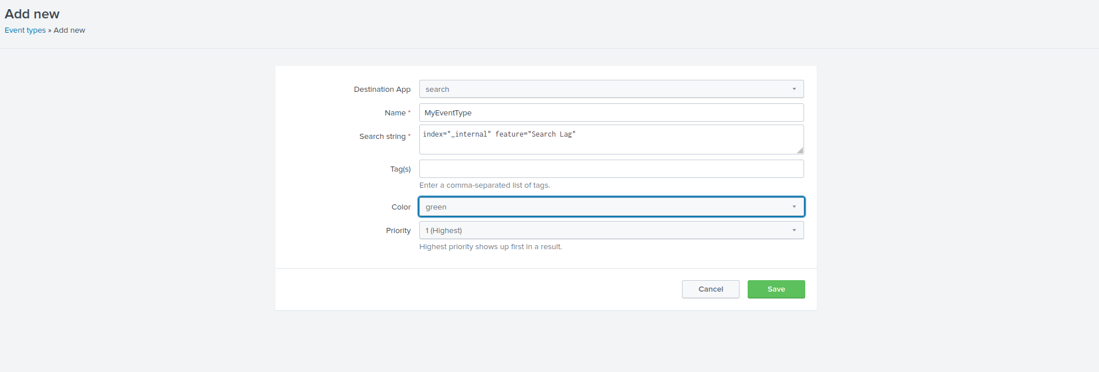
d

Macros
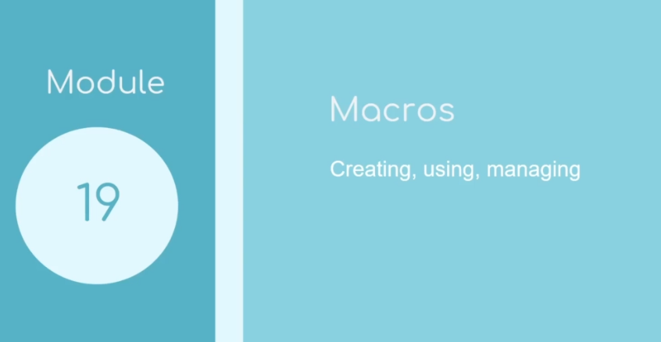
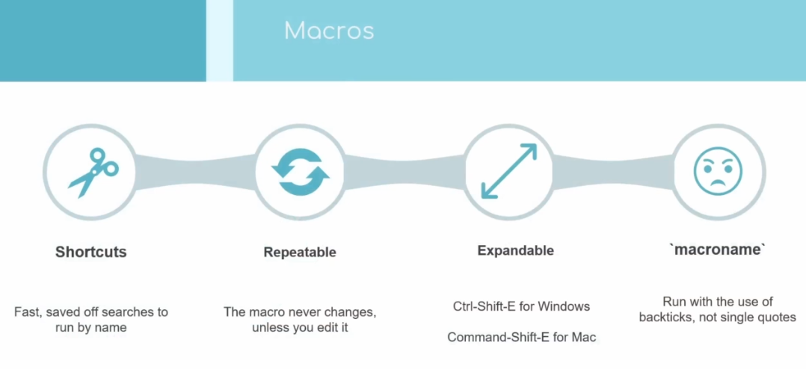
d
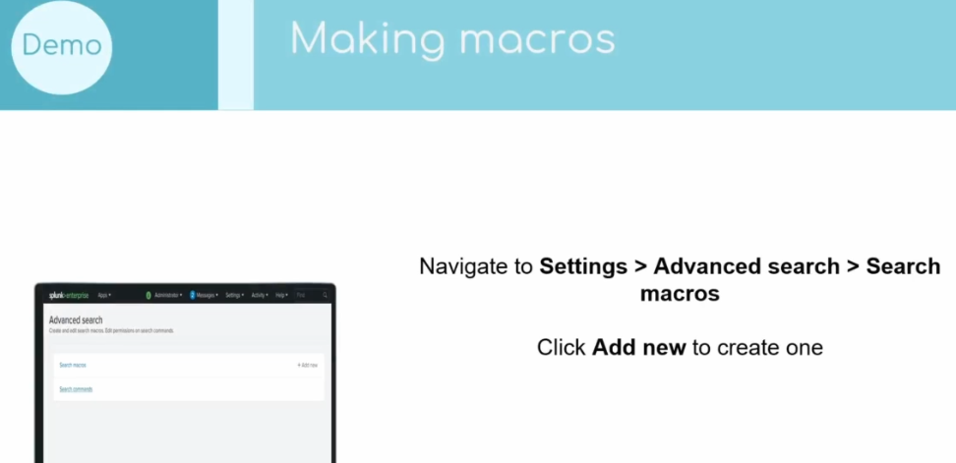
j

index=web action=purchase
| stats count by host
| addtotals col=t row=f fieldname="Total" labelfield=host count

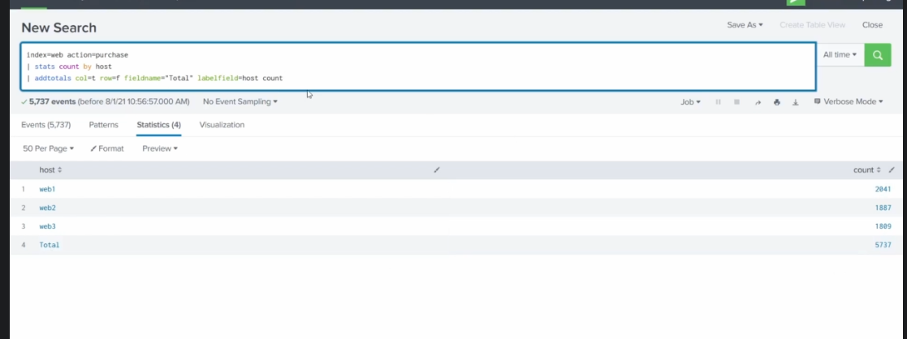
g
d

To call our macro
`SeachPurchase`
d
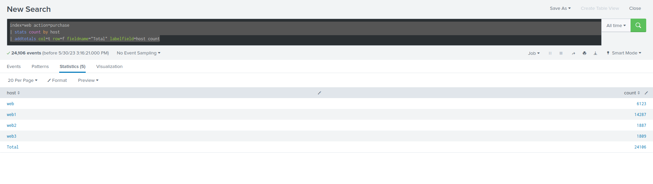
d
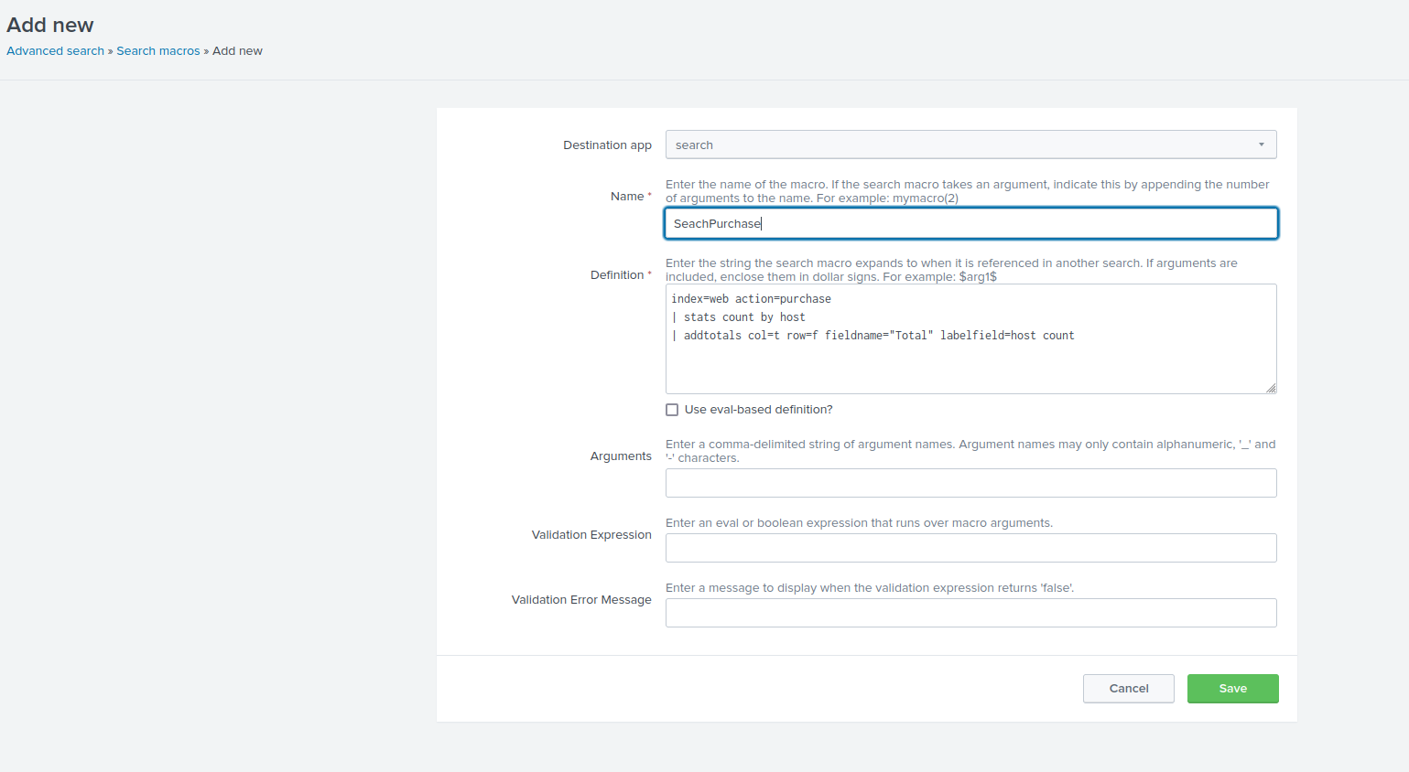
d
Les macros avec des arguments :
index=_internal log_level=*
| table host, log_level, event_message, _time

Créer la macro
index=_internal log_level=$level$
| table host, log_level, event_message, _time

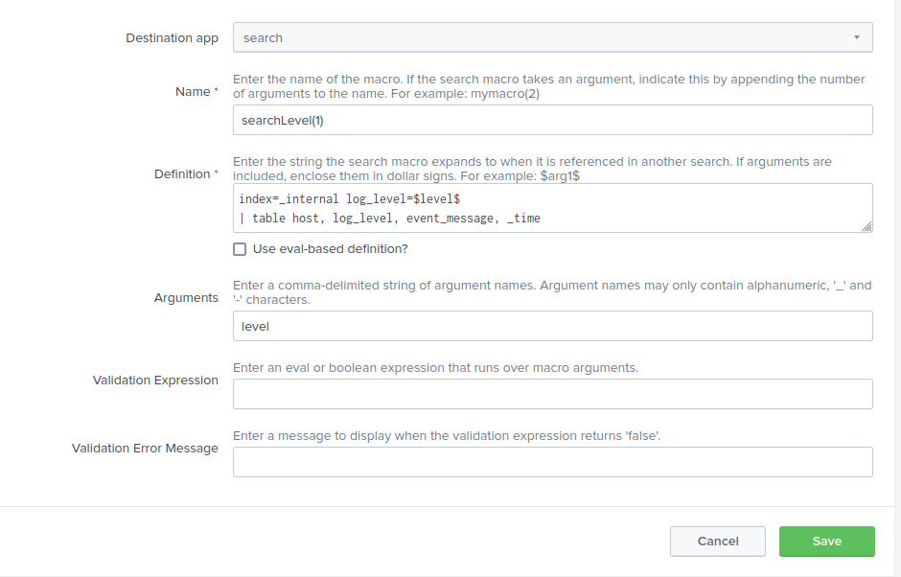
d
Appeler la macro
`searchLevel(ERROR)`

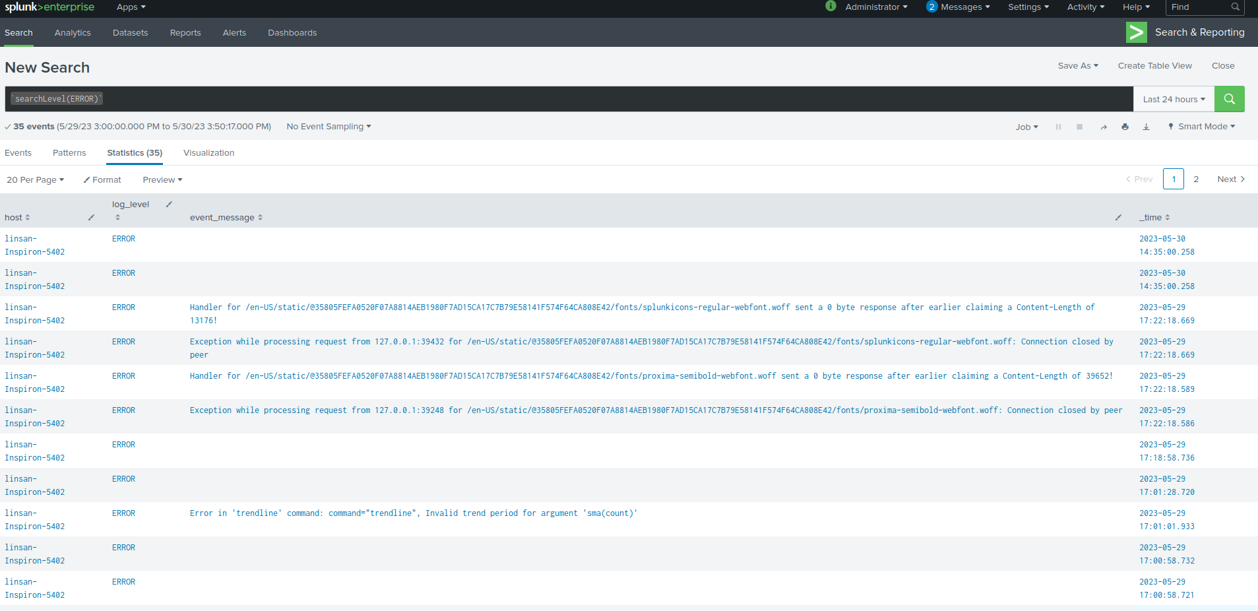
x

Workflow to save you time
Workflow Actions

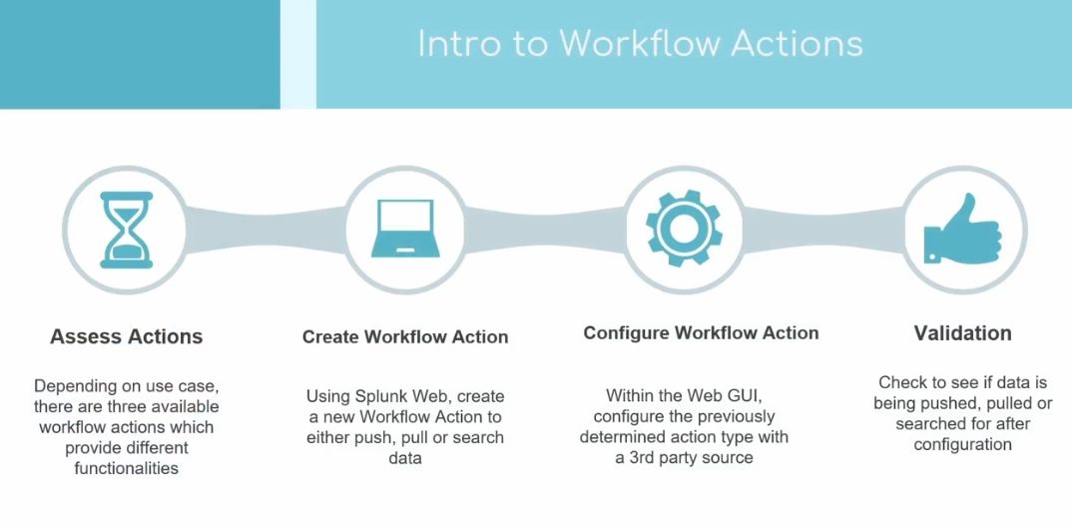
k
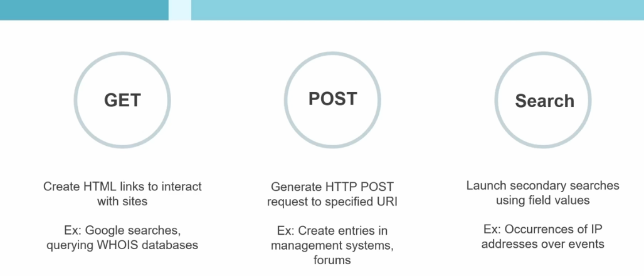
h
https://whois.domaintools.com

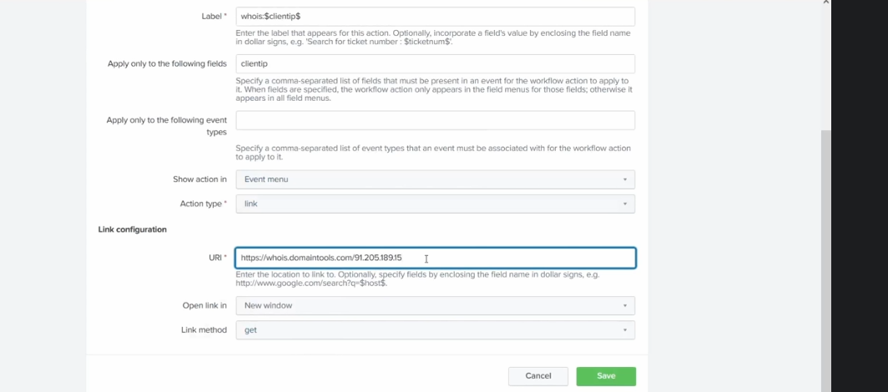
h

https://www.whois.com/whois/

92.205.189.15
https://www.whois.com/whois/92.205.189.15
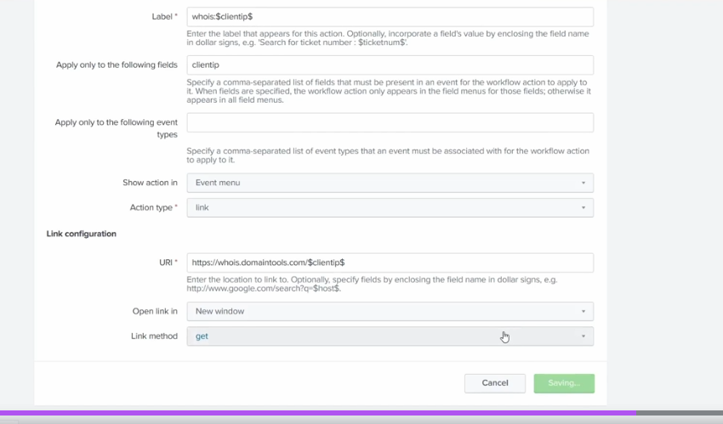
d

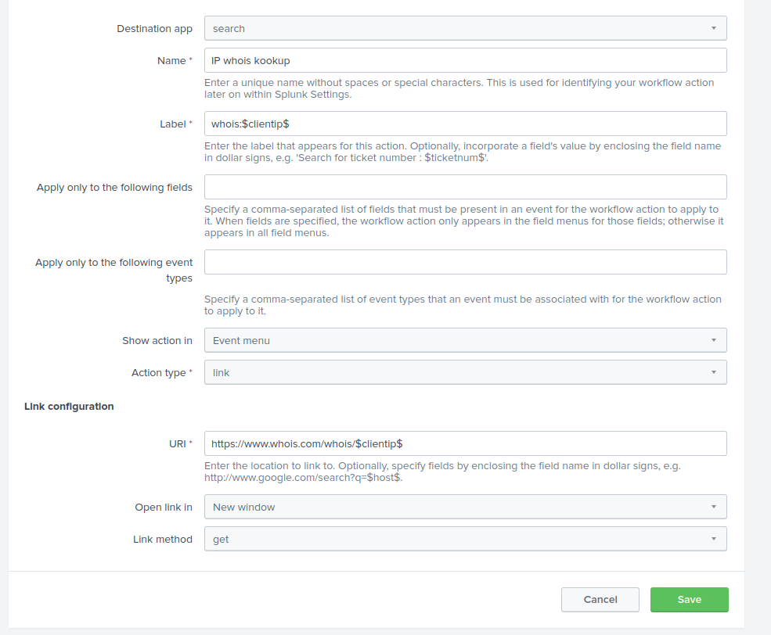
h
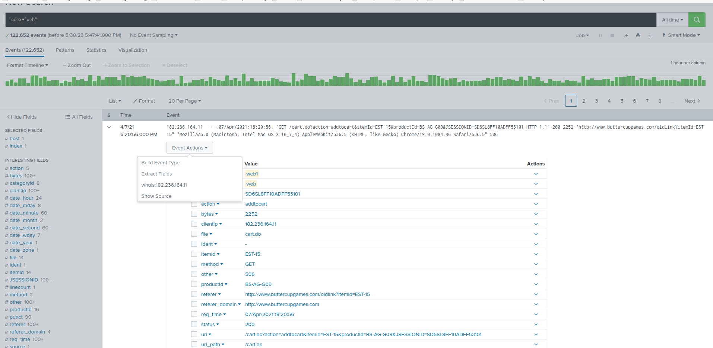
j

Data Normalization & Troubleshooting
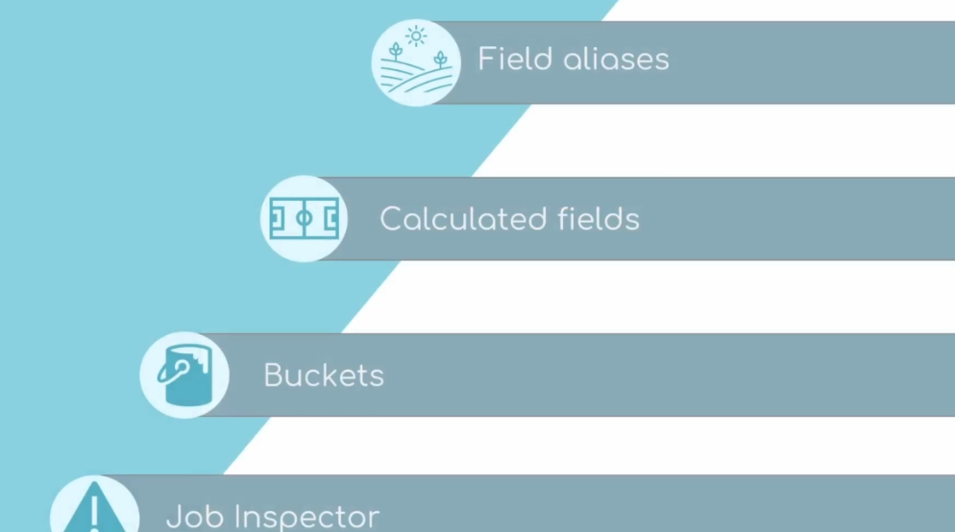

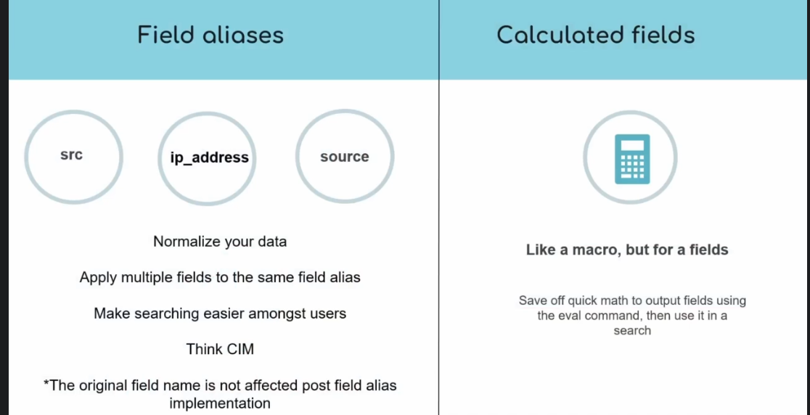

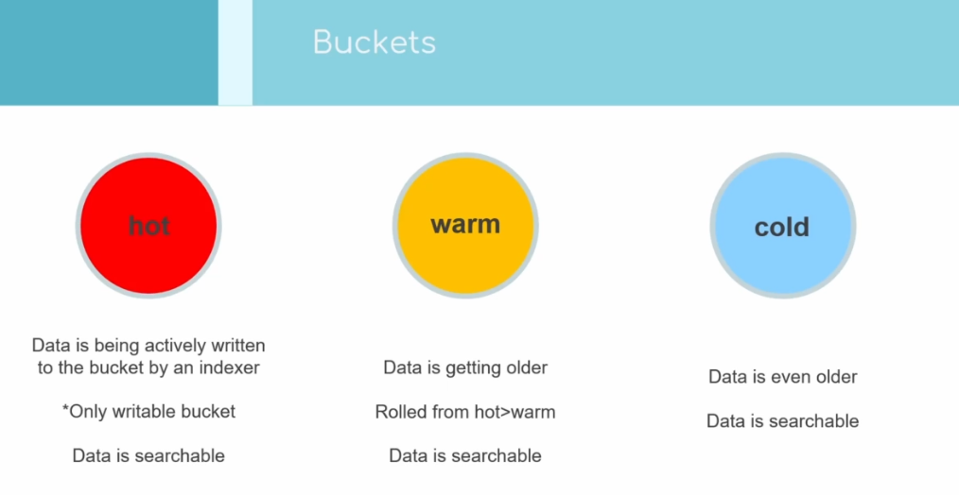

hh

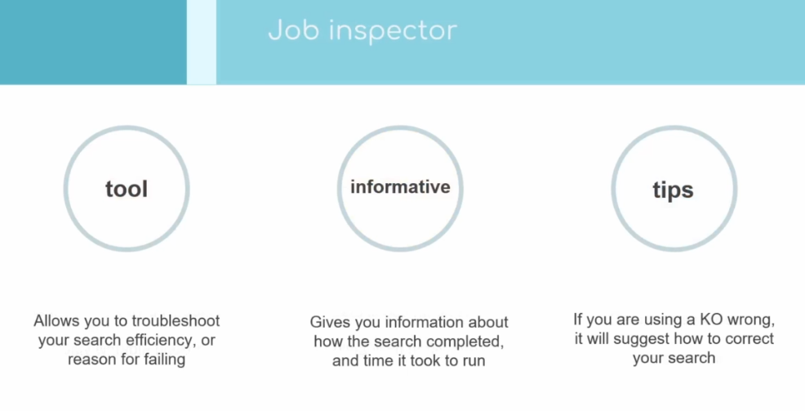

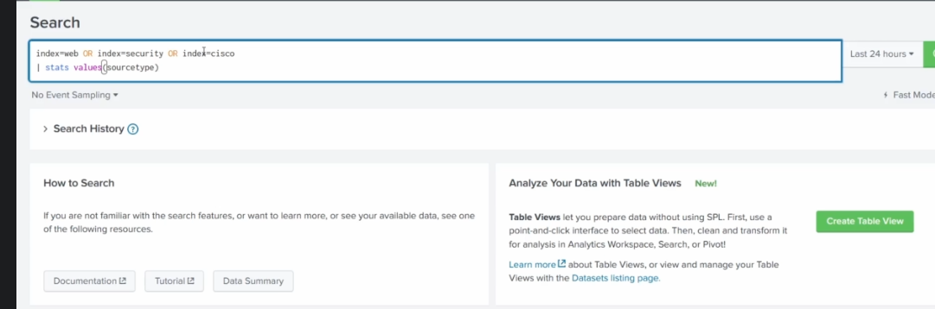
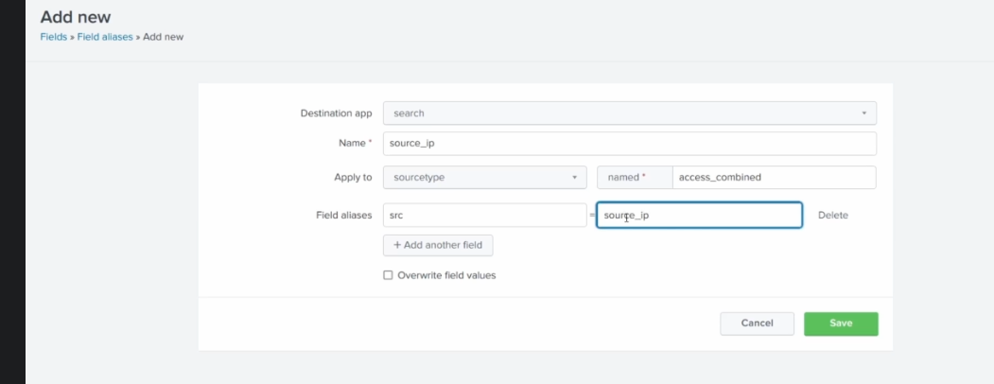
s

Job inspector: Trouble shooting

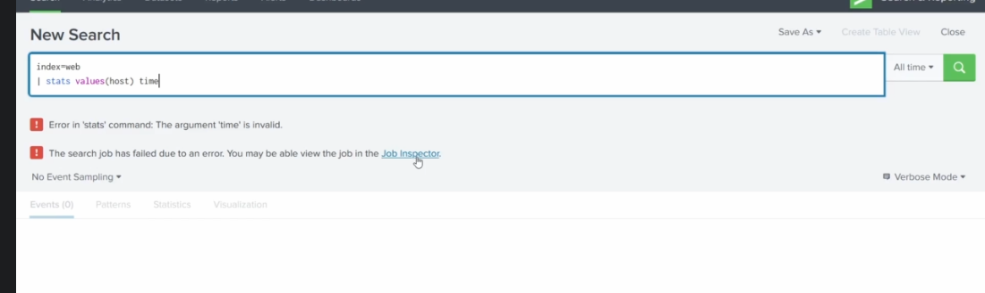
Datamodels

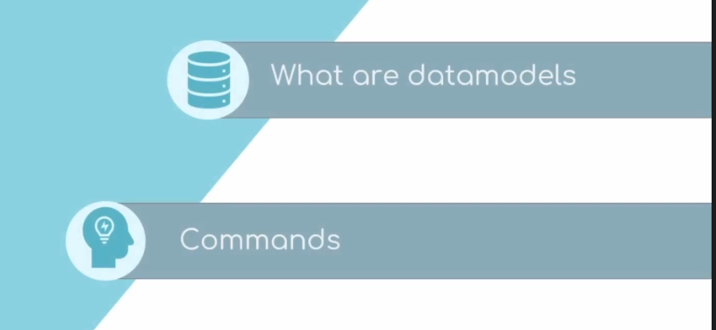
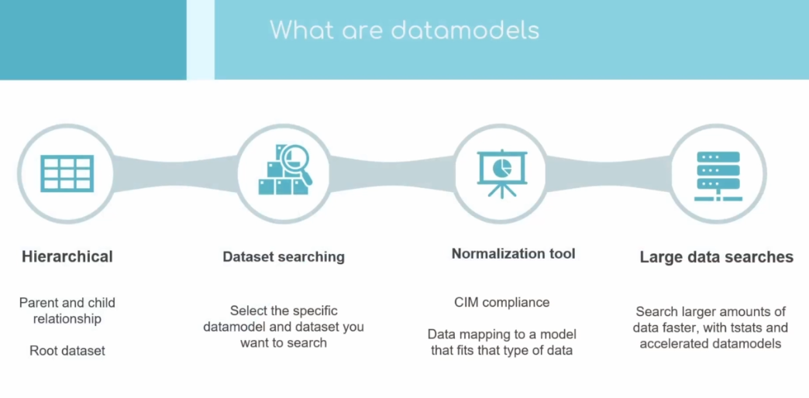
s
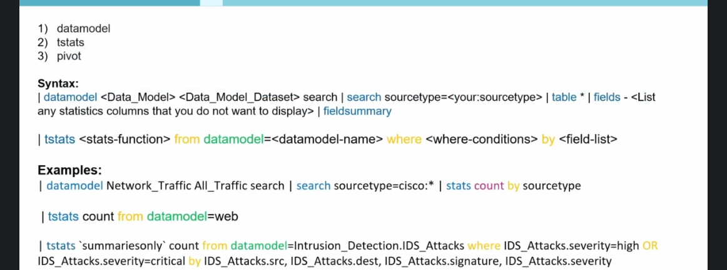
d
dd

The Common Information Model
ss

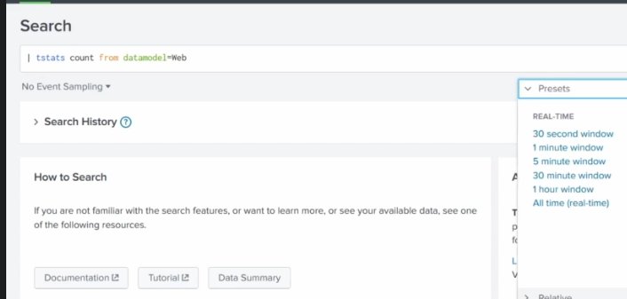

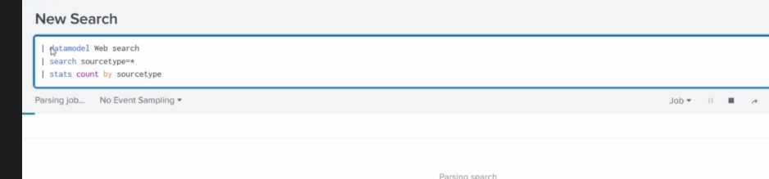

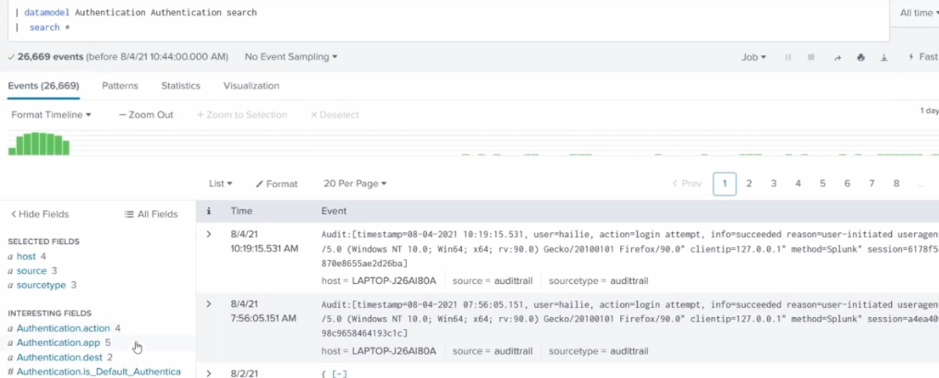

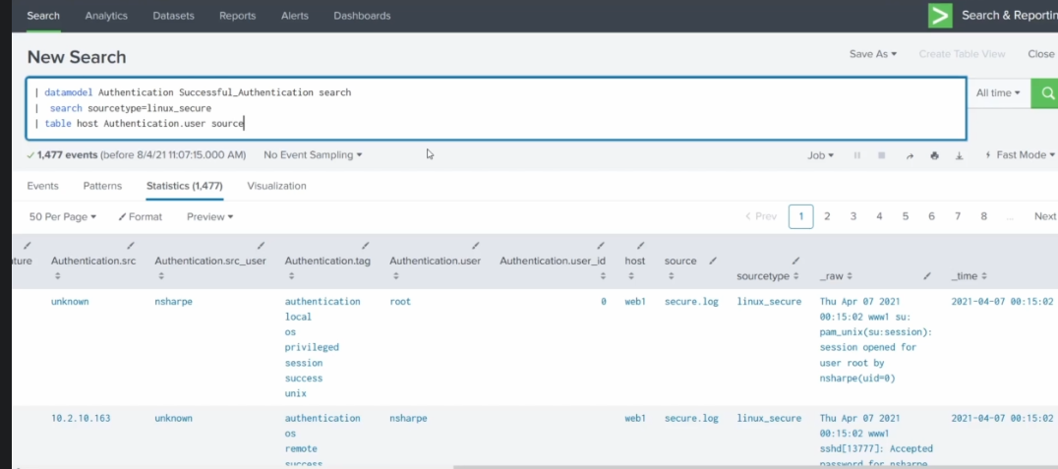

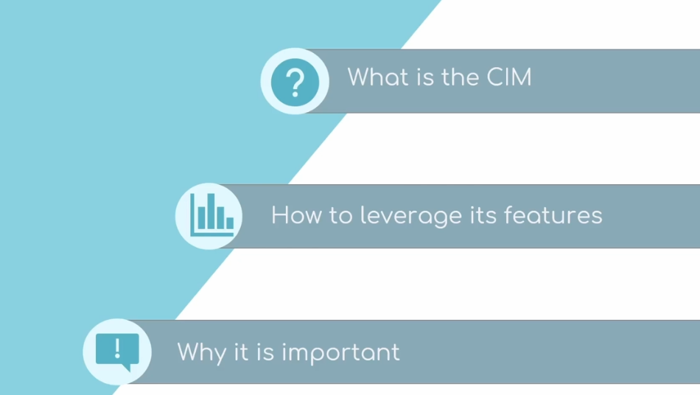
d

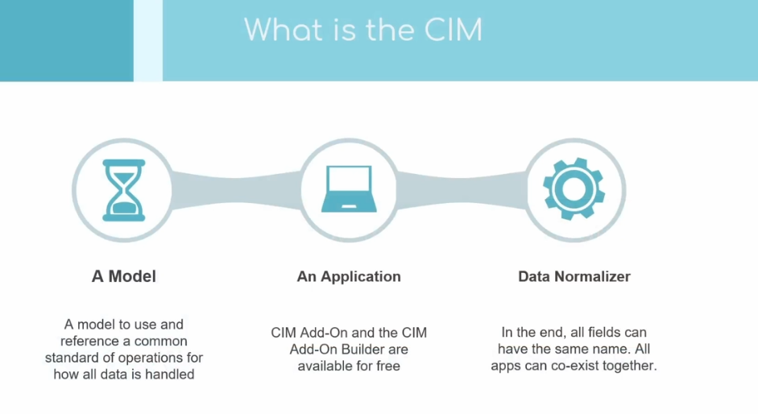
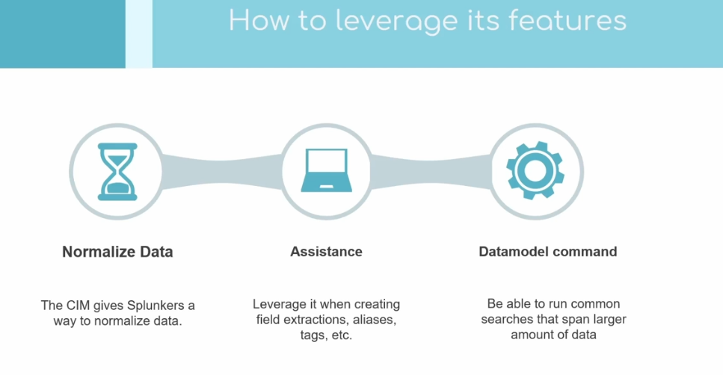
d
x

