EU Citizen
D.Trygoniaris
2026-05-21
Setup for Citizen
Define the citizen KSTs
Skills (S):
- Java
- Python
- C ++
Knowledge (K):
- MySQL
- cloud technologies
- project management
Target role: Software Developer
Fit score: Overall measure between candidate’s skillset alignment with job demand
## [1] "Fit score of the candidate: 0.16"
## [1] "Fit score of the candidates on skills: 0.12"
## [1] "Fit score of the candidates on knowledge: 0.1"
Missing skills and competences
## [1] "######### Skill ###################"
## Skill Importance
## 1 computer programming 0.51
## 2 web programming 0.50
## 3 JavaScript 0.36
## 4 define software architecture 0.33
## 5 create software design 0.33
## 6 develop new products 0.32
## 7 develop software prototype 0.31
## 8 analyse software specifications 0.31
## 9 oversee development of software 0.31
## 10 use markup languages 0.31
## 11 PHP 0.30
## 12 C# 0.30
## 13 advise on customs regulations 0.27
## 14 provide customer follow-up 0.27
## 15 provide ICT support 0.27
## 16 support ICT system users 0.25
## 17 design database scheme 0.21
## 18 TypeScript 0.21
## 19 design database backup specifications 0.20
## 20 define database physical structure 0.20
## 21 SAP R3 0.20
## 22 prepare scientific reports 0.19
## 23 ABAP 0.18
## 24 operate relational database management system 0.17
## 25 maintain database security 0.16
## 26 maintain database performance 0.16
## 27 balance database resources 0.16
## 28 ASP.NET 0.16
## 29 use content management system software 0.16
## 30 plan resource allocation 0.16
## 31 use object-oriented programming 0.15
## 32 use scripting programming 0.15
## 33 use software design patterns 0.15
## 34 Visual Basic 0.14
## 35 use microsoft office 0.14
## 36 administer ICT system 0.14
## 37 assemble hardware components 0.14
## 38 perform system analysis 0.12
## [1] "######### Knowledge ###################"
## Skill Importance
## 1 Agile development 0.36
## 2 JavaScript Framework 0.35
## 3 integrated development environment software 0.33
## 4 SQL Server 0.33
## 5 incremental development 0.32
## 6 Iterative development 0.32
## 7 ICT system programming 0.31
## 8 ICT software specifications 0.31
## 9 style sheet languages 0.29
## 10 consultation 0.27
## 11 CSS 0.25
## 12 SQL 0.20
## 13 automation technology 0.20
## 14 programmable logic controller 0.19
## 15 Android (mobile operating systems) 0.19
## 16 computer engineering 0.17
## 17 Oracle Relational Database 0.16
## 18 Microsoft Visual C++ 0.15
## 19 principles of artificial intelligence 0.15
## 20 internet governance 0.14
## 21 iOS 0.12
## 22 ICT problem management techniques 0.12
## 23 tools for software configuration management 0.12
Competition standing
## [1] "The candidate is aligned higher than 78% of the competitors."
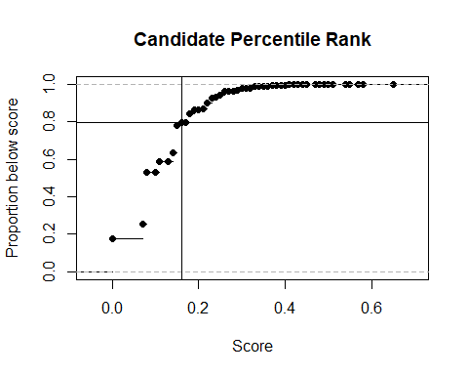
Skills need to learn to achieve higher than 99% of the competition
## [1] "KSTs need to learn to stand above 99% of the competition:"
## Skill Importance
## 1 computer programming 0.51
## 2 web programming 0.50
Alternative career paths
## Priority Career to Pursuit Relative Standing
## 1 1 software analyst 91%
## 2 2 software architect 89%
## 3 3 software developer 78%
## 4 4 user interface developer 0%

