# The Garden

## “Student vs. School”

**Task 1. 3m, 40w.** List four course objectives or program requirements that are most on your mind right now.

Courses impose a number of conditions on your life: 1. Fixed time: courses 2. Variable time: assignments 3. Uncertain time: studying

**Task 1. 3m, 40w.** What are your top 4 goals for the next 10 years? you could work on any part of yourself, move toward any goal you want.

list four goals, Each no longer than 10 words

**Task 3. 3m 40w** Your current program requires things your 10 year plan does not. What’s the difference?

### afterlude

Imagine a perfect course exists, designed to teach you to fulfill your specific ambitions. every aspect of what you NEED to know, that is known and communicable, is the only thing written. everything that cannot be known but must be discovered or practiced, is laid out as a set of instructions, described in the words that maximize the learning opportunity, and your progress.

Rather than a course in a classroom, the perfect class is a manual to reference as you live your life, or at least until you’ve internalized its contents: when to take a break to strategize your decisions, lessons on what opportunities to watch for and resist, and so on. Any social role you wish to take on, artist, engineer, therapist, insurance salesperson, reliable partner, is customized intimately, curated perfectly for what you need.

Any relationship, interpersonal skill, that is realistically possible for you, is preceded with the guidance and education that prepares you emotionally to choose the right experiences that set you up to be most likely to find and make the most of opportunities to share yourself with another.

If you then take this notion of a personal book and consider one for all the humans in the world, then identify what is in common, in theory you have a description of the social sciences.

This is silly to imagine, because such books are far from reality. The thesis of *this* book is that social sciences are missing a vital factor to approximates such a book, a census of all human thought and actions.

### to Education

(No one chose to be born.) Everyone begins life with problems that do not have names.

School books tell a student what the answer is not (quite).

The gap between problem and book answers is left for the student to “apply”.

ANSWER: let the student Define the problem through their reality and life goals.

Let them write the plan and teach them only what is needed to succeed.

## Part One: Self

Imagine your life is a garden. Every one of your life ambitions, GOALS, is buried in the ground as seeds. Finding a life partner, acquiring a car or promotion, or resolving a conflict with your childhood friend are all matters spread across the dirt in need of water, sunlight, and—most important—your time.

Other goals, like naps, your favorite hobbies, or TV shows, take little work and grow almost anywhere. Whether they are dear to you or weeds, if they take your time, they are in your garden.

### today

Today, you are on one end looking out across the entire garden. What has already been planted? What will you add and how much time will you devote to those goals? Every seed you plant — even an abstract one like passing a course or making a friend— implies things in and out of your control like work and weather, or beyond your awareness, like what your boss loses sleep over.

Meditate on the final products of your garden. Is there a more important plant that deserves your time today?

Meditate on the prioririties of your work. Do two plants grow better when together?

Make a quick and accurate assessment, but don’t sit here all morning thinking about it. A garden is for working in, to get the goods you need. What do you need to cultivate, today? What do you want to cultivate in this life?

### L4: Time

These are two exercises that can be used to plan your day. They are set up in a way that confronts one of the most common mistakes of planning: being unrealistic in your expectations.

#### A. Typical Day

Think about a day and how much time you spend on various activities, averaged over 365 days in a year. Then pick a GOAL, and estimate the changes required to make it happen. The first step reflects your HABITS, and the changes reflect COSTS.

__Table 3. __First approximation of how my time is spent (hours), sorted by GOALS and subgoals, and any details that are worth noting. Hours total 24, and assume 365 days / year. Non-daily activities such as visiting the dentist are factored in, accordingly. Second approximation (ideal) reflects where I would like to be over the next 3-4 months of my life.

#### B. Morning Bets

Task 1. 5m, 50w.

Take five minutes to produce the words that are most likely to accomplish your goals for the day. This may include describing the goals, the plan, and/or the doubts.

Task 2. 5m, 50w.

Copy those 50 words, and revise them according to the following instruction.

Replace “accomplish your goals” with “do”. In 50 words, what should you (or an all-knowing observer) bet on that you will do, today? Regardless of what you assumed in Response one, do not write with the intention of ‘motivating’ yourself, but to simply describe your day. (If this is too hard, simply evaluate what you did yesterday.)

Task 3. 5m, 0w.

Compare your responses. Positive differences (more optimistic) in your first response reflect bets you are making against your habits.

@## today’s answer.

First, you want what your body and mind best respond to. Many of these seeds will be obvious. It is up to you how curious you are for what better life is possible.

The only way to know is to make the best assessment you can about past outcomes to make predictions about what new seeds or gardening techniquest you should try. You don’t have enough time in the day to tend to try everything, and many are not worth trying. There is not always harm to planting something that does not grow, but sometimes there is. —you could run out of space, time, or  
energy that could have been devoted to better crops; you might get a weak yield for trying to grow something not suitable in your climate, or find you have no taste or stomach for the fruit.

In the garden, the COSTS of goals are grounded in their most basic sense: time and attention.

## Ideas

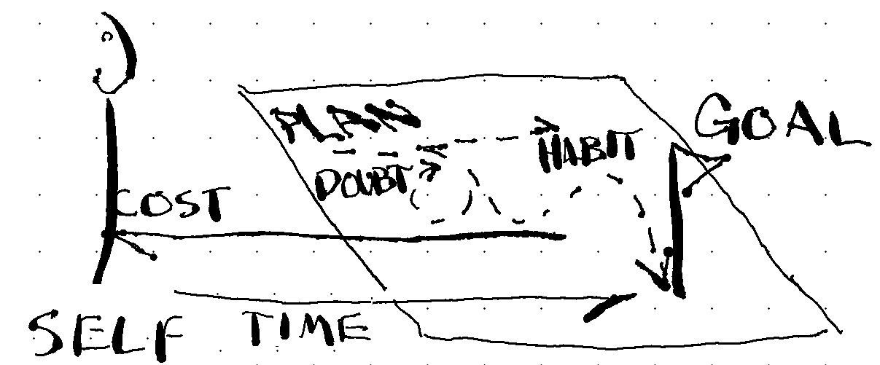

### GOAL

A GOAL names a problem,  
comprises a PLAN for an ideal outcome, and has COSTS associated with exercising the PLAN.  
It can be finite or persistent, singular or recurring, or [realistic or not](REALITY%20or%20FANTASY).

### PLAN

Words intended to improve the chance and decrease the cost of achieving your GOAL.

PLAN types:  
1. INSTR. Instructions for learning, making, changing, reminding.  
2. DOC. Document-based GOALs, like manuscripts and resumes.

PLAN templates:  
1. LESSONs are a template for thinking. Read and complete steps in order.  
2. TOOLs. Physical or mental objects.

### Self

Every day, as a human, you spend time and attention just meeting basic needs: eating, drinking, pooping, and sleeping.

SELF is what’s necessary and sufficient to manage CHUD, and maximize BETs.

FITNESS is ALIGNING CHUD toward CAKE.

Good self-management is maximizing the homeostasis of these needs, on the bet that they will maximize your values. Each person’s CHUD will vary.

1. Keep a clean HOME, and LIB

### HOME

The collection of places and tools needed for the habits that underscore SELF-maintenance, are “HOME”. Home is an example of a GROUP.

A HOME further groups related actions into rooms, such as a room for eating, for pooping, for sleeping. Take the eating room, a kitchen. It is also for storing, preparing and disposing of food.

This definition of HOME is expanded to include all physical material and resources you own, including MONEY; and environment and basis for HABITS.

A good HOME is a PLAN for SELF; simplifying the GOALS of eating, sleeping, and other basic needs. A bad HOME facilitates bad HABITs, and takes more time to maintain than provide homeostasis.

### VALUES

Anything fulfilling, including the reason for living.

VALUES are a good basis for GOALS. Any non-SELF value is called CAKE.

## Plans

### SELF

Cake can appear as VALUES that are sufficient but not necessary for SELF. 1. Identify and revise. 5. Separate what you need from what you want.  
6. Master the SELF (survive well).

1. Build routines for health and fitness, physical safety (shelter), a sound mind, healthy relationships.
2. Satisfy HOME, and SELF GOALs

## Lesson: Self250

How accurately can you describe yourself? Relate to those who care, including your better self, by practicing the right words.

### A. SELF-past

Task 1. 20m, 250w

Look back on your life. What are your values, and where did they come from?

### B. SELF-future

Where are you going? Imagine your life plays out - ideally,  
- terribly, and  
- typically.

Consider 1. What could go right or wrong, 2. What it depends on and the likelihood. 3. Who you will be if it happens.

Create a “choose your adventure”, ordered by likelihood.

For example:

80% make enough money to be content. 50% marry, and - 50:50 ends well or in divorce.  
10% major accident leading to depression.

### C. SELF-now

Task 3. (20m, 250w)

If you have not done **Lesson: Times**, skim it.

Task 3a. 2m, 50w.

Choose a goal you named in **Self-Future**  with a probability of outcome that you would like to increase. What change is needed in your daily schedule to make this increase?

List the activities and durations you will reduce or increase.

Task 3b. 3m, 50w.

List most likely reasons this plan fails, especially reverting back to old habits.

Task 3c. 10m, 150w.

Add steps to create and protect changes in your schedule.

Task 3d. 1m, [decide-date]

Bet on this (Task 3b vs 3c). Set a date on the calendar to assess your commitment to this plan.

## Lesson: Food vs Cake

Often you will define experiences by your priorities and immediate desires. Experiences out of line with your desires are dreaded, and those in line with them are eagerly anticipated. For example, a college student dreads midterms and anticipates spring break.

Each are about one week long, yet the feeling of time passing and the motivation to engage with challenges are very different. Anticipations can create disappointment, so reduce speculation, especially its harmful effects on you.

Do more of what you like when you most need it, try to appreciate what you dread, as it is, including the suffering.

**Task 1. 4m, 50w.**

List 4 goals to accomplish for midterms, before spring break

**Task 2. 4m, 50w.**

List 4 goals for the best spring break you can imagine.

**Task 3. 15m, 200w.**

There are only so many hours in a day. What aspects of self-care can you incorporate during your midterms to improve your sanity, and hopefully your midterm performance? We know what happens if you don’t. You’re staring at your phone, you’re reading random articles on the internet and wasting time. Let’s take that same honest realism and intentionally plan better alternatives: instead of garbage breaks, how about spring breaks? In what strategic ways can you get a head start on your spring break goals, as a form of self-care and therapy during your marathon of midterm work?

Write out your midterm goals with self-care and/or spring break strategically built in.

**Task 4. 15m, 200w.**

Now imagine that spring break more fully. You’re spending time on one of your goals, when suddenly you remember something you need to do for midterms. Maybe you get an email from your instructor or boss, or there’s a project that looms large.

What are you going to do to be okay with this intrusion? Would it help to allow some time to work on it, without feeling guilty or beating yourself up, or is it vital that you embrace your independent needs and resist any urge to do work? Regardless of how you might ideally respond, incorporate compassion toward yourself for how you might end up responding, including feeling anxious for the entirety of spring break.

Write out your spring break goals with midterm goals incorporated.