## frm intro-reader

A perfect human is one who sees their destination as clear as the sun on the horizon, able-bodied to get there.

This framework considers two interrelated ideals: a FIT self with WIT.

Your intention is to be FIT for the actions the world requires, and have WIT to decide what’s required, and act accordingly.

# main

## The Garden: Pri

### LIFE, LOVE and DEATH

Many people believe in seeds with special powers, like true love, or winning the lottery. One seed grows the duration of your life, which you rarely notice but are often aware of. When you eat it, the sun sets for  
the last time and you bite the dust. Think about this, but don’t dwell on it. It happens to all of us.

Think of what you can grow from the seeds of the best apple in  
your crop, which you tended to with dedication and skill.

*REALITY* Think of what’s happening  
right this very moment: nothing in your garden, while you’re sitting  
here thinking. Reflect only enough to improve your actions.

Visualizing your life as a garden allows you to ground actions and plans. The mind analyzes well with visual space. into a medium the mind is well-equipped to analyze: visual space.

Maybe it  
seems unnecessary to represent work satisfaction and relationship  
quality in terms of carrots and tomatoes.

When you arrive at the moment  
of boredom or frustration, ask yourself why you  
are bored and frustrated attempting to define the things that apparently  
define you. What is happening in your life, and what is in your control  
if these are unclear? If you are not reflecting on your life, your garden is a foggy labyrinth and you are a drunk gardener wearing  
oven-mitts.

### Bad days

Maybe you are sick, down or depressed.

Do not look out onto your field as a day to work. You have assumed your field is only meaningful for its future. Today your field gives to you, and you should take what you need. This is what it is for. Do not beat yourself up for what you cannot give today.

Prevent the urge to be disappointed the next time you are less than productive. If you must work to feel worthwhile, work to budget for a fact of being human: you are always sometimes less than productive, and occasionally your setbacks come in unfortunate forms, at inconvenient times.

## Ideas

Planning for goals requires attention. All GOALs rely on a single, limited source of attention, and existence:  
you.

Managing the set of goals in your life is  
the goal of PRI.

At its best, this limiting fact drastically improves the reality of PLANs and GOALS. At its worst, it is the most common oversight responsible for bloated CHUD.

GOAL importance (PRIs) partly depends on context.

### SAVINGS

completing an action  
that serves various goals.

An example is Grouping. (See Fig. 3) Grouping works for  
IDEAS, PLANS, GOALS, or HOME things.

Figure 3.

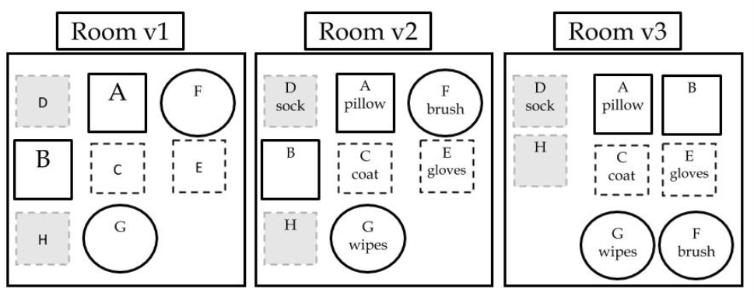

SAVINGs are illustrated as a function of GROUPs, across three rooms. The same OBJECTs are: As you find them (Room 1),  
labeled clearly (Room 2), and  
grouped by function (Room 3).  
Letters reflect different things, and  
shape differences reflect different kinds of things.

### TIME

The constant (or denominator) for FORCES, FORGETTING, PRI, and LIB.

## Plans

### PRI

group GOALs by shared actions, places, or times.  
Make/group/keep, order, reduce in the order presented in Figure 4. “A place for everything, everything in its place”

ALIGN SELF and VALUE Adopt all your goals to REALITY (“above”, e-you will die). Think about the sum of your GOALS,

1. Ask what it would take to change (if possible), and whether change is worth it.

### TIME

Do not ignore time Estimate durations accurately for GOAL accomplishment

1. Study Time to learn reality, SELF, and the LINK between the two.
2. Ask/reflect/study: Does the benefit of a GOAL outweigh the cost of time?