**Step-by-Step Explanation of the Code**

This code generates a heart shape filled with a user-specified character. Below is a detailed explanation of how it works:

**1. Get the Letter Input from the User**

letter = input("Enter a letter to fill the heart: ")

* The program prompts the user to input a single character (a letter, symbol, or number) that will be used to create the heart.

**2. Validate the Input**

if len(letter) != 1:

print("Please enter a single character.")

* This condition checks whether the input is exactly one character long.
* If the input is not a single character, an error message is displayed, and the program stops further execution.
* Example:
  + Input: "ab"
  + Output: "Please enter a single character."

**3. Construct the Heart Shape**

heart = f"""

{letter} {letter} {letter} {letter} {letter} {letter}

{letter} {letter} {letter} {letter}

{letter} {letter}

{letter} {letter}

{letter} {letter}

{letter} {letter}

{letter} {letter}

{letter} {letter}

{letter}

"""

* This block uses a formatted string literal (f-string) to create the heart shape.
* {letter} placeholders are dynamically replaced with the character provided by the user.
* The heart shape is defined using spaces and the letter variable to align the structure properly.

**4. Print the Heart**

print(heart)

* Once the heart shape is constructed, it is displayed to the user.

**Example Walkthrough**

**Input:**

Enter a letter to fill the heart: *

**Execution:**

1. User enters "*" as the input.
2. The program checks that the input is a single character (valid input).
3. The heart shape is constructed:

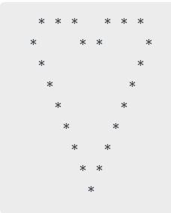

1. The program prints the heart filled with "*".

**Output:**

