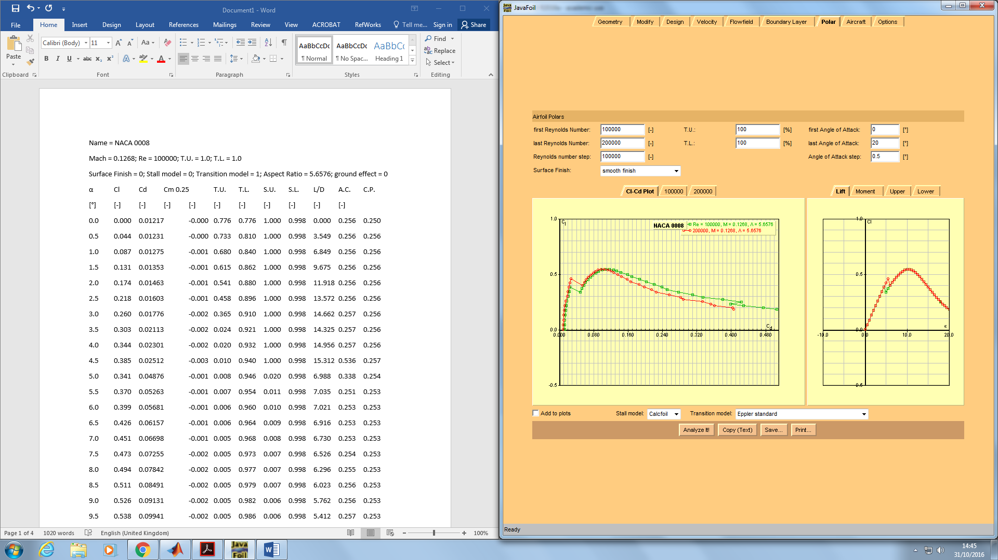

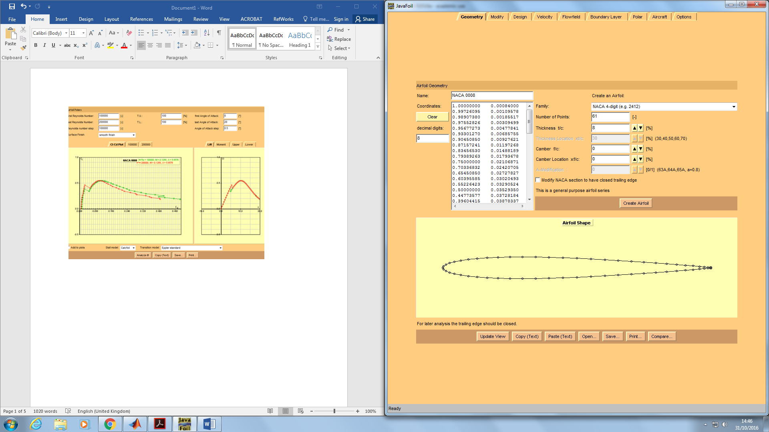

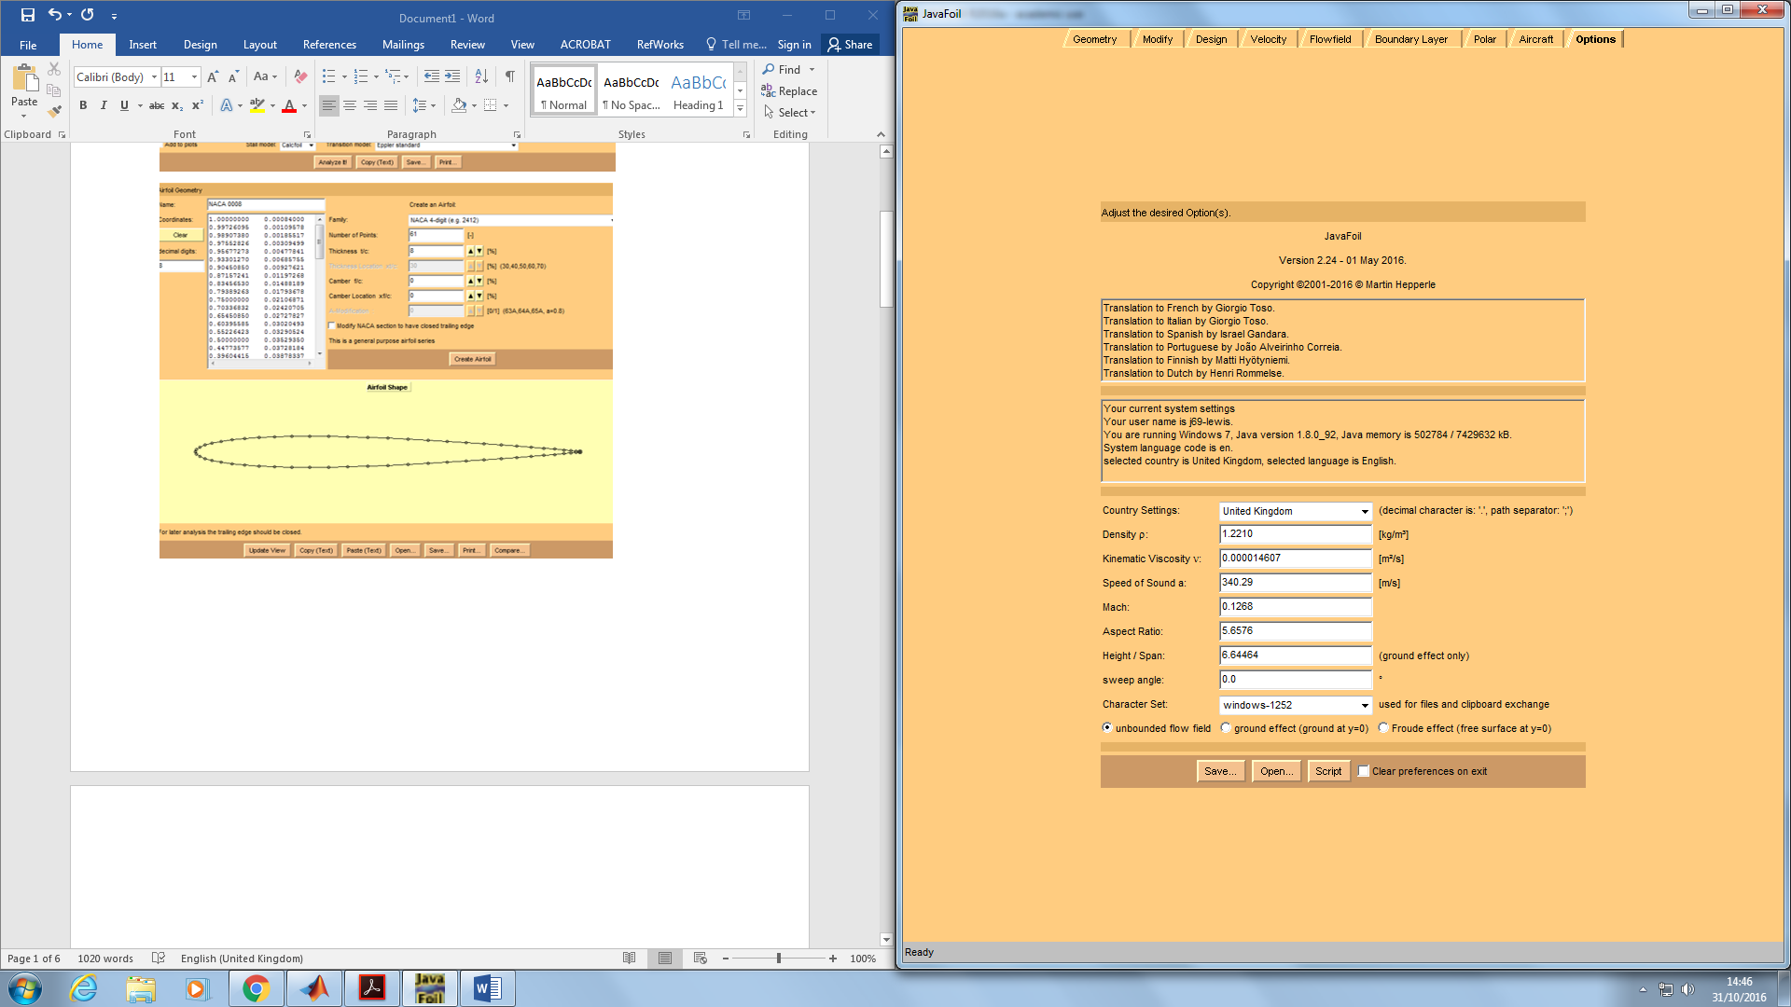

Name = NACA 0008

Mach = 0.1268; Re = 100000; T.U. = 1.0; T.L. = 1.0

Surface Finish = 0; Stall model = 0; Transition model = 1; Aspect Ratio = 5.6576; ground effect = 0

α Cl Cd Cm 0.25 T.U. T.L. S.U. S.L. L/D A.C. C.P.

[°] [-] [-] [-] [-] [-] [-] [-] [-] [-] [-]

0.0 0.000 0.01217 -0.000 0.776 0.776 1.000 0.998 0.000 0.256 0.250

0.5 0.044 0.01231 -0.000 0.733 0.810 1.000 0.998 3.549 0.256 0.256

1.0 0.087 0.01275 -0.001 0.680 0.840 1.000 0.998 6.849 0.256 0.256

1.5 0.131 0.01353 -0.001 0.615 0.862 1.000 0.998 9.675 0.256 0.256

2.0 0.174 0.01463 -0.001 0.541 0.880 1.000 0.998 11.918 0.256 0.256

2.5 0.218 0.01603 -0.001 0.458 0.896 1.000 0.998 13.572 0.256 0.256

3.0 0.260 0.01776 -0.002 0.365 0.910 1.000 0.998 14.662 0.257 0.256

3.5 0.303 0.02113 -0.002 0.024 0.921 1.000 0.998 14.325 0.257 0.256

4.0 0.344 0.02301 -0.002 0.020 0.932 1.000 0.998 14.956 0.257 0.256

4.5 0.385 0.02512 -0.003 0.010 0.940 1.000 0.998 15.312 0.536 0.257

5.0 0.341 0.04876 -0.001 0.008 0.946 0.020 0.998 6.988 0.338 0.254

5.5 0.370 0.05263 -0.001 0.007 0.954 0.011 0.998 7.035 0.251 0.253

6.0 0.399 0.05681 -0.001 0.006 0.960 0.010 0.998 7.021 0.253 0.253

6.5 0.426 0.06157 -0.001 0.006 0.964 0.009 0.998 6.916 0.253 0.253

7.0 0.451 0.06698 -0.001 0.005 0.968 0.008 0.998 6.730 0.253 0.253

7.5 0.473 0.07255 -0.002 0.005 0.973 0.007 0.998 6.526 0.254 0.253

8.0 0.494 0.07842 -0.002 0.005 0.977 0.007 0.998 6.296 0.255 0.253

8.5 0.511 0.08491 -0.002 0.005 0.979 0.007 0.998 6.023 0.256 0.253

9.0 0.526 0.09131 -0.002 0.005 0.982 0.006 0.998 5.762 0.256 0.253

9.5 0.538 0.09941 -0.002 0.005 0.986 0.006 0.998 5.412 0.257 0.253

10.0 0.547 0.10828 -0.002 0.004 0.989 0.006 0.998 5.048 0.271 0.254

10.5 0.545 0.11705 -0.002 0.004 0.998 0.005 0.998 4.656 0.232 0.254

11.0 0.539 0.12594 -0.002 0.003 0.998 0.005 0.998 4.279 0.243 0.254

11.5 0.529 0.13393 -0.002 0.003 0.998 0.005 0.998 3.948 0.244 0.254

12.0 0.515 0.14381 -0.002 0.003 0.998 0.005 0.998 3.581 0.244 0.254

12.5 0.498 0.15881 -0.002 0.003 0.998 0.005 0.998 3.137 0.246 0.255

13.0 0.479 0.16876 -0.002 0.003 0.998 0.004 0.998 2.836 0.246 0.255

13.5 0.457 0.18635 -0.002 0.002 0.998 0.005 0.998 2.454 0.246 0.255

14.0 0.435 0.20228 -0.003 0.002 0.998 0.004 0.998 2.148 0.247 0.256

14.5 0.411 0.22077 -0.003 0.002 0.998 0.004 0.998 1.861 0.248 0.256

15.0 0.387 0.23814 -0.003 0.002 0.998 0.004 0.998 1.624 0.249 0.257

15.5 0.363 0.25088 -0.003 0.001 0.998 0.003 0.998 1.446 0.250 0.257

16.0 0.339 0.27749 -0.003 0.001 0.998 0.003 0.998 1.222 0.249 0.258

16.5 0.316 0.31027 -0.003 0.001 0.998 0.003 0.998 1.019 0.248 0.258

17.0 0.294 0.33402 -0.003 0.001 0.998 0.003 0.998 0.880 0.247 0.259

17.5 0.273 0.37989 -0.003 0.001 0.998 0.003 0.999 0.717 0.247 0.260

18.0 0.252 0.42384 -0.003 0.001 0.998 0.003 0.998 0.595 0.244 0.261

18.5 0.233 0.39822 -0.003 0.001 0.998 0.003 0.998 0.586 0.241 0.263

19.0 0.215 0.42832 -0.003 0.001 0.998 0.004 0.998 0.503 0.244 0.265

19.5 0.198 0.47491 -0.003 0.001 0.998 0.004 0.998 0.418 0.243 0.267

20.0 0.183 0.50574 -0.003 0.001 0.998 0.004 0.998 0.361 0.241 0.269

Name = NACA 0008

Mach = 0.1268; Re = 200000; T.U. = 1.0; T.L. = 1.0

Surface Finish = 0; Stall model = 0; Transition model = 1; Aspect Ratio = 5.6576; ground effect = 0

α Cl Cd Cm 0.25 T.U. T.L. S.U. S.L. L/D A.C. C.P.

[°] [-] [-] [-] [-] [-] [-] [-] [-] [-] [-]

0.0 0.000 0.00936 -0.000 0.776 0.776 1.000 0.998 0.000 0.256 0.250

0.5 0.044 0.00951 -0.000 0.733 0.810 1.000 0.998 4.592 0.256 0.256

1.0 0.087 0.00997 -0.001 0.680 0.840 1.000 0.998 8.755 0.256 0.256

1.5 0.131 0.01076 -0.001 0.615 0.862 1.000 0.999 12.166 0.256 0.256

2.0 0.174 0.01184 -0.001 0.541 0.880 1.000 0.999 14.721 0.256 0.256

2.5 0.218 0.01328 -0.001 0.458 0.896 1.000 0.999 16.389 0.256 0.256

3.0 0.260 0.01504 -0.002 0.365 0.910 1.000 0.999 17.319 0.257 0.256

3.5 0.303 0.01867 -0.002 0.024 0.921 1.000 0.999 16.208 0.257 0.256

4.0 0.344 0.02052 -0.002 0.020 0.932 1.000 0.999 16.767 0.257 0.256

4.5 0.385 0.02270 -0.003 0.010 0.940 1.000 0.998 16.943 0.257 0.257

5.0 0.424 0.02493 -0.003 0.008 0.946 1.000 0.998 17.000 0.257 0.257

5.5 0.462 0.02710 -0.003 0.007 0.954 1.000 0.998 17.032 0.304 0.257

6.0 0.400 0.05353 -0.001 0.006 0.960 0.018 0.998 7.466 0.296 0.254

6.5 0.426 0.05801 -0.001 0.006 0.964 0.010 0.998 7.342 0.250 0.253

7.0 0.451 0.06267 -0.002 0.005 0.968 0.009 0.998 7.194 0.253 0.253

7.5 0.474 0.06764 -0.002 0.005 0.973 0.008 0.998 7.001 0.254 0.253

8.0 0.494 0.07314 -0.002 0.005 0.977 0.008 0.998 6.752 0.255 0.253

8.5 0.511 0.07872 -0.002 0.005 0.979 0.007 0.998 6.497 0.255 0.253

9.0 0.526 0.08443 -0.002 0.005 0.982 0.007 0.998 6.234 0.255 0.253

9.5 0.538 0.08997 -0.002 0.005 0.986 0.006 0.998 5.979 0.256 0.254

10.0 0.547 0.09709 -0.002 0.004 0.989 0.006 0.998 5.630 0.271 0.254

10.5 0.545 0.10413 -0.002 0.004 0.998 0.006 0.998 5.234 0.229 0.254

11.0 0.539 0.11275 -0.002 0.003 0.998 0.005 0.998 4.780 0.241 0.254

11.5 0.529 0.12071 -0.002 0.003 0.998 0.005 0.998 4.381 0.244 0.254

12.0 0.515 0.12643 -0.002 0.003 0.998 0.005 0.998 4.074 0.245 0.254

12.5 0.498 0.13630 -0.002 0.003 0.998 0.005 0.998 3.655 0.246 0.255

13.0 0.479 0.14389 -0.002 0.003 0.998 0.005 0.998 3.327 0.245 0.255

13.5 0.457 0.15829 -0.003 0.002 0.998 0.005 0.998 2.890 0.245 0.256

14.0 0.435 0.16659 -0.003 0.002 0.998 0.005 0.998 2.609 0.246 0.256

14.5 0.411 0.18605 -0.003 0.002 0.998 0.006 0.998 2.209 0.246 0.257

15.0 0.387 0.19756 -0.003 0.002 0.998 0.005 0.998 1.958 0.248 0.257

15.5 0.363 0.21482 -0.003 0.001 0.998 0.005 0.998 1.689 0.248 0.258

16.0 0.339 0.22556 -0.003 0.001 0.998 0.004 0.998 1.504 0.248 0.258

16.5 0.316 0.25573 -0.003 0.001 0.998 0.004 0.998 1.236 0.247 0.259

17.0 0.294 0.28222 -0.003 0.001 0.998 0.004 0.998 1.042 0.248 0.260

17.5 0.273 0.28847 -0.003 0.001 0.998 0.004 0.999 0.945 0.246 0.261

18.0 0.252 0.33343 -0.003 0.001 0.998 0.005 0.998 0.757 0.241 0.263

18.5 0.233 0.35229 -0.003 0.001 0.998 0.005 0.998 0.662 0.241 0.265

19.0 0.215 0.36026 -0.004 0.001 0.998 0.006 0.998 0.598 0.244 0.266

19.5 0.198 0.40307 -0.004 0.001 0.998 0.006 0.998 0.492 0.244 0.268

20.0 0.183 0.40598 -0.004 0.001 0.998 0.006 0.998 0.450 0.242 0.271