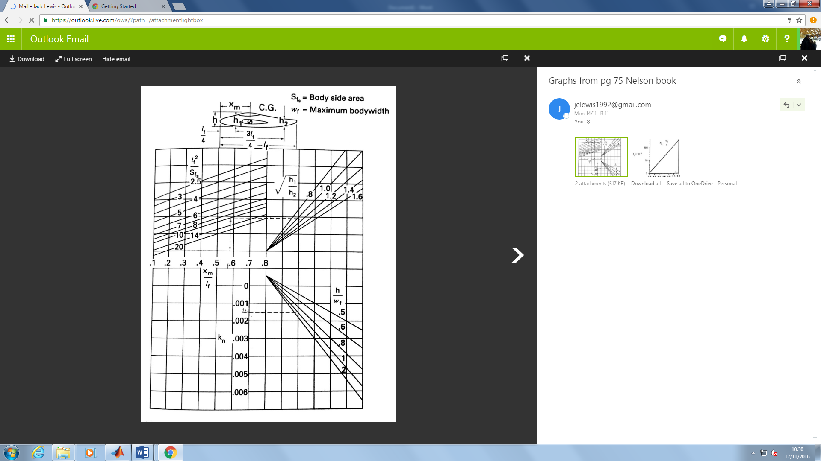



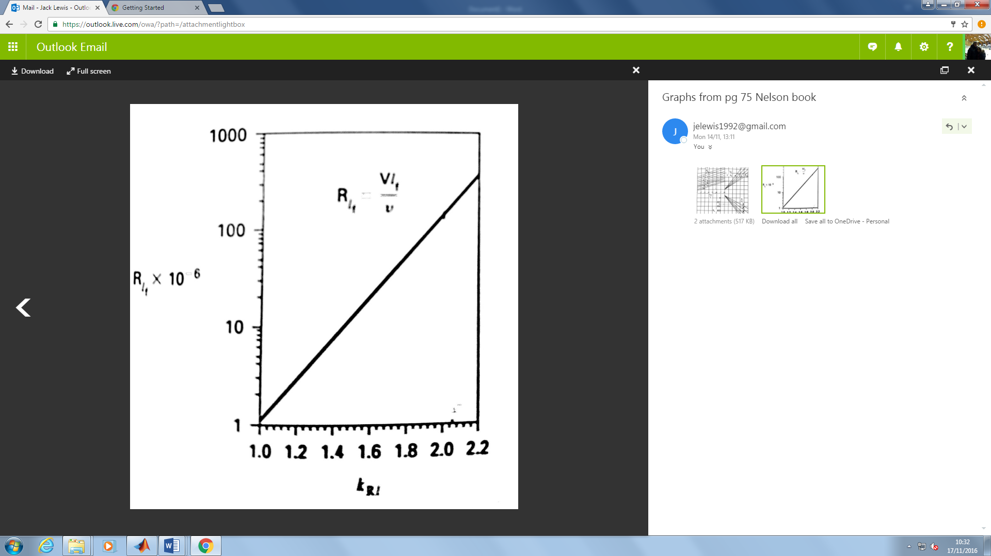

229 mm

711 mm

482 mm

6934.5 mm

Swept Angle