Name = NACA 63-418

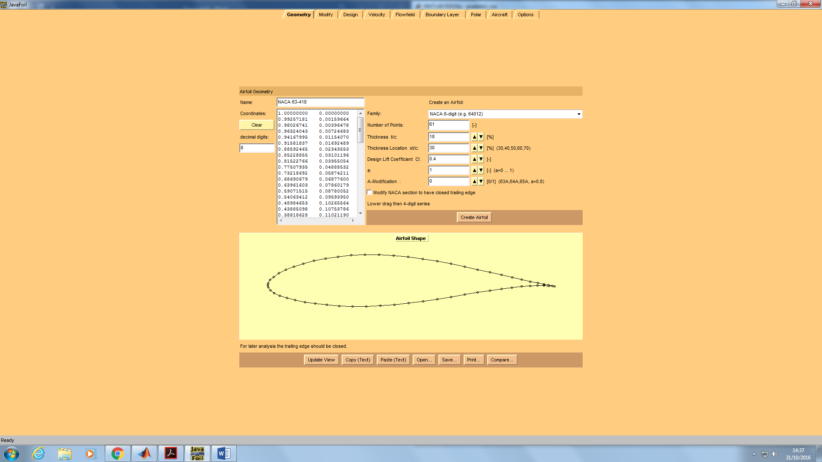

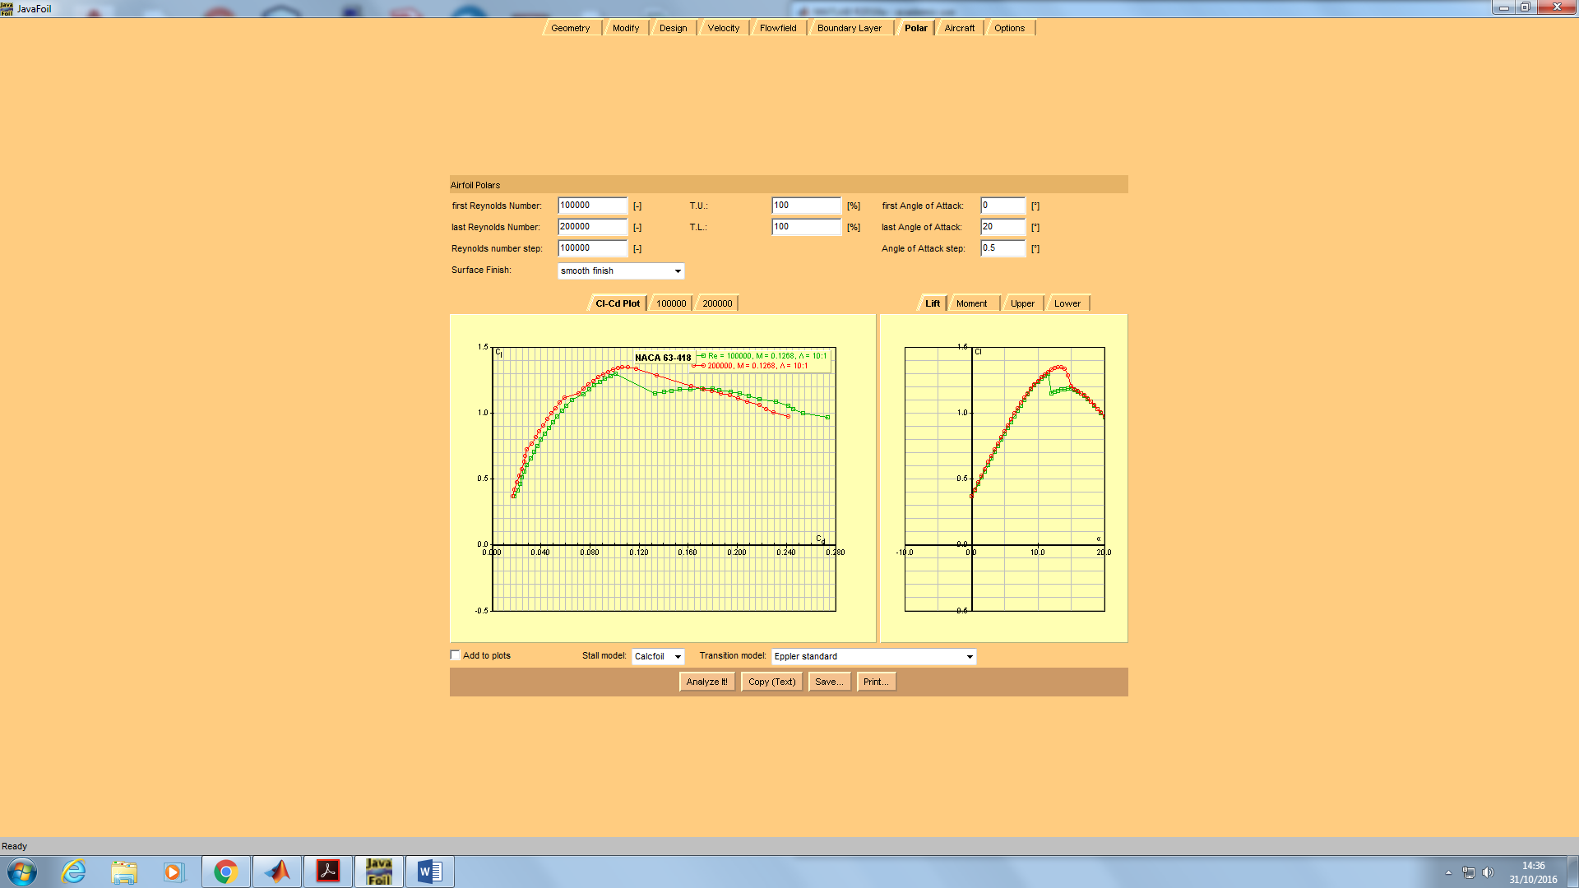

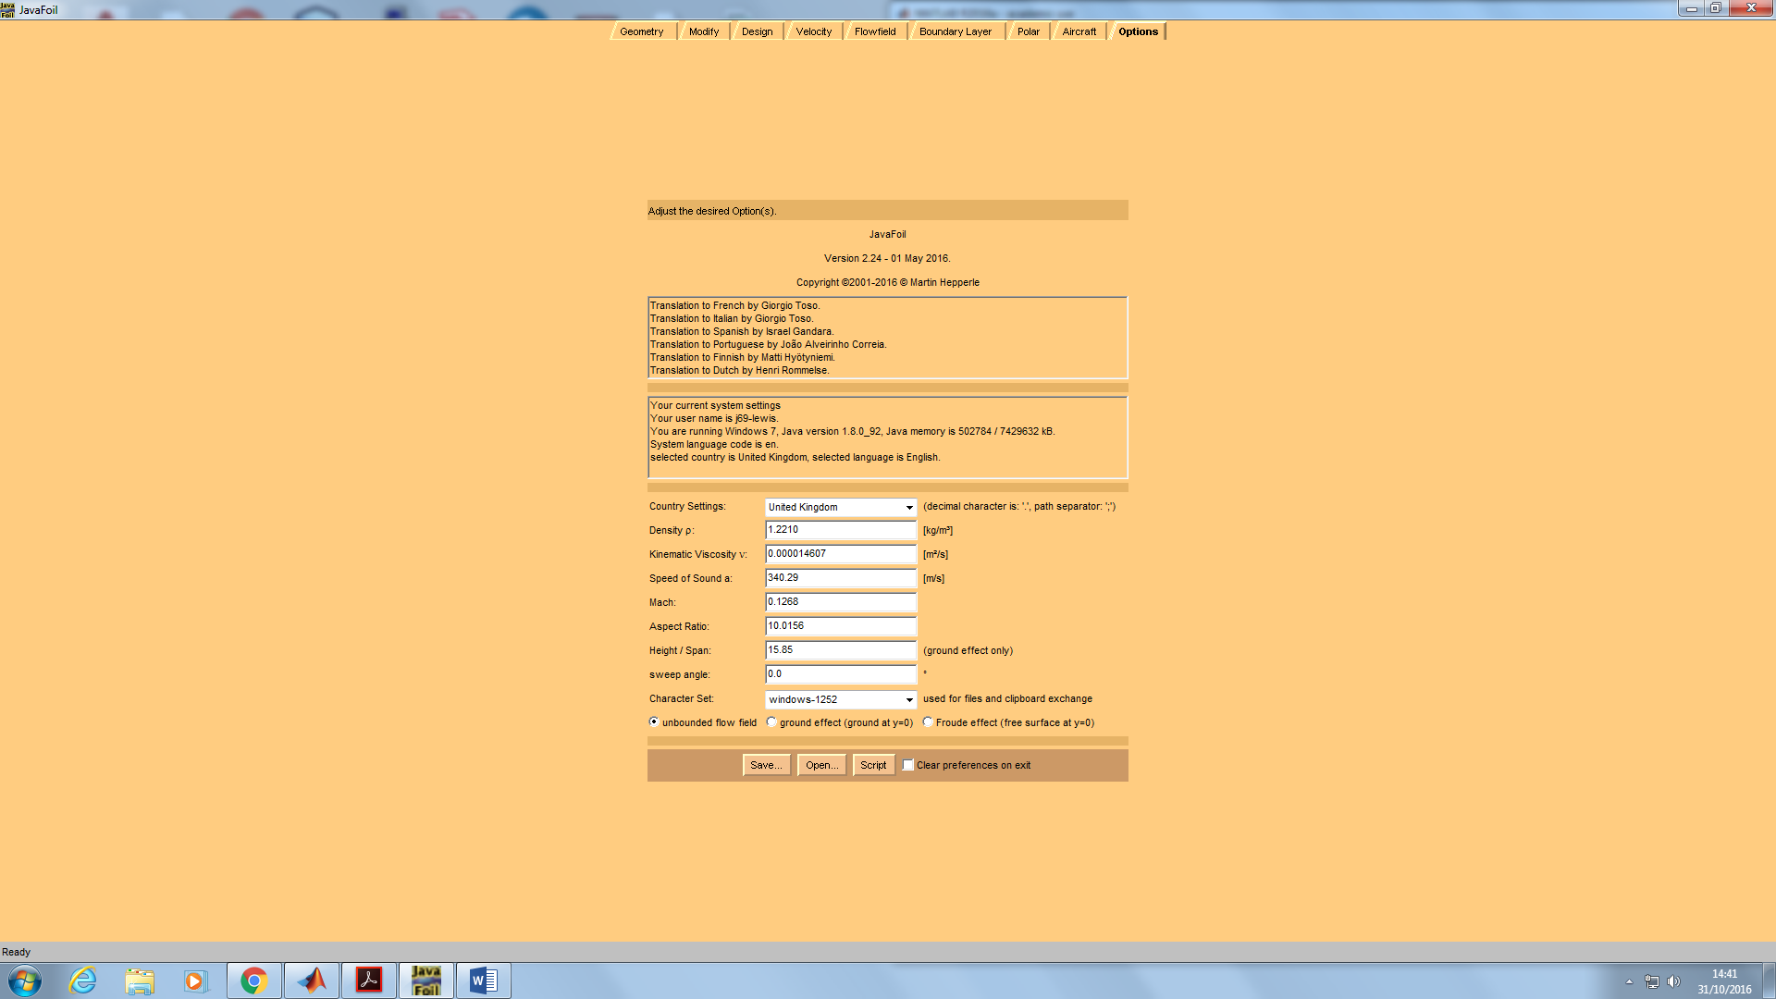

Name = NACA 63-418

Mach = 0.1268; Re = 100000; T.U. = 1.0; T.L. = 1.0

Surface Finish = 0; Stall model = 0; Transition model = 1; Aspect Ratio = 10.0156; ground effect = 0

α Cl Cd Cm 0.25 T.U. T.L. S.U. S.L. L/D A.C. C.P.

[°] [-] [-] [-] [-] [-] [-] [-] [-] [-] [-]

0.0 0.368 0.01852 -0.059 0.468 0.454 0.919 0.829 19.898 0.268 0.411

0.5 0.412 0.02111 -0.060 0.460 0.461 0.901 0.846 19.528 0.266 0.396

1.0 0.462 0.02277 -0.061 0.452 0.470 0.882 0.861 20.270 0.265 0.382

1.5 0.510 0.02463 -0.062 0.446 0.480 0.863 0.878 20.725 0.266 0.371

2.0 0.559 0.02667 -0.063 0.439 0.489 0.846 0.896 20.961 0.267 0.362

2.5 0.608 0.02852 -0.063 0.430 0.498 0.833 0.917 21.311 0.276 0.354

3.0 0.656 0.03172 -0.065 0.421 0.507 0.820 0.993 20.677 0.273 0.349

3.5 0.703 0.03426 -0.066 0.414 0.514 0.805 0.995 20.532 0.262 0.343

4.0 0.750 0.03697 -0.066 0.406 0.525 0.791 0.995 20.298 0.262 0.338

4.5 0.797 0.03995 -0.067 0.399 0.536 0.778 0.995 19.953 0.261 0.334

5.0 0.842 0.04303 -0.067 0.393 0.546 0.760 0.995 19.557 0.262 0.330

5.5 0.887 0.04632 -0.068 0.382 0.557 0.753 0.995 19.148 0.264 0.326

6.0 0.931 0.04975 -0.068 0.372 0.567 0.743 0.995 18.706 0.264 0.323

6.5 0.974 0.05327 -0.069 0.360 0.578 0.735 0.995 18.289 0.263 0.321

7.0 1.015 0.05693 -0.070 0.350 0.591 0.722 0.994 17.834 0.263 0.318

7.5 1.056 0.06088 -0.070 0.337 0.600 0.713 0.994 17.349 0.268 0.316

8.0 1.099 0.06503 -0.071 0.308 0.609 0.721 0.994 16.908 0.273 0.315

8.5 1.143 0.07485 -0.072 0.019 0.620 0.738 0.994 15.274 0.271 0.313

9.0 1.177 0.07915 -0.073 0.017 0.630 0.725 0.994 14.865 0.265 0.312

9.5 1.208 0.08352 -0.073 0.016 0.643 0.712 0.994 14.460 0.266 0.311

10.0 1.236 0.08781 -0.074 0.014 0.653 0.699 0.994 14.076 0.266 0.309

10.5 1.261 0.09215 -0.074 0.013 0.662 0.682 0.994 13.684 0.265 0.309

11.0 1.282 0.09655 -0.074 0.012 0.674 0.663 0.994 13.277 0.260 0.308

11.5 1.297 0.10102 -0.074 0.011 0.686 0.635 0.994 12.841 0.485 0.307

12.0 1.147 0.13290 -0.043 0.010 0.697 0.037 0.994 8.632 0.496 0.287

12.5 1.159 0.14015 -0.040 0.009 0.709 0.027 0.994 8.268 0.029 0.285

13.0 1.168 0.14599 -0.038 0.009 0.723 0.019 0.994 8.001 0.142 0.282

13.5 1.177 0.15303 -0.038 0.007 0.736 0.019 0.994 7.690 0.265 0.282

14.0 1.182 0.16155 -0.038 0.007 0.748 0.018 0.994 7.317 0.275 0.282

14.5 1.185 0.17104 -0.038 0.006 0.762 0.018 0.994 6.927 0.529 0.282

15.0 1.185 0.17951 -0.039 0.005 0.776 0.018 0.994 6.599 0.353 0.283

15.5 1.175 0.18491 -0.037 0.005 0.794 0.014 0.994 6.355 0.270 0.282

16.0 1.163 0.19450 -0.038 0.004 0.813 0.016 0.994 5.982 0.275 0.283

16.5 1.147 0.20214 -0.037 0.004 0.847 0.012 0.994 5.675 0.268 0.282

17.0 1.129 0.20926 -0.038 0.004 0.993 0.013 0.993 5.396 0.255 0.283

17.5 1.107 0.21820 -0.037 0.004 0.993 0.011 0.993 5.075 0.262 0.283

18.0 1.084 0.23138 -0.037 0.003 0.993 0.011 0.993 4.685 0.264 0.284

18.5 1.058 0.24152 -0.036 0.003 0.993 0.009 0.993 4.380 0.286 0.284

19.0 1.030 0.24553 -0.035 0.003 0.993 0.008 0.993 4.195 0.257 0.284

19.5 1.001 0.25336 -0.035 0.003 0.994 0.008 0.995 3.951 0.256 0.285

20.0 0.970 0.27343 -0.035 0.002 0.994 0.007 0.995 3.549 0.271 0.286

Name = NACA 63-418

Mach = 0.1268; Re = 200000; T.U. = 1.0; T.L. = 1.0

Surface Finish = 0; Stall model = 0; Transition model = 1; Aspect Ratio = 10.0156; ground effect = 0

α Cl Cd Cm 0.25 T.U. T.L. S.U. S.L. L/D A.C. C.P.

[°] [-] [-] [-] [-] [-] [-] [-] [-] [-] [-]

0.0 0.368 0.01730 -0.063 0.468 0.454 1.000 0.995 21.295 0.265 0.420

0.5 0.421 0.01867 -0.063 0.460 0.461 1.000 0.993 22.533 0.266 0.401

1.0 0.473 0.02031 -0.064 0.452 0.470 1.000 0.993 23.273 0.266 0.386

1.5 0.525 0.02215 -0.065 0.446 0.480 1.000 0.994 23.690 0.266 0.374

2.0 0.577 0.02422 -0.066 0.439 0.489 1.000 0.994 23.817 0.266 0.364

2.5 0.629 0.02649 -0.067 0.430 0.498 1.000 0.995 23.733 0.260 0.356

3.0 0.674 0.02701 -0.067 0.421 0.507 0.954 0.994 24.964 0.257 0.349

3.5 0.721 0.02839 -0.067 0.414 0.514 0.928 0.995 25.417 0.261 0.344

4.0 0.769 0.03279 -0.068 0.406 0.525 0.910 0.995 23.456 0.262 0.338

4.5 0.817 0.03560 -0.069 0.399 0.536 0.895 0.995 22.938 0.262 0.334

5.0 0.862 0.03849 -0.069 0.393 0.546 0.877 0.995 22.400 0.262 0.330

5.5 0.908 0.04164 -0.070 0.382 0.557 0.864 0.995 21.796 0.263 0.327

6.0 0.952 0.04488 -0.070 0.372 0.567 0.851 0.995 21.212 0.264 0.324

6.5 0.996 0.04831 -0.071 0.360 0.578 0.840 0.995 20.614 0.263 0.321

7.0 1.038 0.05177 -0.071 0.350 0.591 0.827 0.994 20.050 0.263 0.319

7.5 1.079 0.05542 -0.072 0.337 0.600 0.814 0.994 19.464 0.265 0.317

8.0 1.120 0.05952 -0.073 0.308 0.609 0.809 0.994 18.820 0.259 0.315

8.5 1.150 0.07031 -0.073 0.019 0.620 0.766 0.994 16.355 0.258 0.313

9.0 1.184 0.07448 -0.073 0.017 0.630 0.754 0.994 15.897 0.266 0.312

9.5 1.215 0.07850 -0.074 0.016 0.643 0.741 0.994 15.480 0.267 0.311

10.0 1.244 0.08257 -0.074 0.014 0.653 0.729 0.994 15.068 0.268 0.310

10.5 1.270 0.08664 -0.075 0.013 0.662 0.716 0.994 14.658 0.269 0.309

11.0 1.293 0.09077 -0.075 0.012 0.674 0.703 0.994 14.242 0.270 0.308

11.5 1.312 0.09465 -0.075 0.011 0.686 0.687 0.994 13.859 0.271 0.308

12.0 1.327 0.09876 -0.076 0.010 0.697 0.671 0.994 13.438 0.274 0.307

12.5 1.339 0.10287 -0.076 0.009 0.709 0.653 0.994 13.016 0.278 0.307

13.0 1.347 0.10643 -0.076 0.009 0.723 0.634 0.994 12.654 0.280 0.307

13.5 1.349 0.11055 -0.076 0.007 0.736 0.608 0.994 12.206 0.346 0.307

14.0 1.337 0.11724 -0.075 0.007 0.748 0.544 0.994 11.402 0.352 0.306

14.5 1.283 0.13404 -0.070 0.006 0.762 0.352 0.994 9.574 0.418 0.304

15.0 1.205 0.16253 -0.053 0.005 0.776 0.088 0.994 7.415 0.498 0.294

15.5 1.181 0.17277 -0.044 0.005 0.794 0.033 0.994 6.834 0.473 0.287

16.0 1.169 0.17921 -0.045 0.004 0.813 0.036 0.994 6.525 0.356 0.289

16.5 1.150 0.18637 -0.041 0.004 0.847 0.021 0.994 6.169 0.270 0.286

17.0 1.134 0.19375 -0.045 0.004 0.993 0.031 0.993 5.853 0.246 0.289

17.5 1.110 0.20058 -0.041 0.004 0.993 0.020 0.993 5.533 0.316 0.287

18.0 1.086 0.20783 -0.041 0.003 0.993 0.020 0.993 5.227 0.257 0.288

18.5 1.060 0.21791 -0.041 0.003 0.993 0.017 0.993 4.864 0.262 0.288

19.0 1.032 0.22365 -0.041 0.003 0.993 0.017 0.993 4.616 0.244 0.290

19.5 1.003 0.22915 -0.041 0.003 0.994 0.017 0.995 4.378 0.261 0.291

20.0 0.972 0.24163 -0.040 0.002 0.994 0.014 0.995 4.024 0.282 0.291