Skill Demand in Agri-Food System Jobs
  - Evidence from Selected African Countries
2026-06-23
Table of contents

Overview
Static version. This document is a static export of an interactive online report. The charts are fixed snapshots and do not reproduce the interactive features of the online version (metric and country toggles, hover tooltips, and view switches). For the full interactive report, visit https://skillmap-nlp.github.io/afs/.
Agri-food systems (AFS) are a major source of employment and income in Kenya, Nigeria, and Uganda. But the structure of AFS labour demand is shifting: as these economies develop, the jobs tied to food and agriculture reach well beyond primary production into off-farm value-chain activities — processing, logistics, wholesale and retail trade, and food services — and into the cross-cutting management, technical, quality-control, finance, and business-support roles that connect them Christiaensen et al., 2021. For skills policy, this wider view matters because productivity and structural transformation depend not only on improving farm-level capabilities, but also on building the skills needed to move, process, market, regulate, finance, and manage food across the whole value chain.
This report measures skill demand in AFS jobs using online job posting data for the three countries. The main analysis covers 2021–2024 using Lightcast data and additional postings scraped from major national job portals; a complementary section draws on individual local portals for 2024–2026 to offer a more recent — though not directly comparable — view of trends.
The report treats online vacancies as a window into formal, digitally mediated labour demand. This is a policy-relevant segment, but not a representative one. Online postings capture jobs that employers choose to advertise through digital recruitment channels — typically formal, urban, higher-skilled, and often off-farm roles. By design, they leave largely outside the frame the smallholder, informal, and community-based hiring through which much AFS work is organised. The results should therefore be read as evidence on advertised employer demand in the formal online recruitment segment, not as estimates of total AFS employment.
The analysis proceeds in four steps. It first sets out the coverage and limits of online posting data in the three countries — focusing on digital connectivity, recruitment channels, and the gap between online advertised demand and the employment structure measured in labour force surveys. It then identifies AFS vacancies through a posting-level classifier that draws on job titles and descriptions and separates on-farm from off-farm activities. Next, it describes the occupational and employer structure of AFS demand, including employer concentration, monthly trends, and regional distribution. Finally, it analyses the skills requested in AFS postings, comparing on-farm and off-farm roles and highlighting distinctive, digital, and specialised skills.
The central finding follows from the lens itself. Within the formal, advertised segment that online data capture, AFS demand is shaped far more by off-farm activities and by managerial, professional, technical, service, logistics, and business-support roles than the farm-centred image of African agriculture would suggest. This does not diminish the importance of primary production; rather, it shows that the online recruitment channel reveals a different layer of the agri-food system — the jobs through which farms, firms, markets, and consumers are increasingly connected.
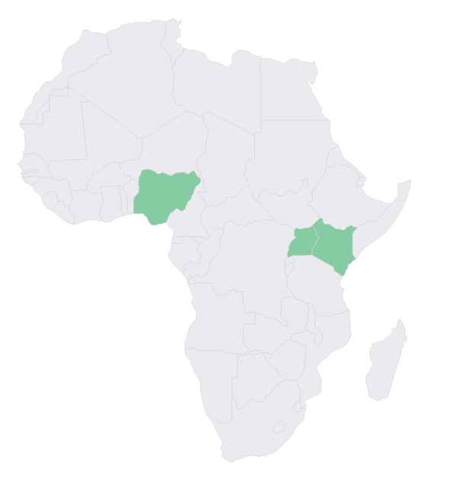

Data

Data sources and construction
Job posting data · 2021–2024 · Kenya, Nigeria, Uganda
The report draws on online job postings to analyse advertised demand for agri-food system (AFS) jobs in Kenya, Nigeria, and Uganda. The main dataset covers 2021–2024 and combines Lightcast vacancy data with additional postings scraped from selected major national job boards. Lightcast is used as the backbone of the analysis because it aggregates postings from multiple sources and therefore provides broader and more consistent coverage than any single job portal. At the same time, we observed gaps in Lightcast coverage for some relevant national sources. Where possible, these gaps were addressed by collecting additional vacancies directly from important local job boards. This made it possible to strengthen the 2021–2024 dataset with postings from sources that were relevant for AFS recruitment but not fully captured in the aggregator data.
- Lightcast — multi-platform aggregator
- MyJobMag — Kenya & Nigeria
- Jobline / Great Uganda Jobs — Uganda
Selected local portals are also used to provide a more recent view of AFS demand for 2024–2026. This most-recent window relies on individual portals rather than the broader Lightcast-plus-major-portals dataset used for the main analysis. These newer data are collected directly from selected portals and therefore differ from the main dataset in source coverage, collection method, and representativeness. They should not be interpreted as a direct continuation of the 2021–2024 time series. Instead, they are presented as complementary evidence on within-portal developments in recent years. With this caveat, they help indicate whether the structure of advertised AFS demand on major portals has changed after the period covered by the main dataset.
The unit of analysis is the online vacancy. A posting represents an advertised job opportunity, not a filled position or an employment stock. The data therefore capture formal, digitally mediated recruitment rather than the full structure of AFS employment. This distinction is important in Kenya, Nigeria, and Uganda, where much agricultural and food-related work takes place through smallholder, informal, seasonal, or community-based arrangements that are largely outside online recruitment channels. Online postings are nevertheless valuable for skills analysis because they show the tasks, credentials, and capabilities that employers explicitly request when recruiting through formal channels.
To construct the analytical dataset, vacancies were first standardised across sources, including job title, employer name, location, date, occupation, sector, and description fields. Duplicate postings were removed where the same vacancy appeared more than once. The cleaned job titles and descriptions were then used to identify whether each vacancy was related to the agri-food system. The classification was conducted at posting level, rather than assigning all jobs from a sector or employer to AFS. This reduces the risk of including unrelated vacancies from diversified firms, recruitment agencies, or employers with only partial involvement in agri-food activities.
AFS vacancies were further divided into on-farm and off-farm roles. On-farm jobs refer to vacancies directly linked to agricultural production and farm-level activities, including crops, livestock, fisheries, agronomy, irrigation, extension, and veterinary services. Off-farm jobs refer to vacancies linked to the wider agri-food value chain, including food processing, storage, logistics, wholesale and retail trade, food services, agricultural inputs, quality assurance, and market-facing or business-support functions. This distinction allows the report to examine whether advertised skill demand is concentrated in primary production or in the broader set of activities that connect farms to firms, markets, and consumers.
Skills were extracted from the text of AFS vacancies and analysed as indicators of employer demand. The report focuses on skills explicitly requested in job descriptions and requirements, and compares their distribution across countries, on-farm and off-farm roles, occupations, and employers. The details of the AFS identification procedure and the skill extraction approach are described in the methodology sections that follow.

Coverage of online job posting data and digital connectivity
- Online job postings proxy aggregate labour demand, especially in African labour markets, where they primarily capture recruitment in the formal, digitalized segment, while much hiring still occurs through offline and informal channels (Chinen & Montorsi, 2025; World Bank, 2019).
- The extent of labour demand observed online depends partly on digital connectivity and platform penetration, not only on underlying hiring activity.
- As a contextual measure, the ICT Development Index (IDI) is a 0–100 composite of digital access, use, and skills.
- Online job postings are likely to capture a larger share of total labour demand in more digitally connected markets—particularly in Kenya than in Nigeria or Uganda.

Online job market activity
Job postings per 100k labour force and real GDP growth · 2021–2024 (Kenya through August 2024)
Kenya shows strong growth in online job postings through 2023, with the 2024 value lower because the Kenya data run only through August. Nigeria’s postings dipped in 2022, rebounded sharply in 2023, and rose further in 2024 to their highest level in the window. Uganda’s posting intensity stays broadly stable across the period (around 150–240 per 100k), easing only slightly in 2024 rather than showing a collapse in online hiring volumes.
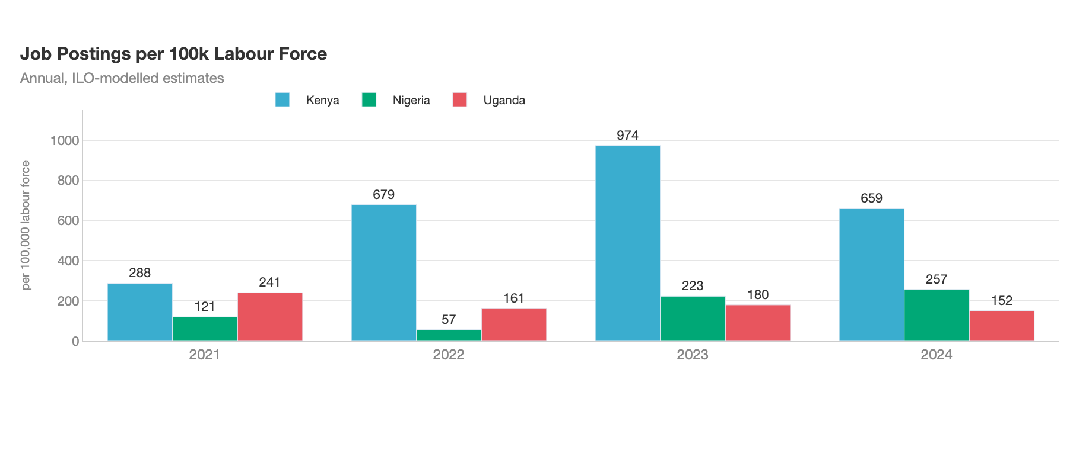
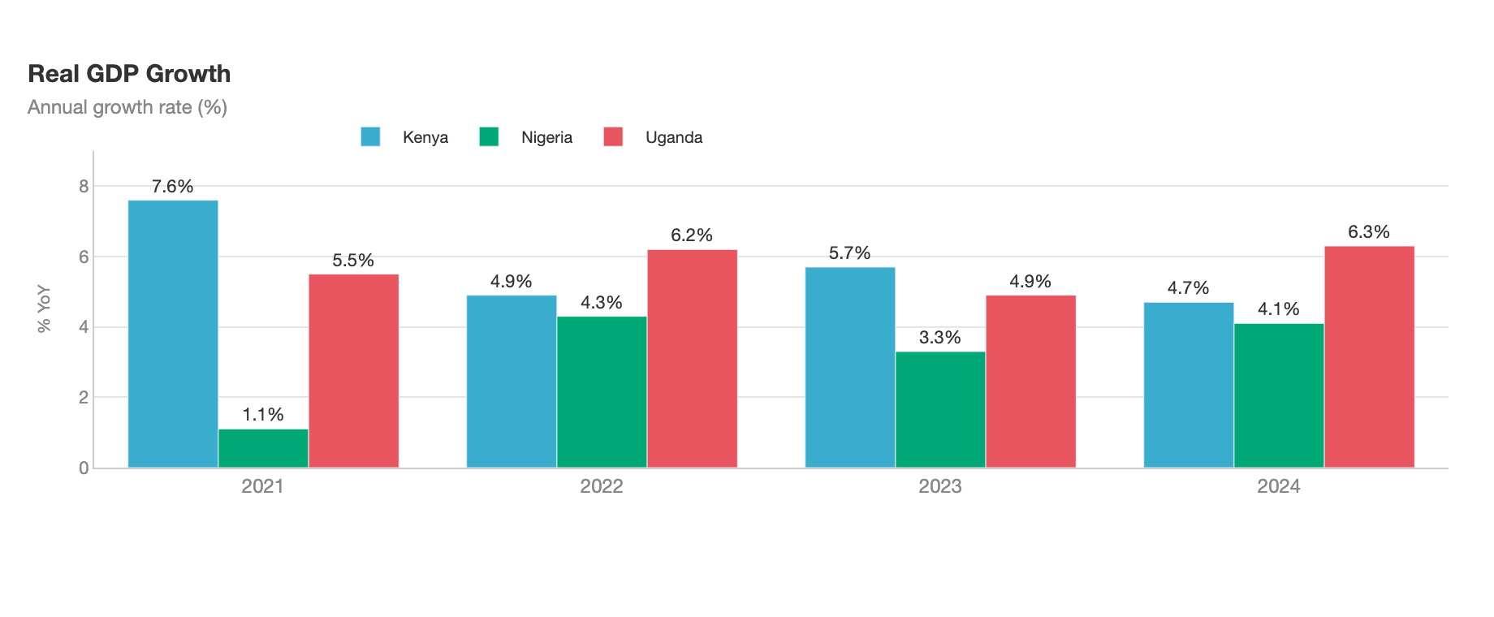
Note: Quarterly correlation analysis shows no statistically significant relationship between GDP growth and posting volumes, including at ±1-quarter lags.

Online demand vs. actual employment structure
How representative is online demand of the underlying labour market?
The widget below contrasts the occupational composition of online job postings (demand, online job offers) with actual employment shares from national labour force surveys reported to the ILO (employment), at the ISCO-08 Major Group level (1-digit).
For each country we compute the Index of Dissimilarity, originally developed to measure residential segregation by race and gender. The same functional form is widely applied in labour market mismatch research — for instance, Beręsewicz et al. (2024) uses it to quantify educational and occupational mismatch between online job postings and employer-survey data in Poland.
Mismatchj=12i​Dij−Eij
where $D_{ij}$ is the share of online job postings in ISCO group $i$ for country $j$ and $E_{ij}$ is the corresponding employment share from national labour force surveys. The index expresses the percentage of the employment structure that would need to shift between occupational groups to match the composition of online demand.
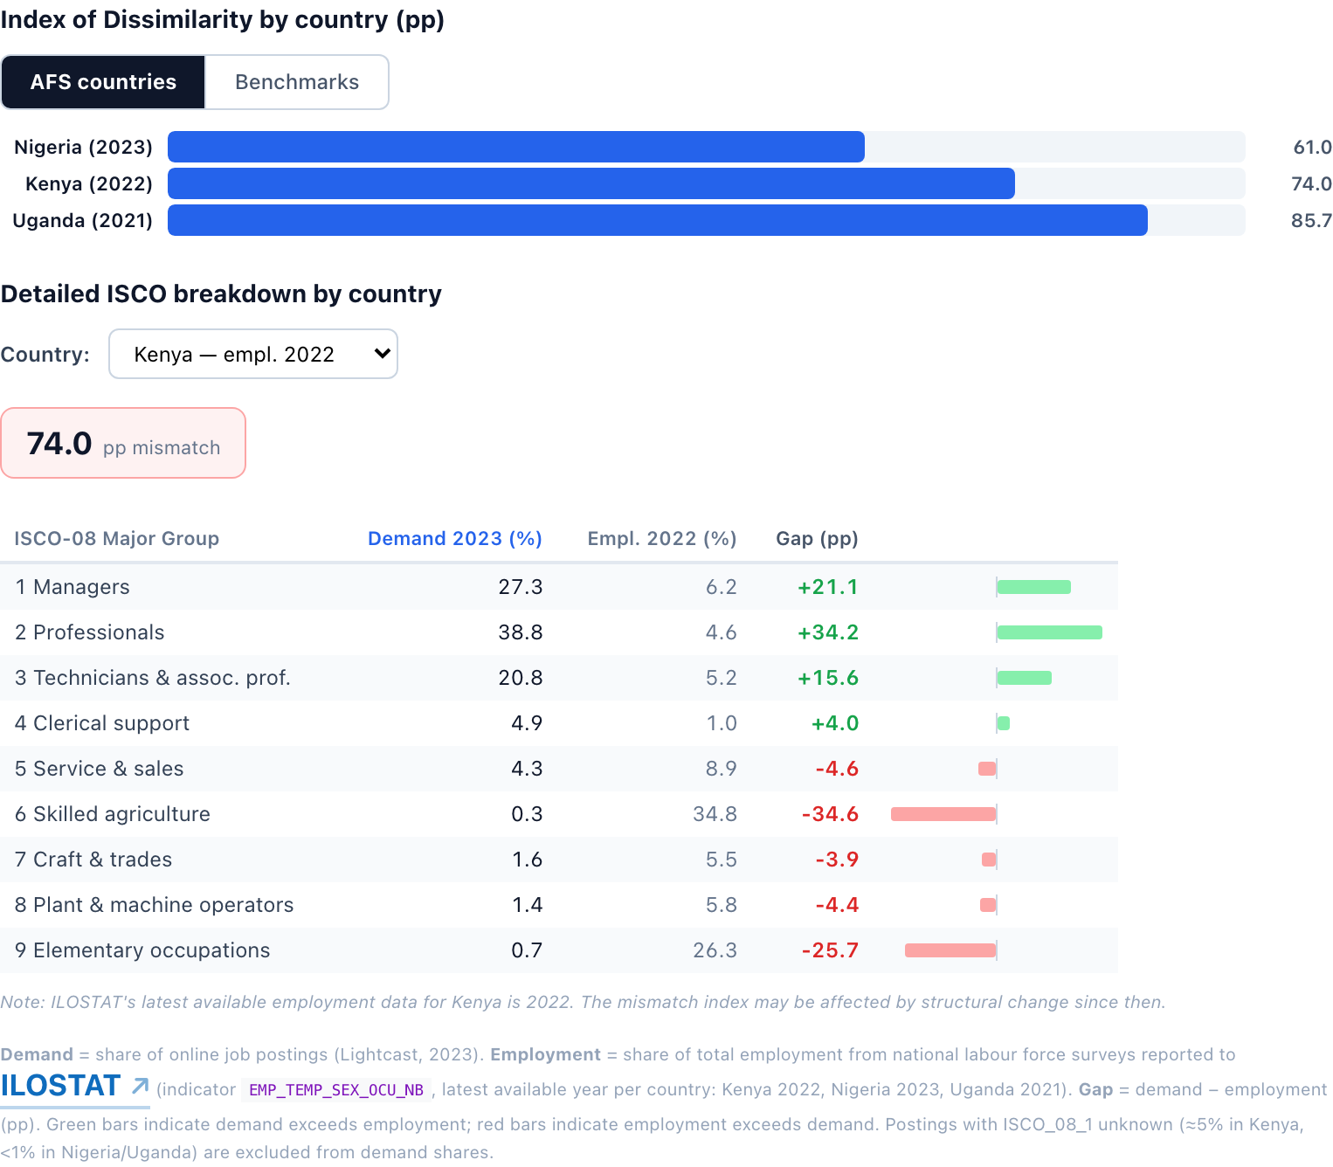
Interpretation. Across all three countries, the structure of online labour demand departs sharply from the structure of actual employment, with mismatches above the levels observed in our comparator country set. The aggregate mismatch reaches 85.7 percentage points in Uganda, 74.1 pp in Kenya and 61.0 pp in Nigeria. The polarization index is large and positive in every case: high-skill occupations (ISCO 1–3) are over-represented in online postings by roughly 70–80 pp, while mid- and lower-skill occupations (ISCO 4–9) are under-represented by a comparable margin.
The disaggregated picture is consistent across countries. Professionals (ISCO 2) account for 35–39% of online postings but only 3–5% of measured employment. Managers (ISCO 1) are over-represented by 6–30 pp and technicians and associate professionals (ISCO 3) by a further 15–20 pp. At the other end of the distribution, skilled agricultural workers (ISCO 6) — the single largest employment category in each country, at 32–60% of the workforce — account for less than 0.3% of online demand. Service and sales workers (ISCO 5) and elementary occupations (ISCO 9) are similarly almost absent from online channels.
These gaps are not artefacts of the data. They reflect a well-established structural feature of African labour markets: online vacancies are concentrated in formal-sector, white-collar roles in urban centres and the modern services economy, whereas the bulk of actual employment is located in informal smallholder agriculture, informal services and elementary occupations, where hiring rarely takes place through online channels.
Implications for the AFS analysis. This baseline mismatch shapes how the AFS results must be read. The on-farm AFS postings captured in our data are strongly self-selected toward the formal, higher-skill segment of the sector — agri-tech, agronomy and extension advisory, farm management and related technical roles — rather than the typical agricultural worker who dominates employment statistics. Online vacancy data therefore offer a window into a specific, more skill-intensive slice of AFS labour demand, not into AFS employment as a whole. Accordingly, the patterns documented in this report should be interpreted as evidence on the formal, digitally advertised segment of the agrifood skills market; they do not support inferences about the structure of skills demand in the AFS sector overall, and cross-country comparisons should be read against this common selection bias rather than as comparisons of total sectoral demand.

Identifying agri-food system jobs
Agri-food system (AFS) work is distributed across the whole value chain, and many relevant jobs do not describe themselves as agricultural. A natural starting point is to identify postings that contain agri-food terms in the job title or occupational area. When a vacancy is advertised as an “agronomist” or classified as a “crop farm worker”, its link to AFS is clear. This keyword-based approach is therefore highly precise, but it is also narrow.
The limitation is that many AFS-related vacancies are not labelled in explicitly agricultural terms. A credit officer at an agricultural lender, a logistics coordinator at a grain trader, a quality controller at a dairy processor, or a sales representative for a fertilizer distributor may all be part of AFS labour demand, even though their titles are sector-neutral. These management, finance, logistics, quality-control, sales, and other business-support roles are especially important in off-farm segments of the value chain. They are also central to the broader pattern of demand that this report aims to capture. In many cases, the AFS link is visible only from the full job description, the employer description, or the product and sector context.
Extending the keyword search to the full posting text is not sufficient. Job descriptions contain many incidental mentions that are unrelated to the sector of the job. For example, terms such as “kitchen”, “farm”, or “logging” may appear in contexts that have nothing to do with agri-food work. Applying simple keyword rules to full descriptions would therefore increase coverage, but at the cost of many false positives.
The report therefore uses a full-text classification model to identify AFS vacancies. The model reads the job title, job description, and employer information, and classifies each posting according to its overall context rather than relying only on a fixed list of words. This allows it to capture sector-neutral support roles when they are connected to agri-food activities, while distinguishing genuine AFS relevance from incidental word matches.
The model is built in three steps. First, each posting is converted into a numerical representation of its meaning, known as an embedding. Postings that describe similar work are located close to one another in this embedding space, even when they use different words. This makes it possible to identify AFS-related vacancies from the semantic content of the posting, not only from explicit agricultural terminology.
Second, a labelled training set is constructed. Because AFS vacancies account for only a small share of all online postings, drawing examples at random would produce mostly non-AFS jobs. The labelling process therefore starts from a broad set of likely AFS candidates, identified through an initial screening model. Two large language models then independently assess candidate postings, and cases are retained for training only when the evidence supports the classification. The labelling process is repeated until a sufficiently large set of validated examples is available across the relevant categories. Ambiguous boundary cases are prioritised because they are most informative for improving the classifier, and the resulting labels are reviewed before use.
Third, a multinomial logistic regression model is estimated on the embeddings, together with supporting information such as the occupational area where available. The trained model is then applied to all postings and assigns each vacancy to one of three categories: on-farm AFS, off-farm AFS, or non-AFS. On-farm vacancies include jobs directly related to agricultural production and farm-level activities. Off-farm vacancies include jobs linked to processing, storage, logistics, wholesale and retail trade, food services, agricultural inputs, quality assurance, and other value-chain or business-support functions.
The classifier performs well in distinguishing AFS from non-AFS vacancies. On held-out labelled data, the AFS/non-AFS classification achieves a precision of 0.874, a recall of 0.942, and an F1 score of 0.906. The model therefore provides a reliable basis for estimating the overall volume of advertised AFS demand. The distinction between on-farm and off-farm AFS jobs is also strong, with performance slightly below an F1 score of 0.9. By contrast, performance varies more across finer-grained subcategories, reflecting smaller sample sizes and less clear boundaries between some parts of the value chain. To avoid over-interpreting classifications that are less stable, the report therefore keeps the main analysis at the on-farm/off-farm level, while treating more detailed categories as supporting information rather than as the primary analytical breakdown.
Throughout the report, the main interpretation of results is based on the full-text classifier, because it provides the broader measure of AFS demand that includes both core agricultural jobs and the off-farm, managerial, technical, service, logistics, and business-support roles that connect the wider agri-food system. At the same time, the keyword approach remains available as a narrower, high-precision benchmark. Where useful, readers can display results based on the keyword definition to see how patterns change when the analysis is restricted to vacancies with explicit agri-food terms in the title or occupational area.
The keyword approach relies on the term lists below. A posting is flagged as AFS when its job title or occupational area contains one of these terms, and is assigned to the most specific matching sub-category. Terms are matched case-insensitively, and short stems capture morphological variants (for example, agronom matches both “agronomist” and “agronomy”).
The two approaches also differ substantially in how much of the online market they classify as agri-food. The chart below compares the share of all online postings identified as AFS under each approach, by country and pooled across the three countries. The contextual model recovers a markedly larger share of AFS demand — driven mainly by off-farm, sector-neutral roles that the keyword definition cannot see — while the keyword approach stays close to vacancies with explicit agri-food terms.
To place these online vacancy shares in context, the chart compares the AFS share of online vacancies (contextual model) with official indicators describing the broader importance of agriculture in the economy, namely its contribution to GDP and total employment. These measures are not directly comparable, as online vacancies capture current formal labour demand, whereas GDP and employment statistics reflect the overall economic importance of the sector.
Nevertheless, the comparison is informative. Agriculture accounts for roughly a quarter of GDP and employs between one-third (Nigeria) and two-thirds (Uganda) of the workforce, while AFS-related vacancies represent only around 9–12% of online job postings. This suggests that online job boards capture only a limited and more formal segment of labour demand in agri-food systems.
Moreover, the official statistics refer primarily to agriculture in the narrow sense and do not include the broader upstream and downstream activities covered by our AFS concept, such as food processing, trade and food services. Consequently, the comparison should be interpreted as illustrative rather than as a direct benchmark.
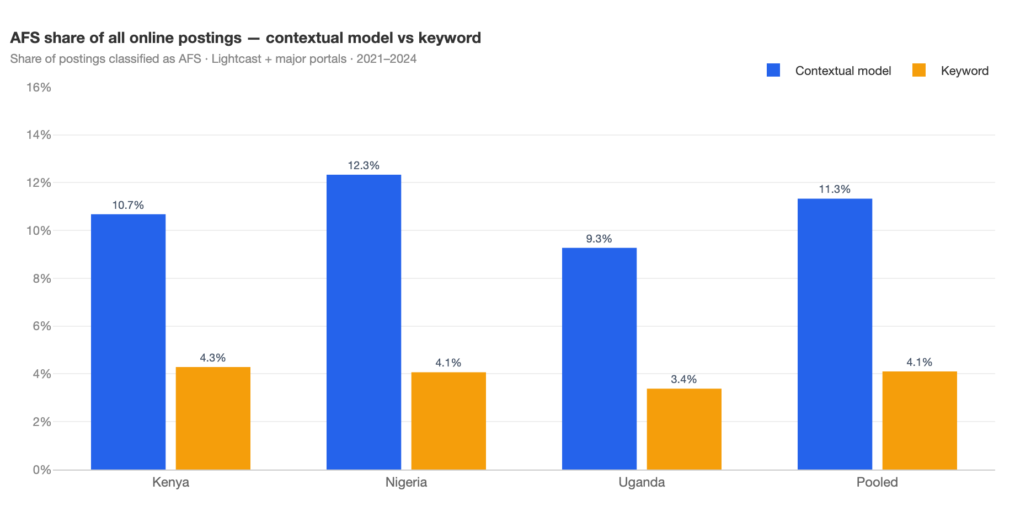
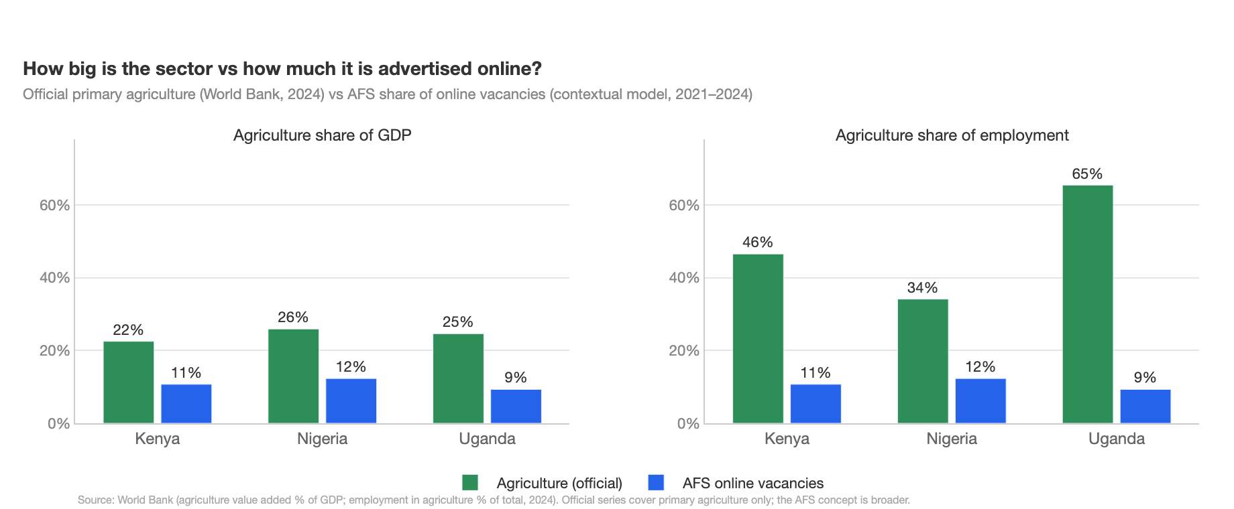
The full technical specification — including the embedding model, labelling protocol, validation metrics, and correction procedure — is provided in Appendix C.

What occupations are inside AFS?
ISCO-08 composition of AFS postings — pooled and by country
Our classification labels each posting as AFS or not. The ISCO-08 lens shows what these AFS jobs actually are in occupational terms — and reveals how strongly the online channel selects formal, higher-skill roles within the agri-food system. Pooled across the three countries, N = 95,503 AFS postings (Kenya 38,721 · Nigeria 48,153 · Uganda 8,629). Use the AFS jobs identification approach toggle above the table to switch every figure between the default contextual model and the keyword method.
ISCO-08 major group | Share of AFS (pooled) | KE | NG | UG
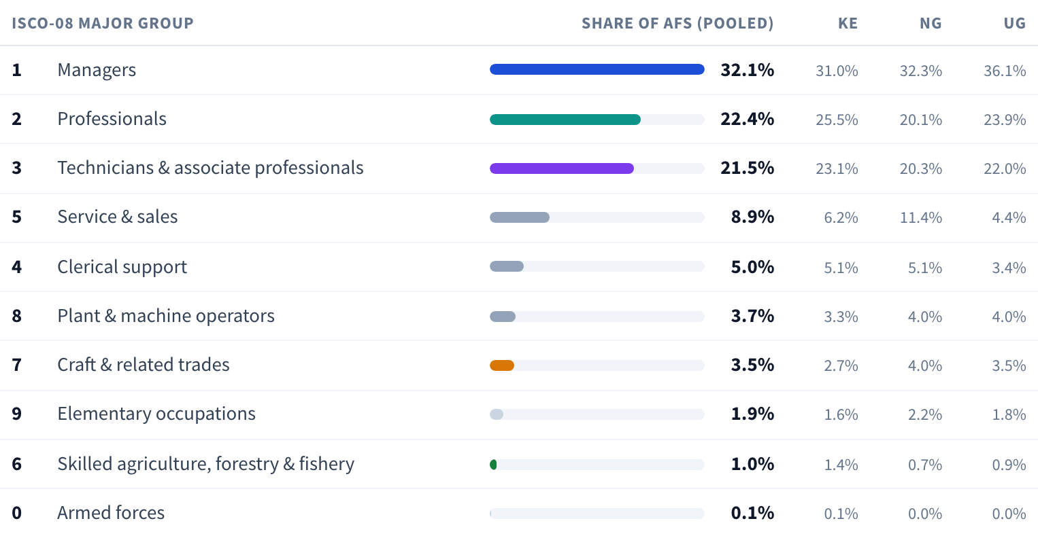
Around 77% of AFS postings sit in ISCO 1–3 — managers, professionals and technicians — and the composition is remarkably stable across countries. The narrowly defined “skilled agricultural worker” group (ISCO 6) accounts for only 1.0% of AFS postings, despite making up 30–60% of total employment in these countries. This is the same selection effect that drives the demand–employment mismatch documented earlier: online channels predominantly surface the formal, higher-skill end of the agri-food labour market.
Drill-down: top ISCO 4-digit occupations within each dominant group
The drill-down clarifies what these aggregate categories actually contain. Within each major group a small number of 4-digit occupations dominates; the leading codes — and how concentrated each group is — shift between the contextual model and the keyword method, which you can compare with the toggle above. The cards below show the top five 4-digit occupations within each of the five largest groups under the selected method.
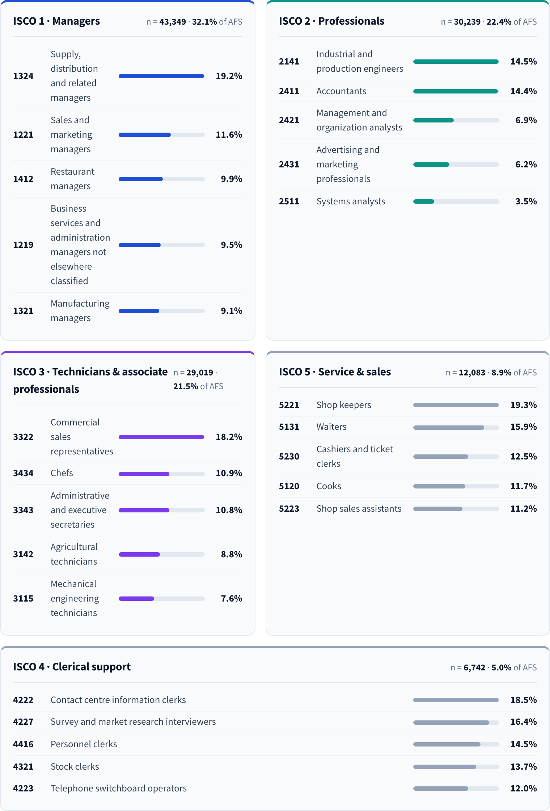
The picture is consistent with the broader narrative. Online AFS demand is anchored by managerial, professional and technical roles — spanning production and operations management, agronomy and agricultural extension, agricultural finance and trade, research and education, and downstream food quality and processing. The exact leading occupations depend on the identification approach (compare via the toggle above), but the structural conclusion is the same: the typical agricultural labourer — the role that dominates actual employment — appears almost exclusively under ISCO 6 and is barely visible at scale, reinforcing the selection-bias caveat applied throughout the report.
Source: Authors’ calculations from Lightcast · 2021–2024, AFS-tagged postings (N = 135,151).

Employer concentration in AFS demand
How concentrated is online demand across employers in AFS, and how does it compare with other sectors?
Beyond the what (occupations) and the how much (skills), employer-level concentration tells us who drives demand. We measure concentration using the Herfindahl–Hirschman Index — the sum of squared employer shares of postings, scaled to 0–10,000 — and the cumulative share of postings going to the top one and top five employers (CR1, CR5). Higher values mean demand is dominated by fewer employers; the reciprocal $10,000/\text{HHI}$ is the effective number of employers in a segment.
HHIs=10,000⋅i∈s​niNs2
The chart compares AFS on-farm, AFS off-farm, and the average across non-agriculture NACE divisions, with a band showing one standard deviation across those divisions to convey how much the typical sector varies. You can add individual NACE divisions to the chart using the chips below.
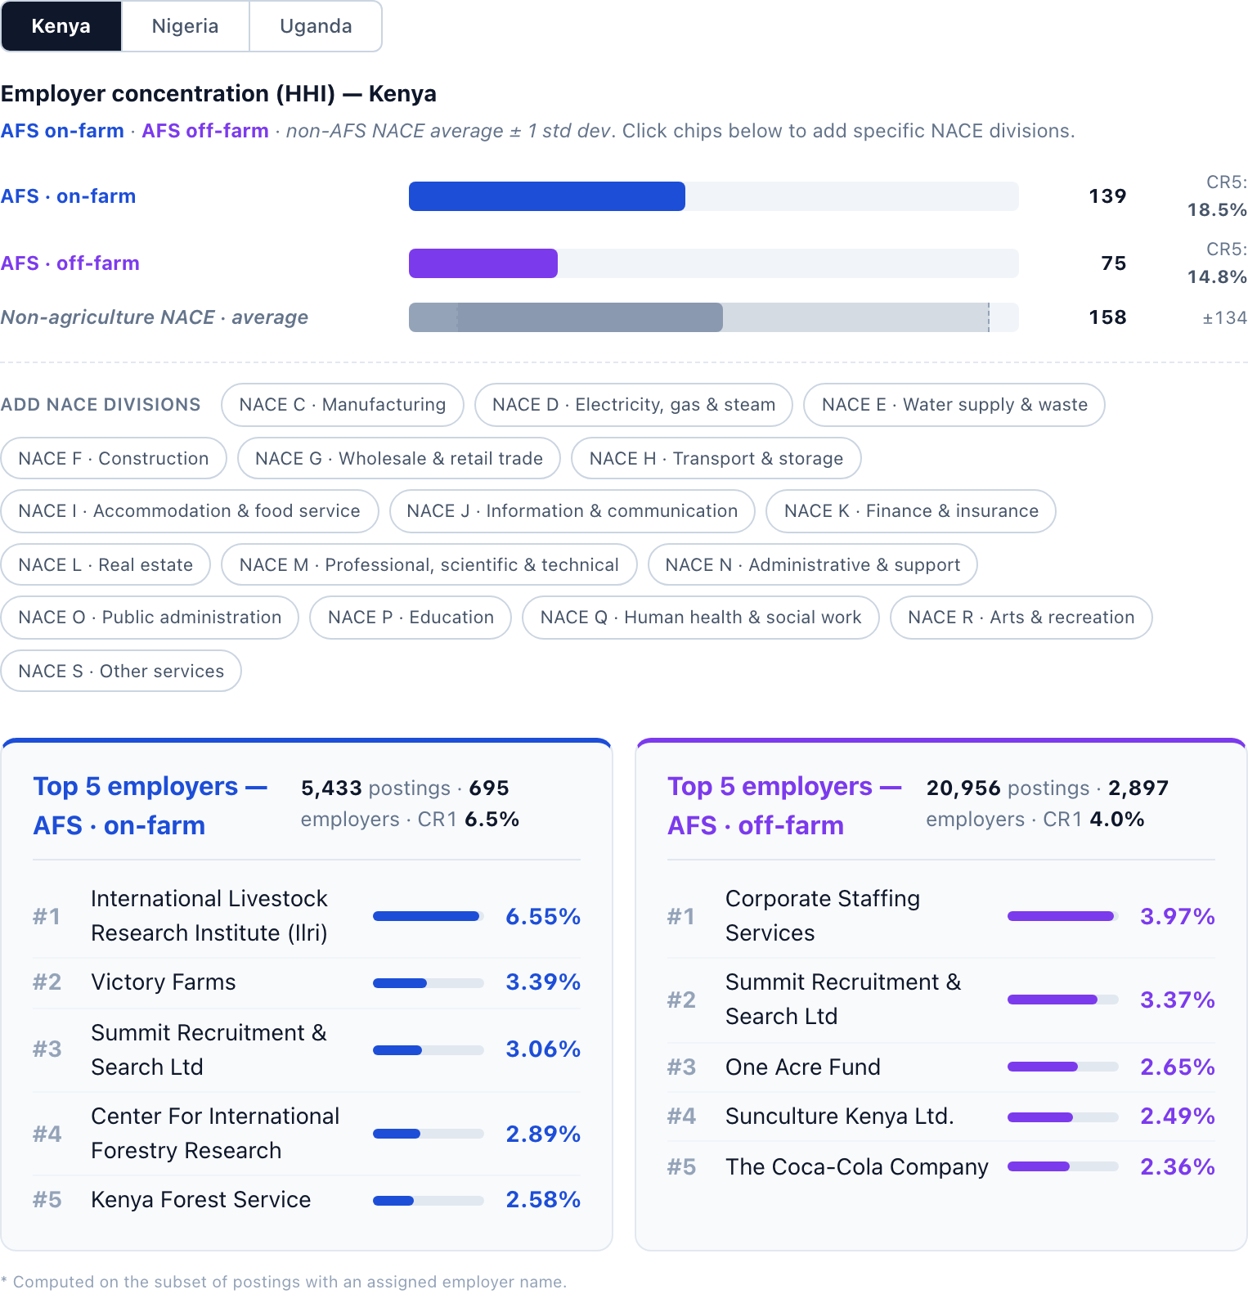
Across all three countries, AFS employer demand is more concentrated than the non-AFS benchmark, but typically sits within the range of variation observed across non-agriculture NACE divisions: a handful of sectors — notably public administration, education, and regulated utilities — are even more concentrated. The balance between the on-farm and off-farm segments varies by country and by identification approach, so the relative concentration of the two segments can reverse depending on the rule applied. Use the AFS jobs identification approach toggle above the chart and the country buttons to read the exact HHI, CR1 and CR5 values for each segment; the chart and the top-employer cards update together.
The composition of the top employers — shown for the selected method and country in the cards above — explains who is doing the hiring. Kenya combines research institutes (e.g. ILRI, JKUAT), conservation NGOs and a few large private operators, with hospitality and food-service groups prominent off-farm. Nigeria shows the most visible private-agribusiness presence of the three (alongside research institutes such as IITA and job-board aggregators). Uganda is dominated by the public sector and development organisations (ministries, SNV, Mercy Corps, WFP), with little private agribusiness at scale.
Two implications follow. First, online AFS demand in these economies is a thin, donor- and institution-led recruitment channel rather than a broad reflection of agri-food sector hiring. Second, cross-country comparisons of AFS skill demand should account for this composition: Nigeria’s results are closest to a private agribusiness signal, while Kenya and especially Uganda primarily reflect the demand profile of NGOs, research institutes and government operating in the sector.

On-farm vs off-farm: monthly trends
3-month rolling average
Zooming in from annual to monthly data, we examine whether trends mask within-year seasonality and whether on- and off-farm demand move together or diverge over time.
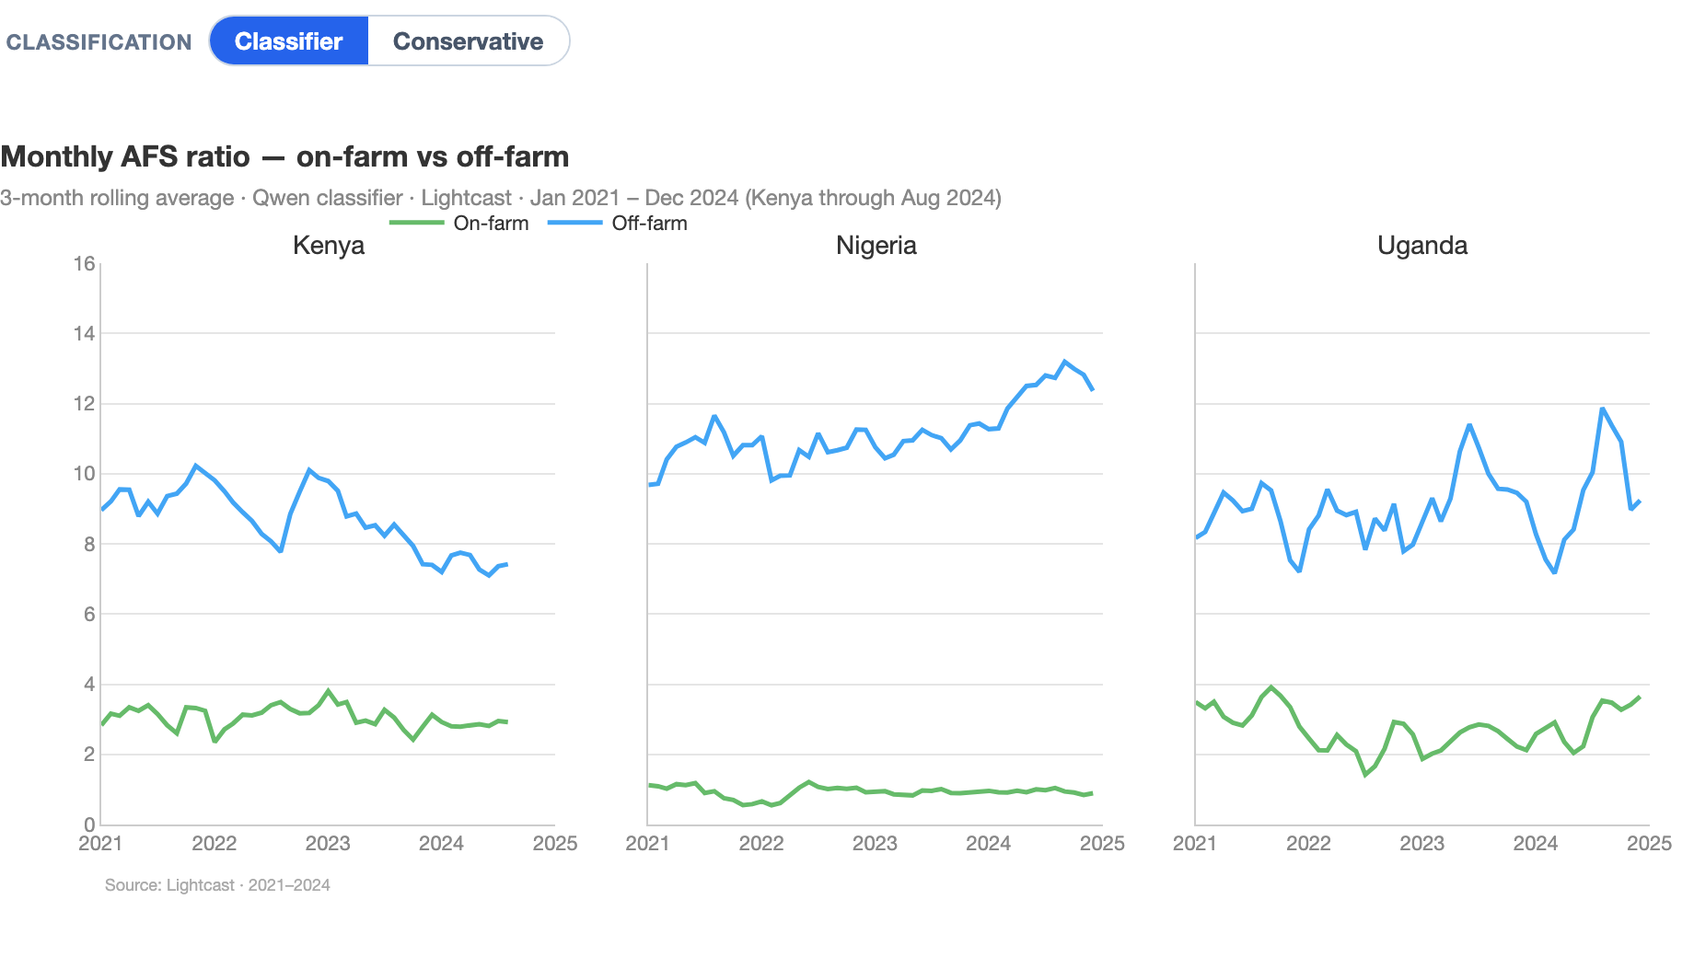
- Off-farm postings dominate in all three countries throughout 2021–2024, confirming that online AFS demand is concentrated in downstream and support roles rather than primary production.
- Nigeria has the clearest off-farm tilt: off-farm postings remain around ten times larger than on-farm postings and rise further in 2024.
- Kenya is the most balanced of the three, but even there off-farm roles remain consistently above on-farm roles; the 2024 series runs only through August.
- Uganda also remains off-farm-led, with a few sharp monthly swings in 2024, while on-farm postings stay comparatively small but slightly higher than in 2022–2023.
Note: OLS regressions of monthly posting counts on month dummies (log-level, January as reference) yield no jointly significant seasonal pattern in any country–sector combination (F-tests, p > 0.10 in all cases). This suggests that online AFS job posting data do not exhibit systematic within-year cyclicality consistent with agricultural production calendars, and predominantly reflect formal-sector hiring unrelated to seasonal agricultural activity.

Regional distribution
Where AFS demand sits within each country
We map online demand to sub-national units — counties in Kenya, states in Nigeria, and Uganda’s sub-regions (the UBOS statistical grouping, e.g. Acholi, Ankole, Busoga, Karamoja) — using the standardised location of each posting. For every region we show the share of all online postings that are AFS, and how that splits into on-farm and off-farm roles. The single AFS jobs identification approach switch above the maps applies either the contextual model or the keyword rule to all three maps at once; on each map, the % AFS / % on-farm / % off-farm buttons switch the displayed metric, and hovering over a region reveals its posting volume and its top-5 AFS career areas (Lightcast taxonomy). For Uganda, the default map uses the sub-regions; the Districts button switches to district-level results, but statistics are shown only for districts with more than 100 online postings.
Two patterns recur across all three countries. First, postings are heavily concentrated in the primary urban hub — Nairobi (≈78% of Kenyan postings), Lagos (≈64%) and Kampala (≈76%) — so absolute AFS volumes are largest there even though these cities are not where farming happens. Second, the AFS share is highest in less urbanised, agriculture-intensive regions: the colour gradient peaks away from the capitals.
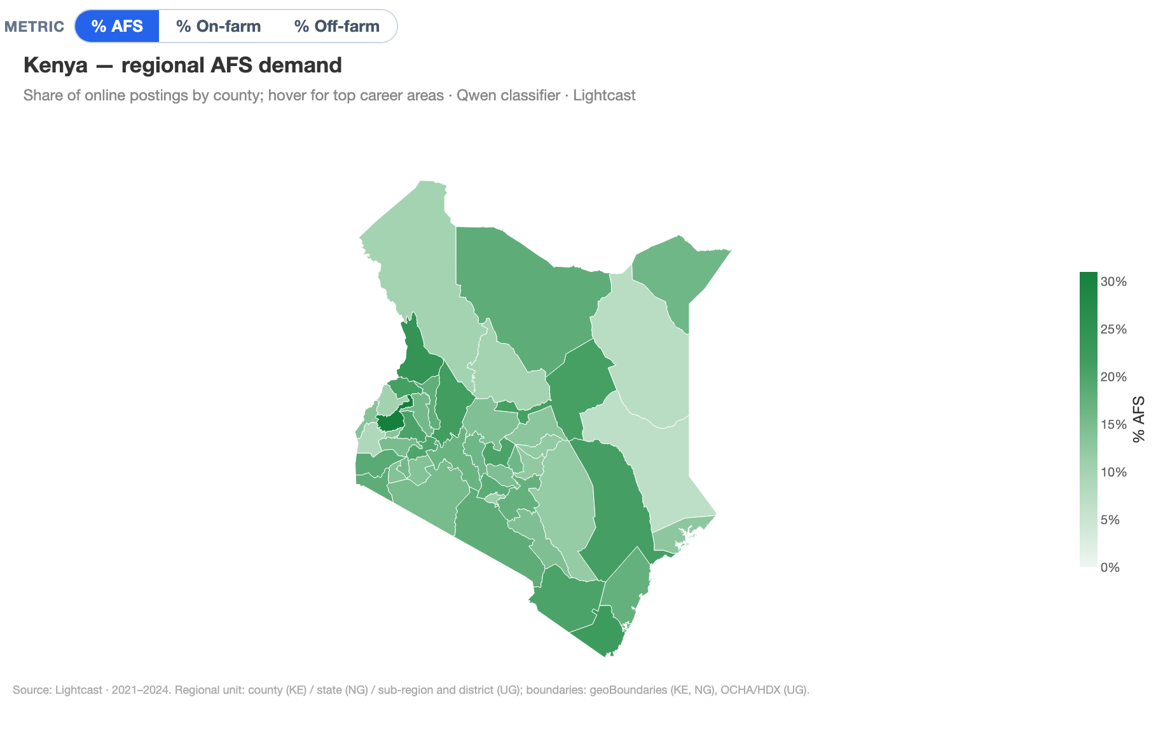
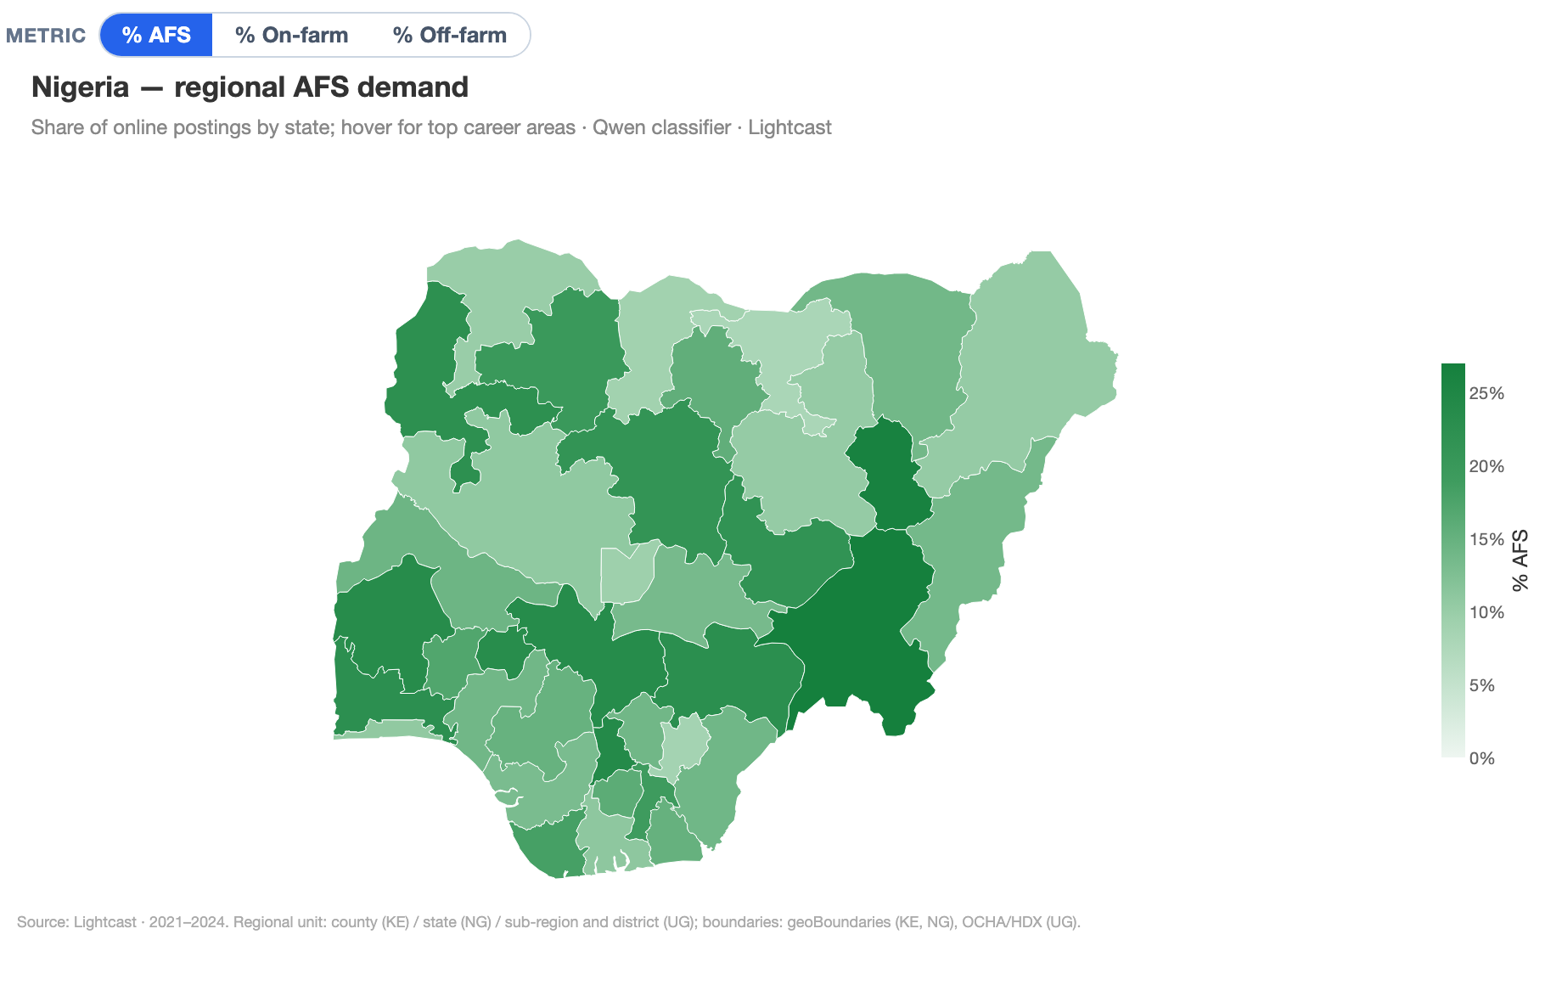
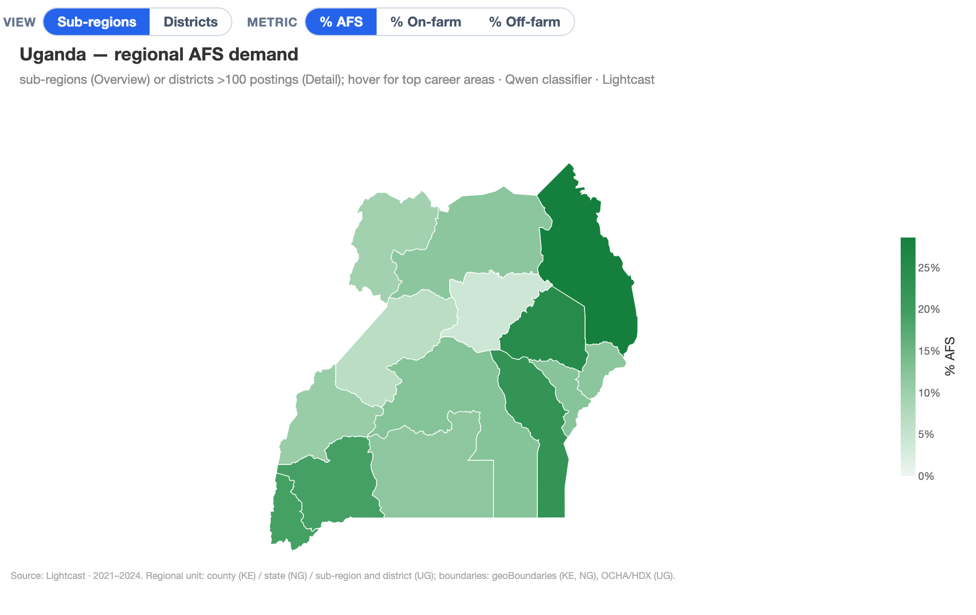
- Kenya. Nairobi dominates posting volume, but the AFS share is highest in the Rift Valley and central highlands — e.g. Laikipia (~21% AFS), Baringo (~17%) and Nyeri (~15%) — reflecting horticulture, livestock and large-scale farming.
- Nigeria. Off-farm roles drive the national AFS count and cluster in Lagos and the FCT, while the highest AFS shares appear in more agricultural states such as Taraba, Kebbi and Oyo.
- Uganda. Demand is overwhelmingly Kampala-centred, but the regional view shows higher AFS intensity outside the Central region, especially in Eastern and Western Uganda. The district detail should be read as a higher-volume subset only: it reports district-level statistics where the underlying online posting count exceeds 100, while thinner locations remain grey.
Reading note. Shares in thinly-posted regions rest on small samples, so the colour scale is anchored on regions with adequate posting volume and every tooltip reports the underlying posting count. Regions with no online postings — and, in Uganda’s detail view, districts with 100 or fewer postings — are shown in grey.

Methods

Processing pipeline
Standardization processing workflow
Job postings contain noisy, unstructured descriptions rather than standardised skill and occupation fields. We transform them into an analytic dataset in four steps: isolate skill-relevant sentences, standardize skills against ESCO, standardize job titles to ESCO occupations, and enrich each posting with sector information using ISIC/NACE activity codes.
Click any card for the detailed description of that step in the Technical appendix.
Full methodological detail for each step — the models, training signal, similarity thresholds and ISIC/NACE crosswalk logic — is provided in the Technical appendix.

Results

Skills profile: on-farm vs off-farm
ESCO Level 1 skill categories
ESCO’s eight major skill groups provide the top level of the occupational skill taxonomy. The chart below shows the composition of skill demand across on-farm and off-farm AFS postings, with non-AFS Lightcast postings (afs=0) included as an all-economy benchmark. Each bar represents a skill group’s share of all S1–S8 mentions within that segment, so the three segments in each country sum to 100%.
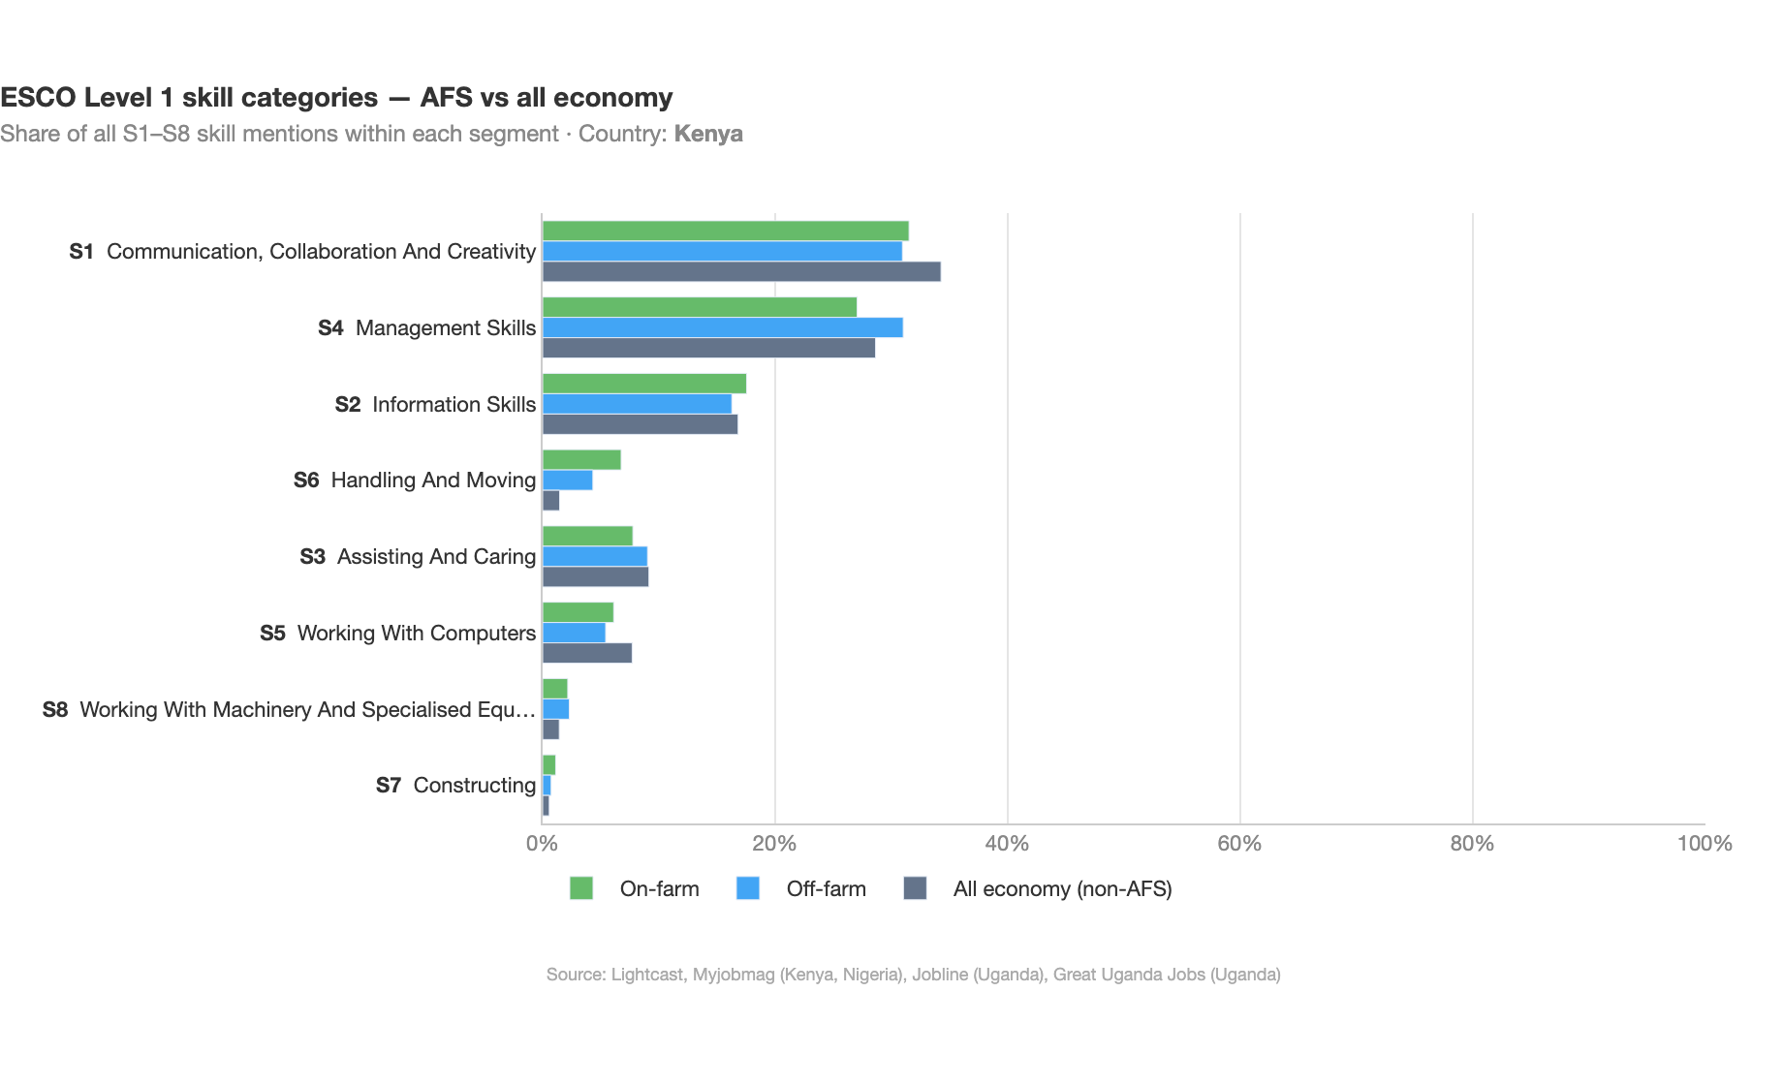
Cross-country differences are limited and the overall composition is broadly similar across segments: communication, collaboration and creativity (S1) and management (S4) together account for roughly 55–65% of skill mentions everywhere. Two patterns set AFS apart from the wider economy. First, working with machinery, plants and animals (S6) carries about 5–10% of AFS skill weight against under 2% in non-AFS postings — the structural fingerprint of agri-food work, visible in both on- and off-farm segments. Second, off-farm AFS postings concentrate assisting and caring (S3) skills at 17–21% of all mentions, roughly two to three times the all-economy share, reflecting the kitchen, food-service and hospitality roles that dominate the off-farm segment. On-farm AFS, by contrast, looks more like a tilted version of the broader economy, with somewhat more information-processing (S2) and slightly less assisting and caring than the non-AFS baseline.
AFS benchmarked against other NACE divisions
To place the AFS profile in context, the chart below compares on- and off-farm AFS postings with skill demand in non-AFS sectors, across the eight ESCO skill groups (S1–S8). Use the dropdowns to select a country and up to three NACE divisions for comparison. Each bar shows a skill group’s share of all S1–S8 mentions within that segment.
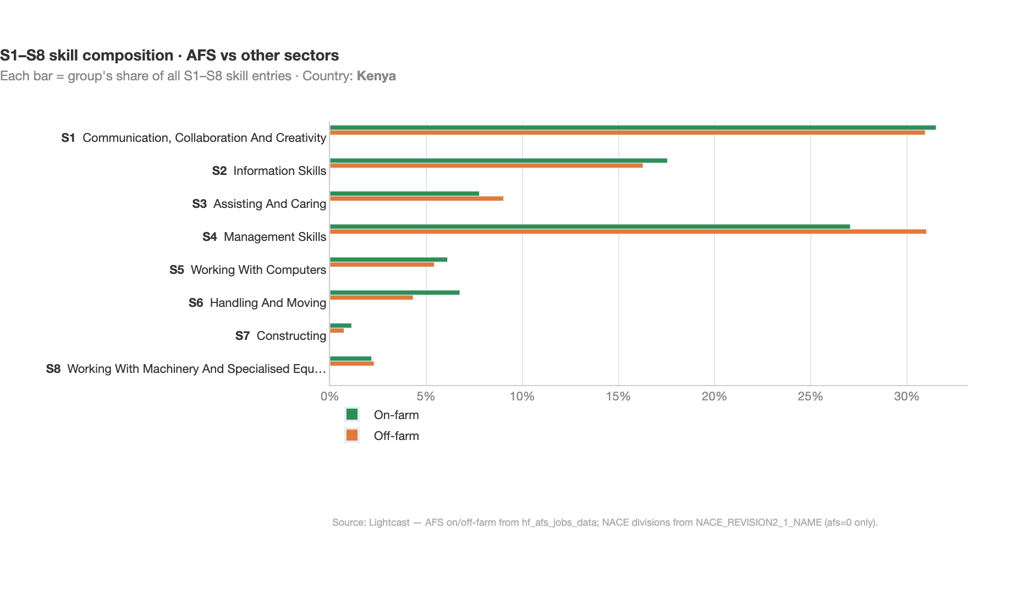
The skill structure of AFS postings (especially on-farm) typically stands out from most other NACE divisions in the share of skills tied to working with machinery, plants and animals and handling and moving, while off-farm AFS profiles tend to align more closely with adjacent service and processing sectors. Knowledge-intensive divisions such as Information service activities or Financial services shift weight strongly toward information and communication skills.

Skills detail: 2-digit level
Top sub-categories within each 1-digit skill group, side by side: on-farm vs off-farm vs non-AFS
Moving one level down the taxonomy, we decompose each of the eight major skill groups into 2-digit sub-categories. For each group, we show the three most prevalent sub-categories, separately for on-farm and off-farm AFS jobs and for the rest of the economy (non-AFS), so the AFS profile can be read against the wider online labour market.
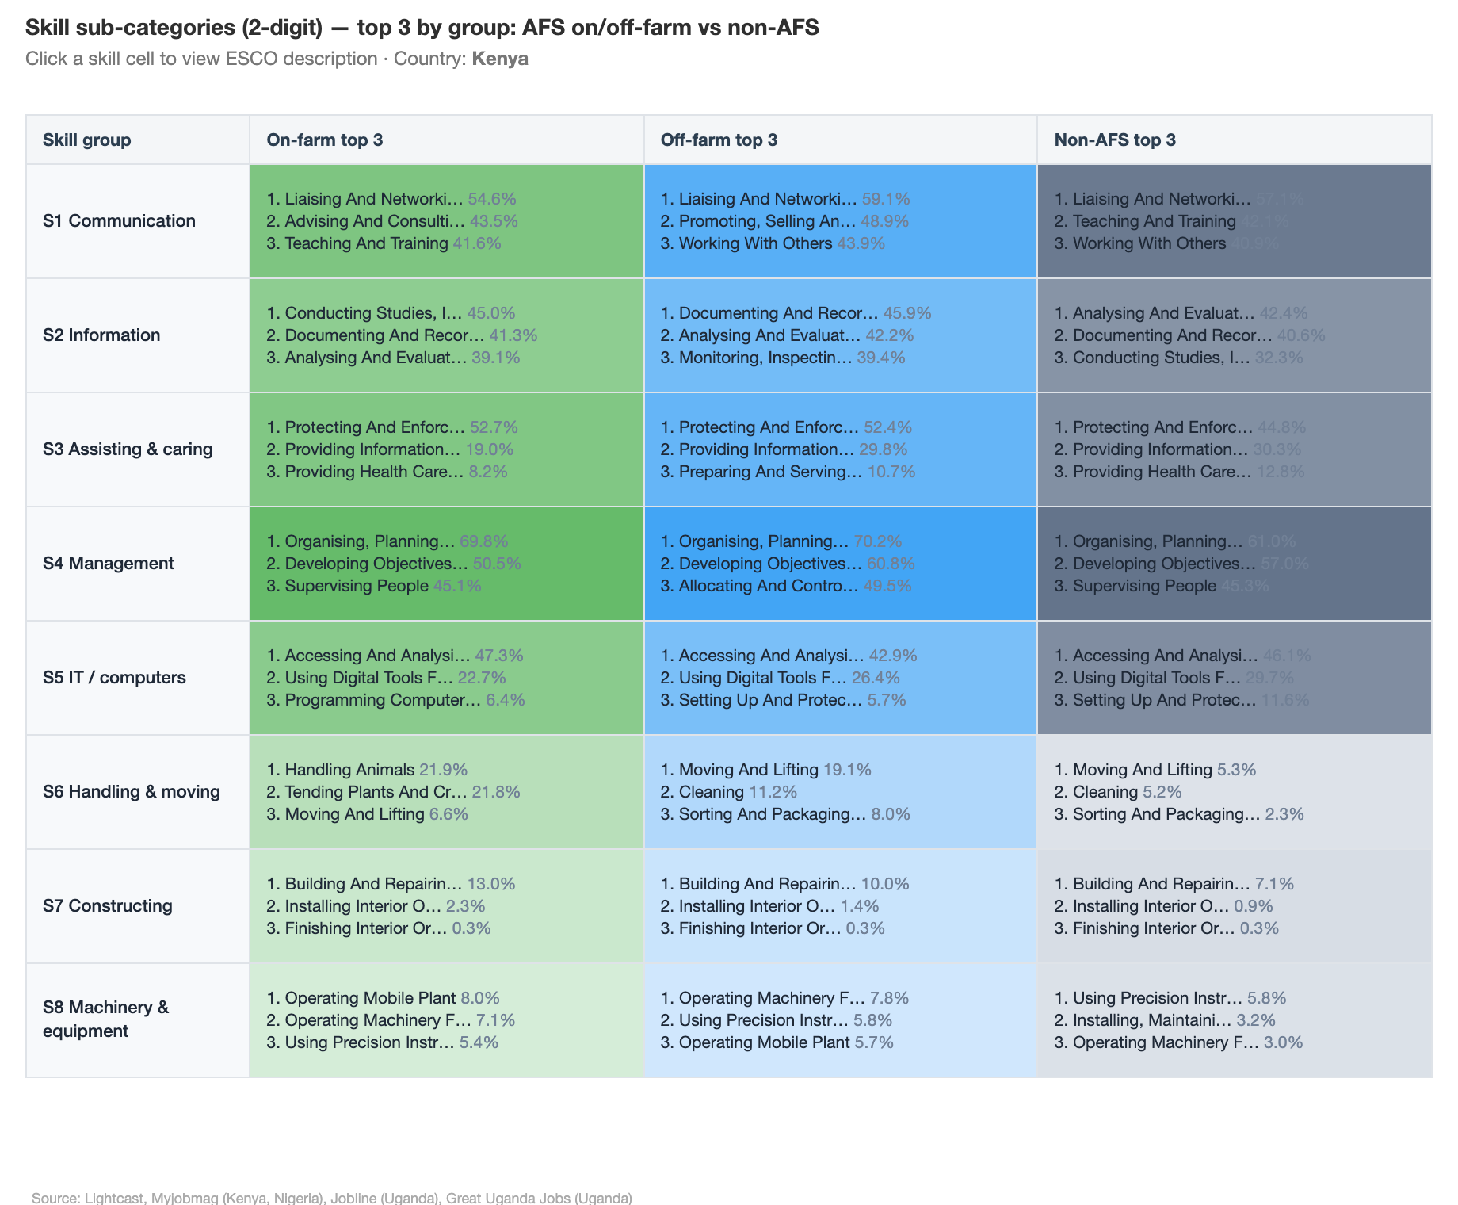
On-farm skill profiles are highly consistent across countries. Off-farm profiles show more cross-country variation, particularly in communication skills (teaching in Kenya, sales in Nigeria, teamwork in Uganda) and in the caring and service domain.

Knowledge domains: on-farm vs off-farm vs non-AFS
ESCO 3-digit knowledge categories
ESCO distinguishes between skills—what workers do—and knowledge concepts—what they need to understand. We extract both; the figure shows how knowledge demand decomposes across 3-digit categories for on-farm and off-farm AFS postings and, as a benchmark, for non-AFS postings (the rest of the online economy).
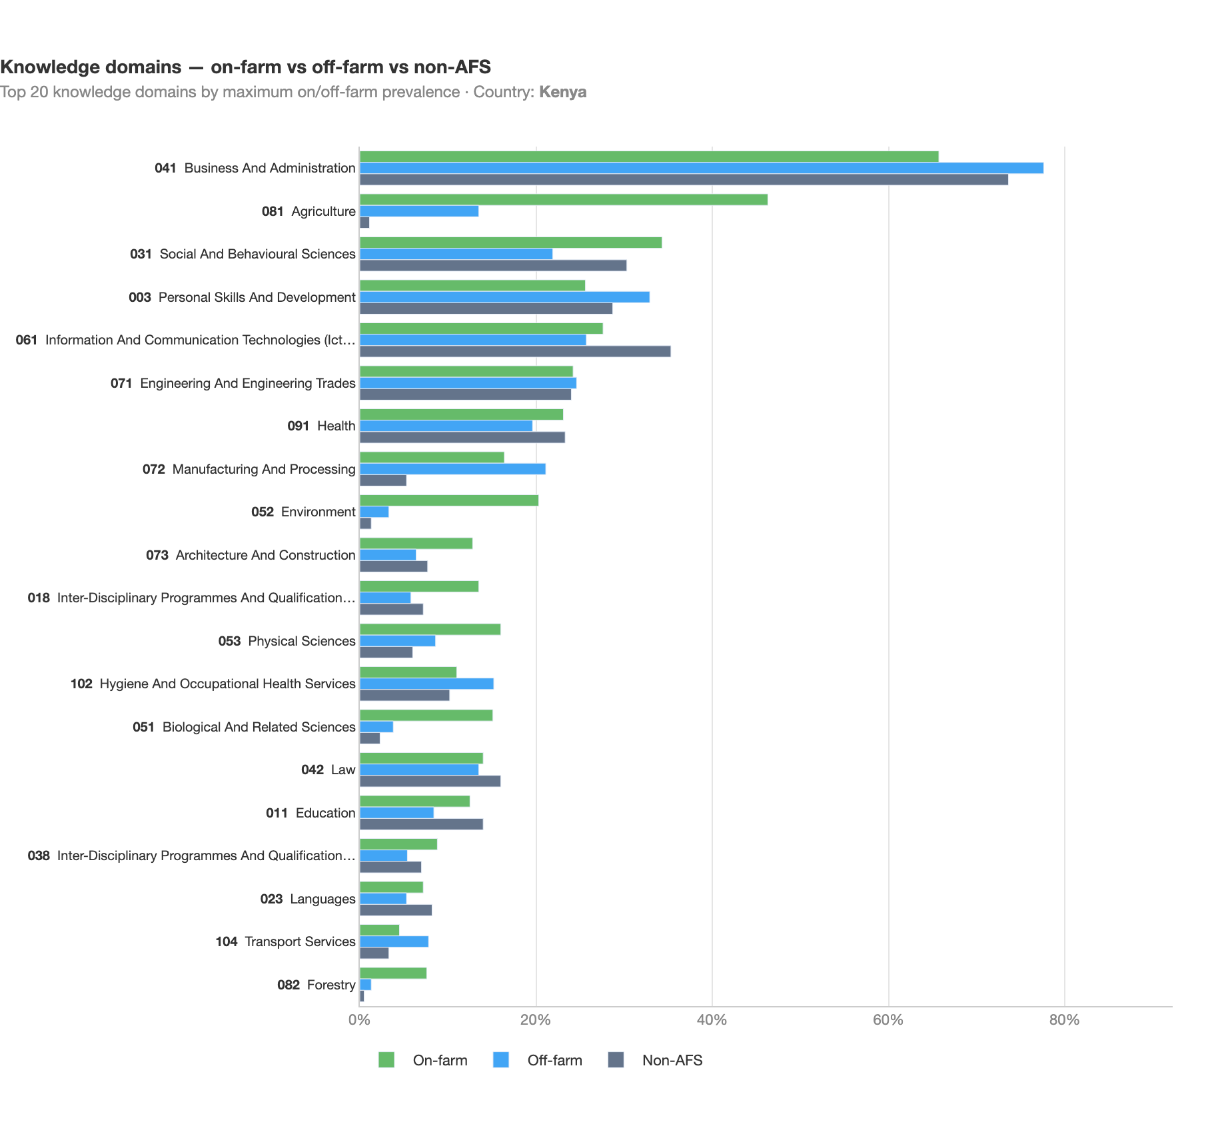
The knowledge profile of AFS job demand is broadly consistent across the three countries: agriculture dominates on-farm postings, while manufacturing & processing and personal services lead off-farm. Business & administration knowledge is prevalent in both segments. Uganda shows somewhat higher demand for architecture & construction knowledge in on-farm roles; Kenya records a comparatively larger share of personal services in off-farm postings.

Skills and knowledge by occupation (ISCO 4-digit)
What do the most common AFS occupations actually ask for?
The sections above describe skills and knowledge for the AFS aggregate and for the on-farm/off-farm split. To make the picture directly comparable with occupation-based accounts such as the FAO report, the heat-map below pivots the same ESCO evidence onto ISCO 4-digit occupations. We take the fifteen most frequent occupations across AFS postings and, for each, show the document-frequency of the eight ESCO skill groups (S1–S8) and of a reduced set of knowledge super-domains. The first two rows are baselines — the whole AFS aggregate and the non-AFS rest of the online economy — so every occupation can be read against both the AFS norm and the wider labour market. Use the View switch to move between skills and knowledge, and the Country switch to change market.
To keep the knowledge view legible we collapse the ISCED-F narrow fields into broader groups (e.g. biological and environmental sciences, social sciences, arts & humanities). We also surface a biophysical cluster — health, hygiene, biology and environment — as a single column, because the prevalence of this kind of knowledge is a distinctive feature of agri-food work.
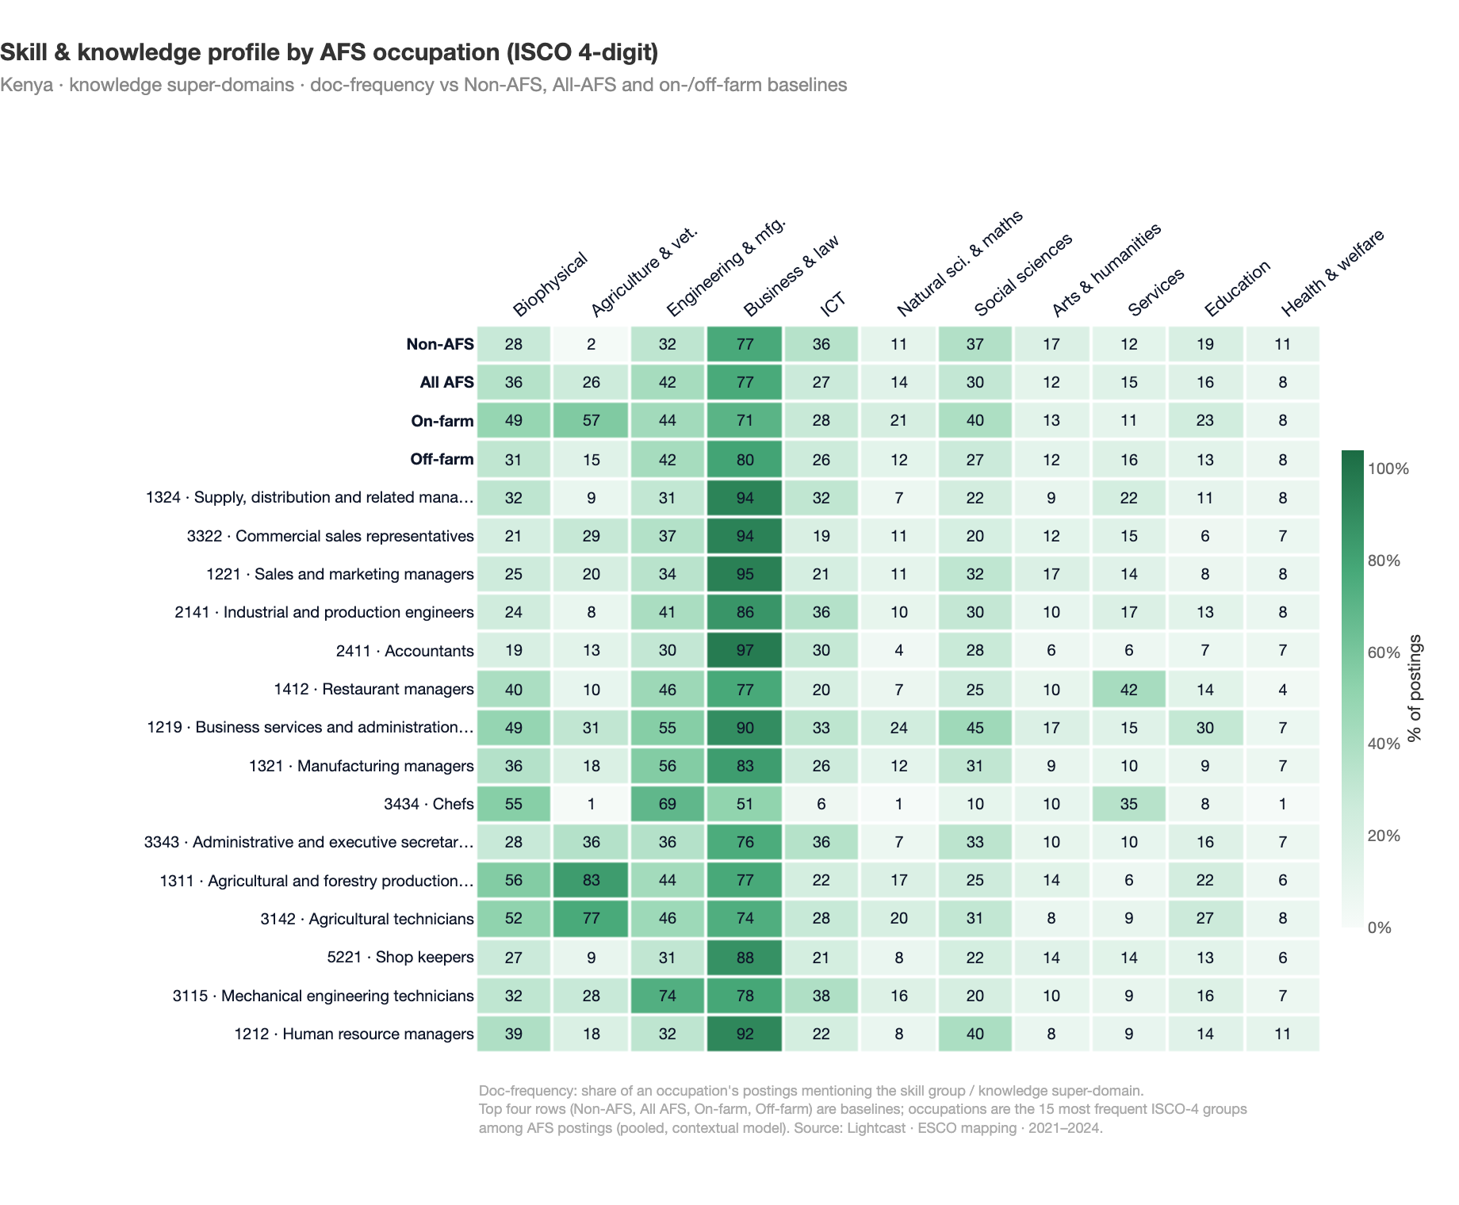
Two patterns stand out. First, biophysical knowledge is systematically more prevalent in AFS than in the rest of the economy, and rises sharply in the agriculture-facing occupations — agricultural and forestry production managers and agricultural technicians lead the column, well above the non-AFS baseline — which matches the FAO emphasis on biological, environmental and health-and-safety knowledge in agri-food work. Second, the skills view shows that most high-volume AFS occupations are managerial and commercial roles whose management, communication and information skills look similar to the wider economy; what separates AFS is the elevated handling & moving and machinery & equipment demand (clearest for chefs, production managers, shop-keepers and engineering technicians) together with the agriculture and biophysical knowledge layer.

Distinctive AFS skills (S1–S8)
Which 3-digit ESCO skill groups define on-farm and off-farm AFS work?
The S1–S8 comparison above shows how much weight each broad skill group carries in AFS postings, but not which specific competencies drive that weight. To isolate the skills that genuinely characterise AFS jobs — and to separate them from skills that are simply popular everywhere — we apply the weighted log-odds ratio with an informative Dirichlet prior, following Monroe, Colaresi & Quinn (2008).
For each country and each AFS segment we treat:
- group $A$ — 3-digit skill-group mentions in the segment (on-farm or off-farm postings, document-frequency per posting),
- group $B$ — 3-digit skill-group mentions in the all-economy baseline (postings with afs = 0 in the same country),
- prior $α=a+b$ — uninformative Dirichlet over the combined corpora.
For every 3-digit skill group $i$ we compute the log-odds difference
$${\hat{δ}}_{i} = log​\frac{a_{i}+α_{i}}{(n_{A}+α_{0})−(a_{i}+α_{i})} − log​\frac{b_{i}+α_{i}}{(n_{B}+α_{0})−(b_{i}+α_{i})}$$
and divide by its standard error $σ_{i}=\sqrt{(a_{i}+α_{i})^{−1}+(b_{i}+α_{i})^{−1}}$, giving a z-score. Positive $z$ means the skill group is more associated with the AFS segment than with the all-economy baseline; $z>1.96$ corresponds to $p<0.05$ (two-sided). The Dirichlet prior shrinks rare skill groups toward the baseline, so smaller segments (e.g. Uganda off-farm) do not produce spurious headline competencies the way raw frequency ratios would.
To keep the picture at a readable, interpretable level, we aggregate concrete skills up to their 3-digit ESCO group (level 3 of the skills pillar, e.g. advising on environmental issues or managing budgets or finances): a posting counts towards a 3-digit group whenever it carries any skill below it. The log-odds comparison then runs over these coherent skill areas rather than thousands of individual competencies, which gives more robust and less noisy contrasts. We also exclude a small set of groups with no plausible agri-food relevance that only appear as mapping noise (for example sports, arts and performance, hairdressing and beauty, and human clinical or personal-care services). We assign each 3-digit group to its S1 ancestor and keep the top ten most distinctive 3-digit groups inside each S1–S8 group. The chart below lets you switch between countries, between the on-farm and off-farm segments, and between the eight S1–S8 groups. Showing one group at a time keeps the labels readable while preserving the same underlying comparison. The Direction switch flips the perspective: More in AFS shows the 3-digit groups that are over-represented in the segment (positive z), while Less in AFS shows the flipside — groups that are under-represented, i.e. common in the rest of the economy but comparatively rare in AFS (negative z).
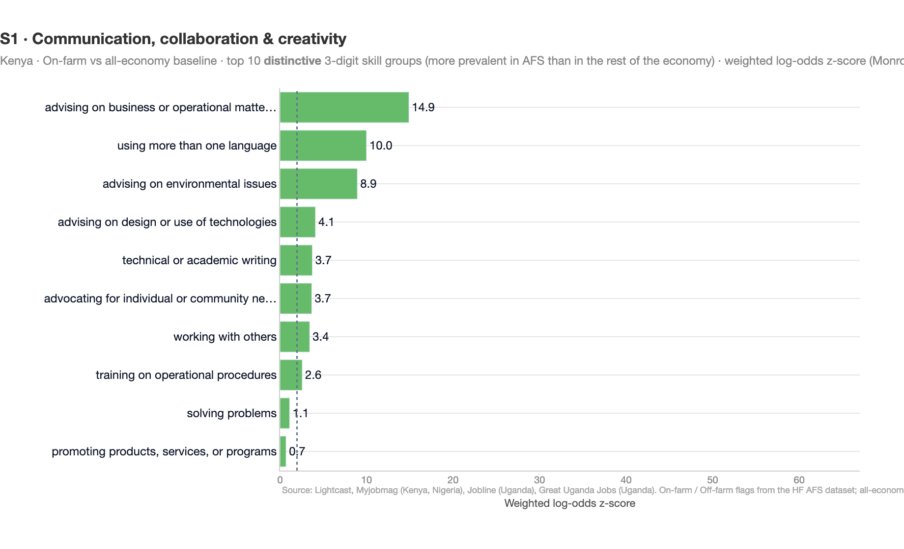
A clear pattern emerges in all three countries. On-farm postings display a tightly coherent agronomic signature: S1 surfaces provide advice to farmers, promote agricultural policies and market farm products; S2 highlights research crop yields and research livestock production; S4 is dominated by manage agricultural staff, develop agricultural production plans and develop agricultural policies; S6 is anchored by manage crop production, manage livestock and monitor crops; S7 by maintain the farm, maintain farm equipment and maintain irrigation systems; S8 by operate / maintain agricultural machinery. Even S5 (working with computers) is led by the agri-tech concept use agricultural information systems and databases.
Off-farm postings look qualitatively different. They are anchored by hospitality and food-processing competencies: S1 is led by present menus, instruct kitchen personnel and advise guests on menus; S3 by handle kitchen equipment, comply with food safety and hygiene and prepare the restaurant for service; S4 by manage restaurant service and clean / maintain kitchen equipment; S6 by ensure cleanliness of food preparation area, cook pastry products and bake goods; S8 by set up equipment for food production, tend bakery ovens and administer ingredients in food production. The off-farm segment thus reflects mainly downstream food-service and food-manufacturing work surfaced by the online portals.
Takeaway. Once aggregate popularity is partialled out, AFS demand splits into two non-overlapping clusters of concrete skills: an on-farm agronomy-and-livestock layer (production, advisory, farm maintenance, agri-tech) and an off-farm food-service-and-processing layer (kitchen operations, hospitality management, bakery and food-manufacturing). This confirms structurally what the broader S1–S8 comparison already suggested, and shows that the on/off-farm split observed in formal hiring channels is not a measurement artefact but a substantive compositional difference in the underlying labour demand.

Skill profiles: logistic regression
P(on-farm) ~ skill categories + country fixed effects · N = 33,000
To test which skill groups systematically discriminate between on- and off-farm jobs across all three markets, we pool the data and estimate a logistic regression with country fixed effects.
OR > 1 = more likely in on-farm; OR < 1 = more likely in off-farm. On-farm roles stand out for their technical, data-driven profile; off-farm roles reflect service-oriented occupations.
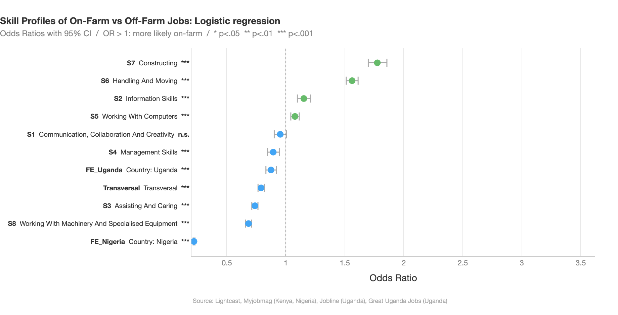

Skill breadth and specialization
How many distinct skill domains does a typical posting span?
For each posting we map every extracted ESCO skill to its level-2 sub-group (74 sub-groups in total, e.g. S1.1 negotiating, S6.11 cleaning, S8.5 operating machinery for the manufacture of products) and count how many distinct sub-groups appear at least once. The result is a simple breadth measure with range $1$–$74$.
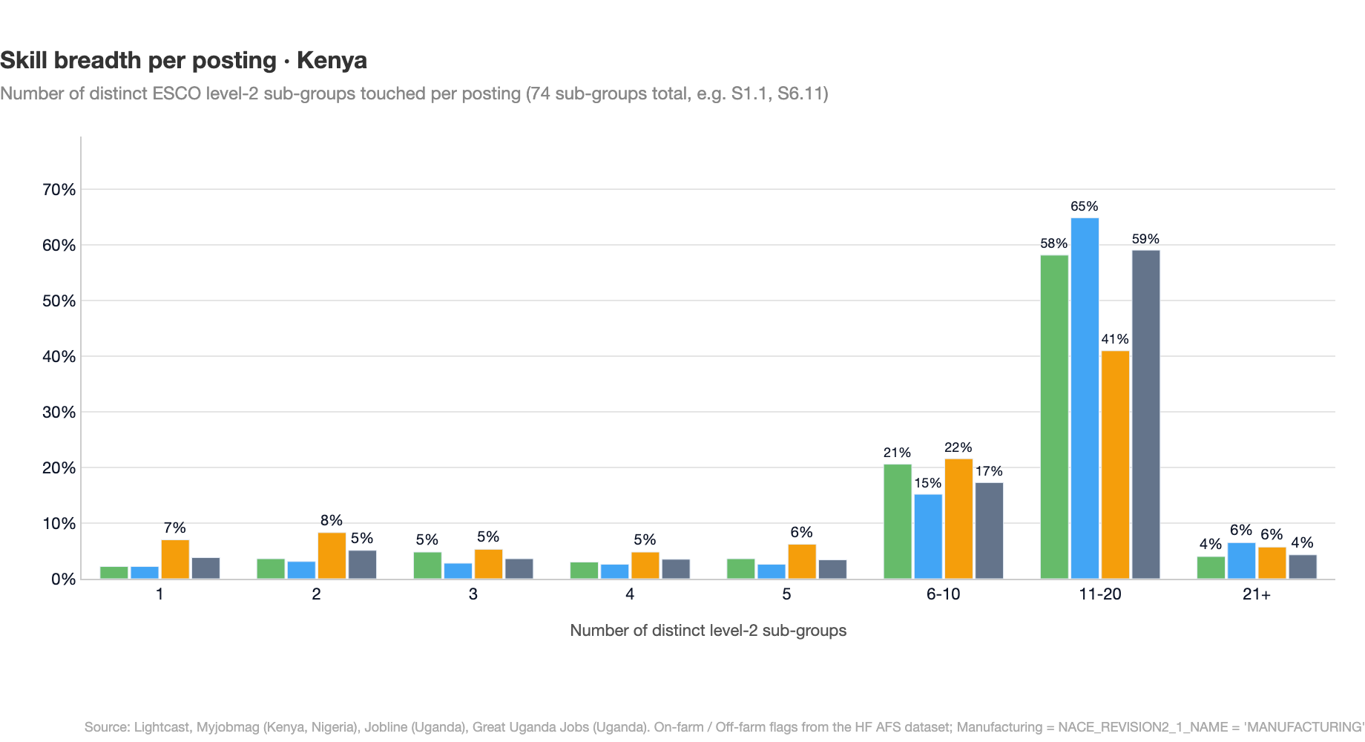
Three patterns emerge from the breadth distribution. On-farm AFS postings touch a median of 11 distinct ESCO sub-groups and off-farm postings 12, both below the all-economy median of 14 — placing AFS in a moderately specialised position within the broader labour market. By way of comparison, manufacturing provides a useful lower benchmark: it is the most “vertical” segment of the four, with a median of 10 sub-groups and the highest share of postings touching only one sub-group (6.9% pooled, 11.5% in Uganda), reflecting the prevalence of narrowly scoped line-operator and machine-handling roles. The wider economy marks the upper bound, with 69% of non-AFS postings listing at least ten distinct sub-groups, against 53% in manufacturing.
When breadth is high, which group still dominates?
Breadth alone does not capture whether a posting concentrates around a single skill domain. We complement it with a specialisation index:
Specialisation = maxgkgg​kg ∈ 18, 1,
where $k_{g}$ is the number of extracted skills in the posting that fall under group $g∈\{S1,…,S8\}$. The index equals $1$ when every skill belongs to a single S1–S8 group (a vertical specialist) and $1/8$ when skills are evenly distributed across all eight groups. Across all segments the median sits around $0.35$–$0.45$, meaning the dominant group typically accounts for roughly 40% of the skill mentions in a posting. The chart below shows which of the eight ESCO groups is dominant — the argmax of the index — across postings in each segment.
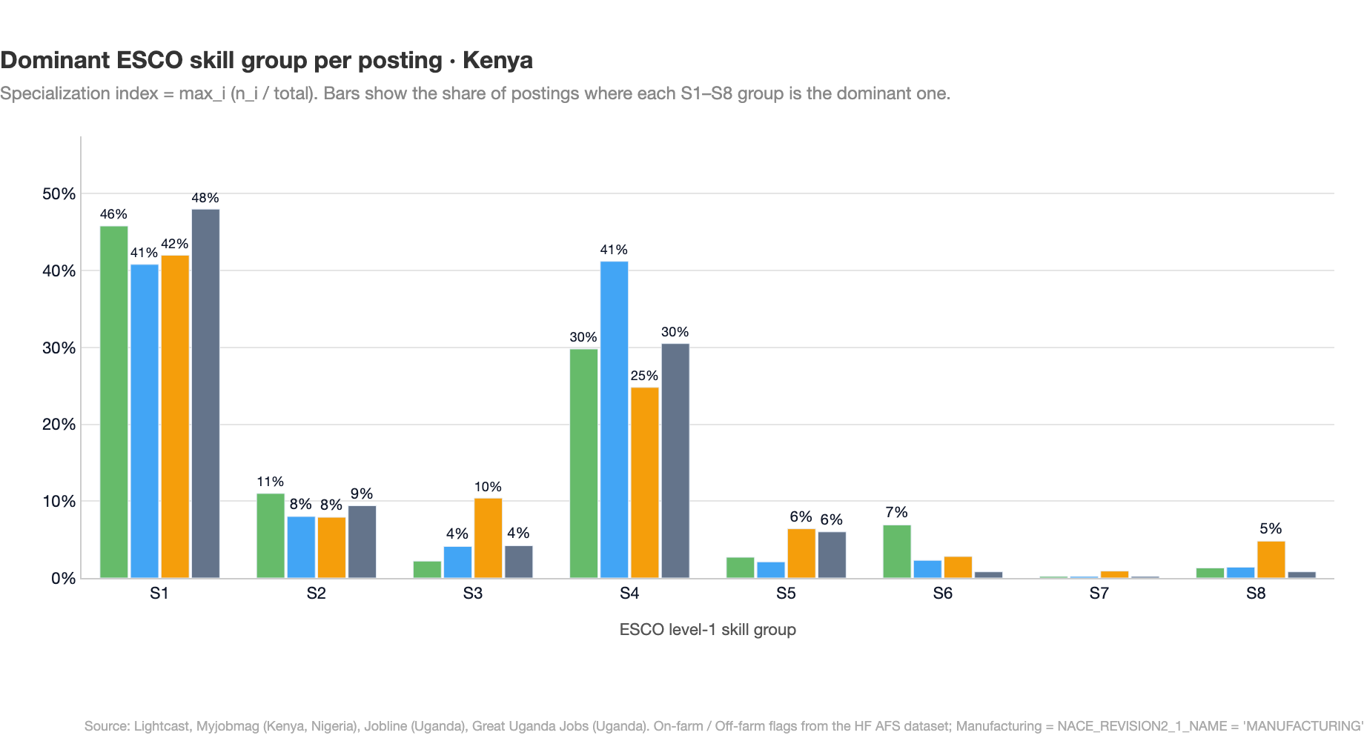
The dominant-group composition isolates the structural identity of AFS more sharply than any single summary statistic:
- On-farm AFS is anchored by S1 communication / advisory (≈45% of postings) and S4 management (≈30%) — the characteristic agronomy-advisory plus farm-management profile.
- Off-farm AFS is distinguished by a large block of postings dominated by S3 assisting & caring (≈23%, against ≤5% in the reference segments). These are kitchen, food-service and hospitality roles where service delivery is the modal skill domain.
- Manufacturing (reference): the only segment with a non-trivial mass on S8 machinery & specialised equipment (≈6%), reinforcing the line-operator and production-line pattern.
- Wider economy (reference): mirrors the on-farm S1 + S4 anchor at first glance, but with virtually no S6, S7 or S8 presence — overwhelmingly office- and service-oriented.
Takeaway. AFS occupies an intermediate position on breadth between manufacturing and the wider economy, but is qualitatively distinct on the dominant-group dimension. On-farm postings concentrate around S1 and S4 (advisory plus management), while off-farm postings carry the unmistakable S3 signature of food-service roles — a profile not visible in either reference segment. The breadth–specialisation pairing thus reveals AFS not as a “middle case” between industrial production and the broader economy, but as a labour market with its own characteristic skill architecture.

Digital skills
Digital skill demand across the AFS labour market
We flag a posting as “digital” when at least one of its extracted ESCO skills belongs to the official ESCO digital skills and knowledge concepts collection (around 1,200 curated concepts spanning ICT use, programming, data, digital communication, and digital content creation).
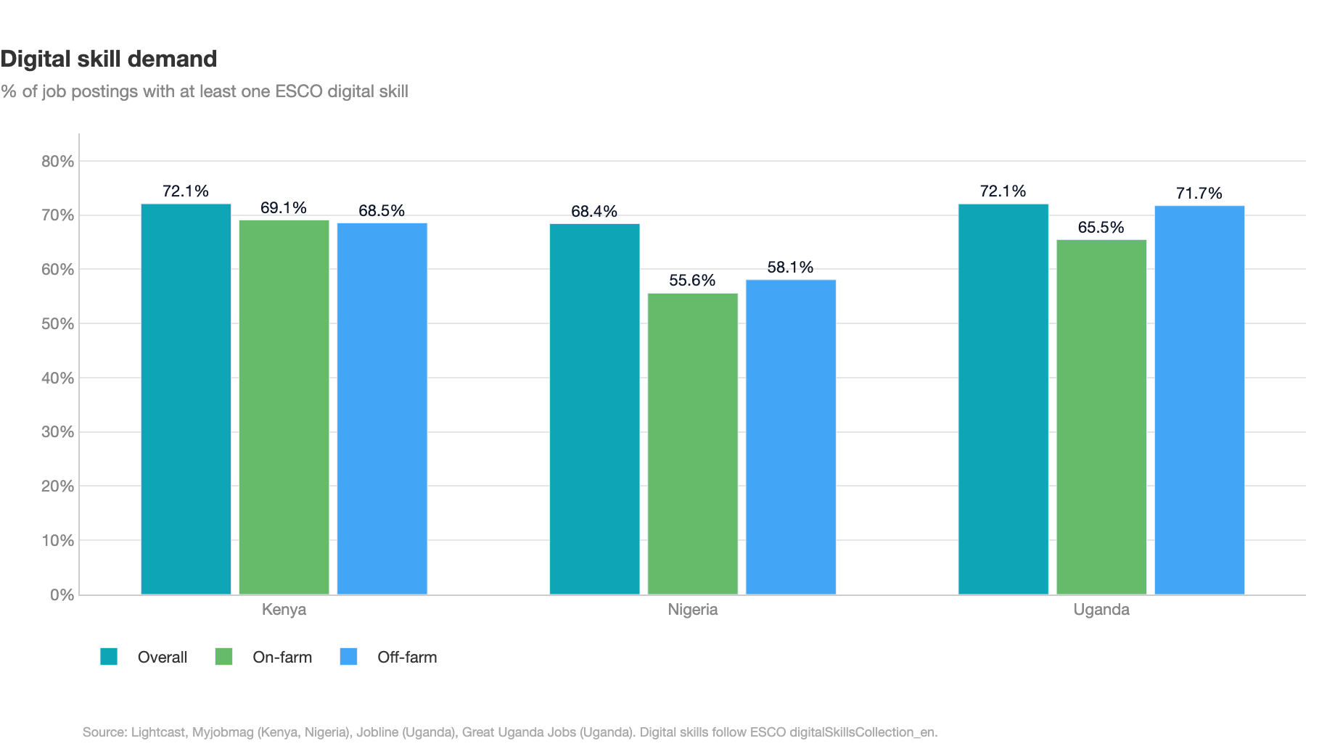
Across Kenya, Nigeria and Uganda, digital exposure in the broader labour market is broadly similar — around 70–72% of all-economy postings list at least one digital skill (Kenya 72.2%, Nigeria 69.9%, Uganda 71.7%). Within the agri-food system, digital exposure is only modestly lower and is comparable across the two segments: on-farm postings list digital skills in 57–71% of cases (Kenya 70.5%, Nigeria 57.3%, Uganda 64.9%) and off-farm postings in 60–71% (Kenya 69.1%, Nigeria 59.7%, Uganda 71.3%). On-farm is marginally higher in Kenya, while off-farm is higher in Nigeria and Uganda, so there is no consistent on-farm/off-farm ranking.
The informative finding is therefore the level rather than the gap: AFS postings of both kinds sit close to the wider-economy benchmark. Online job portals do not capture the full agricultural labour market; they predominantly surface its formal, higher-skill end — agronomists, supply-chain coordinators, farm and operations managers, processing and trade specialists — roles in which digital tools (farm-management systems, sensor and remote-sensing data, agri-fintech, traceability and warehouse platforms) are increasingly embedded.
Read this way, the digital-skill profile says less about what agri-food employment looks like in aggregate, and more about which slice of it formal hiring channels select for. What we observe on these portals is the technical, managerial and logistical layer of the agri-food system — and across both on-farm and off-farm work that layer is now about as digitally intensive as the rest of the formal economy.
How many digital skills does a typical posting require?
Switching between the segments shows how digital demand is distributed: in the wider economy around a quarter to a third of postings list no digital skill (25–29%) and roughly a fifth list six or more. Within AFS the distribution shifts toward fewer skills per posting — between 29% and 43% list none and only about 8–14% reach six or more — with on-farm and off-farm segments broadly similar rather than sharply different.
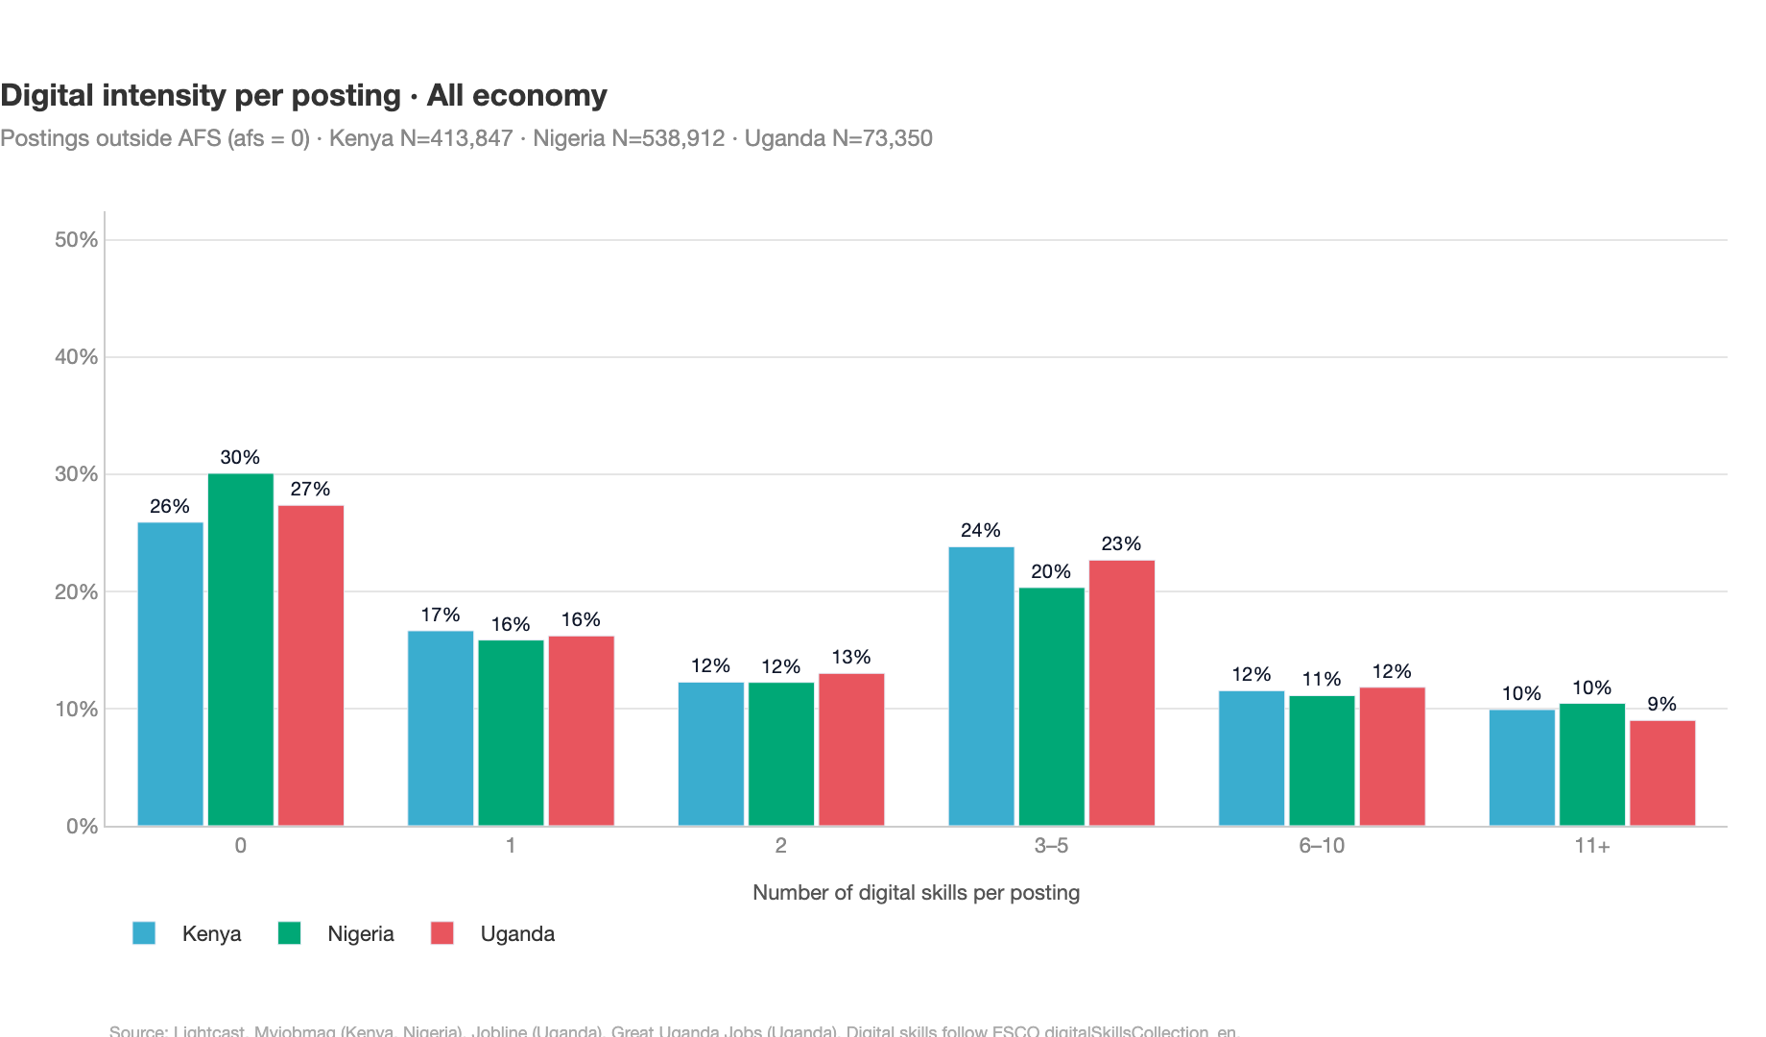
What digital skills are employers asking for?
Demand is distributed across more than 1,200 unique digital skills in each country, but is anchored by a relatively small set of foundational ICT competencies. To characterise the shape of this distribution, we report the normalised Shannon entropy of skill mentions:
$$H^{′} = \frac{−\sum_{i=1}^{N}{p_{i}}logp_{i}}{logN} ∈ [0,1]$$
where $p_{i}$ is the share of skill $i$ in all digital-skill mentions and $N$ is the number of distinct digital skills observed in the country. The index approaches $1$ when demand is spread evenly across many skills and $0$ when it collapses onto a single skill. As a benchmark, values around $0.9$ indicate highly dispersed demand, around $0.5$ moderate concentration, and around $0.1$ a highly concentrated mix. Normalisation by $logN$ ensures the index is comparable across countries that observe slightly different numbers of distinct skills.
Normalised entropy is preferred to the Herfindahl–Hirschman Index in this application. HHI sums squared shares and is therefore dominated by the few most-frequent skills, which limits its informativeness when the distribution has a long tail of more than $1,000$ less-frequent competencies. Entropy weighs every skill by $p_{i}logp_{i}$, so the full distribution contributes to the measure.
All three values sit close to the upper end of the scale ($≈0.82\text{–}0.84$), so demand for digital skills is very dispersed — no single competency dominates, and the top-10 captures less than a quarter of all mentions. Uganda is marginally more concentrated than Kenya and Nigeria, which is consistent with its higher top-10 share (21.4% vs 16.6–18.5%).
Which digital skills are distinctive of AFS jobs?
Aggregate frequencies do not tell us which competencies are characteristic of AFS jobs — popular skills such as MS Office show up everywhere. We therefore apply the same weighted log-odds methodology as in Distinctive AFS skills (S1–S8), restricted to the curated ESCO digital-skill subset and without the on/off-farm split — group $A$ is all AFS postings (on-farm or off-farm), group $B$ is the all-economy baseline (afs = 0).
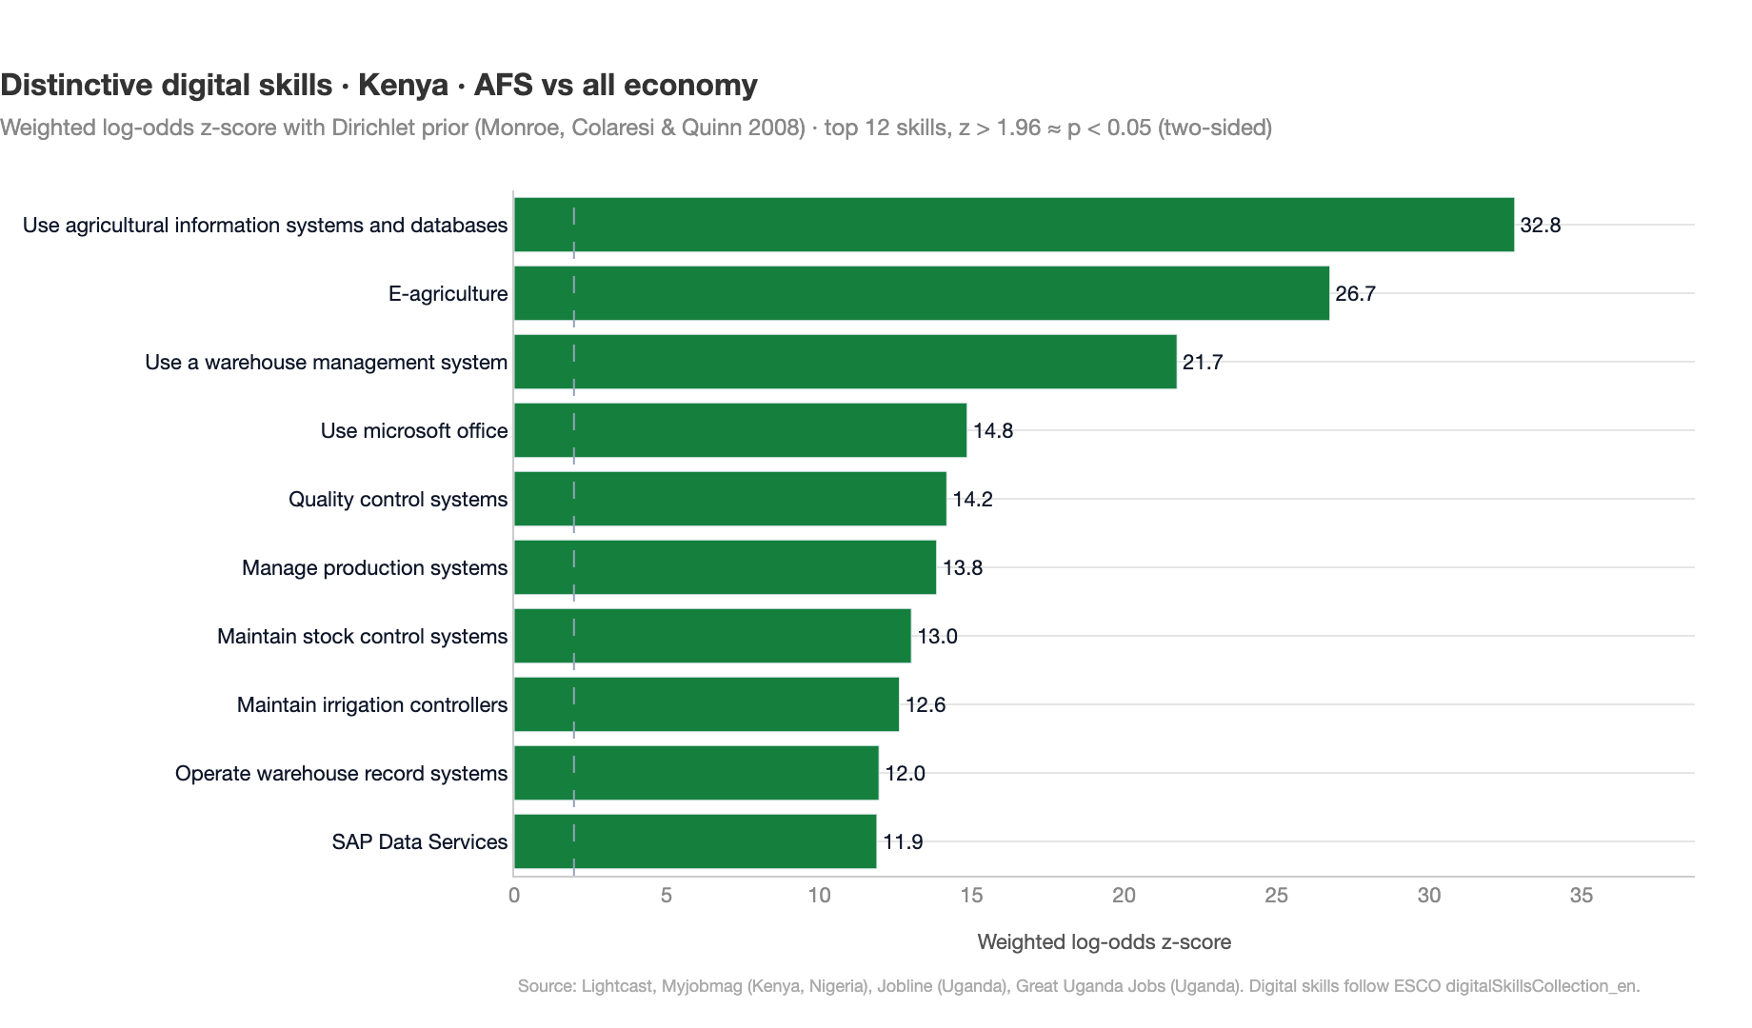
The signal is largely consistent across the three countries, with two complementary clusters. The first is genuinely agri-specific: use of agricultural information systems and databases is the single most distinctive AFS digital skill in Kenya ($z=28.0$) and Uganda ($z=13.7$) and is among the strongest in Nigeria ($z=17.9$), and e-agriculture is strongly distinctive in every country (Kenya $z=24.1$, Nigeria $z=15.1$, Uganda $z=10.4$). Country-specific agri-tech competencies follow further down — maintain irrigation controllers in Kenya, use fleet management system in Uganda.
The second cluster is the supply-chain and production-systems layer that runs through agri-food employers: use a warehouse management system (the single most distinctive skill in Nigeria, $z=24.8$), operate warehouse record systems, maintain stock control systems, maintain warehouse database, manage production systems, and quality control systems all surface with high z-scores. A handful of more mainstream competencies — use Microsoft Office, SAP Data Services, gather data — also clear the baseline with positive but much smaller log-odds, indicating that AFS postings demand foundational ICT above the all-economy average, though far less sharply than the agri- and operations-specific skills.
Takeaway. Once aggregate popularity is partialled out, AFS postings advertise a distinctive layer of agri-tech digital skills (agricultural information systems, e-agriculture, irrigation and fleet systems) together with a strong supply-chain and production-systems signature (warehouse management, stock control, production and quality-control systems), on top of an above-baseline use of foundational ICT. Digital-upskilling programmes targeted at AFS workers should therefore combine an agri-tech and logistics-systems component with the generic ICT-literacy track that already serves the broader labour market.

Local job portals (2024–2026)
A separate, more recent window from national job boards
The main analysis above covers 2021–2024 and draws on Lightcast — a commercial aggregator that continuously scrapes many sources — supplemented with postings scraped from major national job boards. To extend the picture into the most recent years, this section uses a distinct and deliberately narrower source base: four individual national job portals scraped directly for 2024–2026 — MyJobMag (Kenya and Nigeria), the Ugandan Jobline, and GreatUgandaJobs — comprising 357,709 postings processed through the same pipeline and column schema as Lightcast.
 | These data are not 1:1 comparable with the main analysis. The 2021–2024 figures rest on a broader multi-source dataset combining Lightcast with additional major portals; this section rests on a single national portal per country. National job boards are significant and influential sources, but each captures only its own slice of the market, so AFS concept shares here should be read as within-portal trends over 2024–2026, not as levels directly comparable to the earlier multi-source numbers. Differences in level between the two windows largely reflect the change in source base, not a change in the labour market.
Why these portals. They were chosen because they permit backward, historical scraping of past vacancies and are among the most significant national boards in each country. Lightcast, by contrast, scrapes on an ongoing basis only: because our project had to assemble historical data after it began, these national portals were the practical way to obtain a recent, continuously refreshable series. They therefore play a different role from Lightcast — a timely national pulse rather than a comprehensive market aggregate.
Method note. The four national portals were processed through the same pipeline as Lightcast: the default contextual model for the AFS labels, and the identical route for skills — classifying skill-bearing sentences and mapping them to the ESCO taxonomy with the contextual model, with no keyword shortcut and no use of the generative model. Across the 357,709 postings the contextual model identifies 41,091 AFS vacancies. The figures below are therefore the contextual-model results, directly analogous in method to the main analysis.

AFS concept shares, 2024–2026
Share of all online postings that are agri-food, split into on-farm and off-farm, by year. Use the in-chart buttons to switch between Kenya, Nigeria, Uganda and the pooled total.
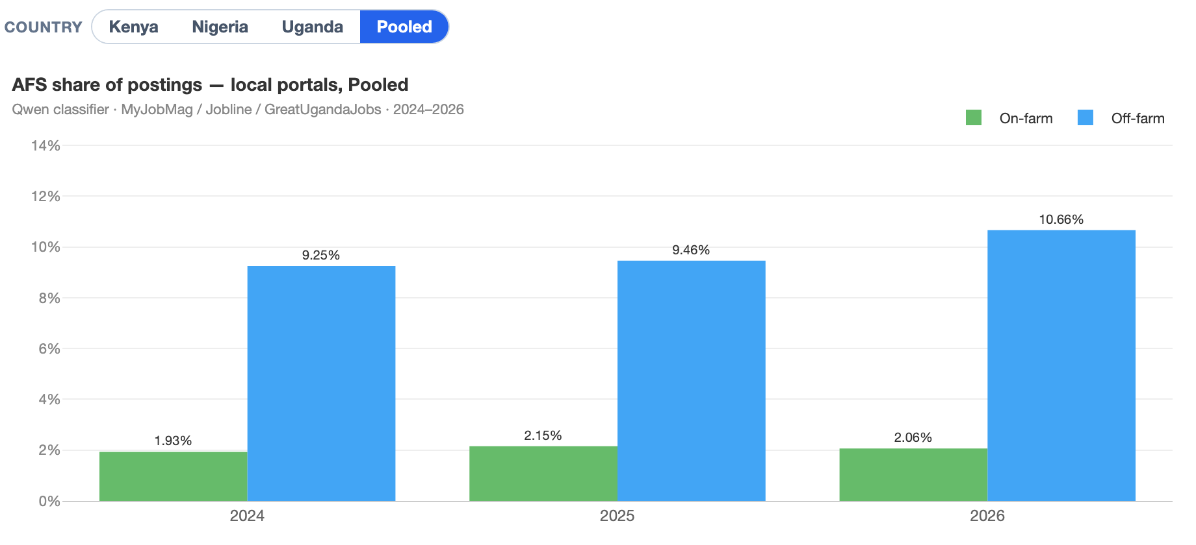
Across the pooled portals the AFS share is broadly stable with a mild upward drift over the window — 11.2% (2024) → 11.6% (2025) → 12.7% (2026, partial) of all postings — and is consistently led by Uganda (≈14–18%, Jobline + GreatUgandaJobs) ahead of Kenya and Nigeria (each ≈10–11%). Off-farm roles (processing, trade and logistics, food service) outweigh on-farm roles by roughly four-to-one (off-farm ≈9–11% vs on-farm ≈2%), echoing the value-chain tilt seen in the main analysis. These classifier-based levels happen to sit close to the pooled 2021–2024 Lightcast AFS share (≈12.1%), but because the source base differs (single national portals vs a multi-source aggregate) this should be read as reassuring rather than as a like-for-like comparison — the value here is in the composition and direction within the portals. The classifier also records, for each agri-food posting, its detailed sub-category (crop, livestock, fisheries, forestry; agri-inputs, agro-processing, food trade & logistics, food service), which underpins the value-chain breakdown discussed above.

New and distinctive skills by country
Which ESCO skills appear more often in agri-food postings on these national portals (2024–2026) than they did in agri-food postings in the earlier Lightcast window (2021–2023), shown separately for each country and for the on-farm and off-farm segments. For every skill we compare how frequently it is mentioned among portal agri-food vacancies with how frequently it appeared among Lightcast agri-food vacancies of the same country and segment; the bars show that ratio (lift), so a high value flags a competency that has become markedly more prominent on a given national board. Both sides are measured on agri-food postings only and use the identical skill-extraction route, so the comparison reflects a shift in the mix of advertised skills rather than a difference in method. Use the Country toggle to focus on Kenya, Nigeria, Uganda or the pooled total, and the AFS segment toggle to switch between on-farm and off-farm.
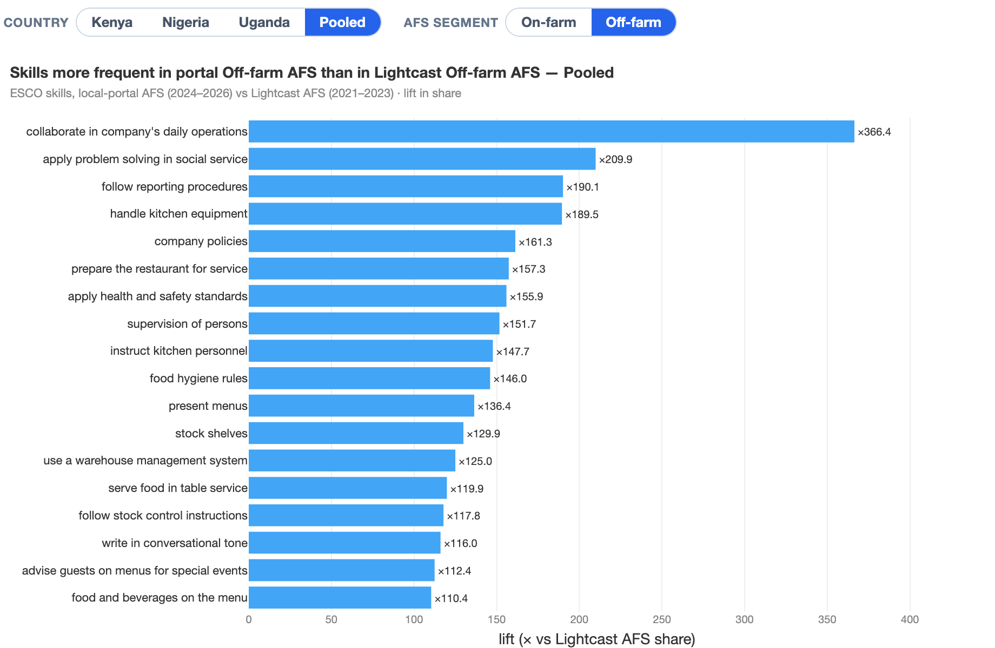
Pooled across the three countries, the two segments tell distinct stories. In the off-farm segment the skills that rise to the top are overwhelmingly food-service and hospitality competencies — handle kitchen equipment, prepare the restaurant for service, instruct kitchen personnel, present menus, together with food hygiene rules — none of which featured prominently in the earlier Lightcast agri-food profile. They sit alongside a band of cross-cutting operational and compliance skills (collaborate in company’s daily operations, follow reporting procedures, company policies, apply health and safety standards, supervision of persons) and a retail and stock cluster (stock shelves). The substantive point is that the national boards surface a far broader downstream food-service and food-retail layer of off-farm agri-food demand than the earlier multi-source window captured.
In the on-farm segment the picture is different: the rising skills combine a livestock and primary-production core (livestock, breed poultry, livestock feeding) with a supervisory and reporting layer (supervision of persons, follow reporting procedures, notify supervisor, collaborate in company’s daily operations, establish collaborative relations) and a thread of development, extension and research competencies (assist community, conduct scholarly research, participate actively in civic life) — consistent with the NGO, extension and farm-management roles that national boards advertise. Because several of these competencies are almost absent from the Lightcast agri-food sample, their lift is very large; in both segments the difference is best read as a shift in source coverage rather than a like-for-like change over time, and it reinforces the off-farm tilt of the concept shares above.
The Country toggle shows that these patterns, while broadly shared, take a distinct shape in each market. In Kenya the on-farm rises are led by a data, livestock and people-management cluster (gather data, livestock, establish collaborative relations, supervision of persons, mentor individuals), while off-farm is dominated by operational, compliance and food-service competencies (collaborate in company’s daily operations, follow reporting procedures, handle kitchen equipment). Nigeria stands out on-farm for a poultry and research signature (breed poultry, conduct scholarly research, livestock) and off-farm for a hospitality and negotiation mix (handle kitchen equipment, moderate in negotiations, deal with pressure from unexpected circumstances). Uganda is the most NGO- and extension-flavoured: its on-farm rises foreground reporting, community and civic competencies (follow reporting procedures, work within communities, exercise rights and responsibilities), and even its off-farm set leans towards sales, teaching and reporting rather than kitchen work. As elsewhere in this section, the very large lifts reflect how thinly these competencies were represented in the earlier multi-source window, so the comparison is best read as a difference in source coverage rather than a change in the underlying labour market.

ESCO skill groups (S1–S8)
The same eight ESCO skill groups used in the main analysis, recomputed on the local-portal agri-food postings (2024–2026). Each bar is a skill group’s share of all S1–S8 mentions within the on-farm or off-farm segment, so the eight groups sum to 100% within each segment. Use the Country toggle to switch between Kenya, Nigeria, Uganda and the pooled total.
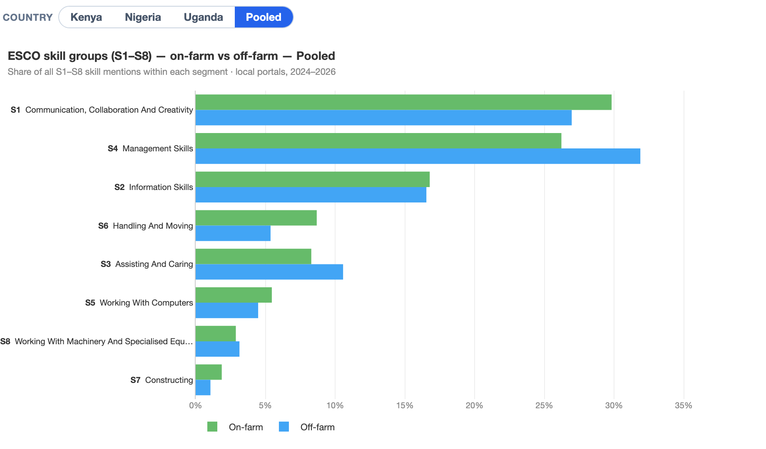
The portal profile echoes the main Lightcast picture. Pooled, communication, collaboration and creativity (S1, ≈27–30%) and management (S4, ≈26–32%) together account for well over half of all skill mentions in both segments, with information skills (S2, ≈17%) third. The agri-food fingerprint is again visible in handling and moving (S6), which is heavier on-farm (≈9%) than off-farm (≈5%), while assisting and caring (S3) tilts the other way (≈11% off-farm vs ≈8% on-farm), reflecting the food-service and hospitality roles concentrated downstream. The remaining groups — working with computers (S5), machinery (S8) and constructing (S7) — each carry only a few percent.

Knowledge domains
ESCO knowledge concepts extracted from the same portal postings, aggregated to broad knowledge domains and shown as the share of segment postings that mention each domain (document-frequency prevalence). The chart keeps the most prevalent domains; use the Country toggle to change market.
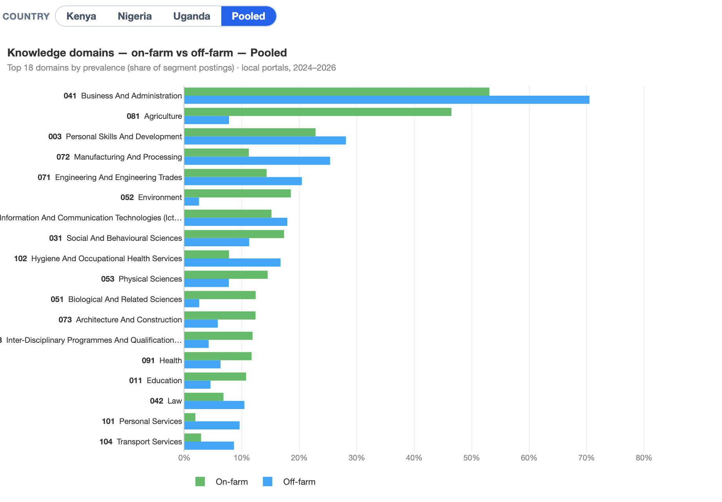
The knowledge profile separates the two segments cleanly. Agriculture knowledge is the defining on-farm domain — present in roughly 47% of on-farm postings but under 8% of off-farm ones — and environment knowledge shows the same on-farm tilt. Off-farm postings instead lean on business and administration (≈70% prevalence), manufacturing and processing and engineering, the signature of processing, trade and food-service work. Personal skills and development and information and communication technologies knowledge are common across both segments, consistent with the cross-cutting managerial and digital content seen elsewhere in the report.

Conclusion
This report has used online job postings to characterise advertised skill demand in agri-food system (AFS) jobs in Kenya, Nigeria, and Uganda. Read within its intended scope — formal, digitally mediated vacancies rather than the agri-food labour market as a whole — the evidence points to a consistent picture. Much of the AFS demand visible online lies beyond primary production, in off-farm activities and in the managerial, technical, service, logistics, quality-control, and business-support roles that connect farms, firms, markets, and consumers. The skills requested in these jobs differ markedly from those requested in on-farm roles. This is the formal, higher-skilled layer of the agri-food system, and it is where the shift “beyond the farm” is most visible in recruitment data.
The implication is not that primary production is becoming less important. Rather, online vacancies reveal a different layer of AFS labour demand: the roles through which agricultural production is processed, moved, marketed, financed, regulated, and connected to consumers. For skills policy and workforce development, this matters because improving productivity and supporting structural transformation require capabilities across the whole value chain, not only at farm level. Training systems, employment services, and sector strategies therefore need to recognise the growing importance of off-farm and cross-cutting roles alongside core agricultural occupations.
The findings should nevertheless be interpreted with care. Online postings capture only the formal and digitally connected segment of hiring. Coverage varies across countries with differences in internet use, recruitment practices, employer structure, and the availability of online job-board data, so cross-country levels should not be read as direct measures of total demand. Identifying AFS jobs from vacancy text also involves uncertainty, especially at the boundary between off-farm agri-food activities and the wider economy. The results are robust at the broad AFS/non-AFS and on-farm/off-farm levels, but finer subcategory breakdowns should be treated as indicative.
The report is therefore best understood as a complement to survey-based evidence, not a substitute for it. Labour force and establishment surveys describe the structure of employment; online postings provide a more current view of the jobs, skills, and capabilities that formal employers advertise. Used together, these sources can help distinguish where most people currently work from where formal employer demand is emerging and how the skill content of AFS jobs is changing.

Future work
Several extensions would strengthen the analysis. The most direct is to refine the classification so that results can be disaggregated more confidently within the agri-food system. The current model performs well in distinguishing AFS from non-AFS vacancies and in separating on-farm from off-farm work. Finer subcategories, however — such as crops, livestock, fisheries, and forestry on the farm, or inputs, processing, trade and logistics, and food services off the farm — are harder to distinguish from vacancy text alone. Expanding the labelled training data around these boundaries, adding more context about employer and occupational features, and correcting for residual misclassification would allow these subcategory breakdowns to be reported with greater confidence.
Other extensions follow naturally. Future work could tighten the boundary between agri-food and the wider economy, extend coverage over time, and integrate the local-portal data more fully with the Lightcast-based series where comparability permits. It could also validate online vacancy patterns against labour force, establishment, and sector-specific surveys. Because the trained classifier is reusable, the approach can also be applied to additional countries and later periods, creating a scalable tool for monitoring how formal agri-food skill demand evolves over time.

Appendix

A. Employer-level AFS imputation
If an employer posts at least one AFS job, by how much — in % — would AFS demand grow if we treated all of that employer’s postings as AFS, on-farm vs off-farm?
Our baseline AFS classification operates at the posting level: each advertisement is assessed independently from its title and description. This appendix asks what would change under an alternative employer-level rule, and first sets out who actually places AFS postings online — the hiring organisations themselves or recruitment intermediaries acting on their behalf.
Who posts AFS jobs: direct employers vs recruitment intermediaries
A meaningful share of online postings is placed not by the hiring organisation itself but by recruitment agencies, HR consultancies and job boards. These intermediaries advertise roles across many unrelated sectors and therefore require careful treatment in any employer-based analysis. While the Lightcast posting data already identify a subset of employers as staffing firms, we extend this coverage using employer profile information. This allows us to identify additional intermediaries that are not pre-flagged in the data but can be recognised as recruitment-related organisations based on their stated business activity, sector description, or profile characteristics.
Combining the two, we measure what share of postings is placed through such intermediaries — and how this differs between AFS jobs and the rest of the labour market.
Table A1 · Share of postings placed through recruitment intermediaries — AFS vs all other jobs
Country | AFS jobs | All other jobs
Kenya | 16.9% | 14.4%
Nigeria | 13.9% | 12.8%
Uganda | 4.6% | 5.4%
In Kenya and Nigeria a slightly higher share of AFS jobs than other jobs is placed through intermediaries (16.9% vs 14.4% and 13.9% vs 12.8%); in Uganda the reverse holds (4.6% vs 5.4%). The gap between Uganda and the other two reflects a thinner, more institution-led online market. Employer-name analysis extends coverage beyond the platform’s own staffing flag by +4.6 pp in Kenya, +10.6 pp in Nigeria, and +1.6 pp in Uganda — the gain is largest in Nigeria, where the platform flag alone captures only around 3% of AFS postings placed by intermediaries.
The imputation exercise
We exclude the recruitment intermediaries identified above and ask: if every remaining employer with at least one AFS posting had its entire posting list counted as AFS, how much would AFS demand grow? Postings without an identifiable employer are set aside, since the rule cannot apply to them. The analysis is reported in percentages — growth rates and shares — and split into on-farm and off-farm work (off-farm spanning inputs & ag services, food processing, trading and food service). The within-employer hit-rate is the share of an AFS employer’s postings that fall in the same AFS segment, an indicator of how specialised that employer is.
Table A2 · AFS composition: observed vs employer-imputed (% of AFS postings, on vs off-farm)
Country | Observed on-farm | Observed off-farm | Imputed on-farm | Imputed off-farm
Kenya | 53.6% | 46.4% | 62.9% | 37.1%
Nigeria | 32.5% | 67.5% | 44.1% | 55.9%
Uganda | 66.0% | 34.0% | 68.2% | 31.8%

Table A3 · Imputation growth (%) by segment — how much the AFS count would grow
Segment | Kenya | Nigeria | Uganda
On-farm | +2,166% | +2,983% | +2,126%
Off-farm (all) | +2,023% | +1,404% | +2,996%
Inputs & ag services | +9,788% | +20,999% | +3,851%
Food processing | +3,010% | +2,447% | +3,967%
Food trading | +10,559% | +12,273% | +8,959%
Food service | +2,978% | +2,093% | +3,672%

Table A4 · Within-employer AFS hit-rate by segment (%) — given an AFS posting, the share of the employer's postings that are AFS in that segment
Segment | Kenya | Nigeria | Uganda
On-farm | 20.5% | 24.2% | 20.4%
Off-farm (all) | 30.0% | 29.8% | 24.8%
Inputs & ag services | 19.4% | 14.5% | 12.3%
Food processing | 18.1% | 21.7% | 21.4%
Food trading | 27.2% | 11.7% | 5.4%
Food service | 26.5% | 28.0% | 26.1%
Interpretation. Treating every AFS employer’s full posting list as AFS would inflate the AFS count by roughly +1,200% to +1,600% overall (Kenya +1,319%, Nigeria +1,232%, Uganda +1,601%) — a 13–17× multiplier. This is an upper bound, and the within-employer hit-rate explains why: conditional on a posting being AFS, only about 20–30% of that employer’s postings are AFS in the same segment, so most AFS employers are diversified rather than agri-specialised. The on/off contrast is informative. Off-farm hiring is somewhat more self-contained than on-farm in Kenya and Nigeria (hit-rate 30% vs 20–24%), while Uganda is more on-farm throughout. Crucially, in every country the employer rule shifts the composition toward on-farm (Kenya 53.6%→62.9%, Nigeria 32.5%→44.1%, Uganda 66.0%→68.2%), because on-farm AFS employers carry proportionally larger posting lists. Among off-farm subcategories, food service and food processing behave like genuine segments (hit-rates 18–28%, growth +2,000–4,000%), whereas inputs & ag services and food trading show extreme growth (+8,000% to +21,000%) on top of single-digit-to-teens hit-rates — these rest on a handful of highly diversified employers and should not be read as latent AFS demand.

B. Technical appendix: processing pipeline
Detailed methodology for each pipeline step
This appendix documents the four standardisation steps summarised under Processing pipeline: skill-sentence filtering, skills standardization, job-title standardization, and ISIC/NACE sector classification.

Step 01 Skill-sentence filtering
Job descriptions typically mix skill requirements with administrative content such as benefits, company history, or application instructions. Isolating the skill-relevant sentences before downstream mapping reduces noise and improves the precision of the extracted skill profiles.
We use a fine-tuned BERT classifier based on the Malandri et al. (2025) SkillLess approach and the BERT-OJA-SkillLess. The model performs binary sentence-level classification, labelling each sentence as either skill-relevant or non-skill. In our sample, approximately 40–60 % of description text is filtered out as non-skill content. Only the retained sentences proceed to the skills standardization step.

Step 02 Skills standardization
The European Skills, Competences, Qualifications and Occupations (ESCO) taxonomy provides a standardised vocabulary of roughly 13,000 skills and competences maintained by the European Commission. Standardizing extracted skill sentences to ESCO entries creates a common analytical framework that enables direct comparison across countries and languages.
We employ a custom contrastive bi-encoder trained on a massive synthetic dataset comprising hundreds of thousands of ESCO-labelled examples derived from the ESCO classification structure. The bi-encoder learns a shared representation space for two different objects — job-posting sentences and standardised ESCO skill labels — by bringing semantically matching pairs closer together while pushing non-matching pairs apart. In practical terms, consider a job-posting sentence such as “experience with SQL and data visualisation”. The model learns to place it close to the correct ESCO entries — “use query languages” and “manage databases” — and away from everything else. Crucially, the training signal is strongest for hard negatives: skills that are semantically nearby but not a correct match, such as “use programming languages” or “develop software”. These are more informative than trivially distant skills like “negotiate contracts”, because the model must learn fine-grained distinctions within the same domain rather than merely separating unrelated concepts. During training, correct sentence–skill pairings act as positives while all other skills in the same batch act as negatives — with the hardest cases (same-domain, wrong skill) driving most of the learning signal. This gives the model a scalable way to learn ranking behaviour across the full ~13,000-skill taxonomy without a separate classifier for each skill.
This approach is well suited to online job postings because employers often describe the same skill in many different ways. By learning semantic proximity rather than relying on exact wording, the model can recover skills even when the phrasing differs from the ESCO label itself.
Our approach also avoids relying only on one averaged sentence representation. Instead, the encoder can attend more strongly to the parts of a sentence that are most diagnostic for a given skill, which is particularly useful when a single sentence mentions several tasks, tools, or competencies at once. This token-level attention mechanism has been shown to improve matching quality in multi-skill sentences (Sun, 2026; Decorte et al., 2025).
Similarity threshold calibration. Not every high-ranking candidate is a true match. Following established practice in ESCO skill extraction (Decorte et al., 2025; Bielinski & Brazier, 2025), we retain only those candidates whose cosine similarity exceeds a calibrated threshold. The threshold is tuned on held-out benchmark data (the same HOUSE and TECH datasets used to evaluate overall pipeline performance) by selecting the value that maximises the trade-off between precision and recall. This step filters out low-confidence matches and controls the total number of skills assigned per posting.
 | Our skill-mapping pipeline outperforms the current state of the art by approximately 3 percentage points in RP@5 on the HOUSE and TECH benchmark datasets reported by Decorte et al. (2025). These benchmarks consist of job postings annotated with ESCO gold-standard skill labels by human experts, against which model predictions are evaluated. The reported RP@5 scores are 0.822 and 0.838, respectively.

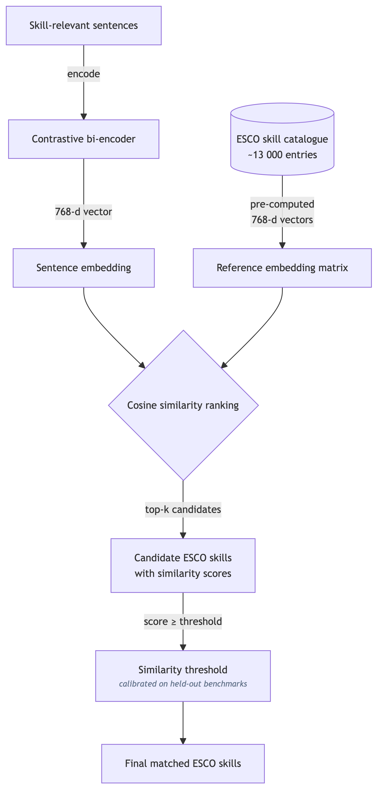
Skills standardization pipeline

Step 03 Job title standardization
Raw job titles are highly variable: the same role may appear as “Software Engineer”, “Backend Developer”, “Platform Engineer”, “Full-Stack Application Developer”, or “Senior API Engineer”. Likewise, an analytical role may appear as “Data Analyst”, “BI Analyst”, “Reporting Specialist”, or “Insights Associate”. Because titles are first translated into English, the standardisation step works on a harmonised title field rather than directly on multilingual raw text. Mapping each title to a standardized ESCO occupation enables comparable occupational analysis and serves as the bridge to sector classification in the next step.
Titles are first cleaned by removing common noise (embedded locations, salary ranges, seniority prefixes). The cleaned titles are then embedded using JobBERT-v3, a domain-specific open model pre-trained on large-scale job market data. We pre-compute embeddings for all ~3,000 ESCO occupation labels and store them in a FAISS vector index for fast retrieval. Each job title is matched to the nearest ESCO occupation by cosine similarity, with the similarity score retained for downstream quality filtering.

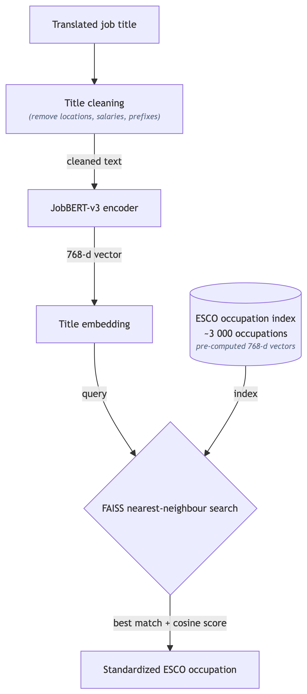
Job title standardization

Step 04 Sector classification (ISIC/NACE)
Assigning an economic sector to each job posting enables analysis of skill demand by industry—a dimension that is critical for targeted workforce development and industrial policy. We classify postings into the ISIC/NACE industry taxonomy. The underlying crosswalk uses the full NACE Rev. 2.1 classification maintained by Eurostat, which provides finer sub-division detail (3- and 4-digit codes) than ISIC. However, because this report analyses sectoral demand at the 2-digit division level, the results are identical under both systems: at 2 digits, NACE Rev. 2.1 and ISIC Rev. 5 share the same division codes and boundaries (Eurostat, 2024). All results in this report are therefore directly comparable with any analysis using either framework.
The assignment relies on the official ESCO-to-NACE crosswalk, which links each ESCO occupation to one or more ISIC/NACE activity codes. Three resolution tiers handle different levels of ambiguity:
- One-to-one mapping — the ESCO occupation maps to a single ISIC/NACE code. The assignment is deterministic.
- Same 2-digit code — all candidate codes share the same 2-digit division (e.g. all fall under C26). The shared division is assigned directly, since finer sub-division differences are below the reporting threshold.
- Ambiguous multi-division cases — candidates span different ISIC/NACE divisions. We resolve these by embedding the job title and description together with each candidate activity label using a multilingual sentence-transformer (paraphrase-multilingual-MiniLM-L12-v2) and selecting the candidate with the highest cosine similarity. A confidence margin between the top two candidates is recorded to support post-hoc quality auditing.

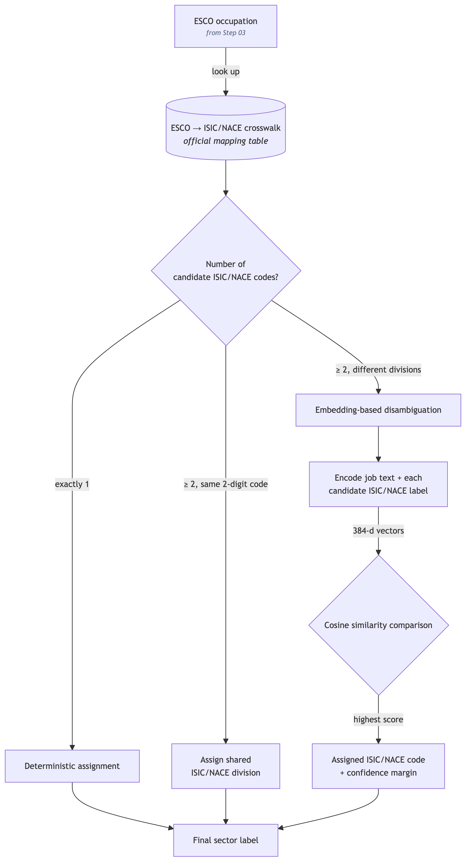
ISIC/NACE sector classification

C. AFS classification: embedding + classifier
How the default AFS classifier is built, calibrated and evaluated
This appendix documents the default method used to flag agri-food postings throughout the report (summarised in Identifying agri-food system jobs). The pipeline turns each posting into a calibrated AFS probability and an eight-way sub-category, learned from LLM-judged gold labels rather than fixed keyword lists.

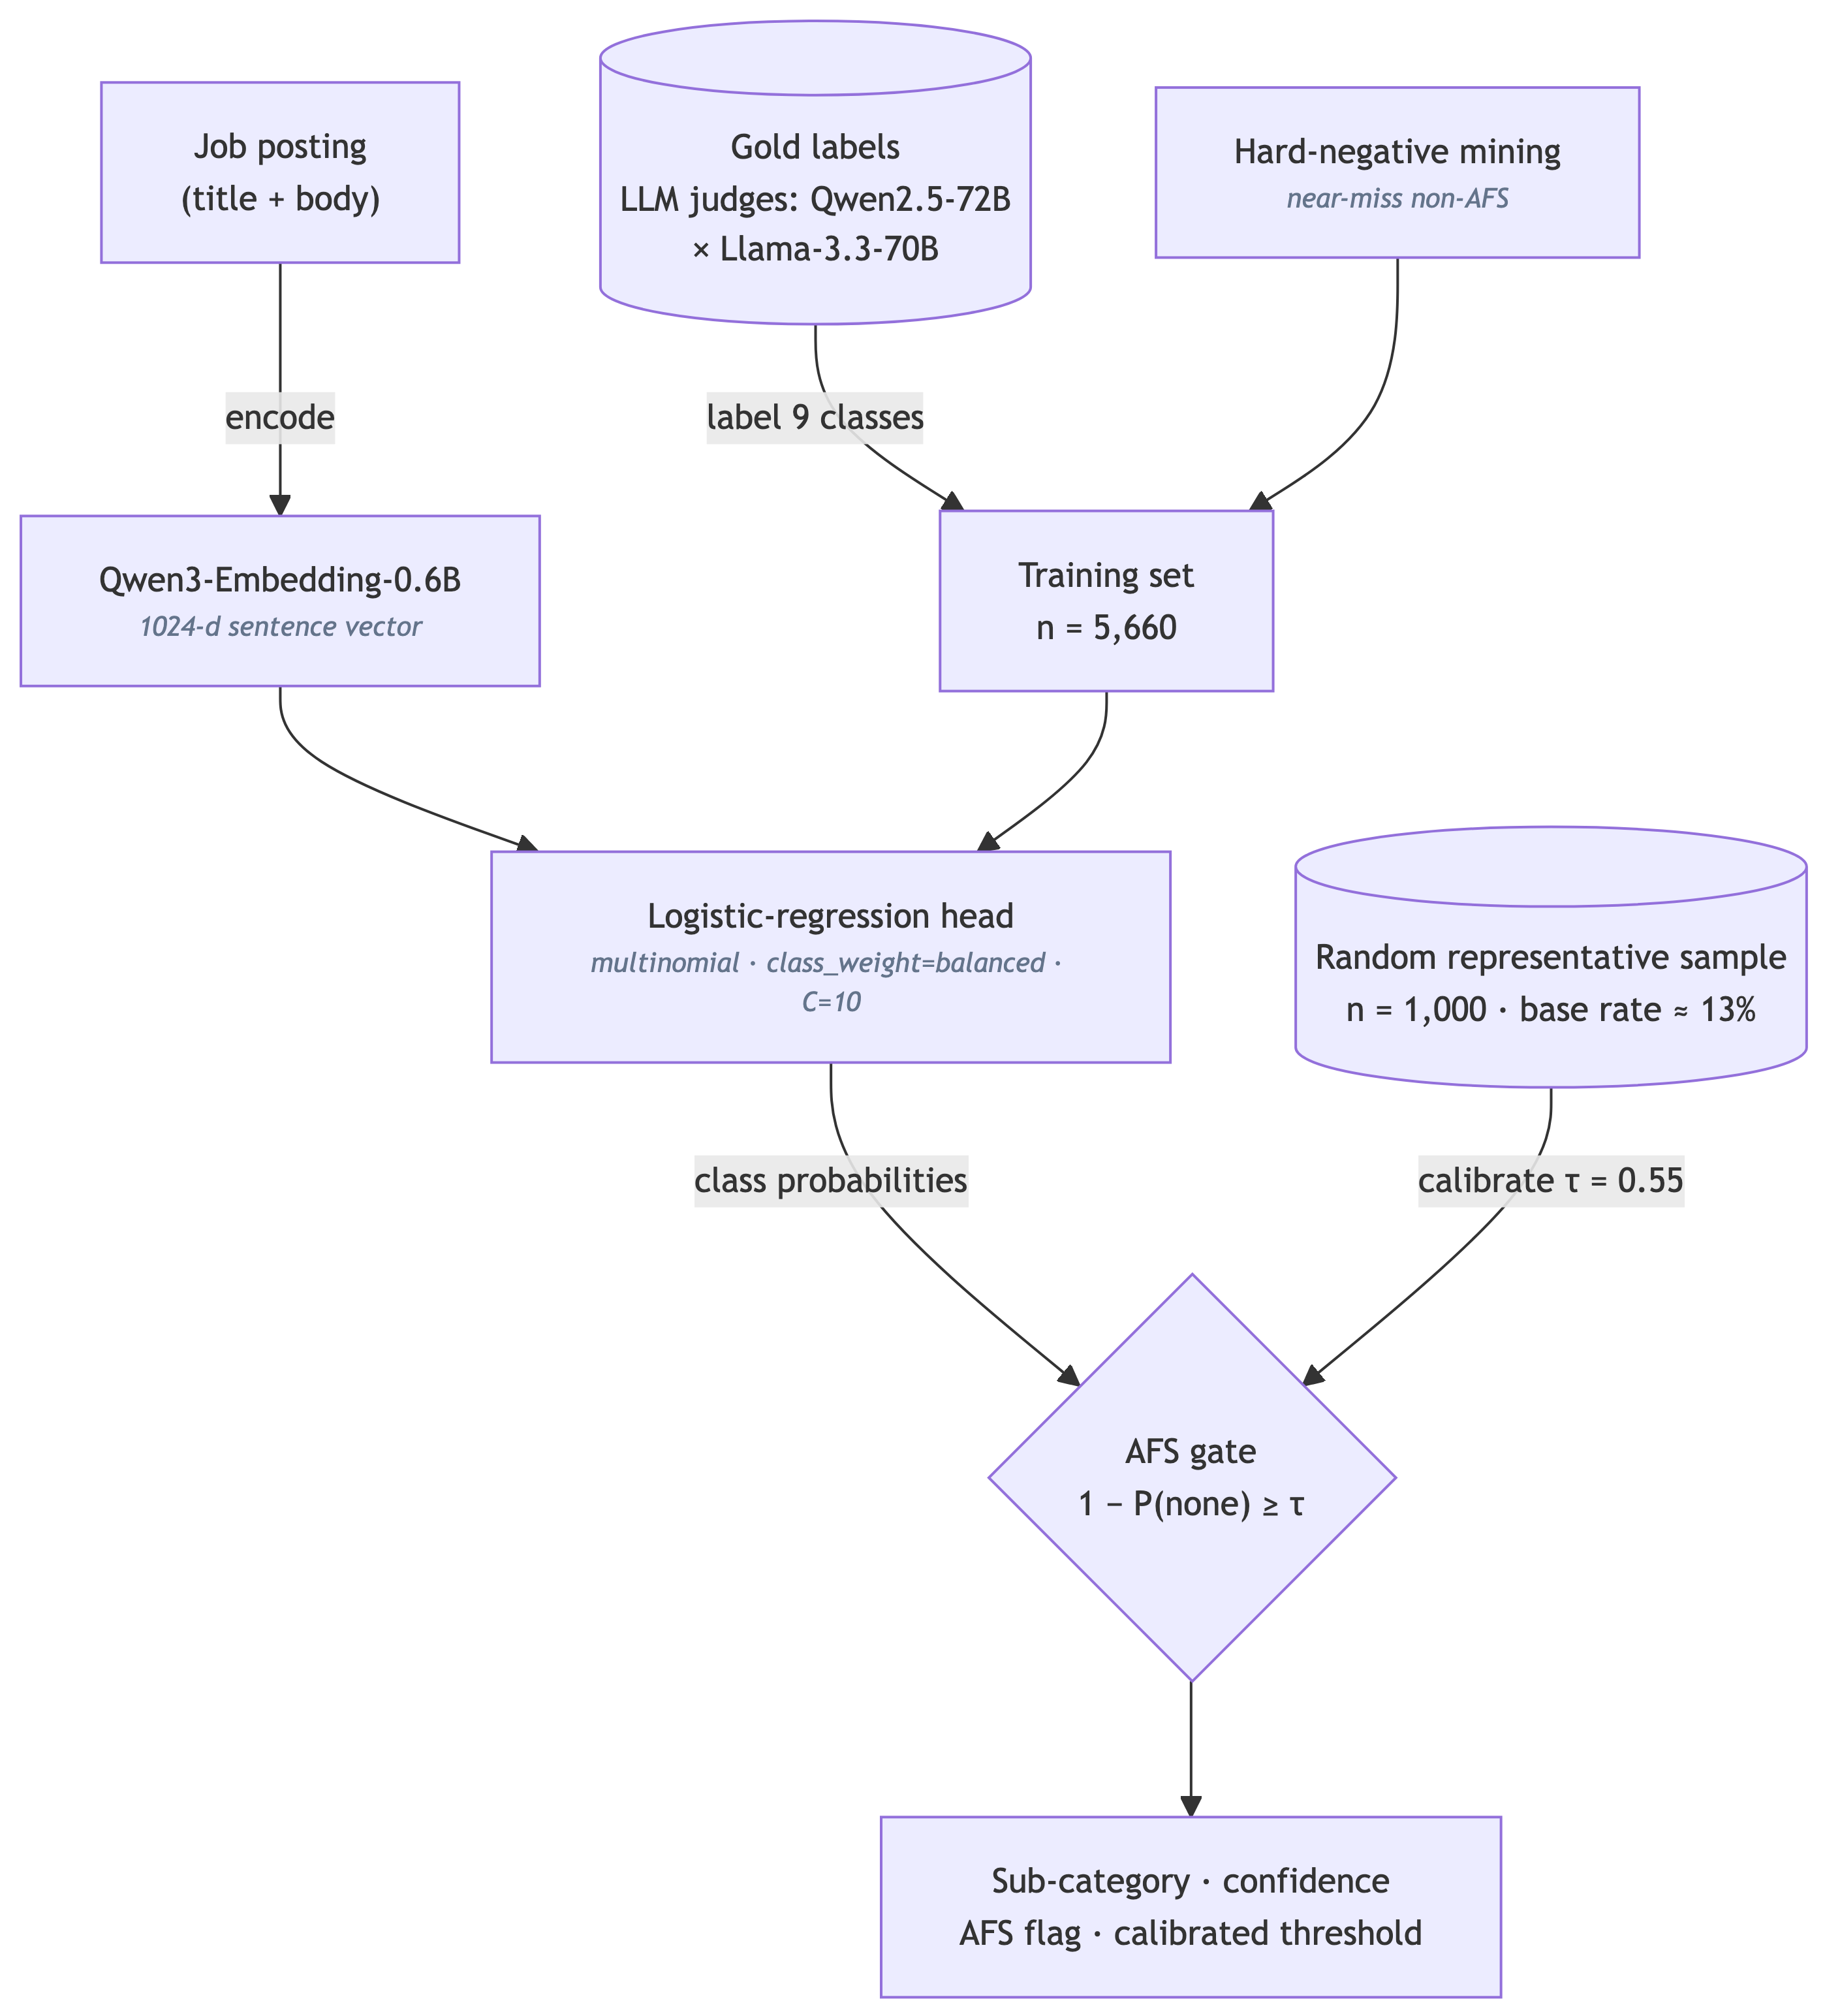
AFS classification pipeline (embedding + supervised head)

Models and key parameters
Component | Model / setting | Role & key parameters
Sentence filter | BERT-OJA-SkillLess | Binary skill-vs-non-skill sentence classifier; removes ~40–60% of boilerplate before skill mapping (pipeline Step 01).
Posting embedding | Qwen3-Embedding-0.6B | Encodes title + body into a dense vector; deployed as an inference endpoint, vectors stored in a FAISS index for reuse.
AFS head | Logistic regression (scikit-learn) | Multinomial; class_weight="balanced"; C=10 (selected by 5-fold macro-F1 over {0.1, 0.3, 1, 3, 10}); 9 classes (8 AFS sub-categories + none).
AFS gate (τ) | Threshold on 1−P(none) | Calibrated τ=0.55 on a random representative sample (true base rate ≈ 13%); CV-optimal τ on the balanced gold set is 0.75. The calibrated threshold and the resulting AFS flag are stored for every posting.
Zero-shot baseline | DeBERTa zero-shot v2 | Used at the evaluation stage as an independent NLI cross-check on the gold labels and as a fallback signal.
Skill mapping | ConTeXT-Skill-Extraction (ESCO) | Contextual bi-encoder mapping skill sentences to the ~13,000-entry ESCO taxonomy (pipeline Step 02).
Gold annotation | Qwen2.5-72B & Llama-3.3-70B | LLM judges assign sub-category labels; high-agreement items form the 5,660-example gold training set.

Cross-validated performance
Honest stratified 5-fold cross-validation on the gold set (the head is refit on each fold; reported predictions are out-of-fold).
Class | Precision | Recall | F1 | Support
binary AFS gate (AFS vs not, argmax) | 0.874 | 0.942 | 0.906 | 5,660
macro avg | 0.741 | 0.773 | 0.754 | 5,660
fisheries / aquaculture | 0.901 | 0.956 | 0.928 | 502
forestry / logging | 0.810 | 0.930 | 0.866 | 500
food service | 0.839 | 0.870 | 0.854 | 538
livestock | 0.795 | 0.861 | 0.827 | 504
crop production | 0.689 | 0.734 | 0.711 | 523
agro-processing | 0.670 | 0.713 | 0.691 | 527
food trade & logistics | 0.565 | 0.722 | 0.634 | 503
agri-inputs & services | 0.626 | 0.584 | 0.604 | 651
At the deployed threshold (τ=0.55) the binary AFS gate scores precision 0.85 / recall 0.96 (F1 0.90) in cross-validation; raising it to τ=0.75 trades recall for precision (0.91 / 0.90). The hardest classes are the off-farm service/trade boundaries (agri-inputs, food trade & logistics), which overlap with generic commercial roles; the on-farm primary classes are recovered most cleanly. Overall accuracy is 0.74 across nine classes.

Reproducibility and model sharing

Worked examples
Top-confidence labelled postings used to audit the classifier’s decisions, drawn from real Lightcast vacancies. Each group below expands, and every posting expands again to reveal its full advertised text. They serve as qualitative checks alongside the quantitative validation metrics reported above.

