To tweet, one needs

1. Create a twitter account (apps.twitter.com)

2. Please verify you email id and phone number.

Phone number is mandatory while creating twitter apps.

3. Now go back to url app.twitter.com

4. Give a name to your app. It is usually unique globally. It can be changed later.

5. Copy the API Key and API Key Secret:

The API Key Secret should NEVER be in a human readable form in your app.

6. On the left panel, click on **Projects & Apps** > **Project 1** > **your application**

7. Now set the **User authentication settings,** to get the write access. i.e to be able to send a tweet.

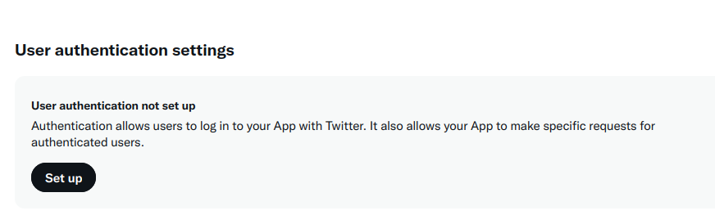

8. Click on **Set Up**, give **Read and Write** Permission and click update.

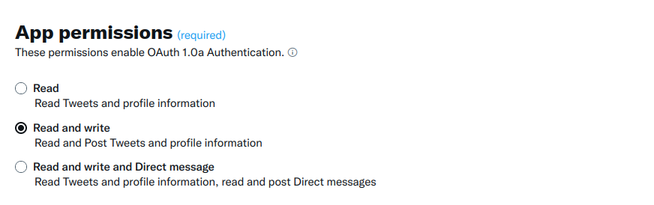**You can give the call back url something random, like bits-pilani.ac.in. Same for the other url.**

8. On the page, you can find Settings, Keys and tokens below your project name. Select **Keys and tokens**.

9. In **Authentication Tokens** section, Click **Generate** button, for **Access Token and Secret** key

10. Now you can see **Read and Write** permissions, below **Access Token and Secret**.

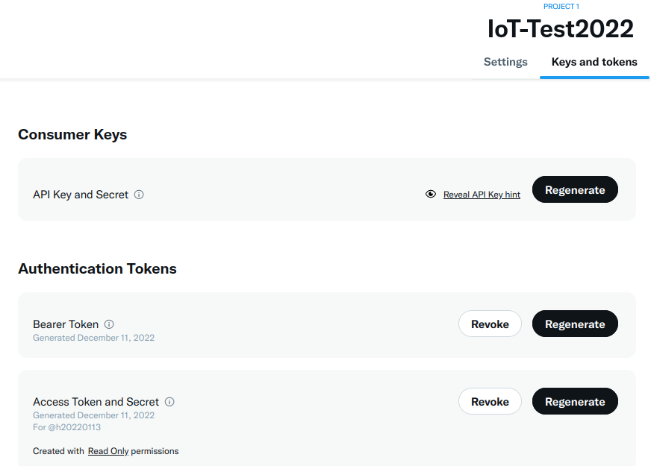

Version 2 has only access to tweet without any image/media. You need to use v1.1 to tweet images. One needs elevated access to have access to v1.1 methods.

<https://developer.twitter.com/en/portal/products/elevated>

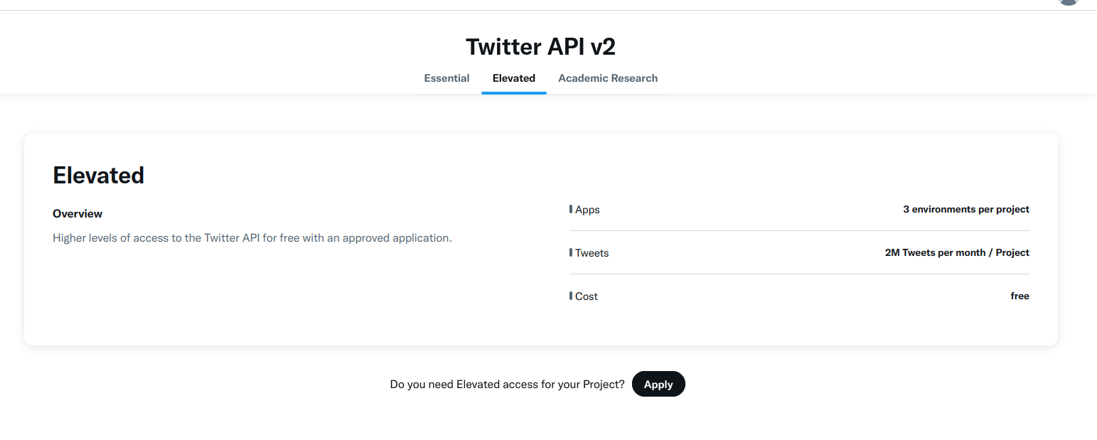step 2: give name and experience

step 3: give other simple details on what the app is for.

Step 4: accept terms and conditions.

**You will get elevated access.**