Test Project

Web Technologies

Module E – JS Browser API

Submitted by:

Zoltan Sisak (HU)

# Contents

1. Contents 2
2. Introduction to Test Project 3
   1. The following is a list of sections or information that must be included in all Test Project proposals that are submitted to WorldSkills. 3
3. Introduction 3
4. Description of project and tasks 4
   * 1. Calendar View 4
     2. Room Type Filtering 4
     3. Unassigned Booking List 4
     4. Drag and Drop Functionality 5
     5. Reset Button 5
     6. Persistent State 5
     7. Clipboard Copy 5
     8. Export/Import Functionality 5
     9. Fullscreen Mode 5
5. Instructions to the Competitor 5
6. Marking Scheme 6

# Introduction to Test Project

## The following is a list of sections or information that must be included in all Test Project proposals that are submitted to WorldSkills.

* Contents including list of all documents, drawings and photographs that make up the Test Project
* Introduction/overview
* Short description of project and tasks
* Instructions to the Competitor
* Other

# Introduction



Haeundae Horizon Hotel is a luxurious four-star hotel located near the picturesque Haeundae Beach. To enhance the efficiency of room management, the hotel is developing an interactive tool to help officers assign rooms to bookings seamlessly. As part of a competitive event, participants are required to create a prototype of this tool.

You are tasked with creating a prototype of an interactive tool that helps hotel officers assign rooms to bookings. The prototype is limited to handling bookings for June 2024. The tool should display a calendar view, manage room assignments, and provide functionalities such as filtering by room type, drag-and-drop booking assignments, and exporting/importing assignments.

Original data should be fetched from the provided backend using the following endpoints: - http://hh-hotel.kr/api/v1/rooms - http://hh-hotel.kr/api/v1/bookings

Alternatively, rooms.json and bookings.json will be provided in case you can’t fetch from the server.

There are following sections in the page:

* Room type selection area
* Unassigned bookings list area
* Calendar with bookings
* Full screen button
* Reset button
* Export button
* Import button

# Description of project and tasks

### Calendar View

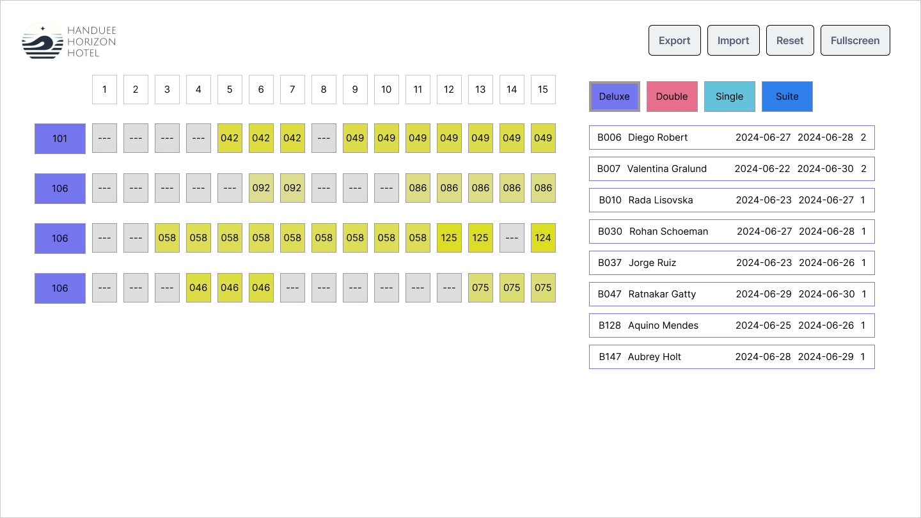

* Display a calendar view showing 15 days at a time.
* Initially, show the interval from June 1 to June 15.
* Clicking on a day in the calendar header adjusts the view to center around the selected day.
  + Days 1-7: Show June 1-15.
  + Days 24-30: Show June 16-30.
  + Other days: Center the selected day in a 15-day interval.
* Room ID background color should match the corresponding room type button color.
* Day boxes with assigned booking should display the last three characters of the booking ID.
* Day boxes with assigned booking background color should be #ddddxx, where xx are the last two digits of the booking ID.

### Room Type Filtering

* Display only bookings for the selected room type in the calendar and unassigned list.
* Deluxe is selected initially.
* The selected room type button has a thicker border.
* Room type can be changed using buttons on the right side of the interface.

### Unassigned Booking List

* Display a list of bookings that are not yet assigned to any room.
* Each unassigned booking should display the following details:
  + Booking ID
  + Guest name
  + Check-in date
  + Check-out date
  + Number of guests
* Unassigned booking button borders should have the same color as the corresponding room type button.
* Clicking an unassigned booking centers its interval in the calendar view. If the booking interval is an odd number of days, one less day should be displayed before the check-in date than after the check-out day.

### Drag and Drop Functionality

* Allow dragging unassigned bookings to room lines in the calendar.
* Enable drop only if the room is free during the booking interval.
* Successful drop displays the booking ID in the calendar and removes it from the unassigned list.
* Dragging a booking from the calendar to the unassigned list area unassigns the booking.
* Provide visual feedback for drag-and-drop actions.

### Reset Button

* Reset the tool to its original state based on data fetched from the backend.

### Persistent State

* Store changes in the browser to retain the state after page refresh or browser restart.

### Clipboard Copy

* Clicking on a day box with a booking copies the booking details to the clipboard.

### Export/Import Functionality

* Export current room assignments to a CSV file in the format: bookingId,roomId when the officer clicks the Export button. The filename should be hhh-bookings.csv.
* Import room assignments from a CSV file with the same format, overwriting current assignments.

### Fullscreen Mode

* When the user clicks the fullscreen button, toggle the fullscreen view of the browser window.
* While in fullscreen mode, if the user clicks the exit fullscreen button or presses the ESC key on the keyboard, the fullscreen view will end, and the browser will return to the normal web page view

# Instructions to the Competitor

* All assessment is done on the server. No assessment process is performed on the workstation.
* You should consider the quality of your code.
* You should consider the accessibility of your application.
* Follow the provided design layout closely, although design implementation is not a key evaluation aspect.
* Ensure your tool meets the described functionality and interaction requirements.
* Focus on creating a user-friendly and responsive interface.

# Marking Scheme

|  |  |  |  |  |  |  |  |
| --- | --- | --- | --- | --- | --- | --- | --- |
|  |  | Work Organization | Communication and Presentation | Design | Layout | Front-end | Total |
| F1 |  |  |  |  |  |  |  |
| F2 |  |  |  |  |  |  |  |
| F3 |  |  |  |  |  |  |  |
|  | Total |  |  |  |  |  | 16 |