Module 8 Exercise Solutions

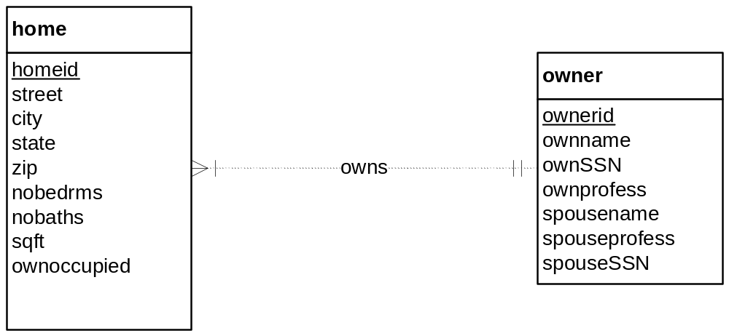

The problem narrative indicates that an owner can possess one or more homes. This statement is a somewhat unclear about the minimum cardinality. A minimum cardinality of 1 is consistent with the narrative but 0 is also acceptable because the problem narrative does not definitively indicate that an owner must possess at least one home.

SSN is a poor choice for a primary key as noted in module 8. The problem narrative indicates that ownerid is unique so it is used as the primary key. The user should be told that SSN is a poor choice for the primary key.

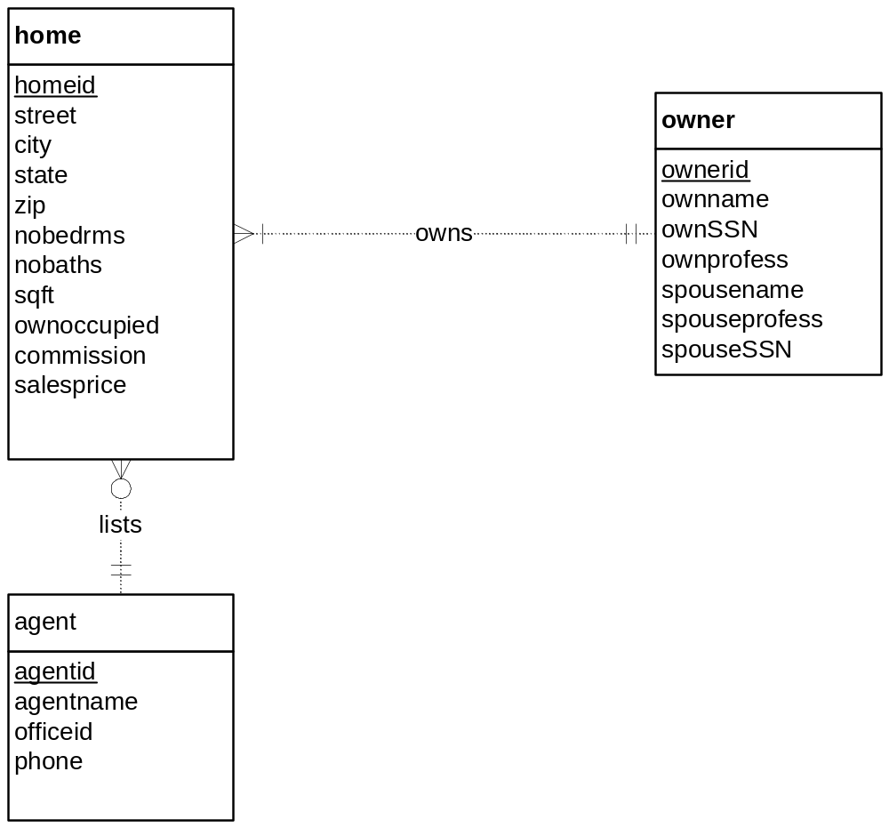

The problem narrative does not specify the minimum cardinalities of the lists relationship. Either 0 or 1 are acceptable for minimum cardinalities for both sides of the lists relationship. The commission attribute can be considered an attribute of the lists relationship if an agent is optional for a home although the more conventional representation is for the commission attribute as an attribute of the home entity type.

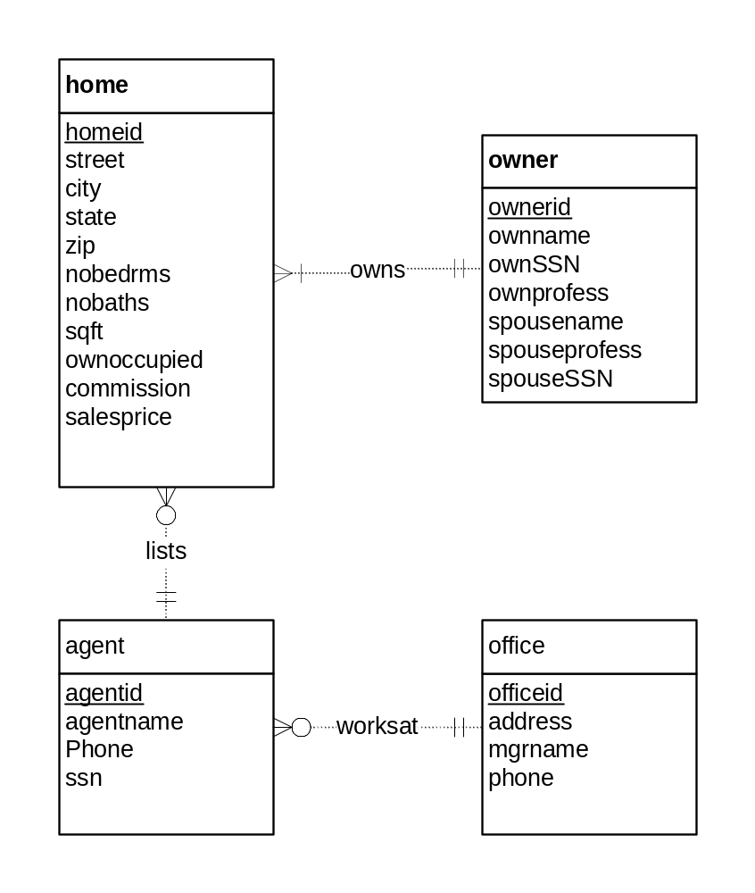
The solution involves the attribute expansion transformation presented in lesson 3 of module 8. In the solution ERD, OfficeId is transformed into an entity type (Office) and 1-M relationship (WorksAt). Note that the minimum cardinalities are not indicated in the problem narrative. Without an indication in the problem narrative, you can inject your own judgement, but you should note that additional requirements collection is necessary for both minimum cardinalities.

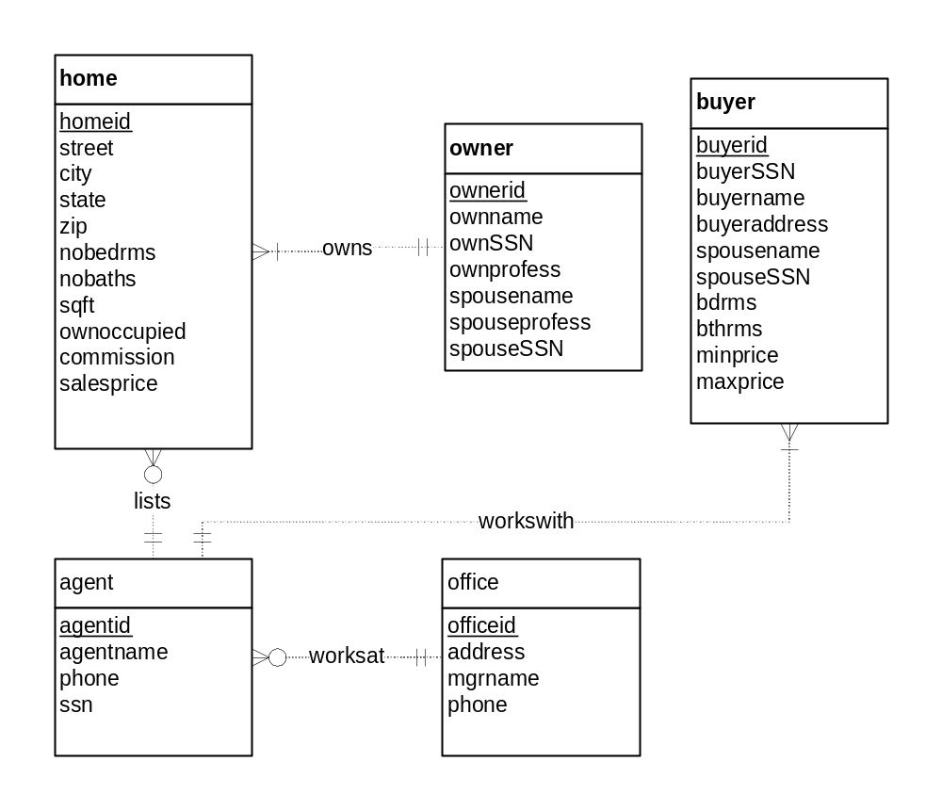
SSN is a poor choice for a primary key as noted in module 8. The problem narrative indicates that buyerid is unique so it is used as the primary key. The user should be told that SSN is a poor choice for the primary key.

The problem narrative does not specify the minimum cardinalities of the workswith relationship. Either 0 or 1 are acceptable for minimum cardinalities for both sides of the lists relationship.

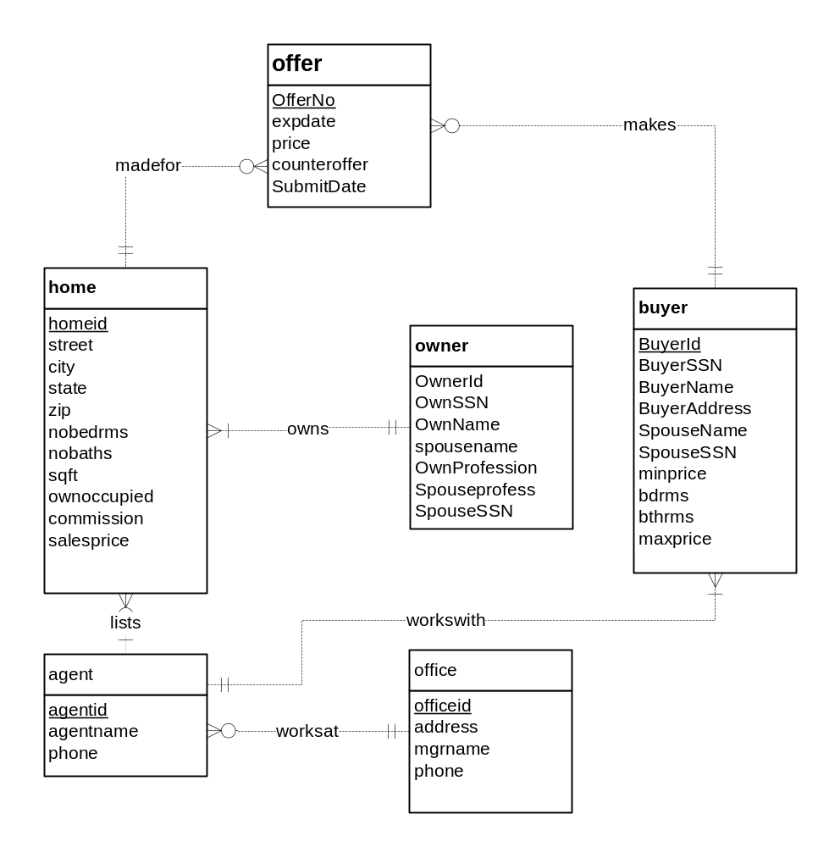

The madefor and makes relationships are 1-M because an offer involves a home and buyer. A buyer can submit multiple offers on the same home.

6.
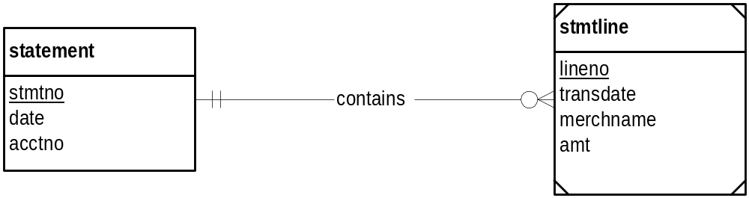

7.
