

**Faculty of Business & Communication Studies**

**Design and implementation of Legal Case Management Information System in small medium Law Firms in Kenya: A Case Study of Kariuki Muigua & Co Advocates**

**ANNE WAIRIMU KIRAMBA: BOBIT/NRB/3390/17**

**A Project Proposal Submitted for The Study Leading to A Project Report in Partial Fulfilment of the Requirement for The Award of a Bachelor of Business Information Technology of St. Paul's University**

**Supervisor: Mr. Pius Nyaanga Momanyi**

**November, 2019**

# DECLARATION

This research proposal is my original work and to the best of my knowledge, it has not been presented for any academic award in any other University.

............................................................... .........................................

**ANNE WAIRIMU KIRAMBA ……………………………. Date …………………………**

This project proposal has been submitted for examination with my approval as the university supervisor.

............................................................... .........................................

**Name………………….. Date…………………..**

Lecturer: **PIUS NYAANGA MOMANYI**

Department of Business and Information Technology

Faculty of Business and Communication

Nairobi Campus.

# DEDICATION

This proposal is dedicated to Dr. Kariuki Muigua, James Ndungu and to my beloved family. They have been a pillar in my academic life.

# 

# ACKNOWLEDGMENT

Special thanks to the Almighty God from whom all blessings flow!

This study would not have materialized without the succinct support of my supervisor, Mr. Pius Nyaanga Momanyi, I would like to express my deep appreciation and indebtedness. I would also like to thank my family, Senior management of Kariuki Muigua & Co Advocates for their unending financial and moral support as well as my colleagues for the positive insights, and the St. Paul’s University for creating an enabling learning environment.

# List of Figures

# ABSTRACT

The global legal industry is facing unprecedented change, which inevitably creates challenges for small medium sized law firms in Kenya. These global changes affect law firms' business and information environments {Evans, 2017 #15}. The proposal demonstrates that law firms’ operations have been considerably altered by the dynamics in the legal environment presented by the globalization of legal practice, advances in information communication technology, electronic publishing, competition amongst law firms and tech-savvy clients.

The proposal presents the findings of empirical research in respect to small medium law firms on three aspects: concentrating on the changes in the legal industry, the subsequent challenges to law firms and their responses. Their current system relies on paper document organization and as well as some electronic documentation in a simple file folder structure on a windows network file server.

While some legal actors will likely benefit from digitalization and expand their business, either by integrating new technologies to reach more clients or by developing new niche areas of practices, the more routinized forms of legal practice are facing serious challenges and will most likely be replaced by technology {Caserta, 2019 #12}.

Thus, the basis of this proposal is to unearth the technology gap in the small medium law firms in Kenya. The focus being on the implementation of a legal case management information system, which is a fully operational and integrated system that incorporates case tracking and pronounced billing system, a document management system, customer data in small medium law firms.

Business analysis assessment for solutions to small medium law firm’s problems and process improvement establishes the need for a cost-effective automated business support and manage daily business processes, automate document creation and filing, track deadlines and tasks, and

comply with new document retention and discovery requirements. In place there will be a well-designed legal Case Management System that supports the medium sized law firms in addressing these problems and aids in the effective performance of their different processes.

# List of Acronyms

CMS – Case Management System

IT - Information Technology

LMS – Legal Management System

# LIST OF FIGURES

Figure 1: ERD Diagram 16

Figure 2: Use Case 17

Figure 3 Sequence 18

**Table of Contents**

Abstract 1

List of Acronyms 1

CHAPTER ONE: INTRODUCTION 2

1. Introduction 2

1.1 Background to the Study 4

1.2 Problem Statement 5

1.3. Objective 6

1.3.1 General Objective 6

1.3.2 Specific Objectives 6

1.4 Scope 7

1.5 Significance of the study 7

CHAPTER TWO: LITERATURE REVIEW 8

2. Literature Review 8

CHAPTER THREE: METHODOLOGY 11

3.0 Introduction 11

3.1.1 Requirements Specification 11

3.1.2 Feasibility study 11

3.2 legal case management system design methodology 11

3.2.1 Database components 11

3.3 Software Requirements 11

3.3.1 Functional requirements 12

3.7 Design and analysis 16

16

3.7.1 Entity relationship diagram 16

3.7.2 Use Case Diagram 16

CHAPTER FOUR: CONCLUSION 20

References 21

# CHAPTER ONE: INTRODUCTION

# Introduction

The technology innovations have grasped firmly, changing virtually all industries, profoundly changing the way business operate, and the legal industry is no exception. Like their counter part who run large partnership law firms, the small medium law firms have to adapt in order to thrive in this new paradigm and maintain a competitive edge. In today's rapidly changing business marketplace, clients are becoming increasingly sophisticated about the procurement of legal services. {Mishra, 2011 #20}. The medium Law firms are still associated with piles of hard copy files with loose papers flying all over the office, file bring ups and notifications effected manually on a big office diary. The same office diary is replicated for use by other paralegal staffs to access the same information. Acquiring and leveraging information effectively in law firms through knowledge management can result in competitive advantage; yet the adoption of this approach remains in its infancy {Fombad, 2009 #2}.

The small medium law firms have web site, use e-mail, word processing, spreadsheet, groupware and presentation software. However, internet-based services such legal case management system are emerging and becoming dominant among large law firms. Notably, the Judiciary is also repositioning itself within the context of the Constitution of Kenya 2010, in order to implement a system to enhance the processes and e-filling.

The manner in which the medium law firm conduct business processes does not reflect their competitive strategy or the way they deliver value for the law firm customers, how that value improves on their business strategy. The medium law firms struggle in putting in place suitable metrics to assess the effectiveness of their business processes and service delivery.

In the advent of digital era the organizational information asset has transitioned into a crucial input. The rise of digital capitalism is transforming the dynamics of the legal field by the introduction of new actors and ways of practicing law, which might challenge the traditional control (and monopoly) of jurists on the production of law (Caserta and Madsen 2019). Notably, the business corporate fraternity has undeniably outshined the medium law firms in Kenya in embracing the technology.

We don't not only have new service providers venturing in the legal market, but also new online tools solving legal disputes or producing legal documents (Ribstein 2010). Equally, there is also the presence of intelligent search systems challenging the role of legal demographics. Evidently small law firm’s survival in the new paradigm, is pegged on use of the legal technologies to maintain effectiveness and deliver value to the client through a well pronounced information resource management system.

The defining factor in the emergence of seamless case management in medium law firms, is the growth in information asset management, improvements in the methods and tools for capturing and preserving information. This is a growing tendency and is compounded by the fast-developing nature of information technology, which stresses the need for sound legal information and knowledge management practices (Fombad, Boon et al. 2009). Small Law firms are also information-intensive, the competitive advantage of which is built on. The legal case management functionality is important, particularly in the fast changing E-business environment (Lee and Hawkins 2005).

Client management involves practices, strategies, technologies that law firm can use to manage and analyze client interactions and data throughout the customer lifecycle, improve business relationships with clients and drive growth {Dyer, 2006 #17}. This counters the emerging trend towards seeking self-help on legal issues from online legal resources. There is a need, not only understand the clients' legal needs but to also understand their businesses.

The case management improves business processes and operations in a law firm by ensuring the staffs are more efficient, safeguarding resources and institutional knowledge, provision of productivity metrics, acquisition and retention of new clients and gain a competitive edge on quality customer service(Owoeye 2011). The resolve to building the case management system that captures the client data and information is to run recurrent daily activity and have in place all-inclusive database that promotes legal practice in the law firm. The system is capable of reviewing and categorizing large bodies of documents, thereby allowing lawyers to retrieve information in the blink of an eye(Caserta and Madsen 2019).

## Background to the Study

The numerous challenges faced the medium law firms in Kenya replicate those faced by other small business enterprise such as globalization, customers, competition, regulatory changes, advances in information technology. There is assumption that law firms remain a profession and not a business, but it’s clear that law firm is actually a business of providing legal services and success lies in the effort to act as real entrepreneurs along being the learned friends. However, lawyers do not embrace ICT that is significant in benchmarking the law firm against the competition (Moppett 2012).

The small Law firms in Kenya undermine drawing upon marketing, business development, market insights that come from business intelligence, business analytics and metrics to retain and grow business with existing clients more effectively while attracting new ones(Olatokun and Nneamaka 2013).

The digital economy has disrupted law firms, wreaked havoc on defined business processes. The legal fraternity is ambushed by new tech concepts. The small law firms have not been concerned with client retention. The Internet of all things has overturned their long-held perception of how lawyers view information resource. The disruption occasioned by new business models and the changing tides in the business environment has posed a real challenge as law firms seek to embrace e-business methodologies and gain a competitive edge.

Despite the importance of information and knowledge to law firms, typically they do not demonstrate an awareness of, or interest in data, information and knowledge management and therefore do not address the fundamental barriers to good information asset management (Evans and Price 2017). Medium law firms are facing the wave and are being swept by the tides of Internet-enabled and are resulting in mergers. Digital can be harnessed for commercial advantage in legal services through a case management system that can differentiate their legal practice, strategy, and leadership (Hyde 2004).

## 1.2 Problem Statement

Legal case management system is seen to have manifested and distributed into various big law firms in Kenya and partnership managed law firms. In this respect, hence this proposal sought to address LCMS as it relates to small medium law firms in Kenya. This is in respect of the fact that most lawyers in the small law firms in Kenya may still not fully understand the concept of legal case management system.

The various small medium law firms in Kenya, embrace traditional practices confined in Paper-based system. The small size law firm haven't transitioned from hard copy to electronic copies of documents. However, the legal profession is faced with a proliferation of information which is proved to be an administrative burden to lawyers in retrieval and retention. Law firms are marred with duplication of workflows by several lawyers and paralegal staff resulting in redundancy.

Additionally, the study chooses law firms because not much has been done particularly with regards to information system within the legal fraternity. In fact, there is very little information small law firms in Kenya. Though large law firms may be perceived as rational users of legal case management systems, it is critical for both large law firms and small law firms to implement LCMS, as an essential survival weapon in dynamic competitive business world. This study therefore sought to examine strategies for LCMS among small law firms in Kenya.

# 1.3. Objective

## 1.3.1 General Objective

To expedite, organize, communicate, client's collaboration, offer additional services that attain efficiency and value proposition to clients through productivity.

## 1.3.2 Specific Objectives

1. The software will allow information to be entered by users, control information in the system and tracking of current case status to enhance public access and law court process.
2. The system will enable the user examine through a business process analysis, the type of records created/generated and or received, their importance and how they are managed at the law firm.
3. Establish the professional knowledge and skills of staff responsible for managing court records.
4. Find out what constitutes administration of justice and relationship between the management of court records and representing the clients.
5. Assess the application of information communication technologies in court process.
6. Identify challenges facing the management of court records and suggest solution and propose a records management best practice for management of court records for effective administration of justice.
7. The system will have “Event” and “Scheduling” that will determine new case arrivals, session, appointments, case deadline, reservation of courtroom and the judge who will head the case.

# 1.4 Scope

The researcher has interacted with the legal department of Kariuki Muigua & Co Advocates as the case study. The emphasis being the Case Management system and enhancing client relationships through technology platforms to thrive, continue to attract, retain new clients and have an edge in the legal market.

# 1.5 Significance of the study

Legal case management software delivers an effective process of following, managing and tracking leads. There is the provision of effective calendar management for clients' follow up. This software allows the users to access the information wherever they are either through the phone, tablet and personal computers. The software also supports unlimited users as different law firms have a varied number of employees and clients.

1. Case management software will help law firms manage all the files digitally while capturing all important data in one place enhancing collaboration.
2. Case management will broaden access to information including judicial decisions, communication with colleagues and clients, and litigation support services.
3. Core to business processes, the system will improve efficiency, increased accessibility, easy retrieval of the same records and eliminate the need for large storage facilities as opposed to going through voluminous textbooks and law reports. The system will offer seamless improved efficiency and provide better client service.

# CHAPTER TWO: LITERATURE REVIEW

# Literature Review

A literature review was performed to review the current state of technology within the field of legal case management and document management systems utilized in law firms. The review further looks into the potential advantages and disadvantages, integration requirements, and quality assurance. It is generally observed that legal practitioners have been quite slow in embracing ICTs for legal practice compared to other profession such as banking and journalism (Coker 2014). law firms continue to face enormous costs associated with the discovery process, requiring the creation and retention of documents which may later be requested for review under a court of law (Fujitani and Kunisaki 2007). However, most small size law firms are still hesitant on embracing ICT and are confined in paper-based systems that generate large volumes of hard copy papers, which are tedious to retain and retrieve.

Several studies depict that innovations in technologies are gradually altering the methods that lawyers use to access, retrieve and process information to solve legal problems and deliver legal services to clients. The internet, as well as legal technology, and legal self-help books continue to slowly but surely take the place of lawyers given that they are now able to offer numerous solutions to most clients’ needs(Wambua 2014). Creating a truly paperless firm is far into the future, but current law case management systems are capable of streamlining workflow processes, integrating with standard and popular business applications, and dramatically lowering discovery costs (Hughes 2007). Document management systems reduce costs by eliminating labor costs creating and manually maintaining documents by taking existing electronic document content and turning it into a new electronic document quickly and efficiently while maintaining version control (Doherty, 2004).

It has now become very obvious in the legal industry that advance in information communication technologies is dramatically transforming the various activities conducted by lawyers, especially with regards to processing knowledge and delivering legal services to clients(Moppett 2012).

Information resource management systems were initially developed to work in conjunction with the life cycle of a document and this system has changed very little since its conception (Shukla 2004). The life cycle begins with the capture and creation of the document from paper to an electronic version, stored, and indexed for retrieval which requires document control and quality assurance (McFadden, 2007). Some improvements have been made such as integrating document management systems with other systems including e-mail and reporting tools, imaging workflow tools, archiving, and web interface tools making it more flexible and robust to meet new business needs. (O’Meara, 2000).

Document management systems deliver a broad solution for managing the creation, capture, indexing, storage, retrieval, and disposition of records and information assets for the clients, thus reducing operational cost. Information asset management ensures that enterprise data, information, content and knowledge are treated as assets in the true sense of the word, and avoids increased risk and cost due to misuse of information assets, poor handling or exposure to regulatory scrutiny (Staudt and Lauritsen 2013).

Additionally, legal fraternity bear costs related to the discovery process, requiring the creation and retention of documents which may later be requested for review {Kabene, 2006 #21}. In electronic format, the document can be used to deliver both a digital representation of the original document and can be queried to build a knowledge database based on the contents of the documents, requiring accurate optical character recognition and quality assurance processes (Khandelwal and Gottschalk 2003). Case management supports collaboration whereby people from across the organization can collect information that could be of benefit to others(Byström, Ruthven et al. 2017).

Given the persistent need from clients for increased efficiency, predictability and cost effectiveness in the services they purchase from law firms, the dynamics of supply and demand have undergone profound long-term changes, indicating that the legal profession now lives in a buyers’ market(Li 2018). It is clear that the prevailing methods of practicing law are being altered by the defined advances, it is more difficult to gauge how the very process of law itself is being impacted. A final challenge that is harder to depict is the transformative impact of new dispute resolution tech on the ways that the processes of solving conflicts are conducted. In other words, as computerized models are increasingly making inroads, they are likely to transform not only the participants in the processes but also the processes themselves (Caserta and Madsen 2019).

There has been immense interest and research in the area of legal case management system as means for supporting lawyers in their legal practice. legal case management system has been in place to assist lawyers in the way they manage information resource and the clients. Equally, existing literature reveals that focus has not had impact on small size law firms in Kenya. If small size law firms are to benefit from LCMS, thus a tool for ascertaining the benefits is significant such as case tracking and diverse billing options for the size law firms so that they can appreciate and embrace the information system. The core of this study is the application of ICT which is an input that could enhance work productivity of the small law firms in Kenya.

The proposal will be relevant as it emphasis that small size law firms need to move from creating and managing internal documents to creating value for the client. Shifting beyond the provision of legal services, to supporting and integrating law firms to cope with information overload, which help lawyers do more with less.

This proposal seeks to close the gap the costs and redundant business processes owing to the current physical record keeping processes and emphasized the need for strong document control and security approaches. This proposal presents a reliable online platform where client interact with legal lawyers, the small law firms will capitalize on intellectual assets, to continuously remodel legal practice management, empower lawyers, increase productivity, transfer skills and knowledge from senior to junior professionals and improve service delivery which can gain competitive advantage.

The CMS will thus redeem time for the lawyers, the paralegal staff and the client. The software will store data; crucial information will be encrypted using cryptography and on a cloud-based software. The software selection process should be carefully chosen based on current technology standards as well as interoperability with current business processes and stability of the vendor.

# CHAPTER THREE: METHODOLOGY

# 3.0 Introduction

This chapter discusses the methodology used in this study. It specifically examined the research methods including the research design, the study setting, population and sampling procedures and data collection instruments. The chapter discusses techniques for data analysis and presentation, and ethical consideration related to the study

The model used for this project is the Waterfall model of software development. This model follows a sequential order which ensures that a phase is completed before another phase begins. The stages of the waterfall model adopted by this project include; 1. Requirements analysis: this phase entails gathering of requirements from users of the system. The requirements are collected in a requirements specification document.

The project entails law procedures, technical words, data and the researcher relied on interviews with lawyers at Kariuki Muigua & Co Advocates.

## 3.1.1 Requirements Specification

Research was conducted by analyzing legal articles and journals that relates to legal case management systems, obtained peer recommendations from lawyers and from peers in private law firms and an Internet search. A comprehensive analysis of gathered documentation was accomplished by ascertaining benefits and possible problems with the implementation of a legal case management system. The research and review was necessary to ensure that the critical requirements concluded by the business analysis were realistic and possible.

The legal case management system will be designed according to the needs of Kariuki Muigua & Co. The requirements and specification stage is about collecting all essential information about on the features required. The features are articulated clearly by the lawyers, paralegal staffs and their clients interviewed in addition to documents used by the lawyers which also contained information about other entities related to their field. The legal case management system will enable the lawyer to:

1. Manage clients.
2. Organize clients’ documents.
3. Have clear dates and time required to meet clients and appear in courts.

## 3.1.2 Feasibility study

Throughout the feasibility study a number of methods and possibilities were conversed. The client did not seem to have any constrains on the technology or software engineering approaches to be used, hence am left with a number of choice of possibilities to choose from. In circumstances the researcher will embark on direct connection between the database and the application.

# 3.2 legal case management system design methodology

## 3.2.1 Database components

The legal case management system database component serves as a data bank which the system will used to store large volume of data that are crucial to user of the system. The main function of the database component will be drowned from data obtained in the field. The database will be designed using MySQL.

# 3.3 Software Requirements

## 3.3.1 Functional requirements

1. Administration login - the administrator should be able to login into the system, register clients, delete clients’ information from the system, upload clients’ legal documents, download clients’ information and generate reports.
2. Authentication - the system should only allow the user and administration with the privileged to gain access to the system.
3. Audit tracking - managing all information related to the legal case management system such as the number of cases and clients. Thus, if a malfunction is detected in a legal case management system after analyzing the status information, an administrator is sent to check the problem.
4. Historical data - is a functional requirement of the system where the system will be able to store recent data and able to remembered it when the system user or administrator is using a system and when the user ask for the last data entered it should be able to display and also by providing them with a hint data or when the system administrator enters the username the system should remember his/her passwords.
5. Report requirement – the system should produce report automatically by itself, example providing
6. Certificate requirement – the system should produce or enter the details of ownership of the system example system’s product key should be entered by the user and also should allow the user validate the system using valid e-mail address and information used on acquiring the system.

## 3.3.2 Non-functional requirements of the legal case management system

1. Availability - is a non- functional of the system by ensuring that the system functions all the time when and not needed to ensure that the data stored in the system is ready all the time.
2. Security - is also a non- functional requirement that the system should not dispose the users and manufacture’s information to some authorized personnel and should encrypt user’s passwords and usernames.
3. Support Multi User: Nowadays, every system work in an environment of multi users. As per requirement of system, the system is developed in multi user’s environment.
4. Usability - System should be easily learned by the user.
5. Maintainability - the system should be easily maintained at least once in a week.
6. Reliability - the system should be able to run and provide the desired results without crushing even when provided with wrong and huge inputs.
7. Recoverability – the system should be easily and able to recover to it state if it crushes and data should be able to be recovered.

# 3.4 Modules

Legal case management system will use the following modules

1. Administrator module – is a module of system where the super user uses it to make changes in the system example. Adding or deleting the system user and his main function is to administer the functioning of the system by updating, saving information and producing reports.
2. Registration module - Which triggers the start of the client and lawyer control process, this module is for initializing of the whole process.

This module controls the whole process of checking, defines the necessary information for the modules and makes the decision which and how many clients are on the waiting list and the cases that are ongoing.

1. Charges Management Module - This module deals with information regarding the charge process by the legal case management system and includes three components: a charge protocol to cooperate with an external charge interface, a charge policy component to determine the charge policy according to prepayment and deferred payment policies, and security management for encryption of the charge information.
2. Security module - This modules ensures that the lawyer data and clients information is protected and is only accessible by the authorized personnel
3. Log in module - Users of the system will key in information which will enable them to gain access into the system

# 3.5 System Design Methodology

The requirement specifications are studied in this phase and the system design is conducted. Analysis of existing system is also carried out in this phase; the limitations of the existing system are analysed and new system implemented.

Design tools used for this project include;

1. VSCode
2. Python Django
3. MySql
4. Apache HTTP Server

During the system analysis of the system the following tools will be used:

* Data Flow Diagrams (DFDs)
* Structured English.
* Data Dictionary
* Flow charts

# 3.6 Design and analysis

## 3.6.1 Entity relationship diagram

The Entity Relationship diagram for the proposed system is shown in figure below. It shows the entities and the relationships that exist among these entities.

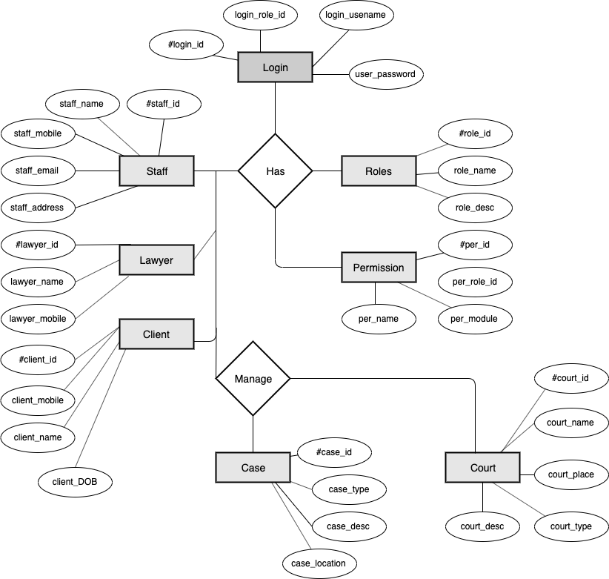

Figure 1: ERD Diagram

Legal Case Management System Entities and their attributes:

**Case Entity:**

Every case registered with the system has the information in this entity. Cases are the main concern of system.

**CaseID** – This is numeric 14 digits’ number which is unique to every case. CaseID is the primary key to case table in the database. Each case is uniquely identified using this id.

**CaseType** - There are several types of criminal and non-criminal case. Every case should be assigned to a type so that we can classify them into the group. Which would help us to manage the case efficiently?

**CaseLocation** – Each Case must be assigned the location in which the case will take place

**CaseDescription** - Case detail would periodically update. As the case goes on case details would also be updated.

## 3.6.2 Use Case Diagram

The use case diagram gives a description of the system major components and features and a demonstration of the functionality of the system. It comprises of the actors, system, use case, and relationships between them. The CRM has the lawyer as the main actor, who will have access and a number of activities are accessible to him and are represented as set in figure 2

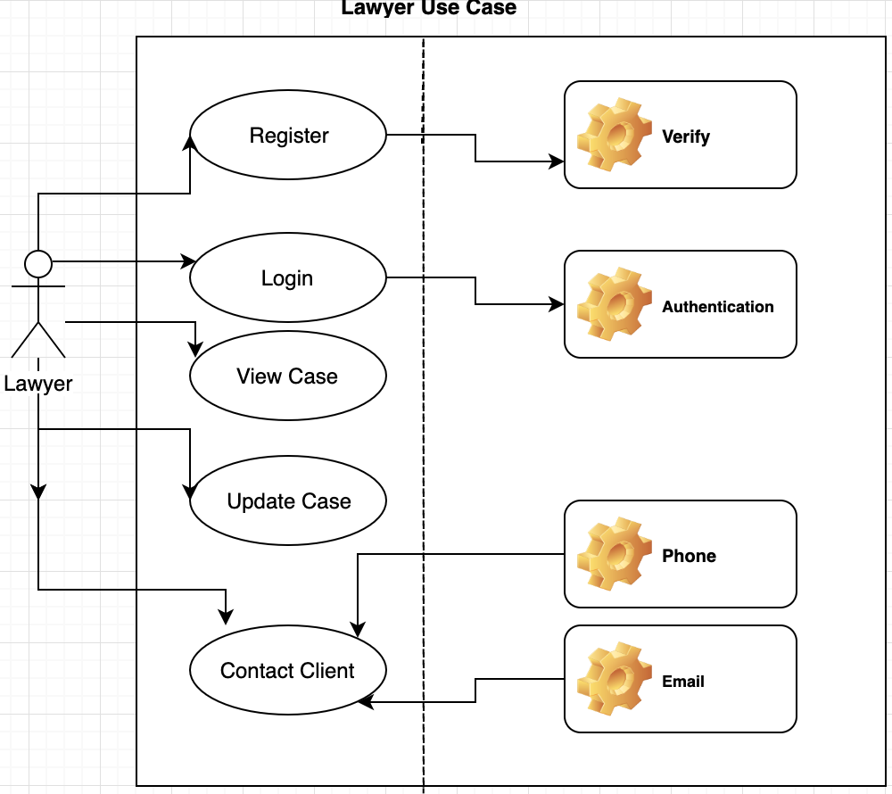

Figure 2: Lawyer (Level 3 User) Use Case

## Screenshot%202019-11-25%20at%2014.41.17.png

Fig 1 Client (Level 2 user) Use Case

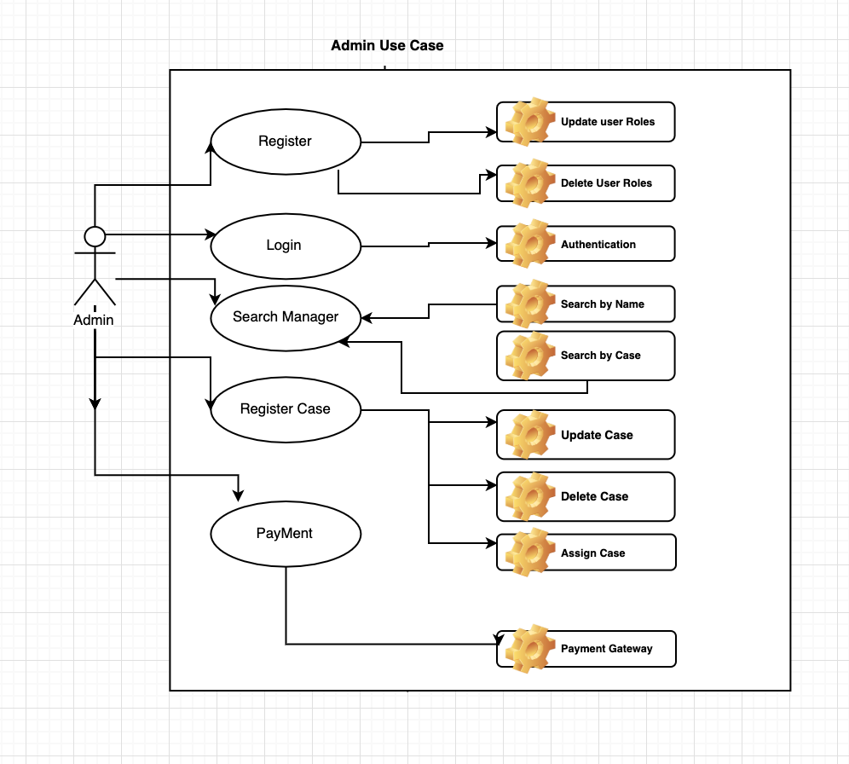Fig 3 Admin (level 1 user) Use Case

## 3.6.3 Sequence Diagram

Shows the sequence diagram of adding a new client information form, the lawyer will follow in order to achieve the add client information process.

Figure 3 Sequence

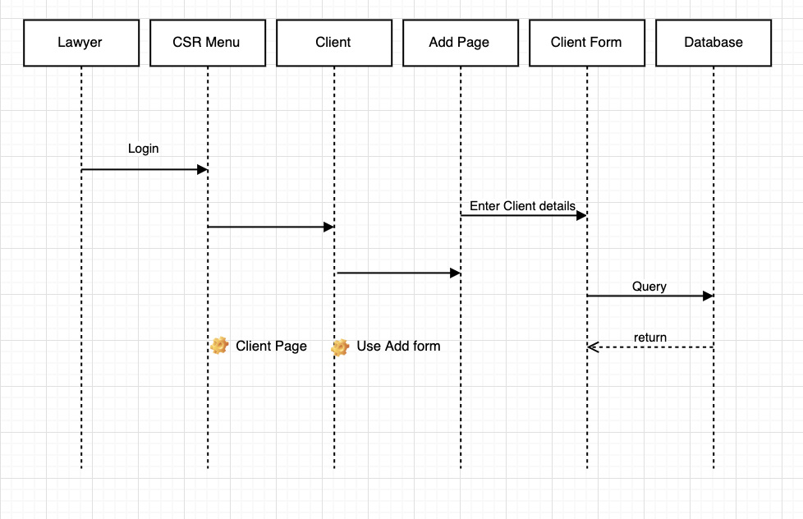

# 3.7 Data Design

Table 3.1 below shows the data used to implement the software, their data type, whether null data is allowed and the description of the data. A data dictionary defines the definitions and the use of the symbols used. It depicts data store and how data is accessed.

**Table Name Fields Data Type Allow Null Description**

1 Lawyer Lawyer ID Integer No Primary Key/stores the id as an auto Increment value

2 Name Varchar No

3 Email Varchar Yes

4 Mobile No Integer No

5 Address Varchar Yes

6 YOB Number No

7. Gender Varchar No

**Table Name Fields Data Type Allow Null Description**

1 Client Client Id Integer No Primary Key/stores the id as an auto Increment value

2 Name Varchar No

3 Email Varchar Yes

4 Mobile No Integer No

5 Address Varchar Yes

6 YOB Date No

7. Gender Varchar No

**Table Name Fields Data Type Allow Null Description**

1 Staff staff Id Integer No Primary Key/stores the id as an auto Increment value

2 Surname Varchar No

3 Other name Varchar No

4 Email Varchar Yes

5 Mobile No Integer No

6 Address Varchar Yes

7 YOB Date No

8. Gender Varchar No

9 Date of Date No

Employment

|  |  |
| --- | --- |
|  |  |

**Table Name Fields Data Type Allow Null Description**

1 Case Master Case Id Integer No Primary Key/stores the id as an auto Increment value

2 Case type Varchar No

3 Lawyerid Interger No Foreign Key

4 Case Status Varchar No

5 Court Name Varchar No

6 Bring up Varchar No

7. Last in court Date No

7. Next Hearing Date No

# CHAPTER FOUR: CONCLUSION

The advances in information communication technology, the Internet, electronic publishing and the shift from paper-based to electronic sources have altered how law firm relate with the client and poses a big challenge which can only be addressed through adoption of a LCMS.

The findings illustrate that major enhancement in law firms' business performance can be driven by overcoming barriers to information asset management such as effective tools that offer value proposition through improved business processes and being client centric. The law firm can attract and retain talented lawyers and clients. In scenarios where lawyers resign from the firm, the continuity of intellectual property is not affected. Lawyers will effortlessly share senior lawyers’ knowledge in the firm, achieve efficiency, improvement of quality of output, and improvement of the quality of the clients.

Thus, this proposal provides valuable insights towards understanding the implementation process, the various modules, sub modules, design and testing issues to provide quality services of legal case management information system. The system offers precise, concise information and the reports. A further revelation of the diverse ways by which information resource management can be managed in law firms in Kenya. It highlighted the aspects vital to the success, the tools and techniques for information management, perceived benefits.

# References

1. Byström, K., et al. (2017). "Work and information: which workplace models still work in modern digital workplaces?".

1. Caserta, S. and M. R. Madsen (2019). "The Legal Profession in the Era of Digital Capitalism: Disruption or New Dawn?" Laws **8**(1): 1.

1. Coker, C. A. (2014). "The use of Information and Communication Technologies (ICTs) among legal practitioners in Ibadan metropolis." Journal of Computer Sciences and Applications **2**(1): 1-5.

1. Du Plessis, T. (2008). "Competitive legal professionals' use of technology in legal practice and legal research." Potchefstroom Electronic Law Journal/Potchefstroomse Elektroniese Regsblad **11**(4): 32-60.

1. Dyer, R. F. and M. Liebrenz-Himes (2006). "Client attraction and retention in the design and building industry: client relationship management for professionals services firms." Society for Marketing Professional Services Foundation: final research report.

1. Evans, N. and J. Price (2017). "Managing information in law firms: changes and challenges." Information Research: An International Electronic Journal **22**(1): n1.

1. Faulconbridge, J. R., et al. (2007). "Global law firms: Globalization and organizational spaces of cross-border legal work." Nw. J. Int'l L. & Bus. **28**: 455.

1. Fombad, M. C., et al. (2009). "Strategies for knowledge management in law firms in Botswana." South African Journal of Information Management **11**(2): 1-16.

1. Fujitani, R. and E. Kunisaki (2007). "Litigation in the information age: taking discovery into the digital era to comply with new federal e-discovery requirements." Journal of Investment Compliance **8**(2): 26-34.

1. Hughes, P. D. (2007). "Analysis, Selection, and Implementation of a Case Management System for Local City Government Attorney's Office."

1. Lee, M. and S. Hawkins (2005). Web-based system and method for managing legal information, Google Patents.

1. Li, J. (2018). "The legal profession of China in a globalized world: innovations and new challenges." International Journal of the Legal Profession: 1-48.

1. Moppett, S. A. (2012). "Lawyering Outside the Box: Confronting the Creativity Crisis." S. Ill. ULJ **37**: 253.

1. Olatokun, W. M. and E. I. Nneamaka (2013). "Analysing lawyers' attitude towards knowledge sharing." South African Journal of Information Management **15**(1): 1-11.

1. Owoeye, J. (2011). "Information Communication Techonology (ICT) Use as a Predictor of Lawyers’ Productivity."

1. Ribstein, L. E. (2010). "The death of big law." Wis. L. Rev.: 749.

1. Shukla, R. (2004). "The case for electronic records management: physical storage of thousands of documents is becoming passe, and companies should consider enterprise records management systems to save labor costs and provide better security." Financial Executive **20**(7): 50-52.

1. Staudt, R. W. and M. Lauritsen (2013). "Justice, Lawyering and Legal Education in the Digital Age: Introduction." Chicago-Kent Law Review **88**: 687.

1. Wambua, M. K. (2014). Strategies for Knowledge Management In Law Firms In Kenya: A Case Study Of Law Firms In Nairobi County, United States International University-Africa.