

**Department of Computing**

**Software Projects**

**(55-407815-AF-20212)**

**Name: J. A. M. Ahmed**

**Student ID: 31051264**

**Degree Route: BEng SE**

**Table of Contents**

1. Reassessment 3

1.1 Use case Diagram 3

1.2 High-Level Design 4

1.3 Detailed-Design 5

1.4 Software and its presentation 5

1.4.1 The Production-Quality Software 5

1.4.2 Video Presentation 5

1.5 Transitioning a Prototype to Production-Quality Software 6

1.6 Test Specification 9

1.7 Unit and Accepting Testing 9

# Reassessment

Creating a Movie Database Manager. This program is simple. When the program is run there will be 1 user. The functionalities should consist of the lines of adding, editing and deleting movies. Each movie will have a name, synopsis, release date, genres and categories.

# Use case Diagram

Attempt 1

This use case diagram is bare. A database should be able to categorize movies, for example only showing certain genres or release dates.

Attempt 2

The single user has freedom to essentially make folders of anything. They will be able to create a favourites category, location category and more. Categories will be shown on the movie page. The delete movie function will be found on the edit movie function.

# High-Level Design

Model View Controller is shown above at a basic level. The model will store and manage the data, the controller will essentially be the manipulation of data and finally the view will be the GUI output. Using this architectural design removes unnecessary dependencies which reduces complexity.

# Detailed-Design

Movie database manager is quite simple. A movie can have zero or many actors, however an actor must have 1 or can have many movies.

# Software and its presentation

# The Production-Quality Software

Submitted as Zip.

# Video Presentation

Prototype.mp4

Production-Quality.mp4

Can be found in the source code zip file

# Transitioning a Prototype to Production-Quality Software

I made the form and laid it out exactly like my prototype.

Then I added some user functionality. Once an item in the list box is selected the movie information updates.

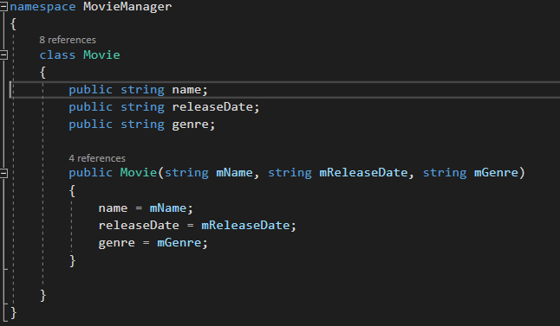

Here is I added variables to the data that has been received. Essentially data manipulation.

# Test Specification

|  |  |  |  |  |  |  |
| --- | --- | --- | --- | --- | --- | --- |
| **Test ID** | **Test Description** | **Test Scenario** | **Expected Result** | **Test Result** | **Remark** | **Programmer Response** |
| T-1 | Launch the software | User clicks exe file to launch the program |  |  |  |  |
| T-2 | Exit | User selects exit or close from the program |  |  |  |  |
| T-3 | Chose movie | User clicks on the desired movie |  |  |  |  |
| T-4 | Click ‘Add new movie’ button | User clicks on the ‘Add New Movie’ button |  |  |  |  |
| T-5 | Inputs new movie data | User enters the data and submits |  |  |  |  |

# Unit and Accepting Testing

|  |  |  |  |  |  |  |
| --- | --- | --- | --- | --- | --- | --- |
| **Test ID** | **Test Description** | **Test Scenario** | **Expected Result** | **Test Result** | **Remark** | **Programmer Response** |
| T-1 | Launch the software | User clicks exe file to launch the program | Opens the program | True | N/A |  |
| T-2 | Exit | User selects exit or close from the program | Closes/ exits program | True | N/A |  |
| T-3 | Chose movie | User clicks on the desired movie | Loads information | True | N/A |  |
| T-4 | Click ‘Add new movie’ button | User clicks on the ‘Add New Movie’ button | Opens the new movie window | True | N/A |  |
| T-5 | Inputs new movie data | User enters the data and submits | Add new movie to the list box | False | Don’t know why |  |