# Modifications to the database

## Branch

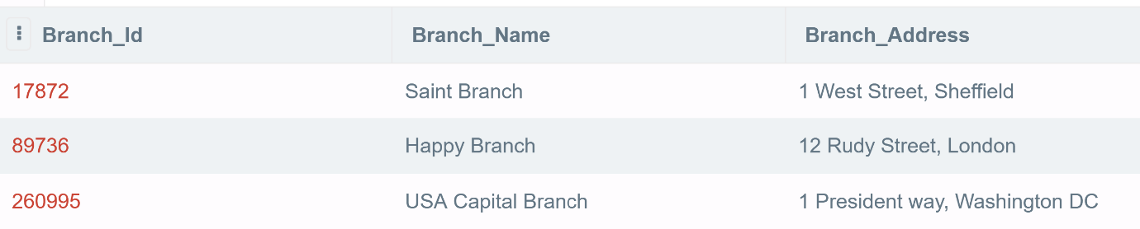

## Member

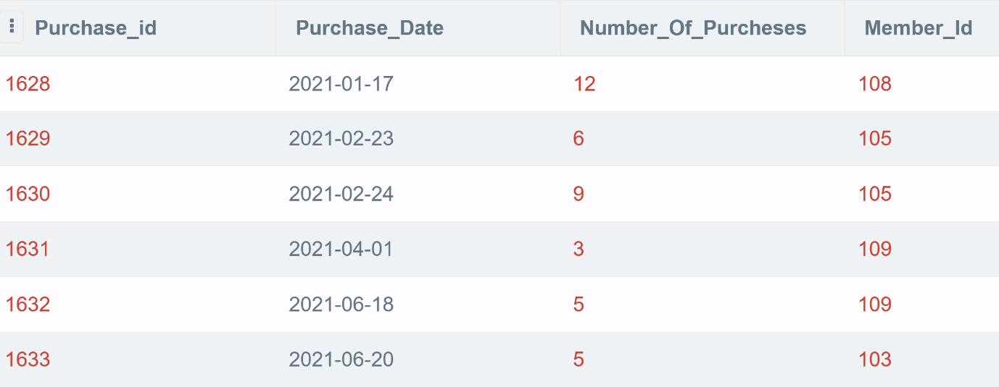

## Product

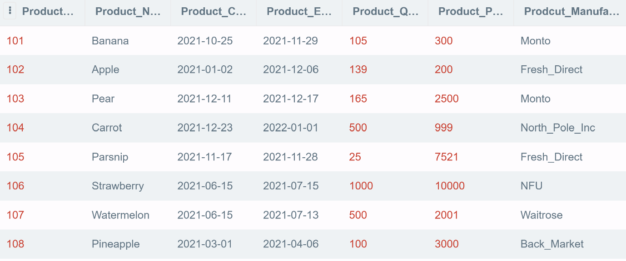

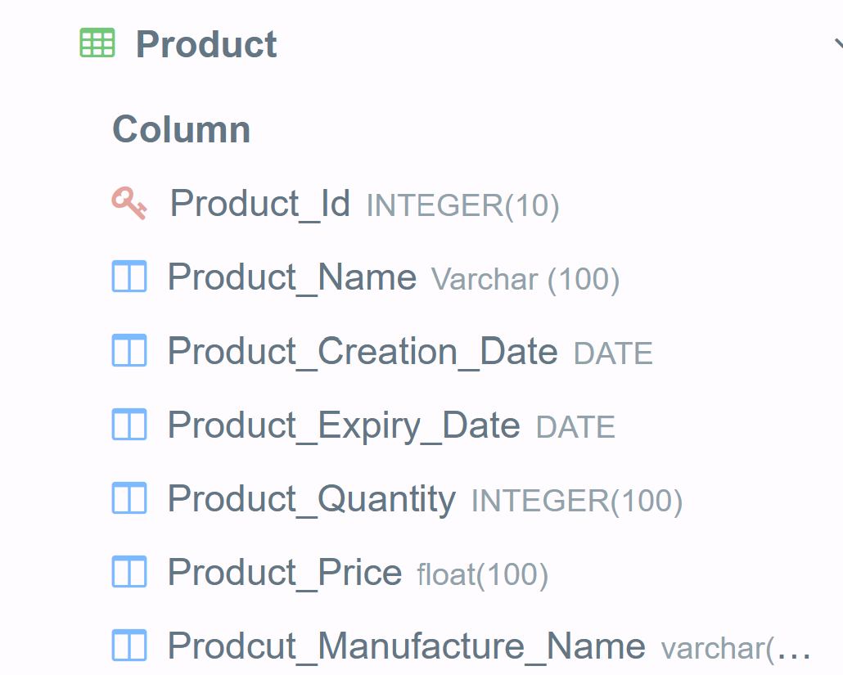

## Products_Purchased

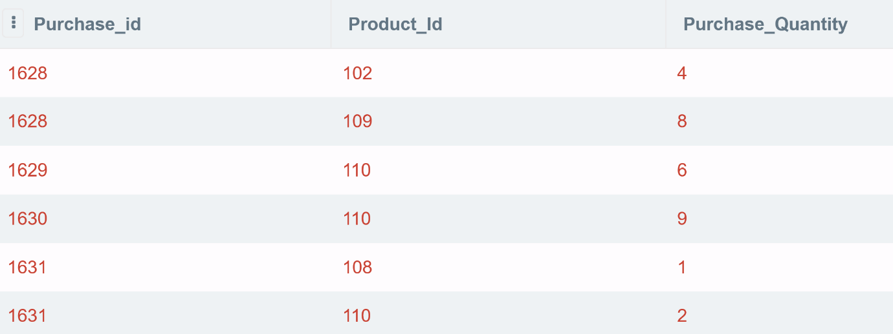

## Products_In_Branch

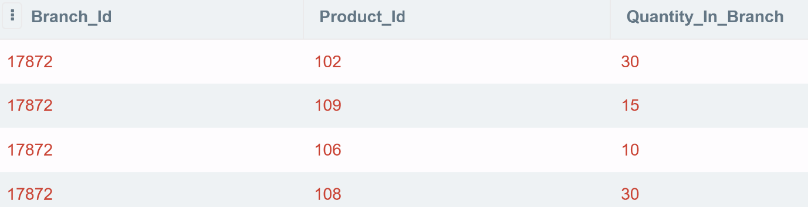

# Queries

## Query A

## Query B

## Query C

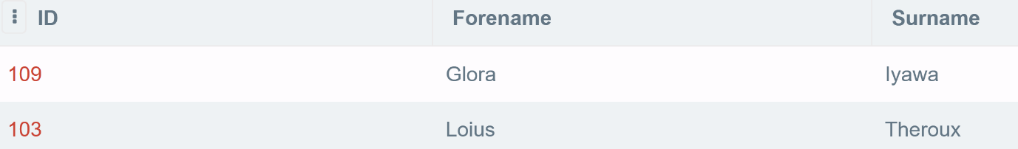

## Query D

