Documentation

## Installation Instructions:

### Python:

Install/update python to the latest version (3.9 as of the creation of this document):

<https://www.pythoncentral.io/how-to-update-python/>

Update/Install pip if required

### Other Python packages:

Navigate to the folder containing requirements.txt

In terminal use the command $ pip install -r requirements.txt

If that doesn’t work use the following method:

Using the “pip install package_name” format in terminal

Flask: pip install flask

DateTime: pip install DateTime

DateUtil: pip install python-dateutil

PyMongo: pip install pymongo

WTForms: pip install Flask-WTF

Passlib: pip install passlib

Functools: pip install functools

### MongoDB

**Install Mongodb:**

First, install MongoDB Community Edition:

<https://www.mongodb.com/docs/manual/administration/install-community/>

Under Available Downloads select:

Version: most current

Platform: your linux’s platform OS

Package: server

Open the file and follow download instructions:

<https://www.mongodb.com/docs/manual/installation/>

**Then install MongoDB Compass - a GUI used to set up the database:**

<https://www.mongodb.com/docs/compass/current/install/>

Using MongoDB Compass set up a new database named “dashboard”:

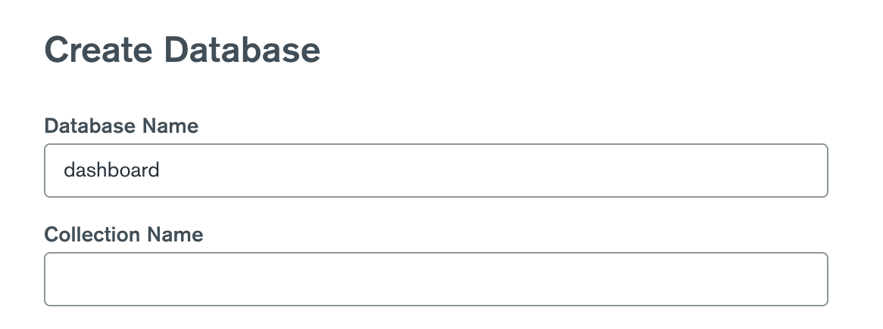

Then create two collections: “dashdata” and “users”

dashdata for the data and users for user registration and logging in

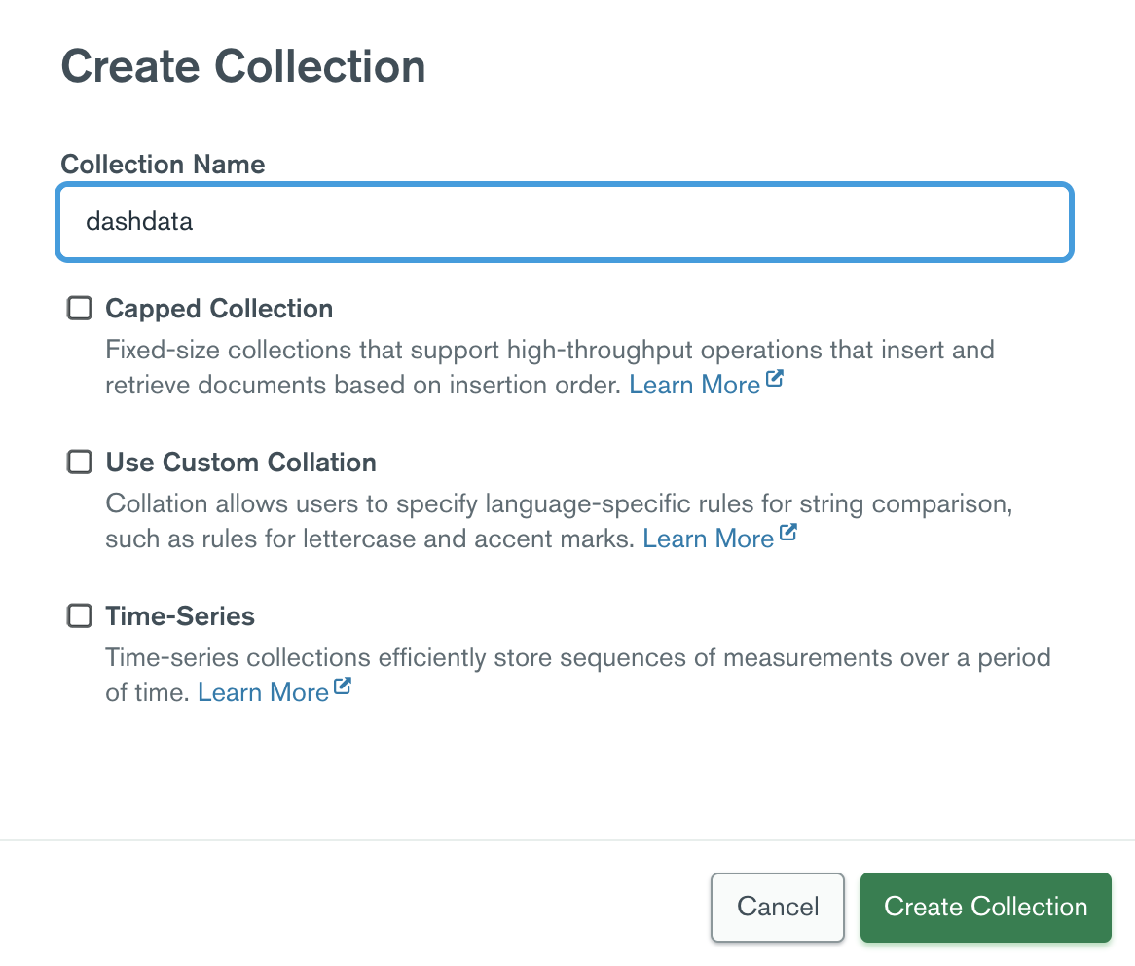

### Ngrok

Ngrok is a free service which allows users to access your localhost via a tunnel url.

Create an account at: <https://ngrok.com/>

Download ngrok and follow instructions at: <https://ngrok.com/download>

## Setup

### Flask webserver

Open a terminal and navigate to the root folder of the app, then run the command:

flask run

### Ngrok URL

Open a second terminal and run the command: ngrok http 5000

This will generate a url which tunnels to your localhost:5000

### The Things Network Webhook

Copy this url then create a webhook at The Things Network

Create a name for the webhook and use the url generated from the previous step in the Base URL field.

Check the uplink message checkbox and type /uplink so that the webhook will send the data there.

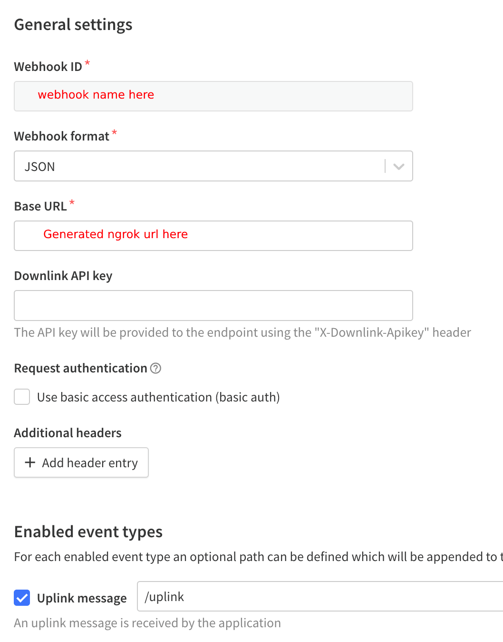

Now the dashboard app is set up to receive data from The Things Network.