Center Cloud Platform — Administrator & User Guide
This guide explains how to use the center cloud platform: the admin Web (platform operator) and the cloud-user Web (tenant who owns gateways), plus how to bind an embedded gateway so it appears online and can be managed remotely.
Screenshots in this document were taken from a live demo host. Use your own center host address and account credentials in production.
Role | URL | Login
Administrator | http://<center-host>:20001/login.html | Admin username and password
Cloud user | http://<center-host>:20000/ | Cloud username and password
Related install / ports reference: ../install.md.

1. Roles at a glance
Admin Web (:20001) Cloud-user Web (:20000) Embedded gateway
---------------- ----------------------- ----------------
Create cloud users ---> Log in as that user <--- agent@heclient
Open user portal port See Gateway List Server / Port /
Configure Device Port Remote Web / Terminal Account / vcode
Configure Proxy Port Port maps, firmware, settings Status: Connected
- The admin account is a platform operator (land@auth). It does not own gateways. It creates cloud users, enables the user portal, and configures center services (device connect port, proxy port, and so on).
- A cloud user (for example ashyelf) owns a set of gateways. Gateways register with that user’s username and Device Verify Code (vcode). The user then monitors devices and uses remote management from the user portal.
- An embedded gateway runs agent@heclient (and usually port-proxy client features) so it can stay connected to center over the network.

Part A — Administrator

A.1 What the admin account is for
Use the admin Web to:
- Create and maintain cloud-user accounts (username, password, device verify code, language, comment).
- Enable / configure the cloud-user Web (default TCP 20000).
- Configure Device Port (center@heport, default TCP 20002) so gateways can register for remote HE control.
- Configure Proxy Port (center@pport, default TCP 20005 plus mapped public ports) so remote Web / SSH / custom TCP maps work.
- Use host System / Debug / Development pages when operating the center machine itself (hostname, web server, logs, SDK notes). Those are host maintenance tools, not day-to-day tenant features.
Admin does not replace the cloud-user portal: after you create a user, that user logs in on port 20000 to manage their own devices.

A.2 Sign in to the admin Web
- Open the admin login page: http://<center-host>:20001/login.html.
- Enter the admin username and password.
- Click Sign In.
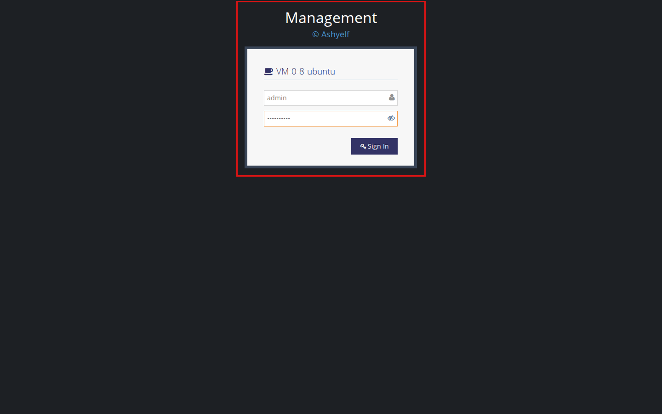
Admin login
After login you see the admin shell (sidebar menus Cloud, System, Debug, Development).
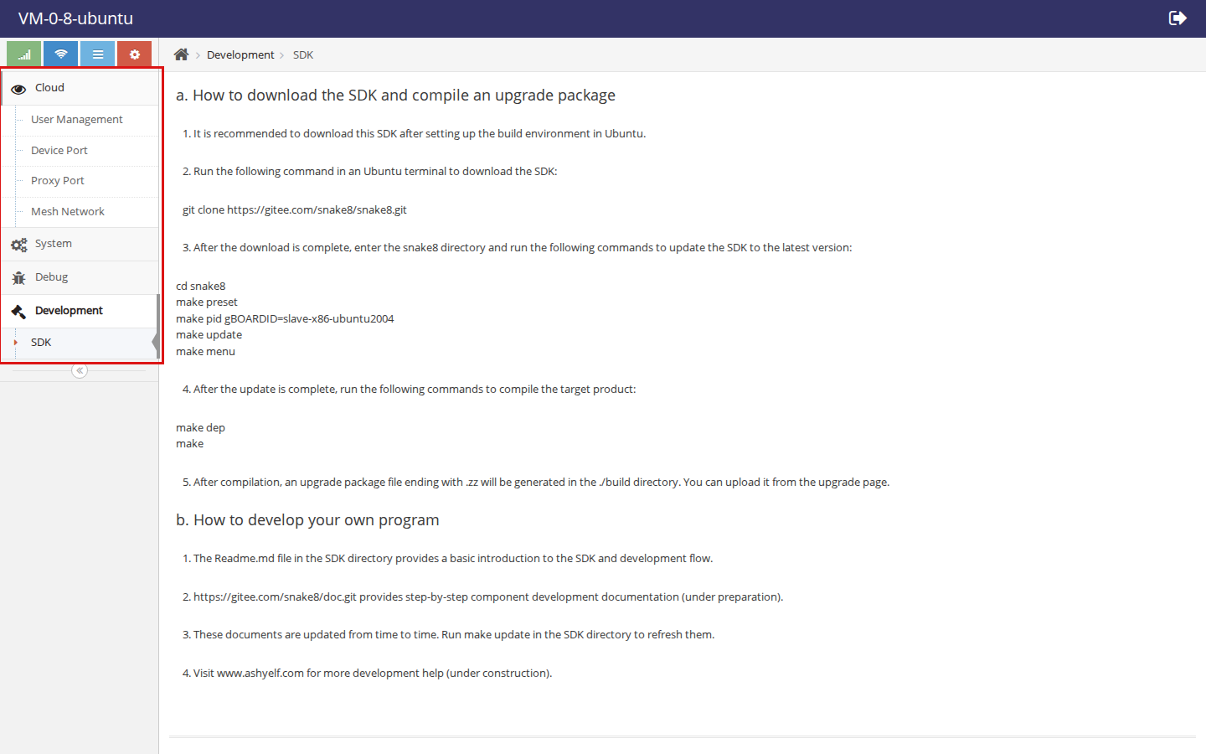
Admin Cloud menu

A.3 Create a cloud-user account (step by step)
Cloud users are managed on the User List page (table caption User Number). On some builds the Cloud menu entry is labeled User List; if that label is missing, open the center user account page that shows the User Number(N) grid (demo host serves /skinos/center/user.html).
- Open the user account table. Existing users appear as rows (demo: ashyelf, xyc, fm160).
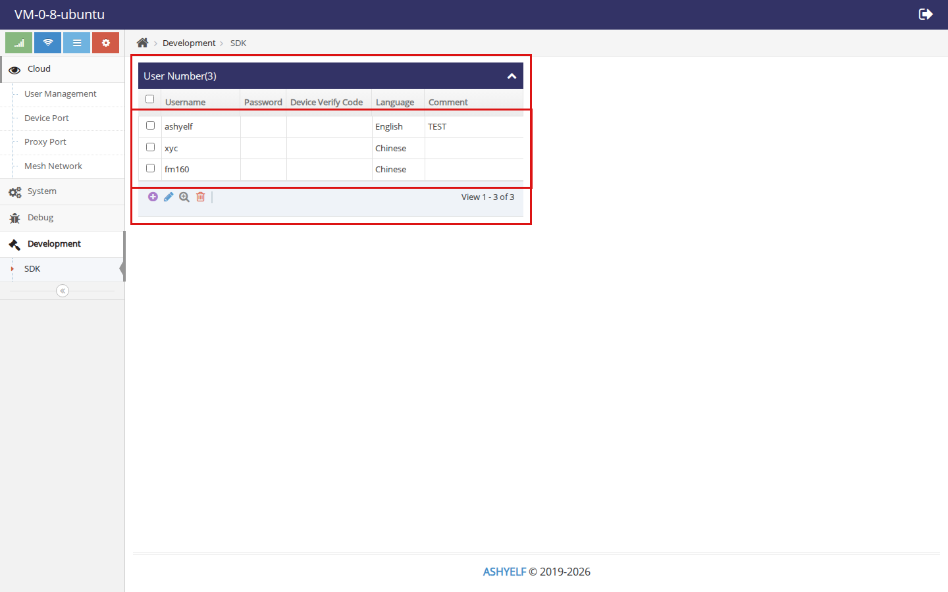
User list
- Click the purple + (Add) icon in the toolbar under the table.
- In Add Record, fill in:
Field | Meaning
Username | Cloud login name (A–Z, a–z, 0–9, _, -)
Password | Password for the user Web on port 20000
Device Verify Code | Shared secret the gateway must set as vcode
Language | UI language preference (Auto / Chinese / English)
Comment | Optional note
- Click Submit. The new user appears in the list.
- Use the pencil / search / trash icons to edit, view, or delete accounts. Changing password or vcode later must be reflected on each gateway’s Agent Control settings.
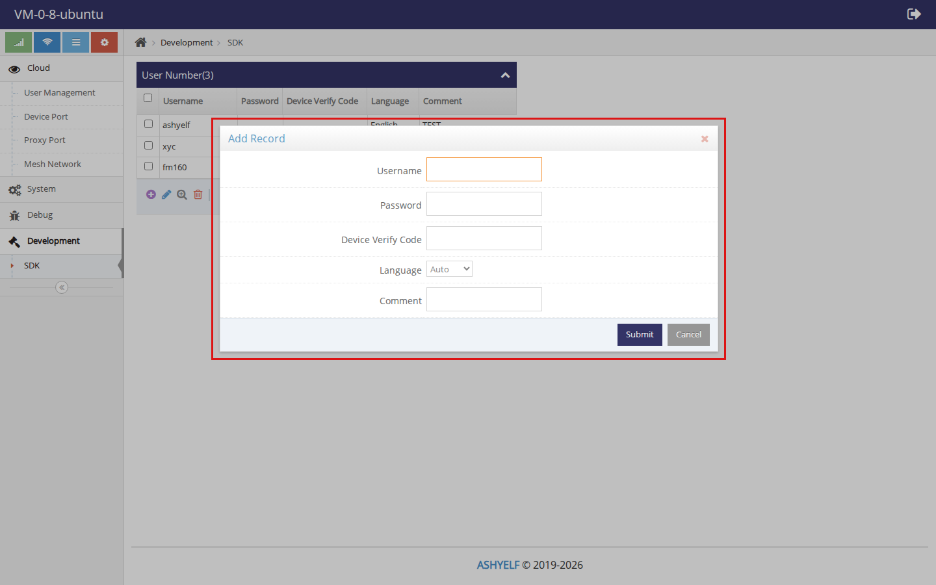
Add user dialog
Tip: give each tenant a unique Device Verify Code. Gateways that present the wrong username or vcode fail to go online (usererror / vcodeerror on the device). An empty vcode is allowed only if both sides leave it empty.

A.4 Cloud-user Web server (port 20000)
Cloud → User Management (User WEB Server) controls the tenant portal listener.
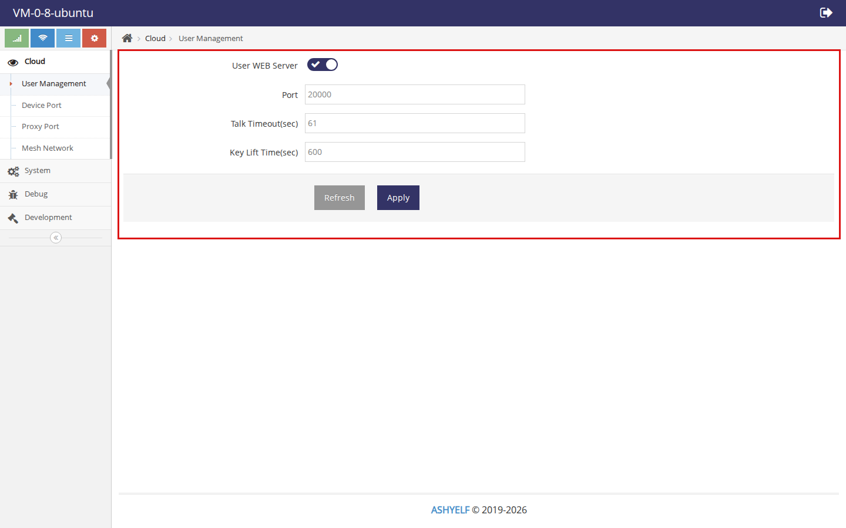
User WEB Server
Setting | Typical value | Notes
User WEB Server | ON | Must be enabled for tenants to log in
Port | 20000 | Cloud-user Web URL port
Talk Timeout / Key Lift Time | defaults | Session timing
Click Apply after changes.

A.5 Device Port (gateway registration)
Cloud → Device Port configures the HE server gateways connect to.
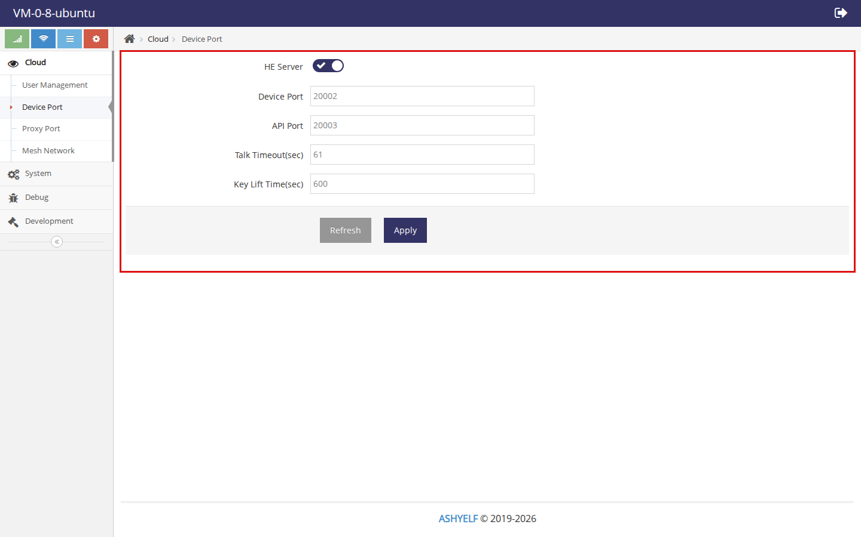
Device Port
Setting | Typical value | Notes
HE Server | ON | Accepts agent@heclient sessions
Device Port | 20002 | Value gateways put in Port
API Port | 20003 | Platform API control port
Gateways must reach the center host on this Device Port (TCP).

A.6 Proxy Port (remote access tunnels)
Cloud → Proxy Port enables port mapping used by remote Web / terminal / custom maps.
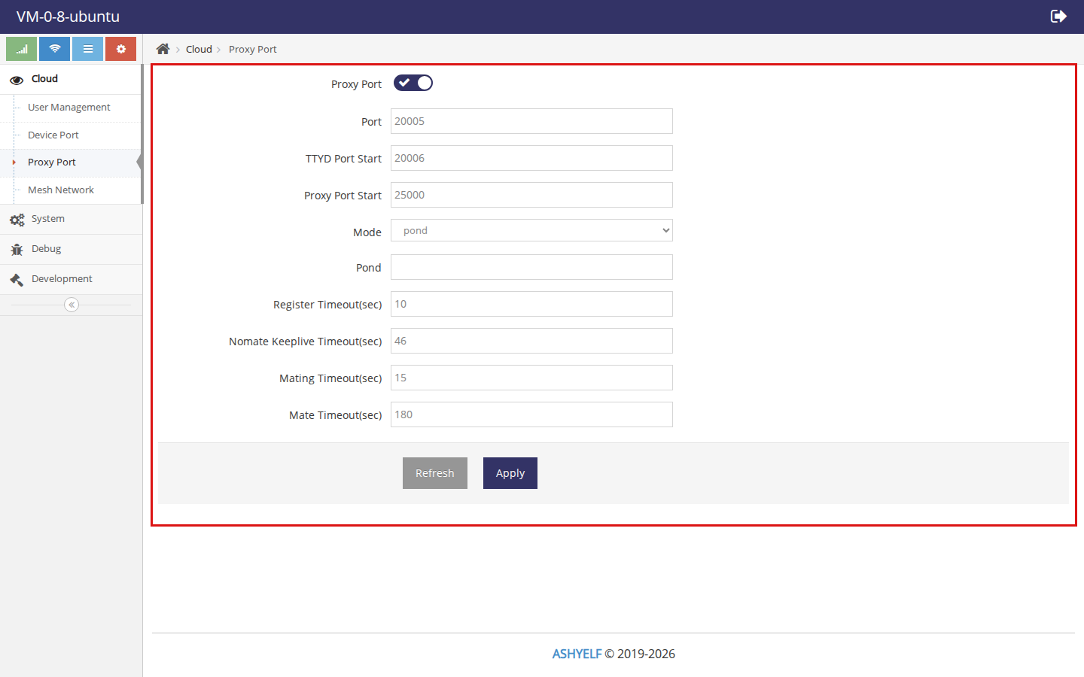
Proxy Port
Setting | Typical value | Notes
Proxy Port | ON | Control channel for maps
Port | 20005 | Gateway port-proxy client target
TTYD Port Start | 20006 | Start of dynamic terminal/Web map pool
Proxy Port Start | 25000 | Start of static map ports
Firewall / security groups should allow the published map range (see install.md §9.3). Without Proxy Port, devices may still show online, but remote Web/SSH maps will not work.

Part B — Cloud user & device binding

B.1 What the cloud-user account is for
A cloud user (demo: ashyelf):
- Logs into the user portal on port 20000.
- Sees only gateways bound to that account.
- Opens remote Web / terminal, reboots or disconnects devices, manages port maps, uploads firmware, and edits User Settings (password, language, device verify code).
It is not the admin account and not the local admin login on the gateway itself.

B.2 Sign in to the user portal
- Open the user portal: http://<center-host>:20000/.
- Enter the cloud username and password created by the admin.
- Click Sign In.
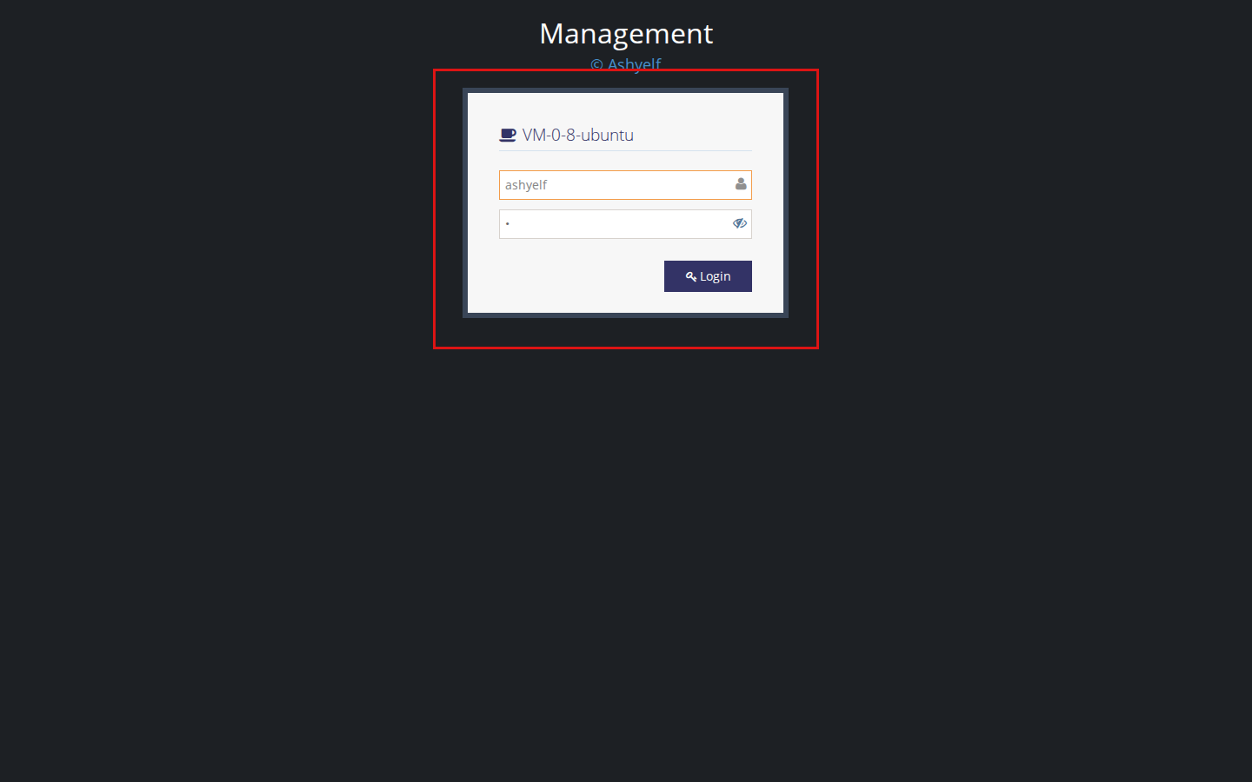
User login
After login the sidebar typically includes:
- Gateway List
- Port Proxy
- Firmware Upgrade
- User Settings
(Mesh Network may appear; it is outside the scope of this guide.)
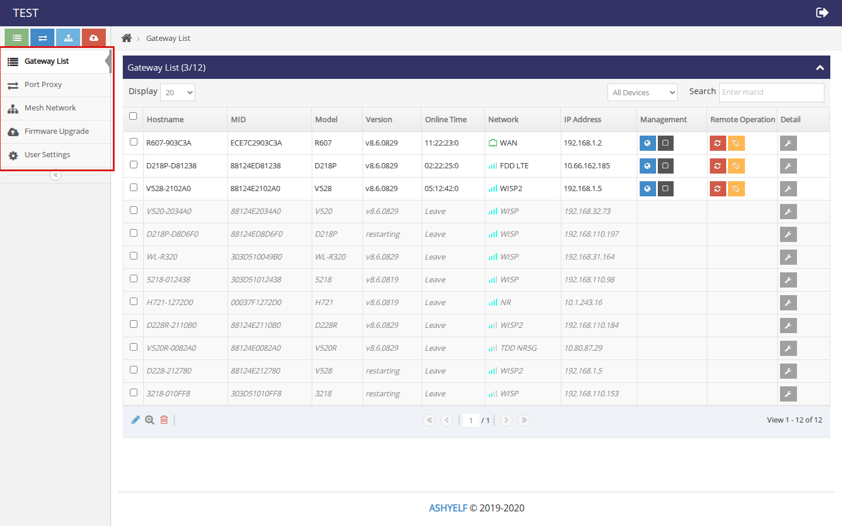
User home sidebar

B.3 Bind a gateway to the cloud account
Do this on the embedded gateway’s local Web UI (LAN address), not on the center admin page.
Demo gateway used for screenshots: device R607-903C3A on the LAN. Sign in with the gateway’s local Web credentials.

Step 1 — Log in to the gateway
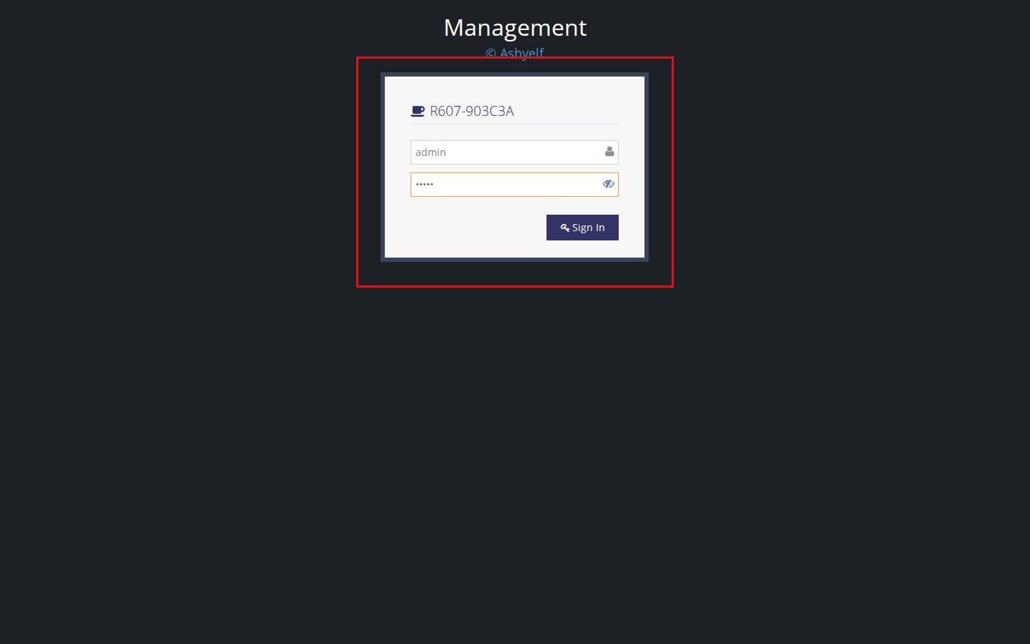
Device login

Step 2 — Open System → Agent Control
- Expand System in the sidebar.
- Click Agent Control.
- Open the Agent Control tab (next to Local Control / MQTT Control). That tab is the HE Client cloud connection form.
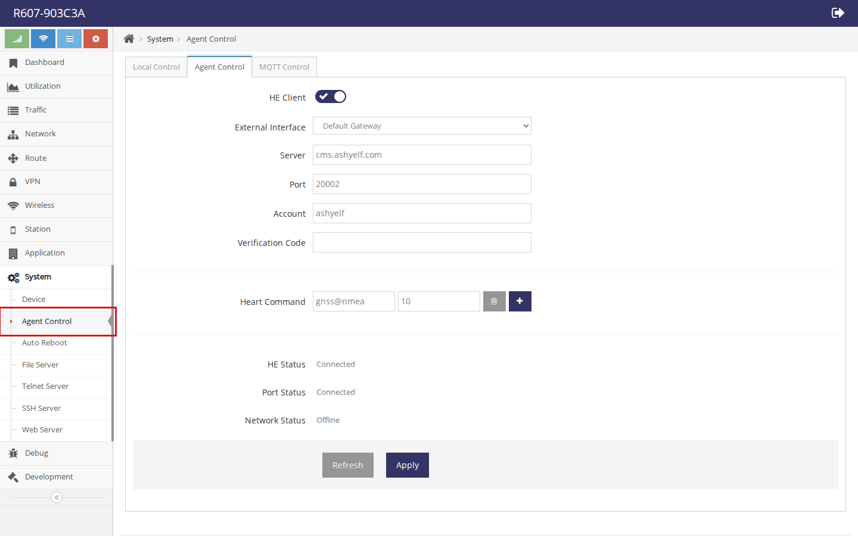
Agent Control page

Step 3 — Fill HE Client settings and Apply
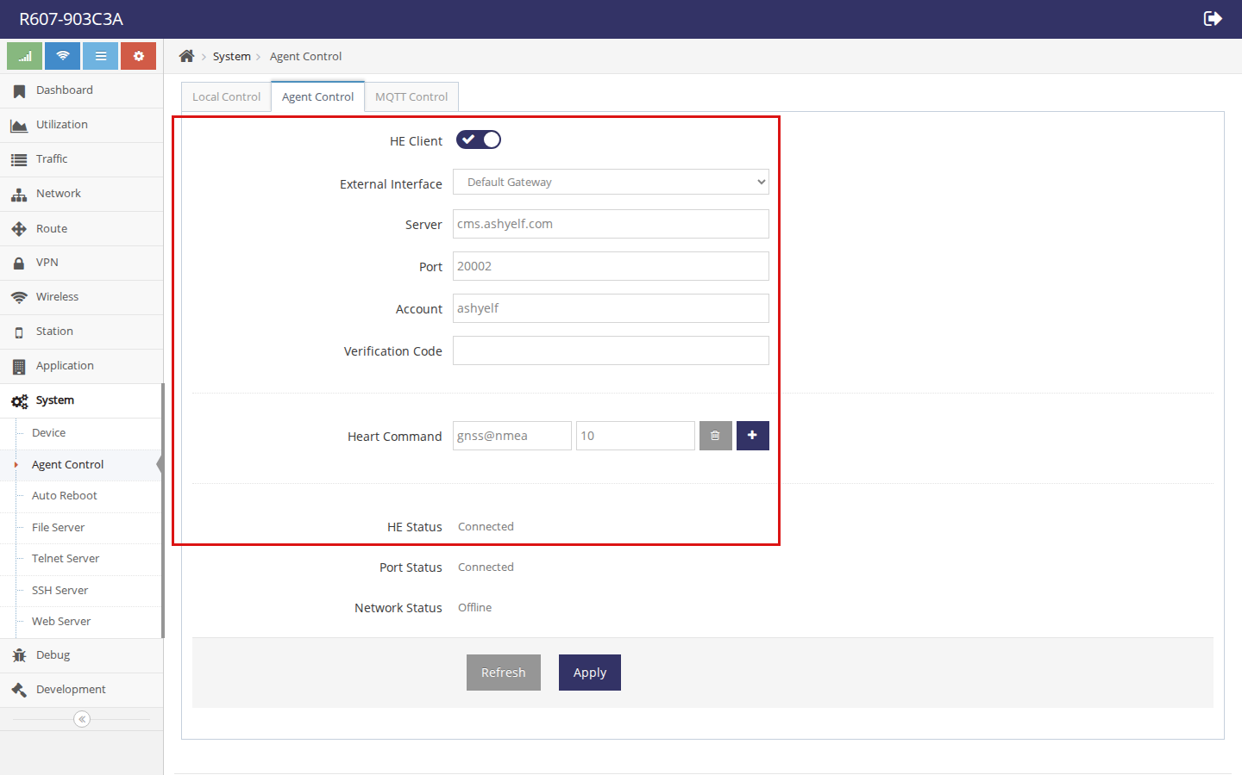
HE Client settings
Field | What to enter
HE Client | ON
External Interface | Usually Default Gateway (outbound path to center)
Server | Center host IP or hostname reachable from the gateway
Port | Device Port from admin, normally 20002
Account | Cloud username (same as the user portal login)
Verification Code | Same Device Verify Code as on center for that user
Click Apply.

Step 4 — Check status on the gateway
HE Status | Meaning
Connected / online | Registered to center
Connecting / uping | Still bringing the session up
usererror / vcodeerror | Fix Account / Verification Code, Apply again
Down / down | Client disabled or not running
Port Status should also become connected when port-proxy is enabled on both sides.

Step 5 — Confirm on the user portal
Log in as the cloud user → Gateway List. The device hostname / MID should appear; Online Time shows a duration when online, or Leave when offline.

Part C — Managing devices (cloud user)

C.1 Gateway List
Gateway List is the main fleet view. Caption Gateway List (online/total) summarizes how many devices are online.
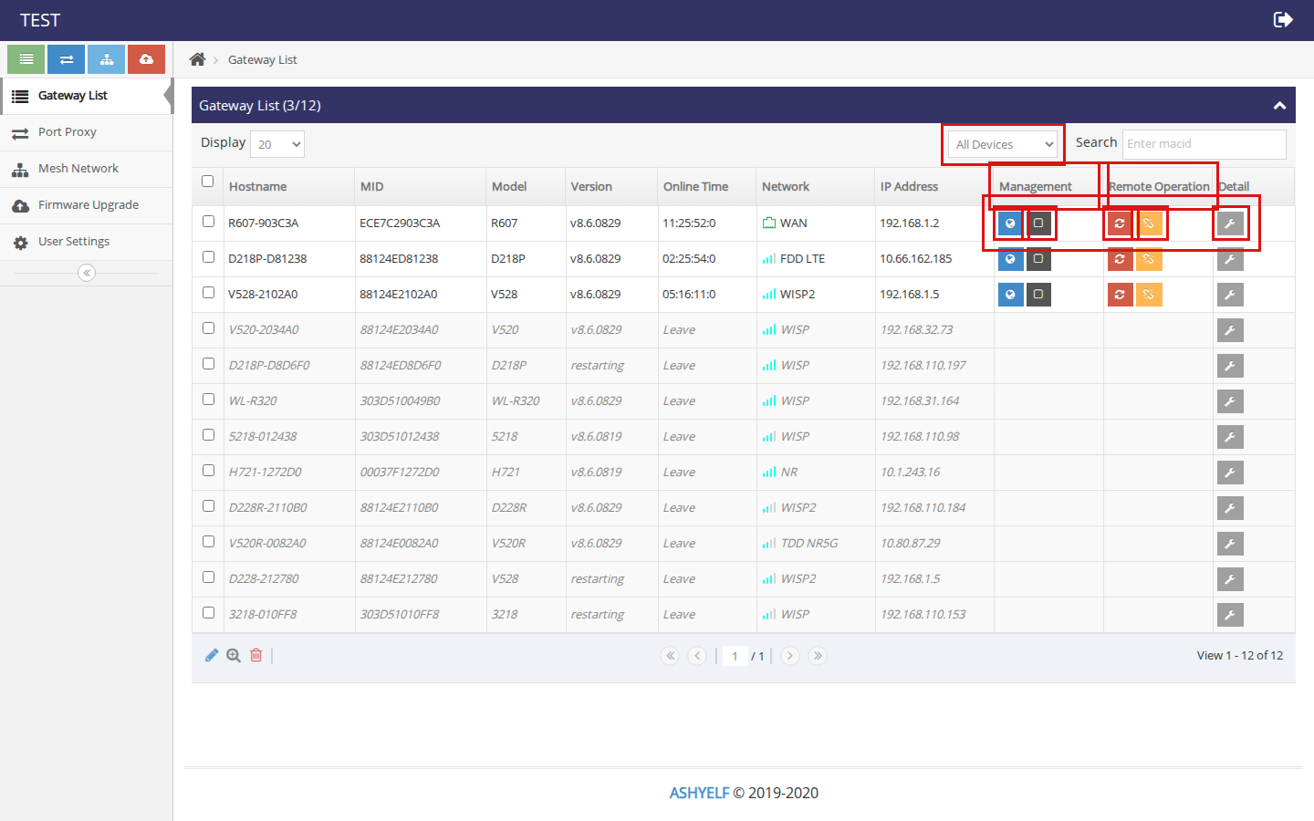
Gateway List
Useful columns:
Column | Meaning
Hostname / MID / Model / Version | Device identity and firmware
Online Time | Connected duration, or Leave if offline
Network / IP Address | Current uplink type and address
Management | Remote Web (globe) and Terminal (square)
Remote Operation | Restart (refresh) and Disconnect (unlink)
Detail | Wrench — device detail / port maps page
Filter with All Devices / Online Devices / Offline Devices, or search by macid.
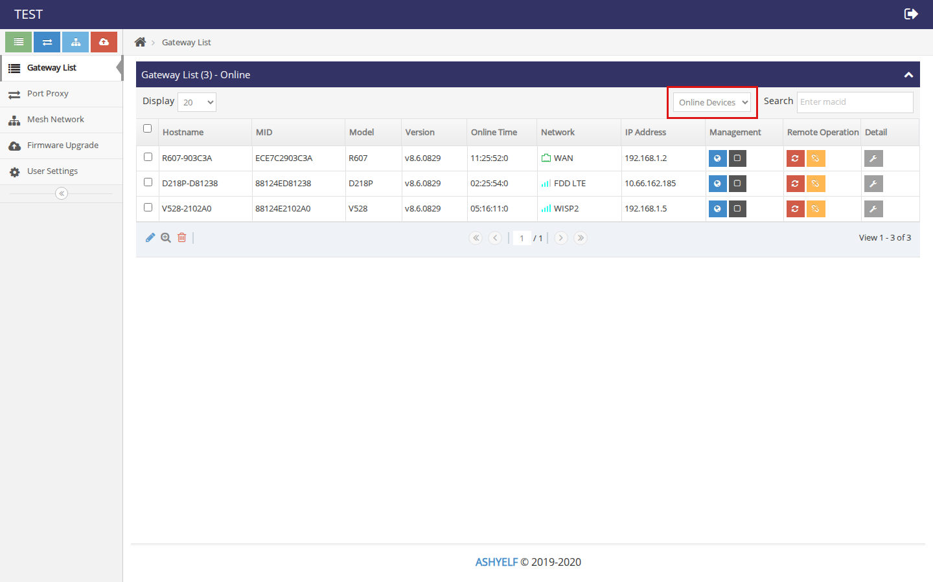
Online filter

C.2 Remote Web access
- Ensure the gateway is online and Proxy Port is working.
- In Management, click the blue globe button (remote Web / PAGE).
- A new browser tab opens through a mapped public port on the center host (form: http://<center-host>:<map-port>/login.html).
- Sign in with the gateway’s local Web credentials, not the cloud-user password.
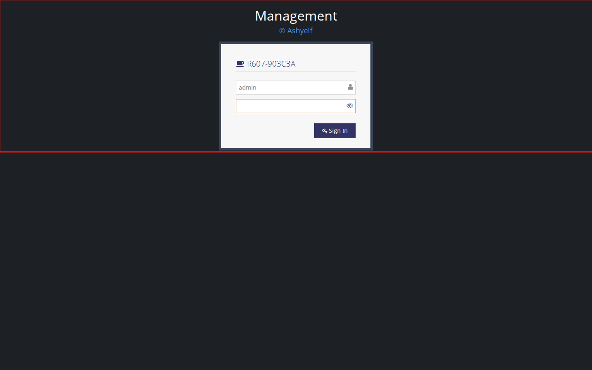
Remote Web login via center map
The dark square button in Management opens a remote terminal session the same way (TTYD-style map).

C.3 Remote restart / disconnect
In Remote Operation:
- Red refresh — request a device restart.
- Orange unlink — disconnect the cloud session.
Confirm prompts carefully; restart interrupts connectivity until the gateway comes back online.

C.4 Device detail and per-device port maps
Click the grey wrench (Detail) on a row to open that gateway’s detail page: identity, online/run time, reboot/disconnect, and the TCP Map Table for maps belonging to this device.
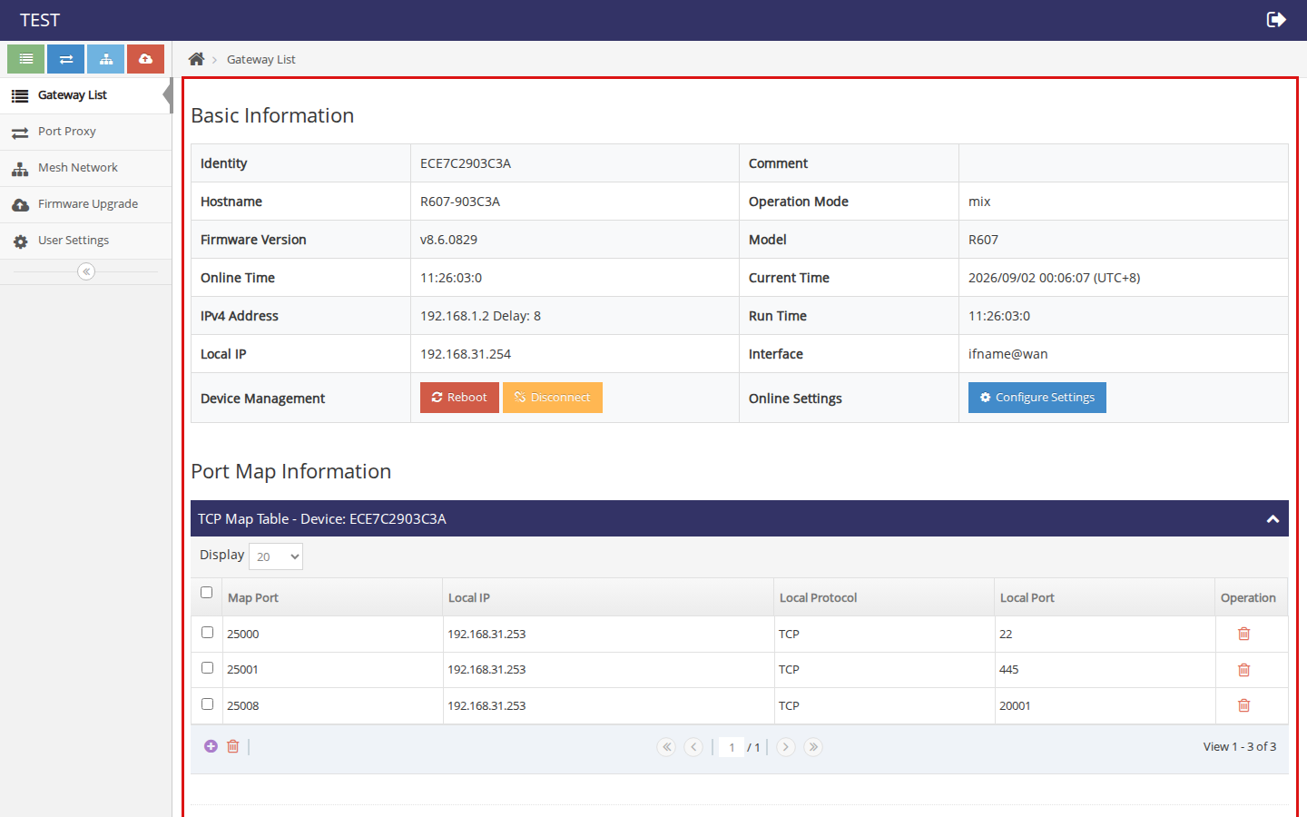
Device detail
Use + under the map table to add a map (public map port → local IP/port on the gateway LAN). Delete with the trash icon.

C.5 Port Proxy (all maps)
Port Proxy lists TCP maps across your account. Each row shows Map Port (public on center), Gateway MID, Local IP, and Local Port.
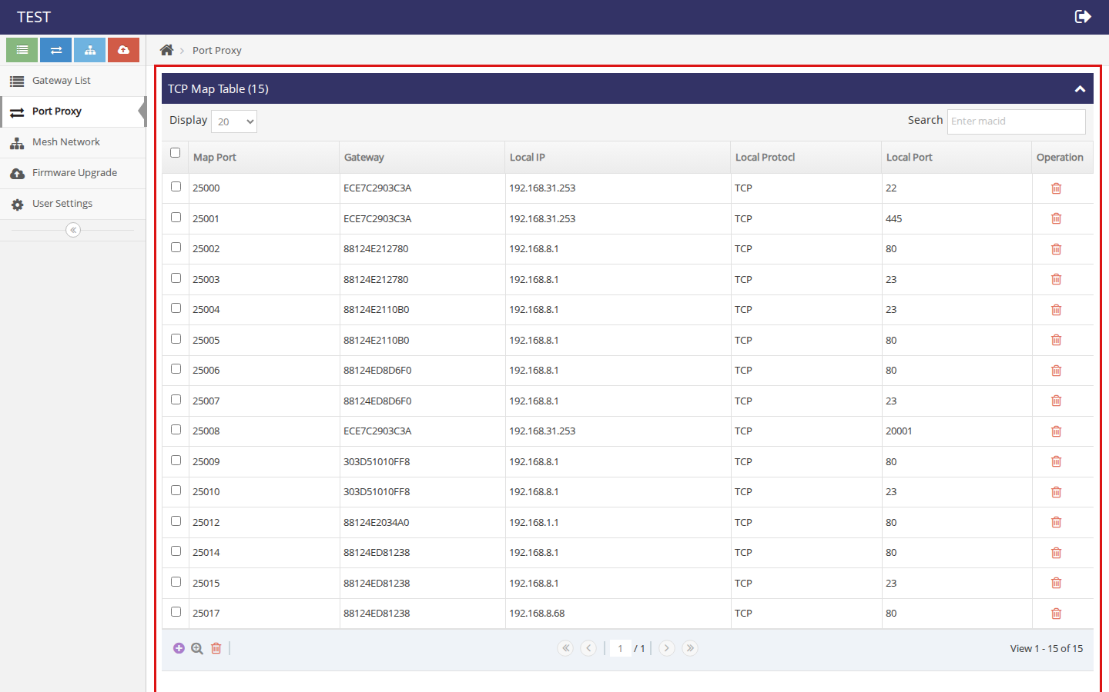
Port Proxy
Example: map port 25000 → local 22 means tcp://<center-host>:25000 reaches SSH on that LAN host through the gateway tunnel.

C.6 Firmware Upgrade
Firmware Upgrade lets you keep .zz images on the cloud and select them for devices.
- Under Firmware Upload, click Choose, pick a .zz file, and upload.
- The file appears in Firmware List (version / custom / scope / filename).
- Use the list actions to select or remove images, then apply upgrades from the workflows your build provides for target gateways.
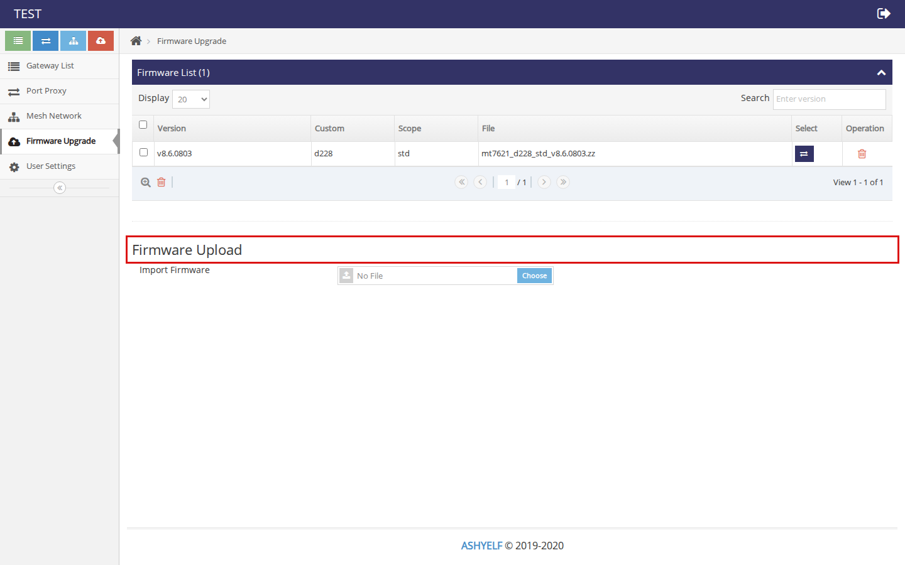
Firmware Upgrade
Match firmware custom/scope to the target product; wrong images can brick or refuse install.

C.7 User Settings
User Settings is where the cloud user maintains their own account:
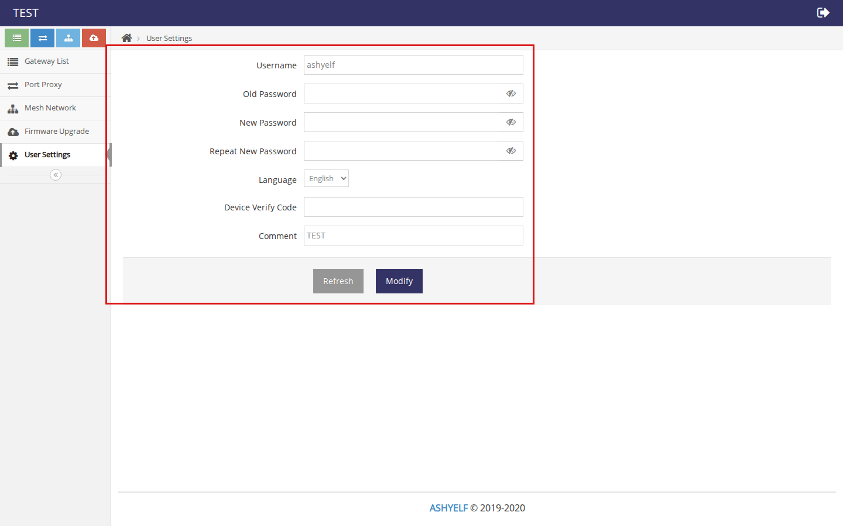
User Settings
Field | Purpose
Username | Read-only cloud account name
Old / New / Repeat Password | Change portal password
Language | Portal language
Device Verify Code | vcode gateways must use; change it only together with all devices
Comment | Optional note
Click Modify to save.

Quick checklist
Admin
- Admin login → create cloud user (username + password + vcode).
- Confirm User WEB Server ON on port 20000.
- Confirm Device Port ON on 20002, Proxy Port ON as needed.
- Open firewall paths from gateways to center (at least 20002/tcp; for remote maps also 20005/tcp and the map port range).
User / device
- User portal login with the cloud account.
- On each gateway: System → Agent Control → Agent Control tab → set Server / Port / Account / Verification Code → Apply → status Connected.
- Gateway List shows the device online → use globe/terminal for remote access, Port Proxy / Detail for maps, Firmware Upgrade for images.

Reference notes
Item | Value
Admin URL | http://<center-host>:20001/login.html
User URL | http://<center-host>:20000/
Example online gateway | R607-903C3A (MID ECE7C2903C3A)
HE Client Port | 20002
HE Client Account | Cloud username bound to the device
Keep admin, cloud-user, and gateway-local passwords distinct. Change defaults before production use.

