

Administrator

User

Ubuntu SkinOS

Ubuntu SSH

TCP:22

Web Server

TCP:8999

TCP:9000

HE Control

TCP:10005

HTTP:10002

Status Gather

TCP:10000

TCP:10005

JSON file

Port Map

TCP:10009

TCP:10010-30010

UDP:10005

UDP:10006

UDP:10007

Mesh Network

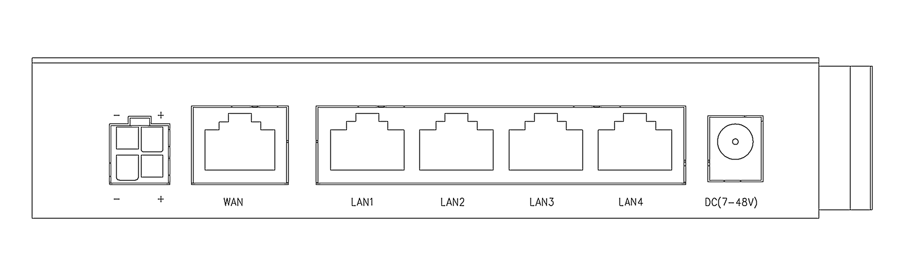

Gateway

**Web Server**

TCP:8999

TCP:9000

HTML

/usr/prj/devms/wui/manage/gwlist.html

/usr/prj/devms/wui/manage/gateway.html

/usr/prj/devms/wui/manage/pport.html

/usr/prj/devms/wui/manage/netlist.html

/usr/prj/devms/wui/manage/network.html

/usr/prj/devms/wui/manage/firmware.html

/usr/prj/devms/wui/manage/upgrade.html

/usr/prj/devms/wui/manage/settings.html

HTML

/usr/prj/devms/webs.html

/usr/prj/devms/user.html

/usr/prj/devms/devport.html

/usr/prj/devms/heport.html

/usr/prj/devms/pport.html



Web Server

TCP:9000

STEP 1, login

HTTP POST /action/login

username=USERNAME&password=PASSWORD

HTTP Return

Cookie

User

STEP 2, get the deivce basic infomation

HTTP POST /action/he

he=Urlencode( Base64( “devms@devapi.device_listv” ) )



Web Server

TCP:9000

HTTP Return

{

“MAC ID”:{ “key”:”Token”,... }

}

User

HE Control

TCP:10005

HTTP:10002

STEP 3, Send the HE command to gateway

HTTP POST /he

{

“mac”:”MAC ID”,

“key”:”Token”,

“command id”:”he command1”,

“command id2”:”he command2”

}



HTTP Return

{

“command id”:{ he command1 return },

“command id2”:{ he command2 return }

}

User

SSL Encryption





STEP 1, login

HTTP POST /action/login

username=USERNAME&password=PASSWORD

Web Server

TCP:9000

HTTP Return

Cookie

User



STEP 2, get the deivce basic infomation

HTTP POST /action/he

&he=Urlencode( Base64( he command1 ) )

&he2=Urlencode( Base64( he command2 ) )

Web Server

TCP:9000

HTTP Return

{

“he”:{ he command1 return }

“he2”:{ he command2 return }

}

User