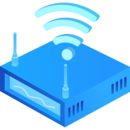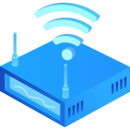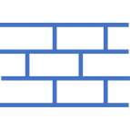

Branch C to Leaf X

Branch A to Leaf X

Branch B to Leaf X

ChaCha20

ChaCha20

ChaCha20

192.168.2.2

192.168.1.2

192.168.1.3

192.168.200.3

192.168.200.2

192.168.100.2

192.168.100.3

Branch A

172.16.0.1

Leaf 6(172.16.0.106)

Leaf 5(172.16.0.105)

Leaf 4(172.160.104)

192.168.200.0/24

Leaf 3(172.16.0.103)

192.168.100.0/24

Leaf 2(172.16.0.102)

Leaf 1(172.16.0.101)

Branch C

172.16.0.3

192.168.2.0/24

Branch B

172.16.0.2

192.168.1.0/24

Cloud Management

LTE/NR

Internet