

192.168.8.100/24

ADSL Modem

 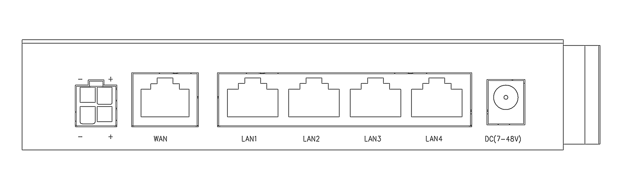

111.221.193.120/32

111.221.192.1/32

192.168.8.1/24

Gateway





Router

111.221.192.1/16

192.168.8.100/24

Gateway



111.221.193.120/16

192.168.8.1/24







192.168.8.100/24



192.168.8.1/24