Welcome to Governing Challenges Day 1!

# Agenda for Day 1: Theory and Empirics of Austerity

Below is a rough timeline for the day. Some parts may be shorter, others longer. We’ll (almost) always prioritise discussion in interrogation of the issues over content delivery.

09.00-10.00 Introduction(s) and Overview

10.00-11.00 The idea of Austerity

11.00-12.30 Austerity Channels.

12.30-13.30 Lunch

13.30-15.30 Comparing Experiences of Austerity: Case studies

15.30-16.00 Coffee/Tea

16.00-17.00 Discussion & Notes for Tuesday

# 09.00-10.00 Introduction & Overview

# Defining Austerity

Austerity is, in itself, a contested concept.

We must engage with the battles taking place over defining austerity before moving on to a discussion of their effects.

The IMF’s Managing Director Christine Lagarde refuses to use ‘austerity’ as a term in interviews and speeches. She will only refer to episodes of ‘fiscal contraction’ or ‘fiscal consolidation’, which means the difference between goverment spending, usually expressed as a percentage of gross domestic product, and taxation revenue, again usually expressed as a percentage of gross domestic product.

The OECD’s experience of the difference between government spending and taxation from 2008 to 2015 is shown below. Clearly some countries have had very different post-crisis experiences.

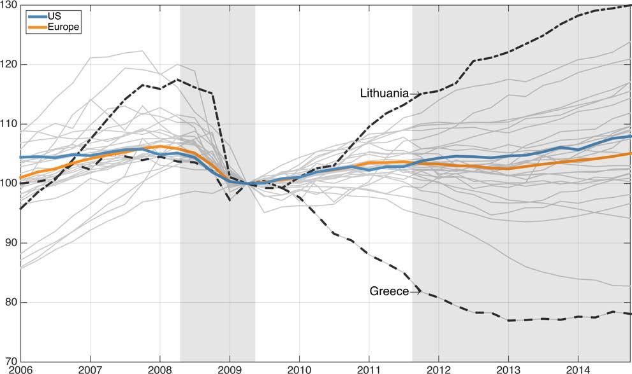

Compare the ‘fiscal consolidation’ experiences of Ireland, of Iceland, and of the Netherlands, for example.

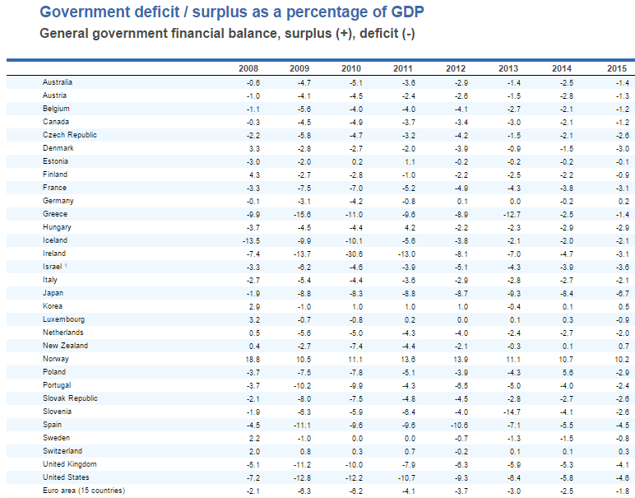

Alesina and Perotti (1994, 1995, 1997, 1998), in a series of studies which pretty much launched the idea of expansionary fiscal contraction, which we will study later, don’t define austerity directly, but discuss two ‘types’ of adjustment during (or after) a fiscal crisis.

These types are:

“Type 1“ relies primarily on expenditure cuts, and, in particular, on cuts in transfers, social security and government wages and employment. Tax increases are a small fraction of the total adjustment and, in particular, taxes on households are not raised at all or are even reduced.

And

“Type 2“ adjustments rely mostly on broad based tax increases, and often the largest increases are on taxes on households and social security contribu- tions . On the expenditure side almost all the cuts are on public investment, while government wages, employment, and transfers are completely untouched, or only slightly affected.

They find, and continue to find, in a 2017 *Journal of International Economics* paper with junior co-authors, that fiscal adjustments of Type 1 is better. Alesina *et al* argue spending cuts are better than tax increases when you want to narrow the difference between government spending and taxation.

Thus austerity is not simply fiscal consolidation, nor is it a static concept. Austerity is rooted in a dynamic conception of the economy as an evolving object with its own inter-temporal budget constraint. The objective of austerity is to inspire confidence amongst international investors that their investment will yield positive returns. The signal provided by the large drop in government expenditure or increase in taxes is traded for increased investment as a result of this increased confidence, generating a so-called ‘expansionary fiscal contraction’. Using fiscal policy to influence investor expectations has been roundly criticized. Guajardo, Leigh, and Pescatori (2014) offer a good summary of these critical voices. Alesina et al. (2015) provides a rejoinder to these critics.

Alesina and Perotti (1997) identify several channels through which austerity works.

* • *Wealth Effects of Consumption:* reducing spending now means taxes won’t rise in the future. Credibly committing to decrease the future tax burden should result in increased present consumption, because people are now that much wealthier, and they are rational enough to know that their taxes won’t rise in the future.
* • *Credibility effects:* Austerity helps reduce risk premia either through reducing the risk of inflation and/or sovereign default risk. This happens because by credibly committing to decreasing the government deficit, the international bond markets are convinced to lend the country more, and at higher levels of debt to gdp.
* • *Changes in labour supply*: Increasing taxes on labour will reduce workers’ desires to work—they will supply less labour, and so labour supply will be reduced.
* *Changes in Labour Market Structure*: The labour market will be effected by inward and outward migration, and by retirements. In countries with large union-representation, an increase in labour taxation leads unions to demand higher real wages to compensate for the decreased after tax income when the economy recovers.

In their 2017 paper, Alesina *et al* show us the average ‘types’ of austerity programmes over a 33 year period. The table below reproduces their analysis.

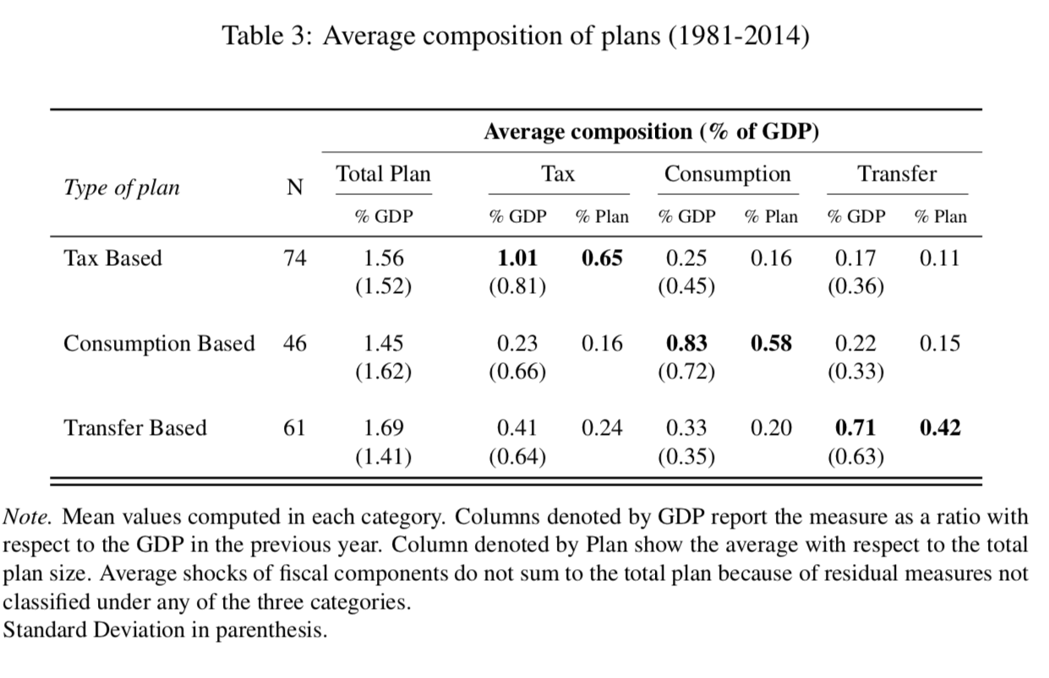

Not every macroeconomic downturn is a full fledged crisis, either. Reinhart and Trebesch (2016) show this table for the USA. They define the disasters as annualized peak-to-trough percentage decrease of real per capita GDP more severe than the average financial recession.

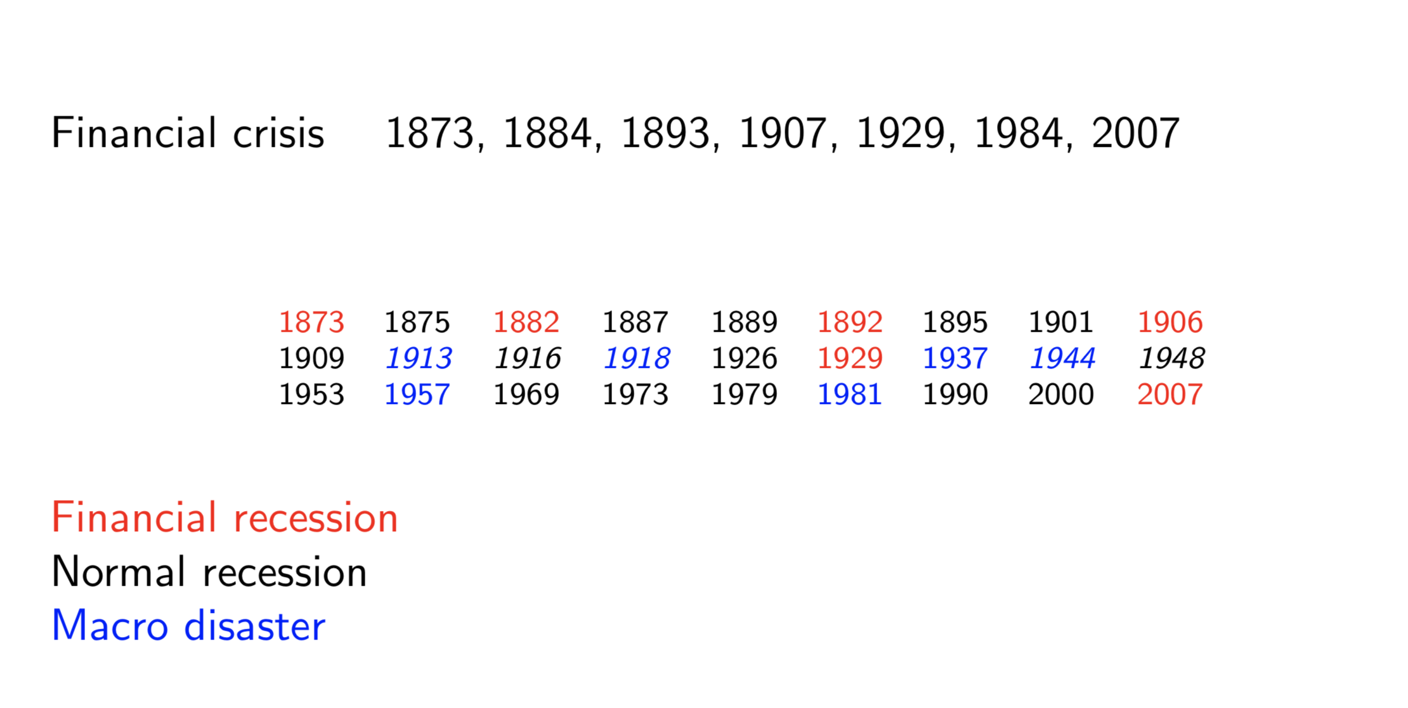

Oxford’s Simon Wren-Lewis, in his 2016 ‘General Theory of Austerity’, defines austerity (pg. 1) as a

“fiscal contraction that causes a significant increase in aggregate unemployment.”

And this definition is a revision of his (2015) definition of austerity as:

Fiscal consolidation that leads to a significant increase in involuntary unemployment, or perhaps more formally but less colloquially as leading to a noticeably more negative output gap.

Note the change from ‘involuntary’ to ‘aggregate’ unemployment.

Blyth (2013a: 866–67), defines austerity much the same as Alesina *et al*:

“cutting the state’s budget to stabilise public finances, restore competitiveness through wage cuts, and create better investment expectations by lowering future tax burdens”

There are others, but these are emblematic.

The definition of austerity essentially requires two components.

First, it is a stated policy by government to effect a large-scale change in the budget deficit of the country achieved by increasing taxes, decreasing spending, or a combination, and second, this policy has clear distributional consequences, such as increasing the rate of involuntary unemployment, changes in relative or absolute inequality, or changes to the industrial structure of the economy.

One can have fiscal consolidation without austerity, particularly in conditions where other economies are growing, and where monetary policy, the control of short term interest rates by central banks, can be used. One of the problems we saw after the Great Recession was the inability of monetary policy to become accommodative, because interest rates were already at the zero-lower bound. Monetary policy was unable to offset the negative impact that fiscal consolidation had on demand and unemployment.

Three questions naturally arise from a definition like this, which combines political, macroeconomic, and distributional, elements.

1. 1. Where did this idea come from?
2. Who, either in government or across the international community, thought austerity was a good idea? And why?
3. What were the effects of austerity?

## Measuring Austerity

There are two main ways to measure austerity. The first looks at policy outcomes. Giavazzi and Pagano, 1990, and Alesina and Ardagna, 2010). Specifically, the cyclically adjusted primary balance (CAPB)—the primary balance adjusted for the estimated effects of business cycle fluctuations—is used as a measure of fiscal consolidation. The cyclical adjustment is needed because tax revenue and government spending move automatically with the business cycle. The hope is that, after this cyclical adjustment, changes in fiscal variables reflect policymakers’ decisions to change tax rates and spending levels. An increase in CAPB would therefore, in principle, reflect a deliberate policy decision to cut the deficit.

There turn out to be quite a number of problems with this appraoch. Measurement errors abound, price or commodity movements are poorly factored in, and changes in this balance are not always correlated with actual policy actions. Sometimes governments just get lucky. For example, in the case of Ireland in 2009, the collapse in stock and housing prices induced a sharp reduction in CAPB despite the implementation of tax hikes and spending cuts exceeding 4.5 percent of GDP.

The second is a narrative approach which focuses on policy actions—tax hikes and/or spending cuts—taken by governments with the intent of reducing the budget deficit. This is the latest version.

Both give rise to the multiplier wars, which are currently raging. More on this later.

**Austerity as Natural Experiment**

The boom, not the slump, is the right time for austerity at the Treasury. — *J. M. Keynes, 1937*

The chapters within Diamond and Robinson (2010, especially chapter 1, 2 and 3) on the natural experiments of history provide us with a framework through which we can understand the development of austerity. Austerity as a set of policies produces a kind of natural experiment. We can reason in a ‘no austerity’ mode, as Jorda and Taylor (2014) do.

They show that austerity is always a drag on growth, and especially so in depressed economies: a one percent of GDP fiscal consolidation translates into 4 percent lower real GDP after five years when implemented in the slump rather than the boom. They use the UK’s move to austerity in 2010 as their example.

Their results contrast with the expansionary austerity view of Alesina et al, and rather amplify the opposing view of Guajardo, Leigh, and Pescatori (2014): they find that austerity is very contractionary. Jorda and Taylor produce this picture as their counterfactual.

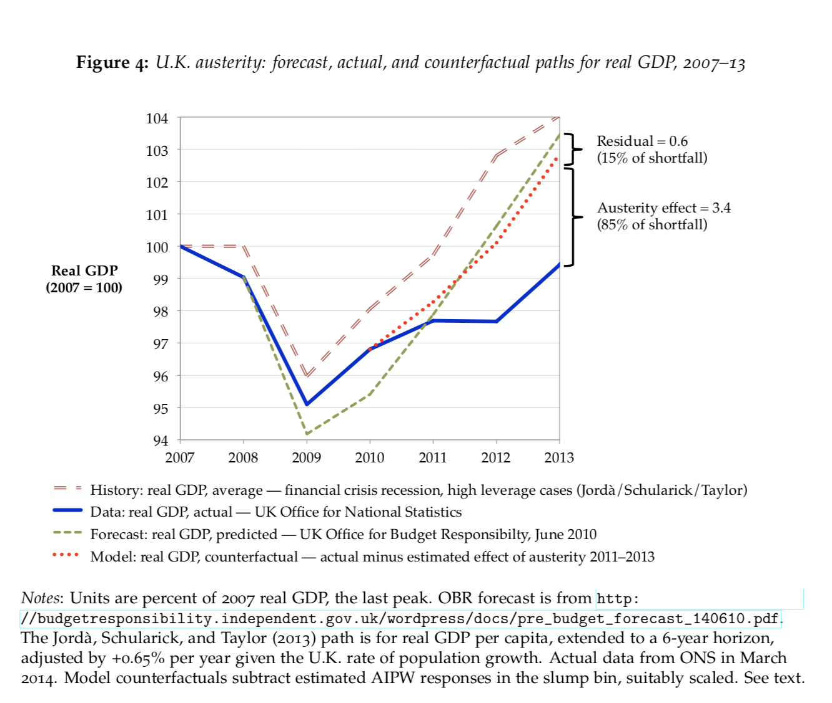

## 10.00-11.30 The idea of Austerity

Blyth (2013b) locates the genesis of the idea for Austerity in the ideas of Locke, Hume, and Smith. Locke and Hume are of course the classic liberal and conservative pillars of the Western intellectual tradition. For Locke, growth and prosperity proceed through the use of private property. Hume desired no influence from the state, especially with respect to it issuing debt. *Once debt levels issues by the state get too high, Hume argued, eventually large parts of the state would end up in the hands of foriegn owners.* Cutting state expenditure was therefore the correct approach, regardless of its distributional consequences, which both Locke and Hume largely ignore in any case. Adam Smith located his theory of growth within the parsimony of the merchant class. Their savings translated into investment, which was the engine of growth. Excessive consumption, fueled by inappropriate levels of debt, is only to be discouraged. Both foresaw what Smith would later term ‘the ineffable enfeeblement of the state by debt’.

None of these giants of westen intellectual thinking make a direct argument for austerity—rather they make an argument for the optimal size of the state based on the basic economics of state-craft, that states are not natural engines of either savings or growth—and the moral arguments against removing from someone by force what they have worked to produce. Taxation, therefore, should be limited at all times and in all ways. Increasing taxation to bail out profligate rulers or those who had lost in war was something all three men had seen in their lifetimes and come across in their studies. Smith saw the state rescue Ayr bank in his lifetime, and railed against the decision many times in his writings.

During the 19th Century, JS Mill wrote in defence of the state as an engine of social progress and accumulation in its own right, and these ideas found favour with large political parties in the UK who, as democratic sufferage was being extended, now saw the state as the defender of the ‘rules’ of capitalism and the enfranchisement of whole swathes of the population. It is here that progressive theories of taxatoin are developed, precisely to fund an increase in the size of the bureaucratic state and to increase the legitimacy of the act of taxation so abhorred by Locke and Hume.

The development of modern economics in the early 20th Century saw much of these ideas internalised. The ‘Treasury View’ which developed during the 1920s and 1930s was explicitly ‘liquidationist’; that is, a policy version of the Austrian theory of the businsess cycle, which said that free trade and balanced government budgets were important, but during a downturn, the government should not intervene to prop up businesses, including banks, which had failed. Intervention by the state, in fact, was actively harmful, by keeping the failed in place—literally—at the expense of the parsimonious tax payer. These debates on the role of the state echo through to today.

The Treasury View is simply that austerity is a natural form of social emetic. Necessary pain must be taken by those who have made mistakes in either becoming irrationally optimistic, or who have lent too much or too poorly. This View accords well with libertarian writers of the period and with those of the Schumpeterian school (including the great man himself) that developed around the same time who viewed ‘creative destruction’ as both necessary and sufficient to social progress and prosperity.

Blyth (2013) carefully contrasts Schumpeter’s liquidationist argument with that of Keynes, the great theorist of business cycle stabilisation and government intervention. In addition to powerfully making the case against the Treasury view and for government intervention, Keynes reasoned logically through many fallacies of composition, some of which are in the table below, taken from Marc Lavoie’s, 2015 *Post-Keynesian Economics: New Foundations, page 18*. These fallacies of composition are vital to understand the arguments both for, and against, austerity policies, because they end up as the modern debate over the size of the multiplier, which is a measure of the effectiveness of government intervention.

# Paradoxes

The basic logic of a paradox arising from a fallacy of composition is this. Imagine you have ten people within a nation with incomes of 100 dollars each. The gross national income is 10*100=1000 dollars in a given year. Now imagine one person saves a little, say 10 dollars. Gross national income is 990 dollars. The economy is ‘smaller’ but only barely. If that person has a positive interest-bearing savings account, or if she invests in a productive asset or business, the economy may even grow in a subsequent year. Now imagine 5 people decide to follow our original person’s lead. This time they save 50% of their wealth, or 50 dollars. Gross National Income has now collapsed from 1000 dollars to 500 dollars. The economy is in crisis. The paradox of thrift is that what is individually rational is collectively irrational. Higher saving rates lead to reduced output.

Lavoie goes further and discusses the paradox of costs, which in its static version, says that a decrease in real wages will not raise the profits of firms and will instead lead to a fall in the rate of employment.

The paradox of costs was explained by Michal Kalecki in the 1930s and again in the 1960s where he concluded that ‘one of the main features of the capitalist system is the fact that what is to the advantage of a single entrepreneur does not necessarily benefit all entrepreneurs as a class’. This observation is especially true if we consider that some entrepreneurs will be ‘born’ with differing endowments, thus exacerbating inequality before the productive process actually starts.

Robert Rowthorn proposed a dynamic version of this paradox which says rising real wages relative to productivity can generate higher profit rates. Individually it is true lower profit margins generate lower profit rates. But if higher real wages generate higher aggregate consumption, higher sales, higher rates of capacity utilization and hence higher investment expenditures, profit rates will be driven up.

There are many paradoxes of this type within mainstream, and less mainstream, macroeconomic approaches.

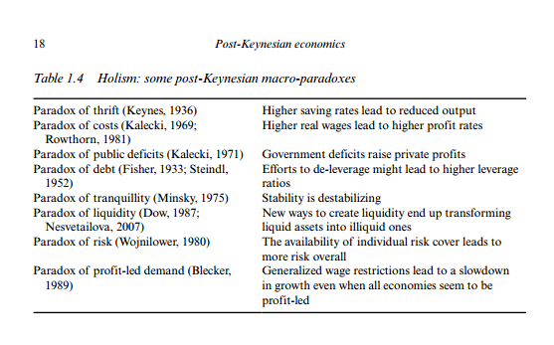

Blyth locates the intellectual support for austerity within *ordoliberalism,* a fusion of Austrian economics and rules-based governance which arose in Germany before the rise of the Nazi party. Germany, a late-industrialiser and export-oriented manufacturer, developed ordoliberalism to enfuse the state with a role as rule-settler, not as employer or financier of last resort.

It is worth doing a little national accounting to see why this is important. In any economy total income (Y) is the sum of consumption (C), government expenditure (G), private investment (I), Exports (X), and imports (M). The ‘fundamental accounting identity’ is

*Y = C + I + G + X - M.*

Another perspective on the national income accounting is to note that households can use total income (Y) in only three ways. It can save (S), consume (C), or pay taxes (T).

*Y = C + S + T.*

You than then bring the two perspectives together (because they are both just “views” of Y, one on income, the other on spending) to write:

*C + S + T = Y = C + I + G + (X – M)*

You can then drop the C (common on both sides) and you get:

*S + T = I + G + (X – M)*

Rearrange to get the accounting identity for the three sectoral balances – private domestic, government budget and external:

*(S – I) = (G – T) + (X – M)*

In words, the Private Sector Balance is equal to the public sector balance plus the external sector balance. This is an accounting identity, so true by construction. Note that it says nothing about causality. It simply adds up elements within national accounting conventions.

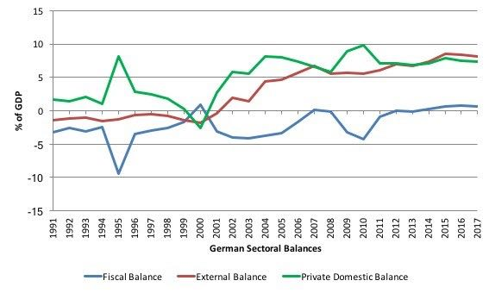

Back to German ordoliberalism. Ordoliberalism essentially sets *(G - T) = 0* by forcing the government to run a balanced budget over the medium term. This means the private sector must run a deficit or surplus, or the external sector must run a deficit, or surplus. The latest IMF Article IV report, which is a fiscal surveillance analysis, puts Germany’s 2018 *(G - T)* reading at 0.5% of GDP, a small but significant surplus given how large Germany is. Remember any government surplus implies at least a little austerity. The *(X - M)* reading is 8.3% of GDP. Plugging this into our sectoral balance equation give us

*(S - I) = 0.5 + 8.3*

This means the private sector has to run a surplus of +8.8% of GDP, saving has to be far greater than investment. This is the financial balance of the German nation expressing the ordoliberal philosophy of ‘first save, then go shopping’, *Esrt Sparen, Dann Kaufen!*

Over the last 25 years or so, the German government has essentially run a *(G - T) = 0* policy, in fact changing its fiscal rules in 1999 to mandate a balanced budget, at least. Having an external sector in the negative here is extremely positive for an individual nation—it means it is selling more to the rest of the world than it is importing.

Sadly, it also means domestic demand must grow more slowly than GDP, and therefore that wages must always be repressed. So you have the tragedy of a country with falling real investment in roads and schools and hospitals, but which runs a surplus not only against the rest of the world, but against most of its own people.

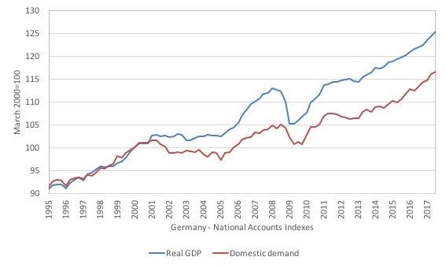

The ordoliberal mindset creates a policy mix where inflation—over spending—is the policy equivalent of the devil, because it erodes savings, which are the core policy variable to be maximised. The German economy, in some sense, is designed structurally to maximise savings. This makes a lot of sense in the context of a late-industrialising country which must catch up with the US, UK, and Japan, post World War II. It makes far less sense within the Eurozone of 2018.

Throughout this period, the intellectual case against intervention by the State was continually made by economists like Murray Rothbard and Gottfried Harberler. Their basic argument ammounted to a combination of rent seeking and moral hazard.

Rent seeking happens when agents get paid more than is justified by their productivity for substantial period of time. There are historical, structural, and legal theories of rent-seeking. All look poorly on the practice. Moral hazard exists when an agent doesn’t bear the full costs of their actions. Both are useful ideas, but have theoretical and practical limits people who use them rarely subscribe to.

It’s useful to consider this kind of thinking in terms of a business cycle. The argument is: banks produce cycles of boom and bust through credit expansion. These are always made worse by governments who either print money to bail out the stupid and corrupt banks, causing inflation, or worse, using the tax payers’ cash to make banks’ balance sheets whole again through fiscal policy. Either action further emboldens the banks and creates the conditions for the next boom and bust cycle.

The final piece in Blyth’s austerity story starts in 1950s Italy. Economist Luigi Einaudi fused US, right wing public choice arguments (it’s all about moral hazard or rent-seeking) to German ordoliberalism. He argued the Italian state should get into the business of managing the rule set of the economy, not intervening in it. Einlaudi’s intellectual heirs at the Bocconi School of Economics, Alesina, Argagna, Tabellini and Perotti, are Einlaudi’s direct intellectual descendents. Their economic thought has a deep distrust of the state and of debt. Everything they have written since the early 1980s is a modern version of the ‘cut your way to growth’ thinking of Hume, Locke, and to a lesser extent, Smith.

The main idea Alesina et al are responsible for is expansionary fiscal contraction. When states cut spending, this emboldens the markets to lend them more at lower rates, public spending doesn’t crowd out private spending, debnt/GDP levels don’t get out of hand, and the economy can grow. Spending less, particularly on bank bailouts and social protection, is not only the right thing to do to minimise rent-seeking and moral hazard, it is the correct thing to do because it will ‘cause’ growth.

The two main economies they studied are Ireland and Denmark. A further example later added was Australia. No case study holds water when scrutinised. Nonetheless their ideas have had enormous impact. For example, Alesina’s words made it directly into the June 2010 ECB Monthly Bulletin to make the case for cuts in spending to the European Periphery. Ideas do have real impact.

## How widespread is the problem of austerity?

Austerity as a policy has been tried many times.

Jayadev and Konczal (2010) followed countries have experienced fiscal consolidation (ie, when the difference between government expenditure minus taxation shrank) during a slump.

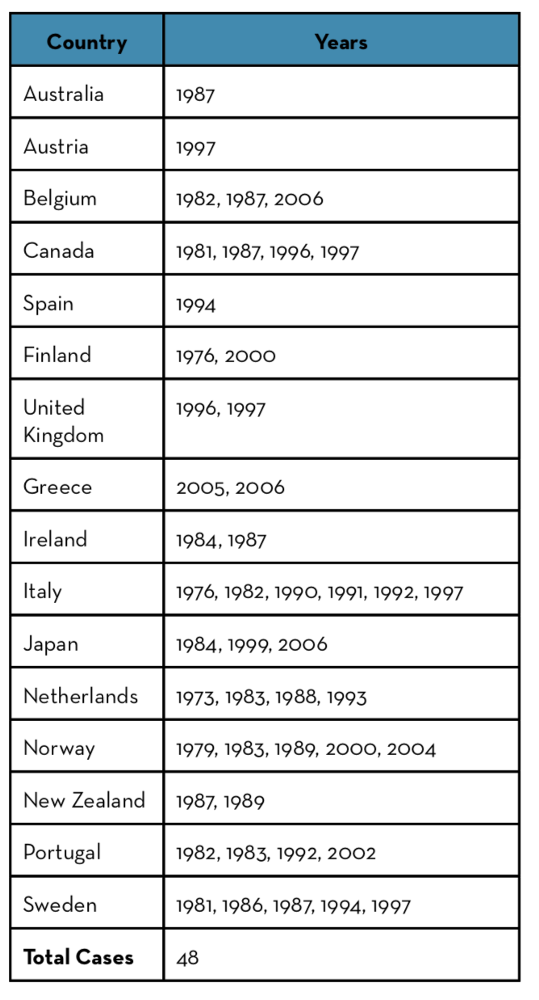

Jayadev and Konczal confine their analysis to OECD countries for the sake of comparability, and still find 48 examples of years in which countries shrank spending during a slump.

Among large consolidation outcomes (defined as improvements in cyclically adjusted balances in terms of per cent of potential GDP) were: Canada in the 1990s (8.1%); Portugal in the 1980s (8.5%); Sweden in the 1980s (9.4%) and in the 1990s (11.7%); Greece in the 1990s (12.1%); and Denmark in the 1990s (13.5%).

Fiscal consolidation was sustained for six years in Australia in the second half of the 1990s as well as in Belgium in the 1980s and 1990s; and in the United Kingdom and the United States in the 1990s. Consolidation lasted for seven years in Sweden in the 1980s and 1990s and for eight years in Japan in the 1980s.

There are serious measurement issues involved in the study of austerity. Guajardo, Leigh and Pescatori, (2011, 2013, 2016) argue against the use of the cyclically adjusted primary balance measure, because it treats one-off accounting episodes in the same way as a large scale macroeconomic crisis, and because it includes ‘non-policy’ elements which might affect economic activity. The CAPB approach often selects periods associated with favorable outcomes but during which no deficit-driven fiscal consolidation occurred. It also tends to omit cases of fiscal consolidation associated with unfavorable outcomes. To see the difference in approach, figure 2 shows the difference in outcome between two measures.

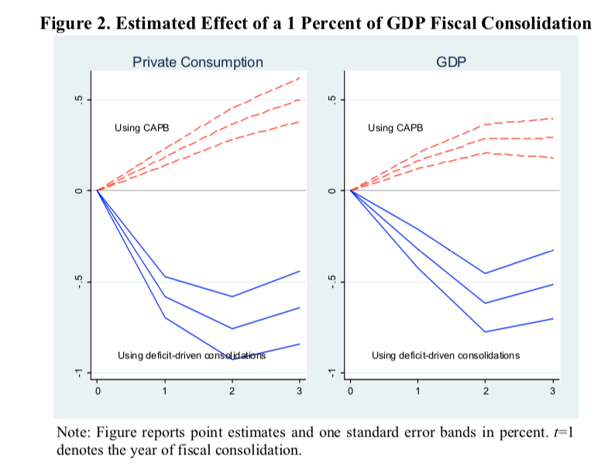

Ortiz and Cummins (2013) went much further than Jayadev and Konczal, at least on one measure. They examined government spending (*G*) in 181 countries during and after the global financial crisis.

Ortiz and Cummins found fiscal contraction was most severe in the developing world.

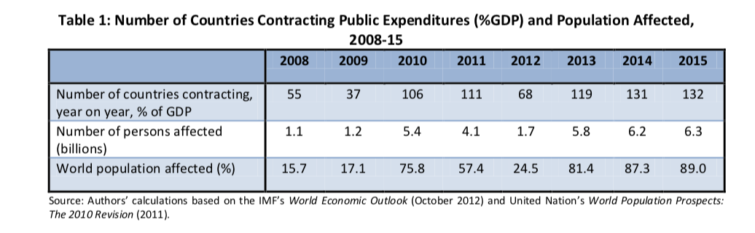

Overall across their whole sample, 68 developing countries cut spending by 3.7% of GDP, on average, in the third phase of the crisis (which they define as 2013-15) compared to 26 high-income countries, which they forecast would contract by 2.2% of GDP, on average. In real terms, 17 developing economy governments had fiscal envelopes in 2013-15 that were smaller than those during 2005-07, on average, which is astonishing.

Ortiz and Cummins also comprehensively examine the measures used to decrease (*G*) and increase (*T*).

**11.30-12.00 Coffee/Tea**

## 12-13.30 Channels of Crisis, and of Austerity

Having thought a little about the definition of austerity and its historical antecedents, it is useful to think about the channels through which austerity operates. Before that, it is important to think about how crises take place. We should remind ourselves that crises happen all the time. This table is from Reinhart and Trebisch (2016).

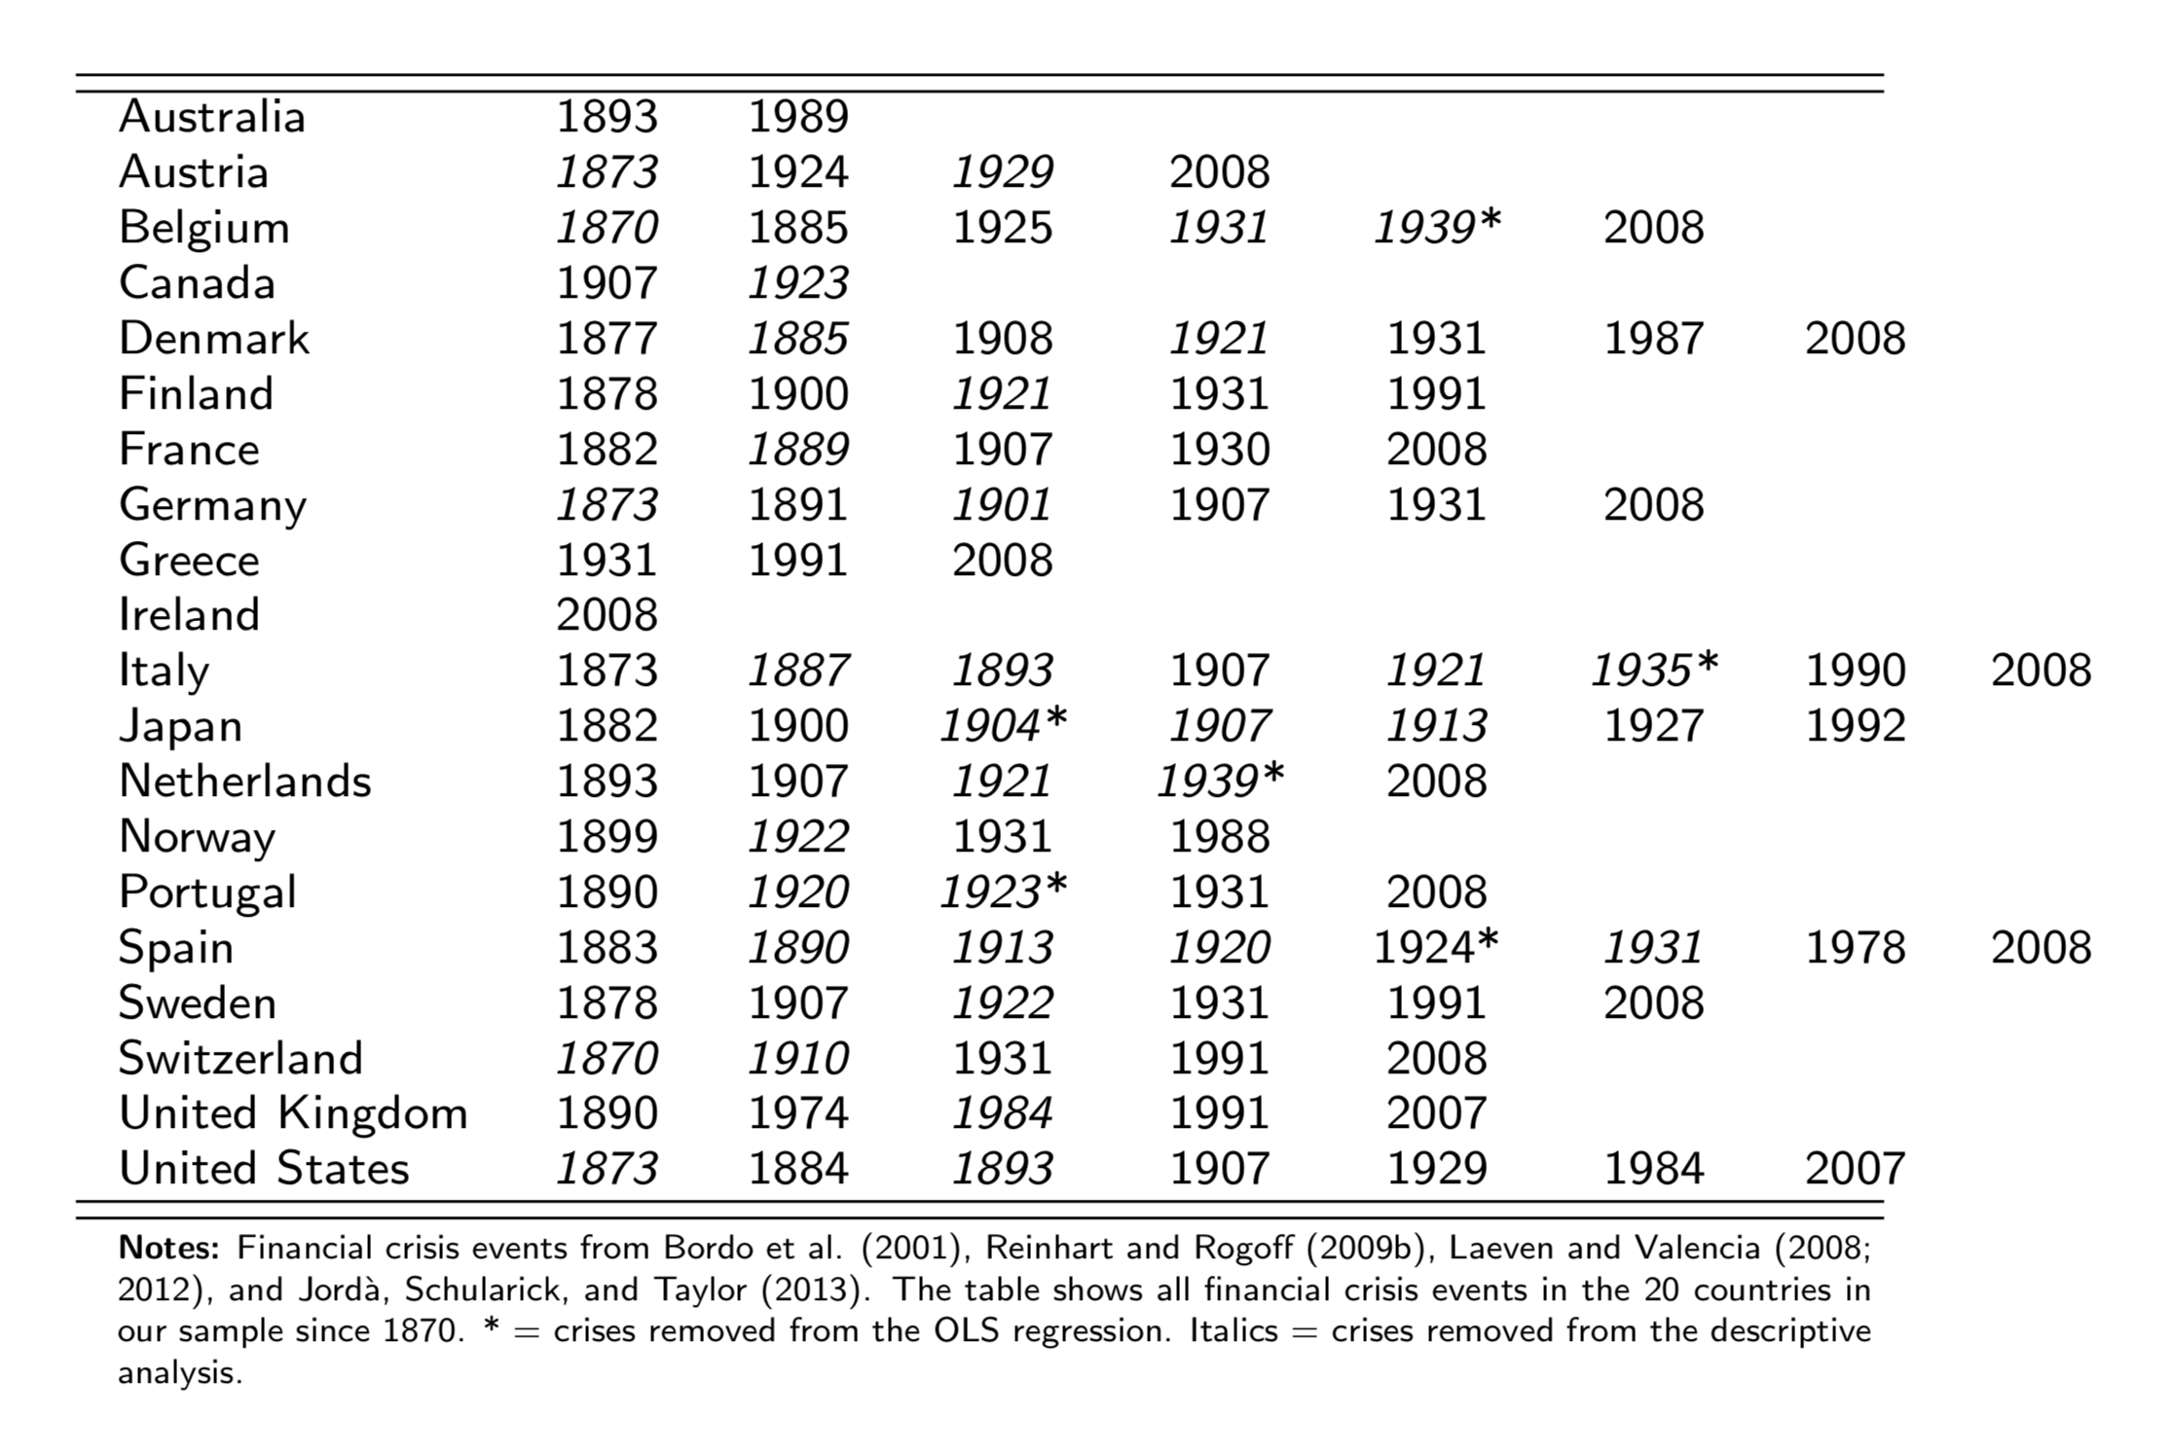

Let us imagine a six-sector economy. We have

1. Households

2. Firms

3. Private banks

4. A central bank

5. A government

6. A ‘rest of the world’

Economies have several ‘routes’ to economic crises. Balteanu and Erce (2015) give a typology. These are:

**Balance sheet channels.** Generally crises involve debt build ups and sharps changes in credit flows.

A balance sheet is a statement of assets, liability, and equity values in a given moment. Every household, firm, central bank, and government has a balance sheet. There are different types of balance sheet crisis.

1. The single bank crisis. Where a crisis is precipitated by a banking collapse, but this does not imperil the sovereign borrowing ability of the nation. A good example is Finland in the 1990s.

2. The twin bank-debt crisis. According to Candelon and Palm (2010), bank rescue operations may impair the sustainability of public finances. Where a banking crisis starts, and this spreads to the sovereign. Most of the European peripheral countries in the recent crisis were of this type, most notably Ireland and Italy.

Recent work by Carmen Reinhart et al (2016) shows the long-run dualistic nature of the bank/sovereign crisis:

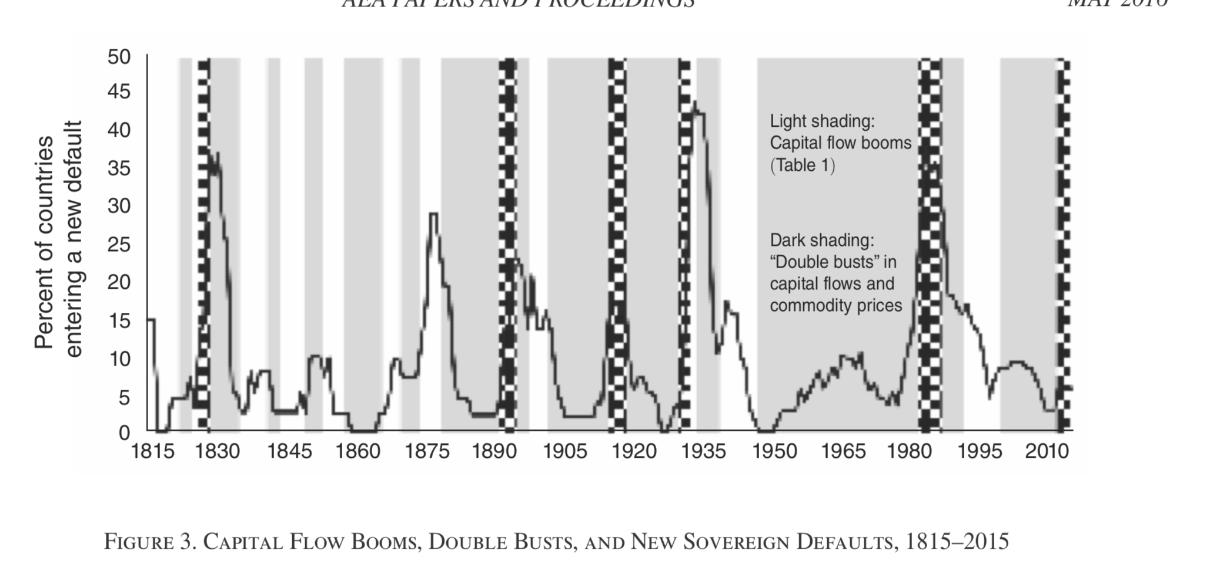

3. A firm-level balance sheet crisis. Where over-borrowed firms default *en masse* and cause large banking or sovereign difficulties, especially if much of the borrowing takes place from the rest of the world. Good examples are Iceland in the 2000s, or Barbados in the 1990s.

4. An old-fashioned debt buildup for property in households.

5. Das et al. (2011) show that corporate borrowers and banks may face a sudden stop in financing after a sovereign default. Sovereign defaults can curtail access to foreign capital also to private agents.

**Macroeconomic channels. The scale of the problems are typically expressed at the level of the entire economy.**

**Fiscal deterioration.** The deterioration of the fiscal position is likely to occur due to a combination of lower revenues and higher expenditures (assistance to troubled banks and outlays associated with the economic downturn).

**Credit crunches.** Sovereign rating downgrades can lead to sudden stops and higher borrowing costs.Laeven and Valencia (2011) focus on the ability of bank rescues to minimize the credit crunch created by the bank crisis. They show that firms dependent on external financing benefit significantly from bank rescues.

**Volatility of taxes**. Honohan (2008) argues that a critical factor explaining the subsequent fiscal distress, beyond the direct cost of bank rescues, is the collapse in tax revenues due to the deep contraction created by the bank crisis.

**A currency crisis.** The collapse of a currency’s value can happen in several ways.

1. *Financial liberalization and overborrowing syndrome* (McKinnon and Pill 1997, when the domestic banking system is plagued by the moral hazard problem, opening up of the financial sector to the rest of the world will induce huge overborrowing and bad debt. In other words, financial integration magnifies a domestic problem.

2. *Fundamental failures.* Another explanation is the simple ‘fundamentals are wrong’ story where domestic credit expansion causes a depreciation of the exchange rate. The central bank can’t hold onto its reserves forever, and there’s a run on the banks or the institution of capital controls.

3. *Herding and cascades.* Another explanation needs herding and information cascades to work. Imagine a government is pursuing two goals. It wants to have a fixed exchange rate on the other hand, but it also wants to keep unemployment down (or alternatively, keep interest rates low, protect banks' balance sheets, contain external debt burden, etc) on the other. Tight money supports the fixed exchange rate but worsens the other situation. While the government is able to maintain exchange rate stability by tight macro policy, it may choose to do so. But when a big attack comes, maintaining the exchange rate becomes too costly, and the government will switch to the other regime of floating the currency and achieving the domestic goal. In other words, the policy of fixing the exchange rate under some domestic strain and the policy of giving up currency stability and achieving domestic goals are both possible. Which one will be realized depends on whether the market attacks or not. The first solution is chosen if the market does not attack, but the second solution is chosen if the attack comes. It is the market, not the government, who decides. This is a self-fulfilling crisis.

Lahiri and Végh (2003) show that bad news about prospective deficits can trigger a currency crisis. Under these circumstances a currency crisis will not be preceded by persistent fiscal deficits, rising debt levels, or falling reserves. These models assume that agents receive news that the banking sector is failing and that banks will be bailed out by the government. The government plans to finance, at least in part, the bank bailout by printing money beginning at some time in future. Burnside, Eichenbaum and Rebelo (2001a) show that a currency crisis will occur before the government actually starts to print money. Therefore, in their model, a currency crisis is not preceded by movements in standard macroeconomic fundamentals, such as fiscal deficits and money growth.

4. The signal approach. It turns out you don’t need too many signals to predict a currency crisis. The real exchange rate turns out to be the best one, but there are others.

|  |  |  |
| --- | --- | --- |
| *Signal* | *Warning sign* |  |
| Real Exchange rate | Home currency overvalued |  |
| Exports | Value of exports falls |  |
| Stock prices | Stock market declines |  |
| M2/International Reserves | International reserves too small relative to money in circulation |  |
| Outout | There’s been a recession. |  |

**External sector channels**

The world is deeply interconnected, especially at the financial level. Financial difficulties in one economy can spill over into another very easily, as we saw in 2008.

Walter and Sen (2008/2013, chapter 5 especially) discusses the role international finance plays in disciplining the individual small economies political systems.

The simple rules of double-entry accounting ensure that, excluding statistical discrepancies, the capital account surplus, or net capital inflow (denoted by KA), is related to the current account surplus (denoted by CA) and to changes in the official reserves account (denoted by RA, where ∆RA < 0 implies the accumulation of reserves by the monetary authority) through the identity:

*CA + KA + ∆RA ≡ 0.*

A country that runs a current account deficit must finance this deficit either by a private capital inflow or by a reduction in its official reserves. In both cases, the country runs down its net foreign wealth.

Cesa-Bianchi et al, 2017: Capital inflows are typically associated with economic expansions and asset price booms.

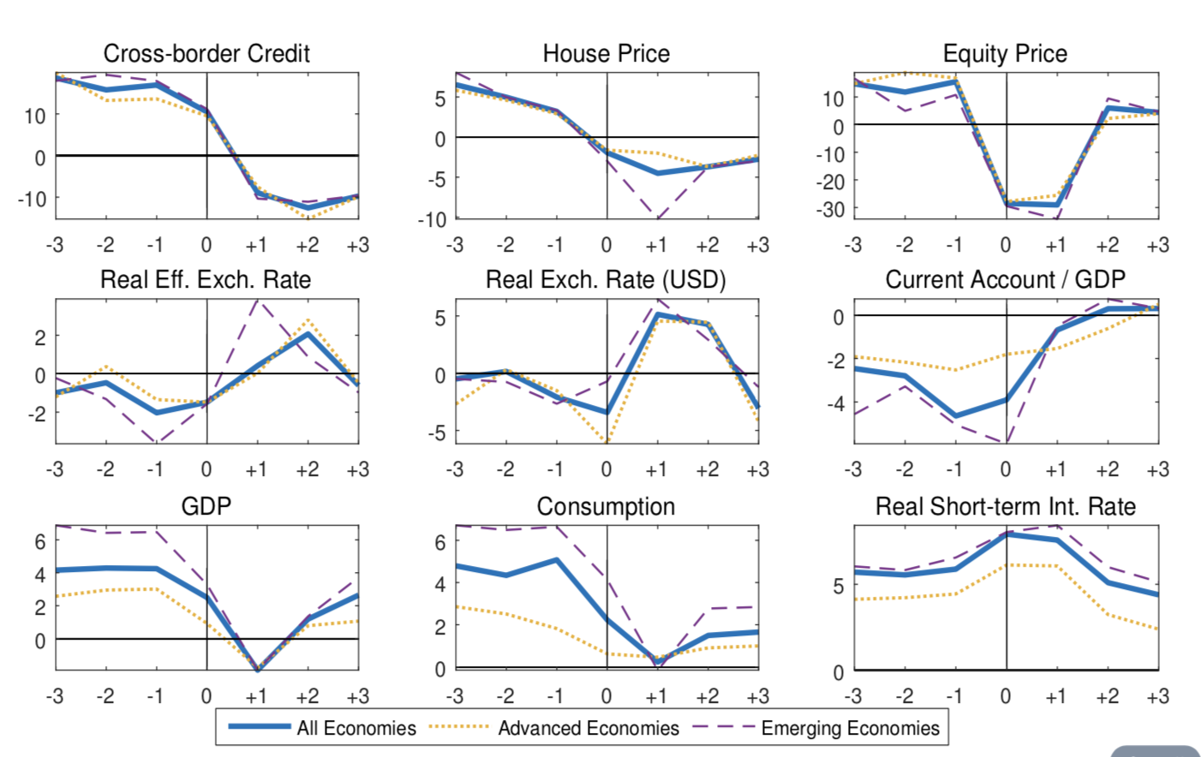

A higher share of foreign currency debt implies a higher sensitivity of consumption and the real exchange rate to leverage.

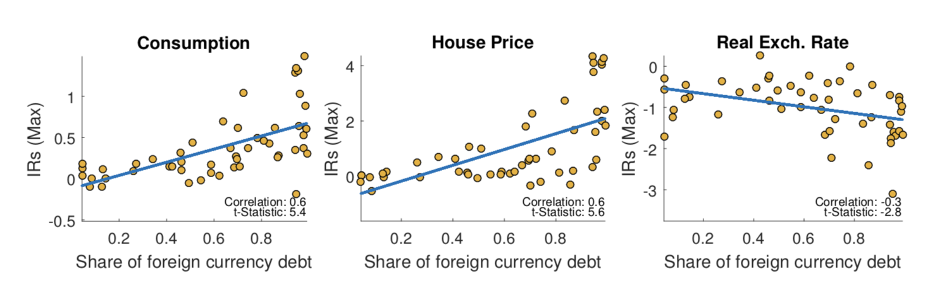

Bank crises may ignite a currency crash, making the sovereign unable to repay foreign currency debt (Reinhart and Rogoff, 2011, De Paoli *et al*., 2009). This is more likely to happen if the central bank uses reserves to finance bailouts, or the government uses monetization to overcome the crisis (Jacome, 2015). Obviously, for small open economies, or for developing economies, the reserve issue is a real one.

The deep connections between the intenational financial system and the domestic banking system are apparent in figures like this from Cesa-Bianchi et al (2017) on cross border credit, banks vs non-banks.

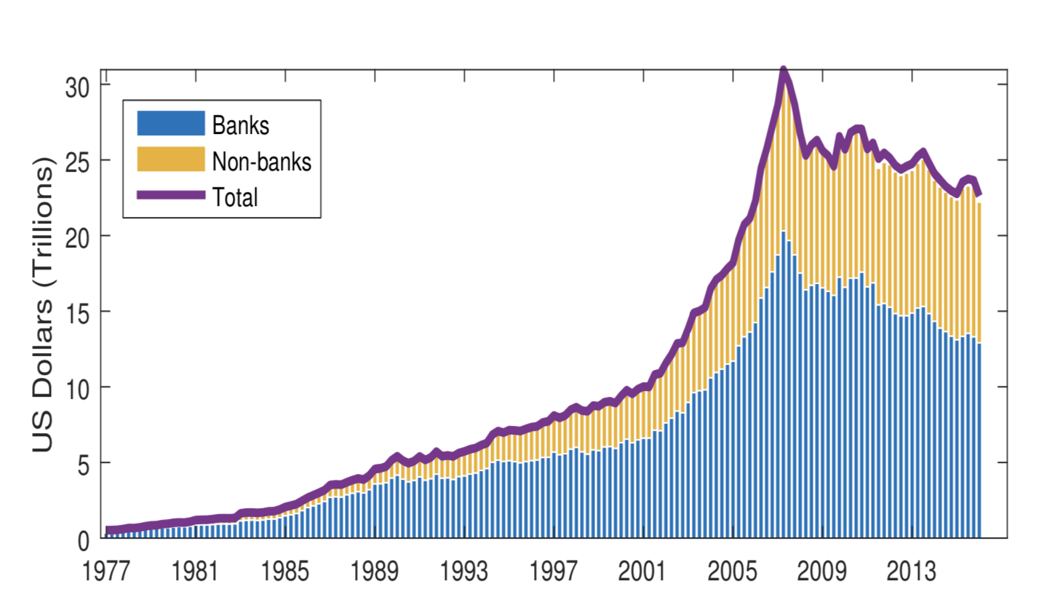

Banking crises could lead to a drop in external financing, via their impact on market sentiment. Cavallo and Izquierdo (2009) show that, in emerging markets, capital flows may collapse for months or years after bank crises, potentially triggering a solvency crisis well after the capital flows have returned.

**Thinking about the *pace architecture* of economic crises.**

There is a ‘pace architecture’ to many economic crises. Different sectors experience the crisis at different times, and over differnt time scales. These ‘symptoms’ of the crisis are expressed in a unique architecture. The causes of the crisis, from the set up of international dealer systems and the incentives governing international financial markets, which take place over one time scale, to the relative clientilism of the elite classes, which changes far more slowly, each crisis needs to be understood in these terms.

Gennaioli et al. (2014) show that sovereign defaults tend to trigger capital outflows and foreign credit crunches. As mentioned above, Reinhart and Trebesch (2016) show for Greece from 1829 to 2015 the following cycle occurs four times: Prior to the default, there is a period of heavy borrowing from foreign private creditors. As repayment difficulties arise, foreign governments step in, help to repay the private creditors, and demand budget cuts and adjustment programs as a condition for the official bailout loans. Political interference from abroad mounts and a prolonged episode of debt overhang and financial autarky follows.

The problem of pace architecture is little studied in the literature. The most important element of such an architecture is figuring out the speed(s) of adjustment taken by each layer. This is easy towards the top of the system, at macro, sectoral, and microeconomic, levels. It becomes progressively more difficult as we move to the institutional level, or the societal level, or the cultural level. It is also fair to assume a kind of power law distribution between the various layers. The macroeconomy moves at something like the square root of the speed of the financial sector. Institutions change at the square root of the speed of the sectoral economy. And so forth, all the way down.

**Risk channels**

According to Candelon and Palm (2010), following a public intervention to resolve a bank crisis, the risk premium increases in the short term. This, through the “sovereign ceiling”, raises borrowing costs also for the private sector, reinforcing the economic contraction and can contribute to a domestic credit crunch.

Domestic banking risk, and inflation or deflation risk, are also present, here we echo Alesina et al (2017) on this part of the risk channel for austerity.

At worst, a debt/default spiral can occur, but this is exactly what modern central banks exist to back stop against. The case of Cyprus in 2013 is instructive here.

## Channels of Austerity

Ortiz and Cummins report on 7 major adjustment measures recommended by the IMF. These are:

1. 1. phasing-out or eliminating subsidies,
2. wage bill cuts/caps and
3. increasing consumption taxes, such as sales and value added taxes (VATs)
4. pension reforms and
5. rationalising and/or further targeting of safety nets.

To a lesser extent, they find recommendations to cut

1. 6. healthcare system reforms, and finally
2. 7. labour reforms.
3. There is an eighth channel, that of sustained protest and violence. Fording (2001) is an excellent resource on this issue.

Here we have the range of policy prescriptions most developed and developing economies have been asked to absorb as part of what Alesina (2012) calls ‘the kindest cuts’. Items 1, 2, 4, 5, 6, and 7 are government spending cuts of one type or another. Item 3 is a tax increase on labour and on households. Many countries have also had property/water/carbon/ type taxes recommended. Corporation tax increases are almost never seen in recommendations. Ortiz and Cummins show the following summarised results.

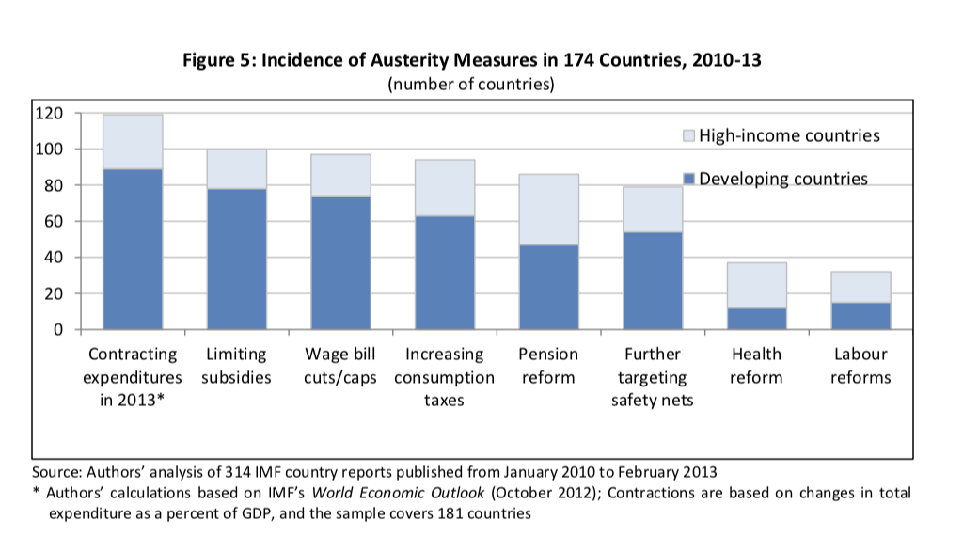

Developed economies and developing economies have very different policy prescriptions. It is useful to compare Ireland with Barbados. Both are tiny open economies with highly business friendly practices. Both had to impose austerity over the 2010-2013 period.

|  |  |  |  |  |  |  |  |
| --- | --- | --- | --- | --- | --- | --- | --- |
| Country | Limiting Subsidies | Wage bill cuts/caps | Increasing consumption taxes | Pension Reforms | Rationalising safety nets | Health Reform | Labour Reform |
| Ireland | X | X | X | X | X | X | X |
| Barbados |  | X | X |  |  | X |  |

Given the severity of the Irish episode, it is not surprising all austerity measures were introduced. Barbados, like many developing economies, saw changes in the labour market introduced, and these took the form of wage cuts and changes to the health system. Larger structural changes were not introduced.

In East Asia, the changes were far closer to Barbados than to Ireland, as Ortiz and Cummins report.

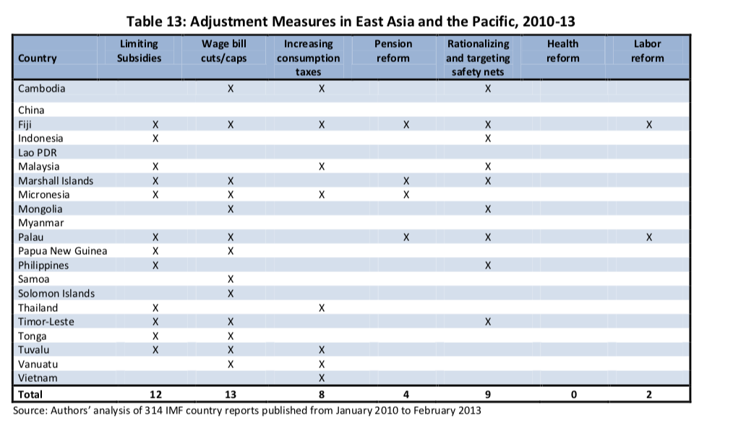

Food subsidies are of particular importance in developing economies. Food prices are typically a large source of uncertainty for poorer families. Limiting subsidies forces ‘local’ prices out of sync with global prices. The local price is typically far less reactive than global prices. Subsidies regimes which are less reactive are bound to cause some hardship if they are changed, as Ortiz and Cummins report on pages 27 and 28 of their study.

It is worth saying that in 2014 the IMF, in a sort of generalised *mea culpa,* rowed back on much of its previous policy stance, saying:

“IMF advocacy of fiscal consolidation proved to be premature for major advanced economies, as growth projections turned out to be optimistic. Moreover, the policy mix of fiscal consolidation coupled with monetary expansion that the IMF advocated for advanced economies since 2010 appears to be at odds with longstanding assessments of the relative effectiveness of these policies in the conditions prevailing after a financial crisis characterized by private debt overhang.”

Consider the Fording (2001) argument. State-level social controls work either by implicit or explicit threats of negative sanctions in the event of non-compliance. “We need austerity or the ATMs will be empty tomorrow.” This is a kind of coercive control. There are also rewards for compliance. “If we do what we say, we’ll pay our way in the world, we’ll get our national dignity back”. Many stories can be told about the dynamics of social control involved here which deeply involve the media.

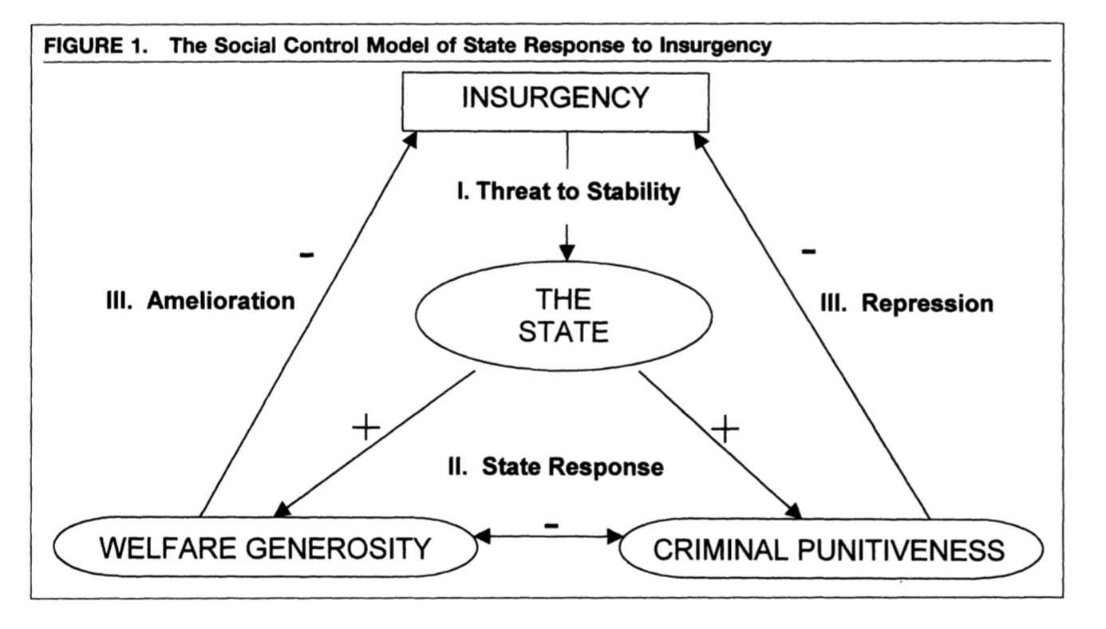

Another manner in which the state exerts more control is via periodic, and controlled, expansion of the welfare state. This calms the poor while increasing legitimacy for the incumbent government. As business cycles improve, the welfare state contracts. The argument is (neo)Marxist in tone and most closely associated with Piven and Cloward (1971). Obviously mixed strategies of beneficience and coercion are employed in the real world. The question is: which is the dominant strategy?

Fording notes the neo-pluralist interpretation of democratic politics relies on the assumpions that the public’s preferences can be communicated effectively to policy makers, that there is no policy making monopoly, that policy makers are responsive to any group which gains access to the policy arena.

The case for anti-austerity social protest, then, is to enter the policy arena using more or less unconventional political tactics. Fording finds evidence the social control perspective wins out over the neopluralist perspective when considering the case of black violence in the 1960s and 1970s in the USA. When levels of violence were low, there was weak electoral influence. When levels of violence was high, there was strong electoral influence, measured as an increase in the welfare state’s spending on these populations.

Ponticelli and Voth (2011) considered 1919 to 2008 and showed a clear corrleation between fiscal retrenchment and political instability. Countries with more constraints on the executive are less likely to see unrest after austerity measures.

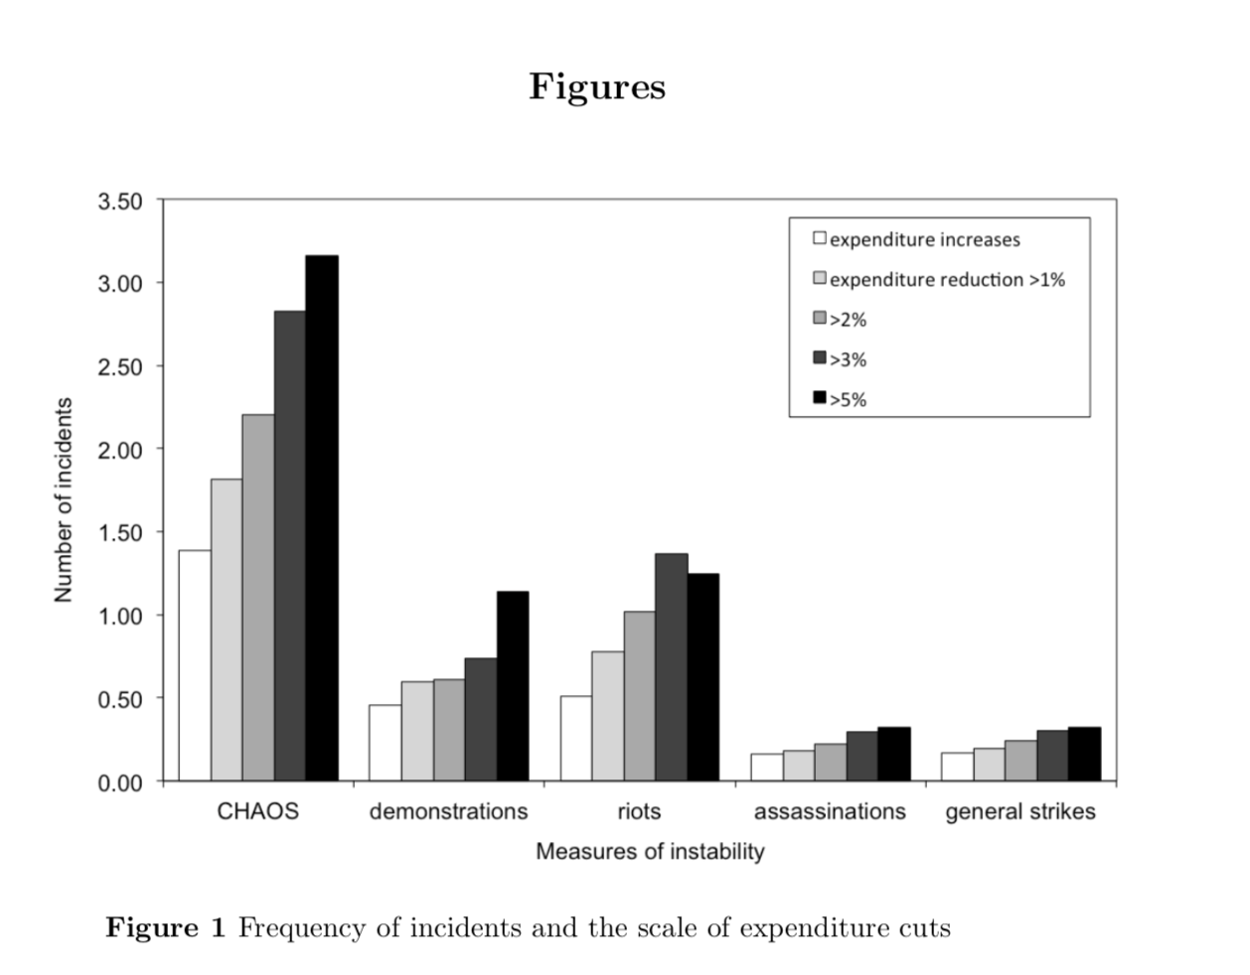

## 13.30-15.30 Comparing Experiences of Austerity: Case studies

We are going to break into groups now to discuss the following case studies. Six questions should giude your group discussion:

1. 1. Defining Austerity: can you see the change in government expenditure and increases in taxation?
2. What are the basic ‘macroeconomic’ and political facts of this case study?
3. Did the ‘channel’ of the crisis matter? (Eg a single bank crisis, a sovereign/bank crisis, etc)
4. What ‘form’ did austerity take? What measures were employed?
5. What were the distributional consequences?
6. How long did it last, and were there political after-effects of the turn to austerity?

The countries we will study are:

1. 1. Ireland
2. Romania
3. Australia
4. Belgium
5. Barbados
6. Canada
7. Germany

## AUSTRALIA

In 1984, the Australian Government introduced a multiyear program of fiscal consolidation, known as the Trilogy. Essentially, the Trilogy required the Government to

• ensure that the percentage of tax revenue did not exceed the 1984-85 share of taxation in the total economy

• reduce Commonwealth Government expenditure as a proportion of the total economy

• reduce the size of the deficit (1985-86 Budget Speech).

This program was introduced as a way of boosting public savings in response to large current account deficits in the early 1980s. Indeed, there was a significant rise in the Australian budget deficit following the recession of the early 1980s. When the Trilogy was introduced, the deficit was sitting at $10 billion, which, at the time, was the largest in the nation’s history. This state-of-affairs has been linked directly to a program of discretionary loosening (Gruen & Sayegh, 2005; Devries et al., 2011).

Thus, fiscal consolidation focused primarily on deficit reduction. For instance, spending cuts yielded cumulative savings of A$1.98 million over 1986-87 and A$1.45 billion over 1987-88. These cuts were generally applied to the states, social security, welfare, defence and transport (Devries et al., 2011).

In its first year, the Trilogy’s fiscal consolidation amounted to 0.45% of GDP. This amount increased to 1.02% in 1986, before reducing to 0.90% in 1987, and reducing further to 0.10% in 198 (Devries et al., 2011). The approach adopted as part of the Trilogy meant that the Government achieved its policy commitments. Five years after the Trilogy was introduced, the Government had converted a deficit of approximately 3.5% of GDP into a surplus of nearly 2%. As a result, the Trilogy principles were broadly maintained throughout the 1980s (Gruen & Sayegh, 2005).

References

Devries, P., Guajardo, J., Leigh, D., & Pescatori, A. (2011), A New Action-based Dataset of Fiscal Consolidation, IMF Working Paper, IMF, Washington.

Gruen, D. & Sayegh, A. (2005), The evolution of fiscal policy in Australia, Treasury Working Paper 2005-04, Treasury, Canberra.

## BARBADOS

The economy of Barbados is driven primarily by sugar and tourism. However, at the end of the 1980s, these two major exports were in decline. In addition, the domestic manufacturing sector was showing signs of weakness. Policies of aggressive fiscal expansion had created massive government deficits, which were financed both by international creditors, and then through borrowings from the Central Bank of Barbados. Unemployment rose, and government expenditure continued to increase. All of this had a negative effect on the balance of payments, and the current account deficit rose. To service this debt, the Government had to borrow from other major lenders, including the International Monetary Fund (Hilaire, 2001).

In response, the Government embarked on a major strategy of fiscal consolidation. Measures here included a stabilization tax of 1.5% on all incomes, increases in employer severance fund contributions, and increases in the consumption tax. Public expenditure was cut by 7%. Public sector wages were also cut by 8%, while 2,000 public sector employees were laid off. Public services also saw reductions in their budgets. Economic services and housing experienced reductions of two-thirds; education and health saw 50% drops; while the budgets of general public services remained almost completely intact (Van der Hoeven et al.,1995).

Through these measures, the Government achieved economic stability relatively quickly and by the second half of 1992 it was able to remove some restrictions on credit. At the same time, unemployment during fiscal consolidation had increased dramatically. Following stabilization, it remained above 20%. In addition, there was still some debts outstanding, particularly foreign debt, which were predicted to remain a problem for many years to come. As a result, the Government had to turn to the IMF for additional support. This was provided, on condition that the country embark on a program of structural adjustment. This included:

• Reform of direct and indirect taxes

• Trade reform

• Reform of the public sector

• Sectoral reform of international business, tourism, the financial sector, and agriculture (Van der Hoeven et al.,1995)

References

Hilaire, A. (2001), Economic Stabilization in the Caribbean, Finance & Development, Vol. 38, No. 1.

Van der Hoeven, R., Pyatt, G. & Richards, P. (1995), Structural adjustment and fiscal policy: A case study for Barbados, International Labour Organization, Geneva.

## BELGIUM

As a result of the oil shock in the early 1970s, Belgium’s economy saw a massive slowdown. This fact, combined with increased government spending, meant that the country’s budget deficit surged. By 1981, the deficit had reached a level of 16.1% of GDP. This fact was compounded by sluggish progress on several important macroeconomic indicators: flat economic growth; high unemployment, high inflation, and a current account deficit. Primary expenditure was also at historically high levels – some 52.6% of GDP (Bisciari et al., 2015).

In response, the incoming Belgian Government of 1982 placed the restoration of macroeconomic stability high on its priority list, focusing specifically on reducing the fiscal deficit to 7% of GNP by 1985. To meet this objective, the Government introduced policies that sought to restore global competitiveness, and create a better balance sheet for the country.

Given the high level of primary expenditure, the focus of these efforts was on reducing government spending. In 1982, fiscal consolidation amounted to 1.66% of GDP, and was based entirely on reductions in expenditure, with spending cuts amounting to some BF 69 billion. At the same time, the Government increased the value-added tax from 17% to 19%, which resulted in estimated savings of BF 15 billion. Other measures included adjustments to social security benefits, and increases in taxes on petrol products. Finally, the Government sought to reduce Belgium’s net borrowing target to 7% of GDP (Devries et al., 2011; Bisciari et al, 2015).

Over the period 1982 – 1987, the budget balance improved by 5.4% of GDP. This came on the back of large reductions in public sector investments, and meant that Belgium was no longer experiencing the record high levels of primary expenditure that it had previously experienced. These policies were successful in reducing the deficit, but did not keep debt from rising (Bisciari et al., 2015).

References

Bisciari, P., Eugene, B., Melyn, W., Schoonackers, R., Stinglhamber, P., Van Meensel, L. & Van Parys, P. (2015), Analysis of policies for restoring sound Belgian public finances, Economic Review of the National Bank of Belgium, National Bank of Belgium, Brussels.

Devries, P., Guajardo, J., Leigh, D., & Pescatori, A. (2011), A New Action-based Dataset of Fiscal Consolidation, IMF Working Paper, IMF, Washington.

## CANADA

Coming into the 1970s, Canada had enjoyed several decades of significant economic growth. This, however, was interrupted by the OPEC oil shock of 1973, which resulted in persistent patterns of slower GDP increases, higher inflation, and increases in unemployment. In response to these issues, the Canadian Government adopted a Keynesian approach and tried to address any fluctuations through counter-cyclical fiscal and monetary policies. However, this meant that deficits actually worsened, with governments maintaining or ramping up expenditure. All of this resulted in the accumulation of a massive debt and a financial crisis in the early 1990s, with significant growth in both the debt and the costs of servicing that debt (Di Matteo, 2017). All of this was compounded by the Mexican peso crisis, which plunged the country, which was already in a recession, into a financial crisis.

In an attempt to address these issues, the Canadian Government moved away from Keynesian approaches to resolving financial crisis. Fiscal consolidation here focused on reducing expenditure. The Expenditure Control Plan, which was announced in the 1990 budget, introduced cuts of $2.4 billion. Taxes were also increased, with an estimated budgetary impact of $3.3 billion. Over the course of the early 1990s, Government budgets were reduced through mandatory spending limits. Operating budgets were frozen, and the wages of Government Ministers and senior public servants were significantly tightened. Over the first half of the 1990s, average fiscal consolidation amounted to 0.46% of GDP. The ratio of spending cuts to tax increases was roughly 7:1, with cuts hitting the health portfolio particularly hard (Devries et al., 2011).

Canada’s approach was successful. Over the second half of the 1990s, debt--to GDP ratios dropped dramatically – from about 70% in 1995 to 55% in 1999. This trend continued over the early 2000s, and by 2006 debt was sitting at about 45% of GDP. In addition, despite predictions that Canada’s approach would amount to significant unemployment, there was no reduction in the employment rate. On the contrary, employment actually rose during this period (Henderson & Anderson, 2011). The federal budget then returned to surplus in the late 1990s, which was, in turn, used to increase spending on social programs in the early 2000s (Makarenko, 2009).

References

Devries, P., Guajardo, J., Leigh, D., & Pescatori, A. (2011), A New Action-based Dataset of Fiscal Consolidation, IMF Working Paper, IMF, Washington.

Di Matteo, L. (2017), A Federal Fiscal History, 1867 – 2017, The Fraser Institute, Van Couver.

Henderson, D. & Anderson, J. (2011), Canada’s reversed fiscal crisis, Working Paper: No. 11-25, George Mason University, Fairfax.

Makarenko, J. (2009), Federal Fiscal Policy in Canada: History, Operation, and Trends in the Global Recession, Mapleleafweb, http://www.mapleleafweb.com/features/federal-fiscal-policy-canada-history-operation-and-trends-global-recession.html#history, accessed 12 January 2018

## GERMANY

In 1982, Germany embarked on a fiscal consolidation program in response to local concerns over the large size of the deficit. According to the IMF, “calls from important groups within the private sector for a reduction of the fiscal deficit through comprehensive measures to slow down the growth of expenditures, including changes in social and other legislation. The strength of these calls suggested to the Government that the absence of decisive and reliable steps towards fiscal consolidation would harm the confidence of, in particular, investors” (Devries et al., 2011).

The Financial Planning Council, which consists of representatives of the Federal Government, the Länder, and local authorities recommended bringing the deficit in 1982 back to the 1980 level. In response to these concerns and recommendations, the Federal Government adopted a new medium-term fiscal consolidation plan in September 1981 consisting mainly of spending cuts, which was passed by Parliament in December 1981. This set of measures was denominated Operation '82. According to IMF Recent Economic Developments 1982 (pp. 27 and 104) and OECD Economic Surveys 1982 (p. 61), the measures for 1982 totaled DM 21.5 billion (split almost equally among revenues and spending) while additional measures of DM -5.7 billion were announced for 1984 (Devries et al., 2011).

This continued into 1983, and was motivated by deficit reduction. Fiscal consolidation amounted to 0.87 of GDP, with spending cuts of 0.57% of GDP, and tax increases amounting to 0.30% of GDP. This amounted to a total of DM 16.6 billion, while spending cuts amounted to DM 10.8 billion. Spending cuts focused on social programs (i.e. the child allowance) and on public sector salaries. Tax increases were applied to the value-added tax rate and the contribution rates for social security and unemployment insurance (Devries et al., 2011).

In 1984, fiscal consolidation was reduced to 0.18% of GDP, and was driven entirely by spending cuts. Continuing with this approach into the new year was a result of the perception of the need to maintain business confidence (Devries et al., 2011).

References

Devries, P., Guajardo, J., Leigh, D., & Pescatori, A. (2011), A New Action-based Dataset of Fiscal Consolidation, IMF Working Paper, IMF, Washington.

## IRELAND

Ireland in the late-20th and early-21st centuries was experiencing some of the fastest economic growth rates in the world. Indeed, during this period, Ireland saw improvements in exports; increases in domestic demand; and slow rates of growth in consumer prices. These factors were underpinned by an increased integration of Ireland with the global economy. Three factors have been cited here as being particularly relevant – foreign direct investment (FDI); the partial embeddedness of global corporate networks; and the integration of local networks of firms into global networks (O’Riain, 2000).

However, this favourable situation came to an end in 2007. The property market had, for several years, seen significant (and unsustainable) levels of growth driven by low levels of unemployment and rises in wages. This was also fuelled by poor lending practices from the banks. Ultimately, purchasers and developers embarked on a form of speculation, in which they bet on the continuance of price increases (Honohan, 2009). In the construction sector, developers built more houses than were necessary. This oversupply led to a significant drop in prices – the property market saw drops of 30% in the residential housing market, and 40% in the commercial property sector. All of this was compounded by the global financial crisis, which resulted in further depression of the Irish economy (Kelly, 2009; Honohan, 2009).

In response, the Irish Government introduced drastic austerity measures. Fiscal consolidation amounted to 4.74% of GDP, with spending measures amounting to 2.39% of GDP, and tax increases of 2.35%. This was primarily conducted as a way of reducing the budget deficit. This was well explained by the Irish Minister for Finance: “The problem is our expenditure base is too high and our revenue base is too low … Already, the share of tax revenues that go to service the national debt has risen from 5% in 2007 to more than 11% this year” (Devries et al., 2011). The approach also involved the Government providing a two-year guarantee of the liabilities of Irish-controlled banks. The corporate tax rate – which, at the time, was the lowest in the EU – remained unchanged at 12.5% in response to fears that any change would reduce FDI. This meant that tax increases had to be found in other areas, and transfers the balance of fiscal adjustment onto the public sector. In addition, value added tax was increased, and a universal social charge was put in place (Hardiman & Regan, 2013).

References

Honohan, P. (2009), Resolving Ireland’s Banking Crisis, Paper delivered at the UCD-Dublin Economic Workshop Conference, Dublin, 12 January

Devries, P., Guajardo, J., Leigh, D., & Pescatori, A. (2011), A New Action-based Dataset of Fiscal Consolidation, IMF Working Paper, IMF, Washington.

Hardiman, N. & Regan, A. (2013), The politics of austerity in Ireland, Intereconomics, Vol. 48, No. 1, pp. 4 – 32.

Kelly, M. (2009): The Irish credit bubble, Working Paper Series, UCD Centre for Economic Research, No. 09/32.

O’Riain, S. (2000). The flexible developmental state: globalization, information technology and the" Celtic Tiger". Politics and Society, 28(2), 157-193.

## ROMANIA

Between 1950 and 1975, the Romanian economy was one of the fastest growing in the world. However, this growth was based on investments in heavy industry, rather than on consumption. The economy overproduced goods from petrochemicals and steel, resulting in input shortages and capacity that was being used. This was compounded by issues related to corruption, statistical falsification, and the build-up of unproductive inventories. This state-of-affairs was only sustained through ongoing support from Western countries. Once the oil shock hit in the second half of the 1970s, Romania was burdened with extensive debts that it could not pay back. With only $400 million left in central bank reserves, the Government was forced to seek credit from the International Monetary Fund (IMF) (Bacon, 2004).

To meet its obligations to the IMF, the Government radically revised its 5-year plan, with the repayment of foreign debt the main priority. This meant that no new debt would be incurred from private lenders or other countries. All imports were drastically cut. The Government also reduced the supply of food and other important primary good; halved the production of consumer goods; and increased exports of those same goods. The push to reduce the debt became obsessive, and the Government resorted to drastic measures. For instance, 80% of the country’s gold reserves were sold in 1988 and 1989 (Ban, 2012). As a result, Romania produced one of the fastest reductions in debt-to-GDP ratios in the world. Similarly, the Government turned a current account deficit of $2 billion into a surplus of $9 billion.

This outcome, however, came at the cost of meeting the basic needs of citizens. The drastic austerity measures did not have a significant effect on income levels. However, overall standards of living dropped dramatically. Large drops in GDP were recorded: -0.5% in 1985, and -5.8% in 1989. Likewise, the Government reduced funding for basic services, including electricity, heating, food, housing and health. Other examples included reduction in imports of medical supplies, and reduced supplies of footwear, clothes and petrol. All this morphed into demands from workers that the Ceausescu regime be removed. The workers went on strike; government buildings were attacked; and Government symbols were destroyed. Following more anti-government protests in the town of Timisoara in 1989, the Ceausescu regime ordered the military to fire on civilians. This further antagonised the protestors, who engaged in additional protests – what has come to be known as the Romanian Revolution. Ceausescu and his wife fled the capital, but were ultimately captured and executed (Ban, 2012).

References

Bacon, W. (2004), ‘Economic Reform’, Romania Since 1989: Politics, Economics, and Society, Lexington Books, Lanham.

Ban, C. (2012), ‘Sovereign Debt, Austerity, and Regime Change: The Case of Nicolae Ceausescu’s Romania’, East European Politics and Societies, Vol. 26, No. 4, pp. 743 – 776.

**15.30-16.00 Coffee/Tea**

## 16.00-17.00 Discussion & Notes for Tuesday

**References (in sequence as mentioned in the lecture note text)**

Alesina, A., & Perotti, R. (1994). The political economy of growth: a critical survey of the recent literature. The World Bank Economic Review, 8(3), 351-371.

Alesina, A., & Perotti, R. (1995). The political economy of budget deficits. Staff Papers, 42(1), 1-31.

Alesina, A., Perotti, R., Tavares, J., Obstfeld, M., & Eichengreen, B. (1998). The political economy of fiscal adjustments. Brookings Papers on Economic Activity, 1998(1), 197-266.

Alesina, A., & Perotti, R. (1996). Fiscal discipline and the budget process. The American Economic Review, 86(2), 401-407.

Alesina, A., Favero, C., & Giavazzi, F. (2015). The output effect of fiscal consolidation plans. Journal of International Economics, 96, S19-S42.

Guajardo, J., Leigh, D., & Pescatori, A. (2014). Expansionary austerity? International evidence. Journal of the European Economic Association, 12(4), 949-968.

Alesina, A., Barbiero, O., Favero, C., Giavazzi, F., & Paradisi, M. (2017). The Effects of Fiscal Consolidations: Theory and Evidence (No. w23385). National Bureau of Economic Research.

Reinhart, C. M., Reinhart, V., & Trebesch, C. (2016). Global Cycles: Capital Flows, Commodities, and Sovereign Defaults, 1815–2015. The American Economic Review, 106(5), 574-580.

Wren-Lewis, S. (2015). The knowledge transmission mechanism and austerity (No. 160-2015). IMK at the Hans Boeckler Foundation, Macroeconomic Policy Institute.

Wren-Lewis, S. (2016). A general theory of austerity. BSG Working Paper Series, University of Oxford.

Blyth, M. (2013a). Austerity as ideology: A reply to my critics. Comparative European Politics, 11(6), 737-751.

Giavazzi, F., & Pagano, M. (1990). Can severe fiscal contractions be expansionary? Tales of two small European countries. NBER macroeconomics annual, 5, 75-111.

Alesina, A., & Ardagna, S. (2010). Large changes in fiscal policy: taxes versus spending. Tax policy and the economy, 24(1), 35-68.

Diamond, J., & Robinson, J. A. (Eds.). (2010). Natural experiments of history. Harvard University Press.

Jordà, Ò., & Taylor, A. M. (2016). The time for austerity: estimating the average treatment effect of fiscal policy. The Economic Journal, 126(590), 219-255.

Blyth, M. (2013b). Austerity: The history of a dangerous idea. Oxford University Press.

Lavoie, M. (2014). Post-Keynesian economics: new foundations. Edward Elgar Publishing.

Jayadev, A., & Konczal, M. (2010). When Is Austerity Right?: In Boom, Not Bust. Challenge, 53(6), 37-53.

Guajardo, J., Leigh, D., & Pescatori, A. (2014). Expansionary austerity? International evidence. Journal of the European Economic Association, 12(4), 949-968.

Bluedorn, J., & Leigh, D. (2011). Revisiting the twin deficits hypothesis: the effect of fiscal consolidation on the current account. IMF Economic Review, 59(4), 582-602.

Devries, P., Guajardo, J., Leigh, D., & Pescatori, A. (2011). A new action-based dataset of fiscal consolidation. IMF Working Paper

Ortiz, I., & Cummins, M. (2013). The age of austerity: a review of public expenditures and adjustment measures in 181 countries. IMF Working Paper

Balteanu, I., Erce, A., & Fernandez, L. (2011). Bank crises and sovereign defaults: Exploring the links. Bank of Spain.

Balteanu, I., & Erce, A. (2014). Bank crises and sovereign defaults in emerging markets: exploring the links (No. 184). Federal Reserve Bank of Dallas.

Erce, A. (2014). Cross‐Border Banking, Externalities And Sovereign Distress: Does The Euro Need A Common Banking Authority?. International Journal of Finance & Economics, 19(3), 188-203.

Candelon, B., & Palm, F. C. (2010). Banking and debt crises in Europe: The dangerous Liaisons?. De Economist, 158(1), 81-99.

Reinhart, C. M., & Trebesch, C. (2016). Sovereign debt relief and its aftermath. Journal of the European Economic Association, 14(1), 215-251.

Pazarbasioglu, C., Laeven, M. L., Nedelescu, O. M., Claessens, S., Valencia, F., Dobler, M., & Seal, K. (2011). Crisis management and resolution: Early lessons from the financial crisis. International Monetary Fund.

Honohan, P. (2008). Cross-country variation in household access to financial services. Journal of Banking & Finance, 32(11), 2493-2500.

McKinnon, R. I., & Pill, H. (1997). Credible economic liberalizations and overborrowing. The American Economic Review, 87(2), 189-193.

Lahiri, A., & Végh, C. A. (2003). Delaying the inevitable: interest rate defense and balance of payments crises. Journal of Political Economy, 111(2), 404-424.

Walter, A., & Sen, G. (2008). Analyzing the global political economy. Princeton University Press.

Cesa-Bianchi, A., & Rebucci, A. (2017). Does easing monetary policy increase financial instability?. Journal of Financial Stability, 30, 111-125.

Reinhart, C. M., & Rogoff, K. S. (2009). The aftermath of financial crises. American Economic Review, 99(2), 466-72.

De Paoli, B. (2009). Monetary policy and welfare in a small open economy. Journal of international Economics, 77(1), 11-22.

Cavallo, E. A., & Izquierdo, A. (2009). Dealing with an International Credit Crunch: Policy Responses to Sudden Stops in Latin America. Inter-American Development Bank.

Gennaioli, N., Martin, A., & Rossi, S. (2014). Sovereign default, domestic banks, and financial institutions. The Journal of Finance, 69(2), 819-866.

Candelon, B., & Palm, F. C. (2010). Banking and debt crises in Europe: The dangerous Liaisons?. De Economist, 158(1), 81-99.

Fording, R. C. (2001). The political response to black insurgency: A critical test of competing theories of the state. American Political Science Review, 95(1), 115-130.

Ponticelli, J., & Voth, H. J. (2017). Austerity and anarchy: Budget cuts and social unrest in Europe, 1919-2008.

Voth, H. J. (2012). The austerity trap: A century of unrest and budget cuts. In Annual Conference of the Institute for New Economic Thinking.