Welcome to Governing Challenges, Day 2

Yesterday was all about the definition of austerity, the intellectual history of the idea, the sources or channels of austerity and the practical, policy applications when it comes down to actually having to impose it.

Today we’ll look at the *impacts* of austerity on populations and sub populations (including children) affected, on groups, and between states. We’ll also look at the sectoral and political consequences.

## Key Readings for Day 2:

* • Andrew Walter and Gautam Sen, Analyzing the Global Political Economy, Princeton University Press, 2008. Chapters 1 and 2 especially. Link
* Murkand, Sharun and Rodrik, Dani ‘The Political Economy of Liberal Democracy”, mimeo, 2017. Link
* Cantillon, Bea, Yekaterina Chzhen, Sudhanshu Handa, and Brian Nolan, eds. Children of Austerity: Impact of the Great Recession on Child Poverty in Rich Countries. Oxford University Press, 2017, chapter 1 especially. Link
* Callan, Tim, Leventi, Chrysa, Levy, Horacio, Matsaganis, Manos, Paulus, Alari, and Sutherland, Holly The distributional effects of austerity measures: A comparison of six EU countries EUROMOD Working Paper EM6/11, 2011. Link
* Kat Chzhen on the effects of the economic crisis on children in high income countries Link

## Agenda

The agenda for today (again, prioritising discussion and synthesis over content delivery every time) is as follows.

0900-10.30 Recap and further observations from Day 1.

10.30-1100 Coffee

11.00-12.30 Distributional effects, Group Exercise on imposing austerity.

12.30-13.30 Lunch

13.30-15.30 Sectoral, Social, and Political effects of austerity

15.30-16.00 Coffee

16.00-17.00 Discussion & assessment preparation

## Recap & Further Observations

Recall the general definition of austerity (Blyth, 2013: 866–67)

“cutting the state’s budget to stabilise public finances, restore competitiveness through wage cuts, and create better investment expectations by lowering future tax burdens”

This definition requires that austerity contain an element of fiscal contraction, but also distributional change. It is also far from clear that austerity is ever expansionary. The latest research tends towards the view that austerity is in fact extremely contractionary.

Austerity is a kind of natural experiment where, by setting G - T on a path toward zero, we alter the savings and investment decisions of households, banks, central banks, and the rest of the world. Small open economy and developing economies are qualitatively different to larger economies which can influence the real interest rate, *r\**.

We must also consider the global aspects of austerity policies, and here we will draw on Walter and Sen (2008/2013).

## Global political economy

Walter and Sen (2013) describe international political economy as consisting of two sets of questions. The first concerns how politics constrains economic choices by actors and social groups. The second concerns how economic forces enable and constrain political choices, such as individuals’ voting behaviour, or firms’ lobbying, or internal and and edternaml policies.

Importantly, economic outcomes have political implications because they change the distribution of power.

We very often care about how *actual* policies are chosen, and what the consequences of those choices are, than deriving an optimal policy which may never see the light of day.

Two-level game analogy of IPE: different countries have different outcomes in responding to crises. Why?

Becker (1983) argued there is a demand for policies from interest groups, and governments supply these at various costs.

Keohane (1984/2005): institutions lower the cost of collective action.

1 explanation: domestic politics is solving a 2 level game between domestic interest groups and foreign powers.

Postive political economists (it’s all about preferences) vs constructivists (it’s all about ideas).

Biggest problem with IPE in 2018 is measurement. We don’t actually know how to model domestic politics and institutions and we don’t have good measurements either.

Ban (2016) discusses the development of the adoption of austerity between Romania and Portugal. He shows conclusively that the transmission of ideas—via PhD studies in the US—was a crucial difference in the adoption of austerity policies in each state. The degree to which ideas matter over rational policy/median voter theorem arguments is obviously contextually dependent, but it is clear ideas matter.

## 11.00-12.30 Sectoral, Social, Political Effects

*Austerity and Social Issues*

In *Children of Austerity,* Cantillon et al look at the experience of social protection systems across developed countries during and after the GFC. Child poverty increased from 2008 to 2013 in most European Area countries, with 2.6 million children more living in poverty.

At the outset, the 11 countries they study as cases differed in their set ups and approaches to child poverty alleviation. They find austerity worsened children’s lives throughout the period, but national political responses mattered far more than international dictats in the actual development of the policies.

*Austerity and Health*

McKee et al (2011) document large changes in health outcomes as a result of austerity. In countries which experienced austerity, there are worrying signs of increases in several infectious diseases, including malaria. In Greece the greatest concern relates to HIV infections, which have risen markedly in the past year, with the epidemic concentrated among a growing number of intravenous drug users. Data from elsewhere are still limited, but one study has shown a marked increase in attendances at Spanish general practitioners by those with mental disorders, especially depression.

Stuckler et al (2017) argue conceptually, austerity can impact on health through two mechanisms:

(i) a ‘social risk effect’ of increasing unemployment, poverty, homelessness and other socio-economic risk factors, while cutting effective social protection programmes that mitigate their risks to health (with the latter being an interaction between austerity and economic shocks); and

(ii) a ‘healthcare effect’ through cuts to healthcare services, as well as reductions in health coverage and restricting access to care.

Emma Bell (2017) describes the problem of austerity in the context of public sector reform. In the UK, Gamble has explained austerity in terms of ‘statecraft’. For him, it can be understood as a political strategy to pin the blame for the financial crisis on ‘irresponsible’ Labour economic policy and thus prove its own economic competence. As mentioned yesterday, Wren-Lewis (2017) developed what he terms a ‘general theory of austerity’ whereby the former Chancellor of the Exchequer flew in the face of economic evidence about the dangers of austerity in order to reduce public spending. State played a vital role in creating hegemonic consent around the austerity project. Clarke and Newman have explained with alacrity how this was done. Firstly, the crisis was ‘nationalised’ as blame was apportioned to New Labour rather than to the failures of global financial capitalism.

This justified swift and drastic action by the nation state to remedy the crisis. Secondly, the crisis was also personalised, presented as one caused by irresponsibility of individual citizens to live within their means and be self-sufficient. This is the ordo-liberal mindset once again—first save, then go shopping.

*Sectoral issues*

One of the key changes austerity shocks cause is sectoral in nature. Peck (2012, 2014, 2016) shows this in the context of urban development. The delivery of much of the day to day services of the state comes at local and municipal levels. These funding areas were one of the first to be targeted during the crisis, creating a funding gap Peck shows using chloropleths.

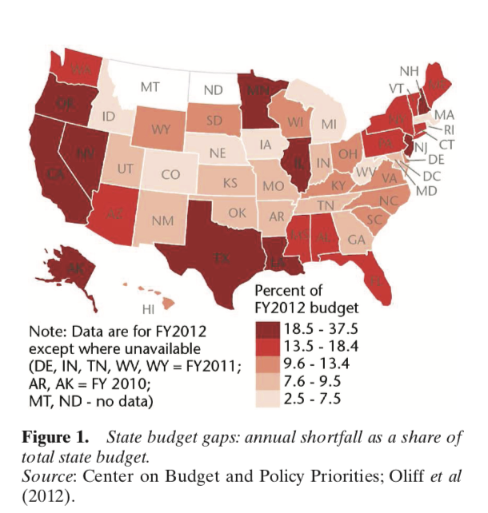

The funding gap forced a large increase in debt, thus a booming municipal bond market was born. This is a move from Keynesian redistributive federalism to scal devolution, debt- nancing and privatized credit. This is financialised urban development. The result is fragile urban financial systems.

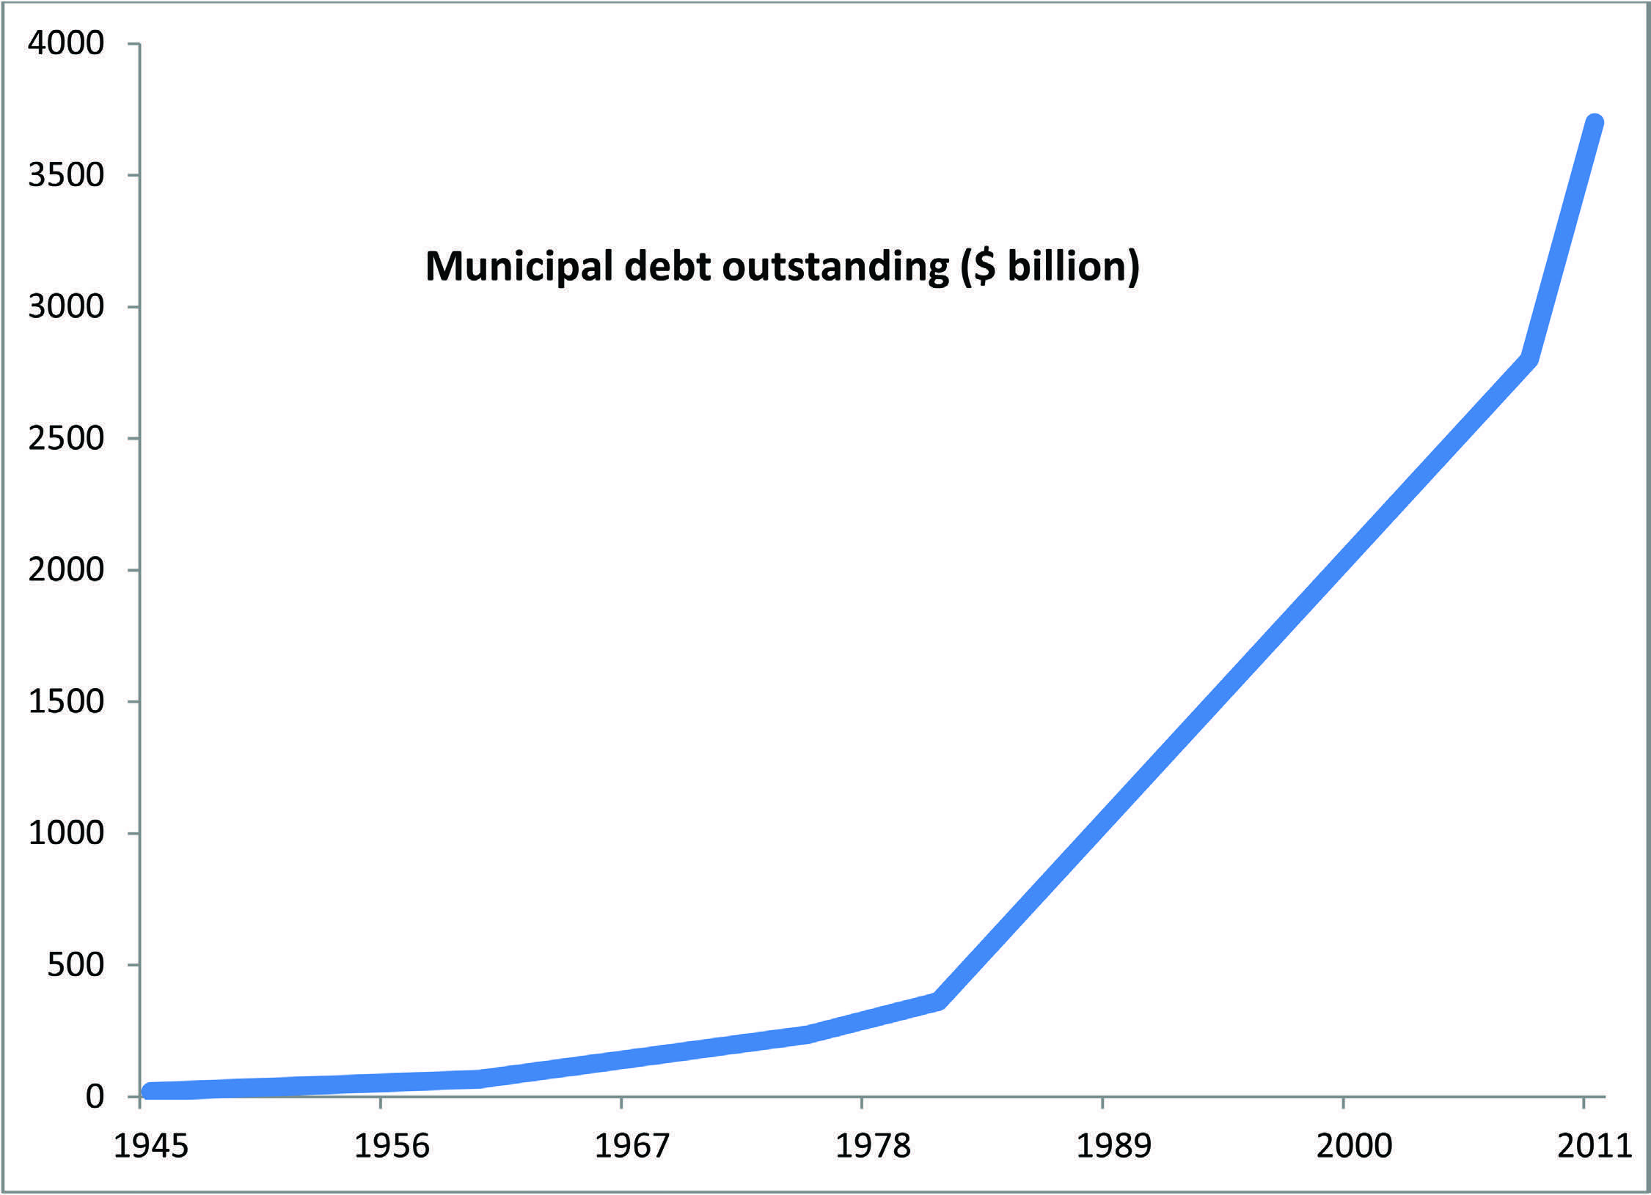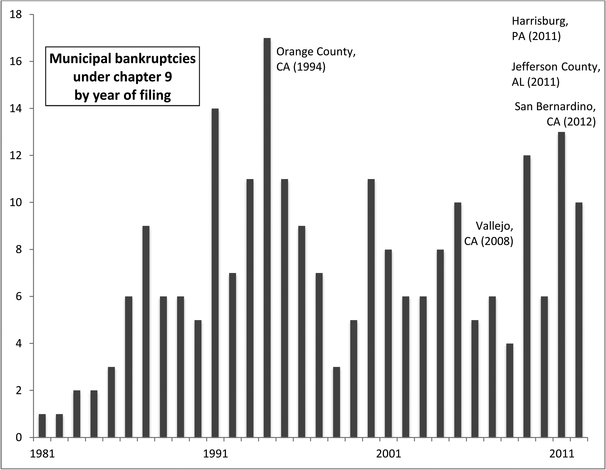

This pattern is also true at the small state level. Here for example is an event study for Ireland’s 10 year bond yield, a measure of the solvency of the state.

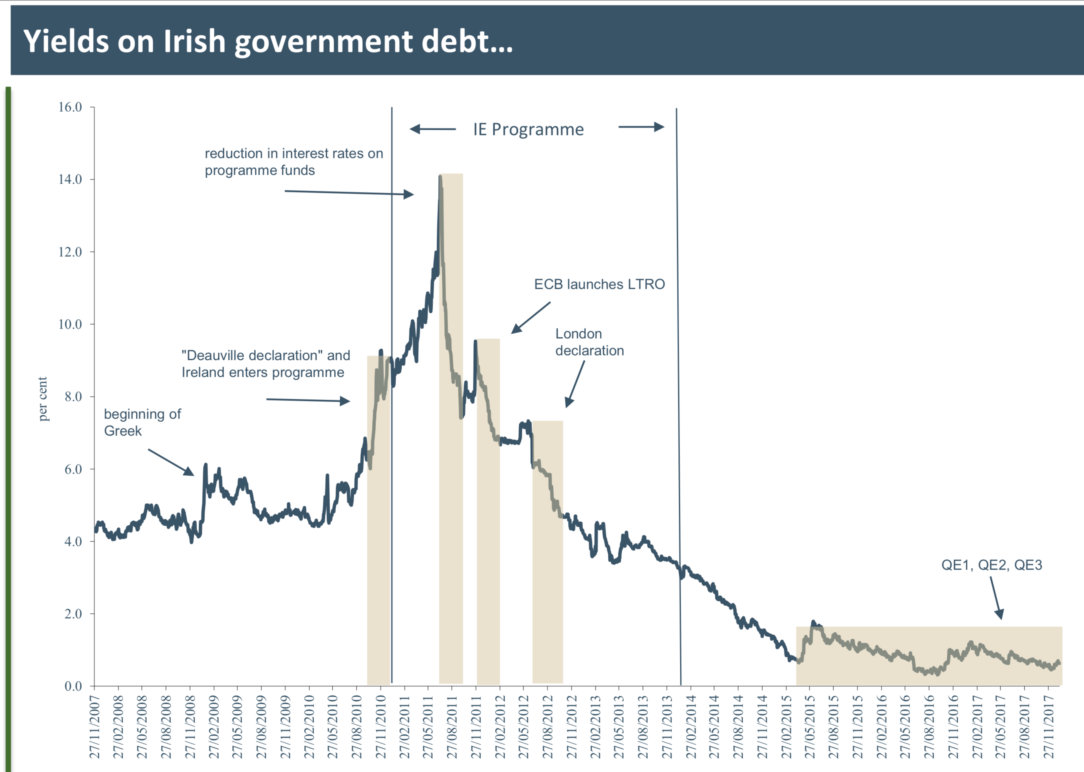

## 13.30-15.30 Distributional effects

Ball et al, 2013 consider the distributional impacts of fiscal consolidation from 1978 to 2009. They find, unsurprisingly, that that fiscal consolidation has typically had significant distributional effects by raising inequality, decreasing wage income shares and increasing long-term unemployment. The evidence also suggests that spending-based adjustments have had, on average, larger distributional effects than tax-based adjustments.

In particular, they find fiscal consolidations in their data set:

1. 1. increased inequality by 0.1 percentage point (about 0.4 percent) in the very short term, and by 0.9 percentage point (about 3.4 percent) over the medium term;
2. led to a significant and long-lasting fall in the wage income share of about 0.8 percentage point of GDP; and
3. raised long-term unemployment by about 0.5 percent over the medium term.

Their main results are shown graphically below.

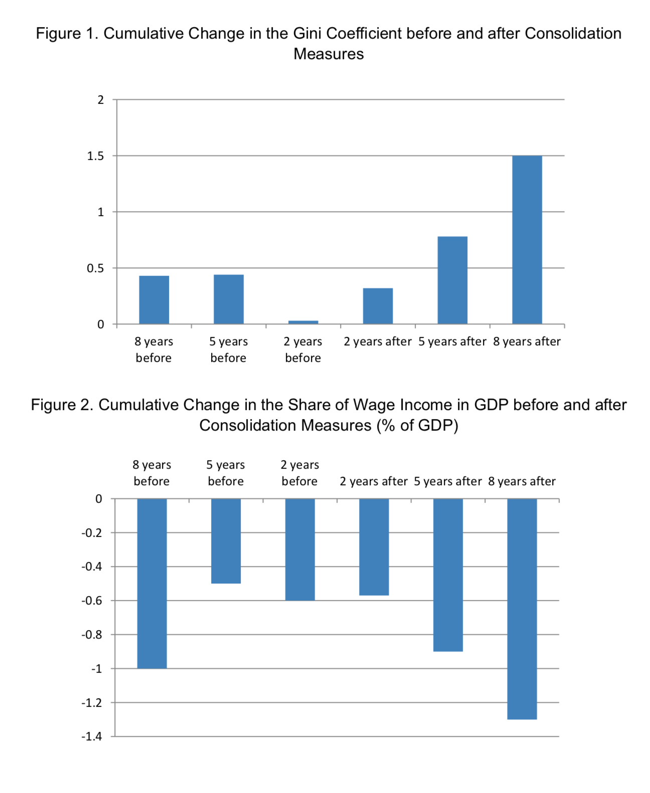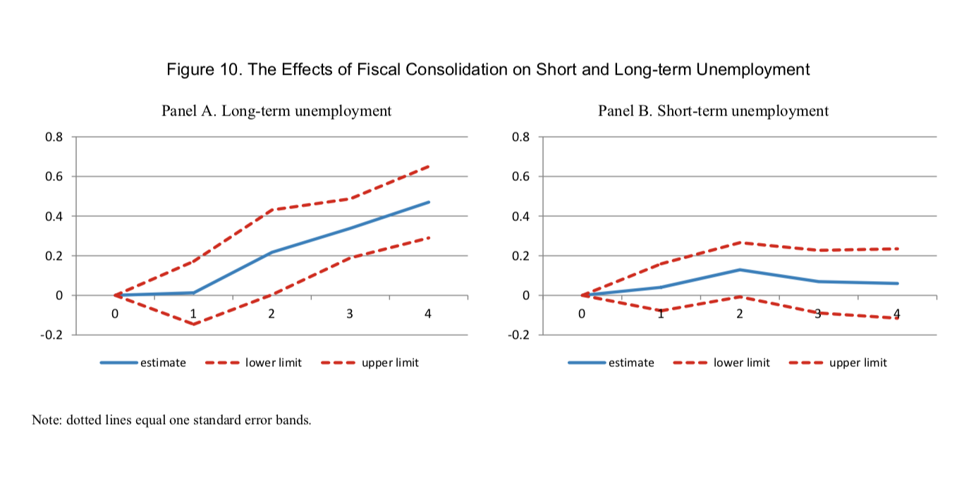

These results are for OECD countries, it is important to note smaller, and developing economies, will have qualitatively different, and perhaps more extreme, results.

For example, here is the latest Survey of Income and Living Condition data across the European Union.

.

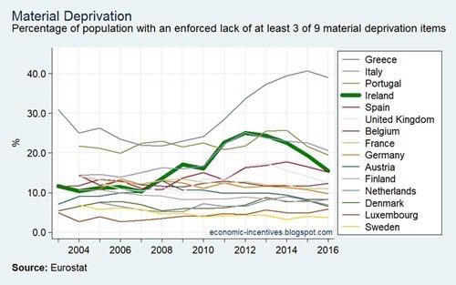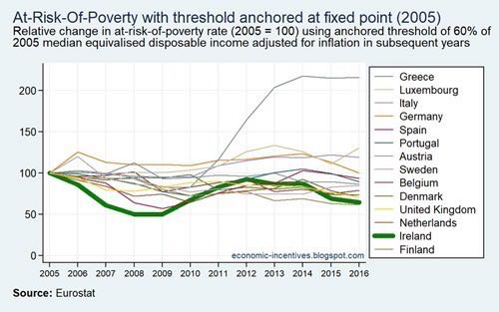

And we can see the year-on-year changes in the components of the deprivation index for Ireland here. This table shows the year on year change in the percentage of the population experiencing each ‘type’ of deprivation. The red colours show a negative change, i.e., things getting worse, relative to the previous year. The green colours show things getting better. The individual elements of the deprivation measure are important in and of themselves. Much of the effects of austerity can only be discerned at this level, or lower. Macroeconomic measures will not suffice.

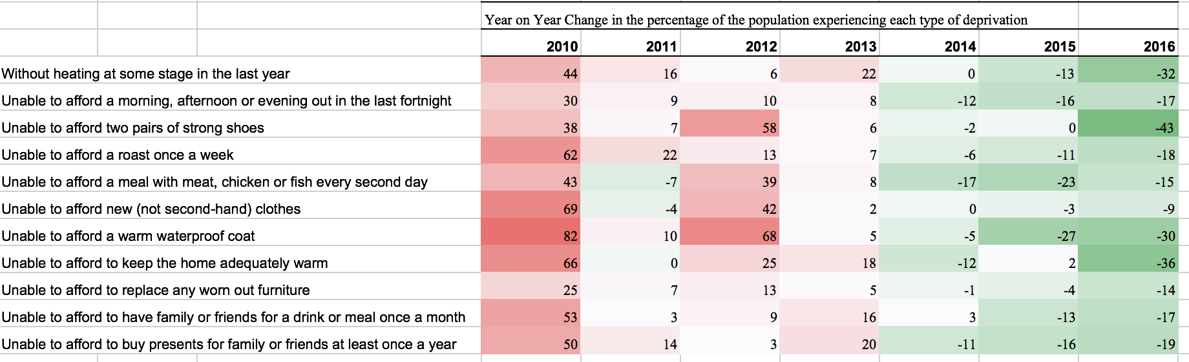

## Permanent effects of austerity: hysteresis

Fatas and Summers (2017) document a long-run problem with austerity. Its effects are negative in the short run, but Fatas and Summers show it has negative effects for far longer than we thought. DeLong and Summers (2012) argue for *self-defeating fiscal consolidations*, i.e. reductions in deficits that end up delivering higher debt-to-GDP ratios because of their negative effects on GDP growth. This has strong implications for the assessment of economic policies during the crisis and provides strong support for the notion that austerity policies not only have caused significant temporary damage to growth but that they might have resulted in exactly the opposite outcome that they were seeking by permanently reducing output.

Cerra and Saxena (2008) produce evidence that after financial and political crises output losses are very persistent even after taking into account the possibility of endogeneity. Using a much longer time horizon Reinhart and Rogoff (2014) also show that recovery from financial crisis is slower than from a regular crisis. This table reports the regression results from Fatas and Summers (2017). They focus on forecasting errors as a result of fiscal consolidation.

The results show that the planned fiscal consolidation of the years 2010-11 had a strong and significantly negative effect on the 2014 and 2019 forecast error on potential output. The effects are the largest for the Euro area, where the fiscal consolidation of 2010-11 helps explain more than 40% of the variation in potential output forecast errors among the 14 countries in the sample.

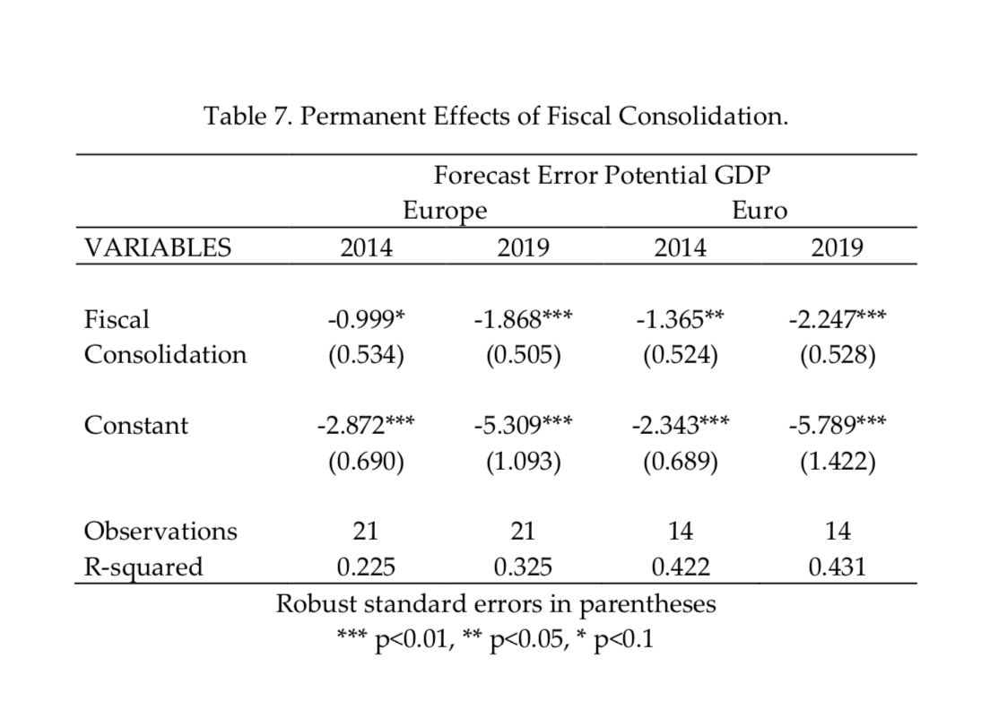

**References**

Becker, G. S. (1983). A theory of competition among pressure groups for political influence. The quarterly journal of economics, 98(3), 371-400.

Walter, A., & Sen, G. (2008). Analyzing the global political economy. Princeton University Press.

Keohane, R. O. (1984/2005). After hegemony: Cooperation and discord in the world political economy. Princeton University Press.

Ban, C. (2016). Ruling Ideas: How Global Neoliberalism Goes Local. Oxford University Press.

Ortiz, I., & Cummins, M. (2013). Austerity measures in developing countries: Public expenditure trends and the risks to children and women. Feminist Economics, 19(3), 55-81.

Cantillon, B., Chzhen, Y., Handa, S., & Nolan, B. (Eds.). (2017). Children of Austerity: Impact of the Great Recession on Child Poverty in Rich Countries. Oxford University Press.

Roche, W. K., O'Connell, P. J., & Prothero, A. (Eds.). (2016). Austerity and Recovery in Ireland: Europe's Poster Child and the Great Recession. Oxford University Press.

Karanikolos, M., Mladovsky, P., Cylus, J., Thomson, S., Basu, S., Stuckler, D., ... & McKee, M. (2013). Financial crisis, austerity, and health in Europe. The Lancet, 381(9874), 1323-1331.

McKee, M., Karanikolos, M., Belcher, P., & Stuckler, D. (2012). Austerity: a failed experiment on the people of Europe. Clinical medicine, 12(4), 346-350.

Reeves, A., McKee, M., Basu, S., & Stuckler, D. (2014). The political economy of austerity and healthcare: Cross-national analysis of expenditure changes in 27 European nations 1995–2011. Health policy, 115(1), 1-8.

Bell, E. (2017). Shrinking the State? Change and continuity in public service reform. Observatoire de la société britannique.

Peck, J. (2012). Austerity urbanism: American cities under extreme economy. City, 16(6), 626-655.

Peck, J. (2014). Pushing austerity: state failure, municipal bankruptcy and the crises of fiscal federalism in the USA. Cambridge Journal of Regions, Economy and Society, 7(1), 17-44.

Peck, J., & Theodore, N. (2012). Reanimating neoliberalism: process geographies of neoliberalisation. Social Anthropology, 20(2), 177-185.

Ball, L. M., Furceri, D., Leigh, M. D., & Loungani, M. P. (2013). The distributional effects of fiscal consolidation (No. 13-151). International Monetary Fund.

Fatás, A., & Summers, L. H. (2016). The permanent effects of fiscal consolidations (No. w22374). National Bureau of Economic Research.

Fatás, A., & Mihov, I. (2010). Fiscal policy at a crossroads: The need for constrained discretion. Completing the Eurozone Rescue: What more needs to be done.

DeLong, J. B., & Summers, L. H. (2012). Fiscal policy in a depressed economy. Brookings Papers on Economic Activity, 2012(1), 233-297.

Cerra, V., & Saxena, S. C. (2008). Growth dynamics: the myth of economic recovery. American Economic Review, 98(1), 439-57.

Reinhart, C. M., & Rogoff, K. S. (2014). Recovery from financial crises: Evidence from 100 episodes. The American Economic Review, 104(5), 50-55.

Cerra, V., Panizza, U., & Saxena, S. C. (2013). International evidence on recovery from recessions. Contemporary Economic Policy, 31(2), 424-439.