Welcome to Governing Challenges Day 3!

# Introduction

The first two days introduced the definition, general idea, history, causes, implementation, and distributional consequences of austerity. We explored the social, political, and economic effects of austerity and the diffusion of the idea across political economies.

Not bad for 16 hours’ work!

Today we look at the domestic political economy of the study of austerity using a policy simulation.

## Agenda

9-10 Recap and introduction to the policy simulation

10-11 *t*

11-12 *t+1*

12-1 Lunch

1-2 *t+2*

2-3 *t+3*

3-4 *t+4*, discussion

4-4.40 Concluding discussion and assignment feedback.

## Why a policy simulation?

Simulations of policy changes employ critical and evaluative thinking. Like austerity, the policy simulation is by design an ambiguous and open-ended process. It encourages students to contemplate the implications of a scenario.

Simulations promote concept attainment through experiential practice (Dolbear *et al*, 1968). They help students understand the nuances of a concept like austerity.

The response to austerity depends on who you are, and who you represent. The policy simulation will take place within your group. Data will be provided on a fictional country. The data will advance in time. The group will represent an individual nation.

Each member of the group will adopt a ‘position’ within society. First, a politician in power, say a Minister for Finance. Second, an opposition politician. Third an advisor to the Minister for Finance in economics and politics. Fourth, a representative of the media. Fifth, a representative of civil society (for example, Unions). We will examine the ‘pace layers’ of the unfolding crisis as well as looking carefully at the ‘national’ responses to austerity as well as the sectoral responses.

## Roles and rules

The rules of the game are simple. Time evolves the situtation. There are four time periods to make decisions in, but the simulation runs from *t-3* to *t+3*. You are given the data for *t-3* to *t*. with each hour or 45 minute segment in class analogous to one ‘year’ or period *t, t+1, t+2, t+3*. These are from 10-11, 11-12, 12-1, and 2-3 today. There is no set goal, other than to capture the inter-sectoral dialogue of the sectors.

Each student represents an actor or a sector within an individual economy. These ‘roles’ in each country are:

1. 1. The Minister for Finance
2. An opposition politician
3. The Minister’s policy advisor
4. Civic society
5. The media

Other important roles are

1. 1. The IMF
2. Other international insitutions representing creditors’ interests (ECB, EU, etc)
3. The Bond Markets

## News drives the simulation

There are two types of news, internally generated news from the interactions of the agents, and externally generated news either from economic or political data, and of course the international institutions.

**At the start of the simulation, you will be given ‘public’ data, some projections, and a rough outline of the political and economic situation. You will also have ‘private’ data on the individual incentives your actor-class faces.**

You must decide how to act next as events unfold. Other countries and institutions will react as well, and this may affect the agent you represent. You may affect them. Country size will matter, as will the political leanings of the government(s) in power and the relative strength of the institutional actors you represent.

You will prepare responses to demands from the international institutions, and deal with internal issues like handovers of power, scandals, pro- or anti-austerity media, or business lobbies, or banking crises.

The ‘role’ each student plays is both public and private. The ‘public’ element consists of the statements each agent makes at different points in the simulation. The ‘private’ element consists of your individual incentives and reactions to those.

For example, imagine you are the media. You are confronted with explaining changes in unemployment, changes in debt/gdp ratios, and changes in the external conditions every sector of the economy faces, while your own revenue base—from property advertisements—dwindles. You can choose how to react here. The political system will seek to control you, to ‘act in the national interest’. You can choose to expose scandal, or not. You can also choose how to report the news of the day based on your political priors, and this may change expectations.

News will be delivered from the instructor’s computer and via regular printouts. The data will be tabular and graphical, and will be responsive to students’ decisions.

These are macroeconomic data. The basic model we will need to think about looks like this.

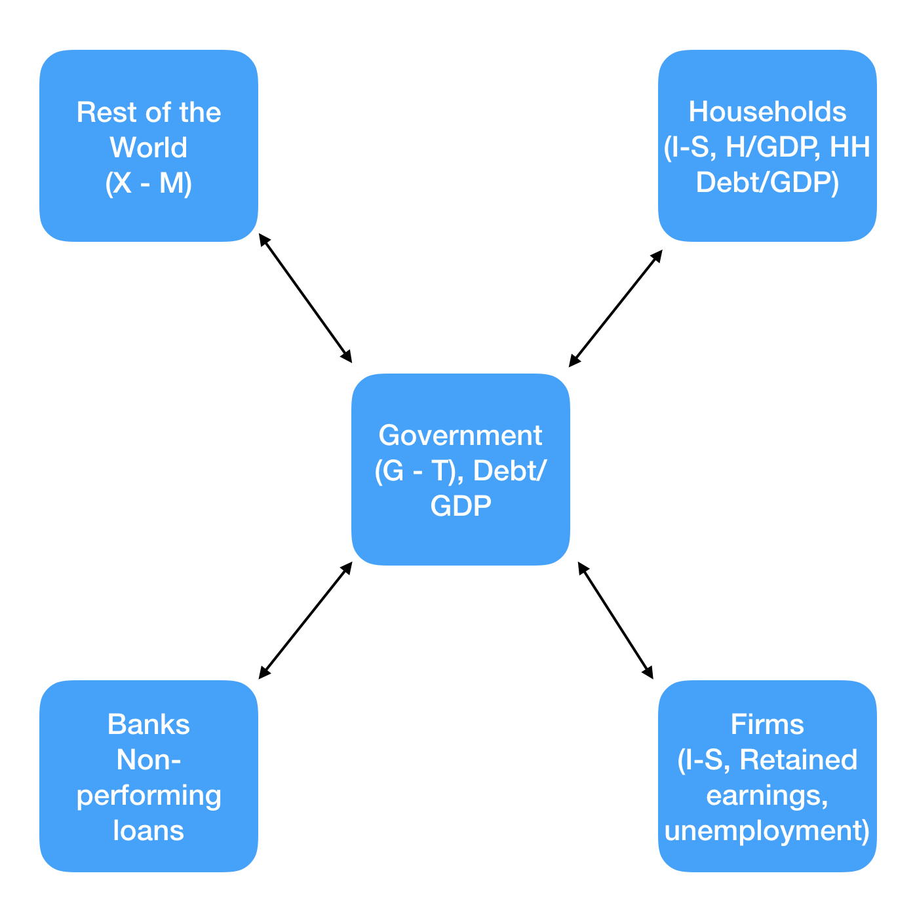

When economists want to dig deeper and look at the state of health of the country, they look at three basic variables:

1. 1. Output growth—the rate of change of output measured as GDP;
2. The unemployment rate—the proportion of workers in the economy who are not employed and are looking for a job;
3. The inflation rate—the rate at which the average price of the goods in the economy is increasing over time.

If a country is a member of a moentary union, it is susceptible to capital inflows, inappropriate monetary policies, and course, it lacks one crucial channel to offset the effects of crisis periods. If euro-area countries had their own currency, they very likely would have decreased their interest rate or depreciated their currency vis à vis other euro members to increase the demand for their exports during the GFC. Because they share a currency with their neighbours, this is not possible.

We also need to look at individual sectors of the economy, such as households, firms (often called ‘non-financial corporates’ in official statistics), the government, the banking system (often called ‘financial corporates’) and the external, or rest of world, sector.

The Balance of Payments is a very important measurement when considering the rest of the world. It is a simple numerical sum of the following elements.

1. The Trade balance: Exports less imports (𝑋−𝑀)

2. The Current account: Trade balance + Net interest & profits (from assets)

3. The Capital & Financial account: Changes in foreign assets owned by home residents, home assets owned by foreign residents, and the CB’s forex reserves.

This gives us

𝐵𝑃 ≡ ((𝑋−𝑀)+𝑛𝑒𝑡 𝑖𝑛𝑡𝑒𝑟𝑒𝑠𝑡 𝑟𝑒𝑐𝑒𝑖𝑝𝑡𝑠) + (𝑝𝑟𝑖𝑣𝑎𝑡𝑒 𝑛𝑒𝑡 𝑐𝑎𝑝𝑖𝑡𝑎𝑙 𝑓𝑙𝑜𝑤𝑠−𝑐ℎ𝑎𝑛𝑔𝑒 𝑖𝑛 𝑓𝑜𝑟𝑒𝑥 𝑟𝑒𝑠𝑒𝑟𝑣𝑒𝑠).

Or in textbook-style algebra:

𝐵𝑃 ≡ (𝐵𝑇+𝐼𝑁𝑇)+ (𝐹−Δ𝑅) ≡ 0

The balance of payments records the sources and uses of foreign exchange and sums to zero. For example, let’s say there’s a trade surplus.

Algebraically, (𝑋>𝑀) implying Home wealth must increase. This has to be used to either purchase foreign assets or increase reserves.

For the purposes of the policy simulation, you will be treating measurements like the Balance of Payments as data in your decision-making process.

## Decision making process

News can be both private and public. It is submitted on paper to the group, or to an individual. The ‘reaction’ to the news must be noted, both publically and privately. The players can then choose what to do with this news. The simulation will then change, depending upon the outcome.

For example, let’s say the interest rate on sovereign borrowing has just gone up. This is public news. So is an increase in the headline unemployment rate. The ‘union’ player can agitate for an increase in benefits, or a cancelling of the sovereign debt, or another policy such as leaving the monetary union. The ‘opposition’ player can choose to oppose this, the media can choose to brief against, or for this, and so forth. The impact of the decision on polling and on the economy’s finances will be announced later.

## References

Dolbear, F. T., Attiyeh, R., & Brainard, W. C. (1968). A simulation policy game for teaching macroeconomics. The American Economic Review, 58(2), 458-468.

Keys, B., & Wolfe, J. (1990). The role of management games and simulations in education and research. Journal of management, 16(2), 307-336.

Smith, E. T., & Boyer, M. A. (1996). Designing in-class simulations. PS: Political Science and Politics, 29(4), 690-694.