Customizable Section – life cycle –

Simulation Authorizing phase

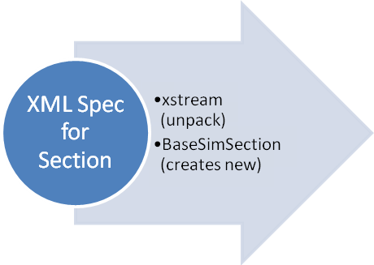
New Section
POJO

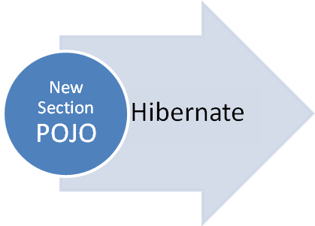
MySQL
Persistent Storage for
new Section definition and content

Simulation Play phase
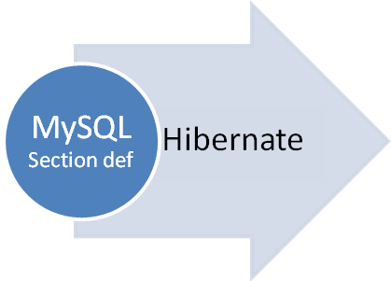
Section in
Running Sim
POJO

Another way to show this is to do a couple of sequence diagrams. One would show the call and return of the new object, it’s information, etc.

I’m not sure I know just who calls whom. If you will provide the steps
e.g.
- Author prepares xml definition of new sim section
- Something calls something…
- BaseSimSection passes the xml (file? string?) to xstream which unpackages it and passes it back as an object of type BaseSimSection
- If it’s truly unique (i.e. not same section id, same author, same organization) the new section is added to the database of available sections and
- Author puts a copy of the new section into his simulation
- Later, the section, along with all the other content of the new simulation is pulled out of the MySQL database by hibernate in response to the simulation startup process (creating a RunningSimulation)

BaseSimSection class creates new BaseSimSection objects from xml, using xstream to unpackage the objects

. . . .

public static BaseSimSection unpackageXML(String xmlString) {

XStream xstream = new XStream(new DomDriver());
xstream.alias("bss", BaseSimSection.class);

return (BaseSimSection) xstream.fromXML(xmlString);
. . . .

Something like this, but with the correct calls to the correct methods in the correct order, etc. A collaboration diagram would also do a good job of

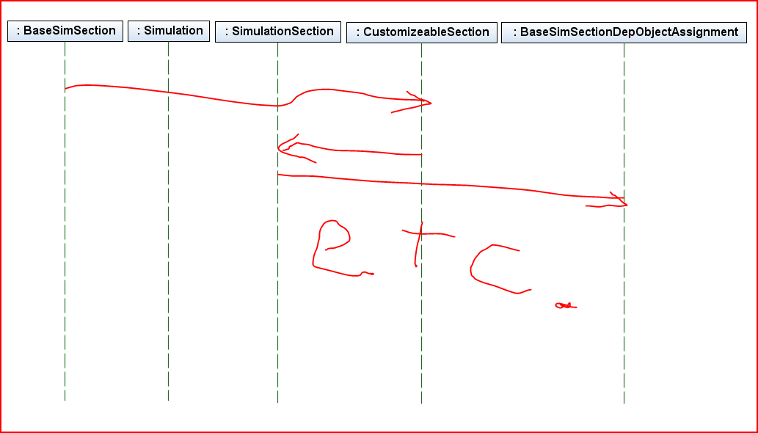
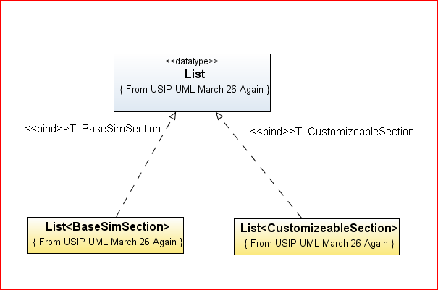
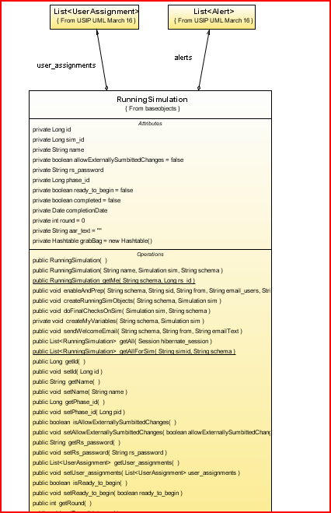

Shared Doc

Section 1

Section 2

Probably don’t want this…
