ST2403 Time-to-Event Analysis Assignment #1
Oleh Kizilov
124712325
The assignment is all my own work and I have not used any AI

Intro.
In this report my goal is to explore the asthma dataset and determine which factors are most significant predictors when it comes to readmission of children who have been previously discharged from the hospital.

Methods.
The statistical methods I am about to use are Kaplan-Meier, Log-rank test and Cox regression. Kaplan-Meier will be useful for visualising time to readmission over time, Log-rank will determine whether the factors such as hospital / sex of a patient are statistically significant, and Cox regression will show the hazard ratios of those factors.

Answers.
Q1
First, we have to consider in detail the association between hospital and time to readmission, ignoring other factors. For this task I will load the dataset and set the data as survival-time data where “time” is the follow-up period and “readmit” is the failure event.
Now it is possible to plot the first Kaplan-Meir graph
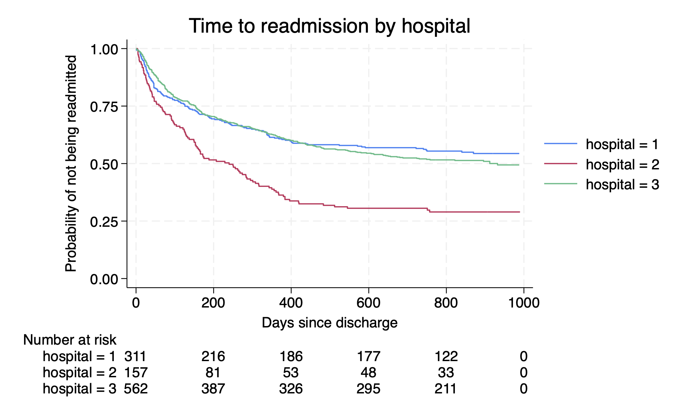
This graph shows a significant difference between hospitals 1, 2 and 3, where hospital 3 is way more likely to have a patient readmitted, but this graph is only a fraction of a whole picture, so we have to dig deeper.
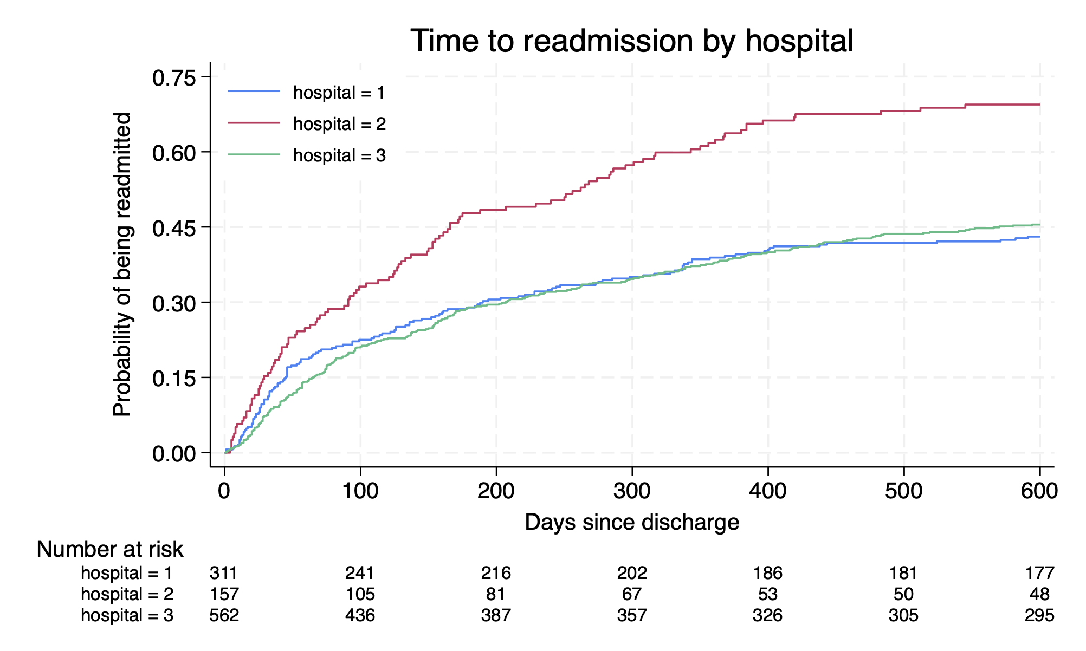
Using the failure function instead, allows us to zoom in, strip the extra space and see the difference more clearly. By the day 600 the number of patients left in the study in hospital 2 less than a third of patients who entered a study. This is vastly different from hospital 1 and 3, in which more than a half have stayed with no events by the day 600. To verify the significance of this difference, we use the log-rank test:

hospital | Observed events | Expected events
1 | 140 | 163.03
2 | 11 | 65.22
3 | 171 | 293.75
Total | 522 | 522.00

chi2(2) = 37.36
Pr>chi2 = 0.0000

The p-value is shown to be 0, this tells us that the difference is, in fact, significant.

Q2
In this question it’s time to consider other variables that might explain the difference in readmission rates between the hospitals.

Summary of age (years)

hospital | Mean | Std. dev. | Freq.
1 | 4.4225806 | 3.0073491 | 310
2 | 11.751592 | 3.2297814 | 157
3 | 4.4652406 | 3.0642152 | 561
Total | 5.5651751 | 4.0411868 | 1028

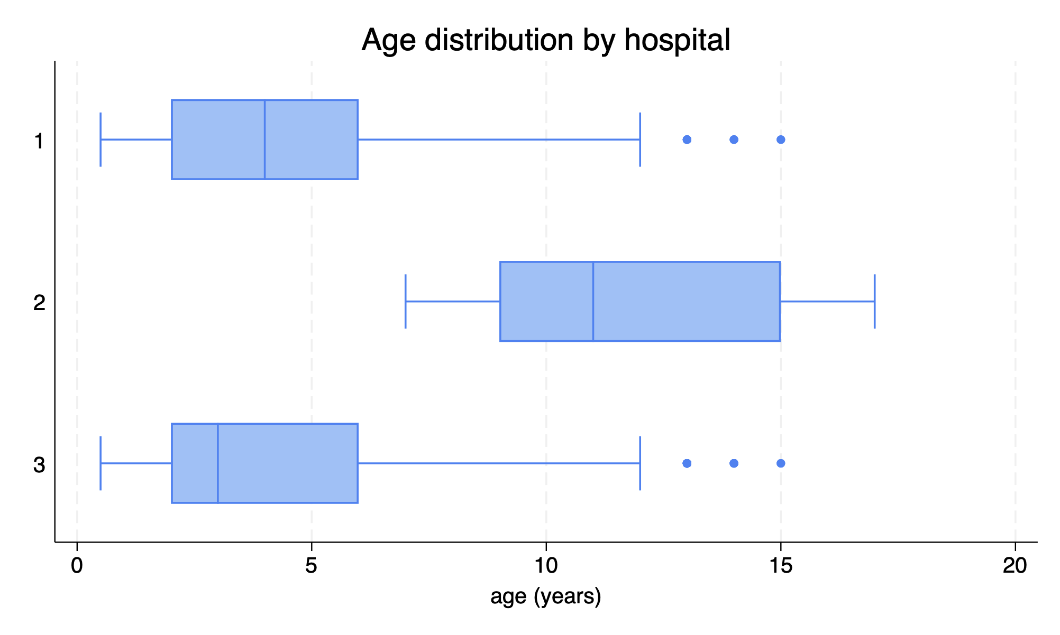
Building a table and a boxplot of age distribution by hospital shows a clear difference of ages between hospitals 1, 2 and 3, which lines up perfectly with previous observations. The reason why readmission rates are so high in hospital 2 could now be explained by the fact that patients there are 11.75 years old on average compared to 4.42 and 4.47 in hospitals 1 and 3 respectively. Trying to account for the age gap between patients in those hospitals would perhaps tell us more
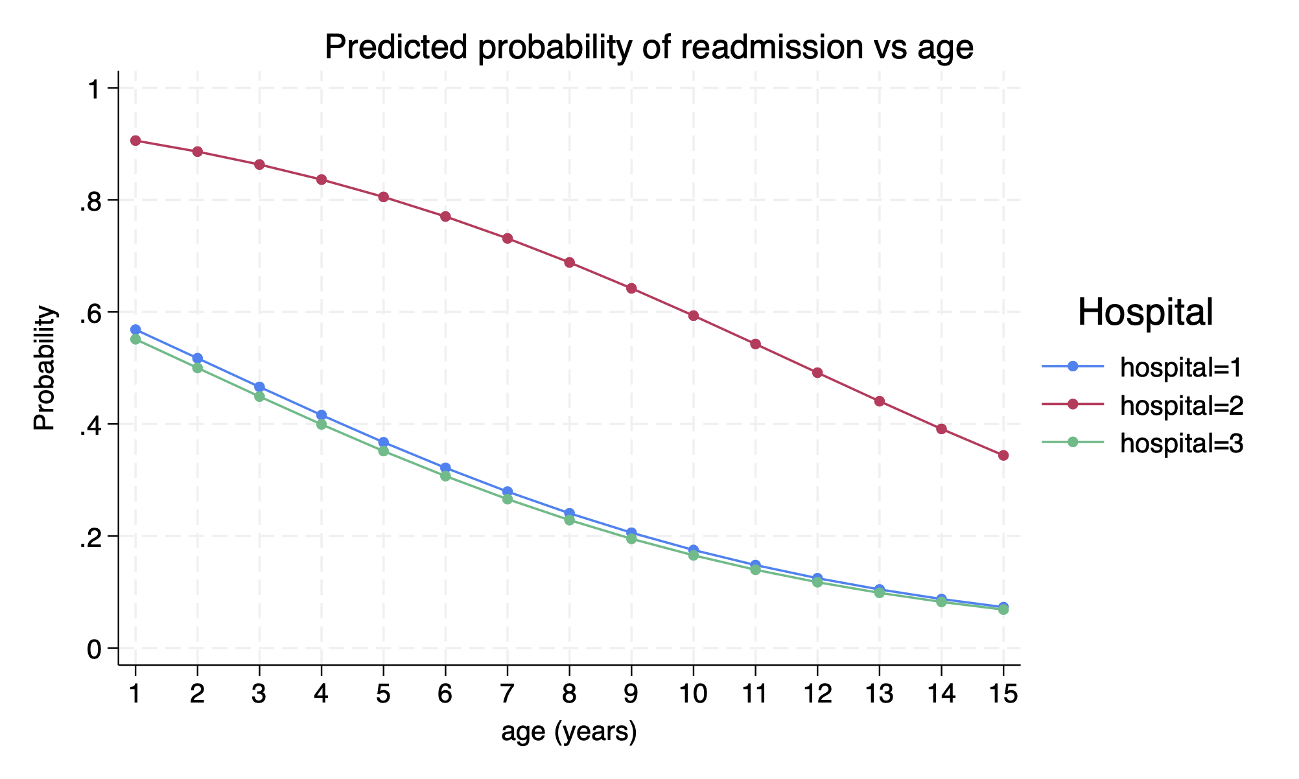
This graph shows that a child at hospital 2 is still substantially more likely to be readmitted than one in hospital 1 or 3, it also shows that older children are way less likely to be readmitted.

Q3
Cox regression with Breslow method for ties

No. of subjects = 1,010 Number of obs = 1,010
No. of failures = 509
Time at risk = 519,473
LR chi2(7) = 126.09
Log likelihood = -3288.1718 Prob > chi2 = 0.0000

_t | Haz. ratio | Std. err. | z | P>z | [95% conf. interval]
hospital
2 | 4.765246 | .919914 | 8.09 | 0.000 | 3.264103 | 6.956757
3 | 1.089572 | .1148691 | 0.81 | 0.416 | .8861702 | 1.33966
age | .8621168 | .0177781 | -7.19 | 0.000 | .8279672 | .897675
sex
boy | .8073517 | .0732495 | -2.36 | 0.018 | .6758259 | .9644743
wheeze | .9998585 | .0006485 | -0.22 | 0.827 | .9985883 | 1.00113
admiss | 1.045946 | .0053313 | 8.81 | 0.000 | 1.035549 | 1.056448
resp | .9980288 | .0039979 | -0.49 | 0.622 | .9902238 | 1.005895

Interpretation.
The model built in Q3 accounting for all factors in the table shows additional contributing forces that help to see the entire picture. As we’ve seen before, hospital 2 is posing 4.765 times more risk than hospital 1 with p-value of 0, ruling it as significant. While hospital 3 is only 1.09 times more hazardous than hospital 1 with p-value of 0.416, which means, the difference is insignificant. Age is also the factor that we considered before and as we already know, older patients have lower risk of readmission with almost 14% risk decrease with each consecutive year.
Now looking at the new discoveries we see that sex also plays a significant role with a p-value of only 0.018, the table is showing that boys are 19.3% less likely to be readmitted than girls. Another discovery would be the fact of previous admissions, as they increase the risk by 4.59% every time they are readmitted. On the other hand, factors such as wheeze and resp are ruled as insignificant with p-values of 0.827 and 0.622 respectively.
Comparing the final model to my answer in question 1 shows no contradictions as despite finding new factors that could explain the risk of readmission such as age, sex and previous admissions, the hospital is still the most significant factor with hospital 2 having a much higher hazard for readmission compared to the other facilities.

Stata Code.
use "/Users/tagirovi4/Downloads/asthmaST2403.dta"
describe
stset time, failure(readmit) scale(1)
sts graph, by(hospital) title("Time to readmission by hospital") xtitle("Days since discharge") ytitle("Probability of not being readmitted")
sts graph, failure by(hospital) risktable(, size(small) rowtitle(, justification(left))) legend(on size(small) position(10) ring(0)) xlabel(0(100)600) ylabel(0(0.15)0.75) tmax(600) title("Time to readmission by hospital") xtitle("Days since discharge") ytitle("Probability of being readmitted")
sts test hospital
oneway age hospital, tabulate
graph hbox age, over(hospital) title("Age distribution by hospital")
gen readmit_1yr = (time <= 365 & readmit == "yes":readmit)
logit readmit_1yr i.hospital age i.sex wheeze admiss resp
margins hospital, at(age=(1(1)15))
marginsplot, noci title("Predicted probability of readmission vs age") ytitle("Probability") legend(title("Hospital"))
stcox i.hospital age i.sex wheeze admiss resp

