1. İnstall redis from; <https://github.com/MSOpenTech/redis/releases>
2. Add dependencies to pom.xml

<**dependency**>  
 <**groupId**>org.springframework.session</**groupId**>  
 <**artifactId**>spring-session-data-redis</**artifactId**>  
 <**version**>1.3.0.RELEASE</**version**>  
 <**type**>pom</**type**>  
</**dependency**>  
<**dependency**>  
 <**groupId**>org.springframework.data</**groupId**>  
 <**artifactId**>spring-data-redis</**artifactId**>  
 <**version**>1.7.4.RELEASE</**version**>  
</**dependency**>  
<**dependency**>  
 <**groupId**>biz.paluch.redis</**groupId**>  
 <**artifactId**>lettuce</**artifactId**>  
 <**version**>3.5.0.Final</**version**>  
</**dependency**>  
<**dependency**>  
 <**groupId**>org.springframework</**groupId**>  
 <**artifactId**>spring-web</**artifactId**>  
 <**version**>4.3.4.RELEASE</**version**>  
</**dependency**>

The red line is not mentioned at spring session start-up page (<https://docs.spring.io/spring-session/docs/current/reference/html5/guides/httpsession.html>)

If you don’t add that dependency, you will get the following error;

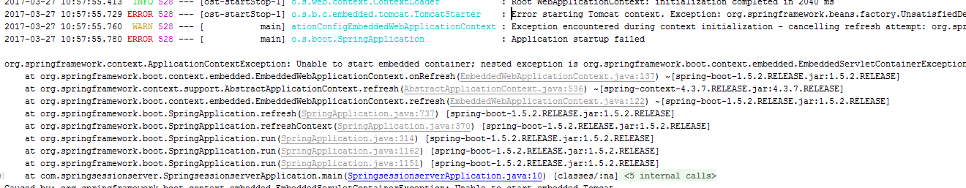

which says “Error starting Tomcat context. Exception: org.springframework.beans.factory.UnsatisfiedDependencyException. Message: Error creating bean with name 'springSessionRepositoryFilter' defined in”

to solve that problem, one of the advice is that:

<**dependency**>  
 <**groupId**>org.springframework.boot</**groupId**>  
 <**artifactId**>spring-boot-starter-tomcat</**artifactId**>  
 <**scope**>provided</**scope**>  
</**dependency**>

that is implemented in the following sample? <http://www.concretepage.com/spring-session/spring-session-redis-servlet-integration-example>

And another advice is given below;

<http://stackoverflow.com/questions/34802268/spring-session-initialization-error>

which seems not reliable. Another conversation is;

<https://github.com/spring-projects/spring-session/issues/318>

At the end, adding specific dependency for class type “springSessionRepositoryFilter” as int the pom.xml solved the problem. And now, server is up.

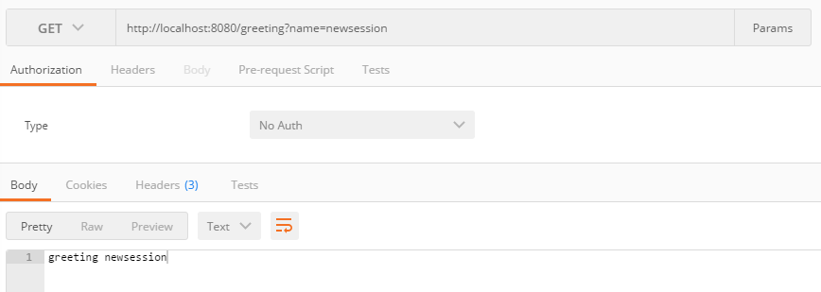

And redis session records;

