**SDEV-240: Group 5**

**Joseph Dyke Jon Lynch Scott Kirby**

**4/30/2017**

Buy 4 Seats:

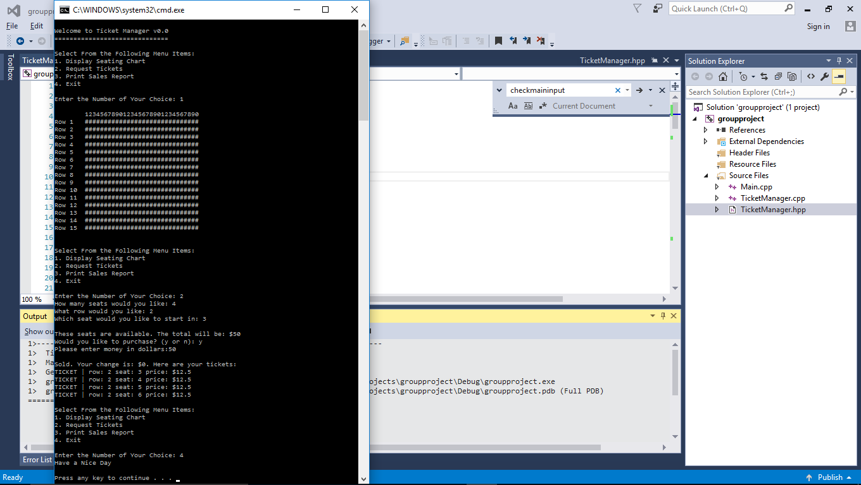

Display Purchased Seats and Seating Chart: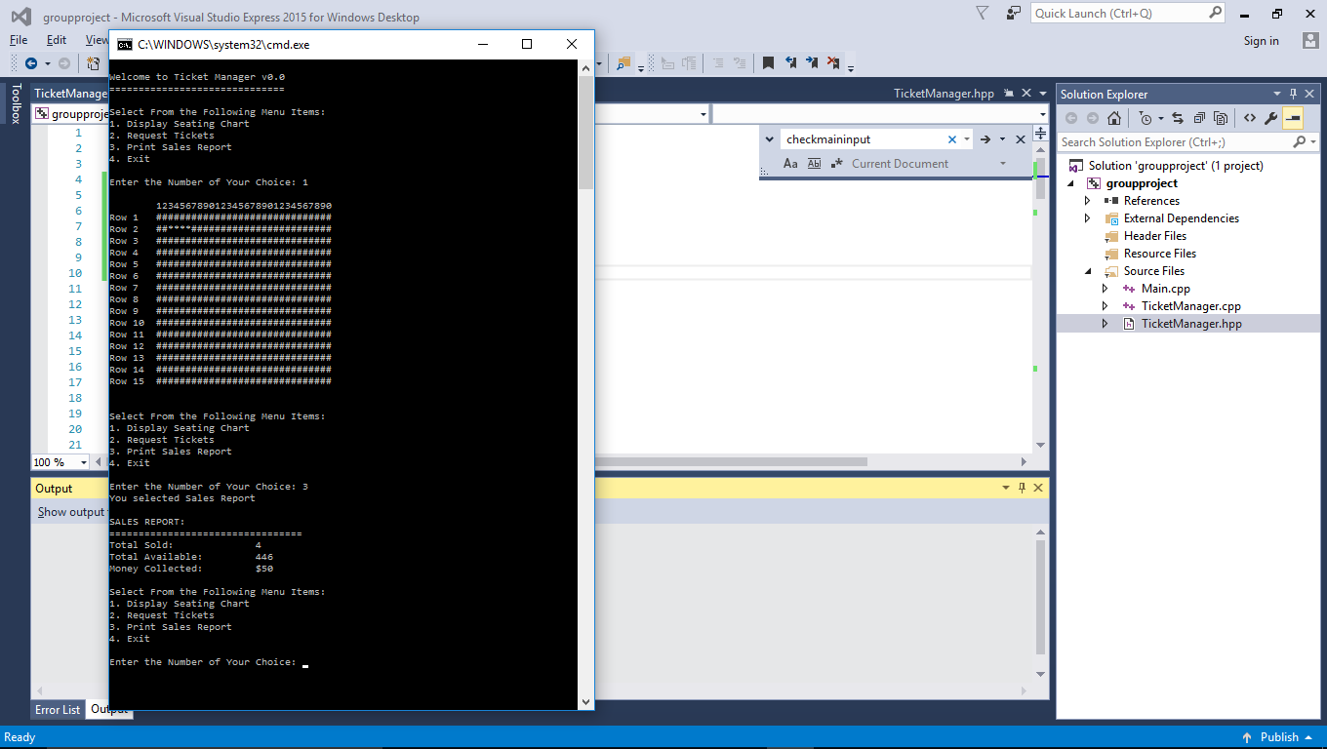

Validate user inputs:

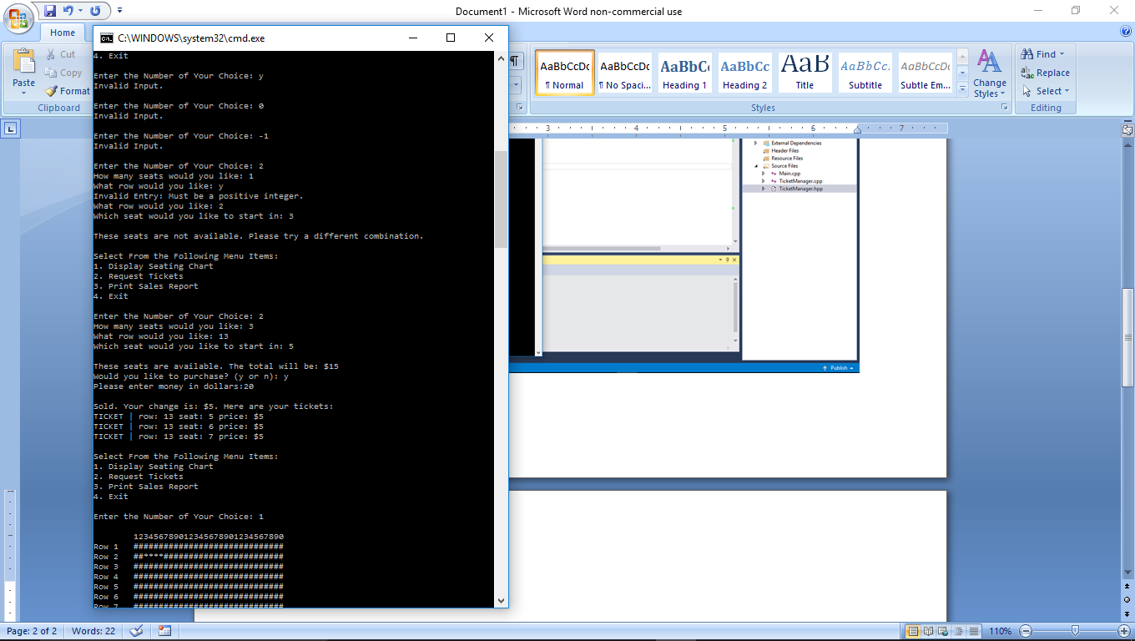

Print sales report:

