Sarah Kirby

Module 3

1. XHTML
   1. URL: <https://web7.jhuep.com/~skirby9/Module3/Module3HW.html>
   2. Validation:

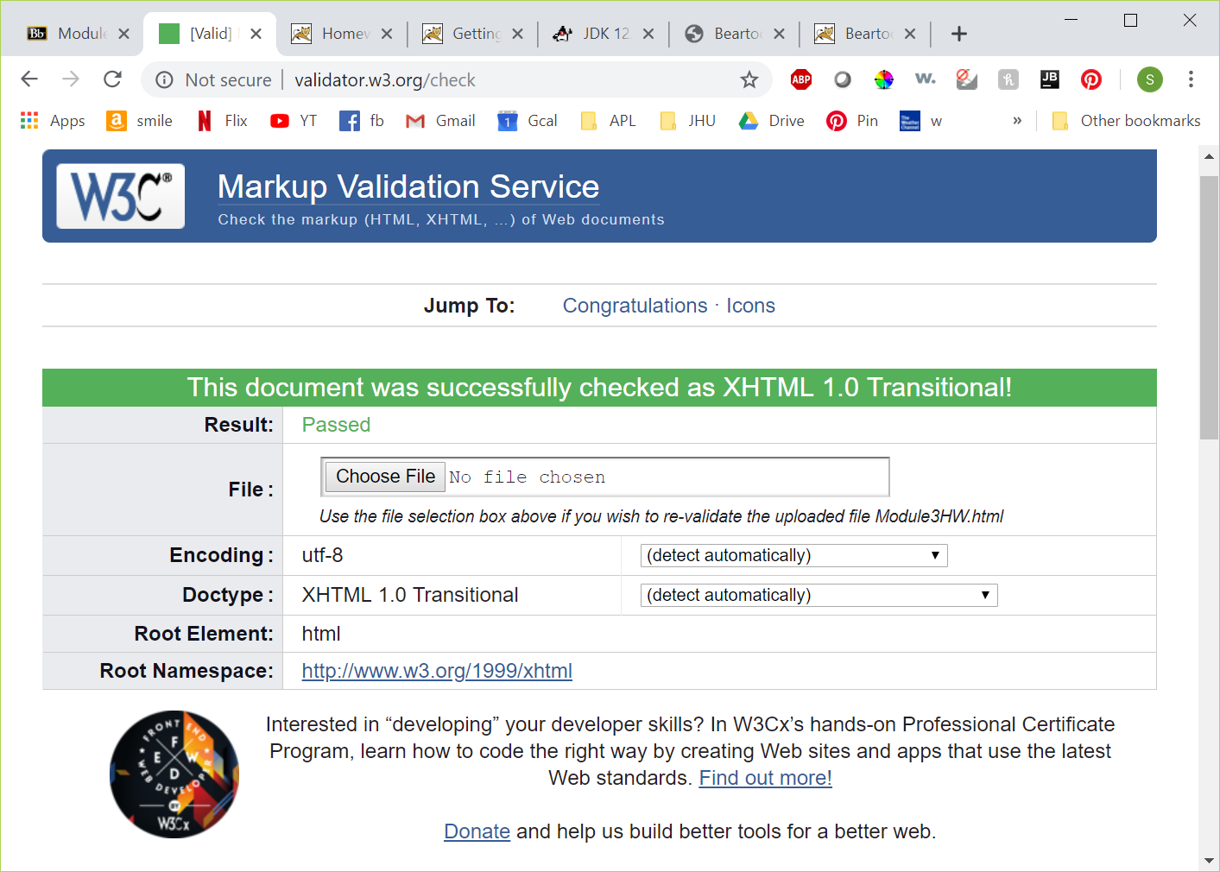

1. Java
   1. Class name: Module3
   2. Application screenshot:

