Cumulative death counts show the COVID vaccines increased COVID and non-COVID ACM
Steve Kirsch
2025-05-26

Abstract
Using only DoB, DoD, and DoV from the The Czech Republic record level data we constructed two cohorts based on vaccination status as of a fixed date (before the non-COVID period) for those 80 years old and younger.
Both cohorts, even though they had different age distribution and sizes, died at identical deaths rates (deaths per week) during COVID and non-COVID periods.
After peak Omicron, the death rate of the vaccinated cohort diverged, but the unvaccinated cohort returned to baseline death rate (before COVID).
The reason is simple: boosters were delivered in late 2021.
This study shows anytime you give a shot, the death rate increases in the cohort you give the shot to.
This shouldn’t be surprising as the Levi Florida study showed the shots increase ACM by 36% or more. So this is more visual confirmation using Czech Republic data.

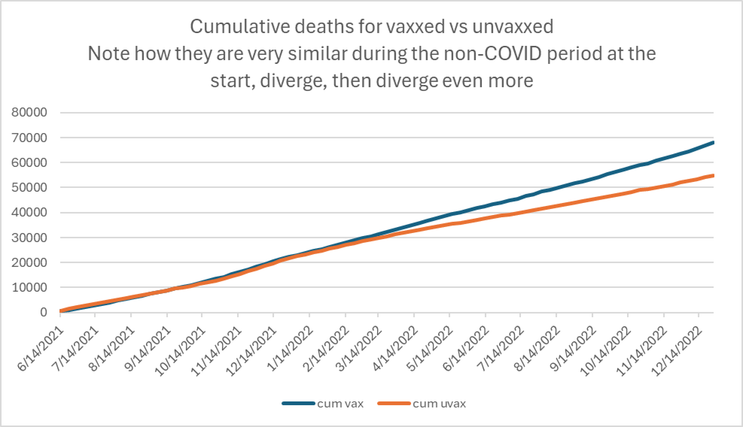
Figure 1. All people in Czech Republic age 80 and younger. Vaxxed if vaxxed by June 2021; else unvaxxed. We got lucky that the death rate per week was matching in the cohorts so the lines conveniently overlapped. This allows us to easily see that the death rate of the previously vaccinated diverged when the booster shots were delivered and increased their monthly mortality rate. This one chart shows this is a deeply flawed product that should be removed from the market ASAP. Anyone can replicate this. Data is public.

The COVID vaccinated had higher NET ACM mortality, the single most important metric of a vaccine. There is no other explanation that fits the data. The divergence in rates happened right when the boosters were given
We also validated increased mortality for the vaccinated cohort of “same age” cohorts after using the non-COVID baseline period to equalize the death rate in the two cohorts.
This method can be replicated for each individual 5-year age group using KCOR. The curves are virtually identical to each other regardless of age which is stunning.
Conclusion: we can now very clearly show that the COVID vaccines offered little to no ACM protection and caused net ACM harm right after they were given and should be stopped.

Method
Using the Czech Republic record level data, we constructed two cohorts on a start date of June 14, 2021 based upon the person’s COVID vaccination status on the enrollment date: vaccinated with 1 or more doses (V group ) or not (U group). Only those 80 and younger were enrolled and we also enrolled people with unknown DOB.
The June 14, 2021 date was chosen because it is when 1) most >70% of the elderly were vaccinated and 2) it was the start of a non-COVID period so we could observe the baseline mortality of the two cohorts.
The choice of 80 and younger was chosen because it resulted in a synthetic control where both cohorts had nearly IDENTICAL deaths per week, even though the v cohort had older people. Our focus was matching deaths per week which eliminated the need to do age, comorbidities, and other adjustments. We wanted two matched absolute deaths per week cohorts.
The two groups had virtual identical deaths per week during:
- the non-COVID period that followed the enrollment date as well (June to August)
- the subsequent COVID period (starting in Sept)
But the death rates clearly diverged over time: the vaccinated died at a higher death rates, similar to their death rate during COVID while the unvaccinated returned to their baseline death rate.

Below is the same graph with tangent lines showing that the death rates for both cohorts increased during COVID, then the vaccinated continued at the COVID rate (the pink line starting on 12/1/2021), while the unvaccinated returned to baseline slope.
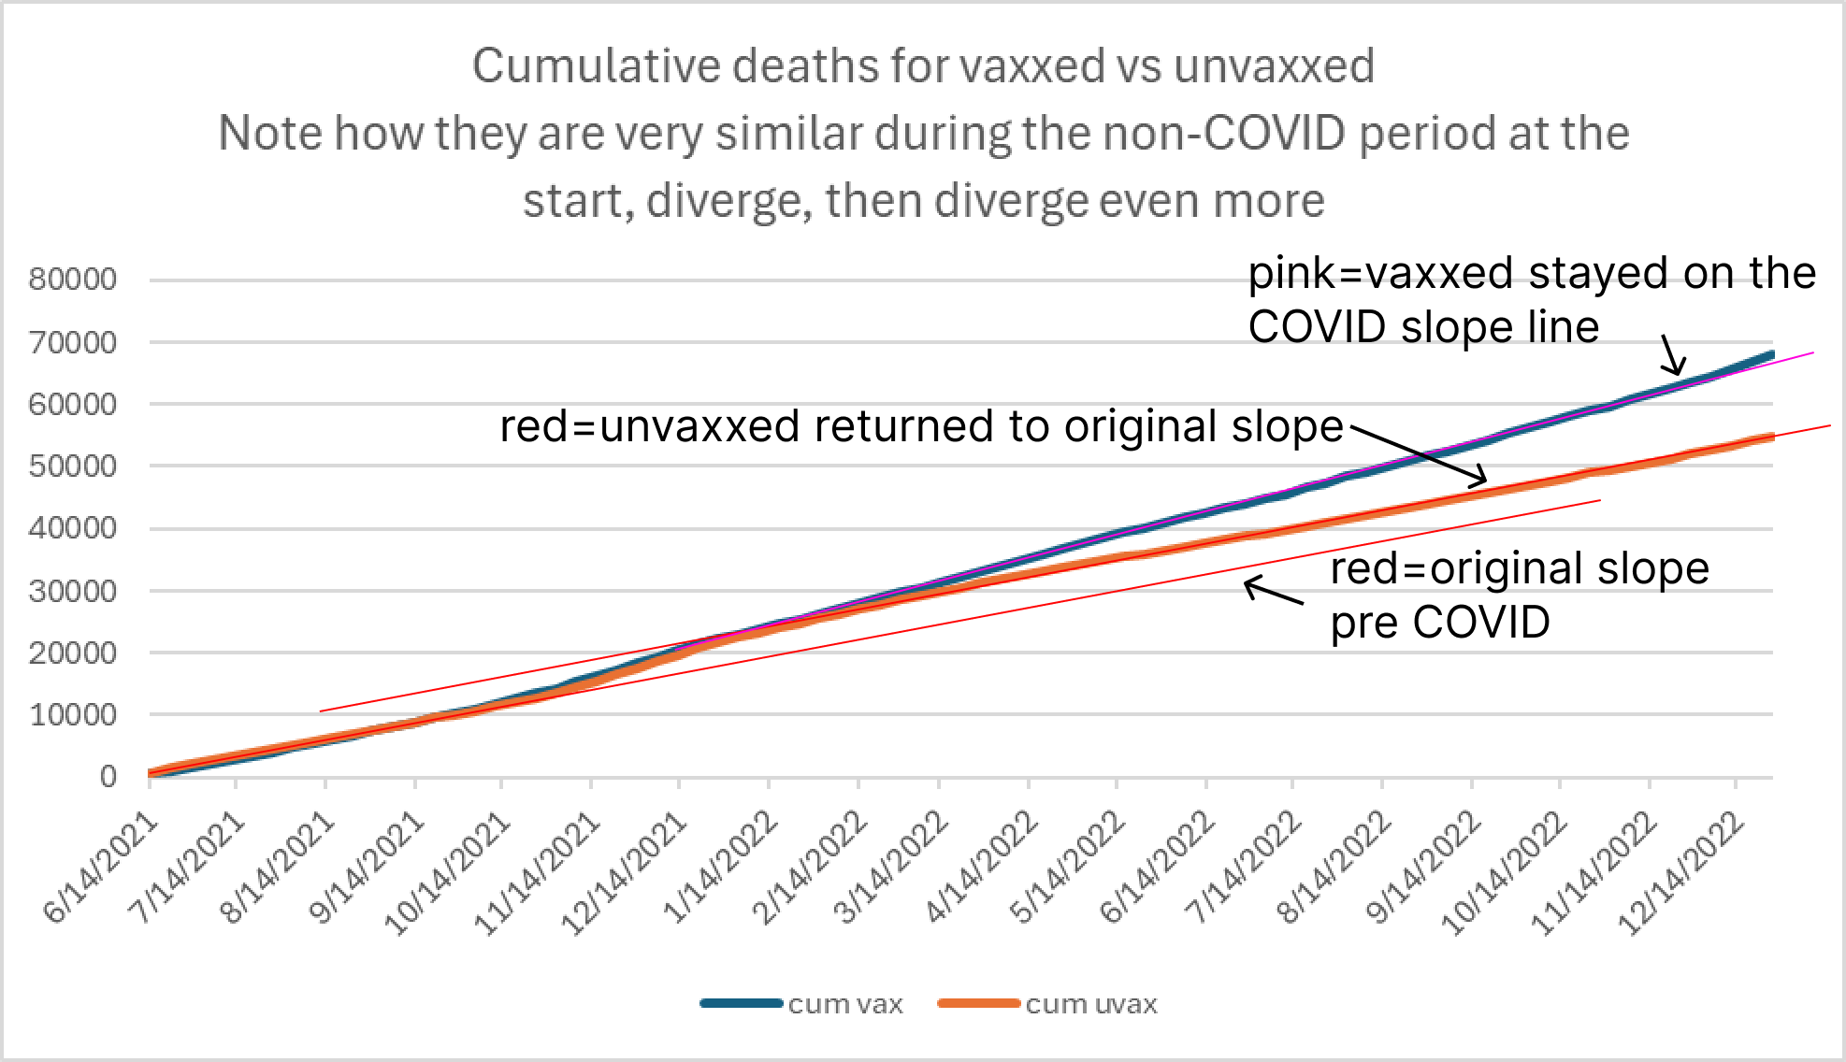
There is no viable explanation for this other than the vaccine is increasing ACM.

KCOR
Using a new method (KCOR), we can show that this is not a fluke. We can show this divergence happening in every 5-year age group. It’s uncanny. The same pattern of death.
KCOR is described in the article, but in essence, we simply compare baseline cumulative death ratio with the same ratio and the end of 2022 to determine whether the ACM impact is positive, negative, or neutral with the baseline ratio computed in the no-COVID period. For every age group, the net ACM impact was negative.
KCOR all ages (a positive slope means net harm from the vaccine)
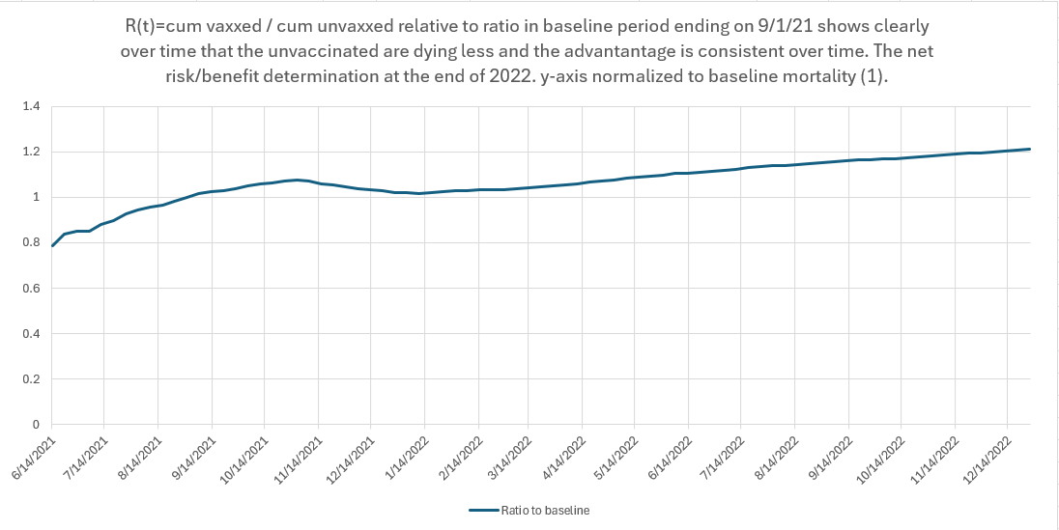
85 year olds
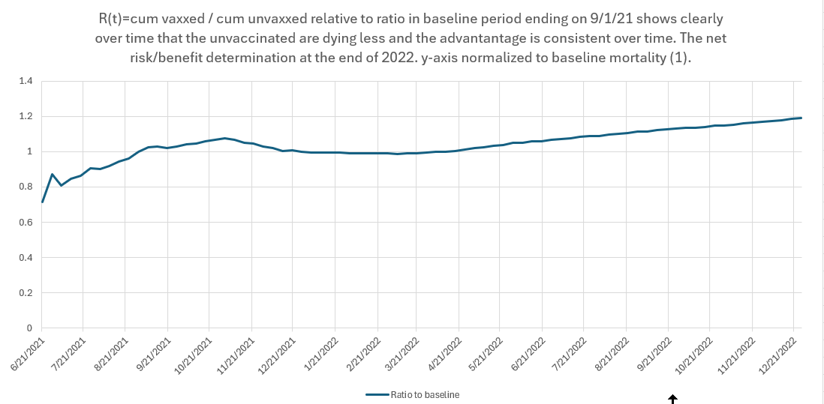
80 year olds
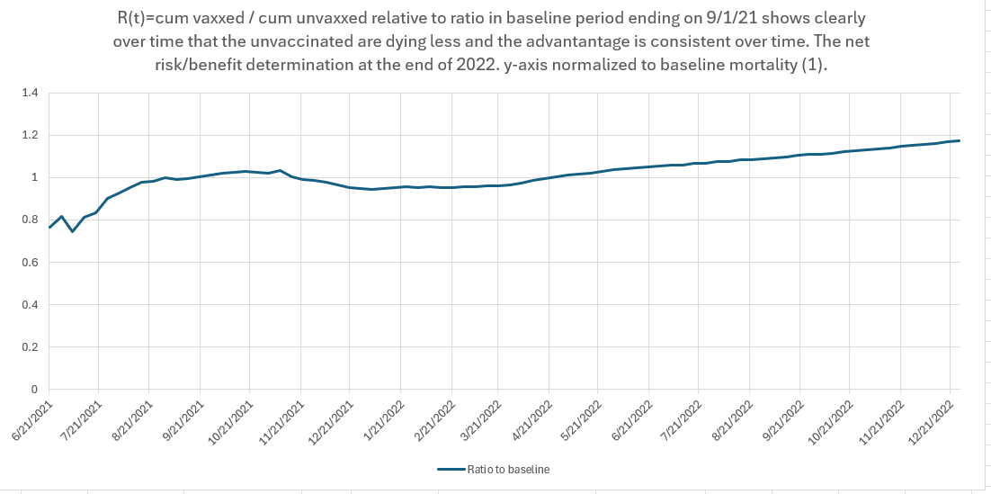
75 year olds
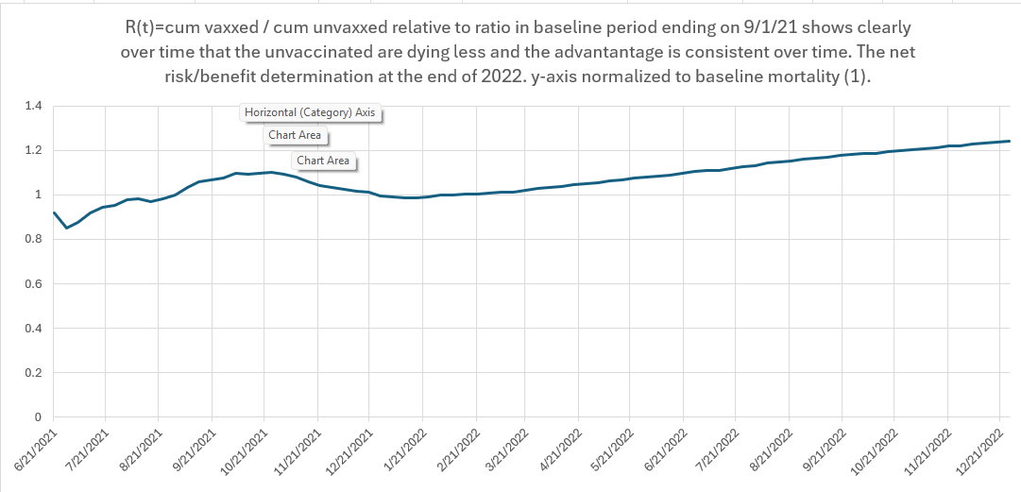

70 year olds
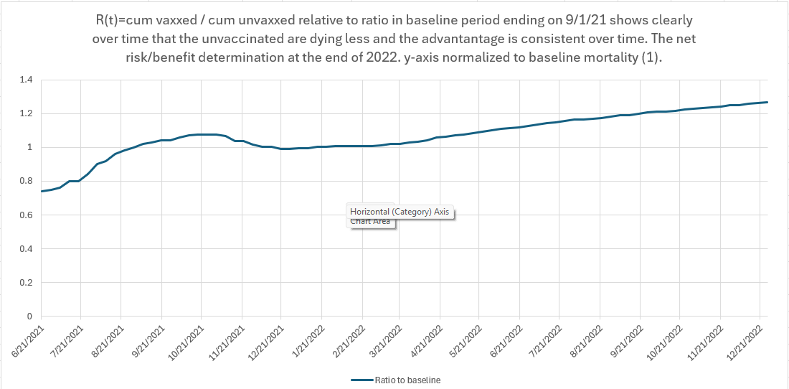

65 year olds
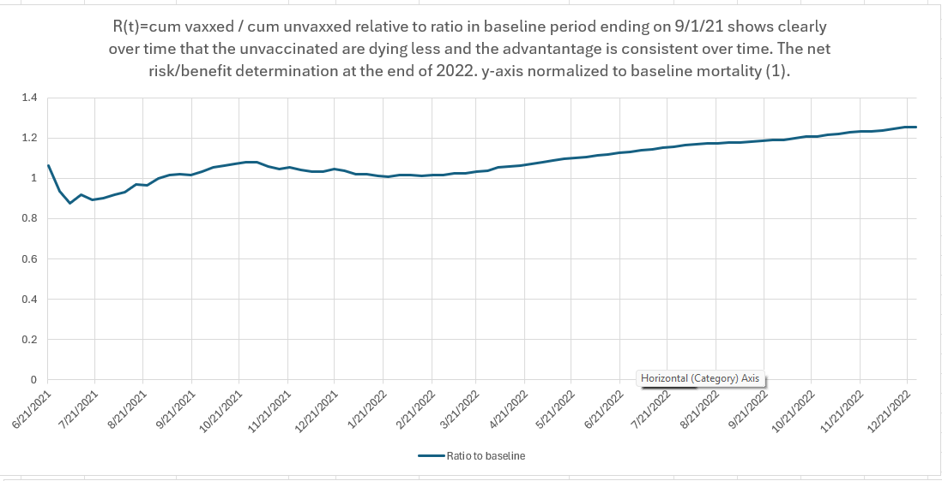

These are all separate age groups and they all have the same 20% excess mortality caused by the vaccine.
This difference is not an artifact of the age differences between the vaccinated and unvaccinated cohorts (a fixed group size will die with a negative slope after age 86). The age effect is quite small (around 1%) for any vaccinated group under age 70.
There is NO WAY TO EXPLAIN THIS ACM DIFFERENCE other than the vaccine cause harm.

Explanation
We know for certain from the Levi Florida study that the vaccine is killing people. A 36% absolute increase in ACM for Pfizer is insane.
So any explanation has to be consistent with that.
By examining the raw death counts in V and U groups combined with the insight from the KCOR curves (the inflection points are when a change occurs), we can get an excellent picture of what is likely going on.
Let’s break it down into areas as to what is likely going on:
- Study start date: We don’t know what happened before the study start so we can’t show the vaccines raised the mortality rate in the V group. We start off with this raised mortality rate as the “baseline rate.”
- During Omicron: Both vax and unvax increase cases in the same proportion as their death rate, but KCOR indicates a vaccine benefit during this period.
- After Omicron: The vaxxed got the booster so their mortality remains persistently elevated. But the unvaxxed didn’t get the booster so their mortality goes back to baseline before the COVID wave. There can also be a return to the upward trend existing before COVID. It seems the vaccine creates a risk of death that escalates slowly over time!
Since everyone gets vaccinated at different times, you never see a huge jump which start to occur shortly after vaccination.
We never saw the initial rise in mortality because we can’t predict in advance who will get vaccinated. We can only see a rise after the start. So the selection bias mixes in with the vaccine added mortality to provide a nicely confusing scenario.
But when everyone gets the booster at the end of December 2021, that’s when the raw counts below increase again in the vaccinated (who are more likely to get a booster).
You can see this in the chart below which is from the 1955 cohort which was mostly vaxxed long before the enrollment time.
See how the two lines (blue and orange) are on top of each other before the booster shots at the far left? Then the blue goes up and the orange is flat. This is likely previously given shots 1 and 2 working to raise mortality and also perhaps shot 2 being given.
The deaths were already elevated before the baseline period and we see the LINGERING effects of the vaccination.
But after the booster, the vaccinated got the shots primarily which increase their mortality very noticeably because now there is a gap between the lines shortly after the booster shots.

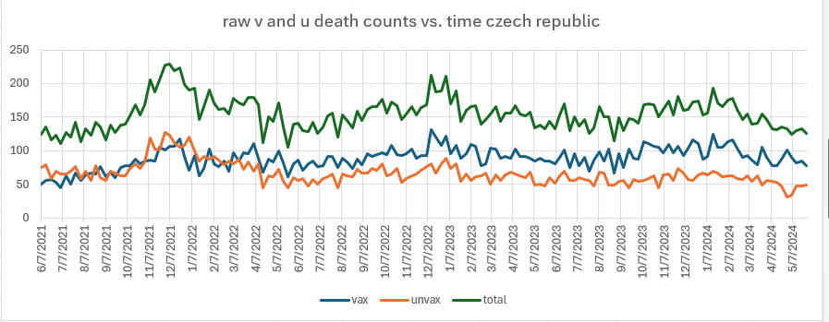
Figure 2 1955 cohort v, u, and total deaths per week

Ethical considerations
It is unethical to be giving people a vaccine that increases ACM.
Vaccines are OPTIONAL interventions, not treatments for a disease you have. The risk/benefit decision is ONLY if you have a disease already.
A vaccine is given before you have a disease. Therefore, they MUST BE WITHDRAWN if they increase your ACM, even if by only a little because you cannot know if they will get the disease or not.
You can never give a vaccine which INCREASES ACM.

Summary
There are 4 different curves of interest here:
- Vr,Ur raw count lines over time (two flat lines)
- Vc,Uc cumulative counts vs. time (2 lines)
- Vr/Ur ratio vs. time
- R(t)=Vc/Uc vs. time (the KCOR test)
Understanding these curves can give us some interesting insights into properly interpreting the data.
It appears that the best explanation for the slope of the KCOR curves are:
- The COVID shots cause a very unusual increase in ACM over a long period of time. This is why we are still seeing a rise in R(t) during the baseline period when it should be flat, e.g., for those born in 1935.
- This trend reversed during COVID because the vaccine really did provide some protection for the vaccinated during COVID. This is the reversal in the KCOR slope.
- After COVID was over, the trend returned back to the trendline, likely aided by the boosters. Basically the shots slowly and steadily increase mortality in a non-random manner which is why the death rate keeps climbing before plateauing.
- This aligns PERFECTLY with the Levi study and the Mostert Fig 1 (lower) showing ever increasing mortality in the highly vaccinated western world. The KCOR curve makes it very clear what is driving this.
Grok concluded:
