Cumulative death counts clearly show the COVID vaccines increased net ACM
Steve Kirsch
2025-05-26
A vaccine is NEVER supposed to increase ACM. Vaccines are OPTIONAL medical interventions designed to reduce virus-specific mortality. The COVID vaccine violates this principle. It provides next to zero protection against mortality during high COVID (end of 2021), and it increases all-cause mortality as you can see from the split after the boosters rolled out. This data the official Czech Republic data. Anyone can replicate this. This is everyone under 80. I simply plotted cumulative deaths in vaxxed vs. unvaxxed cohorts where the cohorts were determined based on vaccination status on June 14, 2021 after most of the elderly were vaccinated. The chart speaks for itself. It is a violation of medical ethics to continue to offer these shots. They are unsafe for all ages. The vaxxed cohort is older, but a fixed group of people, aged 55 or older, will have fewer deaths per day the older they get due to depletion and higher absolute mortality rates. There is no other way to explain this data. The Levi/Ladapo Florida study showed a 36% higher NCACM caused by the shots. They are unethical to give for that reason. The Czech data simply confirms the Florida study.
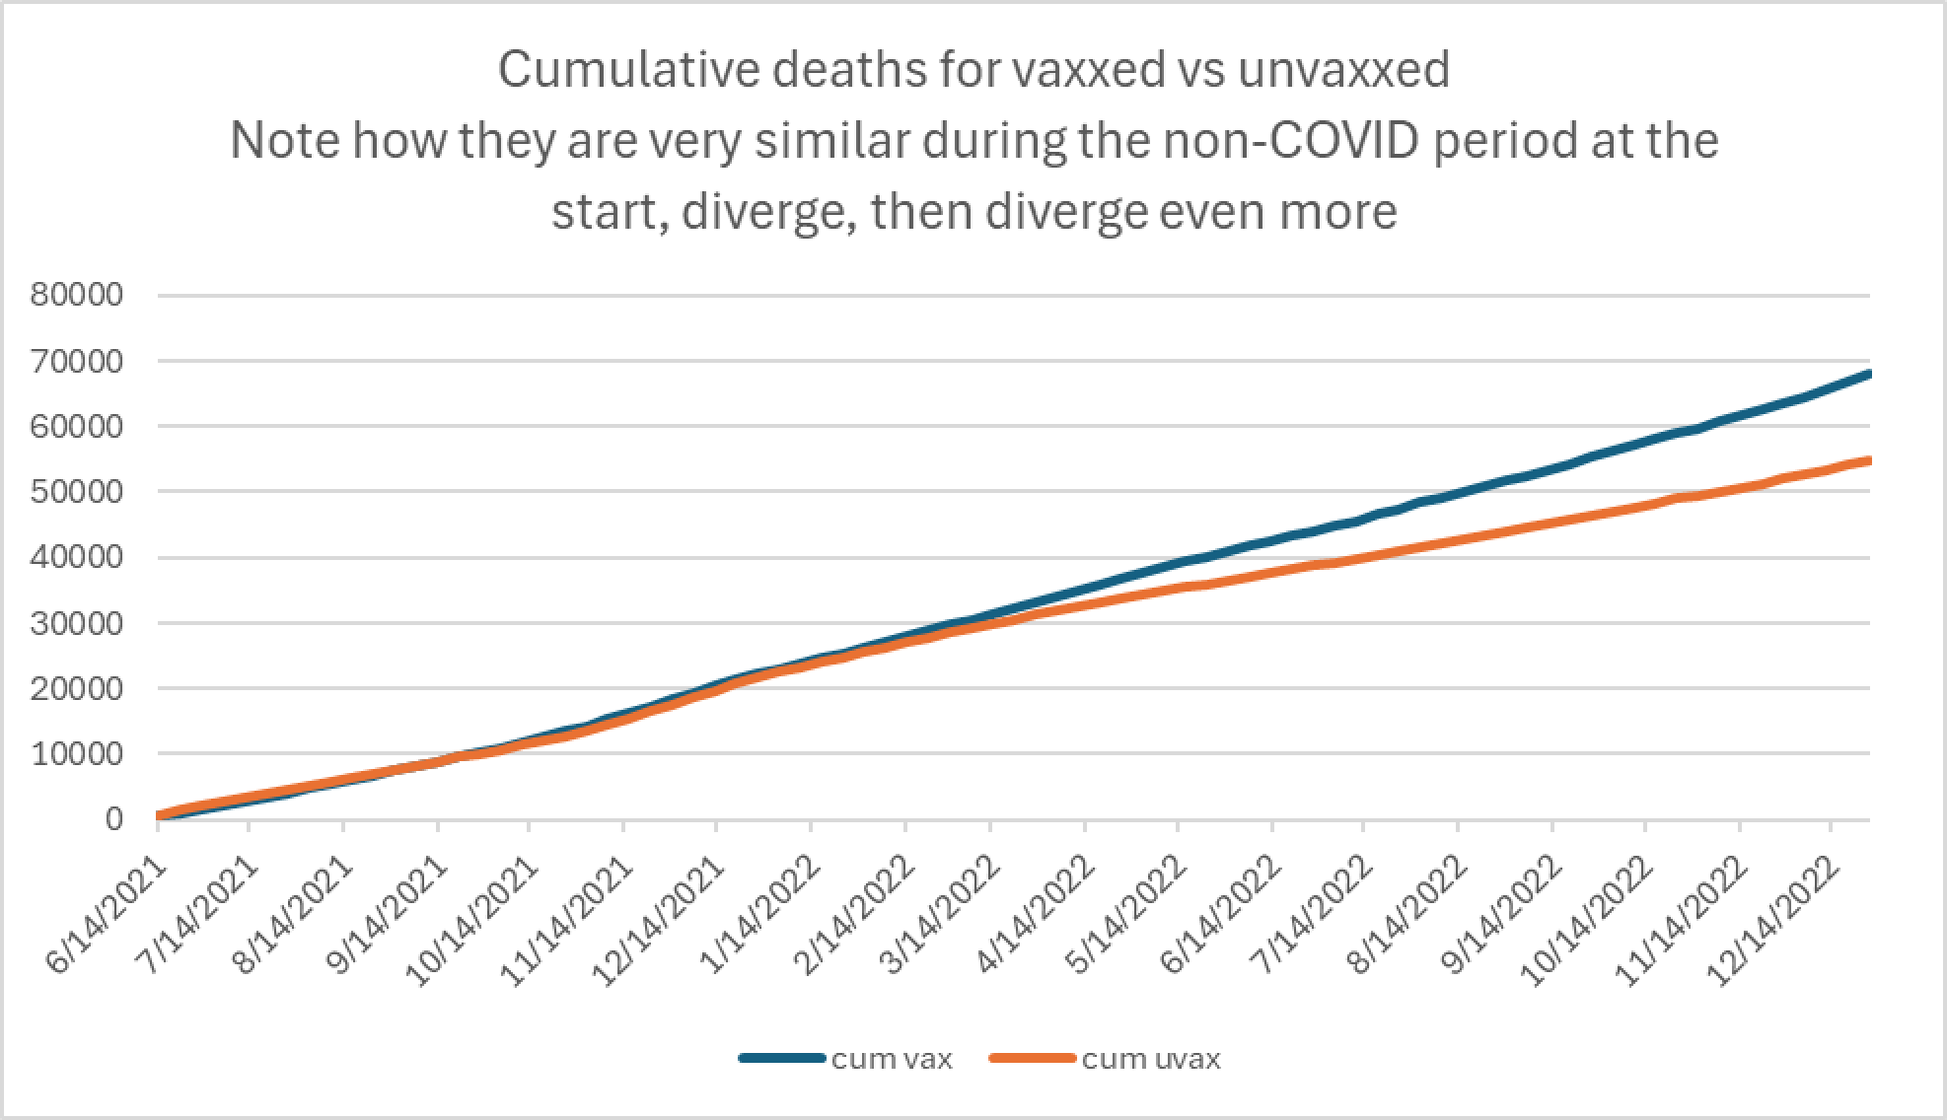
Figure 1. All people in Czech Republic age 80 and younger. Vaxxed if vaxxed by June 14, 2021; else unvaxxed. Not scaled. Divergence happened after the boosters were given.

