KCOR Supplementary material
Supplementary appendices provide mathematical derivations and full control-test specifications.

Supplementary Figures
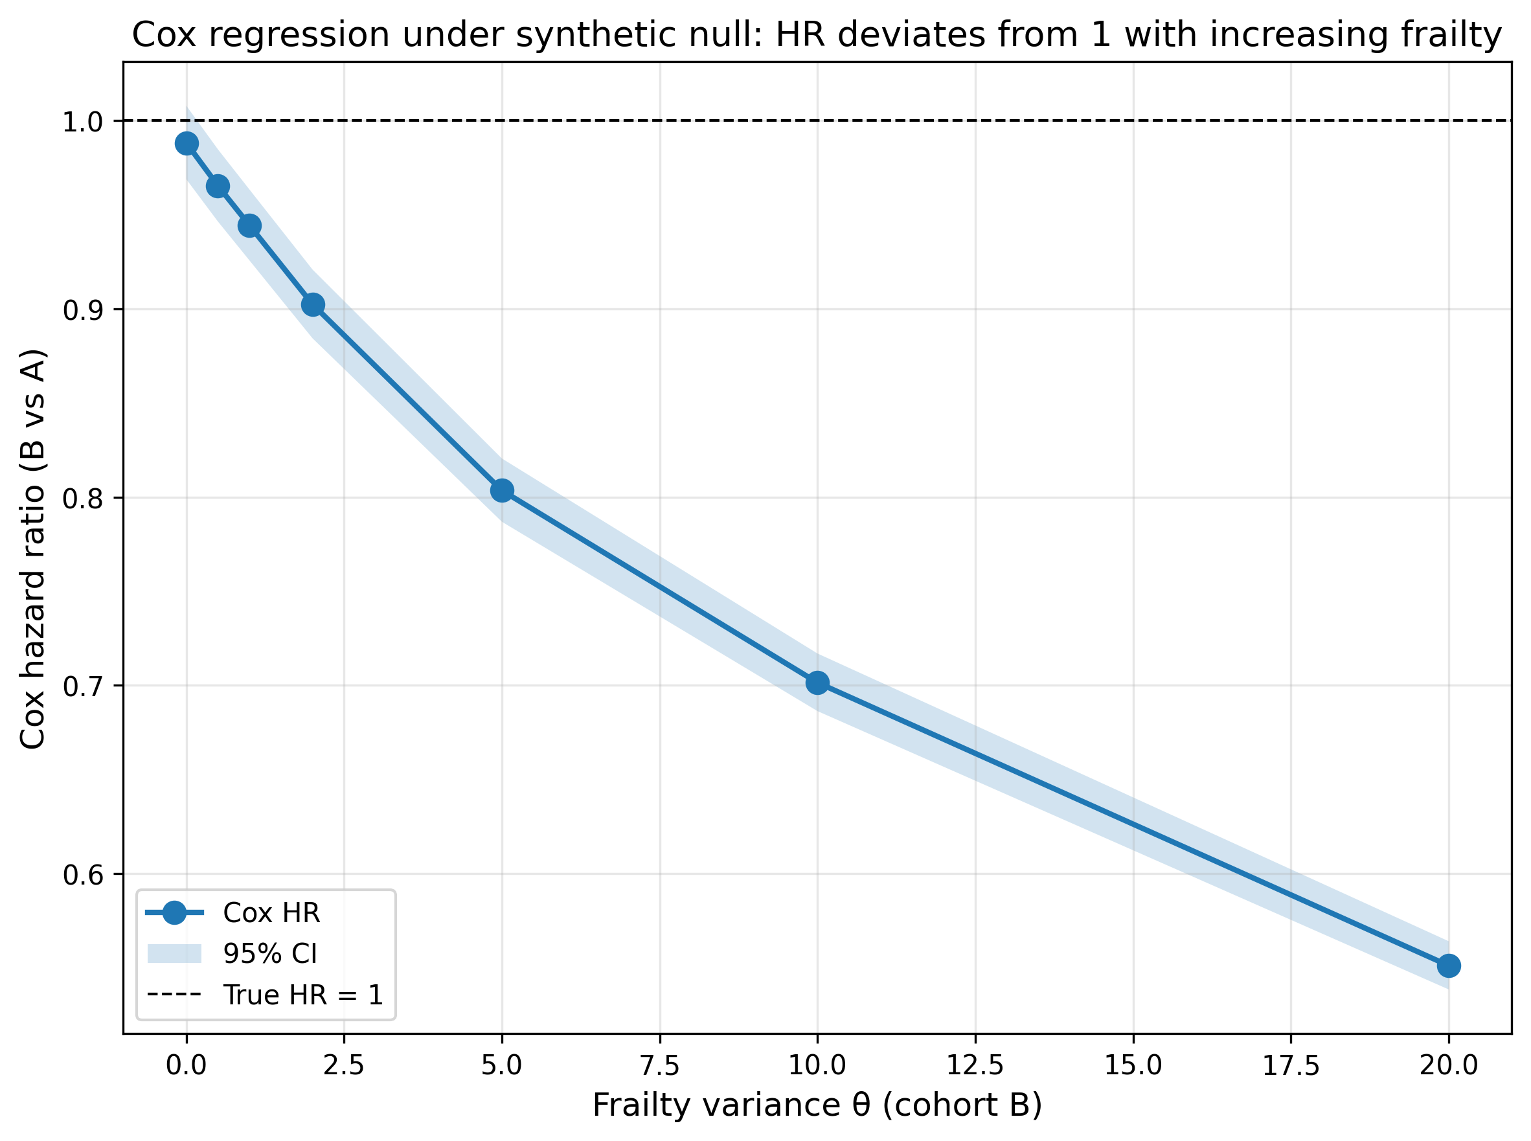
Figure 5. Cox regression produces spurious non-null hazard ratios under a synthetic null as frailty heterogeneity increases. Hazard ratios (with 95% confidence intervals) from Cox proportional hazards regression comparing cohort B to cohort A in simulations where the true treatment effect is identically zero and cohorts differ only in frailty variance ($θ$). Deviations from HR=1 arise solely from frailty-driven depletion and associated non-proportional hazards.
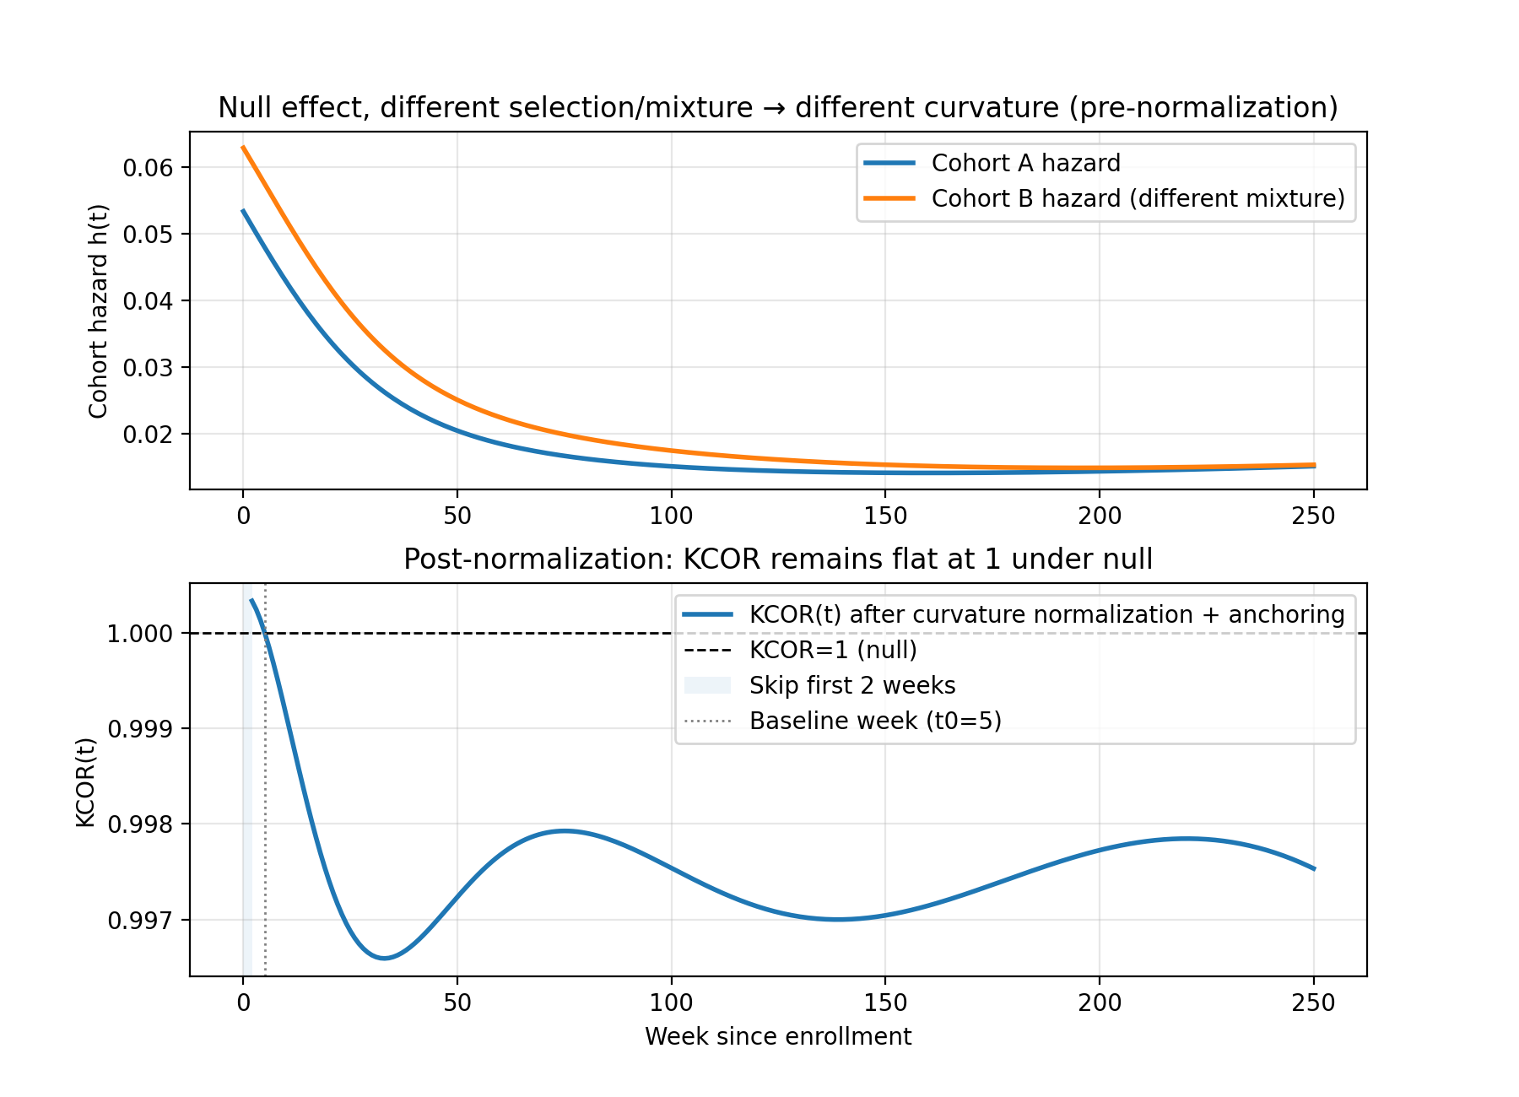
Figure 6. Synthetic negative control under strong selection (different curvature) but no effect: $KCOR(t)$ remains flat at 1. Top panel shows cohort hazards with different frailty-mixture weights inducing different curvature. Bottom panel shows $KCOR(t)$ remaining near 1.0 after normalization, demonstrating successful depletion-neutralization under the null. Uncertainty bands (95% bootstrap intervals) are shown.
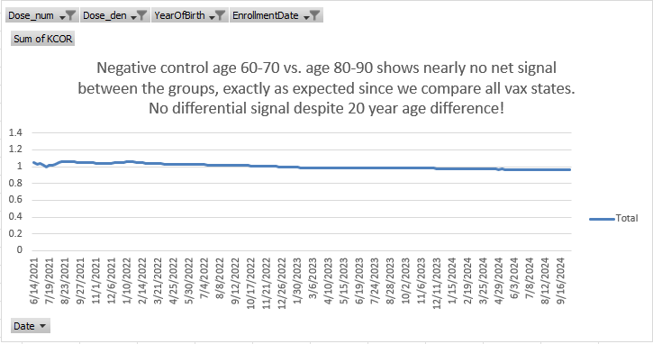
Figure 7. Empirical negative control with approximately 20-year age difference between cohorts. Even under extreme composition differences, $KCOR(t)$ exhibits no systematic drift, demonstrating robustness to selection-induced curvature. KCOR curves are anchored at $t_{0}=4$ weeks (i.e., plotted as $KCOR(t;t_{0})$). Uncertainty bands (95% bootstrap intervals) are shown. Data source: Czech Republic mortality and vaccination dataset processed into KCOR_CMR aggregated format (negative-control construction; see Appendix B.2).
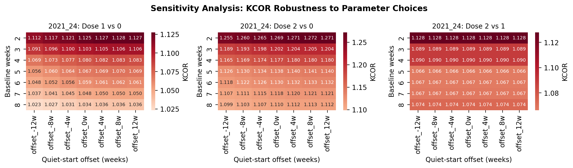
Figure 8. Sensitivity analysis summary showing $KCOR(t)$ values across parameter grid. Heatmaps display $KCOR(t)$ estimates for different combinations of baseline weeks (rows) and quiet-window start offsets (columns). Across all comparisons, $KCOR(t)$ varies smoothly and modestly across a wide range of quiet-start offsets and baseline window lengths, with no qualitative changes in sign or magnitude, indicating robustness to reasonable parameter choices. All panels use a unified color scale centered at 1.0 to enable direct visual comparison across dose comparisons.
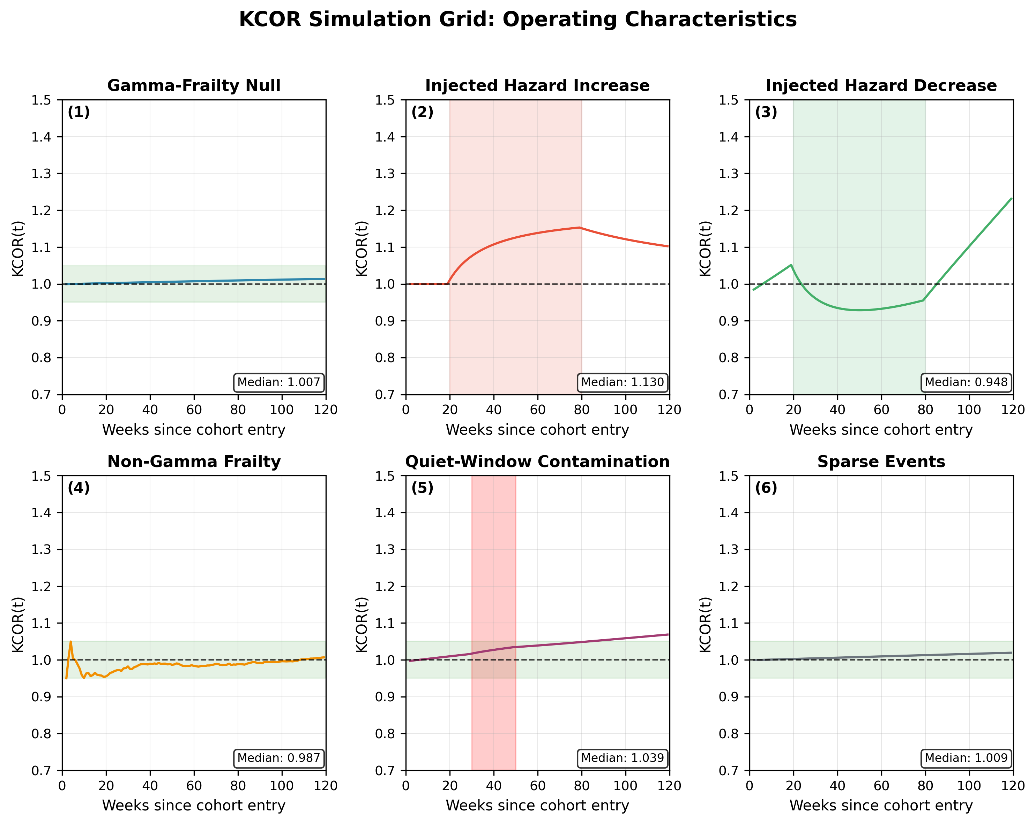
Figure 9. Simulation grid overview: $KCOR(t)$ trajectories across prespecified scenarios, including gamma-frailty null with strong selection, injected hazard increase and decrease, non-gamma frailty, quiet-window contamination, and sparse-event regimes. Under true null, $KCOR(t)$ remains near-flat at 1; injected effects are detected in the expected direction; adverse regimes are accompanied by degraded diagnostics and reduced interpretability. Uncertainty bands (95% bootstrap intervals) are shown where applicable.
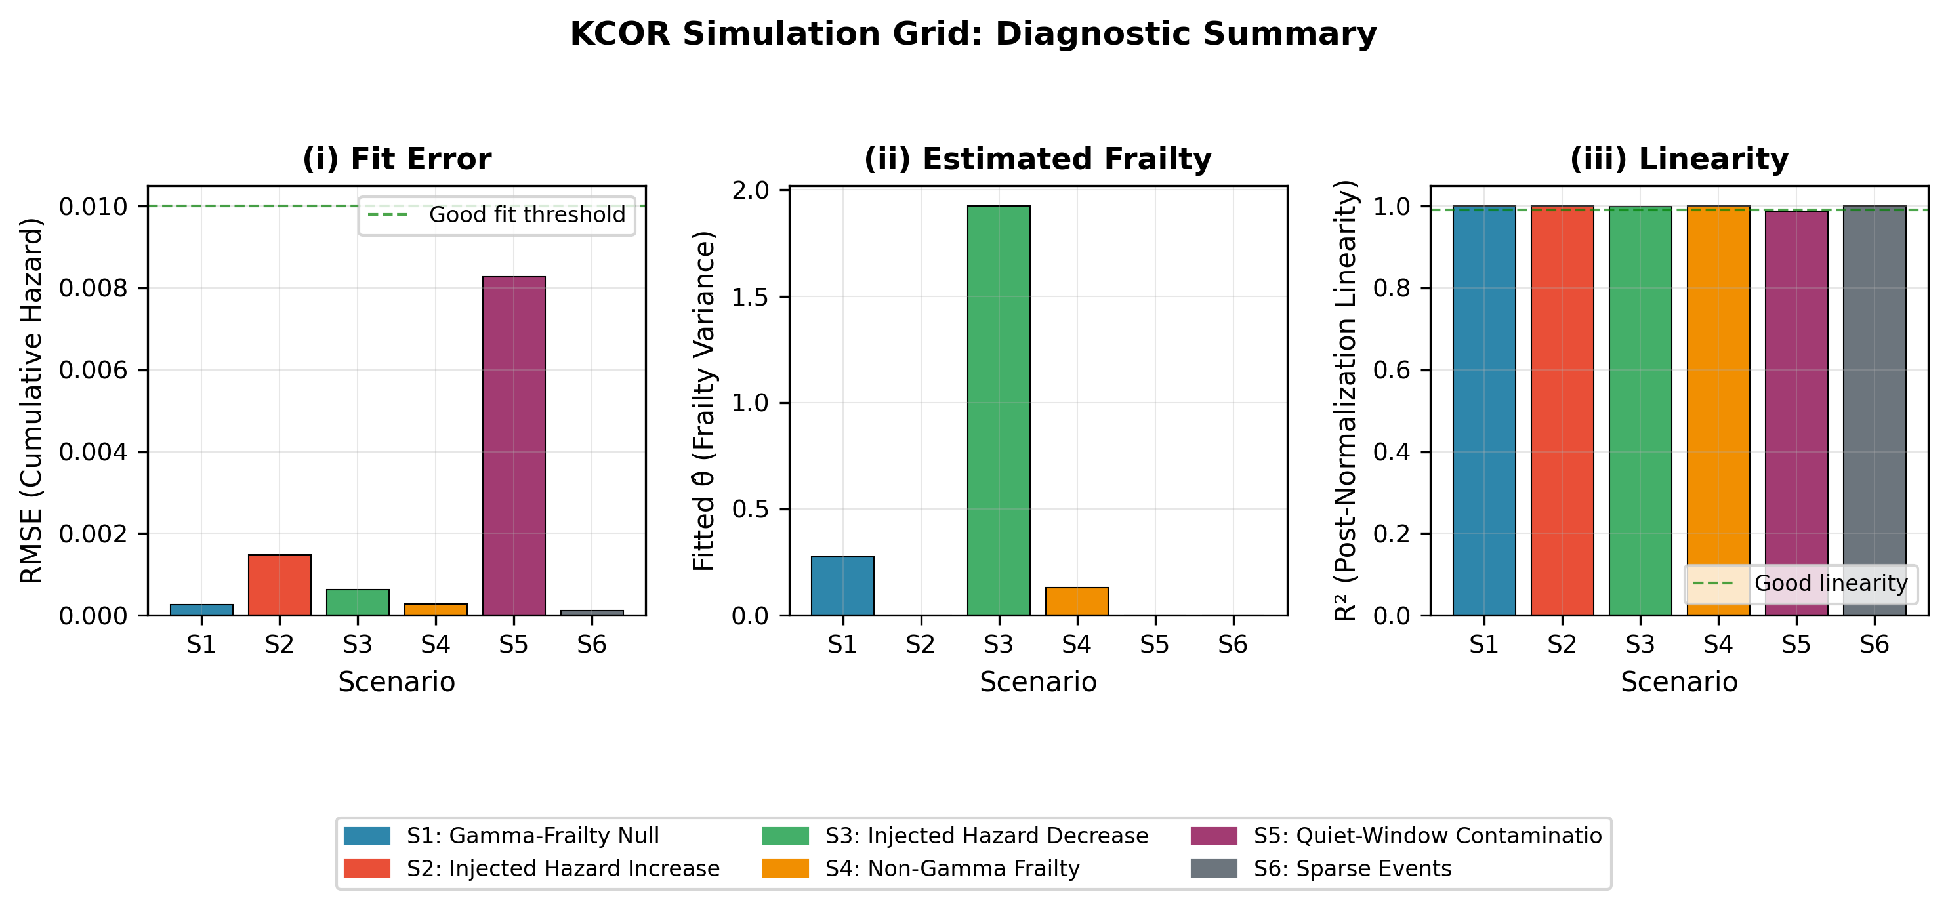
Figure 10. Simulation diagnostics across scenarios: (i) cumulative-hazard fit RMSE over the quiet window, (ii) fitted frailty variance estimates, and (iii) a post-normalization linearity metric for depletion-neutralized baseline cumulative hazards. Diagnostics identify regimes in which frailty normalization is well identified versus weakly identified.
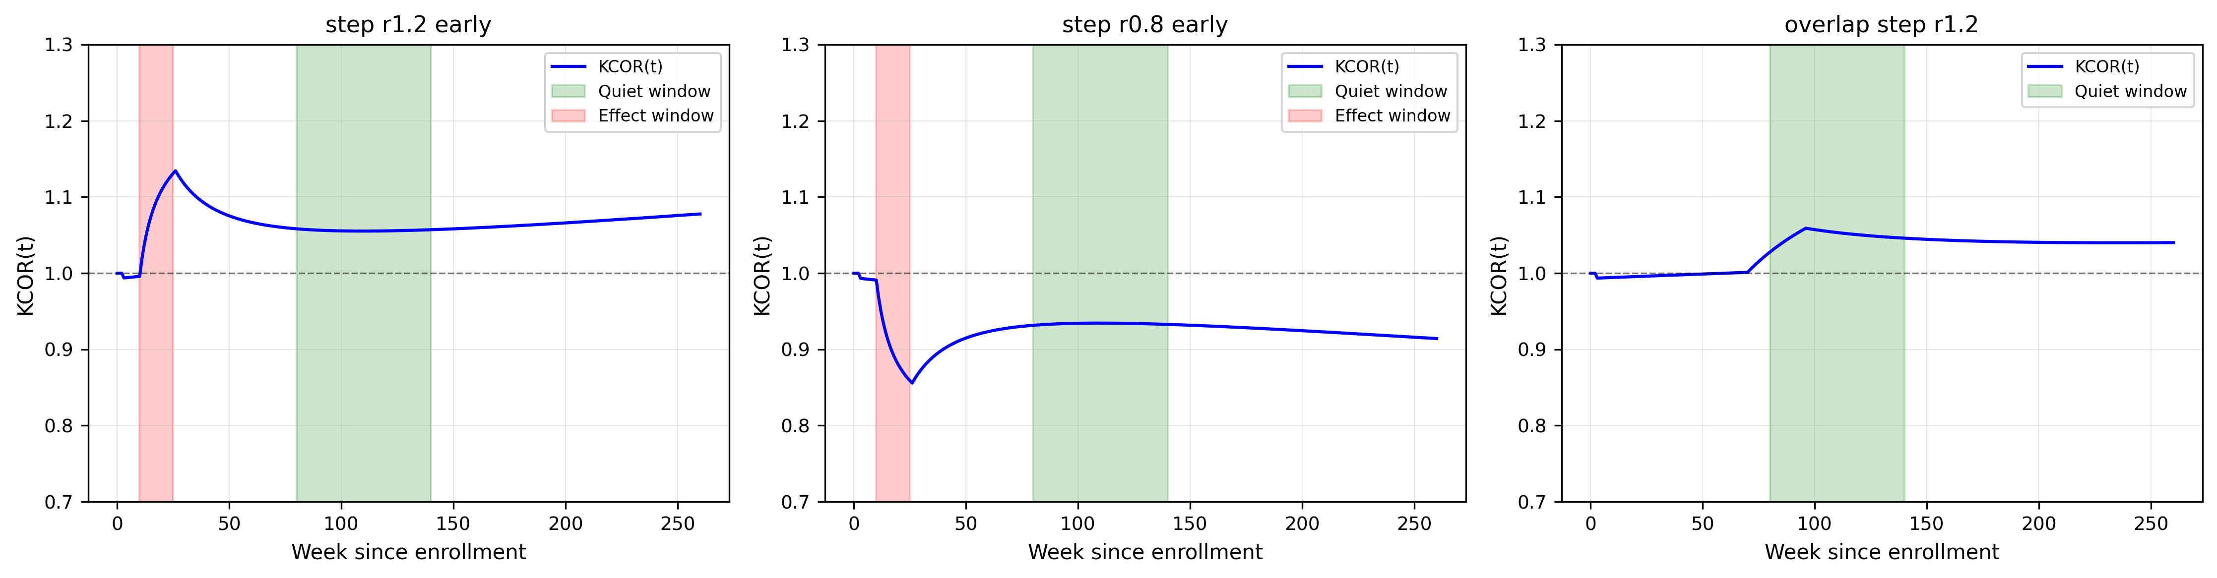
Figure 11. S7 simulation results: $KCOR(t)$ trajectories demonstrating temporal separability. Left panel shows harm scenario (r=1.2) with effect window (weeks 10-25) and quiet window (weeks 80-140) non-overlapping. Middle panel shows benefit scenario (r=0.8). Right panel shows overlap variant where effect window intersects quiet window, demonstrating diagnostic degradation. $KCOR(t)$ remains approximately flat during the quiet window and deviates only during the effect window when temporal separability holds. Uncertainty bands (95% bootstrap intervals) are shown. The overlap variant is included to demonstrate failure-mode behavior and should not be interpreted as a valid application regime for KCOR.
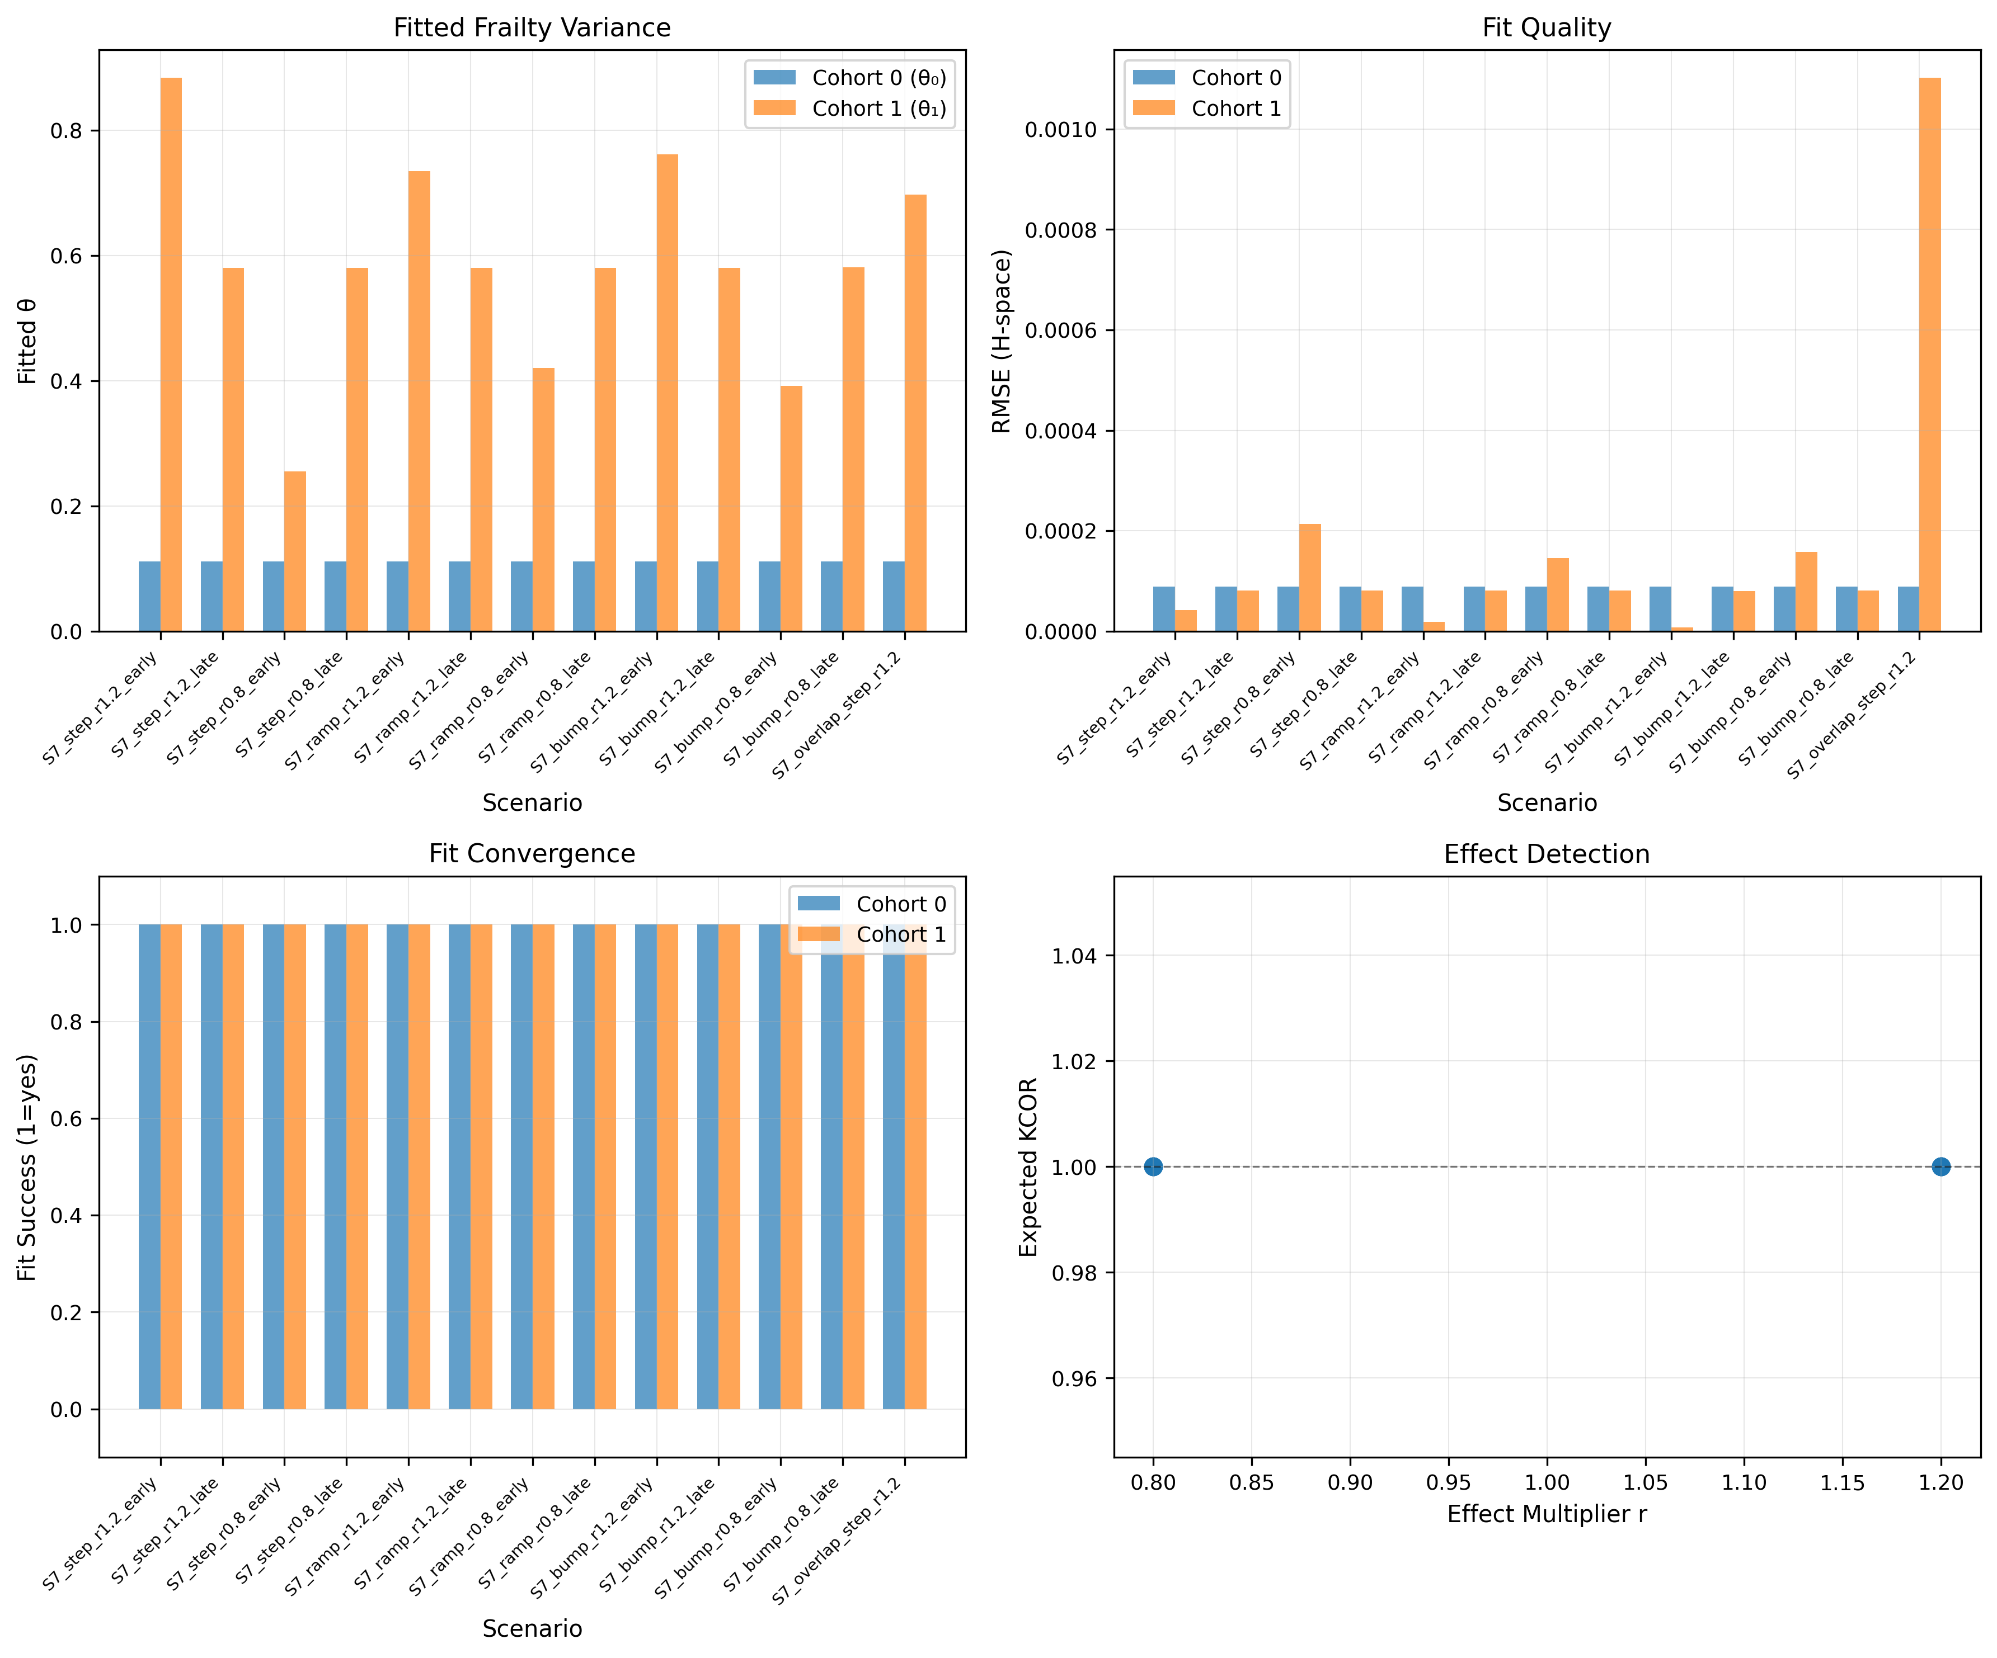
Figure 12. S7 simulation diagnostics: Fitted frailty variance parameters (${\hat{θ}}_{0}$, ${\hat{θ}}_{1}$), fit quality (RMSE), and convergence status across S7 scenarios. The overlap variant shows degraded fit quality, correctly signaling violation of temporal separability assumptions.
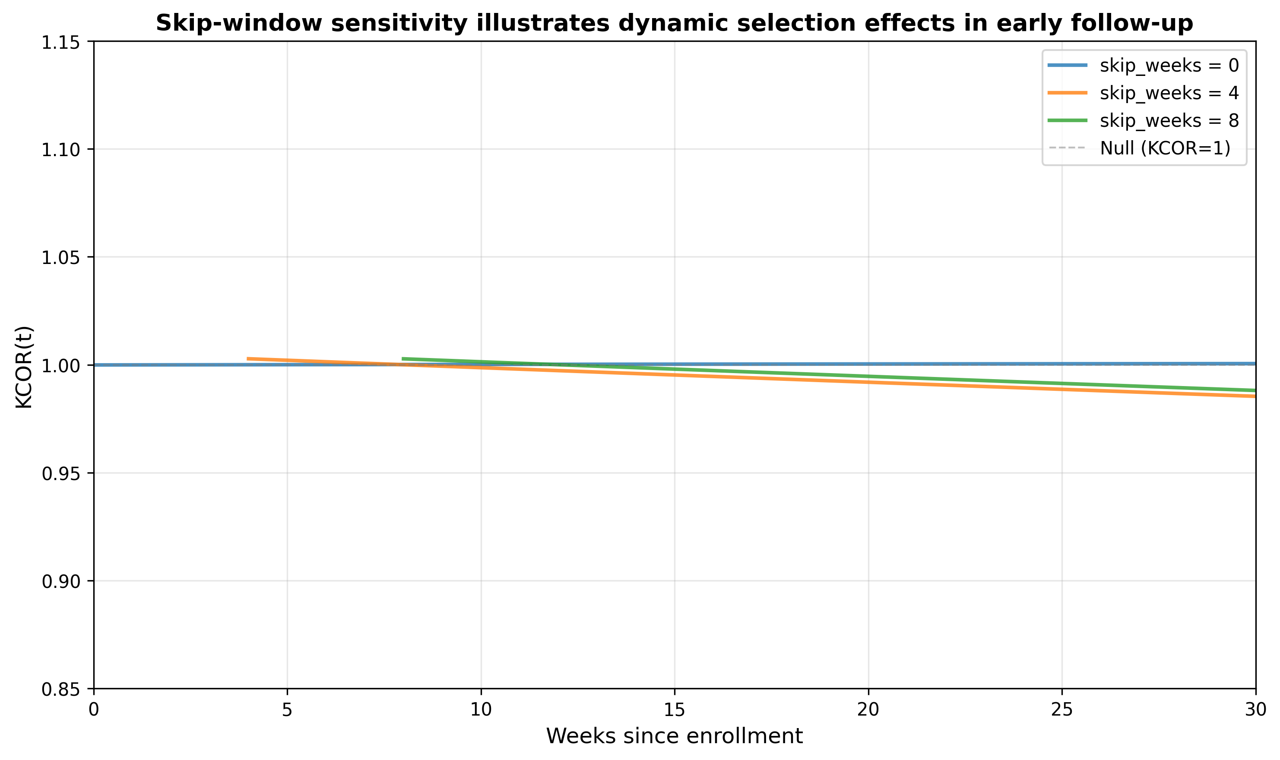
Figure 13. Skip-window sensitivity illustrates dynamic selection effects in early follow-up. $KCOR(t)$ computed on the same fixed-cohort comparison using skip windows of 0, 4, and 8 weeks. Early-time departures that attenuate with larger skip windows are consistent with dynamic selection immediately following cohort entry; later-time behavior is comparatively stable.

Appendix A: Mathematical derivations

A.1 Frailty mixing induces hazard curvature
Consider a cohort $d$ in which individual $i$ has hazard
$$h_{i,d}(t)=z_{i,d} h_{0,d}(t). \text{(A.1)}$$
where the frailty $z_{i,d}$ is drawn from a distribution with mean 1 and variance $θ_{d}>0$. Let
$$S_{i,d}(t)=exp​\left(−z_{i,d}H_{0,d}(t)\right). \text{(A.2)}$$
denote the individual survival function, where
$$H_{0,d}(t)=\int_{0}^{t}{h_{0,d}}(s) ds. \text{(A.3)}$$
is the baseline cumulative hazard.
The cohort survival function, obtained by integrating over the frailty distribution, is
$$S_{d}(t)=E[S_{i,d}(t)]=E[exp(−z H_{0,d}(t))]=L_{z}(H_{0,d}(t)). \text{(A.4)}$$
where $L_{z}(⋅)$ denotes the Laplace transform of the frailty distribution. The corresponding cohort-level hazard is
$$h_{d}(t)=−\frac{d}{dt}logS_{d}(t). \text{(A.5)}$$
Even when $h_{0,d}(t)=k_{d}$ is constant (so that $H_{0,d}(t)=k_{d}t$), the cohort hazard $h_{d}(t)$ is generally time-varying. High-frailty individuals experience events earlier, progressively depleting the higher-risk portion of the cohort and shifting the surviving population, conditional on survival, toward lower frailty over time. This selection-induced depletion is the mechanism by which frailty heterogeneity induces curvature in cohort-level hazards.

A.2 Gamma-frailty identity derivation
For gamma-distributed frailty $z∼Gamma(α=1/θ_{d},β=1/θ_{d})$ with mean 1 and variance $θ_{d}$, the Laplace transform is:
$$L_{z}(s)={\left(1+θ_{d}s\right)}^{−1/θ_{d}}. \text{(A.6)}$$
The cohort survival function becomes:
$$S_{d}^{cohort}(t)={\left(1+θ_{d}H_{0,d}(t)\right)}^{−1/θ_{d}}. \text{(A.7)}$$
The observed cumulative hazard is defined as:
$$H_{obs,d}(t)=−logS_{d}^{cohort}(t). \text{(A.8)}$$
Substituting the gamma Laplace transform yields the canonical gamma-frailty identity:
$$H_{obs,d}(t)=\frac{1}{θ_{d}}log​\left(1+θ_{d} H_{0,d}(t)\right). \text{(A.9)}$$
This is the gamma-frailty identity (see Equation (6) in the main text).

A.3 Inversion formula
Solving for $H_{0,d}(t)$ from the gamma-frailty identity gives the canonical inversion:
$$H_{0,d}(t)=\frac{exp​\left(θ_{d} H_{obs,d}(t)\right)−1}{θ_{d}}. \text{(A.10)}$$
This inversion recovers the baseline cumulative hazard from the observed cumulative hazard, conditional on the frailty variance $θ_{d}$.

A.3a Relationship to the Vaupel–Manton–Stallard gamma frailty framework
KCOR’s normalization step is grounded in the classical demographic frailty framework (e.g., Vaupel–Manton–Stallard), in which individual hazards are multiplicatively scaled by latent frailty and cohort-level hazards decelerate due to depletion of susceptibles. Under gamma frailty, the Laplace-transform identity yields a closed-form relationship between observed cohort cumulative hazard and baseline cumulative hazard, and the inversion in §A.3 recovers the baseline cumulative hazard from observed cumulative hazards given $θ_{d}$.
The distinction in KCOR is not the frailty identity itself, but the direction of inference and the estimand. Frailty-augmented Cox and related regression approaches embed gamma frailty within a regression model to estimate covariate effects (hazard ratios). KCOR instead uses quiet-window curvature to estimate cohort-specific frailty parameters and then inverts the frailty identity to obtain depletion-neutralized baseline cumulative hazards, defining KCOR as a ratio of these cumulative quantities. Thus, KCOR solves an inverse normalization problem and targets cumulative comparisons under selection-induced non-proportional hazards rather than instantaneous hazard-ratio regression parameters.

A.4 Variance propagation (sketch)
For uncertainty quantification, variance in KCOR$(t)$ can be approximated via the delta method. Define:
$$KCOR(t)=\frac{{\tilde{H}}_{0,A}(t)}{{\tilde{H}}_{0,B}(t)}. \text{(A.11)}$$
If the variance of the depletion-neutralized cumulative hazard is available (e.g., from bootstrap or analytic propagation through the inversion), then:
$$Var​\left(KCOR(t)\right)≈KCOR(t)^{2}\left[\frac{Var({\tilde{H}}_{0,A}(t))}{{\tilde{H}}_{0,A}(t)^{2}}+\frac{Var({\tilde{H}}_{0,B}(t))}{{\tilde{H}}_{0,B}(t)^{2}}−2\frac{Cov({\tilde{H}}_{0,A}(t),{\tilde{H}}_{0,B}(t))}{{\tilde{H}}_{0,A}(t){\tilde{H}}_{0,B}(t)}\right]. \text{(A.12)}$$
In practice, Monte Carlo resampling provides a more robust approach that captures uncertainty from both event realization and parameter estimation.

Appendix B: Control-test specifications

B.1 Negative control: synthetic gamma-frailty null
The synthetic negative control (Figure 6) is generated using:
- Data source: example/Frail_cohort_mix.xlsx (pathological frailty mixture)
- Generation script: code/generate_pathological_neg_control_figs.py
- Cohort A weights: Equal weights across 5 frailty groups (0.2 each)
- Cohort B weights: Shifted weights [0.30, 0.20, 0.20, 0.20, 0.10]
- Frailty values: [1, 2, 4, 6, 10] (relative frailty multipliers)
- Base weekly probability: 0.01
- Weekly log-slope: 0.0 (constant baseline during quiet periods)
- Skip weeks: 2
- Normalization weeks: 4
- Time horizon: 250 weeks
Both cohorts share identical per-frailty-group death probabilities; only the mixture weights differ. This induces different cohort-level curvature under the null.

B.2 Negative control: empirical age-shift construction
The empirical negative control (Figures 3 and 7) is generated using:
- Data source: Czech Republic administrative mortality and vaccination data, aggregated into KCOR_CMR format
- Generation script: test/negative_control/code/generate_negative_control.py
- Construction: Age strata remapped to pseudo-doses within same vaccination category
- Age mapping:
  - Dose 0 → YoB {1930, 1935}
  - Dose 1 → YoB {1940, 1945}
  - Dose 2 → YoB {1950, 1955}
- Output YoB: Fixed at 1950 (unvax cohort) or 1940 (vax cohort)
- Sheets processed: 2021_24, 2022_06
This construction ensures that dose comparisons are within the same underlying vaccination category, preserving a true null while inducing 10–20 year age differences.

B.3 Positive control: injected effect
The positive control (Figure 4 and Table 8) is generated using:
- Generation script: test/positive_control/code/generate_positive_control.py
- Initial cohort size: 100,000 per cohort
- Baseline hazard: 0.002 per week
- Frailty variance: $θ_{0}=0.5$ (control), $θ_{1}=1.0$ (treatment)
- Effect window: weeks 20–80
- Hazard multipliers:
  - Harm scenario: $r=1.2$
  - Benefit scenario: $r=0.8$
- Random seed: 42
- Enrollment date: 2021-06-14 (ISO week 2021_24)
The injection multiplies the treatment cohort’s baseline hazard by factor $r$ during the effect window, while leaving the control cohort unchanged.

B.4 Sensitivity analysis parameters
The sensitivity analysis (Figure 8) varies:
- Baseline weeks: [2, 3, 4, 5, 6, 7, 8]
- Quiet-start offsets: [-12, -8, -4, 0, +4, +8, +12] weeks from 2023-01
- Quiet-window end: Fixed at 2023-52
- Dose pairs: 1 vs 0, 2 vs 0, 2 vs 1
- Cohorts: 2021_24
Output grids show KCOR(t) values for each parameter combination.

B.5 Tail-sampling / bimodal selection (adversarial selection geometry)
We generate a base frailty population distribution with mean 1. Cohort construction differs by selection rule:
- Mid-sampled cohort: frailty restricted to central quantiles (e.g., 25th–75th percentile) and renormalized to mean 1.
- Tail-sampled cohort: mixture of low and high tails (e.g., 0–15th and 85th–100th percentiles) with mixture weights chosen to yield mean 1.
Both cohorts share the same baseline hazard $h_{0}(t)$ and no treatment effect (negative-control version). We also generate positive-control versions by applying a known hazard multiplier in a prespecified window. We evaluate (i) KCOR drift, (ii) quiet-window fit RMSE, (iii) post-normalization linearity, and (iv) parameter stability under window perturbation.
- Generation script: test/sim_grid/code/generate_tail_sampling_sim.py
- Base frailty distribution: Log-normal with mean 1, variance 0.5
- Mid-quantile cohort: 25th–75th percentile
- Tail-mixture cohort: [0–15th] + [85th–100th] percentiles, equal weights
- Baseline hazard: 0.002 per week (constant)
- Positive-control hazard multiplier: $r=1.2$ (harm) or $r=0.8$ (benefit)
- Effect window: weeks 20–80
- Random seed: 42

B.6 Joint frailty and treatment-effect simulation (S7)
This simulation evaluates KCOR under conditions in which both selection-induced depletion (frailty heterogeneity) and a true treatment effect (harm or benefit) are present simultaneously. The purpose is to assess whether KCOR can (i) correctly identify and neutralize frailty-driven curvature using a quiet period and (ii) detect a true treatment effect outside that period without confounding the two mechanisms.

Design
Two fixed cohorts are generated with identical baseline hazards but differing frailty variance. Individual hazards are multiplicatively scaled by a latent frailty term drawn from a gamma distribution with unit mean and cohort-specific variance. A treatment effect is then injected over a prespecified time window that does not overlap the quiet period used for frailty estimation.
Formally, individual hazards are generated as
$$h_{i}(t)=z_{i}⋅h_{0}(t)⋅r(t). \text{(B.1)}$$
where $z_{i}$ is individual frailty, $h_{0}(t)$ is a shared baseline hazard, and $r(t)$ is a time-localized multiplicative treatment effect applied to one cohort only.

Frailty structure
- Cohort 0: $z∼\text{Gamma}(θ_{0})$
- Cohort 1: $z∼\text{Gamma}(θ_{1})$, with $θ_{1}≠θ_{0}$
Frailty distributions are normalized to unit mean, differing only in variance, thereby inducing different depletion dynamics and cumulative-hazard curvature across cohorts in the absence of any treatment effect.

Treatment effect
A known treatment effect is applied to Cohort 1 during a finite window $[t_{\text{on}},t_{\text{off}}]$. Three effect shapes are considered:
- Step change (constant multiplicative factor),
- Linear ramp,
- Smooth pulse (“bump”).
Both harmful ($r(t)>1$) and protective ($r(t)<1$) effects are evaluated. The treatment window is chosen to lie strictly outside the quiet period used for frailty estimation.

Quiet period and estimation
Frailty parameters are estimated independently for each cohort using observed cumulative hazards over a prespecified quiet window $[t_{q}^{\text{start}},t_{q}^{\text{end}}]$ during which $r(t)=1$ by construction. KCOR normalization is then applied to the full time horizon using these estimated parameters.
This design enforces temporal separability between selection-induced depletion and treatment effects.

Evaluation criteria
The simulation is considered successful if:
- KCOR(t) remains approximately flat and near unity during the quiet window,
- KCOR(t) deviates in the correct direction and magnitude during the treatment window,
- Fit diagnostics (e.g., residual curvature, post-normalization linearity) remain stable outside intentionally violated scenarios.
An additional stress-test variant intentionally overlaps the treatment window with the quiet period. In this case, KCOR diagnostics degrade and normalized trajectories fail to stabilize, correctly signaling violation of the identifiability assumptions rather than producing spurious treatment effects.

Interpretation
This simulation demonstrates that when selection-induced depletion and treatment effects are temporally separable, KCOR can disentangle the two mechanisms: frailty parameters are identified from quiet-period curvature, and true treatment effects manifest as deviations from unity outside that window. When separability is violated, KCOR does not silently misattribute effects; instead, diagnostics flag reduced interpretability.

Appendix C: Additional figures and diagnostics

C.1 Fit diagnostics
For each cohort $d$, the gamma-frailty fit produces diagnostic outputs including:
- RMSE in $H$-space: Root mean squared error between observed and model-predicted cumulative hazards over the quiet window. Values < 0.01 indicate excellent fit; values > 0.05 may warrant investigation.
- Fitted parameters: baseline hazard level and frailty variance. Very small frailty variance (< 0.01) indicates minimal detected depletion; very large values (> 5) may indicate model stress.
- Number of fit points: $n_{obs}$ observations in quiet window. Larger $n_{obs}$ provides more stable estimates.
Example diagnostic output from the reference implementation:
KCOR_FIT,EnrollmentDate=2021_24,YoB=1950,Dose=0,
k_hat=4.29e-03,theta_hat=8.02e-01,
RMSE_Hobs=3.37e-03,n_obs=97,success=1

C.2 Residual analysis
Fit residuals should be examined for. Define residuals:
$$r_{d}(t)=H_{obs,d}(t)−H_{d}^{model}(t;{\hat{k}}_{d},{\hat{θ}}_{d}). \text{(C.1)}$$
- Systematic patterns: Residuals should be approximately random around zero. Systematic curvature in residuals suggests model inadequacy.
- Outliers: Individual weeks with large residuals may indicate data quality issues or external shocks.
- Autocorrelation: Strong autocorrelation in residuals suggests the model is missing time-varying structure.

C.3 Parameter stability checks
Robustness of fitted parameters should be assessed by:
- Quiet-window perturbation: Shift the quiet-window start/end by ±4 weeks and re-fit. Stable parameters should vary by < 10%.
- Skip-weeks sensitivity: Vary SKIP_WEEKS from 0 to 8 and verify KCOR(t) trajectories remain qualitatively similar.
- Baseline-shape alternatives: Compare the default constant baseline over the fit window to mild linear trends and verify normalization is not sensitive to this choice.
The sensitivity analysis (§3.3 and Figure 8) provides a systematic assessment of parameter stability.

C.4 Quiet-window overlay plots
Recommended diagnostic: overlay the prespecified quiet window on hazard and cumulative-hazard time series plots. The fit window should:
- Avoid major epidemic waves or external mortality shocks
- Contain sufficient event counts for stable estimation
- Span a time range where baseline mortality is approximately stationary
Visual inspection of quiet-window placement relative to mortality dynamics is an essential diagnostic step.

C.5 Robustness to age stratification
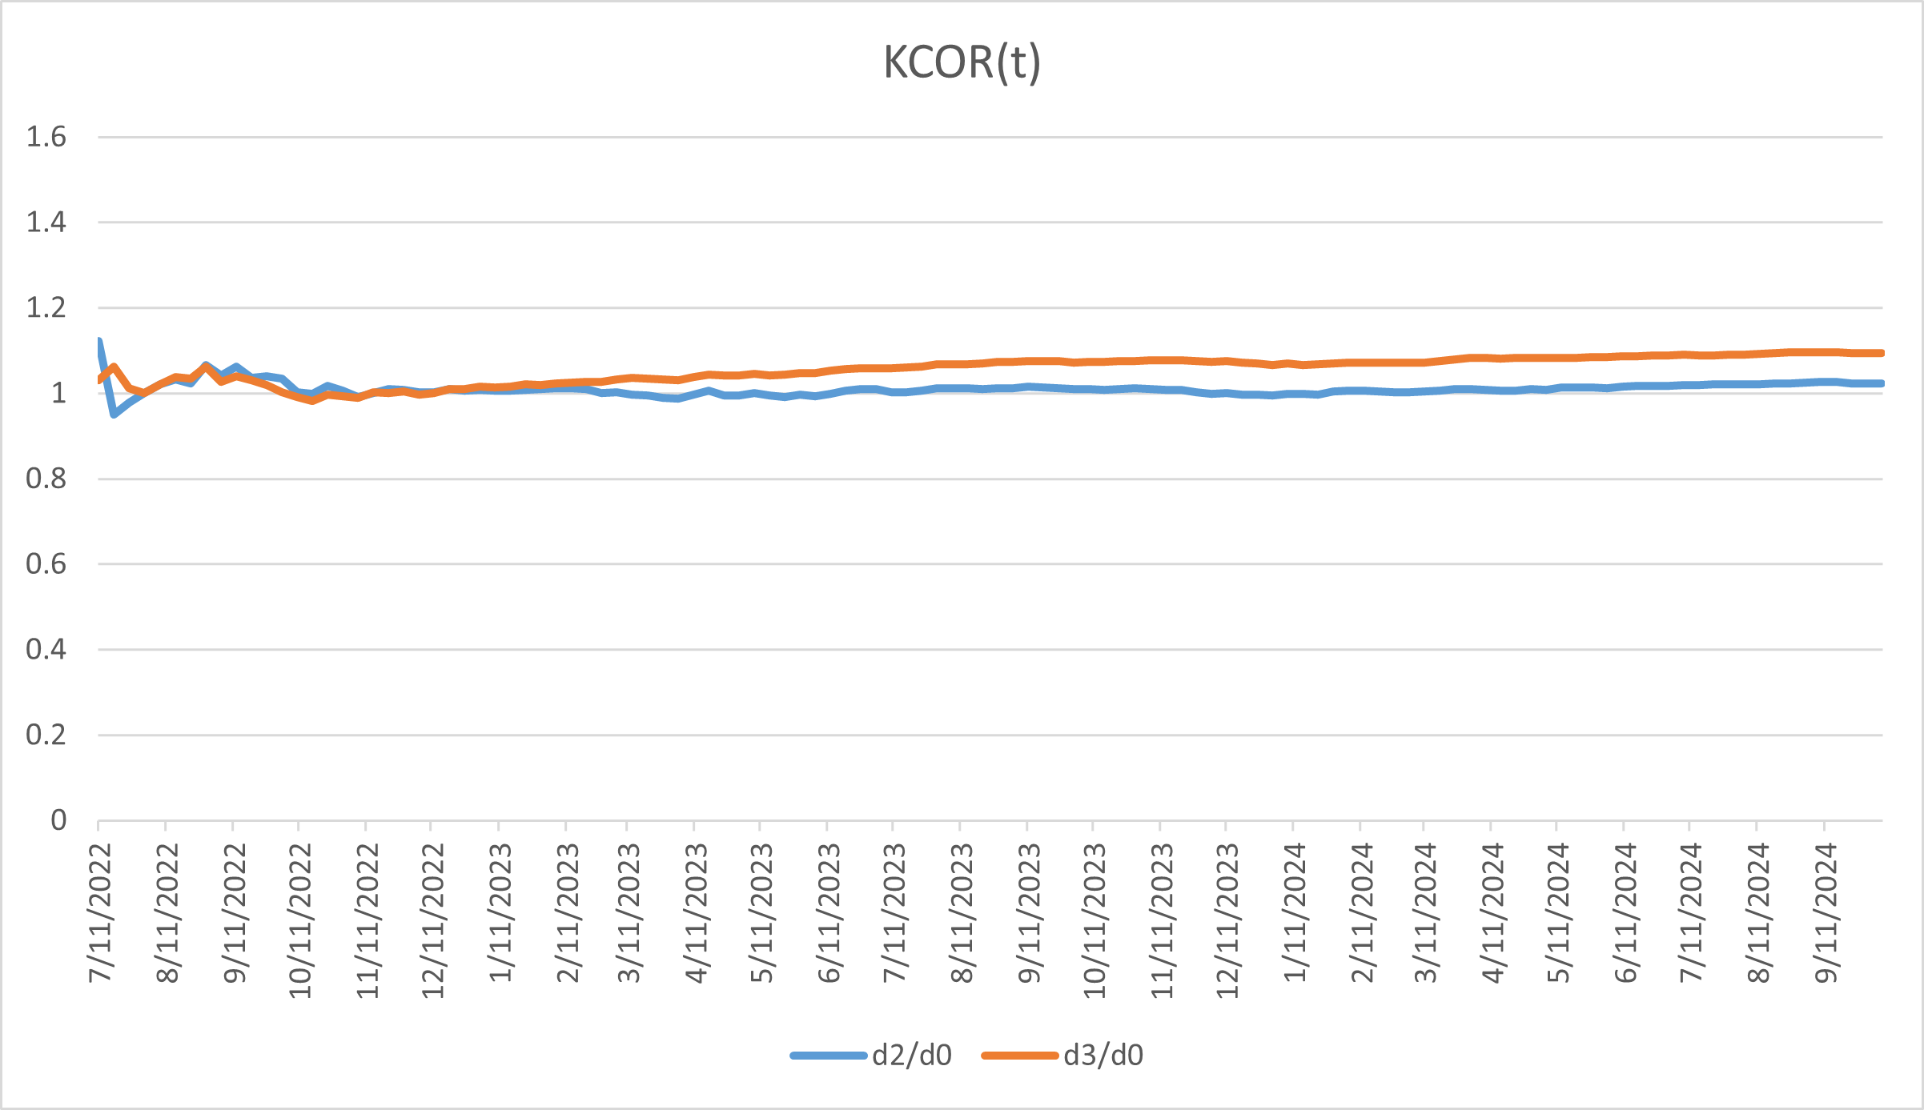
Figure S1. Birth-year cohort 1930: KCOR(t) trajectories comparing dose 2 and dose 3 to dose 0 for cohorts enrolled in ISO week 2022-26 and evaluated over calendar year 2023. KCOR curves are anchored at $t_{0}=4$ weeks (i.e., plotted as $KCOR(t;t_{0})$). This figure is presented as an illustrative application demonstrating estimator behavior on registry data and does not support causal inference.
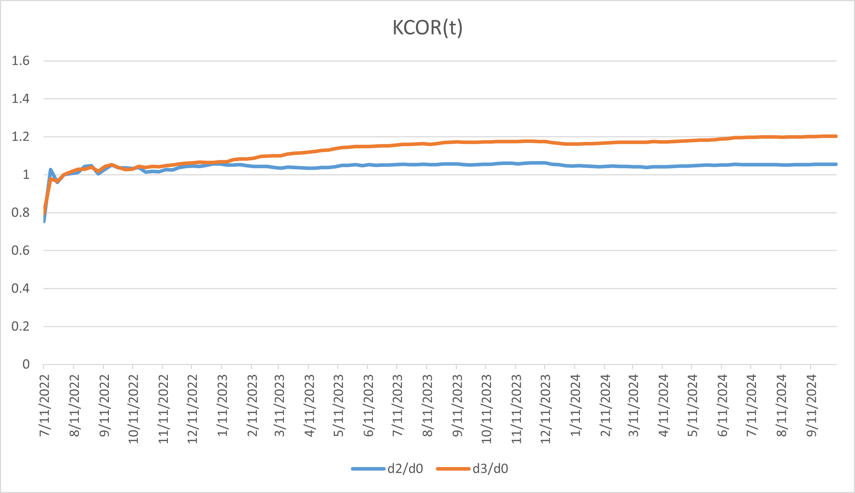
Figure S2. Birth-year cohort 1940: KCOR(t) trajectories comparing dose 2 and dose 3 to dose 0 for cohorts enrolled in ISO week 2022-26 and evaluated over calendar year 2023. KCOR curves are anchored at $t_{0}=4$ weeks (i.e., plotted as $KCOR(t;t_{0})$). This figure is presented as an illustrative application demonstrating estimator behavior on registry data and does not support causal inference.
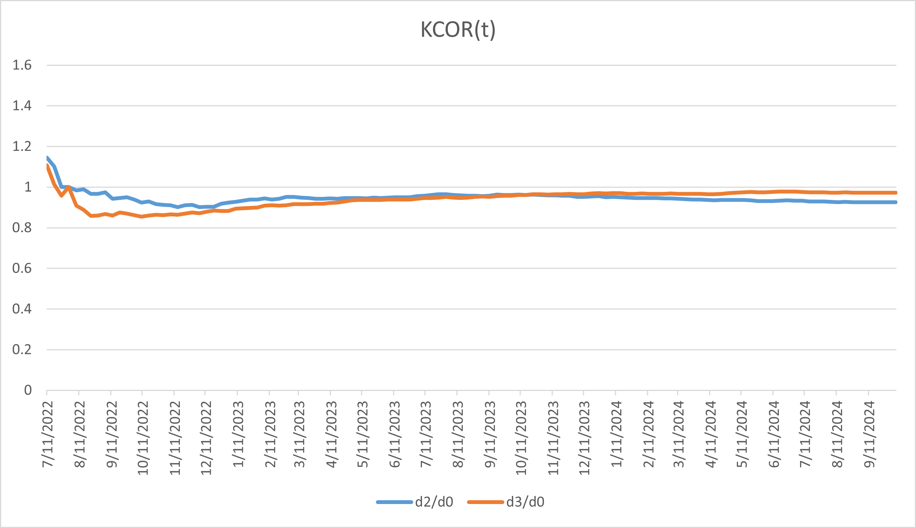
Figure S3. Birth-year cohort 1950: KCOR(t) trajectories comparing dose 2 and dose 3 to dose 0 for cohorts enrolled in ISO week 2022-26 and evaluated over calendar year 2023. KCOR curves are anchored at $t_{0}=4$ weeks (i.e., plotted as $KCOR(t;t_{0})$). This figure is presented as an illustrative application demonstrating estimator behavior on registry data and does not support causal inference.

C.6 Empirical application with diagnostic validation: Czech Republic national registry mortality data
The Czech results do not validate KCOR; they represent an application that satisfies all pre-specified diagnostic criteria. Substantive implications follow only if the identification assumptions hold. Throughout this subsection, observed divergences are interpreted strictly as properties of the estimator under real-world selection, not as intervention effects.
Unless otherwise noted, KCOR curves in the Czech analyses are shown anchored at $t_{0}=4$ weeks for interpretability.

C.6.1 Illustrative empirical context: COVID-19 mortality data
The COVID-19 vaccination period provides a natural empirical regime characterized by strong selection heterogeneity and non-proportional hazards, making it a useful illustration for the KCOR framework. During this period, vaccine uptake was voluntary, rapidly time-varying, and correlated with baseline health status, creating clear examples of selection-induced non-proportional hazards. The Czech Republic national mortality registry data exemplify this regime: voluntary uptake led to asymmetric selection at enrollment, with vaccinated cohorts exhibiting minimal frailty heterogeneity while unvaccinated cohorts retained substantial heterogeneity. This asymmetric pattern reflects the healthy vaccinee effect operating through selective uptake rather than treatment. KCOR normalization removes this selection-induced curvature, enabling interpretable cumulative comparisons. While these examples illustrate KCOR’s application, the method is general and applies to any retrospective cohort comparison where selection induces differential depletion dynamics.

C.6.2 Frailty normalization behavior under empirical validation
Across examined age strata in the Czech Republic mortality dataset, fitted frailty parameters exhibit a pronounced asymmetry across cohorts. Some cohorts show negligible estimated frailty variance:
$${\hat{θ}}_{d}≈0. \text{(C.2)}$$
while others exhibit substantial frailty-driven depletion. This pattern reflects differences in selection-induced hazard curvature at cohort entry rather than any prespecified cohort identity.
As a consequence, KCOR normalization leaves some cohorts’ cumulative hazards nearly unchanged, while substantially increasing the depletion-neutralized baseline cumulative hazard for others. This behavior is consistent with curvature-driven normalization rather than cohort identity. This pattern is visible directly in depletion-neutralized versus observed cumulative hazard plots and is summarized quantitatively in the fitted-parameter logs (see KCOR_summary.log).
After frailty normalization, the depletion-neutralized baseline cumulative hazards are approximately linear in event time. Residual deviations from linearity reflect real time-varying risk—such as seasonality or epidemic waves—rather than selection-induced depletion. This linearization is a diagnostic consistent with successful removal of depletion-driven curvature under the working model; persistent nonlinearity or parameter instability indicates model stress or quiet-window contamination.
Table S2 summarizes these diagnostic checks across age strata.
All age strata in the Czech application satisfied the prespecified diagnostic criteria, permitting KCOR computation and reporting. KCOR results are not reported for any age stratum where diagnostics indicated non-identifiability.
Interpretation: Unvaccinated cohorts exhibit frailty heterogeneity, while Dose 2 cohorts show near-zero estimated frailty across all age bands, consistent with selective uptake prior to follow-up:
$${\hat{θ}}_{d}>0. \text{(C.3)}$$
for Dose 0 cohorts and
$${\hat{θ}}_{d}≈0. \text{(C.4)}$$
for Dose 2 cohorts. Estimated frailty heterogeneity can appear larger at younger ages because baseline hazards are low, so proportional differences across latent risk strata translate into visibly different short-term hazards before depletion compresses the risk distribution. At older ages, higher baseline hazard and stronger ongoing depletion can reduce the apparent dispersion of remaining risk, yielding smaller fitted $θ$ even if latent heterogeneity is not literally smaller. Frailty variance is largest at younger ages, where low baseline mortality amplifies the impact of heterogeneity on cumulative hazard curvature, and declines at older ages where mortality is compressed and survivors are more homogeneous. Because Table S1 demonstrates selection-induced heterogeneity, unadjusted cumulative outcome contrasts are expected to conflate depletion effects with any true treatment differences; see Table S3 for raw cumulative hazards reported as a pre-normalization diagnostic. KCOR normalization removes the depletion component, enabling interpretable comparison of the remaining differences.
These raw contrasts reflect both selection and depletion effects and are not interpreted causally.

C.6.3 Illustrative application to national registry mortality data
We include a brief illustrative application to demonstrate end-to-end KCOR behavior on real registry mortality data in a setting that minimizes timing-driven shocks and window-tuning sensitivity. Cohorts were enrolled in ISO week 2022-26, and evaluation was restricted to calendar year 2023, yielding a 26-week post-enrollment buffer before slope estimation and a prespecified full-year window for assessment. Frailty parameters were estimated using a prespecified epidemiologically quiet window (calendar year 2023) to minimize wave-related hazard variation. This example is intended to illustrate estimator behavior under real-world selection and heterogeneity and does not support causal inference.
Figure S4 shows $KCOR(t)$ trajectories for dose 2 and dose 3 relative to dose 0 for an all-ages analysis. We deliberately present an all-ages analysis as a high-heterogeneity stress test, since aggregation across age induces substantial baseline hazard and frailty variation. To assess whether apparent stability could arise from cancellation across strata, we also present narrow birth-year cohorts spanning advanced ages (1930, 1940, 1950) in Figures S1–S3. Across aggregation levels, $KCOR(t)$ remains stable over the evaluation window after depletion normalization, consistent with effective removal of selection-induced curvature in a real-data setting. These figures are presented as illustrative applications demonstrating estimator behavior on registry data and do not support causal inference; no hypothesis testing is performed.
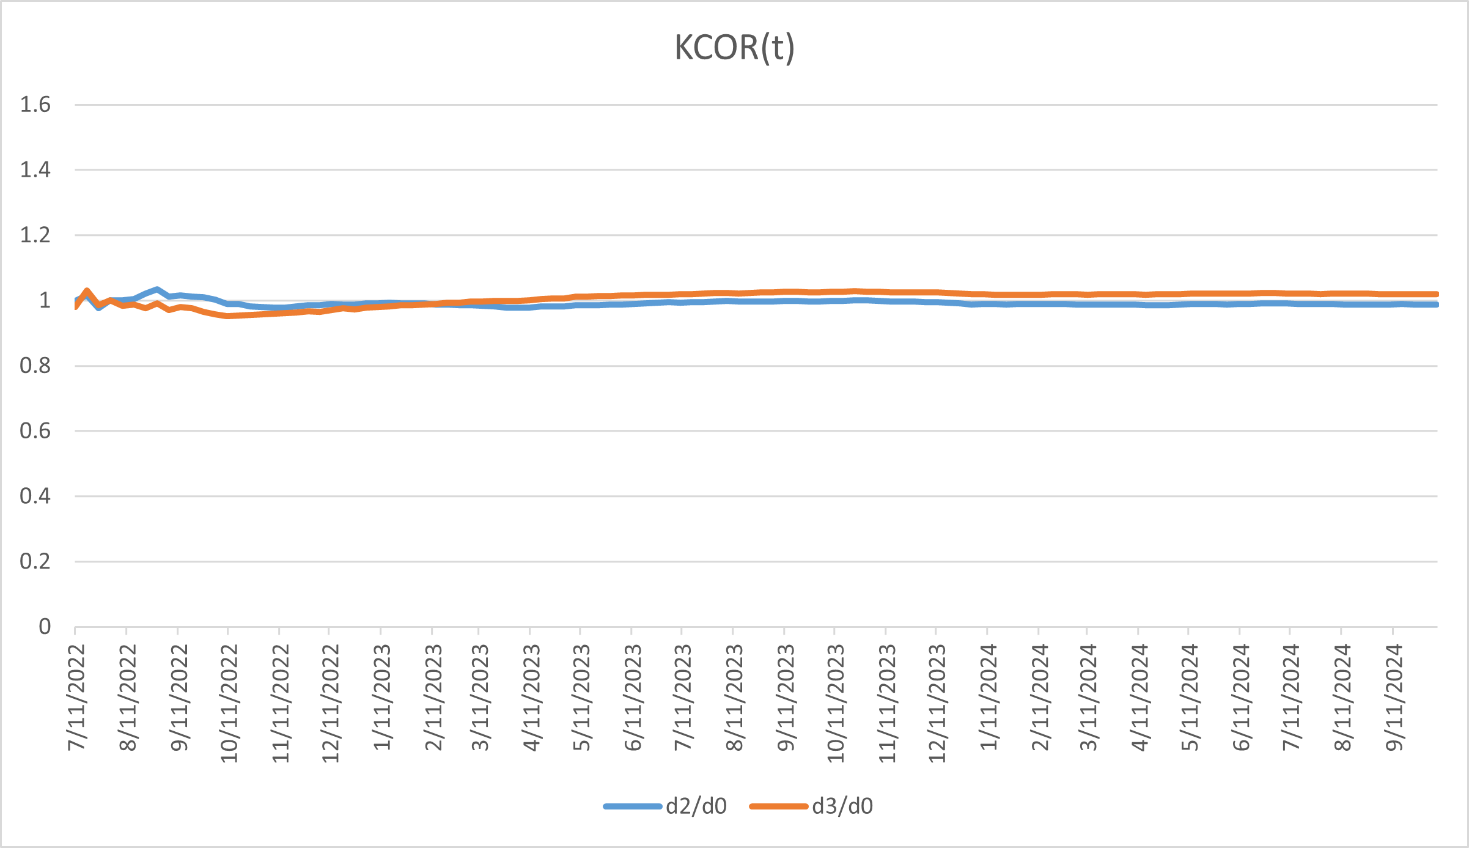
Figure S4. All-ages stress test: $KCOR(t)$ trajectories comparing dose 2 and dose 3 to dose 0 for cohorts enrolled in ISO week 2022-26 and evaluated over calendar year 2023. KCOR curves are anchored at $t_{0}=4$ weeks (i.e., plotted as $KCOR(t;t_{0})$). This figure is presented as an illustrative application demonstrating estimator behavior under extreme heterogeneity and does not support causal inference.

Appendix D: Diagnostics and Failure Modes for KCOR Assumptions
This appendix describes the observable diagnostics and failure modes associated with each of the five KCOR assumptions (A1–A5). No additional assumptions are introduced here. KCOR is designed to fail transparently rather than silently: when an assumption is violated, the resulting lack of identifiability or model stress manifests through explicit diagnostic signals rather than spurious estimates.
A compact summary mapping each assumption to its corresponding diagnostic signals and recommended actions is provided in Table D.1.

D.1 Diagnostics for Assumption A1 (Fixed cohorts at enrollment)
Assumption A1 requires that cohorts be fixed at enrollment, with no post-enrollment switching or censoring in the primary estimand.
Diagnostic signals of violation.
- Inconsistencies in cohort risk sets (e.g., unexplained increases in at-risk counts).
- Early-time hazard suppression or inflation inconsistent with selection or depletion geometry.
- Dependence of results on as-treated reclassification or censoring rules.
Interpretation. KCOR is not defined for datasets with post-enrollment switching or informative censoring in the primary estimand. Such violations are design-level failures rather than modeling failures and indicate that KCOR should not be applied without redefining cohorts.

D.2 Diagnostics for Assumption A2 (Shared external hazard environment)
Assumption A2 requires that all cohorts experience the same calendar-time external mortality environment.
Diagnostic signals of violation.
- Calendar-time hazard spikes or drops that appear in only one cohort.
- Misalignment of major mortality shocks (e.g., epidemic waves) across cohorts.
- Cohort-specific reporting artifacts or administrative discontinuities.
Interpretation. External shocks are permitted under KCOR provided they act symmetrically across cohorts. Cohort-specific shocks violate comparability and are visible directly in calendar-time hazard overlays. When detected, such violations limit interpretation of KCOR contrasts over affected periods.

D.3 Diagnostics for Assumption A3 (Selection via time-invariant latent frailty)
Assumption A3 posits that selection at enrollment operates primarily through differences in a time-invariant latent frailty distribution that induces depletion of susceptibles.
Diagnostic signals of violation.
- Strongly structured residuals in cumulative-hazard space inconsistent with depletion.
- Instability of fitted frailty parameters not attributable to window placement.
- Early-time transients that do not decay and are inconsistent across related cohorts.
Interpretation. Frailty in KCOR is a geometric construct capturing unobserved heterogeneity, not a causal mechanism. If dominant time-varying individual risk unrelated to depletion is present, curvature attributed to frailty becomes unstable. Such cases are revealed by residual structure and parameter instability rather than masked by the model.

D.4 Diagnostics for Assumption A4 (Adequacy of gamma frailty approximation)
Assumption A4 requires that gamma frailty provides an adequate approximation to the depletion geometry observed in cumulative-hazard space over the estimation window.
Diagnostic signals of violation.
- Poor fit of the gamma-frailty cumulative-hazard model during the quiet window.
- Systematic residual curvature after frailty normalization.
- Strong sensitivity of results to minor model or window perturbations.
Additional internal diagnostics for Assumption A4 include the magnitude, coherence, and stability of the fitted frailty variance parameter ($θ$). Values of $θ$ approaching zero are expected when cumulative hazards are approximately linear, while larger values correspond to visible depletion-induced curvature. Implausible $θ$ estimates—such as large values in the absence of curvature, sign instability, or extreme sensitivity to small changes in the estimation window—indicate model stress or misspecification rather than substantive cohort effects.
Interpretation. Gamma frailty is used as a mathematically tractable approximation, not as a claim of biological truth. When depletion geometry deviates substantially from the gamma form, KCOR normalization can degrade visibly through poor fit and residual curvature. Such behavior indicates model inadequacy rather than supporting alternative interpretation.

D.5 Diagnostics for Assumption A5 (Quiet-window validity)
Assumption A5 requires the existence of a prespecified quiet window in which selection-induced depletion dominates other sources of curvature, permitting identification of frailty parameters.
Diagnostic signals of violation.
- Failure of KCOR(t) trajectories to stabilize or asymptote following frailty normalization.
- Persistent nonzero slope in KCOR(t), indicating residual curvature after normalization.
- Instability of fitted frailty parameters ($θ$) under small perturbations of quiet-window boundaries.
- Failure of depletion-neutralized cumulative hazards to become approximately linear during the quiet window.
- Degraded cumulative-hazard fit error concentrated within the nominal quiet period.
Interpretation. Quiet-window validity is the primary dataset-specific requirement for KCOR applicability. When this assumption is violated—e.g., due to overlap with strong treatment effects or external shocks—KCOR does not amplify spurious signals. Instead, normalization becomes unstable and KCOR(t) trajectories attenuate toward unity or may fail to stabilize, explicitly signaling loss of identifiability.
Under a valid quiet window, depletion-neutralized baseline cumulative hazards are expected to be approximately linear and $KCOR(t)$ trajectories to stabilize rather than drift. Persistent $KCOR(t)$ slope or ${\hat{θ}}_{d}$ instability indicates contamination of the quiet window by external shocks or time-varying effects and signals loss of identifiability rather than evidence of cohort differences.
The diagnostics above are designed to detect quiet-window violations that induce residual curvature or parameter instability. They do not, by themselves, exclude the possibility of smooth, approximately stationary cohort-differential hazards within the quiet window that may be absorbed into fitted frailty parameters without producing obvious drift. For this reason, when feasible, we additionally recommend split-window and multi-window stability checks, in which frailty parameters and post-normalization linearity are assessed for consistency across sub-windows. Failure of such stability checks is treated as evidence against Assumption A5.

D.6 Diagnostic coherence across assumptions
Several diagnostics operate across assumptions A4 and A5, including stabilization of KCOR(t) trajectories and coherence of fitted $θ$ parameters with observed cumulative-hazard curvature. These diagnostics are not assumptions of the KCOR framework; rather, they are observable consequences of successful frailty normalization. When these behaviors fail to emerge, KCOR explicitly signals reduced interpretability through residual curvature, parameter instability, or attenuation toward unity.

D.7 Identifiability under sparse data
KCOR does not require large sample sizes by assumption; however, reliable estimation of frailty parameters and depletion-neutralized cumulative hazards requires sufficient event information within the identification window. When event counts are very small, frailty estimates may become unstable, resulting in noisy normalization, non-linear baseline cumulative hazards, or drifting KCOR(t) trajectories.
Such failures are diagnosable: sparse-data regimes are characterized by instability of estimated frailty parameters under small perturbations of the quiet window, loss of post-normalization linearity, and non-stabilizing KCOR(t). In these cases, KCOR signals loss of identifiability rather than producing spurious effects. Applicability should therefore be assessed via diagnostic stability rather than nominal sample size thresholds.

D.8 Summary: Diagnostic enforcement rather than assumption inflation
KCOR relies on exactly five assumptions (A1–A5), stated exhaustively in §2.1.1. This appendix demonstrates that each assumption has explicit, observable diagnostics and well-defined failure modes. When assumptions are violated, KCOR signals reduced interpretability through instability, poor fit, or residual structure rather than producing misleading cumulative contrasts. This diagnostic enforcement is a core design feature of the KCOR framework.

Appendix E: Reference Implementation and Default Settings
This appendix documents the reference implementation and default operational settings used for all analyses in this manuscript. These defaults are not intrinsic to the KCOR framework; they represent one prespecified operationalization chosen to ensure reproducibility and internal consistency. Alternative reasonable choices yield qualitatively similar conclusions when applied to depletion-neutralized hazards.
The manuscript describes KCOR generically; for reproducibility, this repository’s KCOR defaults are:

E.1 Cohort construction defaults
- Cohort indexing (implementation): enrollment period (sheet) × YearOfBirth group × Dose, plus an all-ages cohort (YearOfBirth $=−2$).

E.2 Quiet-period selection defaults
- Quiet window: ISO weeks 2023-01 through 2023-52 (inclusive; calendar year 2023).

E.4 Frailty estimation and inversion defaults
- Skip weeks: a fixed prespecified skip, SKIP_WEEKS = DYNAMIC_HVE_SKIP_WEEKS (see code), applied by setting $h_{d}^{eff}(t)=0$ for $t<SKIP_WEEKS$.
- Fit method: nonlinear least squares in cumulative-hazard space (not MLE), with constraints $k_{d}>0$ and $θ_{d}≥0$.

Supplementary Tables
Table S1. Estimated gamma-frailty variance (fitted frailty variance) by age band and vaccination status for Czech cohorts enrolled in 2021_24.
Age band (years) | Fitted frailty variance (Dose 0) | Fitted frailty variance (Dose 2)
40–49 | 16.79 | $2.66×{10}^{−6}$
50–59 | 23.02 | $1.87×{10}^{−4}$
60–69 | 13.13 | $7.01×{10}^{−18}$
70–79 | 6.98 | $3.46×{10}^{−17}$
80–89 | 2.97 | $2.03×{10}^{−11}$
90–99 | 0.80 | $8.66×{10}^{−16}$
All ages (full population) | 4.98 | $1.02×{10}^{−11}$
Notes: - The fitted frailty variance quantifies unobserved frailty heterogeneity and depletion of susceptibles within cohorts. Near-zero values indicate effectively linear cumulative hazards over the quiet window and are typical of strongly pre-selected cohorts. - Each entry reports a single fitted gamma-frailty variance for the specified age band and vaccination status within the 2021_24 enrollment cohort. - The “All ages (full population)” row corresponds to an independent fit over the full pooled age range, included as a global diagnostic. - Table S3 reports raw outcome contrasts for ages 40+ (YOB ≤ 1980) where event counts are stable.
Diagnostic checks: - Dose ordering: the fitted frailty variance is positive for Dose 0 and collapses toward zero for Dose 2 across all age strata, consistent with selective uptake. - Magnitude separation: Dose 2 estimates are effectively zero relative to Dose 0, indicating near-linear cumulative hazards rather than forced curvature. - Age coherence: the fitted frailty variance decreases at older ages as baseline mortality rises and survivor populations become more homogeneous; monotonicity is not imposed. - Stability: No sign reversals, boundary pathologies, or numerical instabilities are observed. - Falsifiability: Failure of any one of these checks would constitute evidence against model adequacy.
Table S2. Diagnostic gate for Czech application: KCOR results reported only where diagnostics pass.
Age band (years) | Quiet window valid | Post-normalization linearity | Parameter stability | KCOR reported
40–49 | Yes | Yes | Yes | Yes
50–59 | Yes | Yes | Yes | Yes
60–69 | Yes | Yes | Yes | Yes
70–79 | Yes | Yes | Yes | Yes
80–89 | Yes | Yes | Yes | Yes
90–99 | Yes | Yes | Yes | Yes
All ages | Yes | Yes | Yes | Yes

Table S3. Ratio of observed cumulative mortality hazards for unvaccinated (Dose 0) versus fully vaccinated (Dose 2) Czech cohorts enrolled in 2021_24.
Age band (years) | Dose 0 cumulative hazard | Dose 2 cumulative hazard | Ratio
40–49 | 0.005260 | 0.004117 | 1.2776
50–59 | 0.014969 | 0.009582 | 1.5622
60–69 | 0.045475 | 0.023136 | 1.9655
70–79 | 0.123097 | 0.057675 | 2.1343
80–89 | 0.307169 | 0.167345 | 1.8355
90–99 | 0.776341 | 0.517284 | 1.5008
All ages (full population) | 0.023160 | 0.073323 | 0.3159
This table reports unadjusted cumulative hazards derived directly from the raw data, prior to any frailty normalization or depletion correction, and is shown to illustrate the magnitude and direction of selection-induced curvature addressed by KCOR.
Values reflect raw cumulative outcome differences prior to KCOR normalization and are not interpreted causally due to cohort non-exchangeability. Cumulative hazards were integrated from cohort enrollment through the end of available follow-up for the 2021_24 enrollment window (through week 2024-16), identically for Dose 0 and Dose 2 cohorts.

