KCOR: Depletion-Neutralized Cohort Comparison via Gamma-Frailty Normalization Under Selection-Induced Hazard Curvature

Manuscript metadata (for journal submission)
- Article type: Methods / Statistical method
- Running title: KCOR via gamma-frailty normalization
- Authors: TODO (names, degrees)
- Affiliations: TODO
- Corresponding author: TODO (email, address)
- Word count: TODO
- Keywords: selection bias; healthy vaccinee effect; non-proportional hazards; frailty; gamma frailty; negative controls; causal inference

Abstract
Retrospective cohort studies often estimate the mortality impact of medical interventions, but selection can create non-exchangeable cohorts that defeat standard comparisons. In particular, selective uptake can induce systematic differences in mortality curvature—differences in the time-evolution of cohort hazards driven by frailty heterogeneity and depletion of susceptibles—that violate the assumptions of standard epidemiologic tools such as Cox proportional hazards models, age-standardized mortality rates, and inverse-probability weighting. We introduce KCOR (Kirsch Cumulative Outcomes Ratio), a method that neutralizes selection-induced curvature before cohort comparison by estimating and inverting a gamma-frailty mixture model in cumulative-hazard space. KCOR v6 fits cohort-specific selection parameters during epidemiologically quiet periods and transforms observed cumulative hazards to depletion-neutralized baseline cumulative hazards, which are then compared cumulatively via ratios. We describe the KCOR framework, its mathematical foundation, and its validation using prespecified negative and positive control tests designed to stress selection-induced curvature. KCOR enables interpretable cumulative cohort comparisons in settings where treated and untreated hazards are non-proportional because selection induces different depletion dynamics.

1. Introduction

1.1 Retrospective cohort comparisons under selection
Randomized controlled trials (RCTs) are the gold standard for causal inference, but are often infeasible, underpowered for rare outcomes, or unavailable for questions that arise after rollout. As a result, observational cohort comparisons are widely used to estimate intervention effects on outcomes such as all-cause mortality.
However, when intervention uptake is voluntary, prioritized, or otherwise selective, treated and untreated cohorts are frequently non-exchangeable at baseline and evolve differently over follow-up. This problem is not limited to any single intervention class; it arises whenever the same factors that influence treatment uptake also influence outcome risk.

1.2 Curvature (shape) is the hard part: non-proportional hazards from frailty depletion
Selection does not merely shift mortality levels; it can alter mortality curvature—the time-evolution of cohort hazards. Frailty heterogeneity and depletion of susceptibles naturally induce curvature even when individual-level hazards are simple functions of time. When selection concentrates high-frailty individuals into one cohort (or preferentially removes them from another), the resulting cohort-level hazard trajectories can be strongly non-proportional.
One convenient way to formalize “curvature” is in cumulative-hazard space: if $H(t)$ were perfectly linear over time then $d^{2}H(t)/dt^{2}=0$ (or discrete second differences are near zero), whereas selection-induced depletion generally produces concavity in $H^{obs}(t)$ during otherwise stable periods.
This violates core assumptions of many standard tools:
- Cox PH: assumes hazards differ by a time-invariant multiplicative factor (proportional hazards).
- IPTW / matching: can balance measured covariates yet fail to balance unmeasured frailty and the resulting depletion dynamics.
- Age-standardization: adjusts levels across age strata but does not remove cohort-specific time-evolving hazard shape.
KCOR is designed for this failure mode: cohorts whose hazards are not proportional because selection induces different depletion dynamics (curvature).

1.3 Evidence from the literature: residual confounding despite meticulous matching
Two large, rigorously designed observational analyses illustrate the core empirical motivation: even extremely careful matching and adjustment can leave large residual differences in non-COVID mortality, indicating confounding and selection that standard pipelines do not eliminate.

1.3.1 Denmark (negative controls highlight confounding)
Obel et al. used Danish registry data to build 1:1 matched cohorts and applied negative control outcomes to assess confounding. Their plain-language summary includes the following:
Meaning: The negative control methods indicate that observational studies of SARS-CoV-2 vaccine effectiveness may be prone to substantial confounding which may impact the observed associations. This bias may both lead to underestimation of vaccine effectiveness (increased risk of SARS-CoV2 infection among vaccinated individuals) and overestimation of the vaccine effectiveness (decreased risk of death after of SARS-CoV2 infection among vaccinated individuals). Our results highlight the need for randomized vaccine efficacy studies after the emergence of new SARS-CoV-2 variants and the rollout of multiple booster vaccines.¹
This is a direct statement that observational designs—even with careful matching and covariate adjustment—can remain substantially confounded when selection and health-seeking behavior differ between cohorts.

1.3.2 Qatar (time-varying HVE despite meticulous matching)
Chemaitelly et al. analyzed matched national cohorts and explicitly measured the time-varying healthy vaccinee effect using non-COVID mortality as a control outcome. They report a pronounced early-period reduction in non-COVID mortality among vaccinated individuals despite meticulous matching, followed by reversal later in follow-up, consistent with dynamic selection and depletion processes.²
Together, these studies motivate a methods gap: we need estimators that explicitly address time-evolving selection-induced curvature, not only baseline covariate imbalance.
Table 1: Summary of two large matched observational studies demonstrating residual confounding / HVE despite meticulous matching.
Study | Design | Matching/adjustment | Key control finding | Implication for methods
Obel et al. (Denmark)¹ | Nationwide registry cohorts (60–90y) | 1:1 match on age/sex + covariate adjustment; negative control outcomes | Vaccinated had higher rates of multiple negative control outcomes, but substantially lower mortality after unrelated diagnoses | Strong evidence of confounding in observational VE estimates; “negative control methods indicate… substantial confounding”
Chemaitelly et al. (Qatar)² | Matched national cohorts (primary series and booster) | Exact 1:1 matching on demographics + coexisting conditions + prior infection; Cox models | Strong early reduction in non-COVID mortality (HVE), with time-varying reversal later | Even meticulous matching leaves time-varying residual differences consistent with selection/frailty depletion

1.4 Contribution of this work
This paper introduces KCOR, a method that transforms observed cohort hazards to remove selection-induced depletion dynamics prior to comparison, enabling interpretable cumulative cohort comparisons under selection-induced non-proportional hazards.
This manuscript is methods-only:
- We present the estimator, model assumptions, and uncertainty quantification.
- We validate the method using prespecified negative and positive controls designed to stress selection-induced curvature.
- We defer any applied real-world intervention conclusions to a separate, dedicated applied paper.

2. Methods
Table 2: Notation used throughout the Methods section.
Symbol | Meaning
$d$ | cohort index (enrollment definition × age group × dose/exposure)
$t$ | event time since enrollment (discrete bins, e.g., weeks)
$h_{d}^{obs}(t)$ | observed cohort hazard at time $t$
$H_{d}^{obs}(t)$ | observed cumulative hazard (after skip/stabilization)
$h_{0,d}(t)$ | depletion-neutralized baseline hazard for cohort $d$
$H_{0,d}(t)$ | depletion-neutralized baseline cumulative hazard
$θ_{d}$ | frailty variance (selection strength) for cohort $d$
$k_{d}$ | baseline hazard level for cohort $d$ under default baseline shape

2.1 Conceptual framework: level vs curvature under selection
Differences in mortality between cohorts can arise from:
- Level effects: multiplicative shifts in hazard that are constant over time.
- Curvature effects: differences in the time-evolution of cohort hazards induced by heterogeneity and selective depletion.
Selection bias commonly produces curvature differences through frailty mixing and depletion. KCOR’s strategy is to estimate and remove the selection-induced depletion component, then compare cohorts on a cumulative scale.

2.2 Cohort construction and estimand
KCOR is defined for fixed cohorts at enrollment:
- Cohorts are fixed at enrollment and defined by intervention status at a specified time.
- No censoring or cohort switching is permitted in the primary estimand.
- Analysis proceeds in event time $t$ (time since enrollment).
This fixed-cohort design corresponds to an intent-to-treat–like estimand under selection. It is chosen deliberately to avoid time-varying deferral bias, immortal time bias, and dynamic health-based sorting that arise when individuals change exposure status during follow-up. Dynamic “as-treated” formulations are treated as sensitivity analyses rather than primary estimands.

2.3 Hazard estimation and cumulative hazards (discrete time)
Let $t$ denote event time since enrollment (e.g., weeks), $D_{d}(t)$ deaths during interval $t$ in cohort $d$, and $N_{d}(t)$ the number at risk at the start of interval $t$. In discrete time, hazards are treated as piecewise-constant and can be computed from interval risk as
$$h_{d}^{obs}(t)=−ln\left(1−\frac{D_{d}(t)}{N_{d}(t)}\right). (1)$$
We work primarily in cumulative-hazard space, accumulating observed hazards after an optional stabilization skip (see §2.7):
Hdobs(t)=s≤t​hdeff(s) Δt, Δt=1 (one time bin). (2)

2.4 Selection model: gamma frailty and the cumulative-hazard identity

2.4.1 Individual hazards with multiplicative frailty
Model individual hazards in cohort $d$ as multiplicative frailty on top of a baseline hazard:
$$h_{i,d}(t)=z_{i,d} h_{0,d}(t), z_{i,d}∼Gamma(mean=1, var=θ_{d}). (3)$$
Gamma frailty is used not as a claim of biological truth, but as a mathematically minimal and widely used model for unobserved heterogeneity whose Laplace transform yields a closed-form relationship between observed and baseline cumulative hazards. In KCOR, gamma frailty is therefore a depletion-neutralizing approximation: its adequacy is treated as empirically testable and is assessed using prespecified negative controls and sensitivity analyses rather than assumed dogmatically.
Frailty $z_{i,d}$ captures latent heterogeneity in baseline risk and drives selective depletion: higher-frailty individuals die earlier, changing the cohort composition over time and inducing curvature in $h_{d}^{obs}(t)$ even when $h_{0,d}(t)$ is simple.

2.4.2 Gamma-frailty identity (core mathematics)
Let the baseline cumulative hazard be
$$H_{0,d}(t)=\int_{0}^{t}{h_{0,d}}(s) ds. (4)$$
Integrating over gamma frailty yields a closed-form relationship between the observed cohort cumulative hazard and the baseline cumulative hazard:
$$H_{d}^{obs}(t)=\frac{1}{θ_{d}} log​\left(1+θ_{d}H_{0,d}(t)\right). (5)$$
This identity can be inverted exactly:
$$H_{0,d}(t)=\frac{e^{θ_{d}H_{d}^{obs}(t)}−1}{θ_{d}}. (6)$$
This inversion is the KCOR v6 normalization step: it transforms the observed cumulative hazard into a depletion-neutralized baseline cumulative hazard for each cohort.
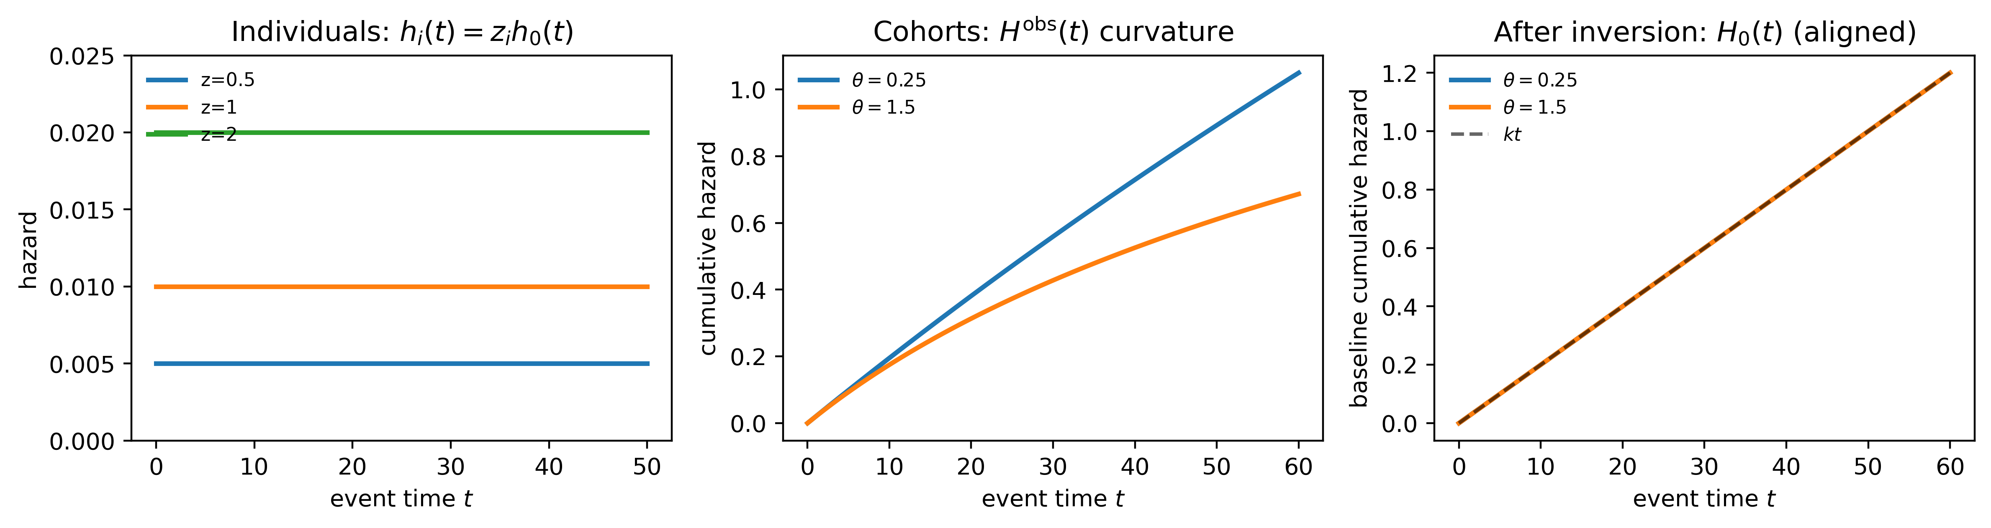
Figure 1: Three-panel schematic illustrating the KCOR v6 normalization logic. Left: individual hazards differ only by multiplicative frailty $z$, with no treatment effect. Middle: aggregation over heterogeneous frailty induces cohort-level curvature in observed cumulative hazards $H^{obs}(t)$ despite identical baseline hazards. Right: inversion of the gamma-frailty identity recovers aligned baseline cumulative hazards $H_{0}(t)$, demonstrating depletion-neutralization.

2.4.3 Baseline shape for fitting (default)
To identify $θ_{d}$ from data, KCOR fits the gamma-frailty model during epidemiologically quiet periods. In the reference specification, the baseline time-shape is taken to be constant over the fit window:
$$h_{0,d}(t)=k_{d} g(t), g(t)=1, H_{0,d}(t)=k_{d}t. (7)$$
This choice minimizes degrees of freedom and forces curvature during quiet periods to be explained by selection (frailty) rather than by an explicit time-varying baseline.

2.5 Estimation during quiet periods (cumulative-hazard least squares)
KCOR estimates $(k_{d},θ_{d})$ independently for each cohort $d$ using only time bins that fall inside a prespecified quiet window in calendar time (ISO week space). The quiet window is prespecified and applied consistently across cohorts within an analysis; robustness to alternate quiet-window bounds is assessed in sensitivity analyses. Let $T_{d}$ denote the set of event-time bins $t$ whose corresponding calendar week lies in the quiet window, with $t$ also satisfying $t≥SKIP_WEEKS$.
Under the default baseline shape, the model-implied observed cumulative hazard is
$$H_{d}^{model}(t;k_{d},θ_{d})=\frac{1}{θ_{d}} log​\left(1+θ_{d}k_{d}t\right). (8)$$
Identifiability of $(k_{d},θ_{d})$ comes from curvature in cumulative-hazard space: the mapping $t↦H_{d}^{obs}(t)$ is nonlinear when $θ_{d}>0$. When depletion is weak (or the quiet window is too short to show curvature), the model smoothly collapses to a linear cumulative hazard, since $H_{d}^{model}(t;k_{d},θ_{d})→k_{d}t$ as $θ_{d}→0$. Operationally, near-linear $H_{d}^{obs}(t)$ naturally drives ${\hat{θ}}_{d}≈0$; fit diagnostics such as $n_{obs}$ and RMSE in $H$-space provide a practical check on whether the selection parameters are being identified from the quiet-window data.
Parameters are estimated by constrained nonlinear least squares:
(kd,θd)=argminkd>0, θd≥0t∈Td​Hdobs(t)−Hdmodel(t;kd,θd)2. (9)
We fit in cumulative-hazard space rather than maximizing a likelihood because the primary inputs are discrete-time, cohort-aggregated hazards and the objective is stable estimation of selection-induced depletion curvature during quiet periods. Least squares on $H_{d}^{obs}(t)$ is numerically robust under sparse events, emphasizes shape agreement over the fit window, and yields diagnostics (e.g., RMSE in $H$-space) that directly reflect the quality of the depletion fit. Likelihood-based fitting can be treated as a sensitivity analysis, but is not required for the normalization identity itself.

Reference implementation defaults (this repo)
The manuscript describes KCOR generically; for reproducibility, this repository’s KCOR v6 defaults are:
- Quiet window: ISO weeks 2022-24 through 2024-16 (inclusive).
- Skip weeks: a fixed prespecified skip, SKIP_WEEKS = DYNAMIC_HVE_SKIP_WEEKS (see code), applied by setting $h_{d}^{eff}(t)=0$ for $t<SKIP_WEEKS$.
- Observed hazard transform used to build $H_{d}^{obs}$ from weekly mortality risk: if ${MR}_{d,t}=D_{d,t}/Y_{d,t}$ is the weekly mortality input,
$$h_{d}^{obs}(t)=−log​\left(\frac{1−1.5 {MR}_{d,t}}{1−0.5 {MR}_{d,t}}\right). (10)$$
- Fit method: nonlinear least squares in cumulative-hazard space (not MLE), with constraints $k_{d}>0$ and $θ_{d}≥0$.
- Cohort indexing (implementation): enrollment period (sheet) × YearOfBirth group × Dose, plus an all-ages cohort (YearOfBirth $=−2$).

2.6 Normalization (depletion-neutralized cumulative hazards)
After fitting, KCOR computes the depletion-neutralized baseline cumulative hazard for each cohort $d$ by applying the inversion to the full post-enrollment trajectory:
$${\tilde{H}}_{0,d}(t)=\frac{e^{{\hat{θ}}_{d}H_{d}^{obs}(t)}−1}{{\hat{θ}}_{d}}. (11)$$
An adjusted hazard may be recovered by differencing:
$${\tilde{h}}_{0,d}(t)≈{\tilde{H}}_{0,d}(t)−{\tilde{H}}_{0,d}(t−1). (12)$$
The key object for KCOR is ${\tilde{H}}_{0,d}(t)$; differenced hazards are optional diagnostics.

2.7 Stabilization (early weeks)
In many applications, the first few post-enrollment intervals can be unstable due to immediate post-enrollment artifacts (e.g., rapid deferral, short-term sorting, administrative effects). KCOR supports a prespecified stabilization rule by excluding early weeks from accumulation and from quiet-window fitting.
In discrete time, define an effective hazard for accumulation:
$$h_{d}^{eff}(t)=\left\{\begin{matrix}0, & t<SKIP_WEEKS \\ h_{d}^{obs}(t), & t≥SKIP_WEEKS.\end{matrix}\right. (13)$$
Then compute $H_{d}^{obs}(t)$ from $h_{d}^{eff}(t)$ as in §2.3.

2.8 KCOR estimator (v6)
For cohorts $A$ and $B$, KCOR compares depletion-neutralized cumulative hazards:
$$KCOR(t)=\frac{{\tilde{H}}_{0,A}(t)}{{\tilde{H}}_{0,B}(t)}. (14)$$
This is a cumulative comparison in hazard space after removing cohort-specific selection-induced depletion dynamics estimated during quiet periods.

2.9 Uncertainty quantification
KCOR can be equipped with uncertainty intervals via:
- Analytic variance propagation for cumulative hazards combined with delta-method approximations for the ratio, and/or
- Monte Carlo resampling to capture uncertainty from event realization and from estimation of $(k_{d},θ_{d})$ and the resulting normalization.
Uncertainty intervals reflect stochastic event realization and model-fit uncertainty in the selection-parameter estimation. They do not assume sampling from a superpopulation and may be interpreted as uncertainty conditional on the observed risk sets and modeling assumptions.

2.10 Algorithm summary and reproducibility checklist
Table 3: Step-by-step KCOR v6 algorithm (high-level), with recommended prespecification and diagnostics.
Step | Operation | Output | Prespecify? | Diagnostics
1 | Choose enrollment date and define fixed cohorts | Cohort labels | Yes | Verify cohort sizes/risk sets
2 | Compute discrete-time hazards $h_{d}^{obs}(t)$ | Hazard curves | Yes (binning/transform) | Check for zeros/sparsity
3 | Apply stabilization skip and accumulate $H_{d}^{obs}(t)$ | Observed cumulative hazards | Yes (skip rule) | Plot $H_{d}^{obs}(t)$
4 | Select quiet-window bins in calendar ISO-week space | Fit points $T_{d}$ | Yes | Overlay quiet window on hazard plots
5 | Fit $(k_{d},θ_{d})$ via cumulative-hazard least squares | ${\hat{k}}_{d},{\hat{θ}}_{d}$ | Yes | RMSE, residuals, fit stability
6 | Normalize: invert gamma-frailty identity to ${\tilde{H}}_{0,d}(t)$ | Depletion-neutralized cumulative hazards | Yes | Compare pre/post shapes; sanity checks
7 | Cumulate and ratio: compute $KCOR(t)$ | KCOR$(t)$ curve | Yes (horizon) | Flat under negative controls
8 | Uncertainty | CI / intervals | Yes | Coverage on positive controls

3. Validation and control tests
This section is the core validation claim of KCOR:
- Negative controls (null under selection): under a true null effect, KCOR remains approximately flat at 1 even when selection induces large curvature differences.
- Positive controls (detect injected effects): when known harm/benefit is injected into otherwise-null data, KCOR reliably detects it.

3.1 Negative controls: null under selection-induced curvature

3.1.1 Fully synthetic negative control (recommended)
Design a simulation where:
- Individual hazards follow a baseline hazard $h_{0}(t)$ multiplied by frailty $z$.
- Two cohorts have different frailty variance $θ$ (or different selection rules), creating different cohort-level curvature in $h_{d}^{obs}(t)$.
- No treatment effect is applied (both cohorts share the same baseline hazard $h_{0}(t)$).
After estimating $(k_{d},θ_{d})$ during quiet periods and applying gamma-frailty inversion, KCOR should remain approximately constant at 1 over follow-up.

In-model “gamma-frailty” stress test (highly convincing null)
One especially clear falsification test is an in-model gamma-frailty null: simulate data directly from the gamma-frailty model with the same $h_{0}(t)$ but different $θ$ between cohorts. This induces strong, visibly different hazard curvature from depletion alone. Because the data-generating process matches the model, the fitted normalization is exact up to sampling noise, and KCOR should be flat at 1.
Suggested construction (example):
- Time unit: weeks.
- Baseline hazard shape: $g(t)=1$ during quiet periods; choose a baseline level $k$ in the chosen time units.
- Cohort A: $θ_{A}>0$ (stronger depletion).
- Cohort B: $θ_{B}>0$ (weaker depletion).
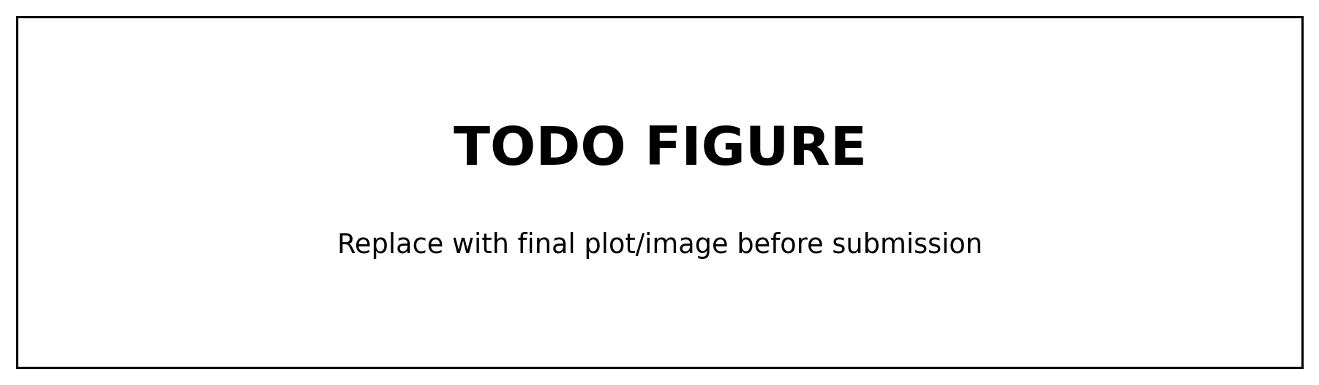
Figure 2: Synthetic negative control under strong selection (different curvature) but no effect: KCOR remains flat at 1. (TODO: generate figure for submission package.)

3.1.2 Empirical “within-category” negative control (already implemented in repo)
The repository includes a pragmatic negative control construction that repurposes a real dataset by comparing “like with like” while inducing large composition differences (e.g., age band shifts). In this construction, age strata are remapped into pseudo-doses so that comparisons are, by construction, within the same underlying category; the expected differential effect is near zero, but the baseline hazards differ strongly.
These age-shift negative controls deliberately induce extreme baseline mortality differences (10–20 year age gaps) while preserving a true null effect by construction, since all vaccination states are compared symmetrically. The near-flat KCOR trajectories demonstrate that the estimator neutralizes selection-induced depletion curvature without introducing spurious time trends or cumulative drift.
Two snapshots illustrate that KCOR is near-flat even under 10–20 year age differences:
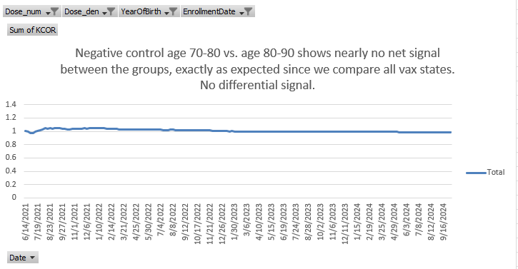
Figure 3: Empirical negative control with approximately 10-year age difference between cohorts. Despite large baseline mortality differences, KCOR remains near-flat at 1 over follow-up, consistent with a true null effect.
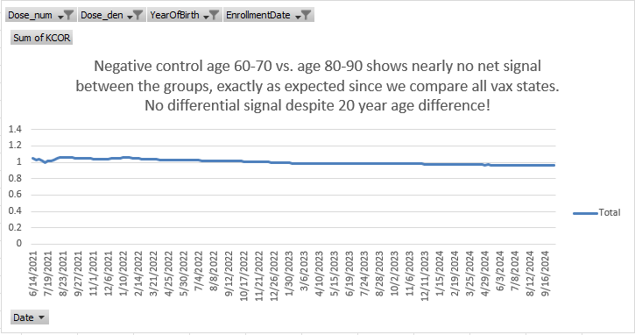
Figure 4: Empirical negative control with approximately 20-year age difference between cohorts. Even under extreme composition differences, KCOR exhibits no systematic drift, demonstrating robustness to selection-induced curvature.
Table 4: Example end-of-window KCOR values from the empirical negative control (pooled/ASMR summaries), demonstrating near-null behavior under large composition differences. (Source: ../../test/negative_control/out/KCOR_summary.log)
Enrollment | Dose comparison | KCOR (pooled/ASMR) | 95% CI
2021_24 | 1 vs 0 | 1.0097 | [0.992, 1.027]
2021_24 | 2 vs 0 | 1.0213 | [1.000, 1.043]
2021_24 | 2 vs 1 | 1.0115 | [0.991, 1.033]
2022_06 | 1 vs 0 | 0.9858 | [0.970, 1.002]
2022_06 | 2 vs 0 | 1.0756 | [1.055, 1.097]
2022_06 | 2 vs 1 | 1.0911 | [1.070, 1.112]

3.2 Positive controls: detect injected harm/benefit
Positive controls are constructed by starting from a negative-control dataset and injecting a known effect into one cohort, for example by multiplying the baseline hazard by a constant factor $r$ over a prespecified interval:
$$h_{0,treated}(t)=r⋅h_{0,control}(t) \text{for }t∈[t_{1},t_{2}], (15)$$
with $r>1$ for harm and $0<r<1$ for benefit.
After gamma-frailty normalization (inversion), KCOR should deviate from 1 in the correct direction and with magnitude consistent with the injected effect (up to discretization and sampling noise).
Figure 5: Positive control with injected effect (benefit/harm) shows clear deviation from KCOR$=1$, with uncertainty intervals excluding 1 over the injected interval. (TODO: generate figure for submission package.)
Table 5: Positive control results comparing injected hazard multipliers to detected KCOR deviations. (TODO: populate after generating positive control runs.)
Scenario | Injection window | Hazard multiplier $r$ | Expected direction | Observed KCOR behavior
Benefit | TODO | 0.8 | < 1 | TODO
Harm | TODO | 1.2 | > 1 | TODO

3.3 Sensitivity analyses (robustness checks)
The primary analysis uses a prespecified quiet window applied uniformly across cohorts; sensitivity analyses explicitly vary quiet-window bounds and related prespecified choices to assess robustness.
KCOR results should be robust (up to numerical tolerance) to reasonable variations in:
- Quiet-window selection (calendar ISO-week bounds)
- Stabilization skip (early-bin handling)
- Time-binning resolution
- Age stratification and/or stratified analyses where appropriate
- Baseline shape choice $g(t)$ (default $g(t)=1$; alternatives can be assessed as sensitivity)
Figure 6: Sensitivity analysis summary (distribution of final KCOR across prespecified parameter sets). (TODO: add figure/table from sensitivity suite outputs.)

4. Discussion

4.1 What KCOR estimates
KCOR is a cumulative comparison of depletion-neutralized cumulative hazards. It is designed for settings where selection induces non-proportional hazards such that conventional proportional-hazards estimators can be difficult to interpret.
Under the working assumptions that:
- selection-induced depletion dynamics can be estimated during quiet periods using a gamma-frailty mixture model, and
- the fitted selection parameters can be used to invert observed cumulative hazards into depletion-neutralized baseline cumulative hazards,
then the remaining differences between cohorts are interpretable, conditional on the stated selection model and quiet-window validity, as differences in baseline hazard level (on a cumulative scale), summarized by KCOR$(t)$.

4.2 Relationship to negative control methods
Negative control outcomes/tests are widely used to detect confounding. KCOR’s objective is different: it is an estimator intended to neutralize a specific confounding structure—selection-induced depletion dynamics—prior to comparison. Negative and positive controls are nevertheless central to validating the estimator’s behavior.

4.3 Practical guidance for use
Recommended reporting includes:
- Enrollment definition and justification
- Risk set definitions and event-time binning
- Quiet-window definition and justification
- Baseline-shape choice $g(t)$ and fit diagnostics
- Skip/stabilization rule and robustness to nearby values
- Predefined negative/positive controls used for validation
- Sensitivity analysis plan and results

5. Limitations
- Model dependence: Normalization relies on the adequacy of the gamma-frailty model and the baseline-shape assumption during the quiet window.
- Sparse events: When event counts are small, hazard estimation and parameter fitting can be unstable.
- Contamination of quiet periods: External shocks (e.g., epidemic waves) overlapping the quiet window can bias selection-parameter estimation.
- Causal interpretation: KCOR supports interpretable cohort comparison under stated assumptions, but it is not a substitute for randomization; causal claims require explicit causal assumptions and careful validation.

5.1 Failure modes and diagnostics (recommended)
KCOR is designed to neutralize selection-induced depletion curvature under its stated model and windowing assumptions. Reviewers and readers should expect the method to degrade when those assumptions are violated. Common failure modes include:
- Mis-specified quiet window: If the quiet window overlaps major external shocks (epidemic waves, policy changes, reporting artifacts), the fitted $({\hat{k}}_{d},{\hat{θ}}_{d})$ may absorb non-selection dynamics, biasing normalization.
- External time-varying hazards masquerading as frailty depletion: Strong secular trends, seasonality, or outcome-definition changes can introduce curvature that is not well captured by gamma-frailty depletion alone.
- Extremely sparse cohorts: When events are rare, $H_{d}^{obs}(t)$ becomes noisy and $(k_{d},θ_{d})$ can be weakly identified, often manifesting as unstable ${\hat{θ}}_{d}$ or wide uncertainty.
- Non-frailty-driven curvature: Administrative censoring, cohort-definition drift, changes in risk-set construction, or differential loss can induce curvature unrelated to latent frailty.
Practical diagnostics to increase trustworthiness include:
- Quiet-window overlays on hazard/cumulative-hazard plots to confirm the fit window is epidemiologically stable.
- Fit residuals in $H$-space (RMSE, residual plots) and stability of $({\hat{k}}_{d},{\hat{θ}}_{d})$ under small perturbations of the quiet-window bounds.
- Sensitivity analyses over plausible quiet windows and skip-weeks values.
- Prespecified negative controls: KCOR curves should remain near-flat at 1 under control constructions designed to induce composition differences without true effects.
In practice, prespecified negative controls—such as the age-shift controls presented in §3.1.2—provide a direct empirical check that KCOR does not generate artifactual cumulative effects under strong selection-induced curvature.

6. Conclusion
KCOR provides a principled approach to retrospective cohort comparison under selection-induced hazard curvature by estimating and inverting a gamma-frailty mixture model to remove cohort-specific depletion dynamics prior to comparison. Validation via negative and positive controls supports that KCOR remains near-null under selection without effect and detects injected effects when present. Applied analyses on specific datasets are best reported separately from this methods manuscript.

Declarations (journal requirements)

Ethics approval and consent to participate
TODO. (Methods-only manuscript using synthetic and/or publicly available aggregated data may be exempt; confirm per target journal policy.)

Consent for publication
TODO (often “Not applicable” for methods-only papers).

Data availability
TODO. Suggested text:
- Synthetic validation data and scripts: available in the project repository.
- If any non-public data are used in supplemental validation, describe access restrictions.

Code availability
TODO. Suggested text:
- The KCOR reference implementation and validation suite are available in the project repository.
- Repository URL (GitHub): TODO (e.g., https://github.com/<user>/KCOR). For archival reproducibility, mint a Zenodo DOI for the exact release used in the manuscript.

Competing interests
TODO.

Funding
TODO.

Authors’ contributions
TODO.

Acknowledgements
TODO.

Supplementary material (appendix placeholders)

Appendix A. Mathematical derivations
TODO: add derivations for (i) frailty mixing → curvature intuition, (ii) gamma-frailty identity and inversion, (iii) variance propagation for cumulative hazards and KCOR ratio.

Appendix B. Control-test specifications
TODO: provide fully specified negative/positive control generation details (parameter values, sampling, seeds) so validation is reproducible.

Appendix C. Additional figures and diagnostics
TODO: diagnostic plots, residual checks, parameter stability, robustness to quiet-window and skip-weeks choices.
1. Obel N, Fox M, Tetens M, Pedersen L, Krause T, Ullum H, et al. Confounding and Negative Control Methods in Observational Study of SARS-CoV-2 Vaccine Effectiveness: A Nationwide, Population-Based Danish Health Registry Study. Clinical Epidemiology. 2024 July;Volume 16:501–12.
2. Chemaitelly H, Ayoub HH, Coyle P, Tang P, Hasan MR, Yassine HM, et al. Assessing healthy vaccinee effect in COVID-19 vaccine effectiveness studies: A national cohort study in Qatar. Schiffer JT, Henry D, editors. eLife. 2025 June;14:e103690.

