X-RAAS
1.0
X-RAAS implements a simulation of the Honeywell Runway Awareness and Advisory System (RAAS), which is itself a set of software extensions to the Enhanced Ground Proximity Warning System (EGPWS) computer. RAAS monitors the aircraft's GPS position and other sensor inputs to construct a picture of the aircraft's position relative to runways and several other threat conditions. When a potentially hazardous condition is detected, RAAS issues caution and warning aural annunciations and visual advisories. X-RAAS models most of the aural annunciations. Modeling visual advisories would require very close integration with 3rd party aircraft add-ons, which was not a primary consideration for the initial release.

Table of Contents
1 Installation 3
2 Activating X-RAAS in the aircraft 3
3 X-RAAS Advisories 4
3.1 Approaching a runway on the ground 4
3.2 Lined up on runway for takeoff 4
3.3 Lined up on runway too short for takeoff 5
3.4 Short runway takeoff 5
3.5 Taxiway takeoff 5
3.6 Late rotation on takeoff 6
3.7 Rejected takeoff 6
3.8 Altimeter setting climbing through transition altitude 6
3.9 Altimeter setting descending through transition level 7
3.10 Approaching a runway to land 8
3.11 Late flap selection during approach to land 8
3.12 Steep descent late in the approach to land 9
3.13 Attempting to land on a parallel taxiway 10
3.14 Long landing 11
3.15 Landing rollout runway length remaining 12
3.16 Go-Around 12
3.17 Runway exit via high-speed exit taxiways 12
4 X-RAAS Configuration 14
5 X-RAAS Electrical System Integration 17

Installation
X-RAAS is written in Lua and as such requires the FlyWithLua plugin (minimum version 2.4.3) for X-Plane 10. Once that is installed, to install X-RAAS, simply copy all the files provided in the compressed ZIP file to the Scripts folder in FlyWithLua. X-RAAS is for the most part fully automated, but you are encouraged to read through this manual to fully understand what it monitors and how to extract the most use from its advisories.
After installation, your X-Plane 10 folder structure should look something like this:
 <X-Plane 10 Folder>
Resources
plugins
FlyWithLua
Scripts
 X-RAAS.cfg
X-RAAS.lua
X-RAAS_msgs
The first time you start up X-Plane 10 and load any airliner, X-RAAS will scan all of your airport sceneries and extract runway information to build its airport data cache. This can take up to 10 seconds or more (depending on how much scenery you have), during which time the simulator will appear to be frozen. Do not be alarmed. Once the cache is built, X-RAAS will use the cache and startup will be much faster. The reason for this cache is to make sure that X-RAAS's runway information matches your scenery as closely as possible, so you don't get spurious runway alerts. Once started up, X-RAAS should not impose any significant additional load on your simulator.

Activating X-RAAS in the aircraft
X-RAAS automatically begins functioning as soon as electrical power is applied to the aircraft's primary avionics systems. Normally, RAAS is only used by airliners with a sophisticated EGPWS, since RAAS advisories and performance monitoring can be a poor fit for small general aviation aircraft or aircraft with performance significantly different from airliners (such as helicopters). To avoid this, by default X-RAAS checks two parameters about the currently loaded aircraft prior to starting up:
- The aircraft must have at least two or more engines.
- The aircraft's Maximum Take Off Weight (MTOW) must be at least 5,700 kg or more.
If any of these parameters is below the above mentioned limits, X-RAAS startup is inhibited. Both of these limits are configurable in the X-RAAS configuration file, so it is possible to re-enable X-RAAS for any aircraft in X-Plane, provided sufficient electrical power is available. See section 4 for details on how to fine tune X-RAAS's behavior.

X-RAAS Advisories
This section lists all the various caution and warning advisories X-RAAS can issue for various potential hazards. It is organized by phase of flight, starting with initially approaching a runway on the ground for takeoff and progressing towards a landing and runway exit.

Approaching a runway on the ground
X-RAAS constructs a virtual bounding box around each runway which extends laterally approximately 1.5x the runway width from the runway centerline and 2,000 feet longitudinally from each runway threshold. X-RAAS will issue an advisory in case the aircraft's nose is approximately 1 second from penetrating this bounding box (calculated based on ground speed). The advisory names the runway end closest to the aircraft.
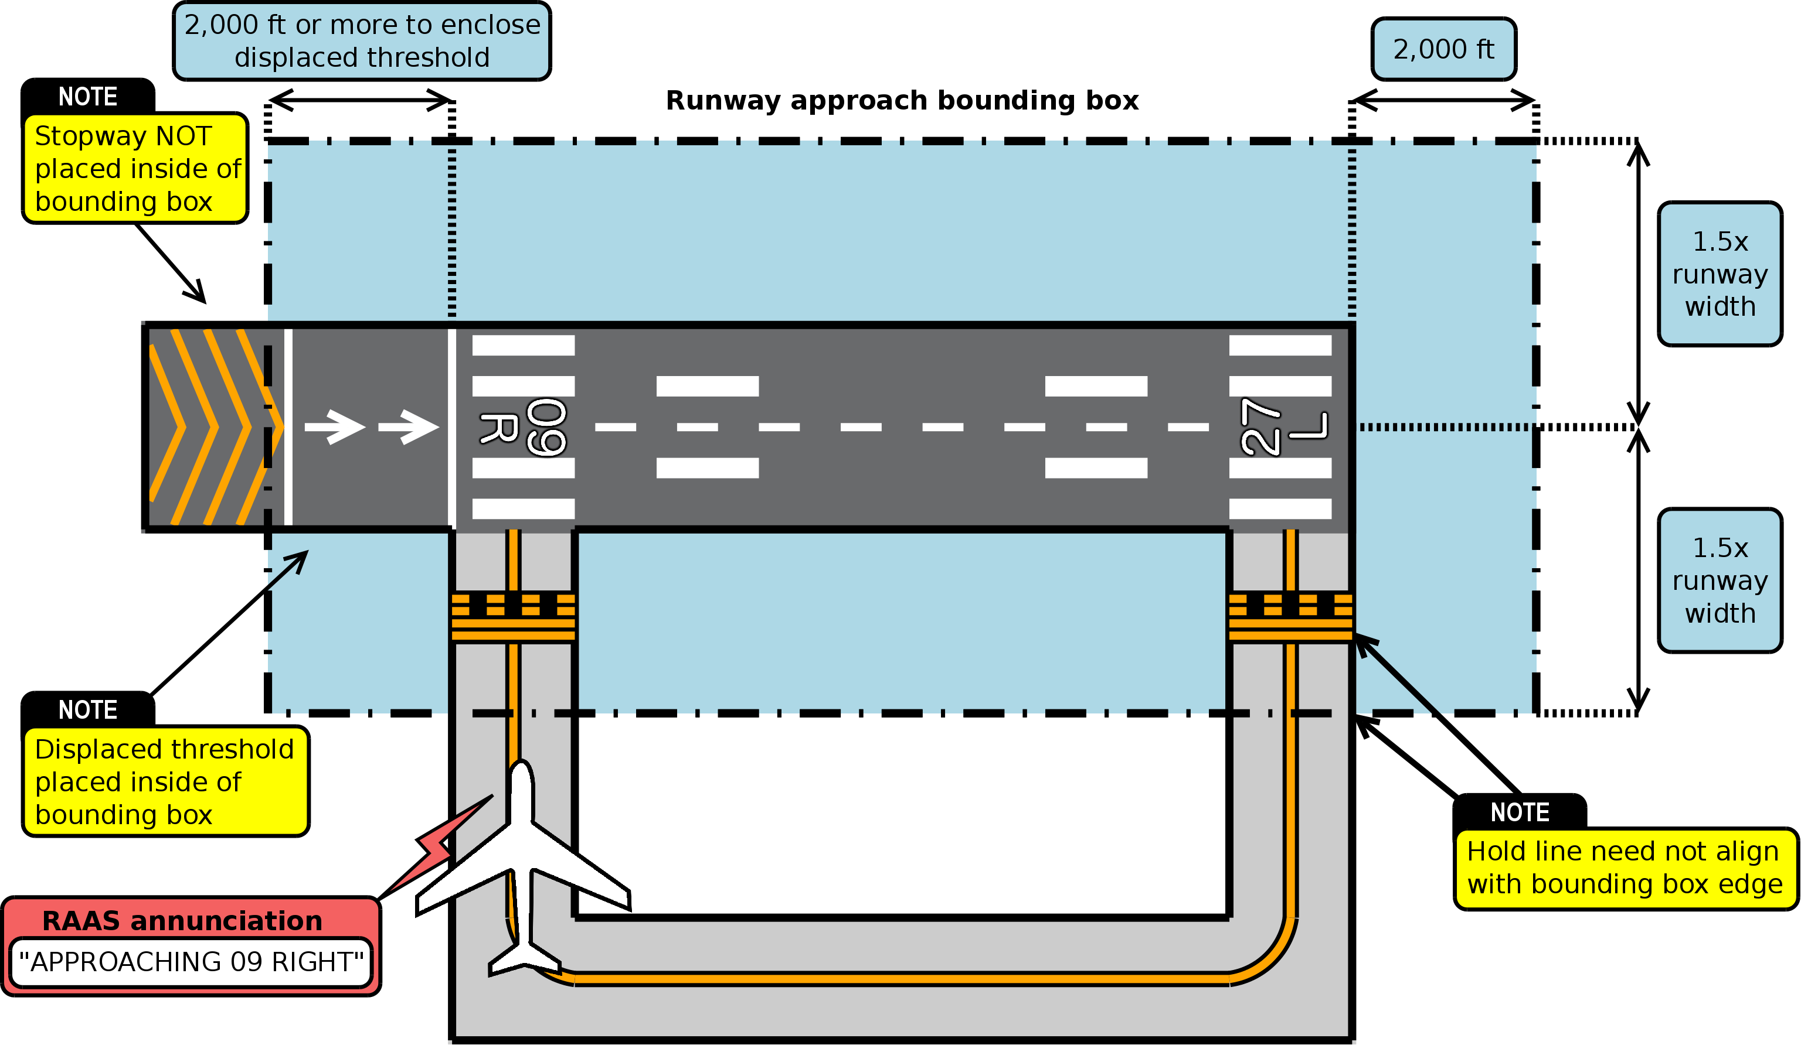Illustration 1: Approaching a runway on the ground
The advisory is inhibited when ground speed exceeds 40 knots (to prevent activation on takeoff through intersecting runways). Please also note that the annunciation does not guarantee the ability to stop before entering the runway.

Lined up on runway for takeoff
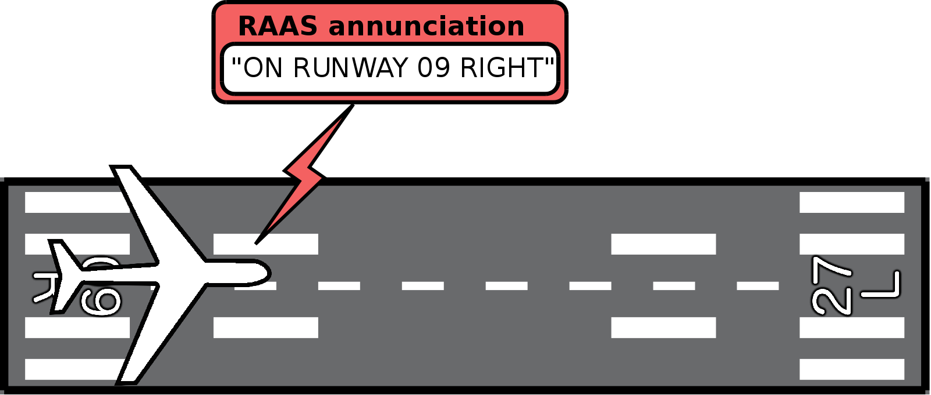Illustration 2: Lined up on runway for takeoff
This annunciation is made on initially lining up on a runway (aircraft heading is within approximately 25 degrees of runway heading). If the aircraft holds in position on a runway for extended periods of time, the annunciation is repeated at configurable intervals up to a configurable maximum number of repetitions before auto-inhibiting.
This annunciation may be supplemented by an annunciation of “FLAPS, FLAPS” if the appropriate takeoff flap configuration has not yet been selected at the time of line up. The takeoff flaps advisory is inhibited if the GPWS flaps override mode is active.

Lined up on runway too short for takeoff
If the runway length remaining for takeoff is below an operator-defined minimum for a safe takeoff, the “on runway” annunciation is supplemented by a runway distance remaining readout.
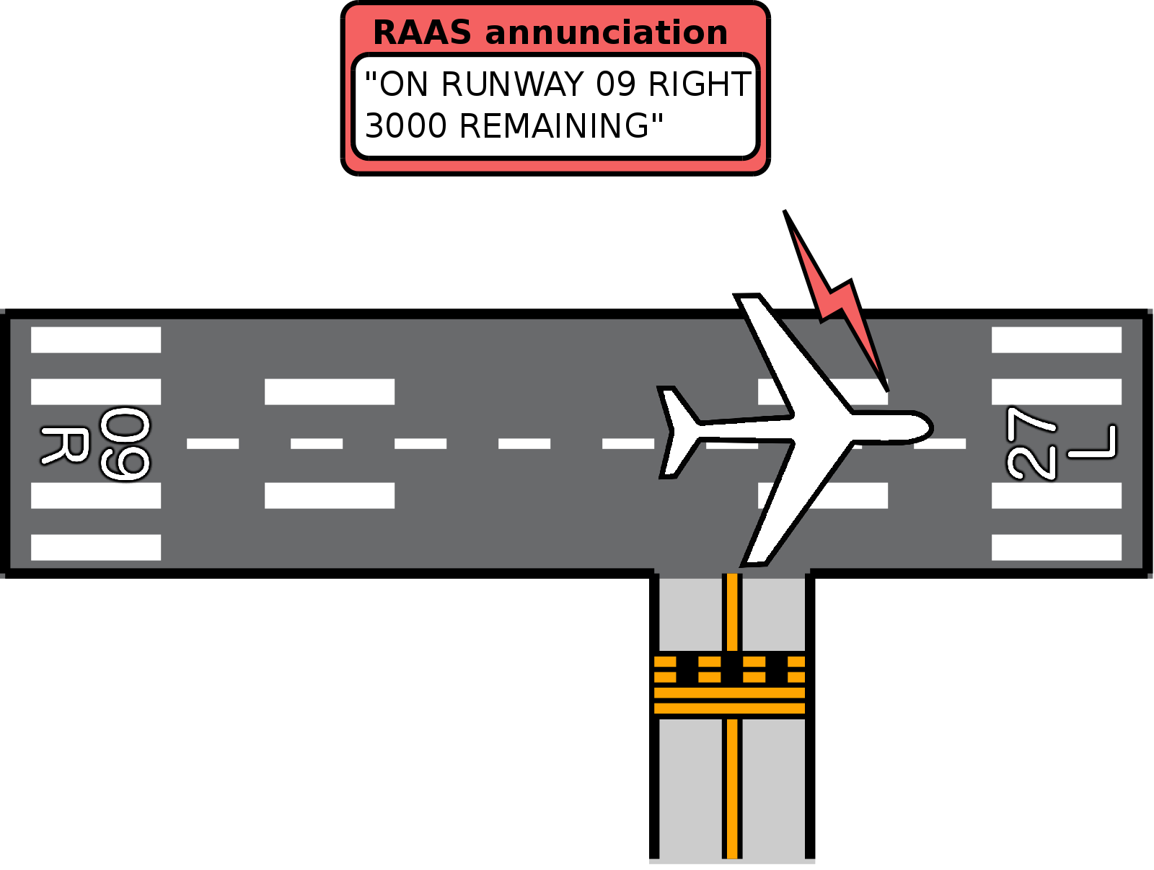Illustration 3: Lined up on runway too short for takeoff

Short runway takeoff
If takeoff is attempted on a runway with runway length remaining below an operator defined minimum, once ground speed exceeds 40 knots, a warning annunciation is generated: “CAUTION! SHORT RUNWAY! SHORT RUNWAY!”
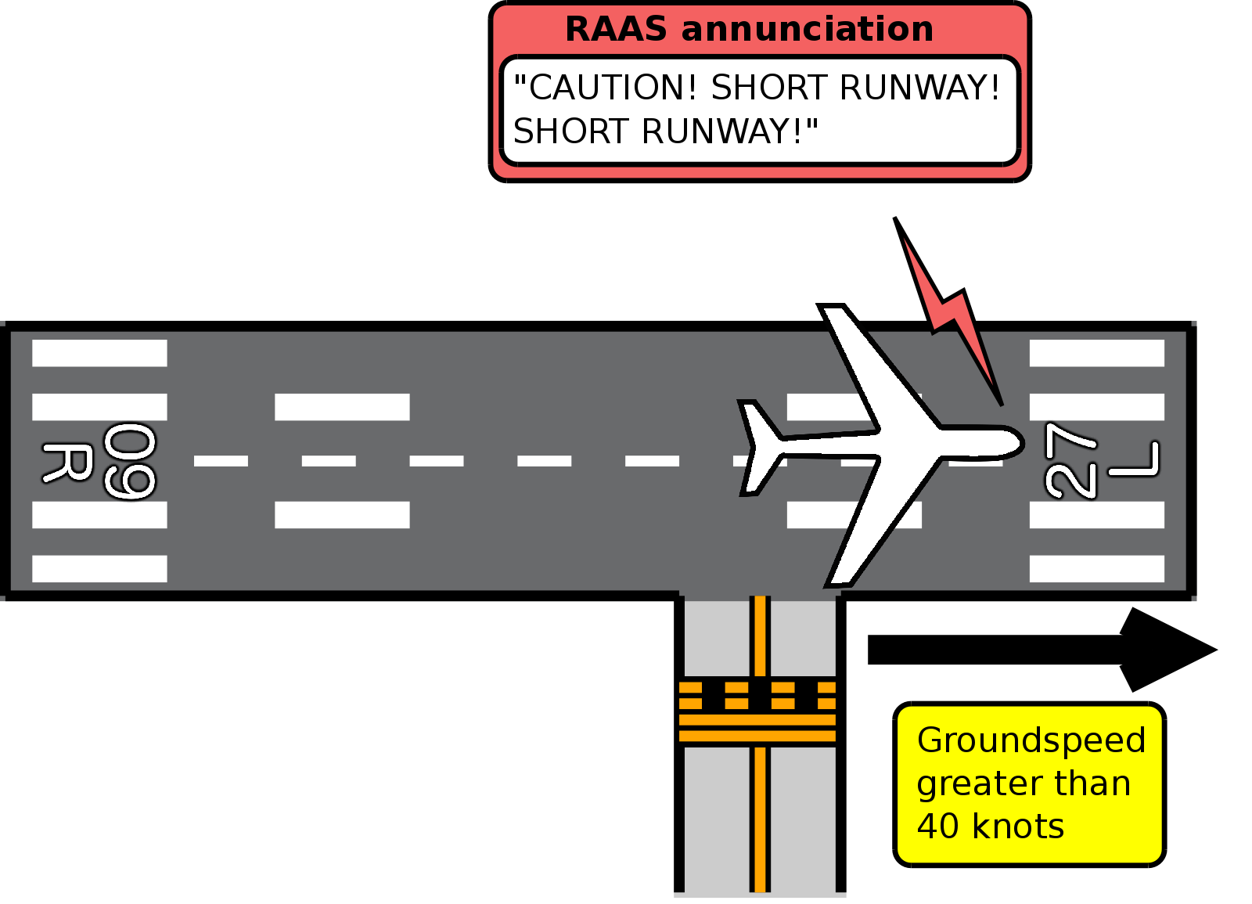Illustration 4: Short runway takeoff

Taxiway takeoff
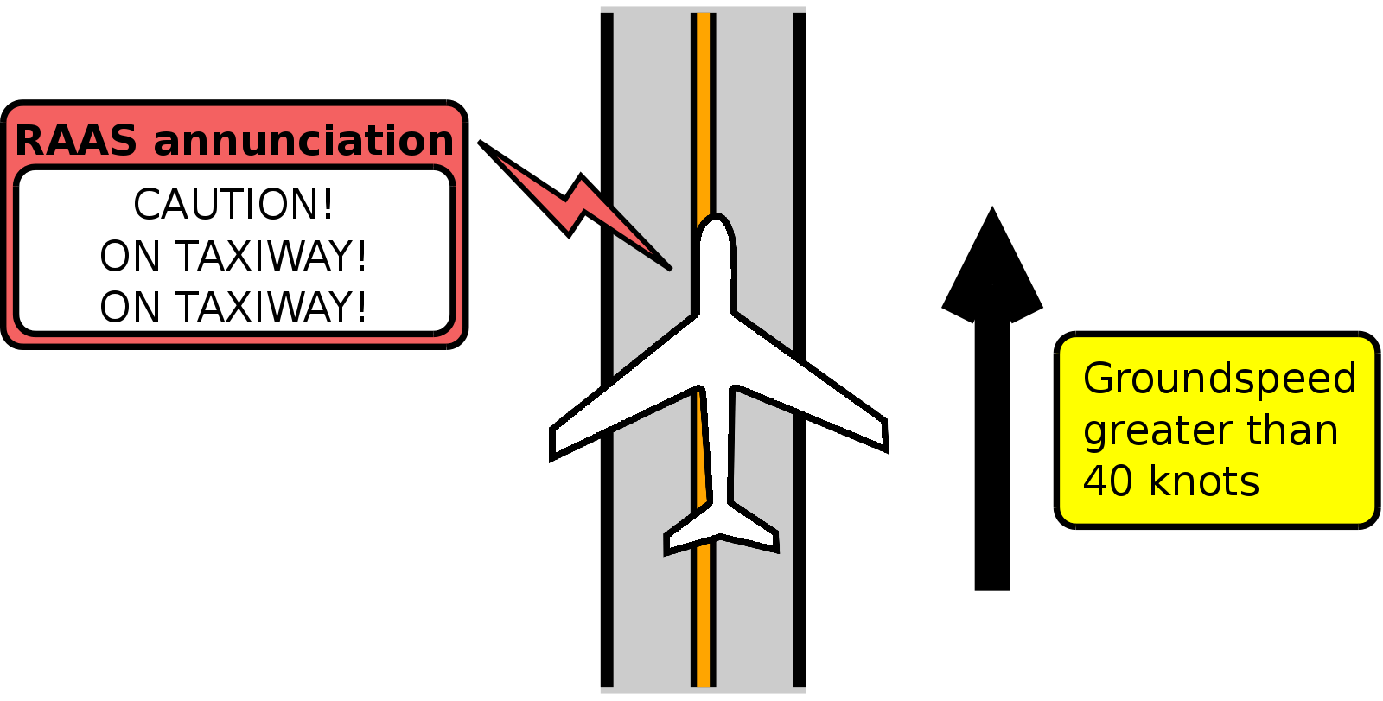Illustration 5: Taxiway takeoff
This annunciation warns of attempting takeoff on a taxiway, typically after missing a turn onto the intended departure runway.
The conditions for triggering this annunciation are:
- Aircraft is NOT on a runway
- Ground speed exceeds 40 knots

Late rotation on takeoff
If the aircraft is on a runway and accelerates past 40 knots ground speed, X-RAAS switches into takeoff mode. Normally most annunciations are inhibited during this mode, however, if the runway length remaining drops below an operator-defined value and rotation has not yet been initiated, X-RAAS will start to issue runway length remaining annunciations to notify the crew of the rapidly approaching runway end and the need to initiate rotation as soon as possible.
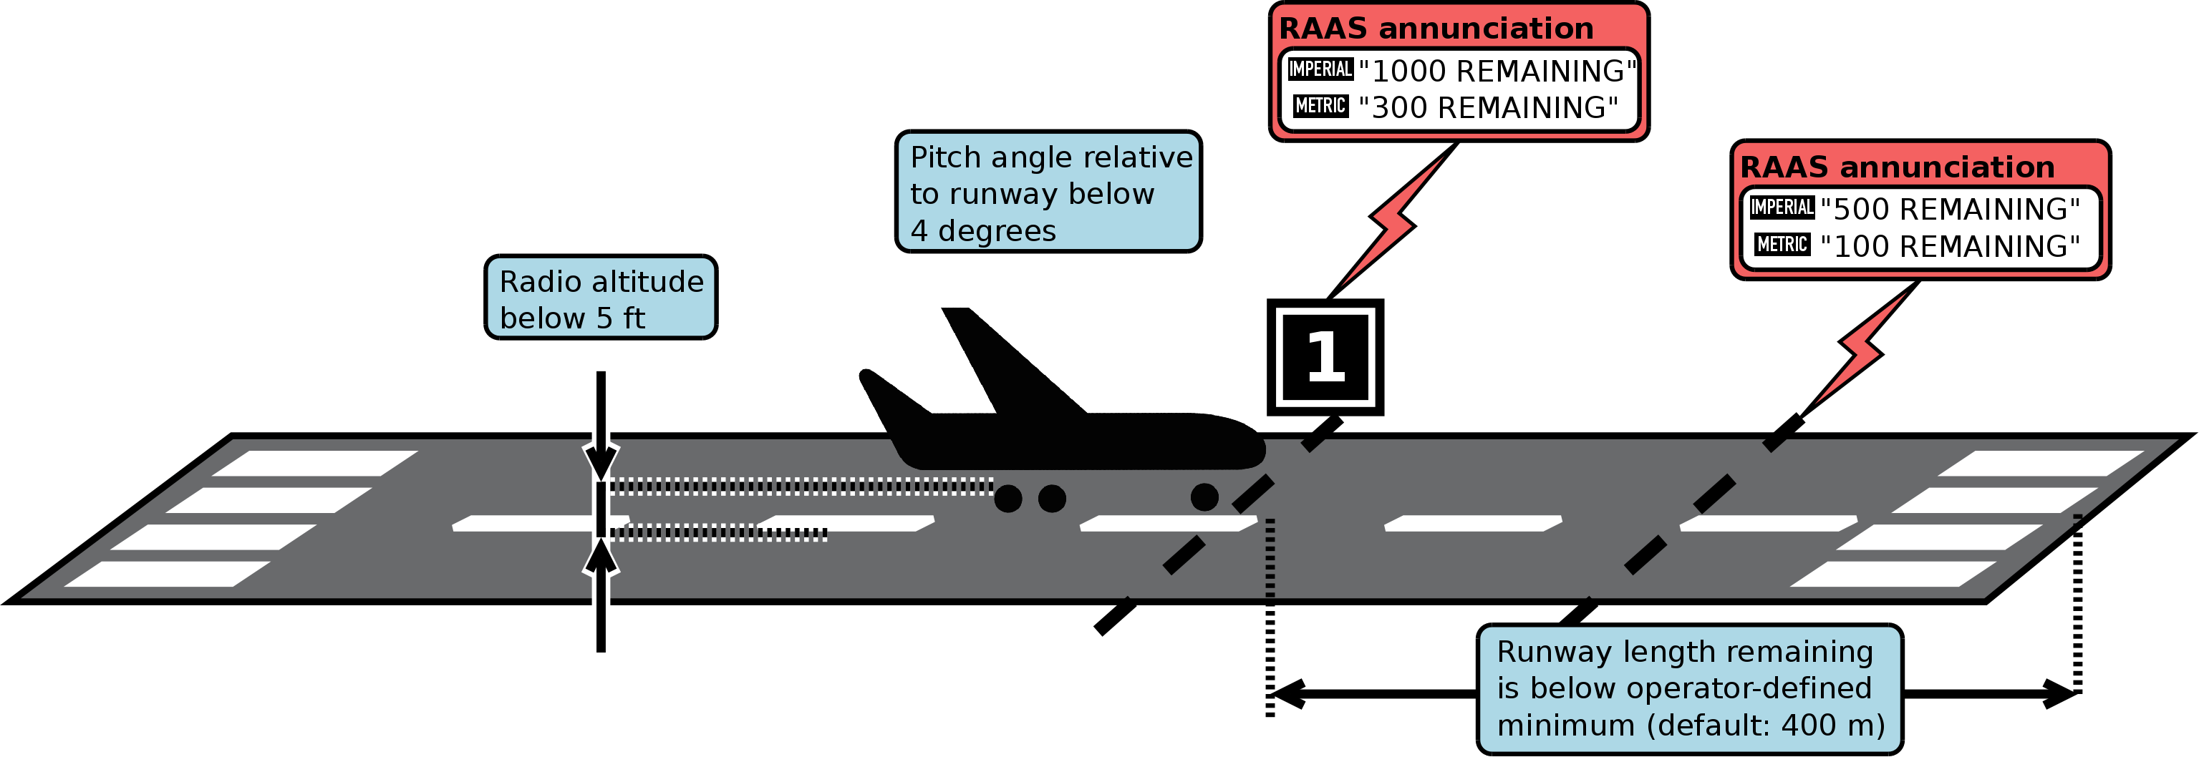Illustration 6: Late rotation on takeoff

Rejected takeoff
In takeoff mode (on runway and ground speed greater than 40 knots), X-RAAS closely monitors the aircraft's ground speed. If the aircraft decelerates 5 knots below the maximum ground speed attained during the takeoff roll, X-RAAS assumes that the takeoff is being rejected. During a rejected takeoff, if runway length remaining decreases below 9000 feet or 2700 meters, X-RAAS will start to issue runway length remaining annunciations.
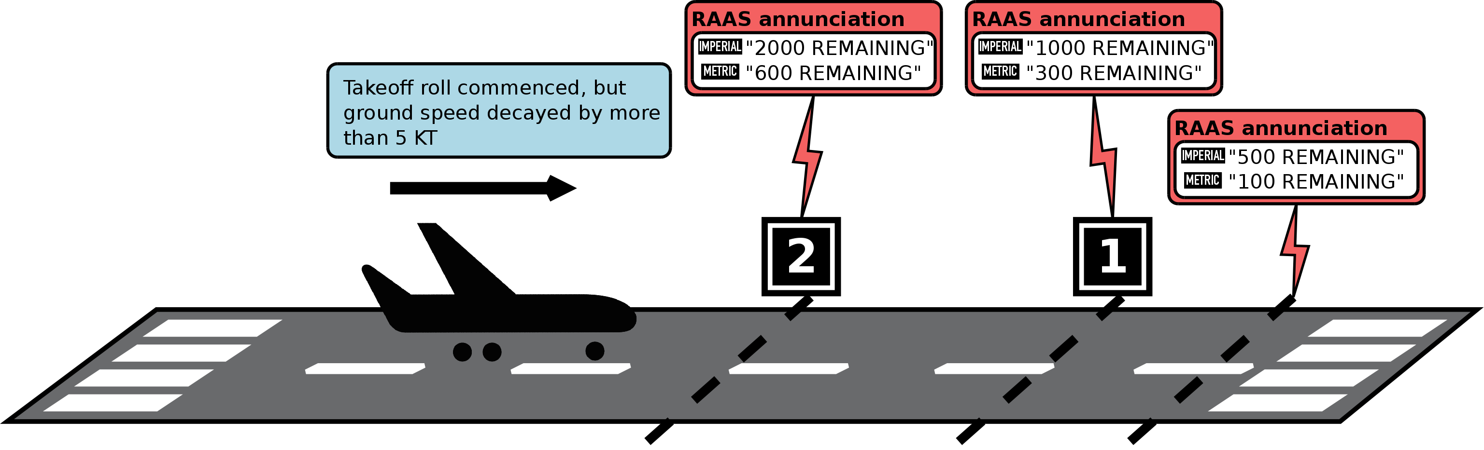Illustration 7: Rejected takeoff

Altimeter setting climbing through transition altitude
X-RAAS determines the transition altitude based on database information for the closest airport to the aircraft. If the aircraft climbs through the transition altitude, X-RAAS monitors the barometric altimeter subscale setting. If by 30 seconds after transitioning the subscale is not set to QNE (1013.25 hPa or 29.92 in.Hg), the following advisory is issued: “ALTIMETER SETTING”. This is to prevent incorrect altitude readings in cruise, which increases the possibility of traffic collisions.
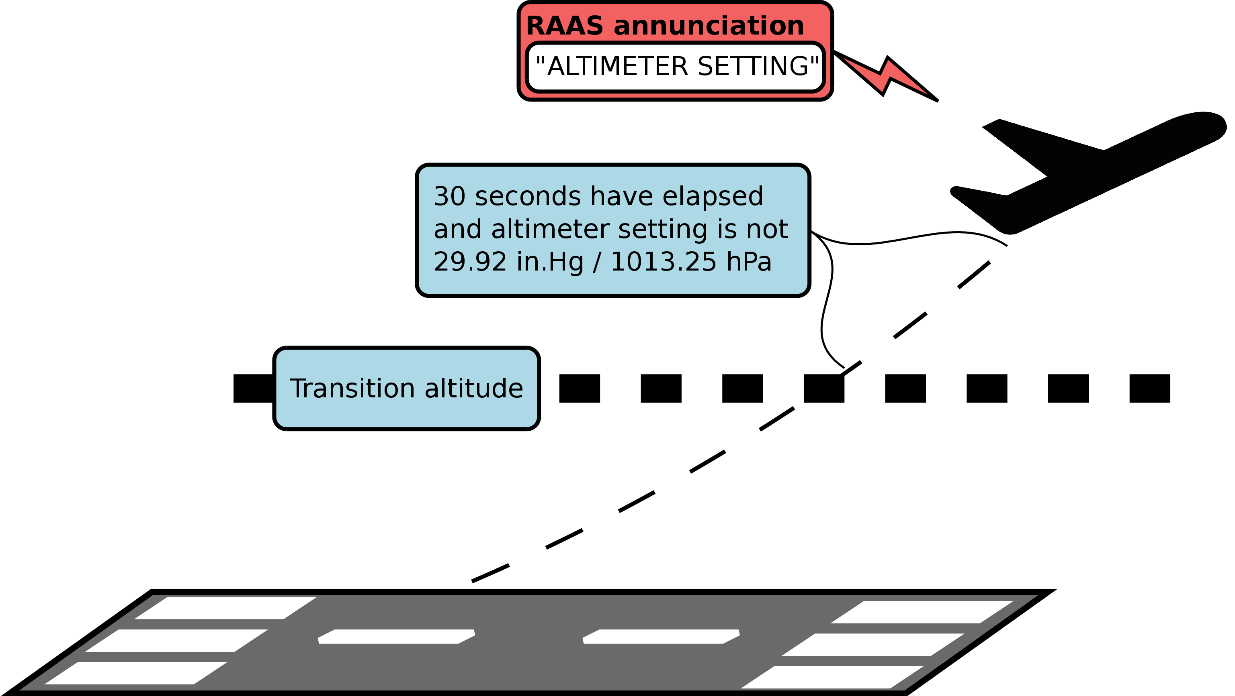Illustration 8: Altimeter setting climbing through transition altitude
Please note that this advisory might not be available if transition altitude is not published in the navigation database. Flight crews must remain fully alert to crossing the transition altitude and reliance on the altimeter setting RAAS annunciation as part of standard operations is prohibited.

Altimeter setting descending through transition level
This is the reverse advisory to the altimeter setting advisory during climb and is intended to assist in preventing CFIT (Controlled Flight Into Terrain). X-RAAS determines the transition level based on the navigational database entries of the airport closest to the aircraft. If a fixed transition level is not published, X-RAAS calculates the lowest possible transition level based on barometric pressure readings, GPS calculated elevation AMSL and a published transition altitude, such that the calculated transition level is equal in true elevation AMSL to the transition altitude. Please note that this fallback mechanism might not be as accurate as using the ATC-assigned transition level, so reliance on this annunciation to determine the correct transition level is prohibited.
Once the aircraft descends through the transition level, X-RAAS monitors the barometric altimeter reading and GPS-calculated altitude:
- If QNH altimetry is enabled, the GPS-determined elevation AMSL is compared to the barometric altimeter reading. If the values differ by more than a pre-determined threshold after more than 30 seconds has elapsed since crossing the transition level, an “ALTIMETER SETTING” annunciation is generated.
- If QFE altimetry is enabled, X-RAAS compares GPS-determined elevation above the nearest aerodrome with the barometric altimeter reading to make sure that they are within a pre-determined threshold.
The 30 second timeout for the barometric altimeter setting check can be preempted and initiated early if the aircraft descends below 1,500 feet above field elevation of the nearest airport.
The default altimetry mode is QNH. Refer to section 4 for information on how to enable QFE altimetry.
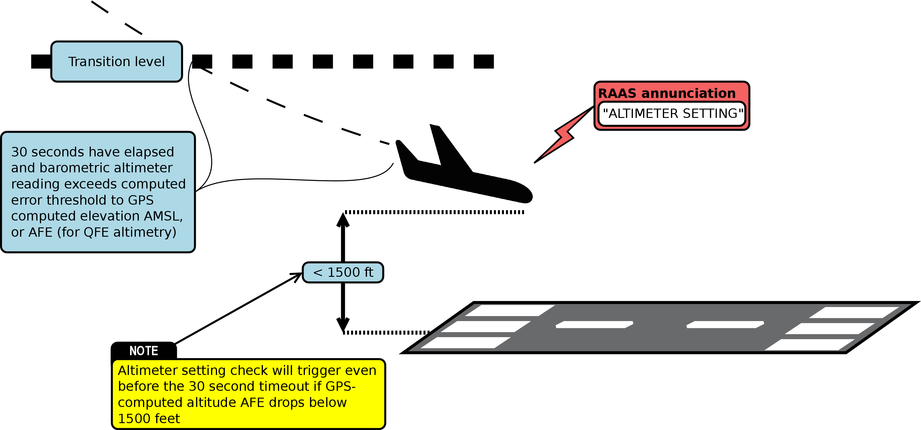Illustration 9: Altimeter setting descending through transition level

Approaching a runway to land
To facilitate proper runway alignment, X-RAAS issues a runway approach annunciation also when approaching a runway from the air with the intention to land. The following conditions need to be met for this annunciation:
- Within approximately 3 nm of a runway.
- Track is aligned with the runway and heading is within 25 degrees of runway heading.
- In landing configuration.
- Descending through between 700 feet and 320 feet above runway threshold elevation.
If the runway length is below an operator-defined minimum, the annunciation is supplemented by an additional callout: “CAUTION! SHORT RUNWAY! SHORT RUNWAY!”
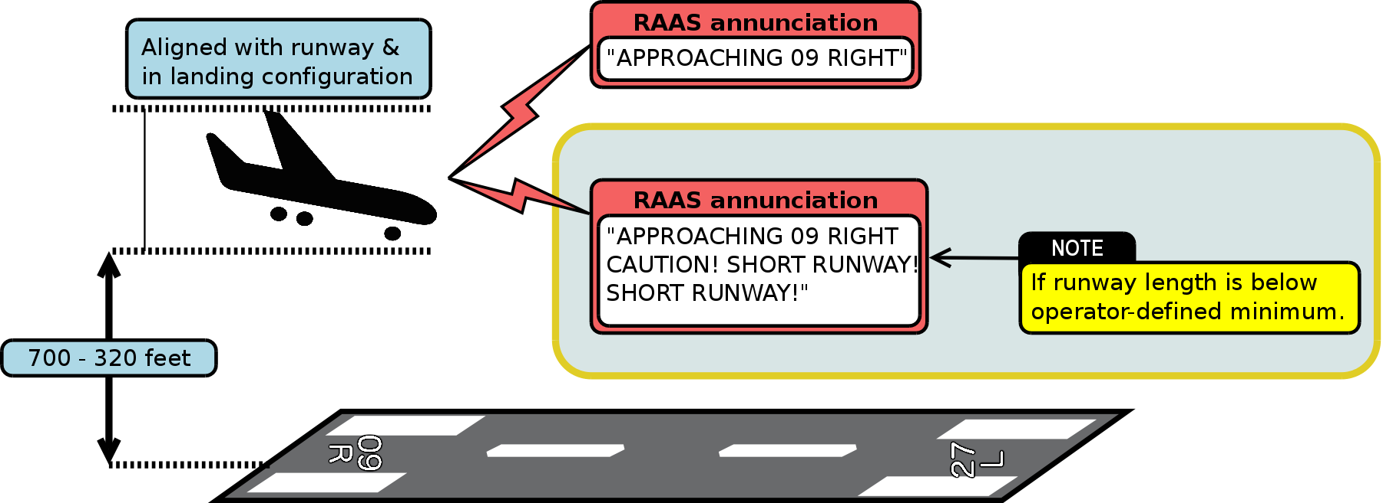Illustration 10: Approaching a runway to land

Late flap selection during approach to land
X-RAAS also monitors the flaps configuration during an approach to land and issues “FLAPS! FLAPS!” advisories in case flaps are not in the proper setting for landing at certain periods during the approach, based on elevation above runway threshold:
- Descending through 950 feet to 600 feet, annunciation: “FLAPS! FLAPS!”
- Descending through 600 feet to 450 feet, annunciation: “FLAPS! FLAPS!”
- Descending through 450 feet to 300 feet, annunciation: “UNSTABLE! UNSTABLE!”
- Annunciation is inhibited below 300 feet above threshold elevation.
This advisory is inhibited if the GPWS flaps override mode is active.
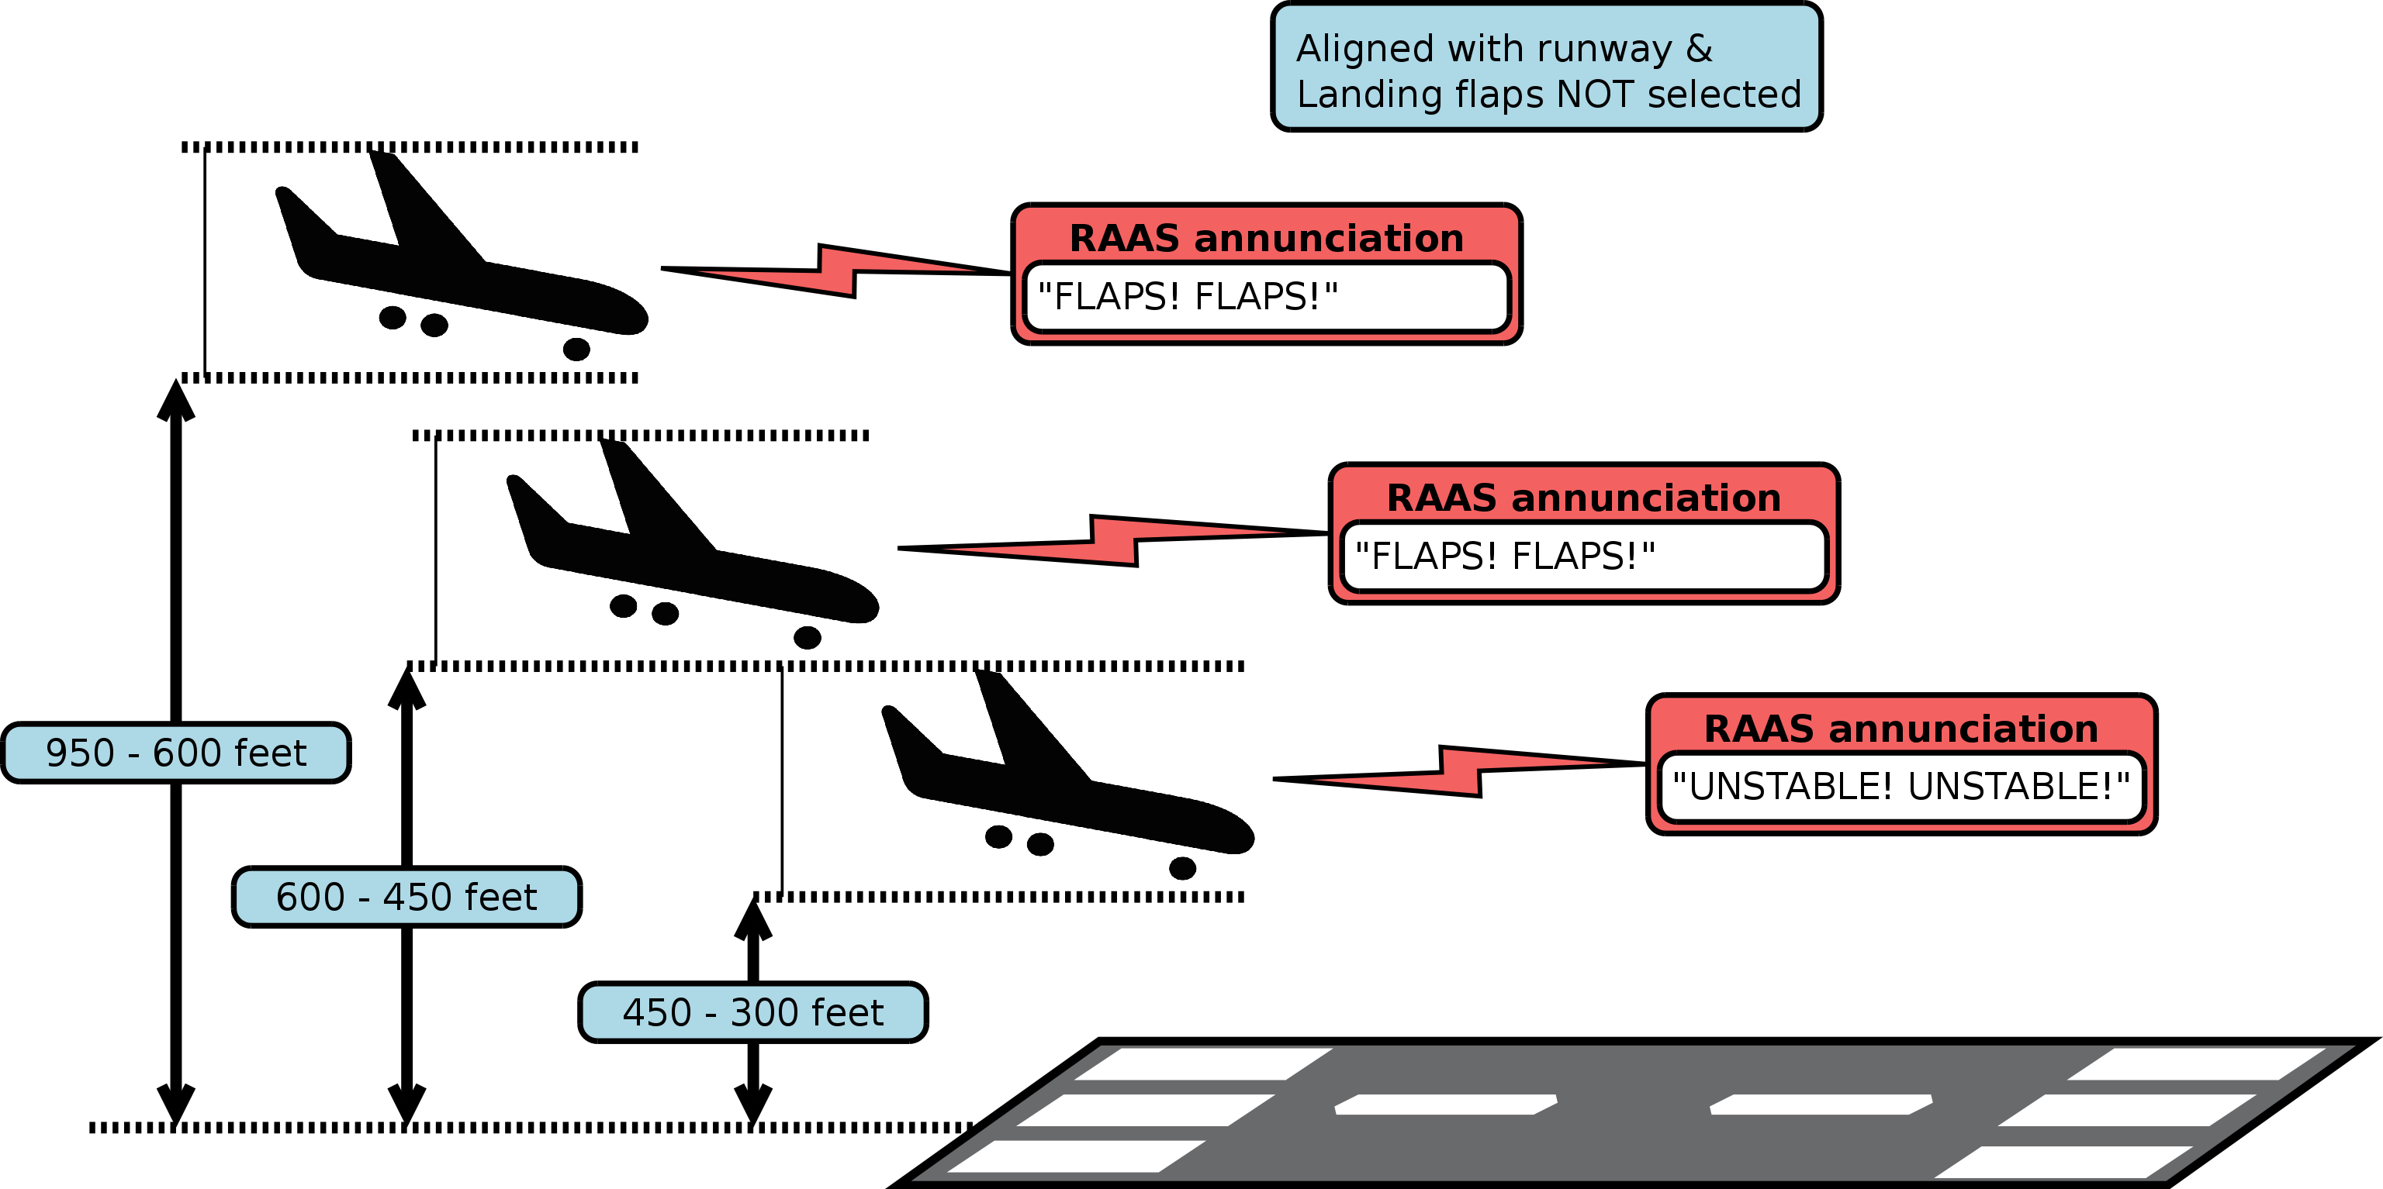Illustration 11: Late flap selection during approach to land

Steep descent late in the approach to land
To protect against steep descents late in the landing approach and “dive bombing it” at the last moment, X-RAAS calculates the aircraft glide path angle and compares it with the optimal glide path angle stored in the database for the runway. If the actual glide path angle exceeds 1.5x the optimal angle (but no more than 8 degrees absolute glide path angle), X-RAAS issues advisories, depending elevation above runway threshold:
- Descending through 950 feet to 600 feet, annunciation: “TOO HIGH! TOO HIGH!”
- Descending through 600 feet to 450 feet, annunciation: “TOO HIGH! TOO HIGH!”
- Descending through 450 feet to 300 feet, annunciation: “UNSTABLE! UNSTABLE!”
- Annunciation is inhibited below 300 feet above threshold elevation.
This advisory is inhibited if the GPWS terrain override mode is active.
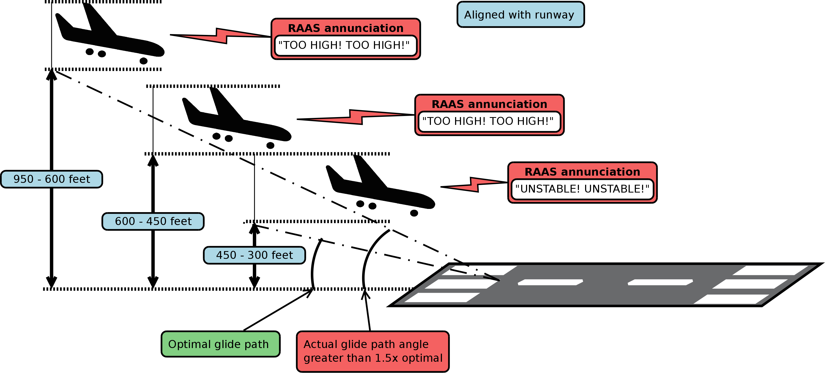Illustration 12: Steep descent late in the approach to land

Attempting to land on a parallel taxiway
Many airports feature runways with close parallel taxiways. Under certain weather conditions, these can look very similar to each other during final approach and lead to confusion as to which is the runway and which is a taxiway. This increases the risk of an aircraft attempting to land on a taxiway, with obvious potential for a collision as a result.
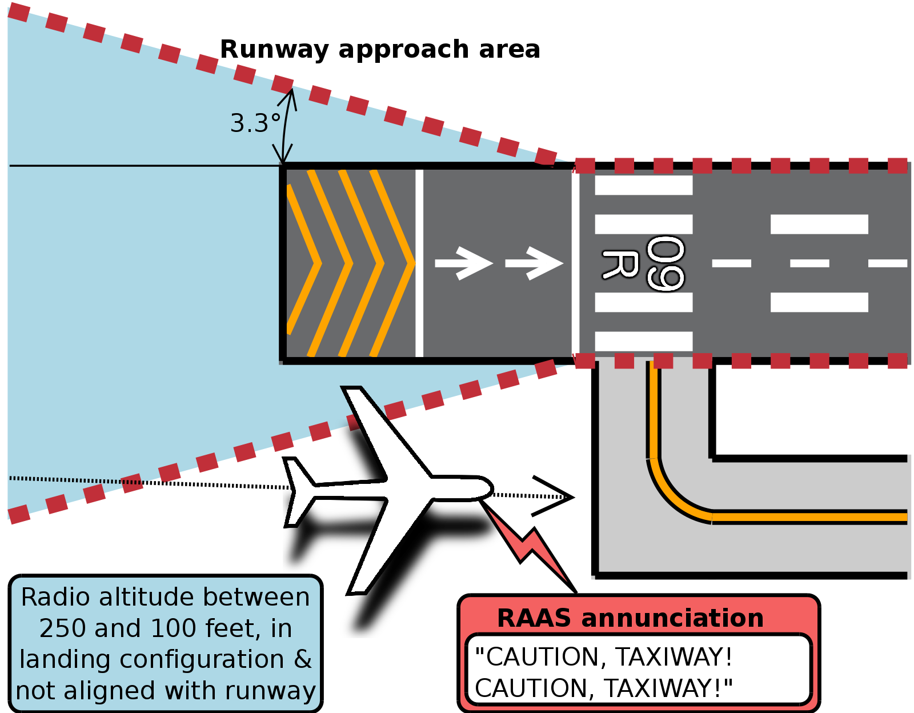Illustration 13: Attempting to land on a parallel taxiway
To help in preventing this hazard, X-RAAS closely monitors an aircraft's position during the final stages of approach. If X-RAAS detects the following conditions, it will issue a warning advisory:
- Radio altitude is less than 250 feet, but above 100 feet.
- Aircraft is in landing configuration (gear is down and flaps in the landing position).
- Aircraft is not in the runway approach area or is not aligned with the runway (aircraft heading within 20 degrees of runway heading).
The advisory is inhibited below 100 feet radio altitude or if the GPWS terrain override mode is active.

Long landing
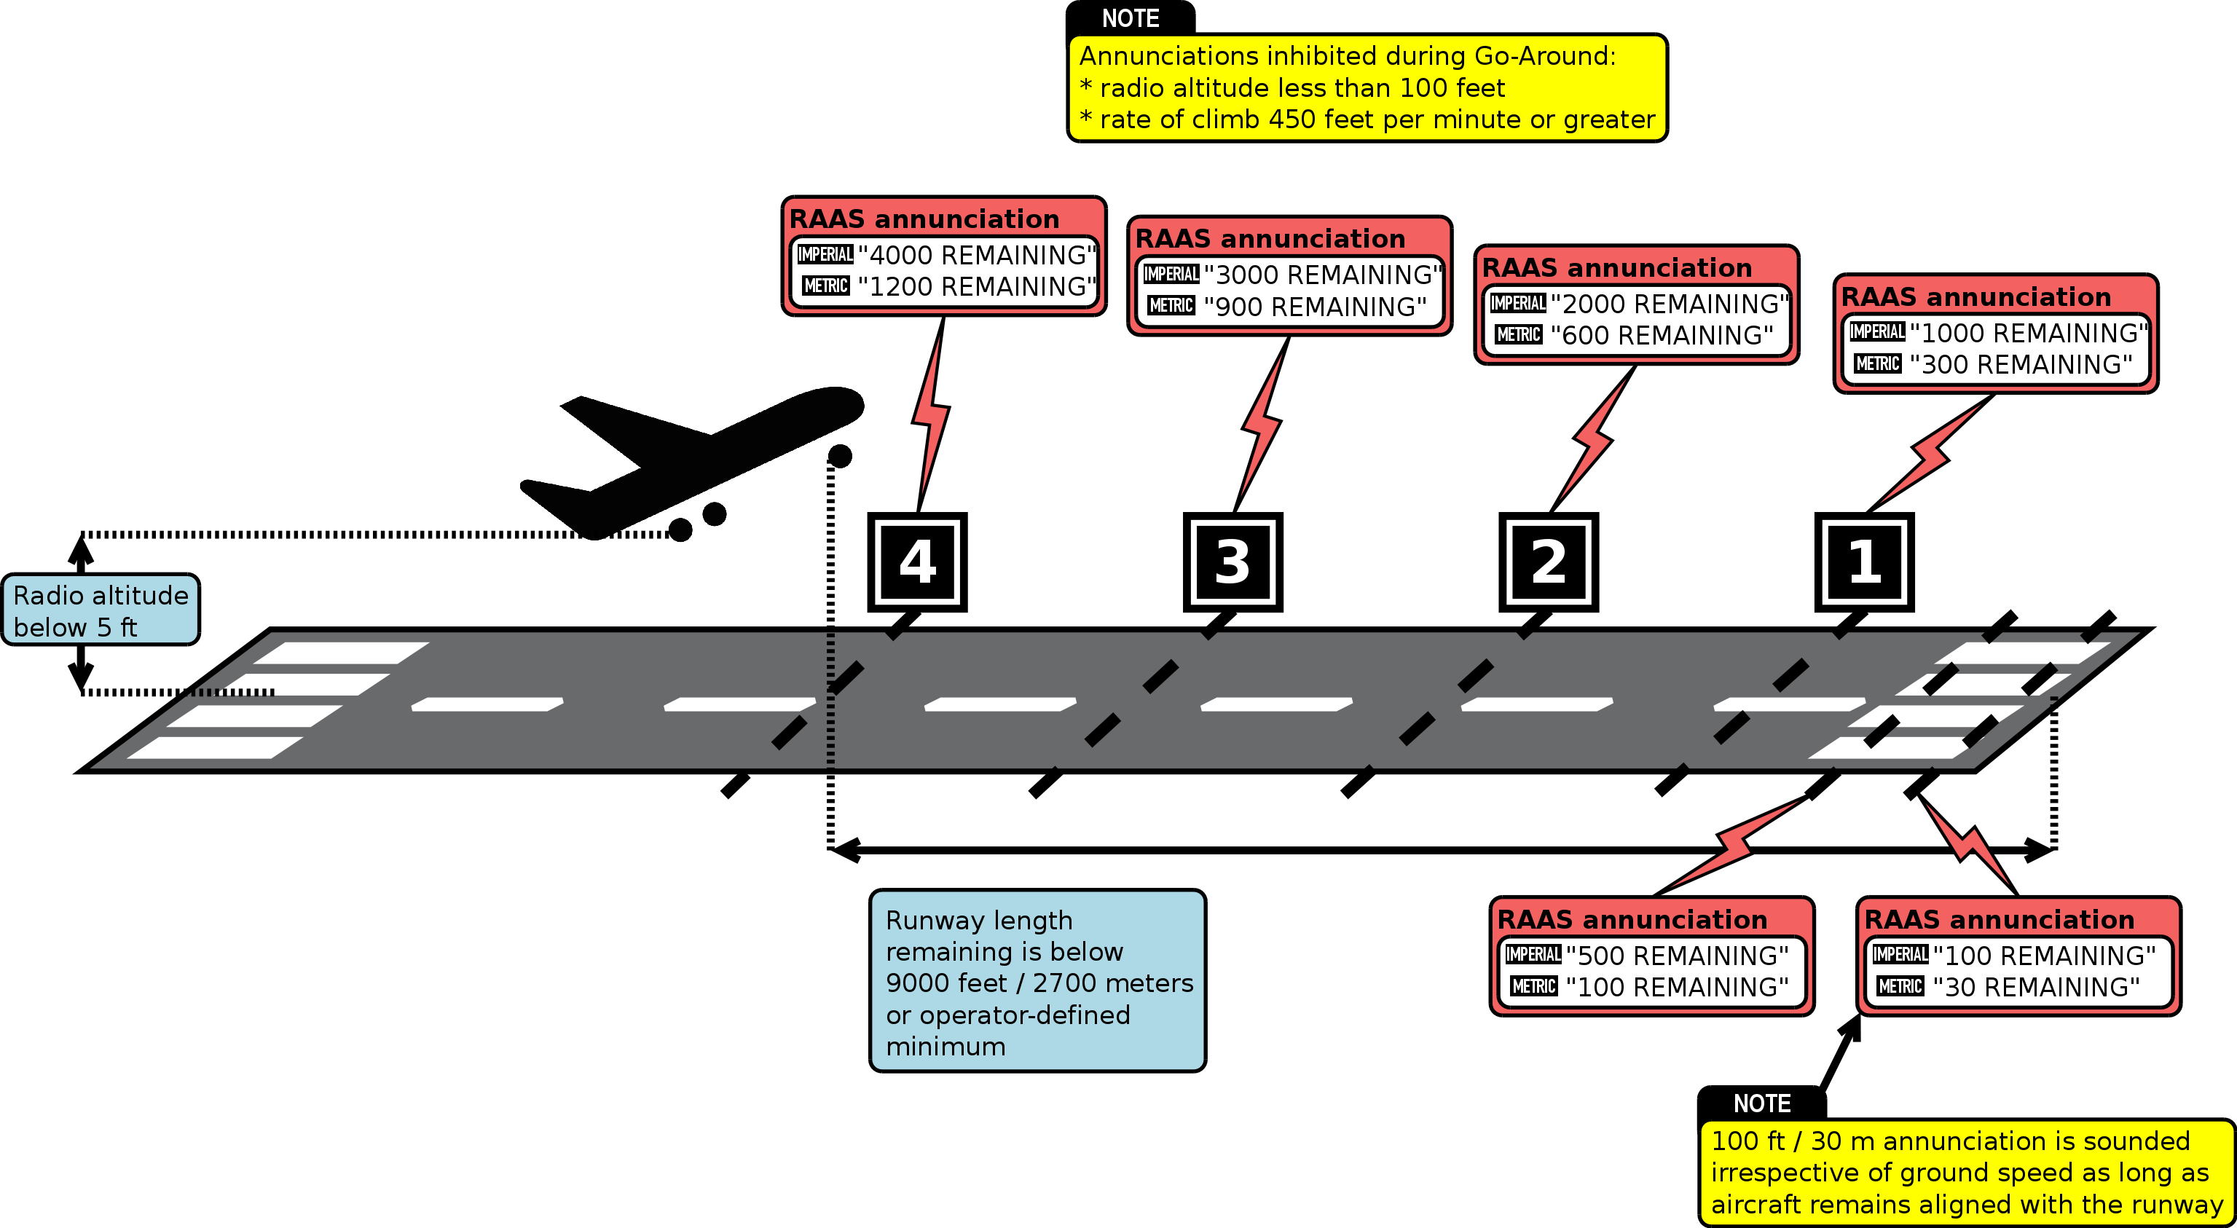Illustration 14: Landing rollout runway length remaining
This annunciation protects against excessive floating on landing or an incorrectly executed too high or too fast approach, resulting in touch down very far down the runway and potentially insufficient runway length available for rollout. Conditions for this annunciation are:
- The aircraft is above the runway.
- Radio altitude indicates less than 50 feet, but more than 5 feet.
- Aircraft is past ½ of the runway length or remaining runway length is less than an operator-specified minimum.
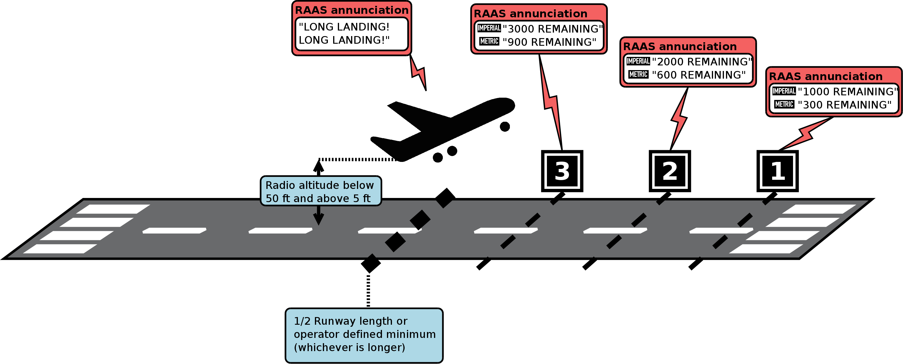Illustration 15: Long landing
X-RAAS will initially annunciate “LONG LANDING!” twice and the remaining runway length if it is less than 9,000 feet (2,700 meters). Afterwards, X-RAAS will continue to annunciate runway length remaining every 1,000 feet (300 meters), unless the aircraft lands and decelerates below 40 knots ground speed, or performs a go-around (refer to section 3.16 for conditions monitored during a go-around).

Landing rollout runway length remaining
During landing rollout, annunciations inform the pilot of runway length remaining for stopping. They are initiated as soon the aircraft reaches 5 feet radio altitude and remain in effect until the ground speed is below 40 knots. Landing distance remaining annunciations are performed at 1,000 foot or 300 meter increments and are based on the position the aircraft's nosewheel will attain in approximately 1 second with an added approximate 200 feet or 60 meter buffer. Therefore a “3000 (feet) remaining” annunciation can be sounded between 3,000 to 3,200 feet remaining. Initial landing distance remaining annunciations are commenced at 9,000 feet or 2,700 meters remaining, or an operator-defined maximum. The last 1,000 feet or 300 meters of runway length remaining feature two additional annunciations:
- The last 500 feet or 100 meters. Inhibited if ground speed is below 40 knots.
- The last 100 feet or 30 meters. This annunciation is sounded irrespective of ground speed as long as the aircraft remains aligned with the runway to warn the pilot of the need to perform an immediate stop or turn to avoid running off the end of the runway.
The runway length remaining is calculated based on the position of the threshold of the opposite runway. If the opposite runway features a displaced threshold, this displacement length is counted towards the runway length remaining, i.e. the displaced threshold portion of a runway is considered to be suitable for landing rollout. If the opposite runway features a stopway (a “blastpad”), this is NOT counted towards the runway length remaining.

Go-Around
During Go-Around, runway length remaining annunciations are inhibited as soon as the aircraft climbs through 5 feet radio altitude and the following two conditions are met:
- radio altitude is below 100 feet
- rate of climb is 450 feet per minute or greater
If the rate of climb decays to below 450 feet per minute, runway length remaining annunciations are continued. If the aircraft climbs through 100 feet radio altitude, runway length remaining annunciations are not resumed, even if the aircraft resumes level flight.

Due to how X-RAAS is implemented, landing rollout annunciations are only guaranteed to sound if the aircraft is flying through each distance “gate” below a maximum ground speed:
Distance [feet] | Distance [meters] | Maximum ground speed [knots]
9,000 – 1,000 | 2,700 – 300 | 250
500 | 100 | 125
100 | 30 | 60

Runway exit via high-speed exit taxiways
To support efficient high-traffic-density operations, landing traffic needs to be able to exit the runway environment after landing in an expeditious manner. To this end, many airports feature “high-speed exit” taxiways. These taxiways, rather than connecting to the runway at right angles, connect at relatively shallow angles, allowing landing traffic to maintain higher speed when turning off the runway. To support high-speed rollouts onto these kinds of taxiways, X-RAAS monitors groundspeed and aircraft position relative to the runway after landing. If the aircraft exceeds a limiting ground speed, the following annunciation will sound: “CAUTION! ON TAXIWAY! ON TAXIWAY!”
- As long as the aircraft remains on a runway, no limiting ground speed is imposed.
- If the aircraft leaves the runway, but remains within the runway approach bounding box (as described in section 3.1), the limiting ground speed is 60 knots.
- If the aircraft leaves both the runway and the runway approach bounding box, the limiting ground speed is 40 knots.
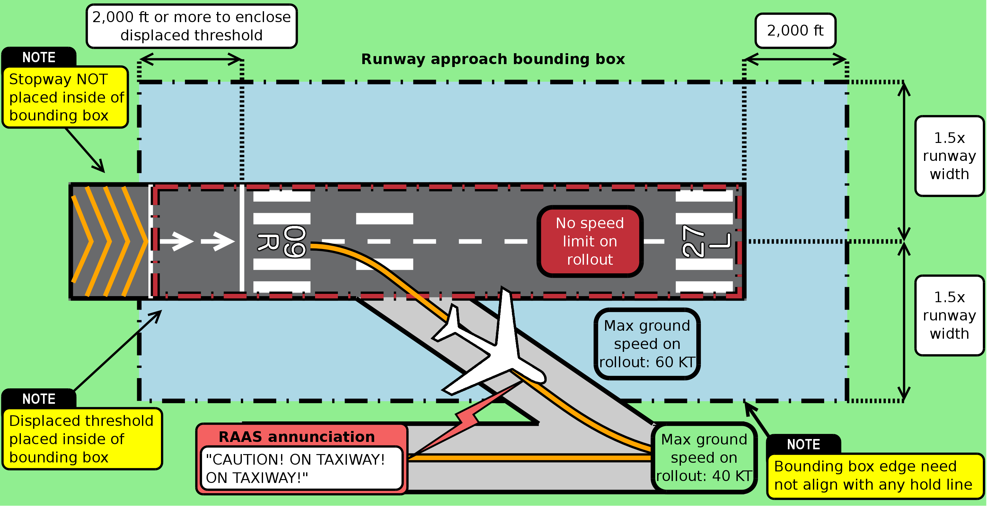Illustration 16: Runway exit via high-speed exit taxiways

X-RAAS Configuration
Just like the real system, X-RAAS can be extensively customized to suit the particular operational requirements of an aircraft or airline. For this purpose, X-RAAS contains a text configuration file called X-RAAS.cfg. You can open it up in any text editor such as Notepad or TextEdit. The configuration file is simply a set of lines in the following format:
<Parameter> = <Value>
You can set the value of a parameter any number of times in a configuration file. The last setting encountered will be the one used. Please note that if you are satisfied with the default value of a parameter, you do not need to set it in the configuration file. Absence of a parameter setting implies that X-RAAS should use the default value. This should help to keep your configuration file short.
Anything following a double-dash (--) is considered a comment and ignored by X-RAAS:
-- This is a comment. X-RAAS ignores what's on this line.
<Parameter> = <Value>
X-RAAS looks for the configuration file in two locations, first in the Scripts folder in FlyWithLua where X-RAAS is installed and then in the aircraft folder of the currently loaded aircraft. If both are present, X-RAAS loads both files in this order, so any parameter set in the global configuration file in the Scripts folder can be overridden by the configuration file in the aircraft folder, giving the ability to override global settings on a per-aircraft basis.
<X-Plane 10 Folder>
Aircraft
<Your Aircraft's Folder>
X-RAAS.cfg ← overrides any global settings only for this aircraft
Resources
plugins
FlyWithLua
Scripts
X-RAAS.cfg ← global settings for X-RAAS shared by all aircraft
The default configuration file shipped with X-RAAS contains a list of all settable parameters with comments on what they do (though all lines are commented out, so all parameters are set to their defaults). For completeness' sake, the list of settable parameters is repeated here.
Parameter Name | Default Value | Description
RAAS_enabled | true | This is the master X-RAAS on/off switch. Setting this parameter to false will disable X-RAAS completely.
RAAS_min_engines  RAAS_min_MTOW | 2  5700 | RAAS is primarily designed for airliners and is a poor fit for light general aviation aircraft or special performance aircraft such as helicopters or aerobatic aircraft. Provided the master RAAS_enabled parameter is set to true, X-RAAS also checks the aircraft's number of engines and Maximum Take Off Weight (MTOW) to see if the aircraft fulfills certain minimum criteria to be considered an “airliner”. To enable X-RAAS on all aircraft just set both of these values to 0.
RAAS_use_imperial | true | By default X-RAAS reads out runway length remaining in thousands of feet. By setting this parameter to false, X-RAAS will read out runway length remaining in increments of 300 meters.
RAAS_voice_female | true | Set to false to make X-RAAS grow a pair.
RAAS_voice_volume | 1.0 | Sets the relative volume of the RAAS announcements from 0.0 (silence) to 1.0 (full volume).
RAAS_min_takeoff_dist | 1000 | This is the minimum runway length remaining (in meters) that X-RAAS will consider to be safe for conducting a takeoff. This affects the advisories in sections 3.3 and 3.4.
RAAS_min_landing_dist | 800 | This is the minimum runway length remaining (in meters) that X-RAAS will consider to be safe for conducting a landing. This affects the advisory in section 3.10.
RAAS_min_rotation_dist  RAAS_min_rotation_angle | 400  4 | Minimum runway length remaining (in meters) and pitch angle (in degrees) relative to the runway slope where X-RAAS will start to issue runway length remaining annunciations on takeoff to warn of the runway end approaching rapidly and the need to initiate rotation immediately. This affects the advisory in section 3.6.
RAAS_accel_stop_dist_cutoff | 3000 | Defines an upper limit (in meters) on runway length remaining for “distance remaining” callouts during a rejected takeoff or on landing rollout (sections 3.7 and 3.15). If the distance remaining is greater than this value, X-RAAS will not generate annunciations until the distance remaining drops below this value. The maximum value is 3000.
RAAS_min_landing_flap | 0.5 | Minimum flap setting (relative flap handle position from 0.0 for “flaps up” to 1.0 for full “flaps down”) that is considered a valid landing flaps setting. This affects the advisory in section 3.11.
RAAS_min_takeoff_flap  RAAS_max_takeoff_flap | 0.1  0.75 | The minimum and maximum valid flap setting for takeoff. This affects the supplemental “FLAPS! FLAPS!” callout when lining up on a runway for takeoff in section 3.2.
RAAS_on_rwy_warn_initial  RAAS_on_rwy_warn_repeat  RAAS_on_rwy_warn_max_n | 60  120  3 | The interval at which “ON RUNWAY” callouts for extended holding on a runway are issued. The initial delay is for the first callout, whereas the repeat delay is for any subsequent callouts from the first. The “max_n” parameter defines the total maximum number of callouts that will be issued to limit annoyance to the crew. Setting RAAS_on_rwy_warn_max_n to 0 will disable any “ON RUNWAY” callouts after extended holding on the runway.
RAAS_too_high_enabled | true | Controls whether X-RAAS will monitor glidepath angle and warn against too high approaches using the advisory described in section 3.12.
RAAS_gpa_limit_mult  RAAS_gpa_limit_max | 1.5  8 | If glidepath angle monitoring is enabled, this defines what X-RAAS considers to be “too high” on the glidepath. RAAS_gpa_limit_mult controls the glidepath angle multiplier, so if for instance the optimal glidepath for a runway is 3 degrees (determined from the database) and the multiplier is 1.5, then the limit before X-RAAS will begin “TOO HIGH” annunciations will be 4.5 degrees (3 x 1.5).  RAAS_gpa_limit_max provides an absolute upper boundary (in degrees) on the allowed glidepath angle limit. Even if the multiplier would calculate a higher limit, X-RAAS will cut the value off at this maximum threshold.
RAAS_alt_setting_enabled | true | Controls if altimeter setting monitoring is enabled, as described in sections 3.8 and 3.9.
RAAS_qnh_alt_enabled  RAAS_qfe_alt_enabled | true  false | When altimeter checks are enabled, when descending through transition level, these parameters determine what type of altimeter setting checks are preformed by X-RAAS. When QNH setting is allowed, X-RAAS checks to make sure that the barometric altimeter reading is within a pre-computed margin from GPS-computed elevation above mean sea level. When QFE setting is allowed, X-RAAS checks to make sure that the altimeter reading is within a pre-computed margin from above field elevation of the nearest airport. Setting both parameters to true allows either altimeter setting, whereas setting both parameters to false disables barometric altimeter checking on descent.

X-RAAS Electrical System Integration
X-RAAS is internally connected to electrical bus #1 and #2 in the aircraft (normally the “left” and “right” electrical bus) and is also subject to the master “Avionics on” switch (if installed on the aircraft). Losing power on both electrical buses or setting the master avionics switch to the “off” position will result in X-RAAS shutting down. X-RAAS requires a minimum of at least 11 Volts to be present on one of the electrical buses to operate and nominally consumes around 40 Watts of power. To prevent generating an additional electrical load by a non-flight-critical advisory system when the aircraft is operating only on battery electrical power, X-RAAS monitors if at least one engine generator or the APU generator is connected to the electrical buses and will automatically shut down if the aircraft is only operating on battery or external power (during external power operation the aircraft can be safely assumed to be on the ground and stationary).

By default X-RAAS is inhibited in small general aviation aircraft. See section 2 for more details.
If the runway has a displaced threshold, the bounding box is extended to encompass it completely, but the 2,000 ft buffer is not extended from the displaced end. Stopways are not placed in the bounding box.
The annunciation is temporarily inhibited between 520-480 feet and 420-380 feet above threshold elevation to allow for GPWS or manual altitude callouts.
Due to the minimum radio altitude constraint and the runway approach area shape, there is a minimum lateral deviation of the aircraft's longitudinal center axis off the runway edge, below which this advisory is inhibited. For runways with a 3° glidepath, a threshold clearing height of 50 feet and roughly flat terrain in the runway approach area, the minimum lateral deviation is approximately 56 feet or 17 meters. The shallower the glidepath or the higher the terrain in the approach area, the wider the minimum lateral deviation below which this advisory will be inhibited. Therefore, if the parallel taxiway is very close to the runway, X-RAAS may not be able to detect a taxiway landing attempt.
Stopways are normally designed for emergency use only.

